**Tips for Parents of Infants**

The COVID-19 is making us more stressed, anxious, and irritable, making parenting more challenging than ever. Parents are best able to support their children when they deal with stress calmly and confidently.

**Here are ideas to help children adapt positively to stressful events such as the COVID-19 pandemic**

**Establish routines and structure**

The COVID-19 pandemic has radically changed children’s routines and physical environments. Children learn and behave best when they have routines and their world is predictable and structured.

You can:

* **Make a schedule** that sets time for reading, free play, and outside time
* **Keep mealtimes, naptime, and bedtime routines** consistent and predictable
* **Put children to bed at the same time** every night

]hy

|  |
| --- |
|  |
| |  |  |  | | --- | --- | --- | | **Guide and teach children**  Children are struggling to cope with so many changes to their lives during the COVID-19 pandemic. Some children may become less compliant, clingier, react easily, cry often, sleep poorly, and become picky eaters.  You can: | | | | * **Set clear limits and expectations:** *“We do not throw food on the floor. Help me pick it up, please.”* * **Use one command at a time:** “*Come here. Please hand me the brush.”* | * **Use praise for good behavior:** *I like what a good listener you are. I like how you didn’t try to go downstairs!”’* * **Redirect to better choices:** *“Look, let’s read your favorite book.”* |  | |   rigan |

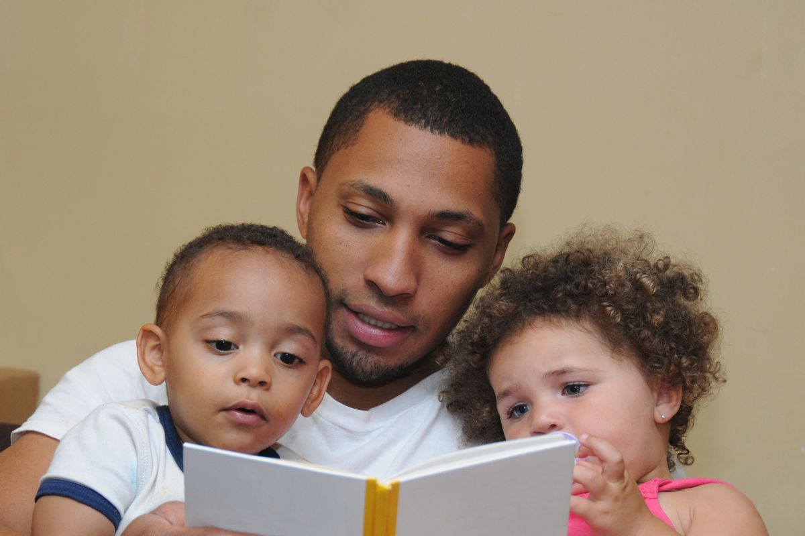

**Play time: Learning is fun!**

During stressful times, children may not want to play. Children learn best when they enjoy what they do and have fun playing.

You can:

* **Give children toys** or activities that they like
* **Give children a choice**: *this or that*
* **Read books** together and let children turn the pages
* **Minimize screen** time and technology use
* **Play together**: hide-and-seek, puzzles, build a fort!

:

**Help children understand their emotions**

Children who are stressed can be restless and feel sad or angry. They need help managing their emotions.

You can:

* **Label** their emotions and feelings: “*I know this is very scary”*
* **Touch and hold** them; it tells them they are loved and it makes them feel secure
* **Help them to calm down** by taking a deep breath, going for a walk, and sticking to routines

and cnit mak

**Tips for Parents for Toddlers**

The COVID-19 is making us more stressed, anxious, and irritable, making parenting more challenging than ever. Parents are best able to support their children when they deal with stress calmly and confidently.

**Here are ideas to help children adapt to stressful events such as the COVID-19 pandemic**

**Guide and teach children**

Children are struggling to cope with so many changes to their lives during the COVID-19 pandemic. Some children may become less compliant, clingier, react easily, cry often, sleep poorly, and become picky eaters.

You can:

* **Set clear boundaries**: “If you want to play with these toys again, you need to clean up”
* **Reward, praise, and encourage** the behavior you want. “It’s so great that you sat through dinner!”
* **Smile, hug, and give high fives** so children feel loved and know how you feel
* **Stay consistent with limits and consequences**: “If you hit, you do not get to play anymore”
* **Redirect but never hit!** it just teaches that hitting is ok

|  |  |
| --- | --- |
|  | |
| |  | | --- | | **Establish routines and structure**  The COVID-19 pandemic has radically changed children’s routines and physical environments. Children learn and behave best when they have routines and their world is predictable and structured.  You can: | | * **Keep mealtimes, naptimes**, and bedtime routines consistent at the same time everyday * **Make a daily schedule**--wake up, reading, free play--in a place where children can see it * **Let children make some decisions--**give them 2 choices: “You can wear this t-shirt or that one” | | |  | | |
| *.* |

**Play time: Learning is fun!**

During stressful times, children may not want to play. Children learn and behave best when they enjoy what they do and have fun playing.

You can:

* **Play dress-up**, pretend play, sing songs, tell stories, dance party!
* **Read books**: talk about the pictures and story, count objects
* **Do art projects** – color or draw, build a fort!

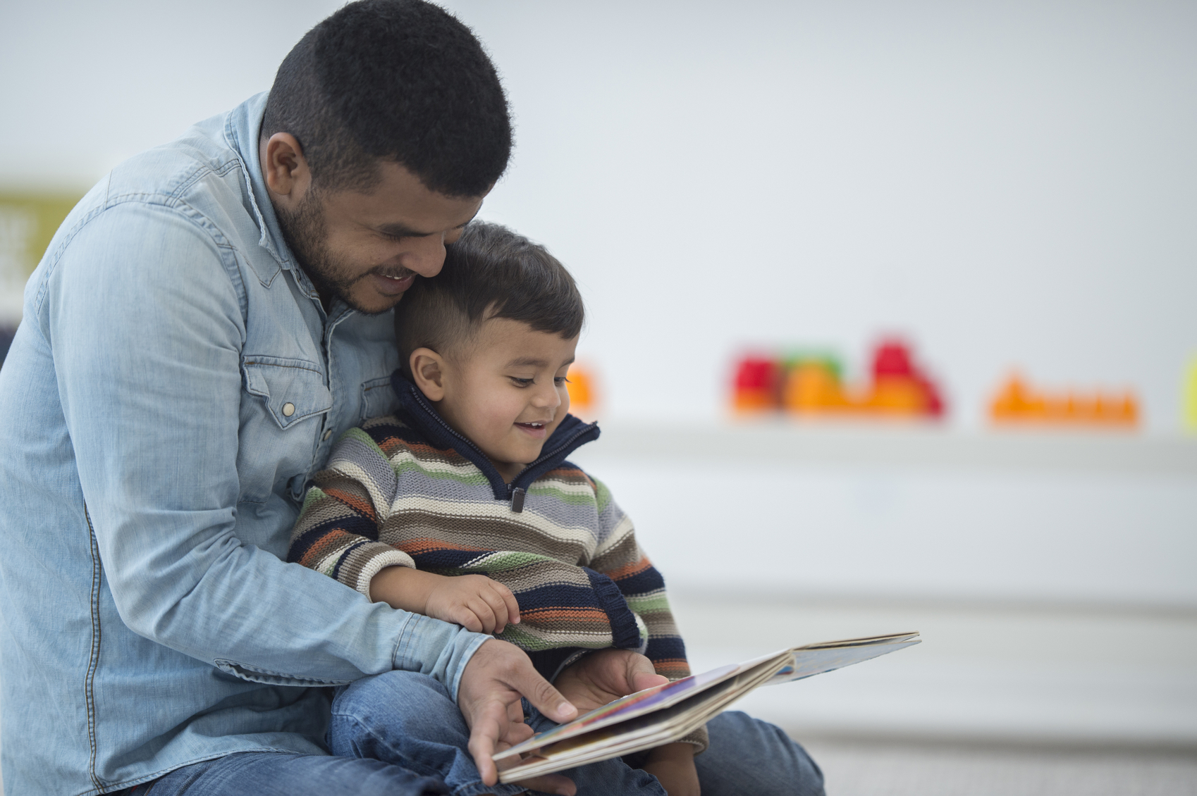

*\*Marina Kerlow, BA, *Natasha Cabrera, Ph.D., and **Stephanie Reich, Ph.D., BabyBooks2*

*\*University of Maryland, **University of California, UCI*

**Help children understand their emotions**

Children who are stressed can be reactive, feel sad or angry. They need help managing their emotions.

You can:

* **Talk to your child about feelings**, yours and theirs. **Label emotions:** *“I know things are scary for you”*
* **Use play** to talk to your child about feelings: “*Look at your baby doll, I think she’s happy*!”
* **Model behaviors** that help your child to calm down: take a deep breath, count to 10, go for a walk
* **Respond to your child’s question**s about what’s going in ways she can understand
* **Explain the reasons behind rules**: “*Washing your hands keeps all of us healthy”*