**BCA-1**

**Subject :Webtechnology& technology**

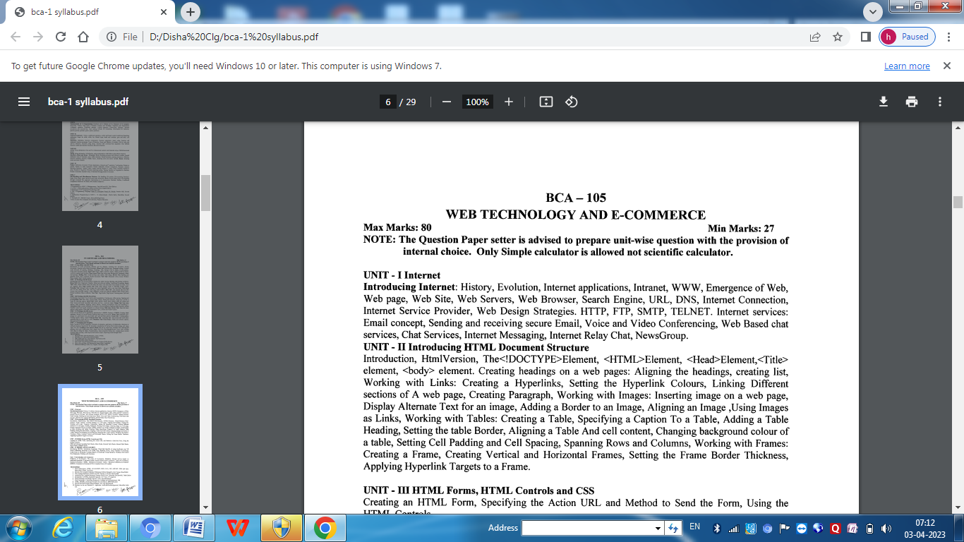

**Unit-1**

**Internet & Its History**

* Internet is a world-wide global system of interconnected computer networks.
* Internet uses the standard Internet Protocol (TCP/IP).
* Every computer in internet is identified by a unique IP address.
* A special computer DNS (Domain Name Server) is used to give name to the IP Address so that user can locate a computer by a name.
* The Internet carries a vast range of information resources and services, such as the inter-linked hypertext documents and applications of the World Wide Web (WWW).
* The origin of Internet devised from the concept of Advanced Research Project Agency Network (ARPANET) in 1969.
* ARPANET was developed by United States Department of Defence.
* Basic purpose of ARPANET was to provide communication among the various bodies of government.
* Initially, there were only four nodes, formally called Hosts.
* In 1972, the ARPANET spread over the globe with 23 nodes located at different countries and thus became known as Internet.

**Application of Internet**

**Search engine**: It can be used to search anything and everything. Most popular search engines are Google and Yahoo searches.

**Shopping:** Shopping has become easier with the advent of internet. We can buy or sell online.

**Communication:** This is a major role of the internet. It helps people to communicate either with the use of social networking websites or through e mails. Even chatting is a major use of the internet.

**Job search:** Nowadays, many people search for their jobs online as it is quicker and there is a larger variety of job vacancies present.

**Hobbies:** Those who are having certain hobbies can try to improve on it by reading up on many aspects of their hobby.

**Research:** Research papers are present online which helps in the researcher doing a literature review.

**Studying:** Now right from kinder garden children are exposed to internet and computers. They find many useful things to learn on the internet (though with supervision). Up to doctorate level education, people rely on internet for their education. Online educational books have even reduced the need for a library.

**Intranet**

* An intranet is a part of Internet that is privately owned by an organization.
* It connects all the computers together and provides access to files and folders within the network.
* It is based on internet protocols (TCP/[IP](https://www.javatpoint.com/ip-full-form)) and is protected from unauthorized access with firewalls and other security systems.
* Information is shared in real-time, or updates are reflected immediately to all the authorized users.

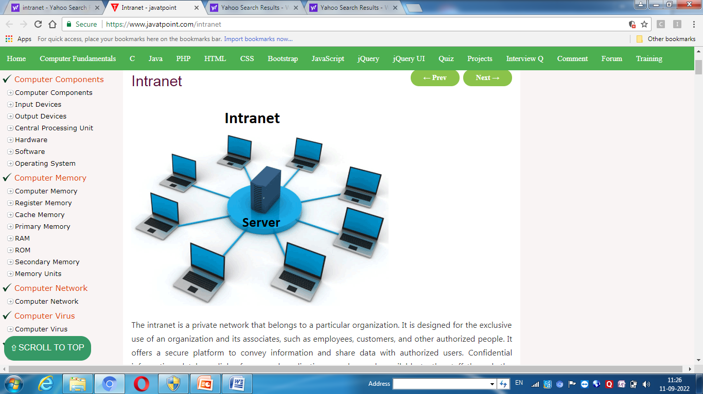

**Difference between Internet & Intranet**

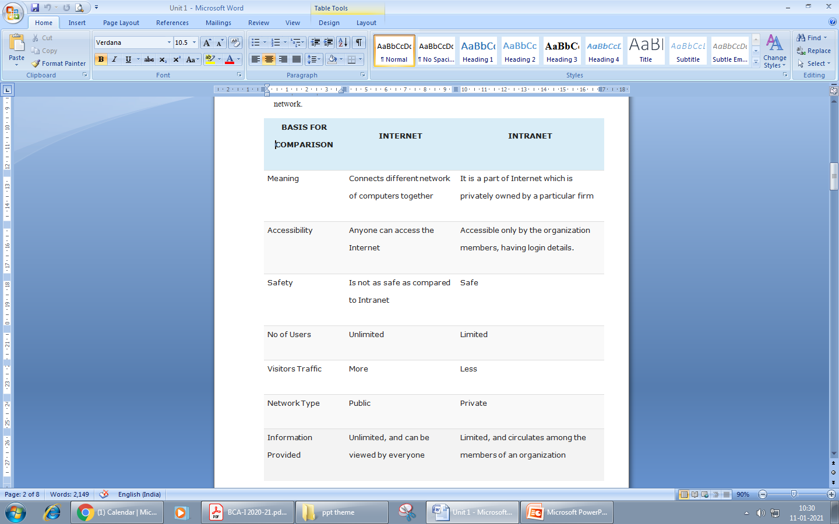

**WWW**

* The World Wide Web, also known as the WWW and the Web, is an information space where documents and other web resources are identified by Uniform Resource Locators (URLs), interlinked by hypertext links, and accessible via the Internet
* It is a way of accessing information over the medium of the internet.
* Tim Berners-Lee invented the World Wide Web in 1989 at CERN in Geneva.
* The WWW consists of billions of pages linked to each other that contain text, hyperlinks, graphics,  multimedia files , and other interactive software that are accessed using a browser.
* The first Internet browser was named WorldWideWeb (later changed to Nexus) and was invented by Tim Berners-Lee in 1990.

**Web Page**

* Webpage is a document commonly written in HTML (Hypertext Mark-up Language) that is accessible through the Internet using a browser.
* Web Pages are stored on web server and can be viewed using a web browser.
* Web pages can contain huge information including text, graphics, audio, video and hyper links. These hyper links are the link to other web pages.

**Static Web page***:* Static web pages are also known as flat or stationary web page. They are loaded on the client’s browser as exactly they are stored on the web server. Such web pages contain only static information. User can only read the information but can’t do any modification or interact with the information.

* Static web pages are created using only HTML. Static web pages are only used when the information is no more required to be modified.

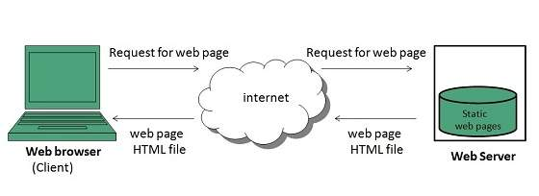

**Dynamic Web page*:*** Dynamic web page shows different information at different point of time. It is possible to change a portion of a web page without loading the entire web page. It has been made possible using Ajax technology.

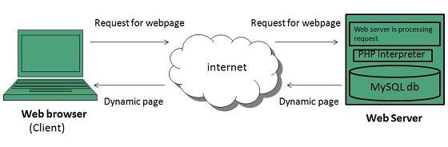

**Website**

* A website is a collection of publicly accessible, interlinked Web pages that share a single domain name. Websites can be created and maintained by an individual, group, business or organization to serve a variety of purposes.
* A website may be accessible via a public Internet Protocol (IP) network, such as the Internet, or a private local area network (LAN), by referencing a uniform resource locator (URL) that identifies the site.
* Websites are typically dedicated to a particular topic or purpose, ranging from entertainment and social networking to providing news and education.
* A static website is one that has web pages stored on the server in the format that is sent to a client web browser. It is primarily coded in Hypertext Markup Language (HTML).
* A dynamic website is one that changes or customizes itself frequently and automatically. Various web application frameworks and web template systems are available for general-use programming languages like Perl, PHP, Python and Ruby to make it faster and easier to create complex dynamic websites.

**Web Browser**

* Web Browser is an application software that allows us to view and explore information on the web. User can request for any web page by just entering a URL into address bar.
* Web browser can show text, audio, video, animation and more. It is the responsibility of a web browser to interpret text and commands contained in the web page.
* The first web browser, called World Wide Web, was invented in 1990 by Sir Tim Berners-Lee.
* A variety of web browsers are available with different features, and are designed to run on different operating systems. Common browsers include Internet Explorer from Microsoft, Firefox from Mozilla, Google Chrome, Safari from Apple, and Opera.

**Web server**

Web server is a computer where the web content is stored. Basically web server is used to host the web sites but there exists other web servers also such as gaming, storage, FTP, email etc.

Web server respond to the client request in either of the following two ways:

1. Sending the file to the client associated with the requested URL.
2. Generating response by invoking a script and communicating with database

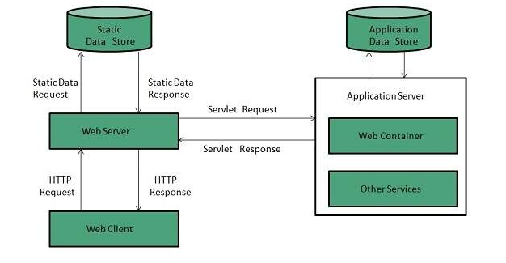

**Search Engine**

* Search Engine refers to a huge database of internet resources such as web pages, newsgroups, programs, images etc. It helps to locate information on World Wide Web.
* User can search for any information by passing query in form of keywords or phrase. It then searches for relevant information in its database and return to the user.

**Search Engine Components**

* Generally there are three basic components of a search engine as listed below:
  + Web Crawler
  + Database
  + Search Interfaces
* ***Web crawler:***It is also known as spider or bots. It is a software component that traverses the web to gather information**.**
* ***Database:***All the information on the web is stored in database. It consists of huge web resources.
* ***Search Interfaces:***This component is an interface between user and the database. It helps the user to search through the database.

## Architecture

The search engine architecture comprises of the three basic layers listed below:

* Content collection and refinement.
* Search core
* User and application interfaces

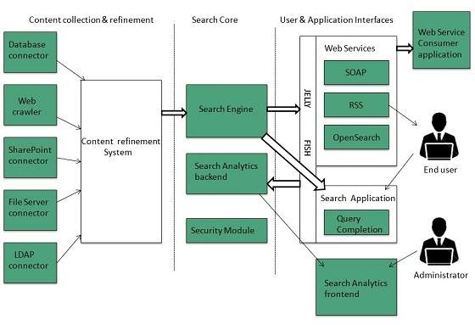

**Search Engine Working**

* The source of all search engine data is collected using a spider or crawler that visits each page on the Internet and collects its information.
* Once a page is crawled, the data contained in the page is processed and indexed.
* The process of validating and storing the content from the WebPages in the search engine’s database called “index”. It is basically a big library of all the websites.
* The data collected is used to rank each page. These rankings then determine which pages to show in the search results and in what order.

Examples

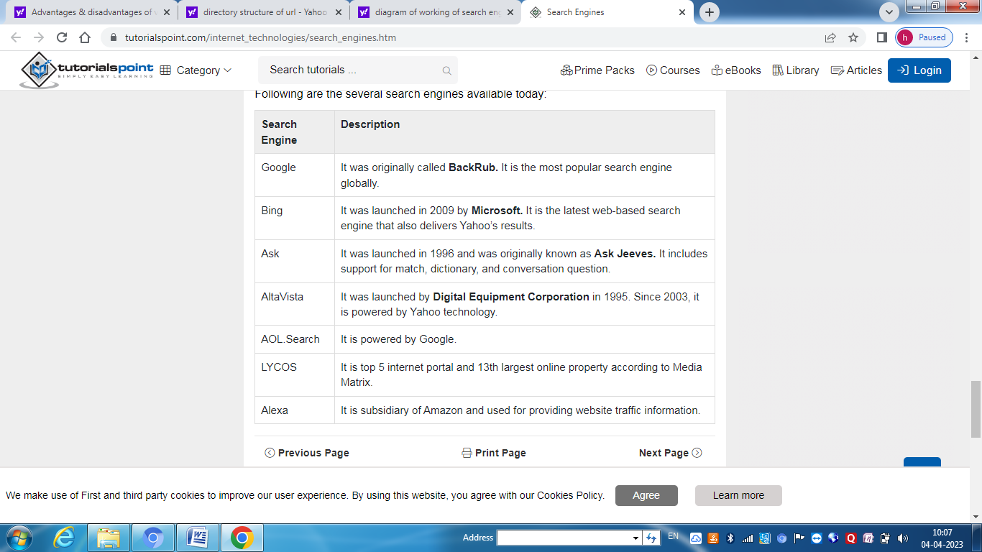

**URL(Uniform Resource Locator)**

A URL is a type of uniform resource identifier and is address of a resource on the World Wide Web and the protocol used to access it. It is used to indicate the location of a web resource to access the web pages.

The URL sends users to a specific resource online such as video, webpage, or other resources. When you search any query on Google, it will display the multiple URLs of the resource that are all related to your search query. The displayed URLs are the hyperlink to access the webpages.

**Structure of URL**

A URL consists of five parts: the scheme, subdomain, top-level domain, second-level domain, and subdirectory.

### 

### 1.Scheme



The scheme tells web servers which protocol to use when it accesses a page on your website.

Nowadays, [HTTPS](https://blog.hubspot.com/marketing/enable-https-on-your-website?hubs_content=blog.hubspot.com/marketing/parts-url&hubs_content-cta=HTTPS) — which stands for Hypertext Transfer Protocol Secure — is the most common scheme. It tells your web browser to encrypt any information you enter onto the page, like your passwords or credit card information, so cybercriminals can’t access it.

**2.Subdomain**

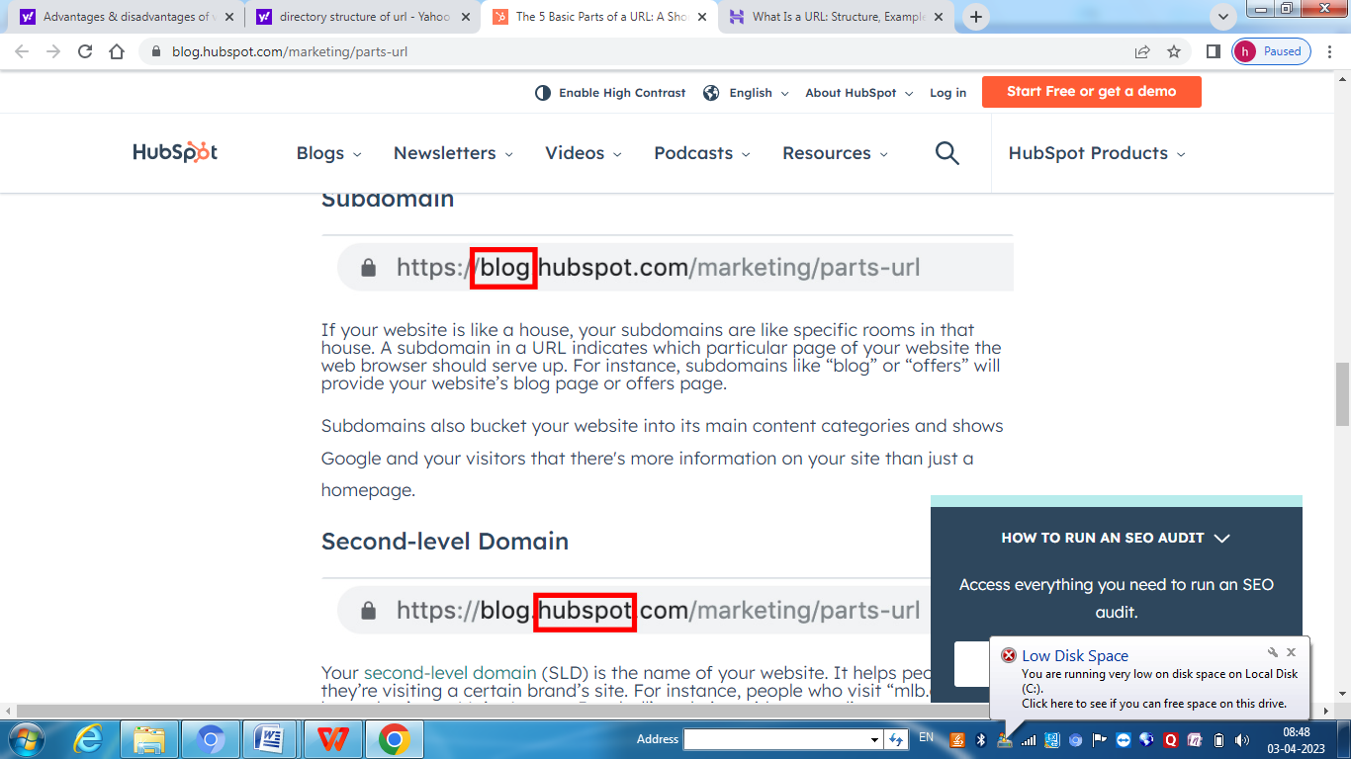

If your website is like a house, your subdomains are like specific rooms in that house. A subdomain in a URL indicates which particular page of your website the web browser should serve up.

### 3.Second-level Domain



Your second-level domain (SLD) is the name of your website. It helps people know they’re visiting a certain brand’s site. For instance, people who visit “mlb.com” know they’re on Major League Baseball’s website, without needing any more information.

### 4.Top-level Domain



The top-level domain (TLD) specifies what type of entity your organization registers as on the internet.

For example, “.com” is intended for commercial entities in the United States, so a lot of American businesses register with a top-level domain of “.com”. Similarly “.edu” is intended for academic institutions in the United States, so a lot of American colleges and universities register with a top-level domain of “.edu”.

### Subdirectory



A subdirectory — also known as a subfolder — helps people as well as web crawlers understand which particular section of a webpage they’re on.

For instance, if you own an online store that sells t-shirts, hats, and mugs, one of your website’s URLs could look like “https://shop.yourstore.com/hats”. Notice that the subdomain is “shop” and the subdirectory is “hats." That means this URL would serve up the “Hats” page, which is a subfolder of the “Shop” page. T-shirts and mugs would be other subfolders of this page.

**DNS (Domain Name System)**

An application layer protocol defines how the application processes running on different systems, pass the messages to each other.

* DNS stands for Domain Name System.
* DNS is a directory service that provides a mapping between the name of a host on the network and its numerical address.
* DNS is required for the functioning of the internet.
* Each node in a tree has a domain name, and a full domain name is a sequence of symbols specified by dots.
* DNS is a service that translates the domain name into IP addresses. This allows the users of networks to utilize user-friendly names when looking for other hosts instead of remembering the IP addresses.
* For example, suppose the FTP site at EduSoft had an IP address of 132.147.165.50, most people would reach this site by specifying ftp.EduSoft.com. Therefore, the domain name is more reliable than IP address.

DNS is a TCP/IP protocol used on different platforms. The domain name space is divided into three different sections: generic domains, country domains, and inverse domain.

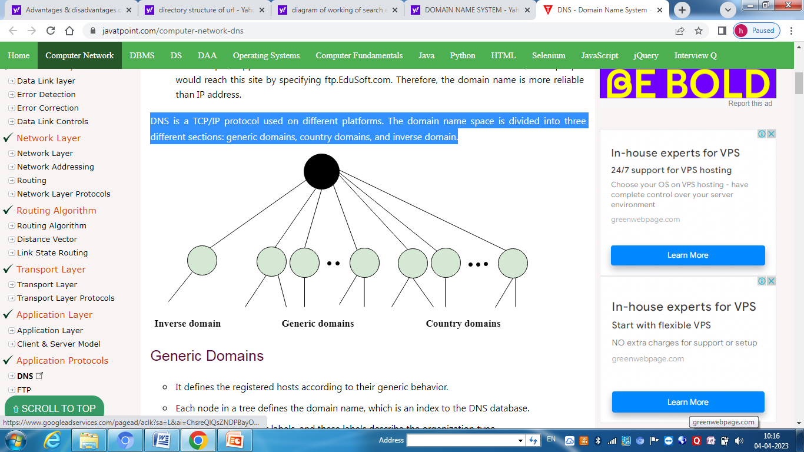

## Generic Domains

* It defines the registered hosts according to their generic behavior.
* Each node in a tree defines the domain name, which is an index to the DNS database.
* It uses three-character labels, and these labels describe the organization type.
* 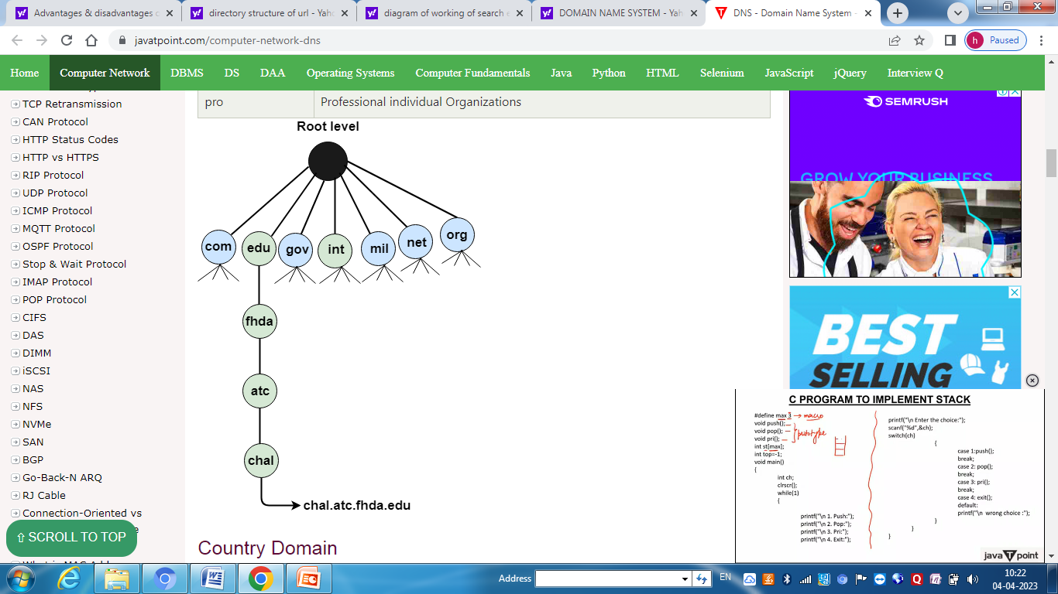

## Country Domain

The format of country domain is same as a generic domain, but it uses two-character country abbreviations (e.g., us for the United States) in place of three character organizational abbreviations.

## Inverse Domain

The inverse domain is used for mapping an address to a name. When the server has received a request from the client, and the server contains the files of only authorized clients. To determine whether the client is on the authorized list or not, it sends a query to the DNS server and ask for mapping an address to the name.

**Internet Services Provider**

Internet Service Provider (ISP) is a company offering access to internet. They offer various services:

* Internet Access
* Domain name registration
* Dial-up access
* Leased line access

ISP Types

ISPs can broadly be classified into six categories as shown in the following diagram

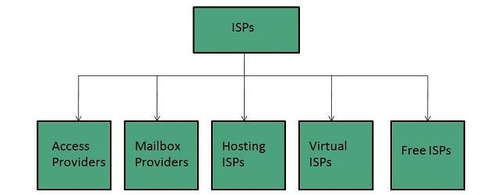

**Access providers**

They provide access to internet through telephone lines, cable wi-fi or fiber optics.

**Mailbox Provider**

Such providers offer mailbox hosting services.

**Hosting ISPs**

Hosting ISPs offers e-mail, and other web hosting services such as virtual machines, clouds etc.

**Virtual ISPs**

Such ISPs offer internet access via other ISP services.

**Free ISPs**

Free ISPs do not charge for internet services.

**Web Design Strategy**

Web Design Strategy is a long-term strategic business planning of how to create and develop the online presence of the company adhering to all business strategies. A successful website is not built in a day or a week, with proper efforts and a little bit of time can make website and business successful.

**1.Vision of Website**

Before defining web strategy or goals, one must first have a clear vision of the site’s purpose which is often in line with the overall company vision and branding elements.

**2. Goals of Website**

What is the purpose of the website? What are the goals of the site? Website should serve a definite purpose

**3. Target Market**

A Target Market is sometimes called the target audience. It is critical to understand one’s market or audience How old are they? What is their gender? What is their education? What do they like? How do they communicate?

**4. Branding**

Brand, in a simple format, ties in all the elements of communication into one clear message. Your brand, as simple as it may appear, should have a purpose for every aspect. Font types, keywords, colours, design, and placement. Your brand is what differentiates your company from your competitors.

**5. Messaging**

Message is the brand and the voice to the audience. A clear message will tell the audience what one want them to hear. Without clarity in the message, website can quickly lose its voice!

**6. Design to Goals**

Designing to goals is a fusion of several skills and art forms. It combines web design, graphic design, SEO (search engine optimization), competitive analysis, future web development trends, message, branding, and purposeful direction to achieve website goals.

**7. Evaluate & Execute**

The last step in web design strategy process is to evaluate the strategy from beginning to end.

**Protocol**

Protocols are set of rules that help in governing the way a particular technology will function for communication. In other words, it can be said that the protocols are digital languages implemented in the form of networking algorithms. There are different networks and network protocols, user's use while surfing.

**Types of Protocols:-**

There are various types of protocols that support a major and compassionate role in communicating with different devices across the network. These are:

1. Transmission Control Protocol (TCP)
2. Internet Protocol (IP)
3. User Datagram Protocol (UDP)
4. Post office Protocol (POP)
5. Simple mail transport Protocol (SMTP)
6. File Transfer Protocol (FTP)
7. Hyper Text Transfer Protocol (HTTP)
8. Hyper Text Transfer Protocol Secure (HTTPS)
9. Telnet
10. Gopher

**HTTP**

* 1,HTTP stands for **HyperText Transfer Protocol**.
* It is a protocol used to access the data on the World Wide Web (www).
* The HTTP protocol can be used to transfer the data in the form of plain text, hypertext, audio, video, and so on.
* This protocol is known as HyperText Transfer Protocol because of its efficiency that allows us to use in a hypertext environment where there are rapid jumps from one document to another document.
* HTTP is similar to the FTP as it also transfers the files from one host to another host. But, HTTP is simpler than FTP as HTTP uses only one connection, i.e., no control connection to transfer the files.
* HTTP is used to carry the data in the form of MIME-like format (Multipurpose Internet Mail Extensions ).
* HTTP is similar to SMTP as the data is transferred between client and server. The HTTP differs from the SMTP in the way the messages are sent from the client to the server and from server to the client. SMTP messages are stored and forwarded while HTTP messages are delivered immediately.

**SMTP**

* SMTP stands for Simple Mail Transfer Protocol.
* SMTP is a set of communication guidelines that allow software to transmit an electronic mail over the internet is called **Simple Mail Transfer Protocol**.
* It is a program used for sending messages to other computer users based on e-mail addresses.
* It provides a mail exchange between users on the same or different computers, and it also supports:
  + It can send a single message to one or more recipients.
  + Sending message can include text, voice, video or graphics.
  + It can also send the messages on networks outside the internet.
* The main purpose of SMTP is used to set up communication rules between servers. The servers have a way of identifying themselves and announcing what kind of communication they are trying to perform. They also have a way of handling the errors such as incorrect email address. For example, if the recipient address is wrong, then receiving server reply with an error message of some kind.

**FTP**

* FTP stands for File transfer protocol.
* FTP is a standard internet protocol provided by TCP/IP used for transmitting the files from one host to another.
* It is mainly used for transferring the web page files from their creator to the computer that acts as a server for other computers on the internet.
* It is also used for downloading the files to computer from other servers.

**There are two types of connections in FTP:**

* FTP Connection

**Control Connection:** Through control connection, we can transfer a line of command or line of response at a time. The control connection is made between the control processes. The control connection remains connected during the entire interactive FTP session.

**Data Connection:**The data connection is made between data transfer processes. The data connection opens when a command comes for transferring the files and closes when the file is transferred.

**Telnet**

The main task of the internet is to provide services to users. For example, users want to run different application programs at the remote site and transfers a result to the local site. This requires a client-server program such as FTP, SMTP. But this would not allow us to create a specific program for each demand.

The better solution is to provide a general client-server program that lets the user access any application program on a remote computer. Therefore, a program that allows a user to log on to a remote computer. A popular client-server program Telnet is used to meet such demands. Telnet is an abbreviation for **Terminal Network**.

Telnet provides a connection to the remote computer in such a way that a local terminal appears to be at the remote site.

There are two types of Login:

1. When a user logs into a local computer, then it is known as local login.
2. When the user wants to access an application program on a remote computer, then the user must perform remote login

**Gopher**

Gopher is an application-layer protocol that provides the ability to extract and view Web documents stored on remote Web servers.

Gopher was designed to access a Web server or database via the Internet. It requires that files be stored in a menu-style hierarchy on a Gopher server that is accessible through a Gopher-enabled client browser and/or directly. It initially supported only text-based file/document access but later came to support some image formats such as GIF and JPEG.

**Internet Services:**

Internet Services allows us to access huge amount of information such as text, graphics, sound and software over the internet. Following diagram shows the four different categories of Internet Services.

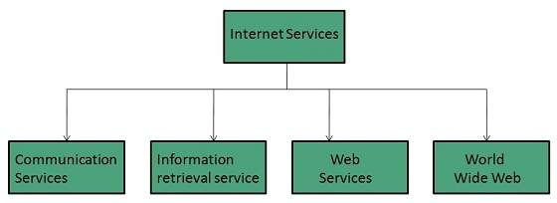

**1.Communication Services:**There are various Communication Services available that offer exchange of information with individuals or groups.

**Electronic Mail** : Used to send electronic message over the internet.

**Telnet** : Used to log on to a remote computer that is attached to internet.

**Newsgroup** : Offers a forum for people to discuss topics of common interests.

**Internet Relay Chat (IRC)** : Allows the people from all over the world to communicate in real time.

**Mailing Lists** : Used to organize group of internet users to share common information through e-mail.

**Internet Telephony (VoIP)** : Allows the internet users to talk across internet to any PC equipped to receive the call.

**Instant Messaging** : Offers real time chat between individuals and group of people. Eg. Yahoo messenger, MSN messenger.

**2.Information Retrieval Services:**

There exist several Information retrieval services offering easy access to information present on the internet. The following table gives a brief introduction to these services:

**1.File Transfer Protocol (FTP)** : Enable the users to transfer files.

**2.Archie**: It’s updated database of public FTP sites and their content. It helps to search a file by its name.

**3.Gopher**: Used to search, retrieve, and display documents on remote sites.

4.**Web services** allow exchange of information between applications on the web. Using web services, applications can easily interact with each other.

**5.WWW** is also known as W3. It offers a way to access documents spread over the several servers over the internet. These documents may contain texts, graphics, audio, video, hyperlinks. The hyperlinks allow the users to navigate between the documents.

**3.Voice & Video Conferencing**

**Voice/Audio Conferencing:**

Audio Conferencing is a telephone meeting conducted between multiple separate callers (three callers define a "conference"). It uses VoIP (Voice over Internet Protocol) Technology.

**The three main conferencing models are ad hoc, reservationless, and scheduled conferencing modes**.

**1.Ad hoc conferencing** is the most basic model and has the fewest features. It is also the easiest for the end user to create, because ad hoc conferences are simply created with the Conference button on the user’s phone.

**2.Reservationless conferencing** is the next most basic model and usually is created using the telephone keypad, after the user has called into the conference bridge. Both ad hoc and reservationless are immediate meetings, created quickly for this instant in time.

**3.Scheduled conferences** are more complex and have the largest set of conferencing features. They are placed on the system calendar for some point of time in the future and require more input from the meeting organizer than reservationless meetings.

**Advantages:**

**1Audio conferencing is Cost effective**: In comparision to other means of conferencing , audio conferencing is a little cheaper with relatively high quality of call by using audio conferencing System.

**2.Audio conferencing is easily accessible:**Audio conferencing is very accessible & easy to setup. By adopting a familiertechnology,audio conferencing makes it easy to host a conference call through telephone lines.

**3.Audio conferencing can save our lot of time & money:It allows people to participate in conversation when they can’t physically make the meeting.**

**Disadvantages:**

**1.Communication is only verbal:**Studies show that effective communication is non verbal,yet audio conferencing is only verbal.The communication does not support visual images,so we cant see the facial expression,eye movement & body language of the person we are talking to.

**2.Audio conferencing can not keep us focused on the meeting**:voice& visual conference forces participants to focus on task during meeting because they exposed to the camera. So in audio conferencing we don’t know wheather our audience is carefully listen to us.

**3.The quality of conference call is not reliable**:At times the sound transmission may be poor quality during the audio conferencing as it mainly relies on the telephone lines .The background noise can also affect the audio conference,or even cut you out.

**4.Video conferencing:**

Video conferencing is live, visual connection between two or more remote parties over the internet that simulates a face-to-face meeting. Video conferencing is important because it joins people who would not normally be able to form a face-to-face connection.

The video conferencing process can be split into two steps:

1. compression
2. Transfer.

**During compression**, the webcam and microphone capture analog audio visual ([AV](https://whatis.techtarget.com/definition/AV-audio-video)) input. The data collected is in the form of continuous waves of frequencies and amplitudes. These represent the captured sounds, colors, brightness, depth and shades. In order for this data to be transferred over a normal network  .[codecs](https://searchunifiedcommunications.techtarget.com/definition/codec) must be used to compress the data into digital [packets](https://searchnetworking.techtarget.com/definition/packet). This enables the captured AV input to travel faster over broadband or Wi-Fi internet.

**During the transfer phase**, the digitally compressed data is sent over the digital network to the receiving computer. Once it reaches the endpoint, the codecs decompress the data. The codecs convert it back into analog audio and video. This enables the receiving screen and speakers to correctly view and hear the AV data.

**Advantages :**

**1. Saves time and resources**

Any business must have efficient and effective communication in order to function properly. Previously, the only way for different offices to communicate effectively was to hold meetings together, which required employees to travel extensively.

**2. Overall internal communication is improved**

Internal communication is now easier, faster, and more convenient than ever before, thanks to live video conferencing companies and video conferencing service providers. Anyone or any team in the organization can communicate with any other team or employee thanks to video conferencing tools.

**3. File and screen-sharing**

Sharing your screen, content, and files with meeting attendees is a critical tool for effective collaboration. One of the most significant advantages of a video call is screen sharing. To recreate it in person, you would need specialised equipment such as a projector, conference room, etc.

**4. Projects become clear and concise**

Every project must have clear, concise, and effective communication in order to be completed properly and delivered on time. **5. Helps build relationships**

**6. Encourage collaborations**

Since new types like hybrid, part-time, online, freelance, and other modes have been developed, not everyone works exclusively from an office setting these days. allowing a collaborative meeting and discussion to take place from their separate locations.

**Disadvantages:**

**1. It still lacks the personal touch of face-to-face communication**

**2.Even the best systems can encounter technical issues**

**3. It has a high initial investment cost**

**5.WebBasedChat:**It refers to any kind of communication over the internet that offers real time transmission of text messages from sender to receiver. Web based chatting is embedded in web browser. Web-based IM requires no application download, updates, installation or configuration.

A web chat is a system that allows users to communicate in real-time using easily accessible web interfaces. It is a type of Internet online chat distinguished by its simplicity and accessibility to users who do not wish to take the time to install and learn to use specialized chat software. This trait allows users instantaneous access and only a web browser is required to chat. Users will always get the latest version of a chat service because no software installation or update are required.

Ex: Google Chat, Live Chat

**6.InstantMessaging:**Instant messaging, often shortened to IM or IM'ing, is the exchange of near-real time messages through a standalone application or embedded software. Unlike chatrooms with many users engaging in multiple and overlapping conversations, IM sessions usually take place between two users in a private, back-and-forth style of communication.

Instant messaging differs from email in the immediacy of the message exchange. IM also tends to be session-based, having a start and an end. Because IM is intended to mimic in-person conversations, individual messages are often brief. Email, on the other hand, usually reflects a longer-form, letter writing style.

**Steps of Instant Messaging**

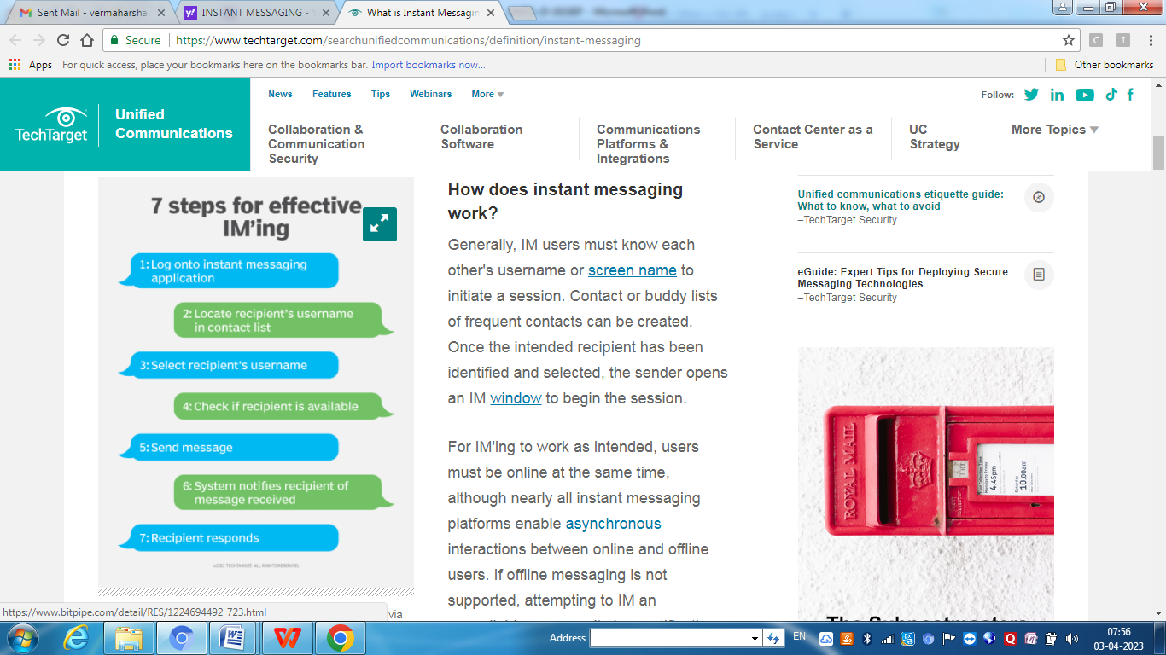

### Instant messaging features

Text-based communication has been the chief function of instant messaging for a long time, but it is now one of many features. Other capabilities include the following:

* **Availability.** [Presence technology](https://www.techtarget.com/searchunifiedcommunications/feature/UC-presence-evolves-amid-remote-work-revolution) enables users to see the availability of their contacts. Many apps show if contacts are online or offline and if they have set their status to free or busy. Some clients let users set an away message and provide detail about their availability. In an active session, many apps indicate in real time when a user is typing.
* **Images.** Many clients let users insert images and [emojis](https://www.techtarget.com/whatis/definition/emoji) into messages.
* **File transfer.** Sending and sharing files is also a standard part of many IM apps. [Facebook Messenger](https://www.techtarget.com/whatis/definition/Facebook-Messenger) even lets users send money via IM.
* **Switching to other communication modes.** Numerous instant messaging apps let IM users move to other modes of communication -- such as group chat, voice calls and video conferencing -- within the app.

**7.InternetRelayChat:**

Internet Relay Chat (IRC) is an application layer protocol that facilitates communication in the form of text. The chat process works on a client/server networking model.

IRC clients are computer programs that users can install on their system or web based applications running either locally in the browser or on a third party server. These clients communicate with chat servers to transfer messages to other clients.  IRC is mainly designed for group communication in discussion forums, called channels, but also allows one-on-one communication via private messages as well as chat and data transfer, including file sharing.

Internet Relay Chat (IRC) is Internet application that was developed by Jakko Oikarinen in Finland.

IRC client connects/communicates with IRC server on Internet. First, you have to log on to server using client and then pick channel on which you want to chat. They are sent to your server when you type words on your keyboard. Now your server is part of global IRC server network. Your server sends your messages to other servers, which in turn, sends your messages to people who are part of your channel.

They can then read and respond to your messages. Many websites use proprietary chat software that does not use IRC protocol but enables you to chat when you are on site. There is another kind of chat, called Instant Messaging. In this kind of chatting, you communicate privately, one-to-one, with another person. You can create special lists so that you are informed when your “buddies” come online, ready to chat, and they are informed when you come online.

**8.Newsgroup**

A newsgroup is an online discussion forum accessible through Usenet. Each newsgroup contains discussions about a specific topic, indicated in the newsgroup name. You can browse newsgroups and post or reply to topics using a newsreader program. Access to newsgroups also requires a Usenet subscription. Most Usenet providers offer monthly access for around $10 USD per month.

News group may be either moderated or unmoderated. In a moderated newsgroup, a moderator must approve posts in order for them to become part of the discussion. In an unmoderated group, everything posted is included in the discussion. Some newsgroups may also use bots to moderate the content, automatically eliminating posts that are deemed offensive or off topic.

Below are some examples of active newsgroups.

* alt.politics
* talk.religion
* sci.physics
* comp.software.testing
* alt.binaries.documentaries
* alt.binaries.multimedia.comedy

**Assingment Question**

1. What is Internet? Briefly describe its application.
2. Explain Internet and Intranet? Also write difference between them.
3. Explain ARPANET?
4. Write Short notes on:
   1. WWW b. Web Page c. Web Site d.Web Browser
5. Explain the Concept of Client and Web Server.
6. What is Search Engine? How a search engine works.
7. What do you mean by protocol? Explain various types of protocol.
8. Explain following protocol in brief:
9. HTTP b. FTP c. SMTP d. TELNET
10. Write short notes on:
    1. URL b. DNS c.ISP d.IRC e. Newsgroup
11. What is E-mail? How to send and receive secure e-mail.
12. Write short notes on:
    1. Voice and Video Conferencing b. Chat Services

c. Internet Messaging

1. Explain the process of creating and maintaining a website.