Veermata Jijabai Technological Institute (VJTI), Mumbai
MINI PROJECT REPORT
“CircuitVision: Automated Conversion of Hand-Drawn Circuit Diagrams into Validated, Simulatable SPICE Netlists using Computer Vision, Image Processing and NLP”
Submitted in partial fulfilment of the requirements for the subject
Minor/MDM: AI and ML
Submitted by
Name | Roll Number
Pranshu Kumar | 231090054
Pawan Shinde | 231090063
Final Year B.Tech, EXTC
Project Guide
Prof. Vedashree Awati
Veermata Jijabai Technological Institute (VJTI), Mumbai
Academic Year 2026–27, Semester VII
Date of submission: November 2026

Certificate
This is to certify that the mini project report entitled "CircuitVision: Automated Conversion of Hand-Drawn Circuit Diagrams into Validated, Simulatable SPICE Netlists using Computer Vision, Image Processing and NLP" submitted by Pranshu Kumar (231090054) and Pawan Shinde (231090063), students of Final Year B.Tech EXTC, is a record of bona fide work carried out by them under my guidance and supervision, in partial fulfilment of the requirements for Minor/MDM: AI and ML at Veermata Jijabai Technological Institute (VJTI), Mumbai, during the Academic Year 2026–27.
______________________
Prof. Vedashree Awati
Project Guide
Date: ____________________
Place: Mumbai

Declaration
We declare that this written submission represents our ideas in our own words, and where others' ideas or words have been included, we have adequately cited and referenced the original sources. We also declare that we have adhered to all principles of academic honesty and integrity and have not misrepresented, fabricated or falsified any idea, data, fact or source in our submission.
All datasets, open-source libraries, published methods and software tools used in this work, including AI-assisted development tools, are acknowledged in this report. Every experimental result reported here is labelled with the kind of data it was measured on, and every real-data number is taken from the experiment's evidence files rather than estimated.

Name | Roll Number | Signature
Pranshu Kumar | 231090054
Pawan Shinde | 231090063
Date: ____________________
Place: Mumbai

Acknowledgement
We express our sincere gratitude to our project guide, Prof. Vedashree Awati, for her guidance, encouragement and constructive feedback throughout this mini project.
We thank Veermata Jijabai Technological Institute (VJTI), Mumbai, for offering the Minor/MDM programme in AI and ML and for the academic environment that made this work possible.
We are grateful to F. Thoma, J. Bayer, Y. Li, A. Dengel and their colleagues at DFKI for publishing the CGHD dataset of hand-drawn circuit diagrams under an open licence, and to the developers of Ultralytics YOLO, OpenCV, EasyOCR, ngspice, NumPy, Gradio and pytest, on whose work this project is built. We also acknowledge the AI-assisted development tools used while writing and testing the software.
Finally, we thank our families and friends for their constant support.
Pranshu Kumar (231090054)
Pawan Shinde (231090063)

Abstract
A circuit sketched on paper has to be retyped as a SPICE netlist before it can be simulated, and node-numbering mistakes made while retyping are easy to miss. CircuitVision takes a phone photograph of a hand-drawn circuit, or an English description of one, and produces a SPICE netlist that is checked against a formal grammar and then simulated.
The image path uses a YOLOv8s detector for nine symbol classes, a HOG and linear-SVM classifier for the polarity of diodes and sources, paper-relative binarisation with Otsu thresholding, scale-adaptive wire tracing with crossover handling, and EasyOCR for component values. The text path uses a hidden Markov model tagger with Viterbi decoding and a series-parallel parser. Both paths share a context-free grammar with an Earley recogniser, semantic checks and ngspice simulation. The detector is set up for the public CGHD dataset with a drafter-wise split (validation drafter 11, test drafter 12).
On synthetic drawings with known circuit graphs, the wire tracer recovers the exact topology in 99.4% of 165 trials across eleven photo conditions, and with ground-truth boxes 18 of 18 circuits match their reference netlists, including the simulated operating point. On real photographs of the unseen test drafter (CGHD release 14, drafter 12), the detector reaches 0.904 mAP@0.5 and 0.611 mAP@0.5:0.95; the voltage source is the weakest class (AP 0.48). With ground-truth boxes, 37.5% of the 48 analog test photos reconstruct to the correct circuit (10.4% with detected boxes); battery terminals in wire tracing and handwritten labels are the main limits. The text path reaches 90% exact circuit match on a fresh 20-sentence test set and 75% on a second set written by a teammate who had not seen the parser. A Gradio application with photo, text and phone upload was tested with real user input.
Keywords: hand-drawn circuit recognition, YOLOv8, image processing, wire tracing, OCR, SPICE netlist, context-free grammar, Earley parser, hidden Markov model, ngspice
Table of Contents
Certificate i
Declaration ii
Acknowledgement iii
Abstract iv
List of Figures vii
List of Tables vii
List of Abbreviations viii
Chapter 1: Introduction 1
1.1 Background 1
1.2 Problem Statement 1
1.3 Motivation 1
1.4 Objectives 1
1.5 Scope and Applications 2
1.6 Organisation of the Report 2
Chapter 2: Literature Review 2
2.1 Early and Classical Approaches 2
2.2 Datasets: CGHD 3
2.3 Deep Detection and Graph Extraction 3
2.4 Relevant NLP and Validation Techniques 3
2.5 Comparison of Existing Approaches 4
2.6 Limitations of Existing Solutions 4
2.7 Gap Addressed by this Project 4
Chapter 3: Problem Definition and Proposed System 4
3.1 Detailed Problem Definition 4
3.2 Proposed AI-Based Solution 5
3.3 System Architecture 5
3.4 Functional Requirements 6
3.5 Non-Functional Requirements 6
3.6 Expected Outcomes 7
Chapter 4: AI Methodology 7
4.1 AI Techniques and Why They Suit the Problem 7
4.2 Dataset and its Source 7
4.3 Data Preprocessing 9
4.4 Feature Extraction and Representation 11
4.5 Model Selection and Training 12
4.6 System Workflow 13
4.7 Tools, Libraries and Technologies 14
Chapter 5: Implementation 14
5.1 Software and Hardware Requirements 14
5.2 Module-wise Description 15
5.3 Important Algorithms 15
5.4 Implementation Details 17
5.5 Screenshots of the Running System 17
5.6 Sample Inputs and Outputs 19
Chapter 6: Results and Discussion 19
6.1 Evaluation Design 19
6.2 Evaluation Metrics 20
6.3 Real CGHD Results (baseline_v1) 20
6.4 Testing with Real User Input 23
6.5 Wire Tracing on Synthetic Photos (SYNTHETIC) 24
6.6 End-to-End Reconstruction against Reference Netlists (SYNTHETIC) 25
6.7 OCR and Orientation (SYNTHETIC) 26
6.8 Text-to-Netlist Results (HAND-WRITTEN) 26
6.9 Comparison with Baselines 27
6.10 Defects Found during Development 27
6.11 Limitations and Observed Errors 28
6.12 Ethical and Privacy Considerations 29
Chapter 7: Conclusion and Future Scope 29
7.1 Summary of the Work 29
7.2 Objectives Achieved 29
7.3 Key Findings 30
7.4 Current Limitations 30
7.5 Future Improvements 31
References 31
Appendix A: Important Source Code 33
Appendix B: Configuration Details 33
Appendix C: Sample Dataset Record 34
Appendix D: Test Cases 34
Appendix E: Gate 1 Rotation Sheets 35

List of Figures
Figure 1: System architecture of CircuitVision: image path, text path and shared back end 6
Figure 2: Six of the eleven synthetic photo conditions applied to the crossover circuit 9
Figure 3: Two Gate 2 label overlays: converted YOLO labels on real CGHD photos (CC BY 3.0); out-of-scope parts such as the MOSFET, IC and loudspeaker carry no box 10
Figure 4: Five more Gate 2 label overlays (REAL CGHD, CC BY 3.0): (a) resistor network, (b) ruled paper, (c) grid paper, (d) notebook in perspective, (e) crumpled sheet with crossovers 10
Figure 5: Binarisation stages on a synthetic photo with grid paper, a shadow, noise and JPEG compression 11
Figure 6: Rotation augmentation of a synthetic diode crop; the + side follows from the label under the convention fixed at Gate 1 (anode or + on the left at 0°, counter-clockwise) 11
Figure 7: Gate 1 rotation sheet for `diode` (REAL CGHD v14 crops, CC BY 3.0): anode on the left at 0°, turning counter-clockwise 13
Figure 8: Gate 1 rotation sheet for `voltage.dc` (REAL CGHD): all 182 rotated crops are labelled 0° with + on top, so 270° is added when reading this label 13
Figure 9: Real-data experiment protocol with two human verification gates 14
Figure 10: Wire tracing on a synthetic bridge drawn on grid paper: nets coloured, and the generated netlist 16
Figure 11: Gradio web demo: input, detected components and nets, SPICE netlist, validation and DC operating point (synthetic input and model) 18
Figure 12: Command-line image path on the example drawing with ground-truth boxes, validation and simulation 18
Figure 13: Command-line text path (tags, netlist, validation) and the test suite 18
Figure 14: Example input drawing and the output overlay produced by the pipeline 19
Figure 15: Training and validation curves of baseline_v1 (REAL CGHD; validation drafter 11). Training stopped early at epoch 73; the best epoch, 43, is evaluated 21
Figure 16: Normalised confusion matrix on test drafter 12 (REAL CGHD) 22
Figure 17: Real user photos processed by the application (USER INPUT): (a) plain paper, reconstructed correctly; (b) ruled paper, where the ruling is traced as wires 24
Figure 18: Exact-topology rate per photo condition (SYNTHETIC, ground-truth boxes) 25
Figure 19: Detector-mode failure on a synthetic crossover circuit: both crossover symbols are missed, merging two independent loops 25
Figure 20: Text-to-netlist scores on the four evaluation runs (HAND-WRITTEN) 26
Figure 21: Rotation sheet for `diode.light_emitting` (LED) 35
Figure 22: Rotation sheet for `diode.zener`, including the mirrored rows that are excluded 36
Figure 23: Rotation sheet for `voltage.battery` 36
Figure 24: Rotation sheet for `voltage.ac` (out of scope) 37
Figure 25: Rotation sheet for `diode.thyrector` (out of scope) 37

List of Tables
Table 1: Comparison of existing approaches and CircuitVision 4
Table 2: Functional requirements 6
Table 3: AI techniques used and why each suits its sub-problem 7
Table 4: Mapping from CGHD labels to the nine detector classes 8
Table 5: Fixed baseline training configuration (baseline_v1) 12
Table 6: Tools, libraries and technologies 14
Table 7: Software and hardware requirements 14
Table 8: Modules of the circuitvision package 15
Table 9: Sample text inputs and generated netlists (actual outputs) 19
Table 10: Validator outputs on deliberately faulty netlists (actual outputs) 19
Table 11: Evaluation metrics by stage 20
Table 12: Detection on test drafter 12: 96 photos, 1,628 symbols (REAL CGHD, `test/metrics.json`) 21
Table 13: Netlists from the 48 analog test photos (REAL CGHD, `downstream/*.csv`) 22
Table 14: End-to-end results on CGHD-format synthetic data (SYNTHETIC) 25
Table 15: Text-to-netlist results on hand-written evaluation sets 26
Table 16: Failures on the fresh 20-sentence set 27
Table 17: Defects found during development and their fixes 28
Table 18: Status of the objectives 29
Table 19: Automated regression tests (139 in total) 34

List of Abbreviations
AP | Average Precision
CFG | Context-Free Grammar
CGHD | Circuit Graph Hand-Drawn dataset
CER | Character Error Rate
CV | Computer Vision
EXIF | Exchangeable Image File Format (photo metadata)
GT | Ground Truth
HMM | Hidden Markov Model
HOG | Histogram of Oriented Gradients
IoU | Intersection over Union
mAP | mean Average Precision
NLP | Natural Language Processing
OCR | Optical Character Recognition
RKM | Resistor value code with the multiplier as decimal point (e.g. 4k7)
SPICE | Simulation Program with Integrated Circuit Emphasis
SVM | Support Vector Machine
VOC | PASCAL Visual Object Classes (annotation format)
YOLO | You Only Look Once (object detector)

Chapter 1: Introduction

1.1 Background
Circuits are usually sketched on paper before anyone simulates them. To simulate one, the sketch has to be typed into a simulator such as SPICE [1] as a netlist: a list in which every component is named, given a value and connected to numbered nodes. A single wrong node number produces a circuit that simulates without error but is not the one that was drawn.
Automating this step is harder for hand drawings than for printed schematics. Every person draws symbols differently, wires wobble or have gaps, photos are taken in uneven light, often on grid paper, and values are handwritten. The output also has to be right as a graph, not just as a list of symbols: if one wire is attached to the wrong node, every node voltage changes, even when every symbol was detected correctly.
Two things made the problem practical for a semester project: single-stage object detectors such as YOLO [2], which can be fine-tuned on a single free cloud GPU, and CGHD [3], a public dataset of photographed hand-drawn circuits with bounding-box annotations.

1.2 Problem Statement
Given a phone photograph of a hand-drawn circuit made of two-terminal elements, produce a SPICE netlist whose circuit graph, component values and source polarity match the drawing, and which can be simulated. Given an English description of a series-parallel circuit, produce the same kind of netlist. In both cases, the netlist must be checked automatically for syntactic and semantic validity before simulation.

1.3 Motivation
- Retyping is slow and error-prone. Node-numbering mistakes are common when a sketch is copied into a simulator by hand, and they are hard to spot afterwards.
- It mixes learned and rule-based methods. Finding symbols and reading handwriting need learned models; connectivity, the netlist grammar and simulation can be handled exactly, which keeps those parts testable.
- The output can be checked. A reconstructed circuit can be compared with the drawn one as a graph and by simulation, which gives a stricter test than detection accuracy alone.
- It fits the course requirement. The minor asks for a project grounded in image processing, computer vision or NLP rather than generic AI; this project uses all three.

1.4 Objectives
- Detect nine circuit-symbol classes in real hand-drawn photos (CGHD) with a reproducible YOLOv8s baseline, evaluated on a held-out drafter.
- Recover the polarity of diodes and voltage sources from the orientation of their symbols.
- Trace wires into electrical nets robustly to photo resolution, grid paper, shadows, noise, pen gaps and imprecise detector boxes, including junctions and wire crossovers.
- Read component values from handwritten labels and attach each value to the correct component.
- Generate SPICE netlists, validate them with a context-free grammar, an Earley parser and semantic checks, and simulate them with ngspice.
- Provide a second input path that translates English series-parallel circuit descriptions into netlists using HMM tagging and compositional semantic parsing.
- Evaluate every stage separately, with ground-truth boxes and with detector boxes, and keep real, synthetic, hand-written and user-input results strictly apart.

1.5 Scope and Applications
In scope. Two-terminal elements (resistors, capacitors, inductors, DC voltage sources and diodes), together with ground symbols, junction dots, wire crossovers and text labels. Simulation is a DC operating point.
Out of scope. Transistors, integrated circuits, op-amps, switches, lamps, AC and current sources, and any element with more than two terminals. Such symbols may still appear in a drawing; they are masked so that they do not corrupt the reconstruction of the rest, but they are not reconstructed.
Applications. Checking homework and laboratory circuits, digitising notebook and whiteboard sketches, and teaching: the overlay shows each net in a different colour, so a student can see which wires the program thinks are connected. The text path allows a circuit to be entered as a sentence.

1.6 Organisation of the Report
Chapter 2 reviews related work. Chapter 3 defines the problem precisely and presents the proposed system. Chapter 4 describes the AI methodology, dataset and training. Chapter 5 covers the implementation with algorithms, screenshots and sample outputs. Chapter 6 presents results and discussion, and Chapter 7 concludes. Source-code excerpts, configuration and test details are in the appendices; the full code is in the project repository [4].

Chapter 2: Literature Review

2.1 Early and Classical Approaches
Off-line recognition of hand-drawn circuits was studied well before deep learning; Edwards and Chandran [5] is one of the early systems. Thoma et al. survey this earlier work and point out that each system was evaluated on its own small collection, which is the reason they released a public dataset [3]. Our summary of the older systems relies on that survey.
Moetesum et al. [6] segmented components from binarised images with morphological operations, described each component with HOG features [7] and classified it with an SVM [8]. On 100 hand-drawn diagrams containing 350 components they report 87.7% segmentation accuracy and a 92% classification rate. According to the same survey, Patare and Joshi [9] classified hand-drawn logic-gate symbols with Fourier descriptors and an SVM and tested on ten sketches [3]. These systems show that hand-crafted features can classify isolated symbols, but neither recovers how the symbols are connected, which is what a netlist needs.

2.2 Datasets: CGHD
Thoma et al. [3] published CGHD, which they describe as the first public ground-truth dataset of hand-drawn circuit images. The first release contained 1,152 images of 144 circuits drawn by 12 drafters, each circuit photographed four times, with 48,563 bounding-box annotations in 45 classes; a Faster R-CNN baseline reached 52% mAP. The dataset has since grown: later papers describe 2,208 images in 58 classes [10] and 2,424 images from 25 drafters [11], and newer releases add rotation, mirror and text annotations [12]. This project uses the versioned Zenodo release 14 [13], pinned by its MD5 checksum for reproducibility.

2.3 Deep Detection and Graph Extraction
Reddy and Panicker [14] detected components with YOLOv5 and located nodes with a Hough-transform method, reporting 98.2% mAP@0.5 for component detection and 80% accuracy for rebuilding the schematic on their own dataset, at about 0.33 s per image. Bayer, Roy and Dengel [10] extended CGHD with binary segmentation maps and polygon and keypoint annotations, and extracted the circuit graph with a Mask R-CNN instance-segmentation model followed by geometric keypoint matching; they describe the result qualitatively as reasonable but incomplete. Bayer, van Waveren and Dengel [11] built a modular pipeline with symbol and text detection (Faster R-CNN, 18% mAP on validation drafters 21–22), U-Net stroke segmentation (98.16% pixel accuracy), handwriting recognition and orientation regression (53.37% of predictions within 5° when a symbol template is provided), followed by graph assembly; they show end-to-end graph extraction qualitatively but report no end-to-end accuracy.

2.4 Relevant NLP and Validation Techniques
Hidden Markov models with Viterbi decoding [15], [16] are a classical approach to sequence labelling such as part-of-speech tagging [17]. Earley's algorithm [18] parses any context-free grammar, including ambiguous ones, in a single left-to-right pass, which makes it suitable for validating the netlist language, where a token such as "5" can be either a node or a value. Among the hand-drawn-circuit papers we reviewed, none converts English descriptions into netlists or checks the generated netlist against a formal grammar.

2.5 Comparison of Existing Approaches
Table 1: Comparison of existing approaches and CircuitVision
Work | Recognition method | Connectivity | Reported evaluation
Moetesum et al. 2018 [6] | Morphology + HOG + SVM | Not recovered | 92% classification, 100 diagrams
Reddy & Panicker 2021 [14] | YOLOv5 | Hough-transform nodes | 98.2% mAP@0.5; 80% schematic rebuild (own data)
Thoma et al. 2021 [3] | Faster R-CNN (baseline) | Not addressed | 52% mAP on first CGHD release
Bayer, Roy, Dengel 2023 [10] | Mask R-CNN + keypoints | Keypoint matching | Qualitative only
Bayer, van Waveren, Dengel 2024 [11] | Faster R-CNN, U-Net, CNN-MLP orientation | Graph assembly | Per-module metrics; end to end qualitative
CircuitVision (this work) | YOLOv8s + HOG/SVM orientation + EasyOCR | Box masking, connected components, crossover union-find | Stage-wise metrics; netlist isomorphism and simulated operating point vs reference; real CGHD results pending

2.6 Limitations of Existing Solutions
- Evaluation stops at detection. Few of the reviewed works check whether the reconstructed circuit is correct, and none checks it by simulation.
- Results are hard to compare. Datasets, versions and splits differ, and several works use private data.
- Polarity is rarely handled, although a reversed diode or source changes the circuit's behaviour.
- Outputs are not validated for syntax, floating nodes, missing ground or short circuits.
- Input is image-only; none of the reviewed systems offers a textual input sharing the same back end.

2.7 Gap Addressed by this Project
We chose to recover connectivity with classical image processing around a box detector, because CGHD's bounding boxes are enough to train it; segmentation-based graph extraction [10] needs polygon and keypoint annotations that exist for only a small part of the data. On top of this, CircuitVision recovers polarity explicitly, validates every netlist with a CFG, an Earley parser and semantic constraints, scores reconstructions against reference netlists by graph isomorphism and simulated operating point (with ground-truth and detector boxes reported separately), and adds an NLP text path that shares the same back end.

Chapter 3: Problem Definition and Proposed System

3.1 Detailed Problem Definition
Input (image path). An RGB photograph I of a hand-drawn circuit, of any resolution, possibly carrying an EXIF orientation tag, on plain or grid paper and under uneven lighting.
Input (text path). An English sentence s describing a series-parallel circuit, for example "a 9V battery driving a 1k resistor in series with (a 2k resistor in parallel with a 3k resistor)".
Output. A netlist N, that is, a set of elements e = (ref, class, n+, n−, value) over integer nodes with node 0 as ground, together with a validity verdict and, if valid, the DC operating point (node voltages and source currents).
Correctness. N is correct if its circuit graph is isomorphic to the drawn circuit (elements as labelled edges between nets, with terminal order for polarised parts), its values equal the drawn values, and hence its simulated element voltages equal those of the drawn circuit. Syntactic validity alone is not sufficient.
Constraints. Two-terminal elements only; out-of-scope symbols must not corrupt the rest of the circuit; results on real data must come from a held-out drafter so that no handwriting is shared between training and test.

3.2 Proposed AI-Based Solution
We built the system as a chain of stages that can each be tested on their own, and used a learned model only where we could not write a reliable rule: finding symbols (YOLOv8s), deciding which way a diode or source points (HOG features with a linear SVM), reading handwritten values (EasyOCR) and tagging the words of a description (an HMM). Everything after detection (connectivity, netlist generation, validation and comparison) is deterministic. When a deterministic stage gives a wrong answer, the cause can be traced to a specific line of code and fixed with a regression test, which is much harder to do with a learned stage.

3.3 System Architecture
Figure 1 shows the architecture. The image path and the text path produce the same netlist representation, so they share one validator, one simulator and one evaluation harness.
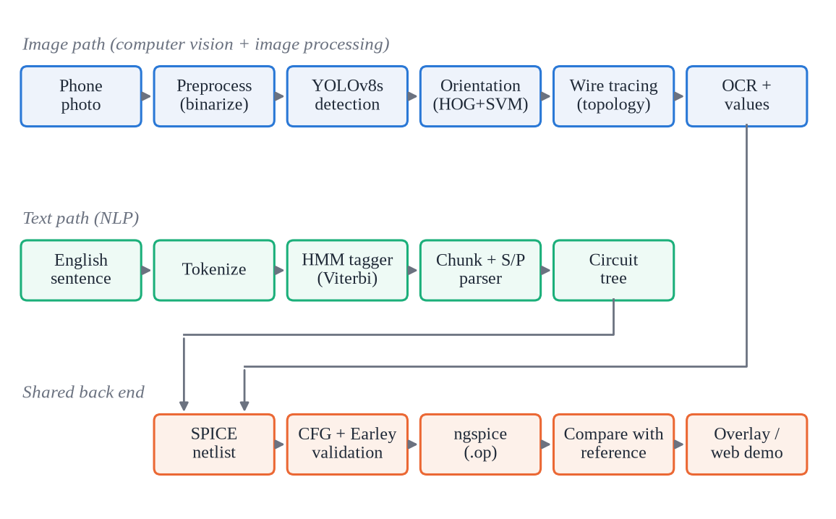
Figure 1: System architecture of CircuitVision: image path, text path and shared back end

3.4 Functional Requirements
Table 2: Functional requirements
ID | Requirement
FR1 | Accept a photograph (JPEG/PNG, any size, EXIF-tagged or not) and return a SPICE netlist and an overlay image with each net coloured.
FR2 | Detect resistor, capacitor, inductor, voltage source, diode, ground, junction, crossover and text symbols.
FR3 | Determine the polarity of diodes and voltage sources from their orientation.
FR4 | Connect wires that meet at junctions and keep crossing wires separate.
FR5 | Read component values (including 4k7-style codes and decimal commas) and attach each to one component.
FR6 | Choose a ground node and record the rule used in the netlist.
FR7 | Validate every netlist (syntax and semantics) and report errors with line numbers.
FR8 | Simulate valid netlists and report node voltages and source currents.
FR9 | Accept an English series-parallel description and return a netlist through the same validator.
FR10 | Provide a web demo and command-line tools, and an evaluation harness that reports every stage separately.

3.5 Non-Functional Requirements
- Reproducibility: fixed training configuration and seed, dataset pinned by MD5, every run's configuration and environment recorded.
- Honesty of reporting: every number labelled as real, synthetic/controlled, hand-written evaluation or user input; proxies named as proxies.
- Robustness: processing parameters scale with the size of the drawing, so the same code handles 400-pixel scans and 4,000-pixel phone photos.
- Testability: every stage covered by automated pytest regression tests (139 tests).
- Portability: runs on CPU for inference and tests (macOS or Linux); training uses a Colab T4 GPU.
- Resumability: the experiment notebook resumes after a disconnect without repeating finished stages.

3.6 Expected Outcomes
- A working image-to-netlist and text-to-netlist system with a web demo.
- A reproducible YOLOv8s baseline on CGHD with per-class test metrics.
- Stage-wise evidence of where reconstruction fails: detection, orientation, OCR or topology.
- An evidence bundle (configuration, logs, metrics, plots, tables) from which every reported number can be traced.

Chapter 4: AI Methodology

4.1 AI Techniques and Why They Suit the Problem
Table 3: AI techniques used and why each suits its sub-problem
Sub-problem | Technique | Why it is suitable
Finding symbols | YOLOv8s single-stage CNN detector [2], [19], fine-tuned from COCO [20] | Symbol shapes vary from drafter to drafter, so hand-made templates break; a single-stage detector is fast, and starting from COCO weights avoids training from scratch.
Symbol orientation (polarity) | HOG features [7] + linear SVM [8] | Orientation is a shape property that gradient histograms capture well; only four classes per symbol; trains in seconds and is easy to inspect.
Ink vs paper | Morphological closing + Otsu thresholding [21] | No training data needed; handles shadows and grid paper by measuring contrast relative to the local paper.
Connectivity | Connected components + union-find [22] | Whether two wires touch is a geometric question with a single right answer, so a deterministic method is easier to check and debug than a learned one.
Reading values | EasyOCR (CRAFT detection [23] + CRNN recognition [24]) [25] | Pre-trained on large text corpora; restricted to digits and unit letters to reduce misreads.
Text description | HMM tagger with Viterbi decoding [15], [16] + rule-based semantic parser | Small tag set and short sentences; an HMM trains on a synthetic corpus and handles unseen words through shape back-off.
Netlist validation | CFG with Earley recogniser [18] + semantic constraints | The netlist language is ambiguous at token level; Earley keeps all readings until the grammar decides, and reports the failing line.

4.2 Dataset and its Source

4.2.1 CGHD (real data)
The real-data experiment uses CGHD [3] release 14 from Zenodo [13]: an archive of about 4.4 GB, licensed CC BY 3.0, verified by its MD5 checksum before use. Each drafter_N folder holds phone photographs (images/) and Pascal VOC XML annotations (annotations/). Each circuit is drawn and photographed several times, which allows a cross-photo consistency check.
Two real annotation files were inspected directly before any training, and they changed the implementation: the rotation of each symbol is stored inside the <bndbox> element at 1-degree resolution (e.g. 2, 90, 269); mirror annotations exist; and many drawings contain out-of-scope symbols such as lamps, switches and transistors.
The full release 14 archive was then audited on 2 November 2026, after its MD5 checksum was verified, together with the rotation sheets (Gate 1) and the label overlays (Gate 2). Two findings changed the implementation again. First, in 336 training images from drafters −1, 29 and 30 the XML <size> is a placeholder (1000×1000) while the boxes are in real image pixels; the first conversion dropped 5,321 boxes and misplaced others, and the converter now takes the size from the image itself (1 box dropped and 5 clipped; 210,782 training objects instead of 205,462; validation and test labels unchanged). Second, the test drafter contains no ground symbols and only 32 voltage sources and 40 diodes, so ground and polarity results on drafter 12 rest on few or no examples. The complete audit tables are written again by the experiment notebook; the final split is 2,981 training images with 210,782 objects, 96 validation images (drafter 11) with 4,032 objects, and 96 test images (drafter 12) with 1,628 objects.
Table 4: Mapping from CGHD labels to the nine detector classes
CGHD labels | Class (YOLO id) | Note
resistor, resistor.adjustable, resistor.photo | resistor (0) | Drawn as a two-terminal resistor body
capacitor.unpolarized, capacitor.polarized | capacitor (1) | Capacitor polarity not modelled
inductor | inductor (2)
voltage.dc, voltage.battery | voltage_source (3) | voltage.ac excluded (would simulate as DC)
diode, diode.light_emitting, diode.zener | diode (4) | Zener breakdown not modelled
gnd | gnd (5) | Marks node 0
junction | junction (6) | Wire dot; treated as wire
crossover | crossover (7) | Crossing wires stay separate
text | text (8) | Value label for OCR
all other labels | not a class | Ink masked during wire tracing ("other")

4.2.2 Train / validation / test separation
The split is by drafter, so no person's handwriting appears in both training and test data: validation is drafter_11, test is drafter_12, and all other drafters are used for training. The split was fixed before any training. It differs from the split used by Bayer et al. (test drafters 23–24) [11], so the numbers are not directly comparable with theirs.

4.2.3 Synthetic data with known circuit graphs
CGHD release 14 contains bounding boxes but no ground-truth circuit graphs, so the correctness of a reconstructed circuit cannot be measured on real photos. To measure topology exactly, a generator (synth.py) draws five circuits with known graphs (a voltage divider, a parallel RC with junction dots, two independent loops crossing twice, a series RLC and a Wheatstone-style bridge) under eleven photo conditions (Figure 2). It can also write a synthetic tree in the CGHD format, with reference netlists, so that the full evaluation harness runs end to end. Results on these data are labelled SYNTHETIC and say nothing about real photos.
For the real test drafter, reference netlists were written for the 12 drawings that contain in-scope symbols (circuits C133–C138, two drawings each; C139–C144 are logic-gate diagrams with nothing to reconstruct). They were drafted from the photos without running the pipeline and checked against the photos by a team member. Out-of-scope parts (switches, AC sources) are left out of these references with their terminals kept apart, as the pipeline masks them, so only circuit C137 is complete enough to simulate.
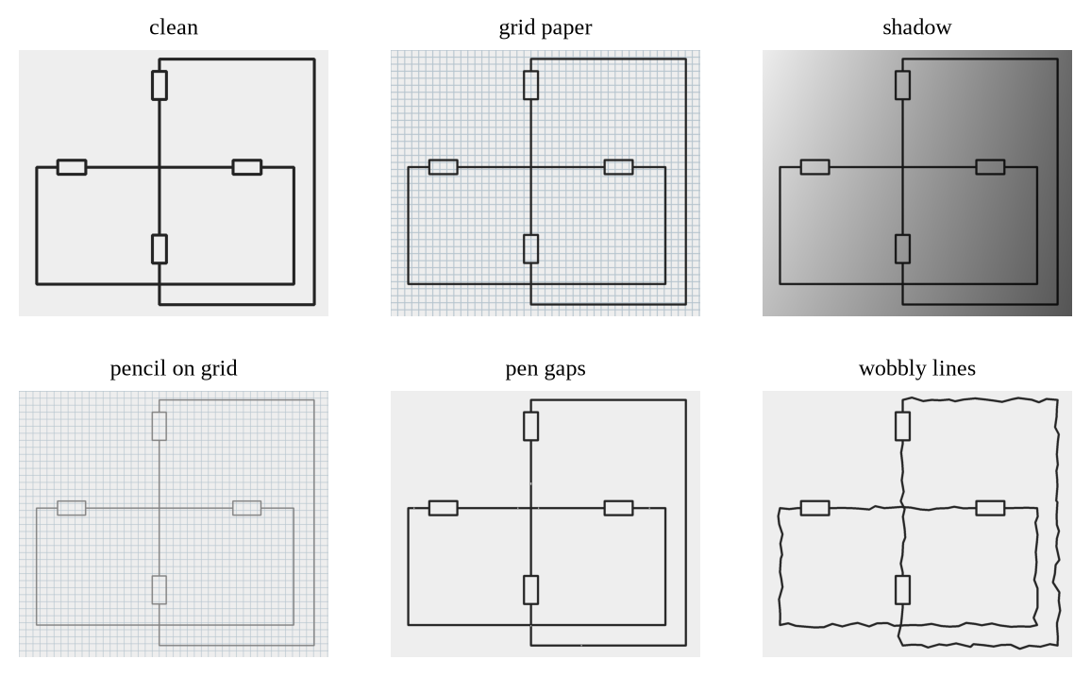
Figure 2: Six of the eleven synthetic photo conditions applied to the crossover circuit

4.2.4 Text data
The HMM tagger is trained on 3,000 sentences generated from templates with lexical variation (nlp/corpus.py). Evaluation uses three hand-written sets that the training corpus never sees: a 30-sentence set frozen before the NLP improvements (later used for error analysis, so its post-change score is optimistic), a fresh 20-sentence set written after development and evaluated exactly once, and a second 20-sentence set written by a teammate who had not seen the parser or the earlier sets, kept exactly as typed (final full stops included) and also evaluated exactly once.

4.3 Data Preprocessing

4.3.1 Annotation conversion
Each VOC object is mapped through the explicit class table (Table 4); boxes are clipped to the image and zero-area boxes are dropped, with every change counted in conversion_stats.json. YOLO labels are written as class cx cy w h, normalised by the annotated image size.
Figure 3 shows two of the 24 overlays checked at Gate 2, with the converted labels drawn on real photos. They show what the detector has to cope with: perspective, a shadow over half of the sheet in (a), dense junction dots and text labels everywhere. They also show the effect of the class mapping. The transformer windings in (a) are labelled as inductors, the photoresistor in (b) as a resistor, and the battery in (b) as a voltage source. The MOSFET in (a), and the eight-pin IC and the loudspeaker in (b), have no box at all, because they are out of scope; their ink is masked during wire tracing, but these circuits can never be reconstructed completely.
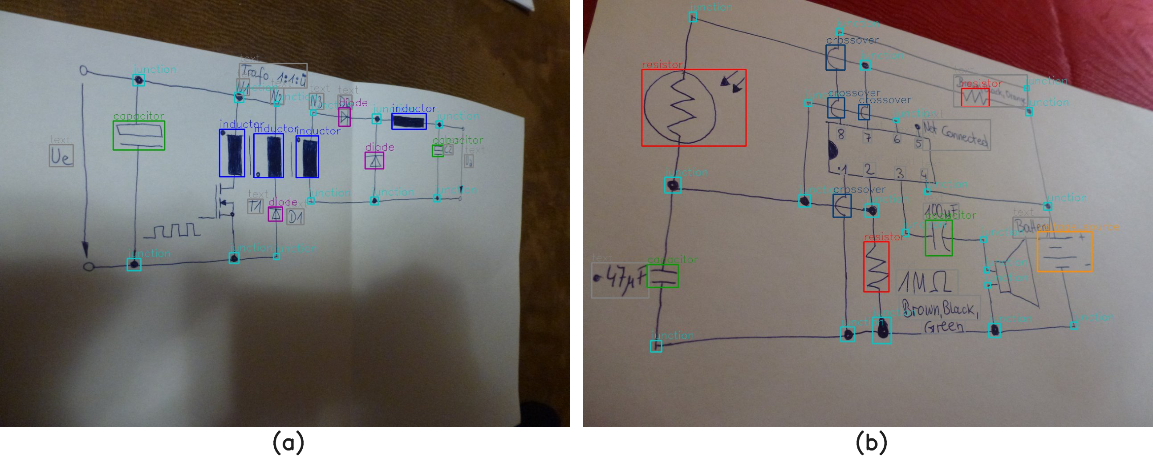
Figure 3: Two Gate 2 label overlays: converted YOLO labels on real CGHD photos (CC BY 3.0); out-of-scope parts such as the MOSFET, IC and loudspeaker carry no box
Figure 4 shows five more of the Gate 2 overlays, from training drafters 3, 4, 30 and 21 and validation drafter 11. They cover the range of real inputs the detector was trained on: (a) a resistor network with handwritten Ω values on plain paper; (b) a dense mains circuit on ruled paper under uneven light; (c) an amplifier on grid paper whose large IC and connectors are out of scope; (d) a 555 timer in a notebook photographed in perspective; and (e) a crumpled sheet with many crossovers and junction dots. Every in-scope symbol carries a box, junction dots and crossovers are labelled separately, and text labels are boxed for OCR.
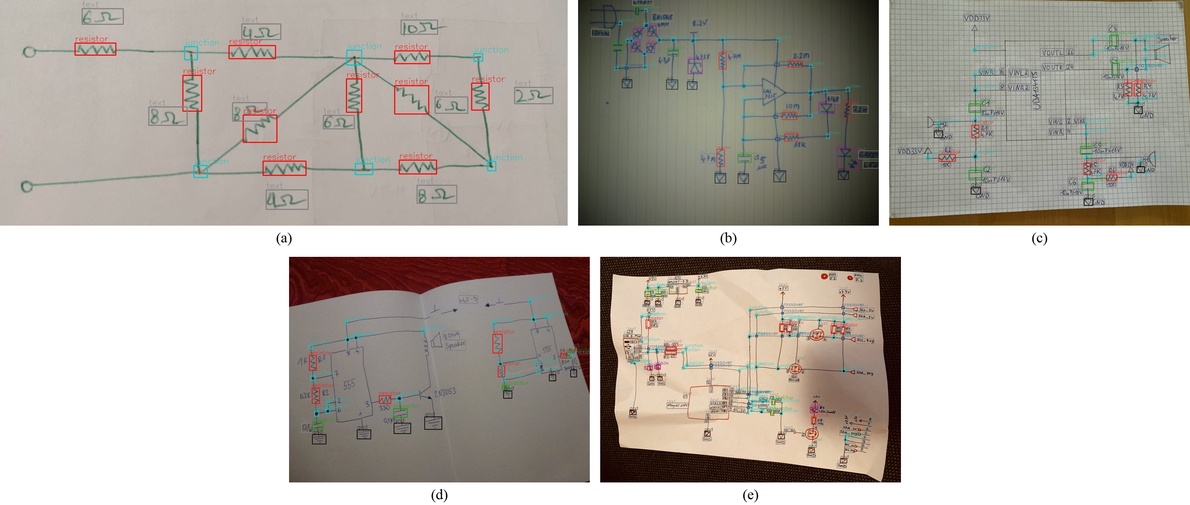
Figure 4: Five more Gate 2 label overlays (REAL CGHD, CC BY 3.0): (a) resistor network, (b) ruled paper, (c) grid paper, (d) notebook in perspective, (e) crumpled sheet with crossovers

4.3.2 EXIF orientation
Phone photos often carry an EXIF orientation tag. Each image is decoded in the pixel frame its annotation refers to, chosen by matching the annotated size against the raw and EXIF-rotated frames. Images with an EXIF rotation are re-encoded without the tag, so that the trainer and every tool see exactly the pixels the boxes refer to, and these images are always included in the visual label check.

4.3.3 Binarisation
Wire tracing needs a clean ink mask. Our first version used OpenCV's adaptive threshold; on grid paper it kept the grid lines, which then joined every wire into a single net. We replaced it with a contrast measure relative to the local paper brightness (Figure 5):
- Convert to grey and apply a 5×5 Gaussian blur.
- Estimate the paper brightness P with a grey-level morphological closing whose square window is 1/15 of the image's shorter side (at least 15 px). The closing removes every dark feature thinner than the window (pen strokes, grid lines, filled junction dots) and follows shadows.
- Compute relative contrast c = 255 · (P − I) / P, so a stroke in shadow scores like one in daylight.
- Threshold c with Otsu's method [21] on the candidate pixels, with a floor of 12; apply a 2×2 opening and remove connected components smaller than 30 px.
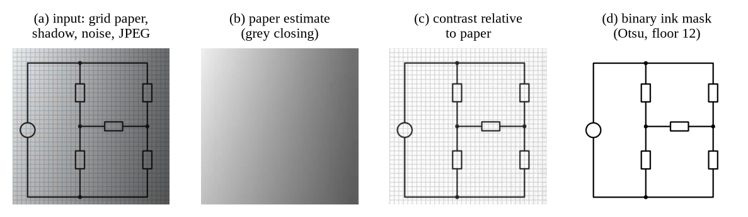
Figure 5: Binarisation stages on a synthetic photo with grid paper, a shadow, noise and JPEG compression

4.4 Feature Extraction and Representation
- Detector: features are learned by the YOLOv8s backbone; input images are resized to 1024 px.
- Orientation: each crop is padded to a square, resized to 64×64 and described by a HOG vector (16×16 blocks, 8×8 cells, 9 orientation bins). Every training crop is also rotated by 90°, 180° and 270° with its label shifted accordingly, so one labelled crop yields four samples (Figure 6).
- Text: each word is lower-cased; words seen fewer than twice in training, and a random 5% of training tokens (word dropout), are replaced by a case-aware shape class (e.g. number-like), so that unseen values and part numbers still receive sensible emission probabilities.
- Circuit: the shared representation is the netlist; for evaluation it is converted to a labelled multigraph (elements as edges between nets) for isomorphism testing.
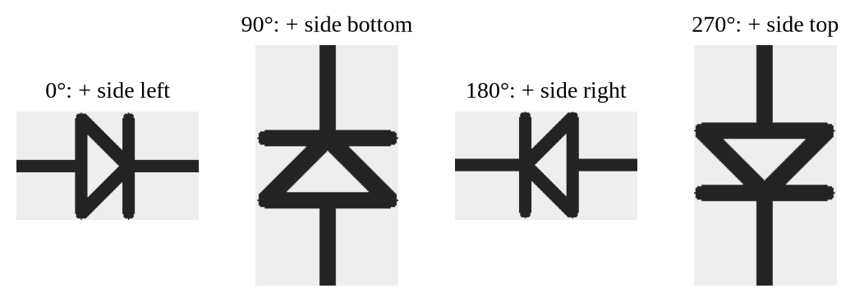
Figure 6: Rotation augmentation of a synthetic diode crop; the + side follows from the label under the convention fixed at Gate 1 (anode or + on the left at 0°, counter-clockwise)

4.5 Model Selection and Training

4.5.1 Component detector
We used the small YOLOv8 model (YOLOv8s), fine-tuned from COCO-pretrained weights, as a compromise between accuracy and what a Colab GPU can train in reasonable time. The configuration (Table 5) was fixed in code before any training, so it cannot drift between runs; each run records it together with the library and GPU versions.
Table 5: Fixed baseline training configuration (baseline_v1)
Setting | Value
Model | YOLOv8s, COCO-pretrained yolov8s.pt
Image size / batch | 1024 px / 16
Epochs | 100, early-stopping patience 30
Optimiser | SGD, lr0 0.01, lrf 0.01, momentum 0.937, weight decay 5×10⁻⁴, 3 warm-up epochs
Augmentation | flips 0.5/0.5, rotation ±5°, scale 0.5, translate 0.1, HSV s 0.3 / v 0.4, mosaic 1.0 (off for the last 10 epochs)
Seed | 0, deterministic
Classes | 9 (see Table 4)
Split | train: all drafters except 11 and 12; validation: drafter 11; test: drafter 12

4.5.2 Orientation classifier
One linear SVM per polarised class (diode, voltage source) is trained on HOG vectors of CGHD crops, with each rotation rounded to the nearest 90°. Mirrored symbols are excluded from training and scoring because the effect of a mirror on polarity depends on undocumented symbol templates. Internally, rotation is counter-clockwise and, at rotation 0, the positive terminal lies on a configured side.
How CGHD's rotation values map to this convention was decided at Gate 1 on 2 November 2026 from sheets of real crops: for diodes, LEDs, Zener diodes and batteries the anode or + is on the left at 0° and the symbol turns counter-clockwise, which agrees with the dataset's own port definitions for diodes. One label is an exception: all 182 rotated voltage.dc crops are labelled 0° with + on top, so 270° is added to that label when annotations are read (the raw value stays visible to the audit). A second team member reviewed both gate decisions independently on 4 November 2026.
Figure 7 and Figure 8 are two of the sheets used for this decision. Each row is one rotation bin (the CGHD value rounded to the nearest 90°), with eight randomly chosen real crops and the number of crops in the bin (n); the row marked none holds symbols with no rotation value, which are skipped. For diodes the triangle points right at 0°, up at 90°, left at 180° and down at 270°, so the anode moves from the left side counter-clockwise round the box. The voltage.dc sheet shows the exception: every rotated crop sits in the 0° bin, yet the + sign is on top. The remaining five sheets (LED, Zener, battery, and the out-of-scope AC source and thyrector) are in Appendix E.
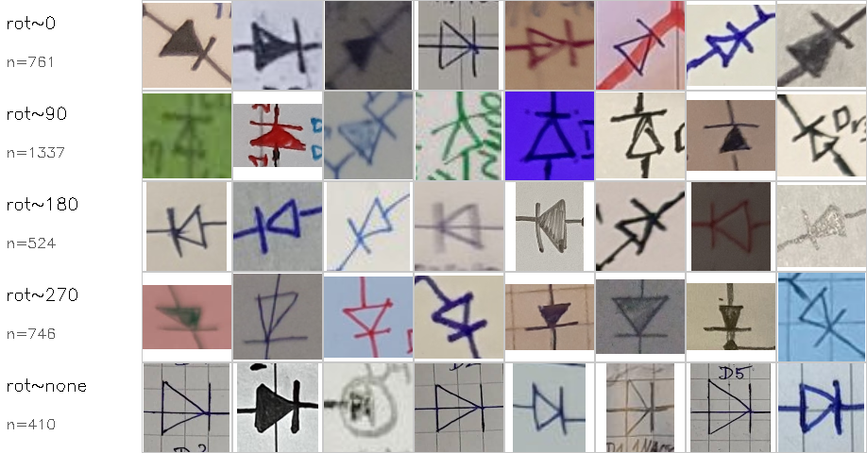
Figure 7: Gate 1 rotation sheet for diode (REAL CGHD v14 crops, CC BY 3.0): anode on the left at 0°, turning counter-clockwise
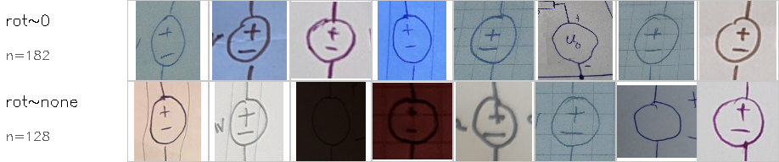
Figure 8: Gate 1 rotation sheet for voltage.dc (REAL CGHD): all 182 rotated crops are labelled 0° with + on top, so 270° is added when reading this label
A preliminary local check on test drafter 12 gave 0.938 orientation accuracy on the 32 voltage sources (0.875 before the voltage.dc correction) and 0.950 on the 40 diodes; because these test crops were seen while choosing the correction, they are not reported as a result.

4.5.3 HMM tagger
A first-order HMM over 11 tags (SRC, RES, CAP, IND, DIO, VAL, UNIT, SER, PAR, SEP, O) is estimated by counting with add-k smoothing (k = 0.1) and decoded with the Viterbi algorithm [16] in log space. With tags t and words w, Viterbi finds argmax over t₁…tₙ of log π(t₁) + Σ log A(tᵢ₋₁, tᵢ) + Σ log B(tᵢ, wᵢ).

4.5.4 OCR
EasyOCR [25] is used pre-trained, without fine-tuning, restricted to the characters 0-9 . , k K m M u µ n p G R r F f H h V v Ω +, so that only values can be read; word labels such as "Resistor" cannot be recognised by design. Labels taller than 1.5× their width are rotated upright before recognition.

4.6 System Workflow
Figure 9 shows the protocol of the real-data experiment, implemented as a single Colab notebook. Two human gates are assert cells that stop execution until approval and notes are recorded: Gate 1 fixes the rotation convention after the dataset audit (the decided values are prefilled, but a person must still approve), and Gate 2 confirms visually, on 24 overlays covering every split and class and the EXIF-rotated photos, that the converted labels sit on their symbols. Every step is logged, stops on failure and writes its outputs to Google Drive; after a disconnect the notebook skips finished stages and resumes training from the last checkpoint.
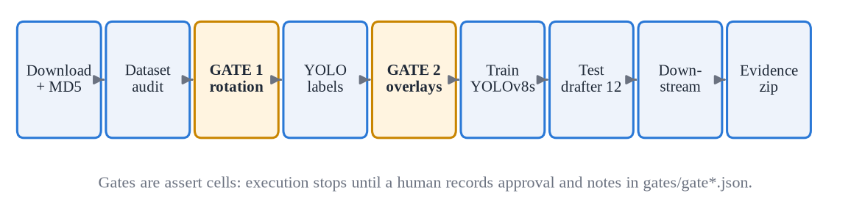
Figure 9: Real-data experiment protocol with two human verification gates

4.7 Tools, Libraries and Technologies
Table 6: Tools, libraries and technologies
Tool | Version | Used for
Python | 3.11 (≥ 3.10 supported) | All code
Ultralytics YOLO [19] / PyTorch | 8.4.184 / 2.x | Detector training and inference
OpenCV (headless, pinned) [26] | 4.10.0.84 | Image processing, HOG, SVM
NumPy, Pillow | — | Arrays, image headers
EasyOCR | 1.7.2 | Reading values
ngspice [27] | 42 (Linux), 47 (macOS) | Circuit simulation
Gradio [28] | ≥ 5 | Web demo
pytest | — | 129 regression tests
Google Colab (T4 GPU) + Drive | — | Training and evaluation runs
Git / GitHub | — | Version control, pull requests

Chapter 5: Implementation

5.1 Software and Hardware Requirements
Table 7: Software and hardware requirements
Item | Development / inference | Training
Operating system | macOS (Apple Silicon) or Linux | Google Colab (Linux)
Processor / GPU | Any modern CPU; Apple MPS optional | NVIDIA T4 GPU (16 GB)
Memory | 8 GB RAM | Colab default
Storage | ≈ 2 GB for environment | ≈ 10 GB local (dataset + converted copy); Drive for results
Software | Python ≥ 3.10, package with extras detect/app/dev, ngspice | Same, installed by the notebook

Training on a laptop is not practical at the fixed settings: on a 16 GB Apple M5, one batch took about 132 s, which is about 29 days for 100 epochs. Training therefore runs on a Colab T4 GPU, and inference and all tests run on an ordinary CPU.

5.2 Module-wise Description
Table 8: Modules of the circuitvision package
Module | Responsibility
preprocess.py | Image loading and paper-relative binarisation
cghd_to_yolo.py | VOC parsing (rotation inside bndbox, mirror), EXIF-aware loading, drafter-wise YOLO export
audit.py, visualize.py | Full dataset audit; rotation sheets (Gate 1); stratified label overlays (Gate 2)
detect.py, train.py, detector_eval.py | YOLO inference; fixed-configuration training with automatic resume; test metrics and failure categories
orientation.py | Rotation convention, HOG + SVM orientation model
topology.py | Wire tracing: box masking, wire labelling, terminal rings, crossovers
ocr.py, netlist.py | EasyOCR; value parsing; label-to-element assignment; ground rule; SPICE text
grammar.py | CFG, Earley recogniser, semantic checks
simulate.py, compare.py | ngspice operating point; isomorphism and operating-point comparison with a reference
pipeline.py, app.py | End-to-end command line and Gradio web demo
evaluate.py, report_tables.py, synth.py | Stage-wise evaluation; tables generated only from result files; synthetic data
nlp/ (lexicon, hmm, corpus, parser, tree, text2netlist, evaluate) | Text-to-netlist path and its evaluation

5.3 Important Algorithms

5.3.1 Wire tracing
Wire tracing turns the ink mask and the symbol boxes into nets (Figure 10). The idea is simple: erase every symbol from the mask, so that only wires are left, and treat each remaining connected piece of ink as one net. The usual alternative is to skeletonise the wires and follow line segments; erasing boxes needs no line-following rules and is easy to test, so we started with it. The price is that two wires drawn touching each other are merged, and a crossing is kept apart only if the detector finds the crossover symbol. All sizes scale with s, the median short side of the element boxes divided by 24, so a 4,000-px photo behaves like a 400-px drawing (Section 6.9 describes what went wrong before this was added).
Algorithm 1: extract_nets(mask, boxes)
s <- max(1, median short side of element boxes / 24)
grow every box by 3s; erase element, ground, crossover, text and
out-of-scope boxes from the mask # junction dots stay ink
dilate the remaining ink by max(3, 3s) # bridge pen gaps
label 8-connected components -> candidate wires
drop components smaller than 40 s^2, and components that never leave
the neighbourhood of a single box # outline slivers
for each crossover box:
union(labels on left side, labels on right side)
union(labels on top side, labels on bottom side)
for each element box:
read wire labels in a ring of width 6s on each side
order sides: + side first if polarity known, else
left,right (wide box) or top,bottom (tall box)
terminals <- distinct union-find roots in that order
return terminals per element
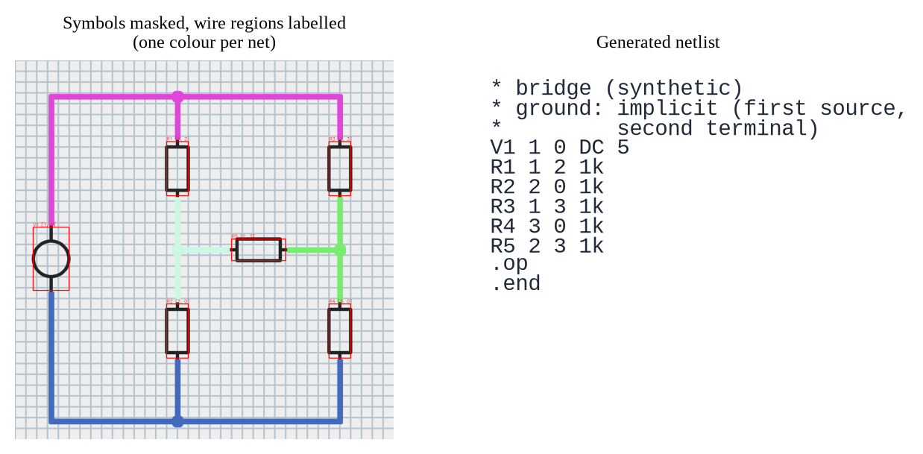
Figure 10: Wire tracing on a synthetic bridge drawn on grid paper: nets coloured, and the generated netlist

5.3.2 Value attachment
Algorithm 2: attach_values(elements, text_boxes)
labels <- [(box, value, unit_class) for OCR text that parses as a value]
pairs <- []
for each element e, label l:
if l.unit_class is set and differs from e.class: skip # no 10uF on a resistor
d <- distance between box centres
if d <= max(150, 1.5 x longer side of e): pairs.append((d, e, l))
for (d, e, l) in pairs sorted by d: # greedy, closest first
if e and l both unused: e.value <- l.value; mark both used
Assigning each element its nearest label fails when two resistors share one nearby label: both take it. Taking pairs in order of distance and using each label once avoids that, and the unit check stops a capacitor value from landing on a resistor that happens to be closer. Value parsing accepts the forms seen on drawings: 10k, 4.7uF, 4,7µF (decimal comma), 220Ω, RKM codes (4k7 → 4.7k, 2R2 → 2.2, 1M5 → 1.5 Meg) and trailing-R ohm values (330R → 330 Ω, a resistor). Names such as R1 are not values and are ignored.

5.3.3 Earley recogniser for the netlist grammar
The grammar covers the generated SPICE subset: a title comment, element lines R|C|L name node node value, V name node node [DC] value, D name node node model, .model, .op and .end. Terminals are regular-expression predicates rather than fixed token types, so a token such as 1 can be a node or a value.
Algorithm 3: earley(tokens)
chart[0] <- {(S -> . alpha, 0) for each rule of S}
for i in 0..n:
for each item (A -> beta . X gamma, j) in chart[i] (agenda):
if X is a non-terminal: add (X -> . delta, i) to chart[i] # predict
elif X matches tokens[i]: add (A -> beta X . gamma, j) to chart[i+1]
for each completed item (B -> delta ., j) in chart[i]: # complete
advance each (A -> beta . B gamma, k) in chart[j] into chart[i]
if chart[i+1] is empty: return (reject, i) # error position -> line number
accept iff (S -> alpha ., 0) in chart[n]
After a successful parse, semantic checks reject: a missing ground node, floating nodes (fewer than two connections), shorted elements, duplicate references and diodes that use an undefined model.

5.3.4 Viterbi decoding
Algorithm 4: viterbi(words)
score[0, t] <- log pi[t] + log B[t, w0]
for i in 1..n-1:
for each tag t:
back[i, t] <- argmax_u score[i-1, u] + log A[u, t]
score[i, t] <- max_u (score[i-1, u] + log A[u, t]) + log B[t, wi]
follow back-pointers from argmax_t score[n-1, t]

5.4 Implementation Details
- Ground. Nets touching a ground symbol become node 0. Many drawings have no ground symbol; then the second (negative, if polarity is known) terminal of the first source becomes node 0, or failing that the most connected net. The rule used is written into every netlist header. Because comparison uses element voltages, the choice of reference node does not affect correctness.
- Defaults. Without a readable value, components get placeholder defaults (R 1k, C 1u, L 1m, V DC 5); diodes use a generic .model DMOD D. An element without exactly two terminals is not emitted but flagged as a * WARNING comment, so a broken reconstruction is visible rather than silently wrong.
- Text parser. Each component noun takes its nearest unclaimed value; an explicit unit decides the class; count words ("two 1k resistors") repeat elements; parentheses group explicitly; a comma followed by an operator closes the preceding clause ("A and B in parallel, in series with C" → S(P(A,B),C)); otherwise operators attach to the right, as in prepositional-phrase attachment. The source is placed across the whole load.
- Evaluation. evaluate.py runs every downstream stage twice, with ground-truth boxes (an oracle detector) and with detector boxes, on all images and on the subset without out-of-scope symbols, and writes CSV files, netlists and a JSON summary. report_tables.py builds the results tables only from these files and prints NOT AVAILABLE when an artefact is missing.
- Testing and reproducibility. 139 pytest tests across 15 files cover every stage, including the application's reports, including one real CGHD annotation file as a regression fixture. The experiment notebook pins package versions, records the commit, the dataset checksum, the GPU and the full package list, and bundles all evidence into a ZIP file.

5.5 Screenshots of the Running System
Figure 11 shows an early version of the Gradio web demo processing a synthetic drawing with a detector trained on synthetic data. The final application runs the baseline_v1 model and has three tabs: Photo (upload, webcam or clipboard, and an Upload from mobile button that shows a QR code so that a phone on the same Wi-Fi can take a photo and send it to the laptop, where the result appears automatically), Text, and Send from phone; its outputs on real user photos are shown in Section 6.4. The overlay colours each net; the netlist reads the handwritten-style values 4k7, 9V and 220; validation passes; and ngspice gives v(2) = 0.4024 V, which matches 9 × 220 / (4700 + 220). Figure 12 and Figure 13 show the command-line tools and the test suite.
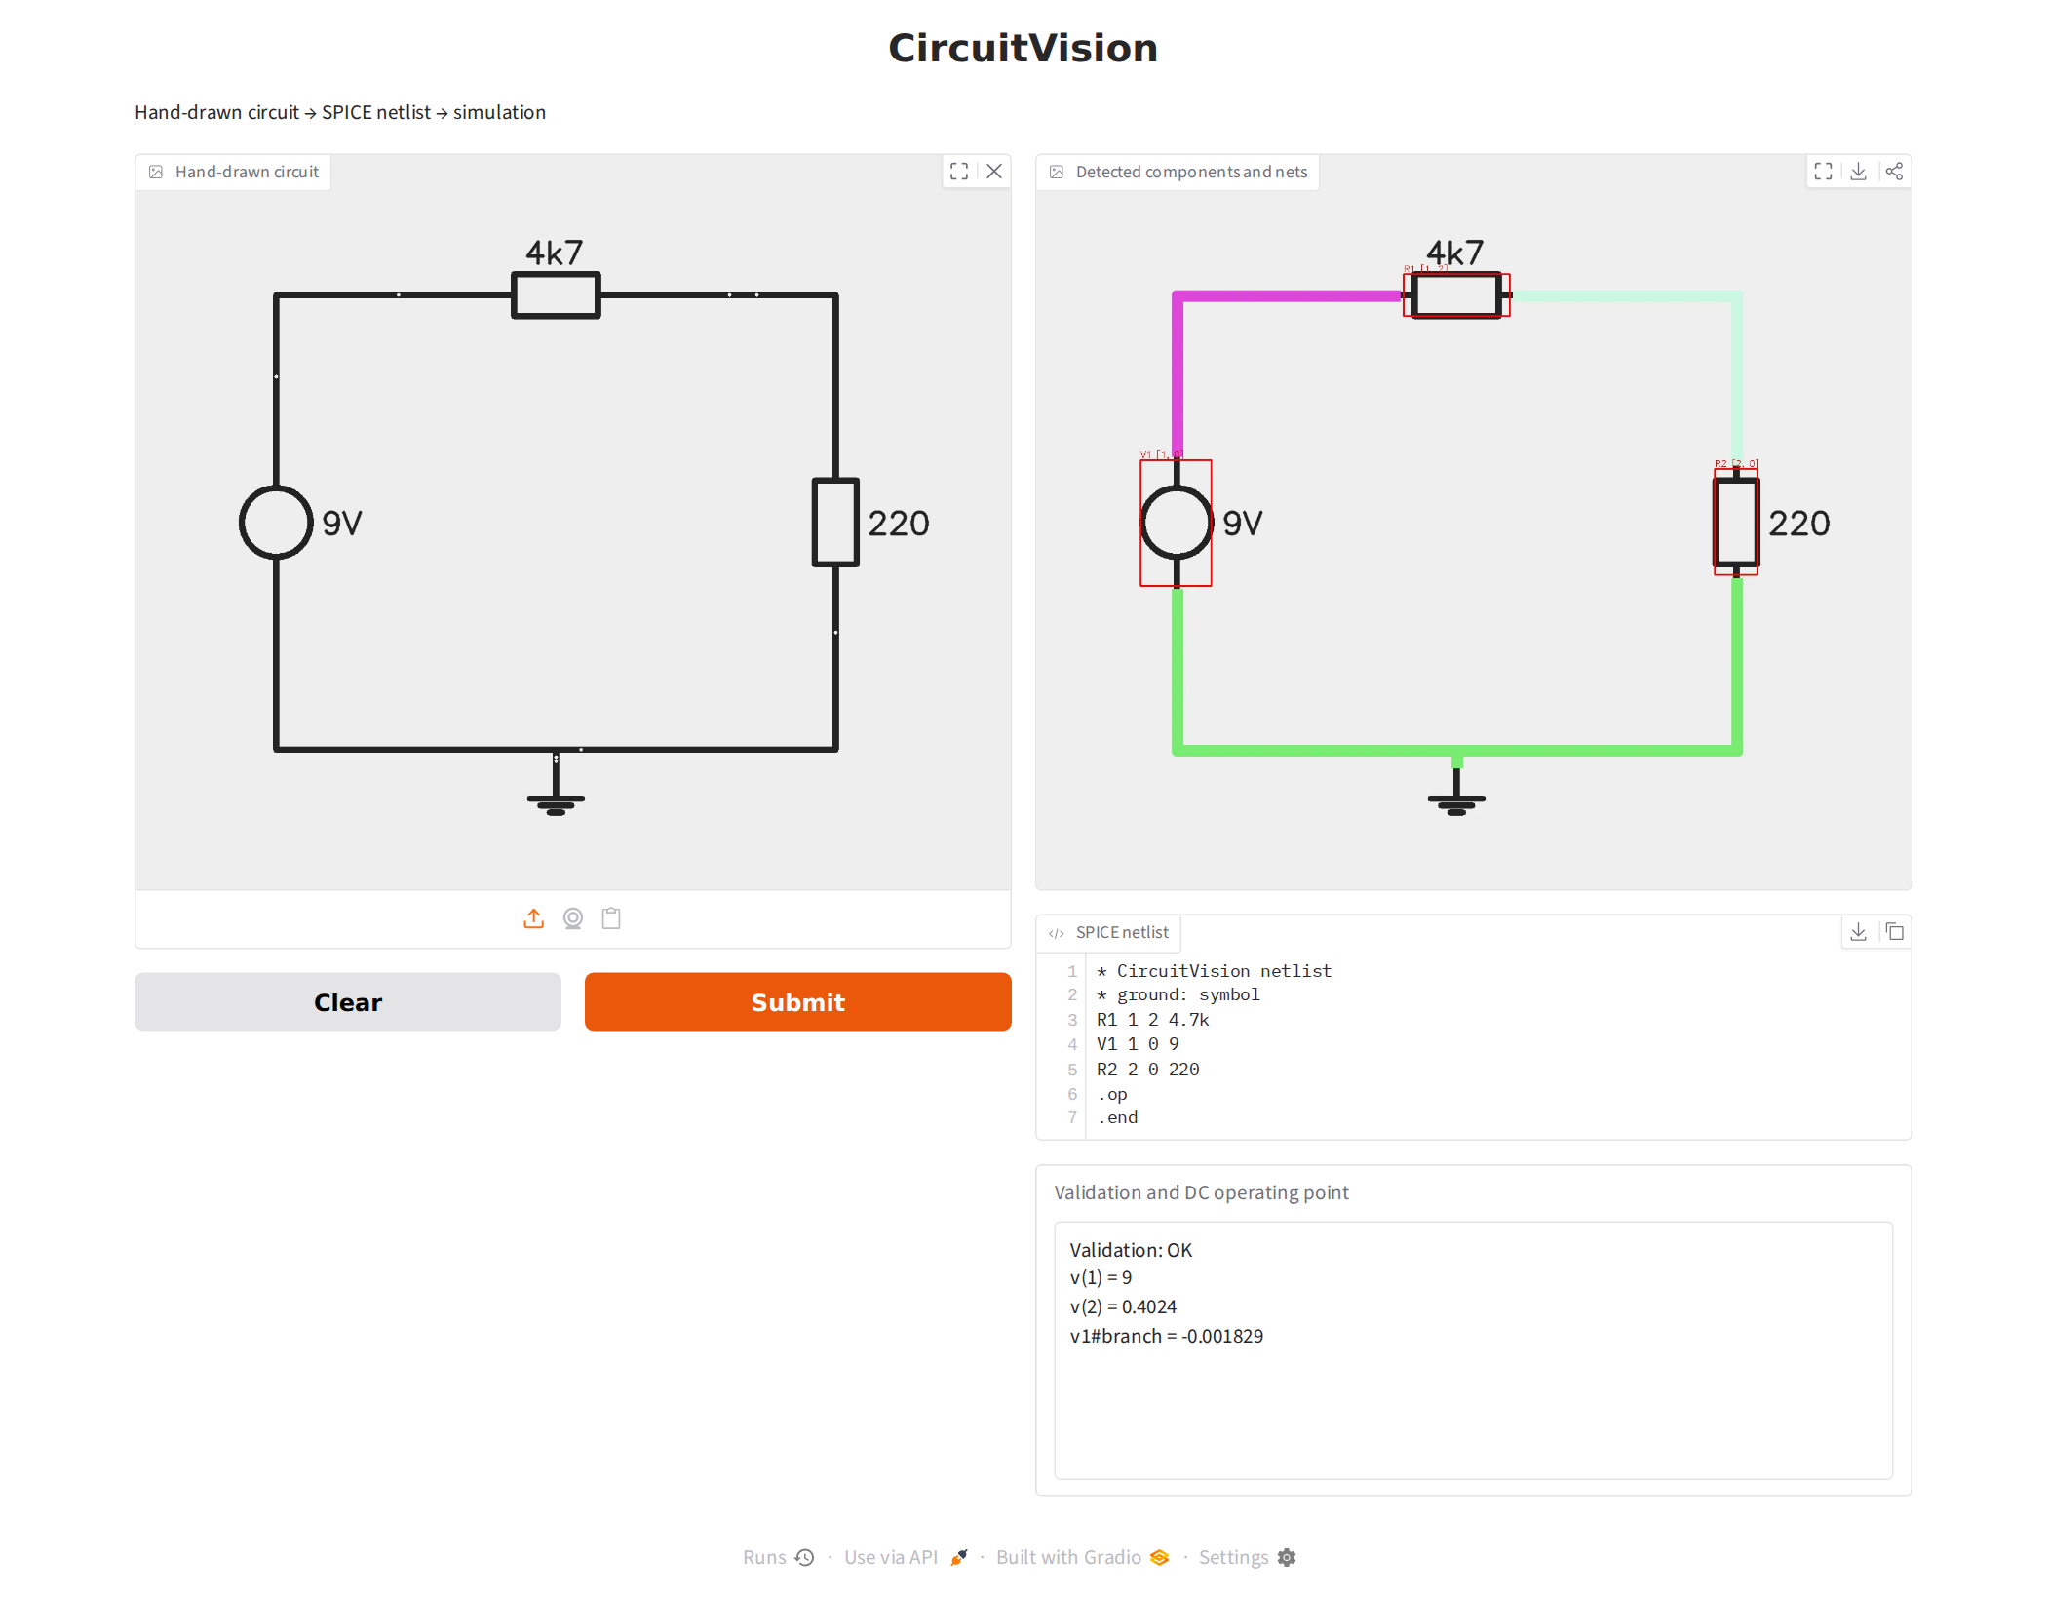
Figure 11: Gradio web demo: input, detected components and nets, SPICE netlist, validation and DC operating point (synthetic input and model)
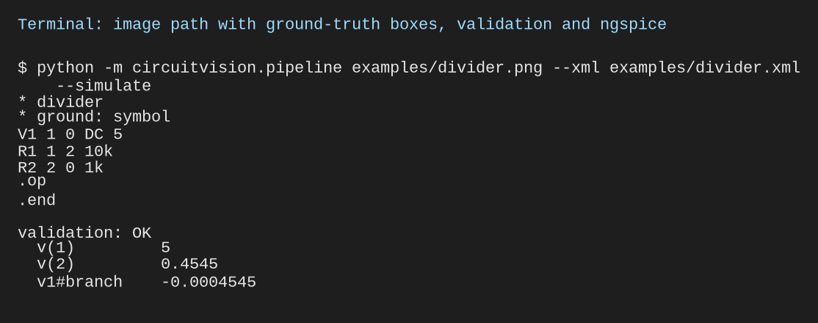
Figure 12: Command-line image path on the example drawing with ground-truth boxes, validation and simulation
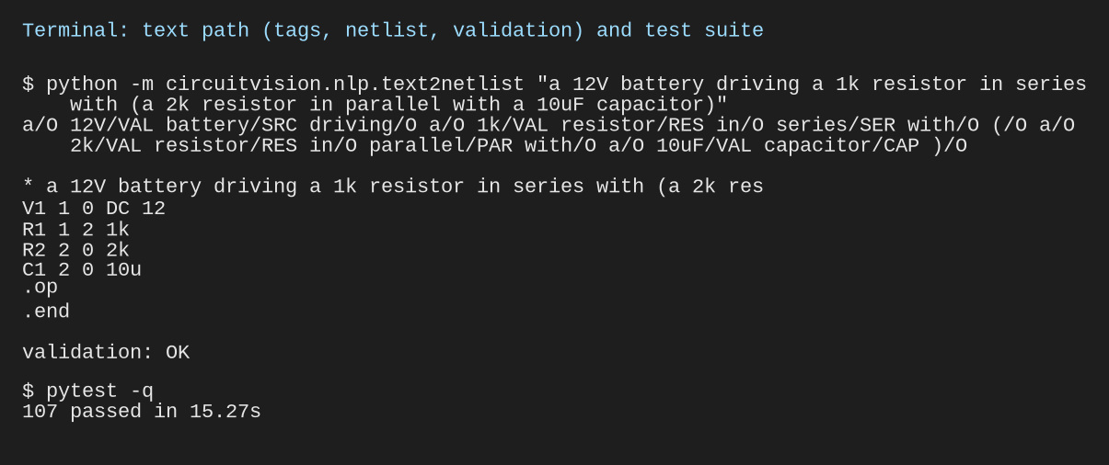
Figure 13: Command-line text path (tags, netlist, validation) and the test suite

5.6 Sample Inputs and Outputs
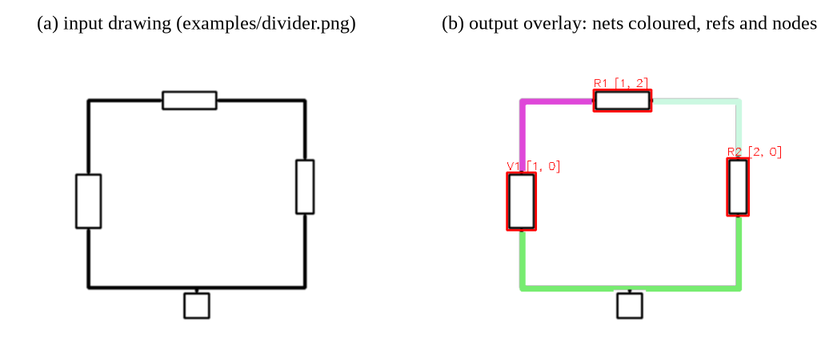
Figure 14: Example input drawing and the output overlay produced by the pipeline
Table 9: Sample text inputs and generated netlists (actual outputs)
Input sentence | Generated netlist (elements) | Validation
a 9V battery driving a 1k resistor in series with (a 2k resistor in parallel with a 3k resistor) | V1 1 0 DC 9; R1 1 2 1k; R2 2 0 2k; R3 2 0 3k | OK
a 12V battery driving a 1k resistor in series with (a 2k resistor in parallel with a 10uF capacitor) | V1 1 0 DC 12; R1 1 2 1k; R2 2 0 2k; C1 2 0 10u | OK

Table 10: Validator outputs on deliberately faulty netlists (actual outputs)
Faulty input | Reported error
R2 line with a missing value (R2 1 0) | syntax error at line 3
Ground reached by only one element | node 0 is floating (1 connection)
Diode referring to model DX that is not defined | D1 uses undefined model DX

Chapter 6: Results and Discussion

6.1 Evaluation Design
Every result in this chapter carries one of four labels: REAL CGHD (measured on the real dataset), SYNTHETIC (data generated by our code, where the right answer is known), HAND-WRITTEN (sentences we wrote for NLP evaluation) or USER INPUT (photos and sentences given to the finished application). Three principles run through the evaluation:
- Isolate stages. Every downstream stage is evaluated with ground-truth boxes and with detector boxes, separating detection errors from reconstruction errors.
- Validate the circuit, not the syntax. Netlists are compared with references by graph isomorphism (topology match), isomorphism with equal values (exact match) and equal simulated element voltages within 0.1% (operating-point match).
- Name proxies as proxies. On real CGHD, where no reference graphs exist, topology is reported only through proxies: the share of elements with exactly two terminals, and the consistency of the reconstructed graph across photos of the same drawing.

6.2 Evaluation Metrics
Table 11: Evaluation metrics by stage
Stage | Metric | Definition / caveat
Detection | Precision, recall, mAP@0.5, mAP@0.5:0.95, per-class AP, confusion matrix | Ultralytics validation on test drafter 12; error categories at IoU 0.5, confidence 0.25
Orientation | Accuracy | Against CGHD rotation binned to 90°, mirrored symbols excluded; valid only under the Gate 1 convention
OCR | Exact match; character accuracy (1 − CER) | On ground-truth text boxes; all labels and value-like labels
Topology | Topology / exact / operating-point match | Only where a reference netlist exists: synthetic data, and 12 drafter-12 drawings (operating point only for the one complete circuit)
Topology (real) | 2-terminal share; cross-photo consistency | Proxies: consistent is not the same as correct
Netlist | Valid share; simulates share | A valid netlist is not necessarily the drawn circuit
Text path | Token accuracy, per-tag P/R/F1, macro F1, exact circuit match, component P/R/F1 | Tagging scored on gold tokens; circuit scored from the raw sentence

6.3 Real CGHD Results (baseline_v1)
The real-data experiment ran on Google Colab on 4 November 2026 with the fixed configuration of Table 5, after both human gates had been approved and independently reviewed. Every number in this section is taken from the run's evidence bundle (test/metrics.json, orientation.json, downstream/summary.json, the downstream CSV files and netlists, and the generated tables.md), copied to results/baseline_v1/ in the repository [4]. Test drafter 12 was not used for any training or gate decision.

6.3.1 Training run
Training stopped early at epoch 73 of 100: the validation score had not improved for 30 epochs (the configured patience). The best epoch was 43, with validation mAP@0.5 0.940 and mAP@0.5:0.95 0.627 on drafter 11, and the checkpoint from that epoch is the one evaluated below (Figure 15). Because free Colab sessions disconnect, the run was resumed from its last checkpoint five times: epochs 1–33 ran on an NVIDIA Tesla T4 and epochs 34–73 on an NVIDIA A100 (40 epochs in 0.45 h), with the same configuration throughout. Every session confirmed that the label conversion was identical to the one approved at Gate 2, and the dataset MD5 checksum matched.
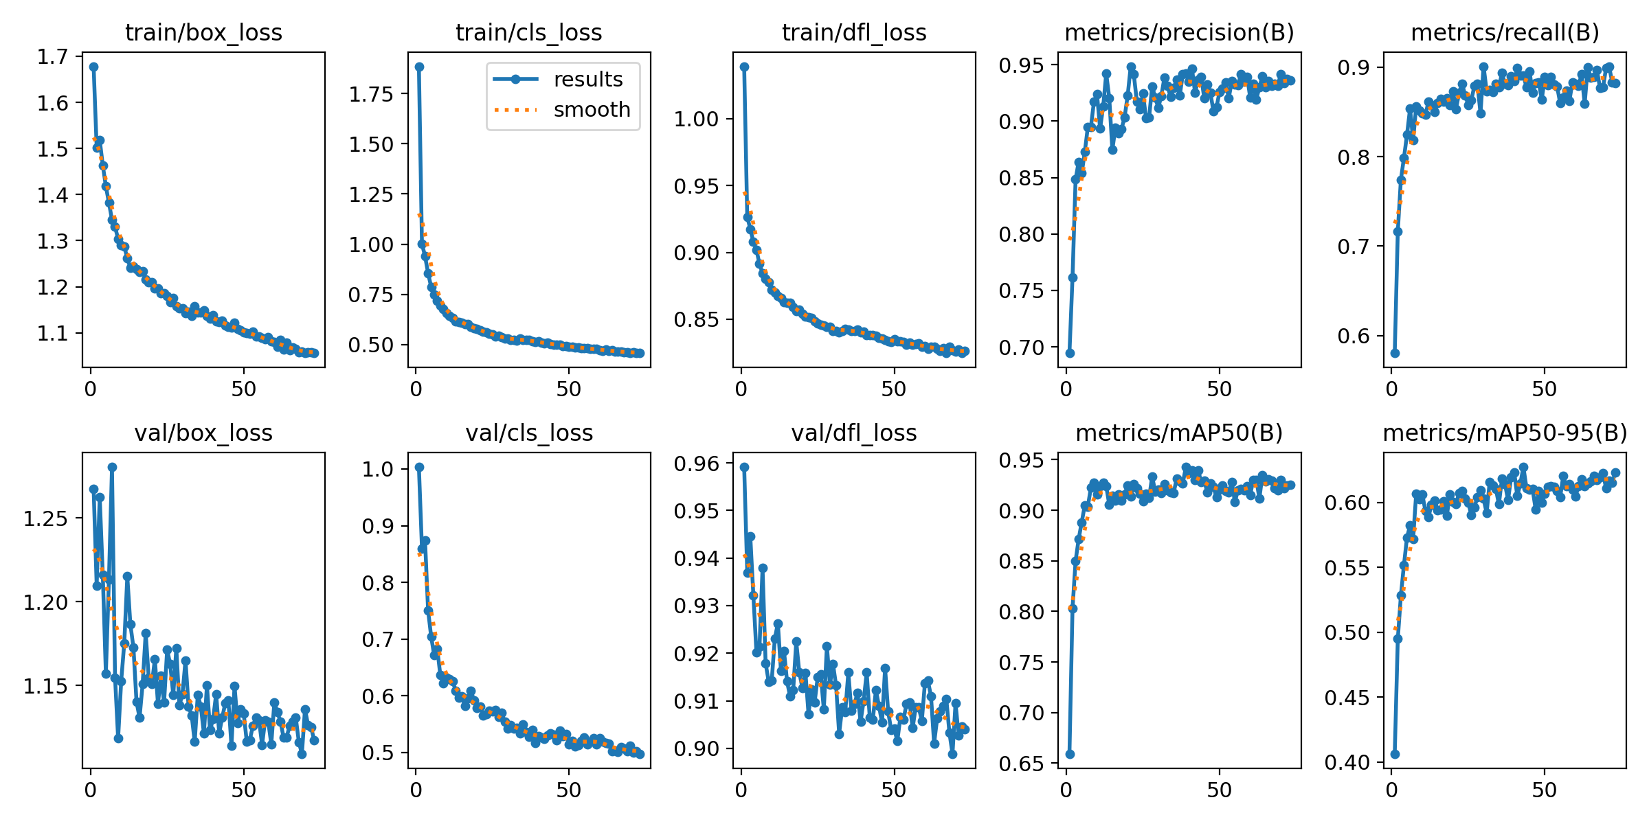
Figure 15: Training and validation curves of baseline_v1 (REAL CGHD; validation drafter 11). Training stopped early at epoch 73; the best epoch, 43, is evaluated

6.3.2 Detection on the test drafter
Table 12: Detection on test drafter 12: 96 photos, 1,628 symbols (REAL CGHD, test/metrics.json)
Class | Precision | Recall | AP@0.5 | AP@0.5:0.95
All classes | 0.886 | 0.875 | 0.904 | 0.611
resistor | 0.963 | 1.000 | 0.995 | 0.766
capacitor | 0.739 | 1.000 | 0.972 | 0.682
inductor | 0.980 | 0.833 | 0.953 | 0.678
voltage source | 0.608 | 0.594 | 0.482 | 0.257
diode | 0.966 | 0.714 | 0.939 | 0.706
junction | 0.943 | 0.874 | 0.906 | 0.411
crossover | 0.947 | 1.000 | 0.994 | 0.655
text | 0.941 | 0.982 | 0.989 | 0.736

The detector finds almost every resistor, capacitor, crossover and text label. At confidence 0.25 there are 1,526 true positives, 181 false positives and 102 misses. The weak class is the voltage source (AP@0.5 0.482): its two-plate symbol resembles a capacitor, and the commonest confusion is voltage source → capacitor (9 cases). In several photos the same battery is boxed twice, once as each class, with box overlap above 0.98. Junction dots are found reliably but placed less tightly (AP@0.5:0.95 0.411), and drafter 12 has no ground symbols, so ground detection is not measured. The normalised confusion matrix is in Figure 16.
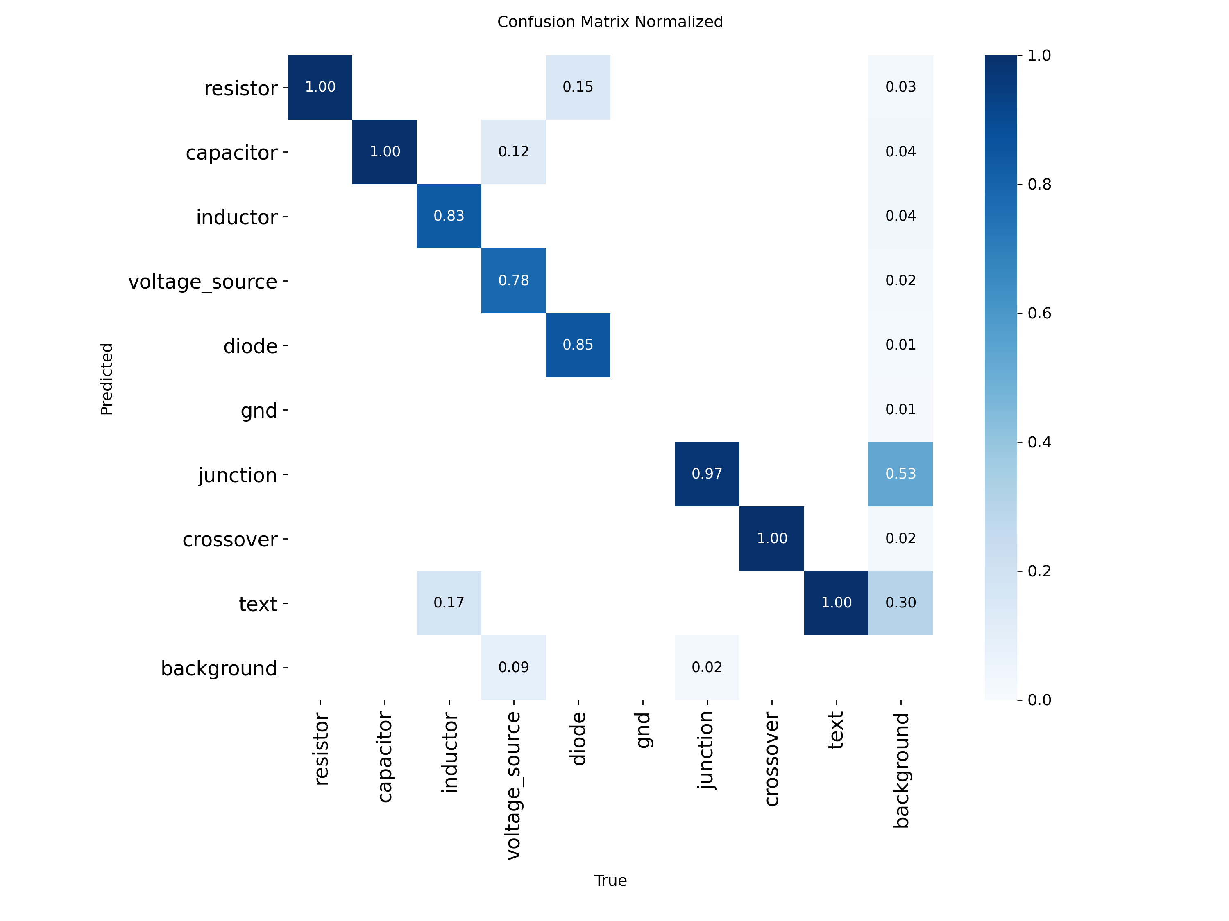
Figure 16: Normalised confusion matrix on test drafter 12 (REAL CGHD)

6.3.3 Orientation and OCR
- Orientation. On real test crops the HOG + SVM classifier reaches 0.906 for voltage sources (32 crops) and 0.775 for diodes (40 crops) (orientation.json). Inside the pipeline, polarity is correct for 0.833 of 72 polarised symbols with ground-truth boxes and 0.639 with detector boxes. The voltage-source crops were also seen while choosing the voltage.dc correction (Section 4.5.2), so 0.906 is slightly optimistic, and both test sets are small.
- OCR. On the 656 ground-truth text boxes, EasyOCR gives 0.021 exact match and 0.148 character accuracy. This figure is misleading: almost all labels on this drafter are words ("Resistor", "Battery", "R1"), which the value-only character set cannot spell, and only 4 labels are values. Reading handwritten values is therefore effectively not measured on the test drafter.

6.3.4 Netlists from real photos
Half of the test photos (circuits C139–C144, 48 photos) are logic-gate diagrams with no in-scope symbol, so they always give an empty netlist. The meaningful base is the 48 analog photos (C133–C138), scored against the 12 reference netlists of Section 4.2.3 (Table 13).
Table 13: Netlists from the 48 analog test photos (REAL CGHD, downstream/*.csv)
Measure | GT boxes | Detector boxes
Valid netlist (grammar and semantic checks) | 12 (25.0%) | 20 (41.7%)
Correct circuit (topology match with the reference) | 18 (37.5%) | 5 (10.4%)
Exact match (topology and values) | 18 | 3
C137, the only fully in-scope circuit (8 photos) | 1 of 8, operating point correct | 0 of 8

A valid netlist is not necessarily the drawn circuit. The detector's netlists are more often valid than the ground-truth ones (42% against 25%) but far less often correct (10% against 37.5%). The reason is the double-boxed battery: the extra capacitor happens to close loose wire ends, so the netlist passes validation while describing a different circuit. Topology match against a reference is therefore the measure of correctness, and validity alone is not.

6.3.5 Error analysis
- Battery terminals. With ground-truth boxes, a part that ends up with other than two wire ends is left out of the netlist. Across the 48 analog photos there are 32 such drops, and 16 of them are voltage sources: the long battery plates reach beyond the box and are traced as extra wires.
- Faint pen strokes. A light stretch of pen breaks a straight wire into dashes wider than the gap-closing distance, splitting one net into two.
- Text labels attached as values. A label such as "Resistor 2" gives a "2" that is attached as 2 Ω, so the values are wrong even when the topology is right.
- Detector false positives (the double-labelled battery) make wrong netlists look valid.
- Out-of-scope symbols. Switches and AC sources in C133–C136 can never be reconstructed, so those circuits are incomplete by design.
After these results were known, a fix was made for the second cause: gaps are now also closed along straight horizontal and vertical lines, so parallel wires are never joined sideways (Section 6.4). Re-running the ground-truth-box evaluation on the same 48 photos gives 21 correct circuits instead of 18, with no photo becoming worse, and the synthetic topology benchmark is unchanged. Because this was measured after seeing the test results, the baseline figures above remain the reported result.

6.4 Testing with Real User Input
To see whether the finished system works for someone who does not know its internals, the application was used the way a user would: photos were uploaded through its Photo tab (from the laptop or, with the phone upload feature, from a phone camera), and circuit descriptions were typed into its Text tab and command-line tool. Each result was compared with a reference written by hand before running, and simulated where possible.
- Text. Of 20 typed descriptions, 15 describe a definite circuit and 12 of these give the electrically correct circuit (topology, values and simulated operating point within 0.1% of hand calculation). Three sentence structures still produce valid but wrong circuits ("two parallel resistors of 2k and 4k", "in series with a parallel combination of …", and a two-branch description). The other five inputs are ambiguous or invalid: two are now rejected with a clear message instead of a program crash, and three are built from stated assumptions that are reported to the user.
- Photos. Figure 17(a) is a circuit drawn by a team member on plain paper: after the faint-wire fix, the netlist is valid and its topology matches the drawing exactly (diode, resistor, inductor, capacitor and battery all on the right nodes). The handwritten "+5V" is read as "45V", because EasyOCR reads the + sign as 4, so the application now lists every value read by OCR for the user to check. Figure 17(b) is drawn on ruled notebook paper: the printed lines are traced as wires and cross-connect every part, two parts are dropped, and the AC source is ignored because it is out of scope. A scanned figure from a published paper was also tried (not reproduced here): its AC source was detected as a DC source, and its large outlined diode was not detected at all, even at confidence 0.001, because it differs strongly from the CGHD drawing style.
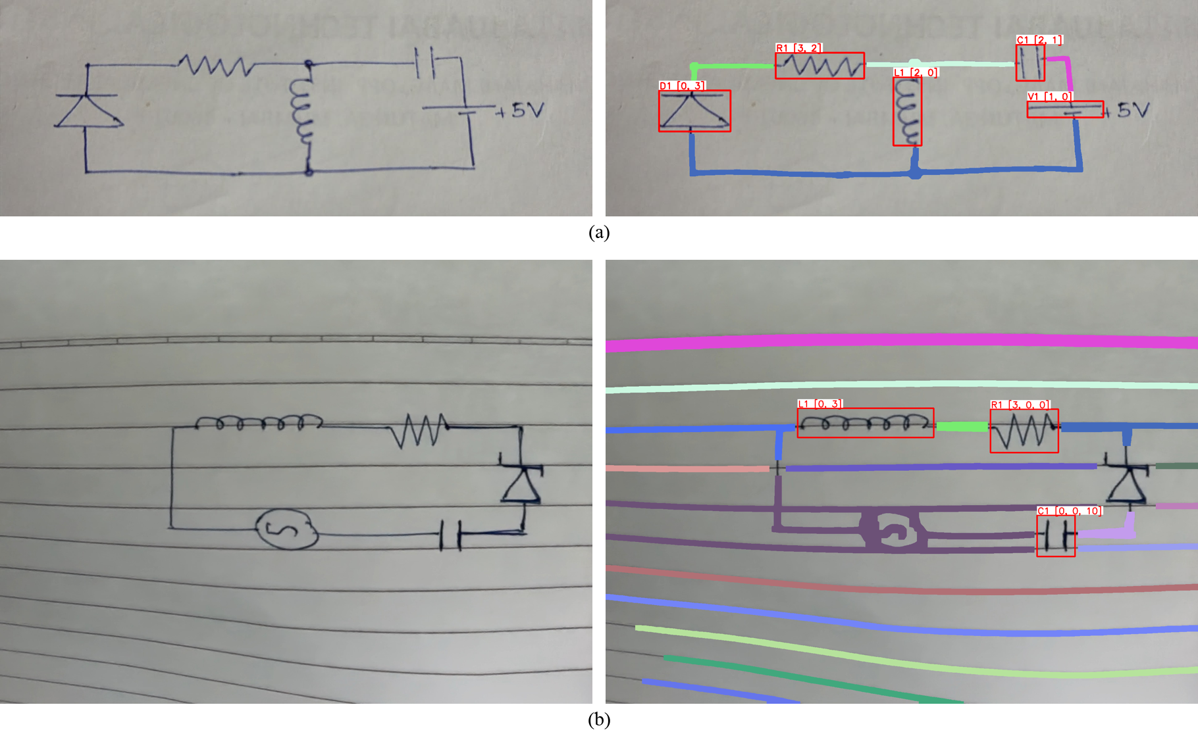
Figure 17: Real user photos processed by the application (USER INPUT): (a) plain paper, reconstructed correctly; (b) ruled paper, where the ruling is traced as wires
Testing changed the application. Reports now state everything that was assumed or uncertain: each part's detection confidence, parts left out because of a wrong number of wire ends, default values, an automatically chosen ground, and a symbol detected under two labels. Text input reports a missing source or value instead of silently inventing one, and spelled-out units such as "2 megohms" are read correctly (they had been read as 2 Ω). The resulting advice for users is to draw in dark pen on plain or grid paper, with batteries rather than AC sources and with values written clearly beside each part.

6.5 Wire Tracing on Synthetic Photos (SYNTHETIC)
With ground-truth boxes, the tracer recovered the exact terminal-to-net partition in 99.4% of 165 trials (5 circuits × 11 conditions × 3 seeds) (Figure 18). The last five conditions were added after the first six passed, and the method was not tuned to them. The only failure occurred under a simulated detector box error of 15%: on one of three seeds of the crossover circuit, a shifted crossover box no longer covered the crossing, so two crossing wires were joined.
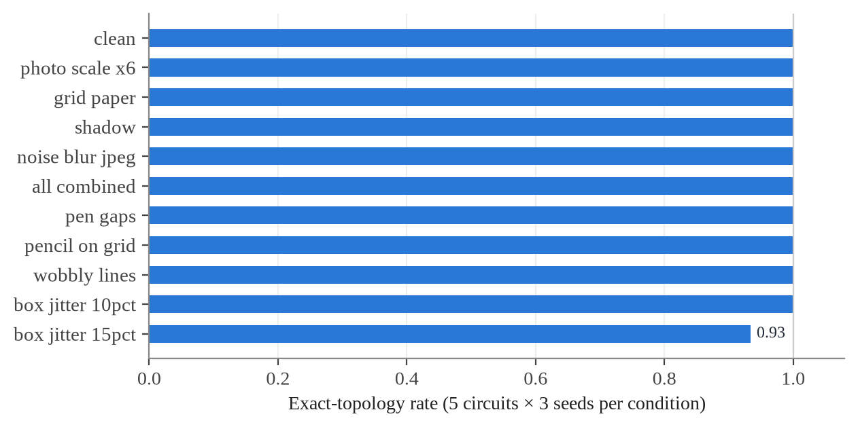
Figure 18: Exact-topology rate per photo condition (SYNTHETIC, ground-truth boxes)

6.6 End-to-End Reconstruction against Reference Netlists (SYNTHETIC)
The full evaluation harness was run on CGHD-format synthetic data with reference netlists (Table 14). With ground-truth boxes, every circuit matched its reference exactly, including the simulated operating point. To exercise detector mode, a YOLOv8s model was trained for 40 CPU epochs on synthetic drafters (not the baseline configuration) and run on synthetic test drafter 12.
Table 14: End-to-end results on CGHD-format synthetic data (SYNTHETIC)
Mode | Images | Valid | Simulates | Topology match | Exact match | Op-point match
GT boxes (drafters 10–12) | 18 | 18/18 | 18/18 | 18/18 | 18/18 | 18/18
GT boxes (drafter 12) | 6 | 6/6 | 6/6 | 6/6 | 6/6 | 6/6
Detector boxes (drafter 12) | 6 | 6/6 | 5/6 | 5/6 | 4/6 | 4/6

Both detector-mode failures are easy to explain. In one bridge circuit the graph was right, but the middle resistor came out as 1k instead of the drawn 10k, so the topology matched while the exact and operating-point comparisons failed. In the crossover circuit the detector missed both crossover symbols (Figure 19), so the two independent loops were merged into one net and the netlist did not produce an operating point. This is a single synthetic example, but it shows the failure we most expect on real photos: a missed crossover symbol breaks the topology even when every component is found. It also shows that the evaluation separates a detection error from a reconstruction error, as intended.
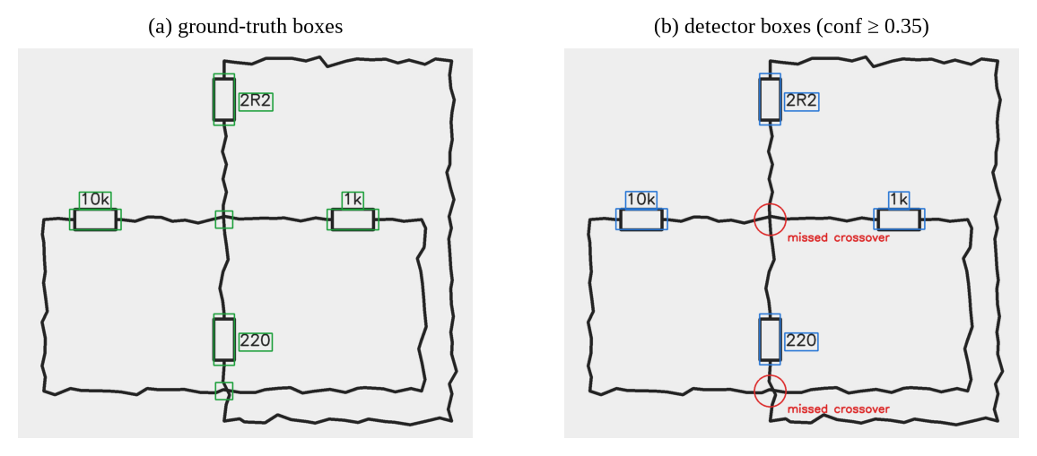
Figure 19: Detector-mode failure on a synthetic crossover circuit: both crossover symbols are missed, merging two independent loops

6.7 OCR and Orientation (SYNTHETIC)
On synthetic value labels, EasyOCR reached 0.914 exact match and 0.950 character accuracy over 70 labels (drafters 10–12), and 0.958 / 0.990 over the 24 labels of drafter 12. The HOG + SVM orientation classifier was correct on 5 of 5 polarised symbols of held-out synthetic drafter 12 (drafters 10 and 11 were in its training data and are not counted). Real OCR and orientation results are in Section 6.3.3.

6.8 Text-to-Netlist Results (HAND-WRITTEN)
Table 15: Text-to-netlist results on hand-written evaluation sets
Set | Sent. | Token acc. | Macro F1 | Exact circuit | Component F1 | Valid netlist
30-sentence set, before NLP changes | 30 | 0.986 | 0.975 | 0.800 | 0.965 | 1.000
30-sentence set, after changes (optimistic) | 30 | 0.995 | 0.980 | 1.000 | 1.000 | 1.000
Fresh 20-sentence set, evaluated once | 20 | 1.000 | 1.000 | 0.900 | 0.972 | 1.000
Teammate 20-sentence set, evaluated once | 20 | 0.994 | 0.990 | 0.750 | 0.986 | 1.000

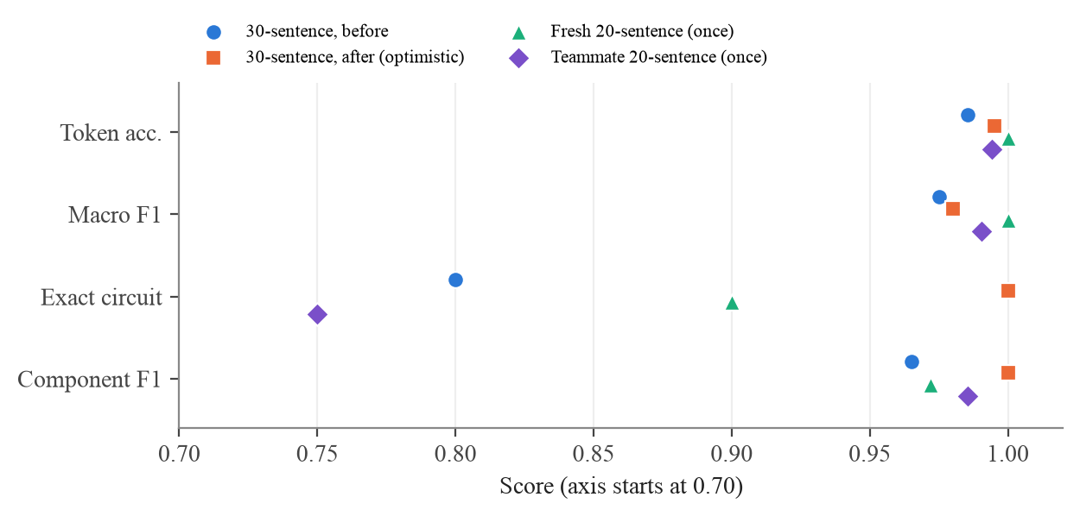
Figure 20: Text-to-netlist scores on the four evaluation runs (HAND-WRITTEN)
The 30-sentence set was frozen before any NLP change, but development then targeted the error categories its baseline exposed, so its after-score is optimistic. The fresh set, written after development and evaluated once, gives 90% exact circuit match, with every generated netlist valid.
The teammate's set is the most independent test, because its author had not seen the parser: 75% exact circuit match, still with every netlist valid and component F1 0.986. All five failures come from how a sentence arranges the parts, not from unknown words or values (the evaluator files them as two tagging, one structure and two component errors): "across both of them" meaning parallel, a physical order given with "through", a parallel group placed before "connected in series with", and two parts attached "across" a single earlier part. The two independent sets together suggest that the parser handles vocabulary and values well but only the common sentence structures.
On the synthetic corpus, the tagger reaches 1.000 token accuracy on held-out sentences from the training templates, but 0.897 on phrasings never used in training (exact circuit 0.980), showing that the semantic constraints recover much of what the tagger misses.
Table 16: Failures on the fresh 20-sentence set
Sentence | Expected | Produced | Cause
a 9 volt battery with a 330R resistor and an LED in series | S(resistor 330, diode) | S(resistor default, diode) | Trailing-R ohm notation "330R" not parsed as a value (fixed later)
a pair of 10k resistors in parallel | P(resistor 10k, resistor 10k) | single resistor 10k | Count phrase "a pair of" not in the count lexicon (fixed later)

Both failures were lexical gaps, and both were fixed afterwards. The "330R" fix also applies to the image path, where a handwritten "330R" label had been ignored. Re-running every set after these fixes gives 1.000 exact circuit match on the fresh set, but that figure is optimistic because the fixes target exactly its two failures, so the once-evaluated 0.900 remains the reported result. The other sets are unchanged (30-sentence set 1.000; the teammate's set 0.750 with identical output). The re-run also corrected the error categories of the teammate's set: a final full stop, which the tokenizer drops by design, had made every failure count as a tokenisation error; the five failures are now classified as two tagging, one structure and two component errors, with the scores unchanged.

6.9 Comparison with Baselines
- Internal baselines. Before the scale-adaptive tracer, the tracer tuned on small drawings recovered 0 of 30 synthetic circuits even on clean images; after the changes it recovers 99.4% across eleven conditions. The text path improved from 0.800 to 1.000 exact match on its development set (optimistic), and scores 0.900 on fresh data.
- Oracle vs detector. On synthetic test data, operating-point match falls from 6/6 with ground-truth boxes to 4/6 with detector boxes, which isolates the cost of detection errors.
- Published work. Published CGHD results (e.g. 52% mAP on the first release [3]; 18% mAP on drafters 21–22 of a later release [11]) use different releases, splits and detectors, and a YOLOv5 result of 98.2% mAP@0.5 [14] uses a different dataset. Our detector reaches 0.904 mAP@0.5 on drafter 12 of release 14; this is not directly comparable with those figures, because the release, the test drafters and the class set differ.

6.10 Defects Found during Development
Most of the serious bugs were not found by unit tests. They appeared when we ran the code on data in the real format or compared its output with reference netlists (Table 17). Three examples show how this went. Our parser first read each symbol's rotation from the <object> element; a real annotation file showed that it is nested inside <bndbox>, so every rotation would have been read as missing and the orientation classifier would have had no labels. Our first wire tracer, tuned on small test drawings, got 0 of 30 synthetic circuits right even on clean images, because at phone-photo resolution pieces of each symbol's outline stuck out of its box and were counted as extra wires. And on the first Colab run the orientation stage crashed with cv2.HOGDescriptor missing, because several OpenCV packages had overwritten the same folder. Each code fix is covered by a regression test; the two installation fixes are checked by scripts/check_opencv.py before every GPU step.
Table 17: Defects found during development and their fixes
Failure | Found by | Cause | Fix
Every CGHD rotation read as missing | A real annotation file | Rotation is nested inside bndbox | Parser reads both levels
0/30 synthetic circuits correct, even clean | Topology benchmark | Outline slivers read as terminals; pixel sizes tuned for small drawings | Sliver rejection; sizes scale with symbol size
Grid paper merges all nets | Topology benchmark | Adaptive threshold keeps grid lines | Paper-relative contrast + Otsu
Wires split at junction dots | End-to-end run vs references | Closing window smaller than a filled dot | Window = 1/15 of the image side
"No ground node" on drawings without a ground symbol | End-to-end run | Ground assumed to be drawn | Implicit ground rule, recorded in the netlist
Out-of-scope symbols short wires | Real annotations | Lamps and switches not masked | Masked as class "other"
Colab run failed: cv2.HOGDescriptor missing | First Colab run | Several OpenCV builds overwrite one folder | Pin exactly one OpenCV build
voltage.dc polarity reversed | Gate 1 rotation sheets | This label uses + on top at 0°, unlike every other polarised symbol | Add 270° when reading voltage.dc
5,321 training boxes dropped, others misplaced | Gate 2 label overlays | Placeholder XML size (1000×1000) in drafters −1, 29, 30 | Take the size from the image
Base install broke orientation | Teammate's reproduction | OpenCV 5 has no cv2.HOGDescriptor | Cap OpenCV below 5
Handwritten "330R" values ignored | Fresh NLP test set | Trailing-R ohm notation not parsed (text and image path) | Parse it as a resistor value
"2 megohms" read as 2 Ω plus a phantom capacitor | User text testing | Spelled-out multiplier unknown to the tagger | Normalise megohm/kilohm before tagging
Missing source or values filled in silently | User text testing | Defaults applied without notice | Every assumption reported to the user
One wire split in two on a user photo | User photo testing | Faint pen stroke wider than the gap-closing distance | Close gaps along straight lines only
Wrong netlists shown without any warning | Real test drafter | Battery boxed as two classes; parts dropped silently | Application reports confidences, dropped parts and double labels

6.11 Limitations and Observed Errors
- Batteries are the weak point. The voltage source has the lowest detection AP (0.48), is often boxed also as a capacitor, and causes half of the parts dropped by wire tracing.
- Handwritten values are barely tested. The test drafter has only 4 value labels; OCR reads printed-style digits but misreads some handwritten signs ("+5V" as "45V").
- Drawing style matters. Ruled notebook paper, scanned figures and unusually large or outlined symbols fall outside the training distribution and fail.
- Real topology rests on 12 references. CGHD has no circuit graphs; the 12 hand-checked drafter-12 netlists cover the in-scope drawings, and only C137 can be simulated. Elsewhere, only proxies are available.
- Synthetic drawings are cleaner than real ones: five circuit types, simple symbols, machine-drawn text.
- Crossovers are fragile. A missed or badly placed crossover box merges two nets (Section 6.6).
- Polarity rests on few test examples. The rotation convention is fixed at Gate 1, but test drafter 12 has only 32 voltage sources and 40 diodes, and no ground symbols; mirrored symbols are excluded.
- Limited scope: two-terminal elements, DC operating point, series-parallel text only.
- Small evaluation sets: 20–30 hand-written sentences, 6–18 synthetic test images.

6.12 Ethical and Privacy Considerations
- Licence. CGHD is used under CC BY 3.0, credited, and not redistributed.
- Privacy. Processing is local; with phone upload, photos travel only over the local Wi-Fi to the laptop, and they leave the network only if Gradio's public share link is enabled. Handwriting is weakly personal, so photos should not be shared without the drafter's consent.
- Over-trust. A valid, simulating netlist can still be the wrong circuit; a person should review it before any safety-relevant use.
- Honest reporting. Real, synthetic, hand-written and user-input results are labelled separately; numbers measured after seeing the test results are reported as such and not as the baseline.

Chapter 7: Conclusion and Future Scope

7.1 Summary of the Work
We built a system that turns a photo of a hand-drawn circuit, or a sentence describing one, into a SPICE netlist, checks it with a context-free grammar and an Earley recogniser, and simulates it in ngspice. The learned parts (YOLOv8s detection, HOG + SVM orientation, EasyOCR and the HMM tagger) are kept to the places where rules do not work; the rest (binarisation, wire tracing, netlist generation and validation) is deterministic and covered by regression tests. Much of the effort went into evaluation: running every stage with ground-truth and detector boxes, scoring netlists against reference circuits rather than only checking that they parse, and keeping synthetic, hand-written and real results apart.

7.2 Objectives Achieved
Table 18: Status of the objectives
Objective | Status
1. YOLOv8s detector on real CGHD | Achieved: 0.904 mAP@0.5 and 0.611 mAP@0.5:0.95 on the unseen test drafter; voltage sources weakest
2. Polarity from orientation | Achieved: 0.906 (voltage sources) and 0.775 (diodes) on real test crops; 0.833 in the pipeline with GT boxes
3. Robust wire tracing | Achieved on synthetic data: 99.4% exact topology over 11 conditions
4. Value reading and attachment | Partly achieved: 0.914–0.958 exact on synthetic labels; handwritten values barely present in the real test set
5. Netlist, validation, simulation | Achieved on synthetic data (18/18); on real analog photos 37.5% correct circuits with GT boxes, 10.4% with the detector
6. Text-to-netlist | Achieved: 0.90 and 0.75 exact circuit match on two independent hand-written sets
7. Stage-wise, labelled evaluation | Achieved: harness, gates, evidence bundle and tables generated from artefacts

7.3 Key Findings
- Measuring ink contrast relative to the local paper, instead of thresholding brightness, is what made grid paper and shadows work.
- Every size in the wire tracer must scale with the drawing; parameters tuned on small drawings failed completely on phone-photo resolutions.
- Testing against the real annotation format and against reference netlists found defects that unit tests did not, including one that would have silently invalidated all orientation results.
- Crossover detection is critical: missing one merges two nets, even when every other symbol is detected correctly.
- A netlist that parses is not necessarily the right circuit; graph isomorphism and simulated operating points are the meaningful checks. On real photos the detector's netlists were more often valid but far less often correct than the ground-truth ones.
- On real photos the detector is no longer the main bottleneck (0.904 mAP@0.5); turning detections into the right circuit is, especially at battery terminals and faint wires.
- Testing with real user input found problems that no benchmark showed, such as silently assumed values and units read wrongly, and made the application state its uncertainty instead of presenting a guess as certain.

7.4 Current Limitations
On real photos the detector is accurate, but complete circuits are reconstructed correctly for only 37.5% of the analog test photos with perfect boxes and 10.4% with detected boxes. Batteries, faint wires and handwritten labels cause most failures, and drawings unlike the training data (ruled paper, scanned figures) fail. Real topology is scored on only 12 reference drawings; the scope is limited to two-terminal elements and DC analysis; and the text path handles only series-parallel descriptions and misses some common sentence structures.

7.5 Future Improvements
- Fix battery terminals: detect the two terminals as keypoints, or treat the plates as part of the symbol, since batteries cause half of the dropped parts.
- Retrain with more varied data (ruled paper, scans, more battery and diode styles) and an AC-source class.
- Extend the reference netlists beyond the 12 drafter-12 drawings, so real topology is measured on more than a handful of circuits.
- Add a second run with the split used in the literature (test drafters 23–24) for comparability.
- Detect terminals as keypoints to support transistors and op-amps, and add AC sources with transient simulation.
- Improve crossover handling with local line-direction analysis at wire crossings.
- Extend the text path to the sentence structures it still misses ("across both of them", "through", a parallel group before "in series with"), add named nodes for circuits that are not series-parallel, and write a larger hand-written test set.

References
[1] L. W. Nagel and D. O. Pederson, "SPICE (Simulation Program with Integrated Circuit Emphasis)," Memo. ERL-M382, Electronics Research Laboratory, University of California, Berkeley, 1973.
[2] J. Redmon, S. Divvala, R. Girshick and A. Farhadi, "You only look once: Unified, real-time object detection," in Proc. IEEE Conf. Computer Vision and Pattern Recognition (CVPR), 2016, pp. 779–788.
[3] F. Thoma, J. Bayer, Y. Li and A. Dengel, "A public ground-truth dataset for handwritten circuit diagram images," in Proc. Int. Conf. Document Analysis and Recognition (ICDAR) Workshops, Springer, 2021, pp. 20–27.
[4] P. Kumar and P. Shinde, "CircuitVision" source code, experiment notebook and result files. [Online]. Available: https://github.com/sudo-pranshu/CircuitVision
[5] B. Edwards and V. Chandran, "Machine recognition of hand-drawn circuit diagrams," in Proc. IEEE Int. Conf. Acoustics, Speech and Signal Processing (ICASSP), 2000.
[6] M. Moetesum, S. W. Younus, M. A. Warsi and I. Siddiqi, "Segmentation and recognition of electronic components in hand-drawn circuit diagrams," EAI Endorsed Trans. Scalable Information Systems, vol. 5, no. 16, pp. 1–5, Apr. 2018, doi: 10.4108/eai.13-4-2018.154478.
[7] N. Dalal and B. Triggs, "Histograms of oriented gradients for human detection," in Proc. IEEE CVPR, 2005, pp. 886–893.
[8] C. Cortes and V. Vapnik, "Support-vector networks," Machine Learning, vol. 20, no. 3, pp. 273–297, 1995.
[9] M. D. Patare and M. S. Joshi, "Hand-drawn digital logic circuit component recognition using SVM," Int. J. Computer Applications, 2016.
[10] J. Bayer, A. K. Roy and A. Dengel, "Instance segmentation based graph extraction for handwritten circuit diagram images," in Proc. 12th Int. Conf. Pattern Recognition Applications and Methods (ICPRAM), 2023. arXiv:2301.03155.
[11] J. Bayer, L. van Waveren and A. Dengel, "Modular graph extraction for handwritten circuit diagram images," arXiv:2402.11093, 2024.
[12] CGHD dataset, Zenodo, record 17469897 (version 16), 2025.
[13] J. Bayer et al., "CGHD: Circuit Graph Hand-Drawn dataset," Zenodo, record 14042961 (version 14), file cghd-zenodo-14.zip, MD5 ab1cde6feb5edaafbde711cd2059a2f4. Licence CC BY 3.0.
[14] R. R. Reddy and M. R. Panicker, "Hand-drawn electrical circuit recognition using object detection and node recognition," arXiv:2106.11559, 2021.
[15] L. R. Rabiner, "A tutorial on hidden Markov models and selected applications in speech recognition," Proc. IEEE, vol. 77, no. 2, pp. 257–286, 1989.
[16] A. J. Viterbi, "Error bounds for convolutional codes and an asymptotically optimum decoding algorithm," IEEE Trans. Information Theory, vol. 13, no. 2, pp. 260–269, 1967.
[17] D. Jurafsky and J. H. Martin, Speech and Language Processing, 3rd ed. draft, 2024. [Online]. Available: https://web.stanford.edu/~jurafsky/slp3/
[18] J. Earley, "An efficient context-free parsing algorithm," Communications of the ACM, vol. 13, no. 2, pp. 94–102, 1970.
[19] G. Jocher, A. Chaurasia and J. Qiu, "Ultralytics YOLO," version 8.4.184, 2023–2026. [Online]. Available: https://github.com/ultralytics/ultralytics
[20] T.-Y. Lin et al., "Microsoft COCO: Common objects in context," in Proc. European Conf. Computer Vision (ECCV), 2014, pp. 740–755.
[21] N. Otsu, "A threshold selection method from gray-level histograms," IEEE Trans. Systems, Man, and Cybernetics, vol. 9, no. 1, pp. 62–66, 1979.
[22] R. E. Tarjan, "Efficiency of a good but not linear set union algorithm," Journal of the ACM, vol. 22, no. 2, pp. 215–225, 1975.
[23] Y. Baek, B. Lee, D. Han, S. Yun and H. Lee, "Character region awareness for text detection," in Proc. IEEE CVPR, 2019, pp. 9365–9374.
[24] B. Shi, X. Bai and C. Yao, "An end-to-end trainable neural network for image-based sequence recognition and its application to scene text recognition," IEEE Trans. Pattern Analysis and Machine Intelligence, vol. 39, no. 11, pp. 2298–2304, 2017.
[25] JaidedAI, "EasyOCR," version 1.7.2. [Online]. Available: https://github.com/JaidedAI/EasyOCR
[26] G. Bradski, "The OpenCV library," Dr. Dobb's Journal of Software Tools, 2000.
[27] H. Vogt, G. Atkinson and P. Nenzi, Ngspice User's Manual, version 42. [Online]. Available: https://ngspice.sourceforge.io
[28] A. Abid et al., "Gradio: Hassle-free sharing and testing of ML models in the wild," arXiv:1906.02569, 2019.

Appendix A: Important Source Code
Only key excerpts are included; the complete, tested source code is in the project repository [4].

A.1 Paper-relative binarisation (preprocess.py)
def binarize(img, kernel=None, min_contrast=12):
gray = cv2.cvtColor(img, cv2.COLOR_BGR2GRAY) if img.ndim == 3 else img
gray = cv2.GaussianBlur(gray, (5, 5), 0)
k = kernel or max(15, (min(gray.shape[:2]) // 15) | 1)
paper = cv2.morphologyEx(gray, cv2.MORPH_CLOSE,
cv2.getStructuringElement(cv2.MORPH_RECT, (k, k)))
dark = (255.0 * cv2.subtract(paper, gray)
/ np.maximum(paper, 1)).astype(np.uint8)
cand = dark[dark > min_contrast]
thr = min_contrast
if cand.size > 100:
otsu, _ = cv2.threshold(cand.reshape(1, -1), 0, 255,
cv2.THRESH_BINARY + cv2.THRESH_OTSU)
thr = max(min_contrast, int(otsu))
mask = np.where(dark > thr, 255, 0).astype(np.uint8)
return cv2.morphologyEx(mask, cv2.MORPH_OPEN, np.ones((2, 2), np.uint8))

A.2 Viterbi decoding (nlp/hmm.py)
def tag(self, words):
obs = [self.w_index[self._norm(w)] for w in words]
n, T = len(obs), len(self.tags)
score = np.empty((n, T)); back = np.zeros((n, T), int)
score[0] = self.log_start + self.log_emit[:, obs[0]]
for i in range(1, n):
cand = score[i - 1][:, None] + self.log_trans # prev x cur
back[i] = cand.argmax(0)
score[i] = cand.max(0) + self.log_emit[:, obs[i]]
path = [int(score[-1].argmax())]
for i in range(n - 1, 0, -1):
path.append(int(back[i, path[-1]]))
return [self.tags[t] for t in reversed(path)]

A.3 Netlist grammar (grammar.py)
GRAMMAR = {
"S": [("TITLE", "EOL", "BODY", "ENDLINE"), ("TITLE", "EOL", "ENDLINE")],
"TITLE": [("comment",)],
"BODY": [("LINE",), ("LINE", "BODY")],
"LINE": [("STMT", "EOL")],
"STMT": [("R",), ("C",), ("L",), ("V",), ("D",), ("MODEL",),
("dotop",), ("comment",)],
"R": [("rname", "node", "node", "value")], # C and L likewise
"V": [("vname", "node", "node", "SRC")],
"SRC": [("value",), ("dc", "value")],
"D": [("dname", "node", "node", "ident")],
"MODEL": [("dotmodel", "ident", "ident")],
"ENDLINE": [("dotend", "EOL")],
}

Appendix B: Configuration Details
The baseline training configuration is listed in Table 5 and the class mapping in Table 4. Polarity follows the Gate 1 decision, which is also the code default (left, counter-clockwise); it can be overridden with two environment variables: CIRCUITVISION_PLUS_AT_0 (left, right, top or bottom) and CIRCUITVISION_CGHD_CLOCKWISE (0 or 1). The detector confidence used by the downstream pipeline is 0.35; the qualitative error analysis uses 0.25 at IoU 0.5.
To reproduce the real experiment: open notebooks/train_colab.ipynb in Google Colab with a T4 GPU and choose Run all. The notebook downloads CGHD release 14, verifies its MD5, audits it, stops at both gates for human approval, trains, evaluates and writes an evidence ZIP. Command-line equivalents are documented in EXPERIMENTS.md in the repository.

Appendix C: Sample Dataset Record
Excerpt from a real CGHD annotation (drafter_13/C145_D1_P1.xml, CC BY 3.0), kept in the repository as a regression-test fixture. Note that <rotation> is nested inside <bndbox>, and that the drawing contains out-of-scope symbols (lamp, switch).
<annotation>
<filename>C145_D1_P1.jpg</filename>
<size><width>1536</width><height>2049</height><depth>3</depth></size>
<object>
<name>lamp</name>
<bndbox>
<xmin>674</xmin><ymin>703</ymin><xmax>826</xmax><ymax>845</ymax>
</bndbox>
</object>
<object>
<name>voltage.battery</name>
<bndbox>
<xmin>399</xmin><ymin>897</ymin><xmax>588</xmax><ymax>967</ymax>
<rotation>269</rotation>
</bndbox>
</object>
<object>
<name>switch</name> ...
</annotation>

Appendix D: Test Cases
Table 19: Automated regression tests (139 in total)
Test file | Tests | Covers
test_topology.py | 55 | Wire tracing: scale, grid, shadow, pen gaps, faint wires, junctions, crossovers
test_cghd_format.py | 14 | Real XML, rotation, mirror, EXIF, placeholder sizes, voltage.dc, ground
test_text2netlist.py | 11 | Tagger and parser; 330R, "a pair of", megohm; reported assumptions; frozen set
test_app.py | 6 | Application reports: confidences, dropped parts, defaults, double labels, phone upload
test_compare.py | 5 | Isomorphism and operating-point comparison
test_grammar.py | 5 | Earley validator and semantic checks
test_audit_images.py | 4 | Header image sizes equal full decodes, all EXIF orientations
test_dataset.py | 4 | CGHD-to-YOLO conversion counts and labels
test_detector_eval.py | 4 | Detector evaluation harness
test_evaluate.py | 6 | Downstream harness; scoring against reference netlists
test_references.py | 13 | Every drafter-12 reference netlist passes the grammar check
test_orientation.py | 4 | Rotation convention and HOG + SVM learning
test_pipeline.py | 4 | End to end on drawn fixtures; crossovers; trailing-R values
test_simulate.py | 2 | ngspice operating point
test_colab_support.py | 2 | Training resume detection; label-check sampling

Appendix E: Gate 1 Rotation Sheets
The remaining rotation sheets produced at Gate 1 by python -m circuitvision.visualize rotation on the MD5-checked CGHD release 14 (REAL CGHD crops, CC BY 3.0). The layout is the same as in Figure 7: one row per rotation bin, eight random crops per row, and n crops in the bin. LEDs and batteries follow the diode convention. The Zener sheet also shows rows marked mirror=vertical; mirrored symbols are excluded from orientation training and scoring (Section 4.5.2). AC sources and thyrectors are outside the project's scope and are shown only because the sheet tool covers every diode.* and voltage.* label.
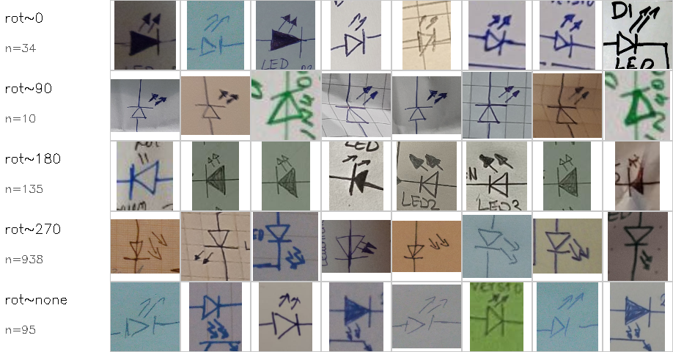
Figure 21: Rotation sheet for diode.light_emitting (LED)
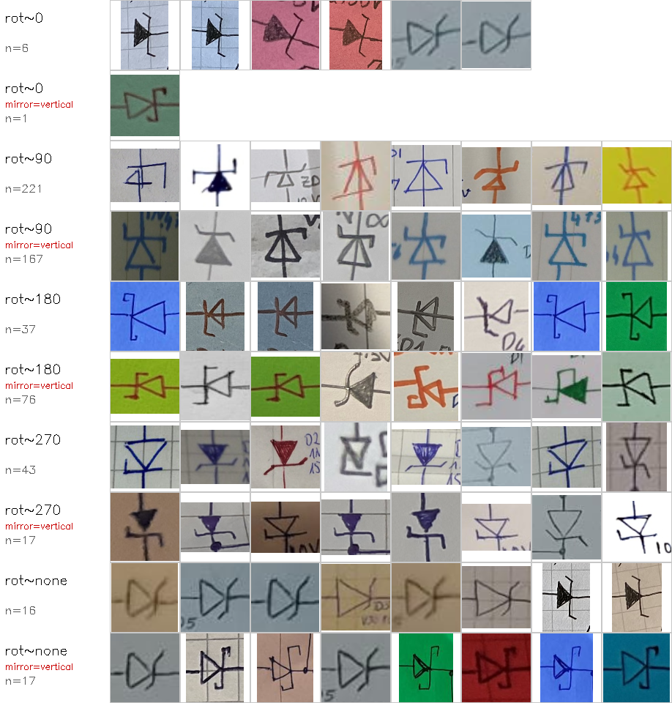
Figure 22: Rotation sheet for diode.zener, including the mirrored rows that are excluded
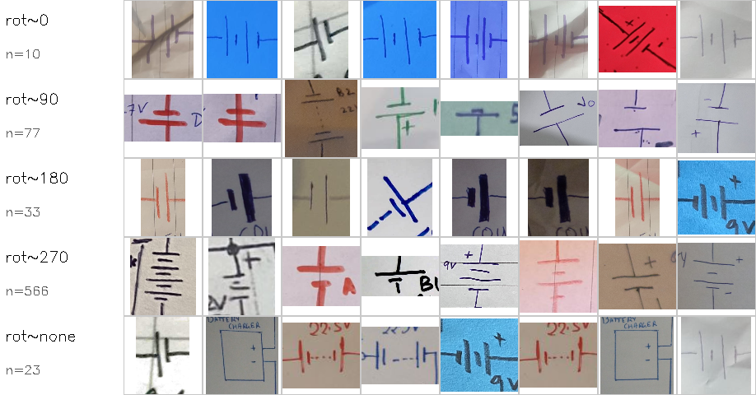
Figure 23: Rotation sheet for voltage.battery
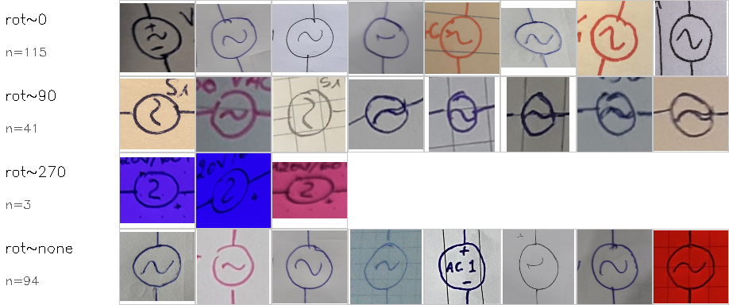
Figure 24: Rotation sheet for voltage.ac (out of scope)
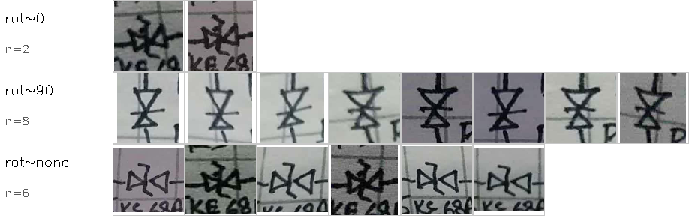
Figure 25: Rotation sheet for diode.thyrector (out of scope)

