

SA'ADU ZUNGUR UNIVERSITY, BAUCHI

FACULTY OF SCIENCE

DEPARTMENT OF MATHEMATICAL SCIENCES

COURSE:

SOFTWARE ANALYSIS AND DESIGN

SOFTWARE NAME:
SMART CAMPUS TRANSPORT MANAGEMENT SYSTEM

S/No. | Name | Matriculation Number
1 | Usman Muhammad | Basug/ug/sci/csc/22/8620
2 | Nura Lumana Yusuf | Basug/ug/sci/csc/22/6604
3 | Komo Iliya | Basug/ug/sci/csc/22/8259
4 | Yusuf Bakari Uba | Basug/ug/sci/csc/22/7281
5 | Kamal Bala | Basug/ug/sci/csc/22/4337
6 | Muhammad Hauwa Bello | Basug/ug/sci/csc/22/3838
7 | Shehu Adamu | Basug/ug/sci/csc/21/1733
8 | Sani Adamu Ameer | Basug/ug/sci/csc/22/3575
9 | Fatima Ahmad Yakubu | Basug/ug/sci/csc/22/7759
10 | Shafaatu Baba Gidado | Basug/ug/sci/csc/22/5865
11 | Khalid Faiza | Basug/ug/sci/csc/22/5219
12 | Abdurrahman Abdullahi Auwal | Basug/ug/sci/csc/22/4101
13
14
15
16
17
18
19
20

INTRODUCTION

The Smart Campus Transport Management System is a comprehensive web-based application aimed at revolutionizing intra-campus transportation in universities. It addresses the growing need for efficient, reliable, and user-centric mobility solutions on large campuses, where thousands of students, staff, and visitors move between academic buildings, hostels, libraries, and other facilities daily.

Key functionalities include:

Online ride booking for shuttle buses or shared rides.

Real-time tracking of bus locations using GPS integration.

Automated notifications (via email, SMS, or in-app push) for schedule changes, delays, arrivals, and booking confirmations.

User dashboards for students, drivers, and administrators.

The system leverages modern web technologies (e.g., React.js for frontend, Node.js/Express for backend, and databases like MongoDB or MySQL) to provide a responsive, accessible platform via browsers on desktops and mobiles. Ultimately, it promotes sustainability by reducing private vehicle usage, easing campus congestion, and enhancing safety and convenience.

BACKGROUND OF THE STUDY

Transportation on many university campuses remains outdated, relying heavily on manual scheduling, paper-based timetables, fixed routes without flexibility, and verbal announcements. This leads to widespread inefficiencies, including unpredictable bus arrivals, long waiting times at stops, overcrowded vehicles during peak hours (e.g., morning lectures or evening returns to hostels), and poor coordination between drivers and transport office staff.

In many Nigerian universities and similar institutions in developing regions, these issues are exacerbated by rapid student population growth, limited fleet sizes, traffic within campus, and lack of digital infrastructure. Studies on campus shuttles show declining ridership when services are unreliable, pushing students toward personal cars or commercial bikes (okadas), which increases congestion, pollution, and safety risks. A smart, digitized system can bridge this gap by introducing automation, data-driven decisions, and user empowerment.

PROBLEM STATEMENT

Students frequently miss classes, appointments, or exams due to unreliable bus information—such as unknown arrival times or sudden cancellations. There is no centralized, real-time platform for viewing bus locations, booking seats in advance, or receiving alerts about delays caused by traffic, breakdowns, or route changes.

Other core issues include:

Overcrowding on popular routes during peak periods.

Inefficient fuel use and route planning due to fixed schedules.

Lack of accountability for drivers (e.g., no tracking of adherence to timetables).

Manual booking or first-come-first-served systems that lead to frustration and inequity.

No data for administrators to analyze usage patterns, optimize routes, or plan fleet expansion.

Without intervention, these problems reduce academic productivity, increase stress, and discourage sustainable transport habits.

AIM AND OBJECTIVES

Aim: To design, develop, and implement a smart, web-based transport management system that enhances efficiency, accessibility, and user satisfaction in campus transportation.

Specific Objectives:

Develop a secure authentication module for different user roles (students, drivers, administrators).

Enable online seat booking with real-time availability checks to prevent overcrowding.

Integrate GPS-based real-time bus tracking with map visualization (e.g., using Google Maps API or OpenStreetMap).

Implement automated notification systems for schedules, delays, arrivals, and booking updates.

Design an admin dashboard for route management, fleet monitoring, analytics, and reporting.

Improve overall transport efficiency by reducing wait times, optimizing routes, and increasing ridership.

Ensure the system is scalable, user-friendly, and accessible on various devices.

SCOPE OF THE SYSTEM

The system focuses exclusively on intra-campus transportation within the university premises. It covers:

Users: Registered students (primary users), bus drivers, and transport administrators.

Core operations: Bus scheduling, booking, tracking, notifications, and basic reporting.

Technologies: Web platform (no native mobile app in initial phase), GPS devices on buses, cloud hosting.

Boundaries: Does not include off-campus travel, integration with public transit, payment processing (free campus service assumed), or hardware procurement (assumes buses already have GPS).

Out of scope: Inter-city transport, private vehicle management, or advanced AI for predictive routing (reserved for future phases).

LITERATURE REVIEW

Existing campus transport solutions range from basic manual systems to advanced smart platforms. Traditional shuttle services (e.g., fixed-route loops) suffer from poor reliability and lack user information, as seen in studies from universities like the University of North Dakota and Qatar University.

Modern implementations include:

GPS/IoT-based tracking systems (e.g., My Bus Tracker using Firebase and Google Maps for live locations and ETAs).

Web/mobile apps for real-time arrival displays and seat reservations.

Systems integrating RFID for attendance or cloud services for data storage.

Gaps in literature include limited user-friendly interfaces in developing regions, poor integration of booking with tracking, and minimal focus on notifications. This project builds on these by combining web accessibility, real-time features, and role-based access in a single platform.

METHODOLOGY (SDLC)

The project adopts the Software Development Life Cycle (SDLC) waterfall-agile hybrid model for structured yet flexible development.

Planning

Define project goals, scope, timeline, resources, and feasibility (technical, economic, operational). Conduct stakeholder interviews (students, drivers, admin) and risk assessment.

Requirement Analysis

Gather functional requirements (e.g., booking, tracking) and non-functional (e.g., performance, security, usability) via surveys, use cases, and interviews. Prioritize features using MoSCoW method.

System Design

Create high-level architecture (client-server), detailed UML diagrams (use case, class, sequence), database schema (ER diagram), and UI wireframes. Decide on tech stack (e.g., HTML/CSS/JS frontend, backend with API, GPS API integration).

Implementation

Code development in phases: authentication → booking → tracking → notifications → admin panel. Use version control (Git) and agile sprints for iterative builds.

Testing

Unit testing (individual modules), integration testing (e.g., GPS with map), system testing, and user acceptance testing (UAT) with sample users. Include security (e.g., SQL injection) and performance tests.

Deployment

Host on a cloud server (e.g., AWS/Heroku), configure domain, set up HTTPS, and provide user training/manual.

Maintenance

Plan for bug fixes, updates (e.g., new routes), backups, and user feedback loops for continuous improvement.

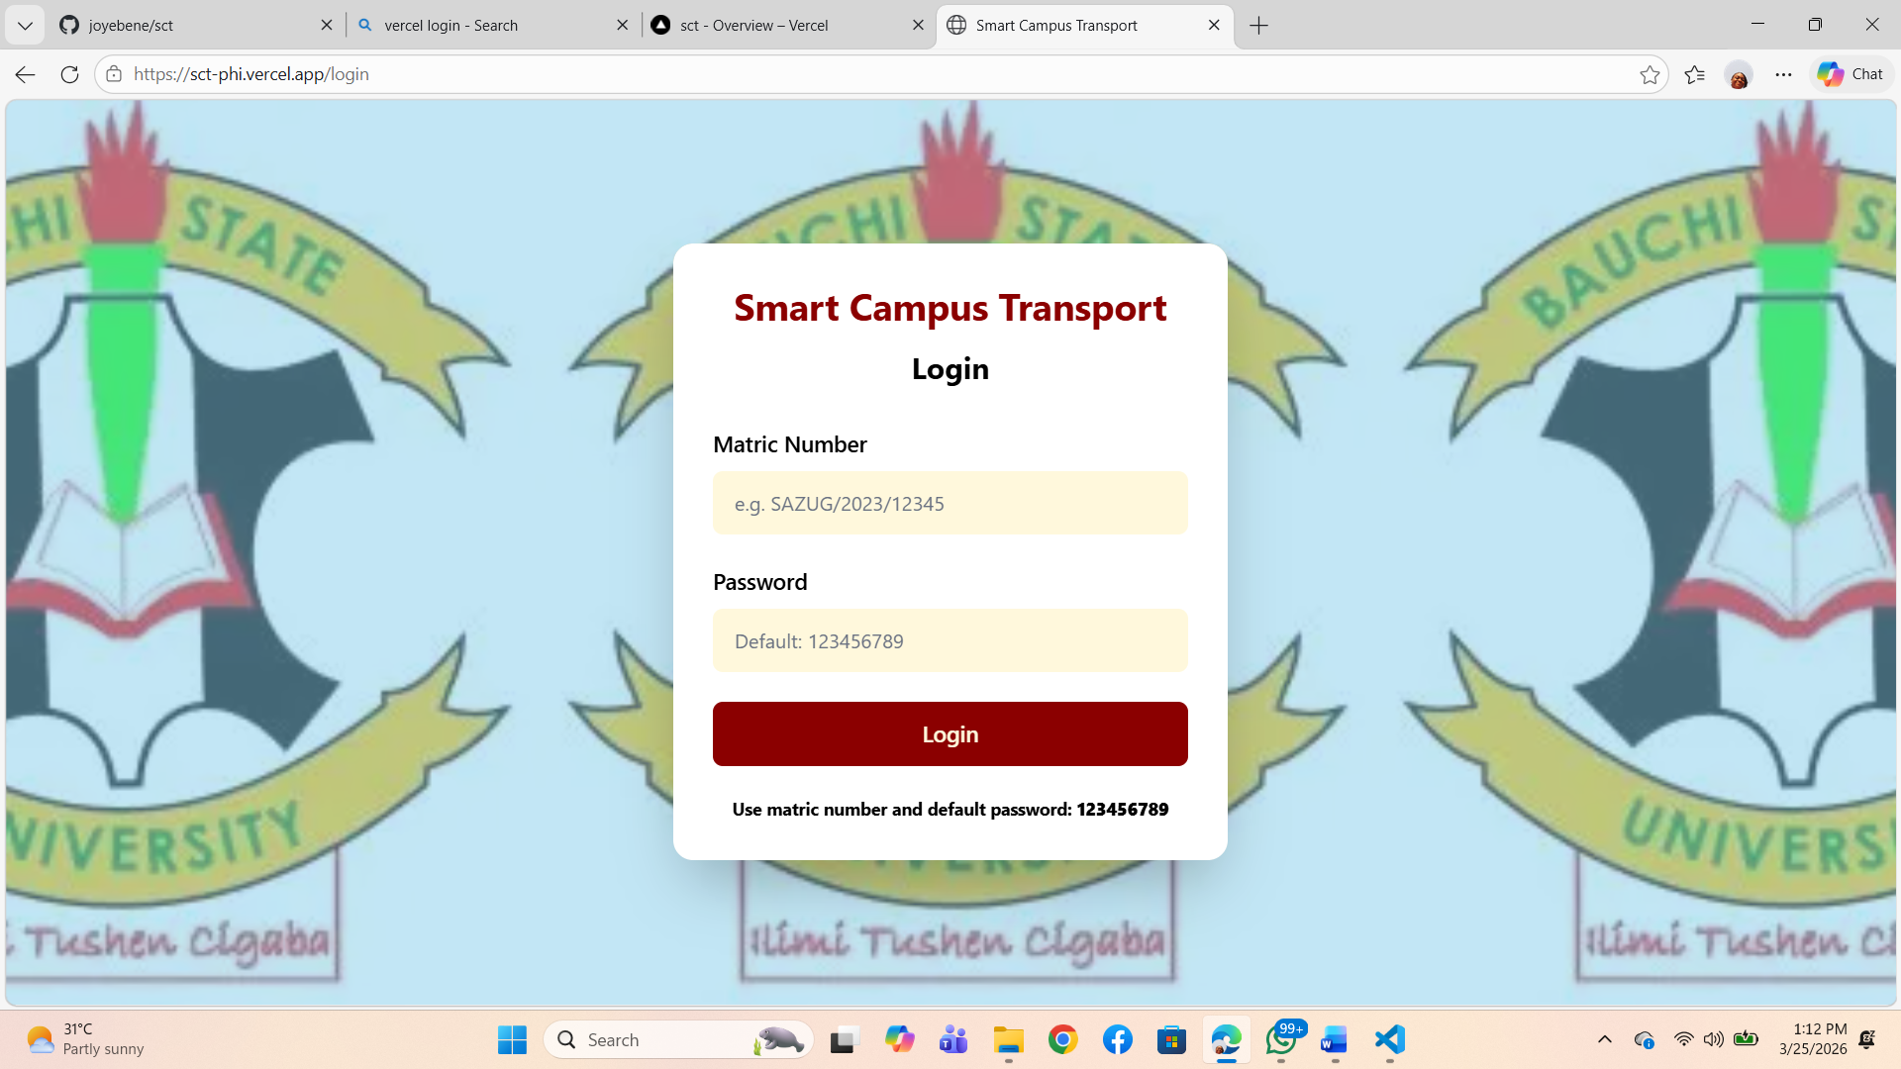

SYSTEM FEATURES

Authentication: Secure login/registration with role-based access control.

Booking: Select route/time, view availability, reserve seat, cancel if needed.

Tracking: Live map view of bus locations, ETA calculations, route paths.

Additional: Admin route/fleet management, usage analytics, feedback form.

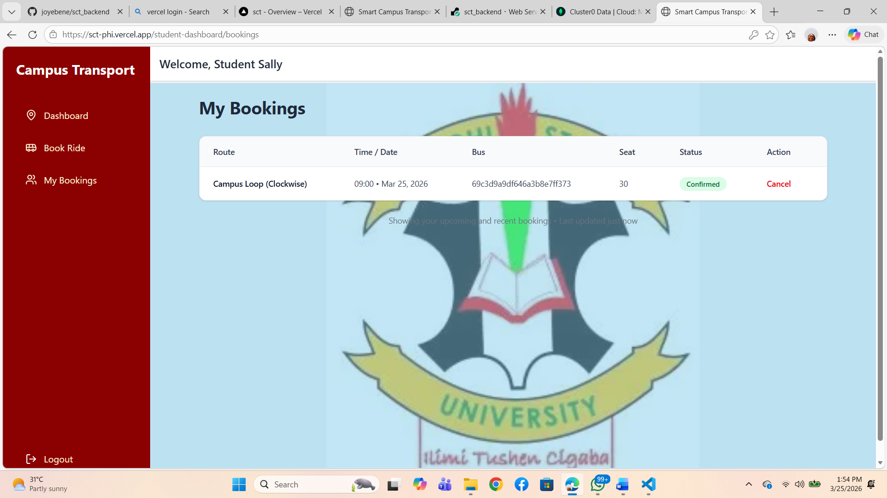
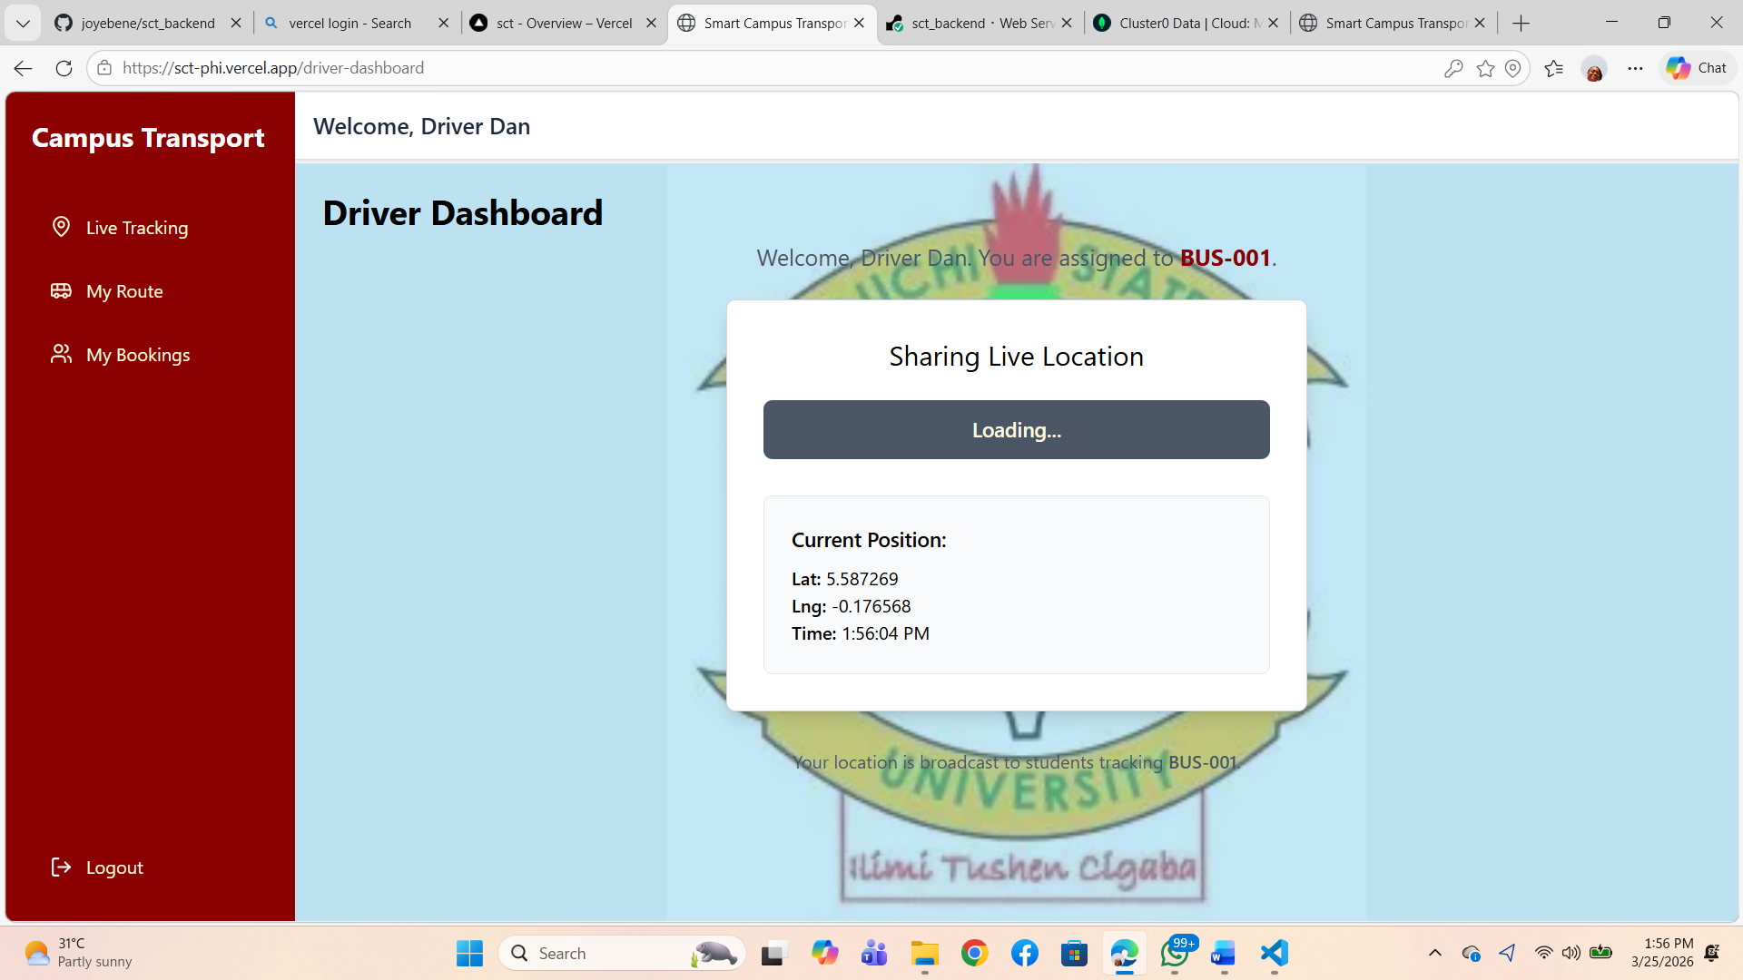

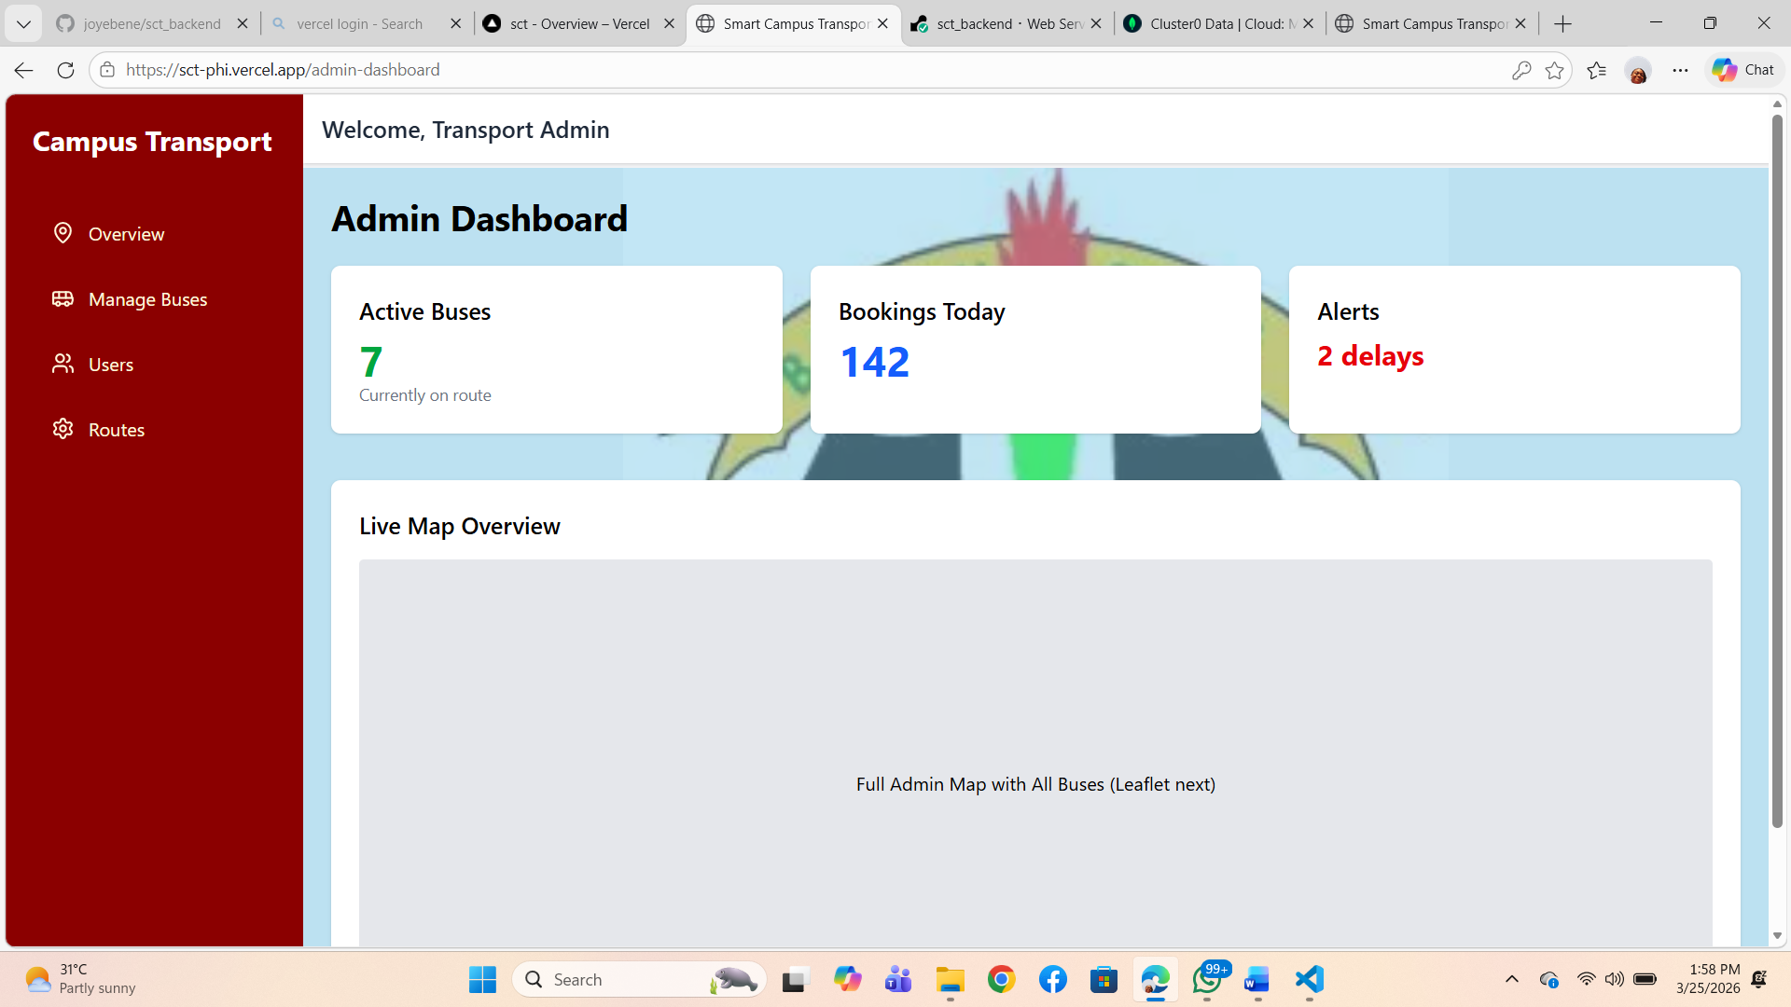

ADVANTAGES

Reduces wait times and missed rides through real-time info.

Minimizes overcrowding via advance bookings.

Enhances safety (tracking ensures accountability).

Improves efficiency (optimized routes, better resource use).

Boosts user experience and satisfaction, potentially increasing ridership.

Provides data for future planning and sustainability.

LIMITATIONS

Heavy reliance on stable internet connectivity (challenging in low-coverage campus areas).

Requires GPS hardware on buses and regular maintenance.

Potential privacy concerns with location data (mitigated by consent and anonymization).

Initial setup costs and training needs.

Limited offline functionality.

FUTURE ENHANCEMENTS

Develop a companion mobile app (Android/iOS) for better accessibility.

Integrate AI/ML for predictive ETAs, dynamic routing, or demand forecasting.

Add payment gateway for premium/future paid services.

Incorporate IoT sensors for passenger counting or fuel monitoring.

Expand to include bike-sharing, carpooling, or electric vehicle integration.

Multi-campus support or public transit linkage.

CONCLUSION

The Smart Campus Transport Management System represents a significant step toward modernizing university transportation. By addressing longstanding inefficiencies with digital tools—real-time tracking, seamless booking, and intelligent notifications—it promises safer, faster, and more reliable mobility. Successful implementation will enhance student welfare, reduce environmental impact, and serve as a model for other institutions seeking smart campus solutions.

Visit the Software: https://sct-phi.vercel.app/

Logins For Current Users:
//Drivers
matricNumber: 'DRIVER001',
matricNumber: 'DRIVER002',
matricNumber: 'DRIVER003',

// Students
matricNumber: 'SAZUG/1001'
matricNumber: 'SAZUG/1002'

// Admin
matricNumber: 'ADMIN001',

