VZW Operation Vendor Portal
Release Notes – September 9th, 2020

Contents

VZW Operation Vendor Portal Release Overview – September 9th, 2020 2
Sector Lock/unlock capability integration with Vendor Portal 3
  - Vendor initiate a lock request with radio info selected 3
  - Additional sector lock/unlock logic 4
  - Additional work types for sector lock/unlock 4
Vendor Portal Enhancement 5
  - Bulk PO dashboard: Add PSLOC ID in Bulk PO dashboard in PO table 5
  - Vendor work order: a new vendor status - Awaiting parts 6
  - VPM-network: display total # of pending work order 7
  - VPM-Network: ability to switch to a different submarket 7

VZW Operation Vendor Portal Release Overview – September 9th, 2020

What’s coming in Vendor Portal for September 2020 release?

- Sector Lock/unlock capability integration with Vendor Portal
  - Vendor initiate a lock request with radio info selected
  - Additional sector lock/unlock logic
  - Additional work types for sector lock/unlock request
- Vendor Portal enhancements
  - Bulk PO dashboard to display PSLOC ID
  - Vendor work order: a new vendor status – Awaiting parts
  - Vendor Portal mobile app: add total # of work pending work orders
  - Vendor Portal mobile app: ability to switch to a different sub market

New Features / Enhancement Details

Enhancements

Sector Lock/unlock capability integration with Vendor Portal
Section lock/unlock capability integration with Vendor Portal has been enhanced to allow the vendor to select the radio to send to IOP as part of the lock request. However the selected radio info is not used by IOP to lock until the automation process is implemented in IOP

Vendor initiate a lock request with radio info selected

After the vendor successfully log into a site for a work order with work type related to antenna/tower, a sector lock/unlock will appear
- Nokia/Samsung
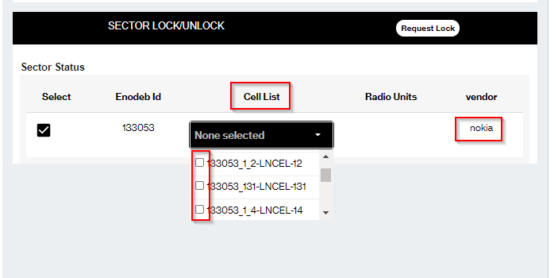
- Ericsson
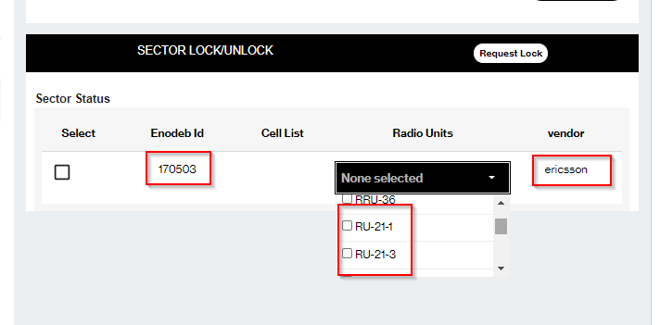

- The user can select the EnodebID and also the radio units (Ericsson) / Cell list (Nokia/Samsung)they need to lock in the initiate request (Note: the selection is not being shown in the current release. It will be implemented later in a future release with the automation process)
- If the user wants to add additional radio unit or cell to be locked, it will be added through the notes for now

Additional sector lock/unlock logic
- When a lock request is handed off at the end of the day, another work order for the same site should be able to create a new lock request on the next day
- When a lock request is handed off at the end of the day, the same work order if not completed should be able to create a new lock request on the next day
- When a lock request is still in New/In Progress status, the same lock_request_id should be used on the next day to retain the history of the communication

Additional work types for sector lock/unlock
The following work types have been enabled for lock/unlock request
- PIM/VSWR Problem
- RET/TMA
- RRU RILink
- RMA

Vendor Portal Enhancement

Bulk PO dashboard: Add PSLOC ID in Bulk PO dashboard in PO table
Cell site Peoplesoft Location ID has been added to all screens in bulk PO management screens
- Dashboard screen
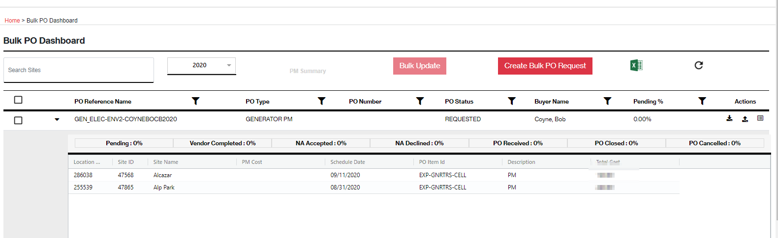
- Bulk update screen
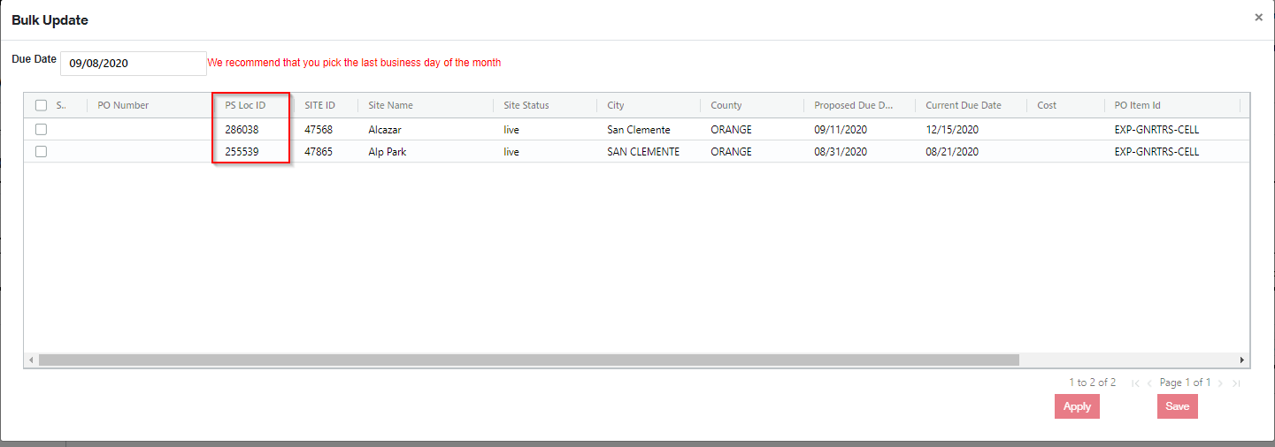
- Create bulk PO screen
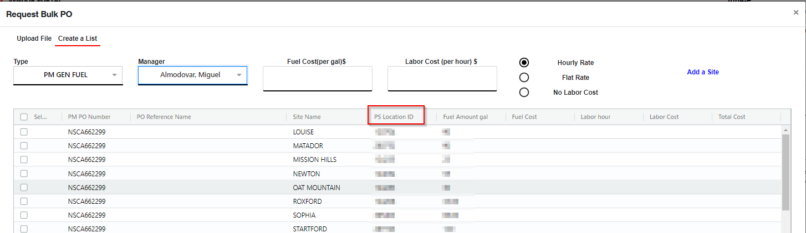

Vendor work order: a new vendor status - Awaiting parts
A new vendor status for Awaiting Parts has been added to Vendor Portal to enhance the communication between the vendor and Verizon network assurance team
The vendor user can mark the work order as Awaiting Parts in Vendor Portal.
- Vendor Portal GUI
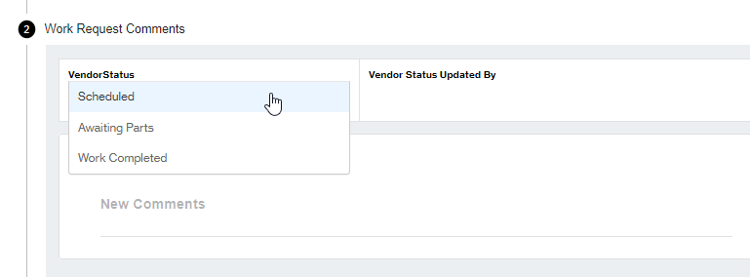
- Ops Tracker GUI
- IOP GUI
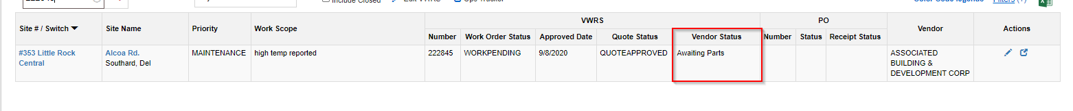

VPM-network: display total # of pending work order
The number of work orders in Work Pending bucket has been added in Vendor Portal Mobile App to provide the visibility of the pending work load for the vendor

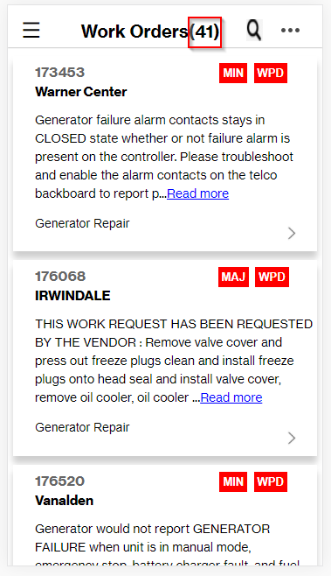

VPM-Network: ability to switch to a different submarket
Some vendors have presence in multiple sub markets in Verizon performing different functions based on the contract. The ability for the vendor to build their work force in one submarket with the ability to switch to different sub market based on the vendor profile in Ops Tracker has been added in Vendor Portal Mobile app.
- “Switch Market” option can be accessed from the three dots in Work Order Screen
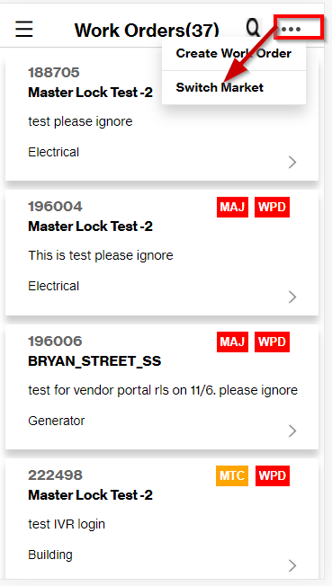
- Switch Market screen will appear upon clicking. The following info is shown in the screen
- The submarket where the vendor is built in
- Red asterisk indicates where the user’s profile is built
- The vendor category is shown after the sub market to provide visibility on what function the vendor provides
- The landing page of the vendor portal mobile app is re-loaded based on the vendor category
