AIM FINAL CAPSTONE
Predicting Student Dropout Risk
An end-to-end, reproducible machine learning project for early student support

4,424  STUDENTS | 0.23  ALERT THRESHOLD | 83.8%  DROPOUT RECALL | 72.9%  TOP-30% CAPTURE

Decision recommendation
Use the model only in a controlled, non-punitive support pilot with human review, correction and appeal routes, calibration checks, and subgroup monitoring. Do not use it for automated adverse decisions.

Prepared for AIM | September 2026

Executive summary
This capstone develops a reproducible early-warning model that ranks university students by the probability of dropping out after first-semester results become available. The intended decision is narrowly defined: help a student-support team prioritize optional outreach when support capacity is limited. The prediction is not a diagnosis, a causal explanation, or a basis for exclusion.
The project uses the public UCI Predict Students' Dropout and Academic Success dataset, containing 4,424 records from one Portuguese higher-education institution. The target has three outcomes: Graduate, Dropout, and Enrolled. Six second-semester academic fields were excluded from the end-of-first-semester prediction scope to reduce temporal leakage. Demographic fields were excluded from model inputs and retained for auditing.
A Random Forest achieved the highest dropout-focused cross-validated F2 score. Its dropout-alert threshold of 0.23 was selected from out-of-fold training predictions among thresholds that met the predefined recall and precision constraints. On the locked 885-record test set, the alert achieved 83.8% dropout recall and 62.6% dropout precision. Separately, the highest-risk 30% of students captured 207 of 284 held-out dropouts, or 72.9%, at 77.8% precision.
Success measure | Predefined target | Held-out result | Status
Dropout recall | At least 75% | 83.8% | Met
Dropout precision | At least 50% | 62.6% | Met
Top-30% dropout capture | At least 60% | 72.9% | Met

Why the 30% review scenario is used
Thirty percent is an illustrative workload scenario rather than a verified staffing limit. It is close to the source dataset's 32.1% dropout prevalence, provides a transparent comparison with random selection, and produces a list large enough to test ranking value. A real institution must replace it with documented outreach capacity before deployment.

Report map
- Problem framing and measurable success criteria
- Dataset provenance, quality, scope, and governance
- Exploratory analysis and prediction-time feature engineering
- Cross-validated modeling, held-out evaluation, and capacity analysis
- Explainability, fairness screening, limitations, and operational controls
- Reproducible open-source repository structure and execution guide

1 Problem framing and decision context

Business problem
Universities often learn about withdrawal after the opportunity for early support has narrowed. The proposed system gives student-support teams a consistent ranking after first-semester academic information becomes available. Staff can review high-risk records, verify context, and offer tutoring, counseling, financial guidance, or other support.

Machine learning task
The analytical task is supervised multiclass classification. The model estimates probabilities for Dropout, Enrolled, and Graduate. The probability of Dropout serves as the operational risk score, while the three-class output preserves the original target definition.
Design element | Project decision
Unit of analysis | One student record
Prediction point | After first-semester results, before second-semester information
Target | Dropout, Enrolled, or Graduate
Operational score | Predicted probability of Dropout
Intended user | Authorized student-support team
Allowed action | Human review and optional supportive outreach
Prohibited action | Automated exclusion, discipline, grading, aid removal, or denial of service

Predefined success criteria
Dropout recall is prioritized because a missed dropout may lose the opportunity for support. Precision remains a constraint because unnecessary outreach can create stigma, frustration, and avoidable workload. The top-30% capture measure evaluates ranking quality under an explicit planning scenario, independently of the probability threshold.
Interpretation of the numeric targets
A 75% recall target means finding at least three of every four actual dropouts. A 50% precision floor means at least one in every two alerts should correspond to an eventual dropout. A 60% top-30% capture target asks the ranking to find three in five dropouts while reviewing less than one third of students, twice the capture expected from random selection at the same capacity.

2 Dataset and data understanding

Source and selection rationale
The UCI dataset was selected because it is public, well documented, licensed for reuse under CC BY 4.0, directly aligned with student dropout prediction, and large enough for a held-out evaluation. It includes enrollment context, academic preparation, socioeconomic indicators, macroeconomic variables, first-semester performance, and the three-class student outcome. The public DOI supports traceable attribution.
Dataset characteristic | Value
Repository | UCI Machine Learning Repository
Dataset | Predict Students' Dropout and Academic Success
DOI | 10.24432/C5MC89
License | Creative Commons Attribution 4.0
Rows | 4,424 student records
Original inputs | 36 predictors
Target | Dropout, Enrolled, Graduate
Machine-readable missing values | None reported in the downloaded CSV
Exact duplicate rows | None detected

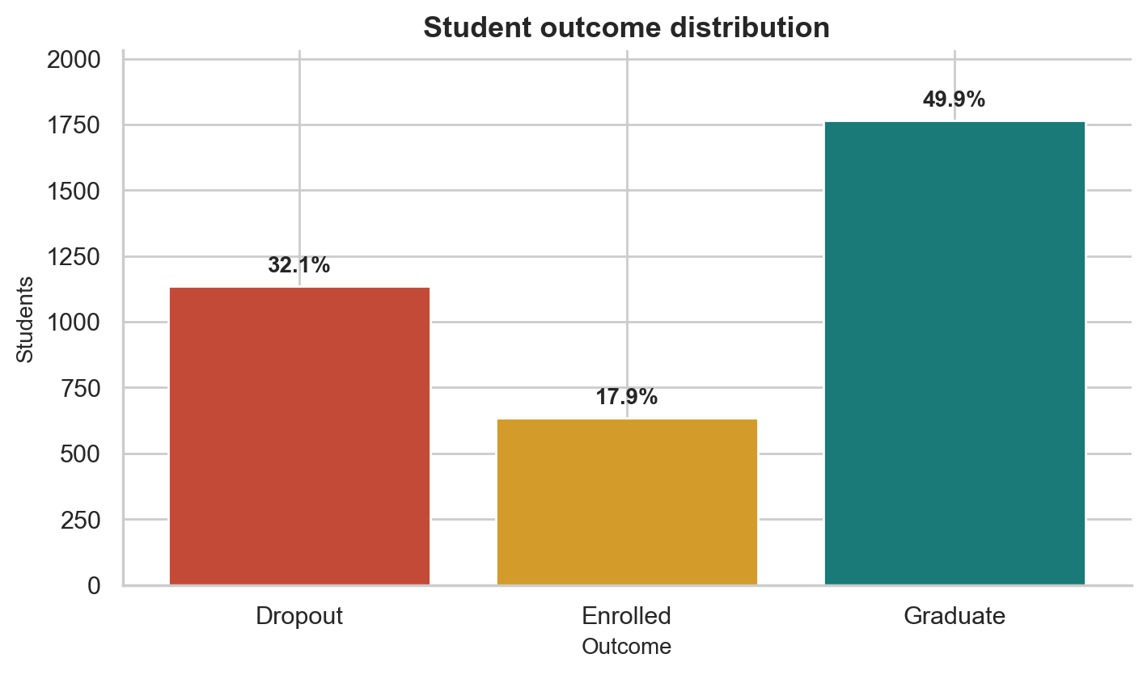
Figure 1. Outcome distribution across the full dataset. Source: UCI dataset; reproduced by the Task 3 workflow.

Quality and scope decisions
- The source spelling Nacionality was standardized to Nationality.
- Occupation code 99 was converted to an explicit Unknown or not stated category.
- Six second-semester academic variables were excluded because they would be unavailable at the stated prediction point.
- Continuous outliers were retained because they were plausible values and tree-based models are comparatively robust to them.
- The dataset was split once into 3,539 development records and 885 held-out test records using stratification and random seed 42.
Data limitation
The records come from one Portuguese institution. Performance, calibration, and fairness may change at another institution or in a later cohort. Local validation is required before student-facing use.

3 Exploratory analysis and feature engineering
Training-only exploratory analysis showed that first-semester academic progress and immediate financial indicators have the clearest descriptive relationship with dropout. These patterns guide feature construction and interpretation, but they do not establish causation.
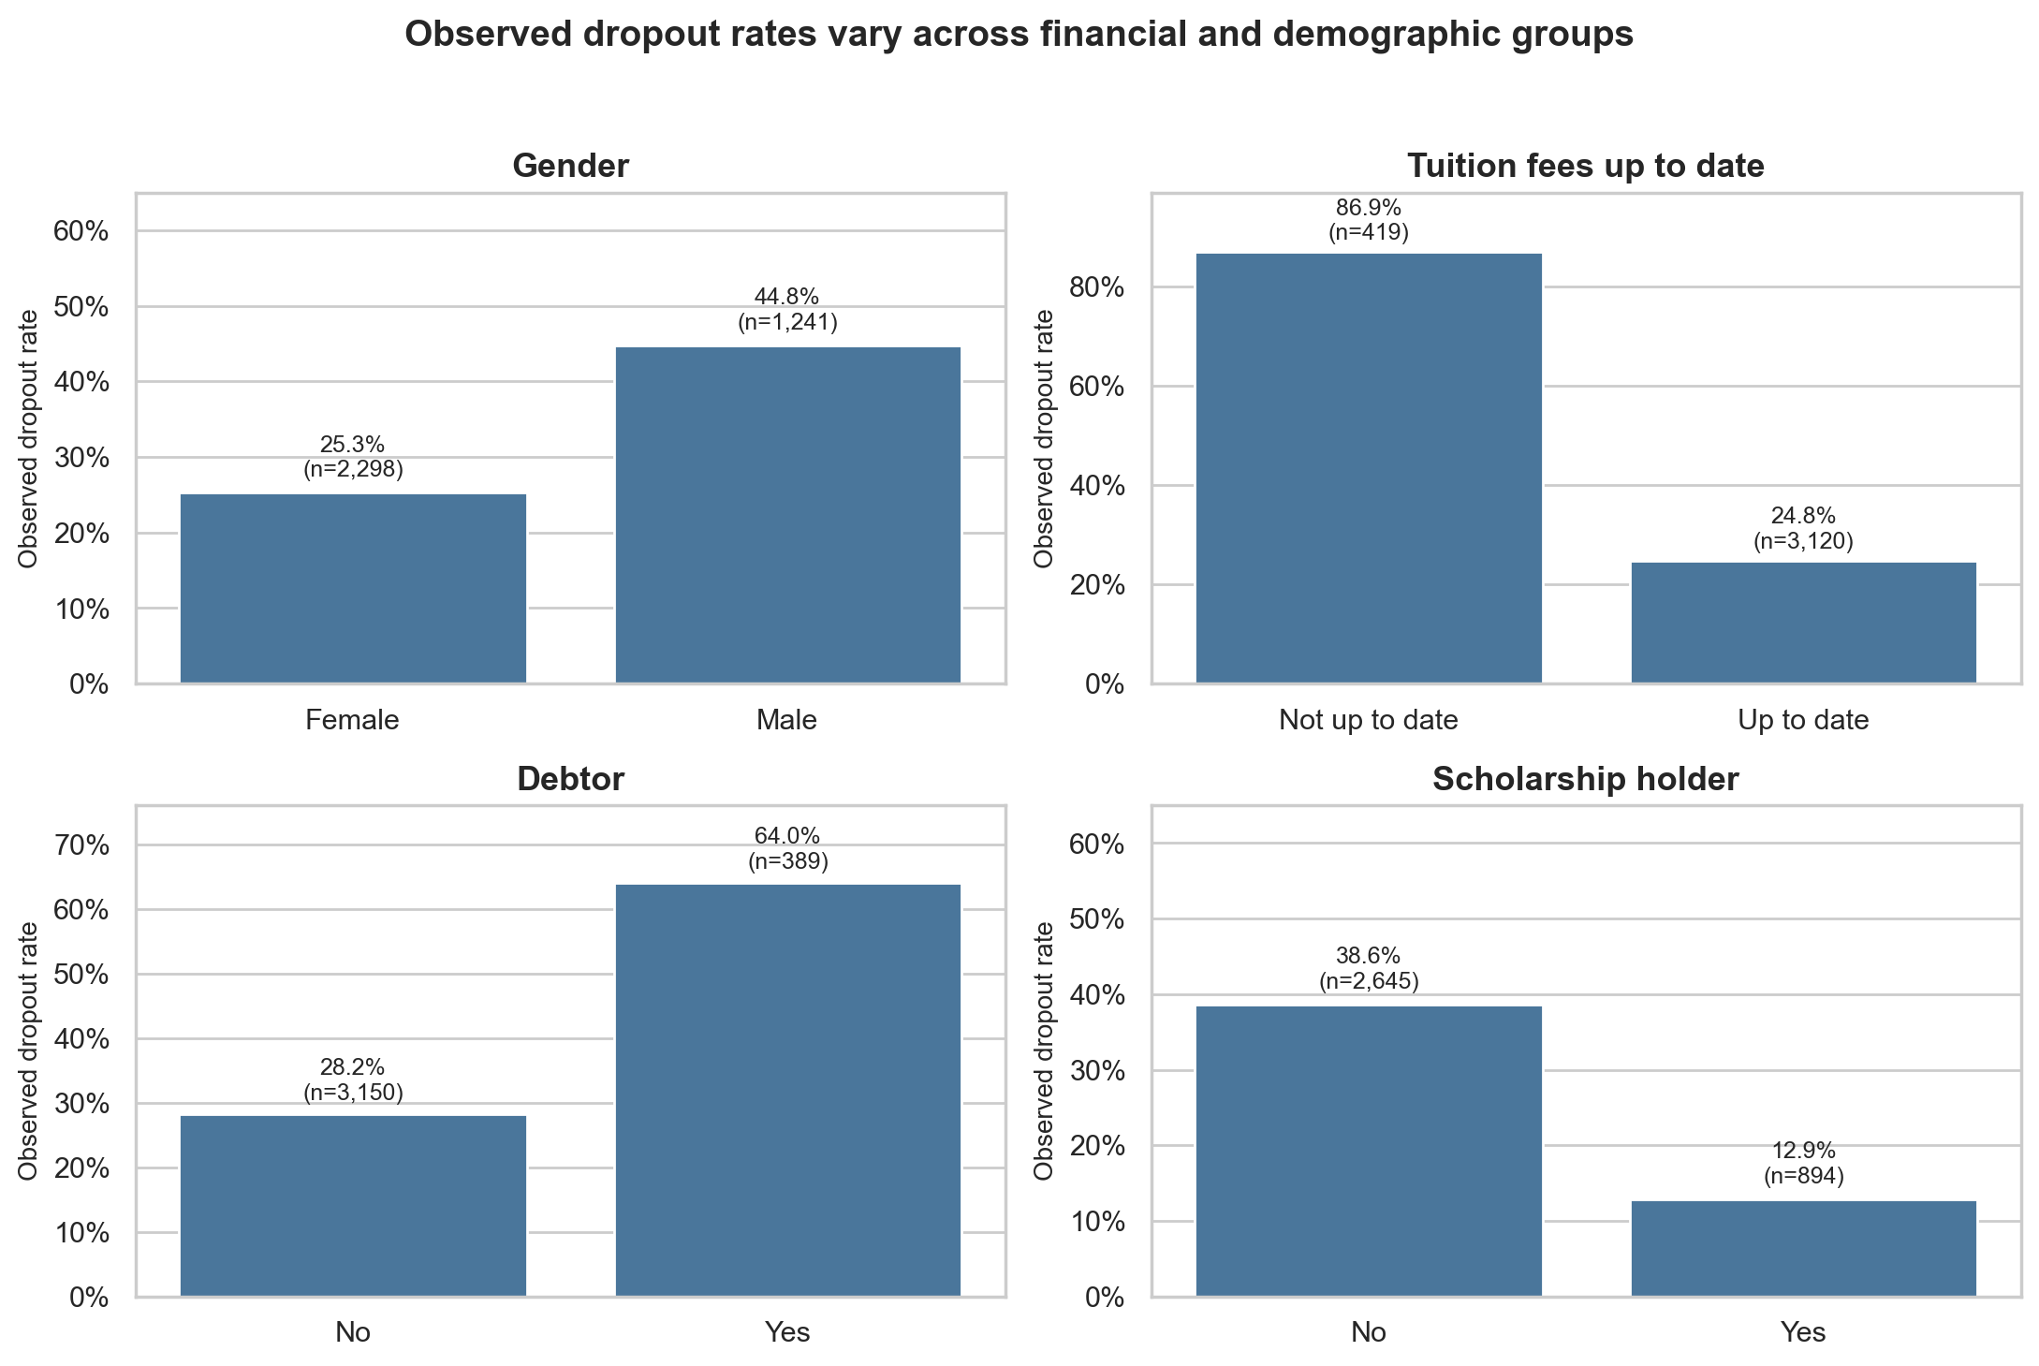
Figure 2. Training-partition dropout rates for selected descriptive factors. Associations are not causal effects.
Engineered feature | Definition and purpose
First-semester approval rate | Approved units divided by enrolled units, bounded from zero to one
Evaluation intensity | Evaluations divided by enrolled units
No-evaluation rate | Units without evaluation divided by enrolled units
Progress index | Approval rate multiplied by normalized first-semester grade
Academic preparation gap | Admission grade minus previous qualification grade
No-enrollment flag | Marks records with no first-semester enrolled units
First-choice flag | Marks first-choice application order
Financial-risk flag | Combines debtor status or tuition not current
Nontraditional-age flag | Marks age 25 or older for descriptive audit only

Feature screening and dimensionality
The primary prediction dataset contains 30 original first-semester predictors and nine engineered features. After audit-only demographic fields were removed, the model used 31 source columns. One-hot encoding produced 125 transformed features. Mutual information and a diagnostic Extra Trees model supported a 30-feature screening option, which Task 4 compared with using all encoded features inside cross-validation.
Principal component analysis required 61 components to explain 80% of variance, 75 for 90%, and 84 for 95%. The first two components explained only 9.4%, so PCA was retained as a diagnostic artifact rather than the default modeling path.

4 Model implementation and evaluation

Experimental design
Task 4 compared a dummy prior baseline with Logistic Regression, Decision Tree, Random Forest, and Histogram Gradient Boosting. Each candidate used an end-to-end pipeline for imputation, categorical encoding, numeric scaling, optional feature selection, and classification. Five-fold stratified cross-validation and grid search used the development set only.
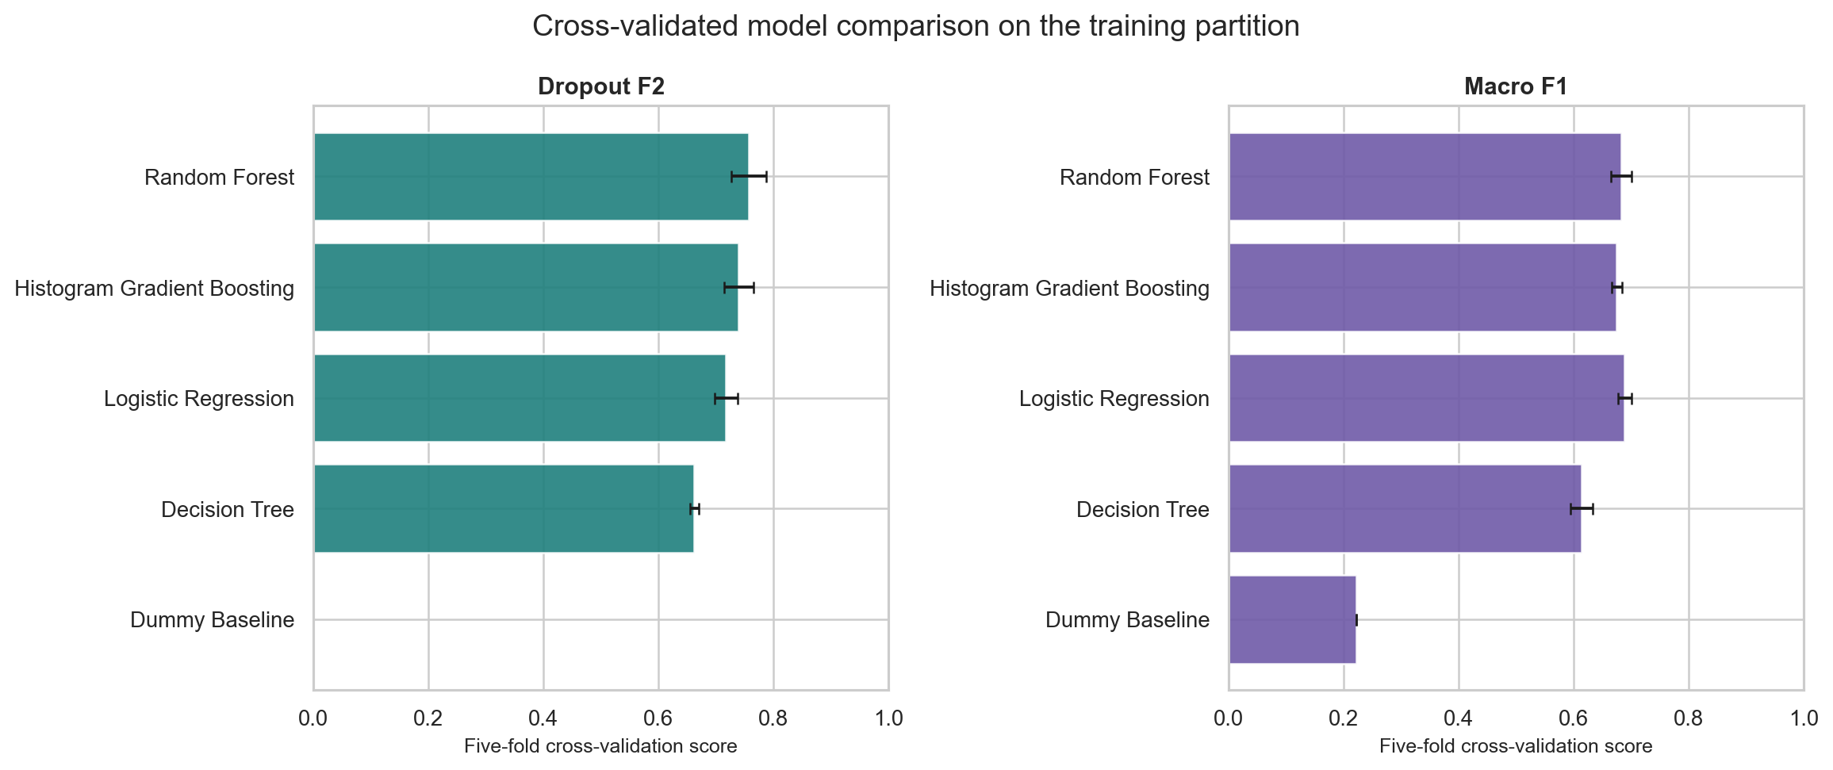
Figure 3. Five-fold cross-validated model comparison on the development partition.
Random Forest produced the highest cross-validated dropout F2 and was selected according to the predefined dropout-focused objective. Logistic Regression showed a slightly stronger macro F1, which demonstrates that model choice depends on the decision objective rather than a single universal score.

Threshold selection
The alert threshold was selected from out-of-fold training probabilities. Among thresholds satisfying at least 75% dropout recall and 50% precision, 0.23 maximized dropout F2. No held-out test information influenced this choice. The threshold changes the alert decision while retaining the same underlying three-class probabilities.
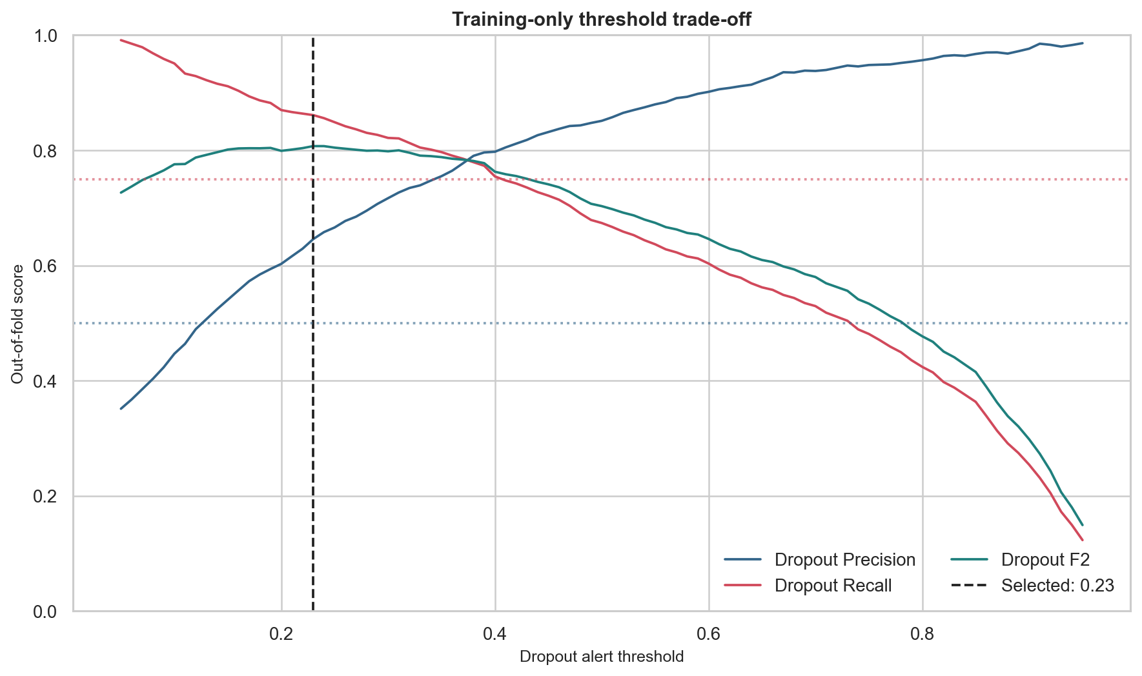
Figure 4. Training-only threshold trade-off using out-of-fold probabilities.

Held-out performance
83.8%  DROPOUT RECALL | 62.6%  DROPOUT PRECISION | 78.5%  DROPOUT F2 | 70.4%  OVERALL ACCURACY

The thresholded alert found 238 of 284 held-out dropouts and generated 142 false-positive alerts. This trade-off is consistent with the support objective: recall increases relative to default argmax prediction, while precision and overall multiclass accuracy decrease. False positives still matter, so outreach should remain low burden and supportive.
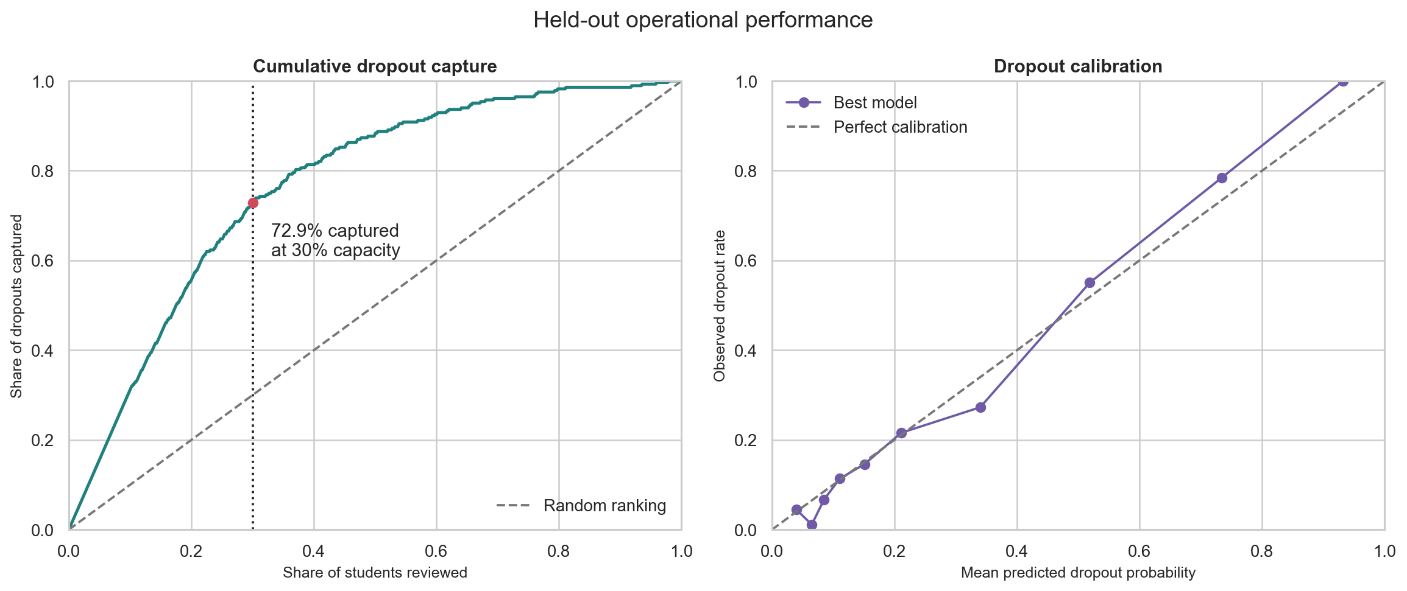
Figure 5. Held-out capacity ranking and probability calibration diagnostics.
Capacity result | Held-out value
Review list | 266 of 885 students
Dropouts captured | 207 of 284
Dropout capture rate | 72.9%
Precision at capacity | 77.8%
Lift over random selection | 2.43 times

Interpretation
The model met all three predefined held-out criteria. The result supports continued evaluation, not unrestricted deployment. The test set is a single historical split from the same institution, and the probability calibration chart indicates additional calibration work before a risk score is presented as an absolute likelihood.

5 Explainability, ethical AI, and fairness

Global and local explanations
Tree SHAP was calculated for all 885 held-out records. The largest grouped contributors were first-semester progress index, approval rate, tuition status, approved units, and the financial-risk flag. Local examples cover a true positive, false positive, and false negative. SHAP explains how the model produced a score; it does not show why a student leaves or what intervention will change the outcome.
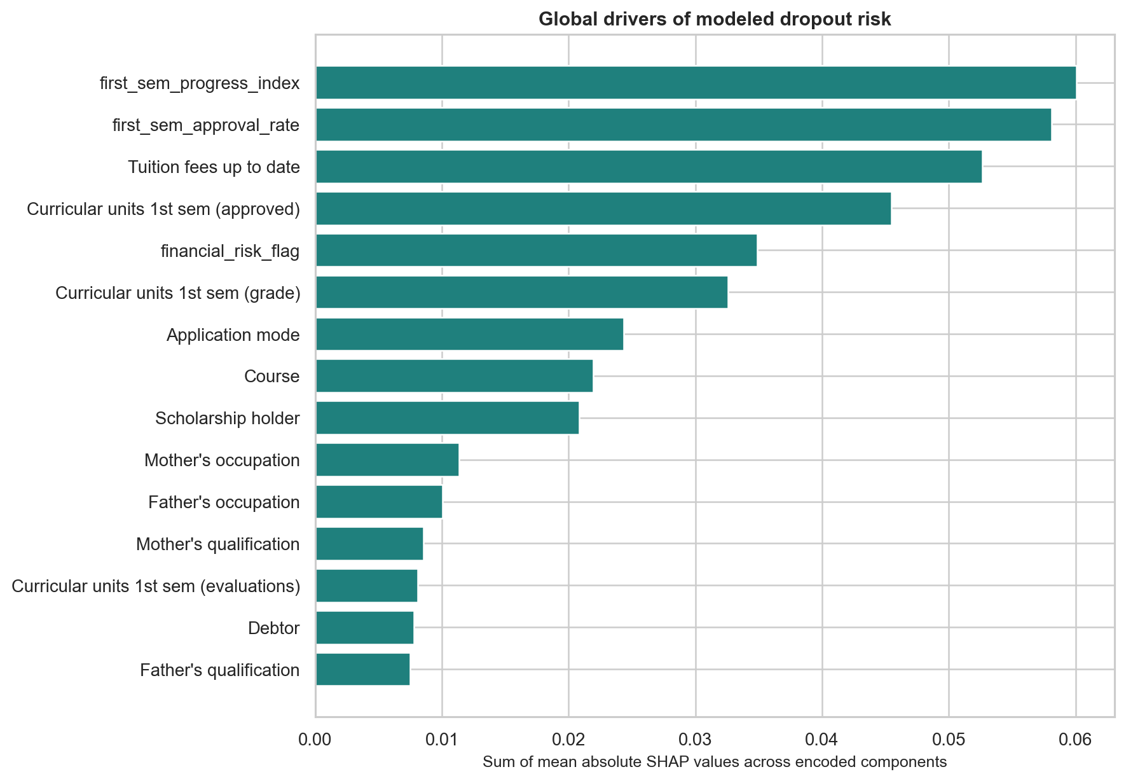
Figure 6. Global Tree SHAP importance for the Dropout class on held-out records.
Partial dependence and individual conditional expectation curves were generated for progress index and approval rate. Because engineered features are related to their component variables, the curves are diagnostic model-response views rather than feasible or causal intervention simulations.

Fairness audit
Gender, age, and international status were excluded from the model inputs and used only for auditing. Debtor status, tuition status, and scholarship status were audited as incomplete socioeconomic proxies. Race is absent, and nationality or international status was not treated as a substitute for race.
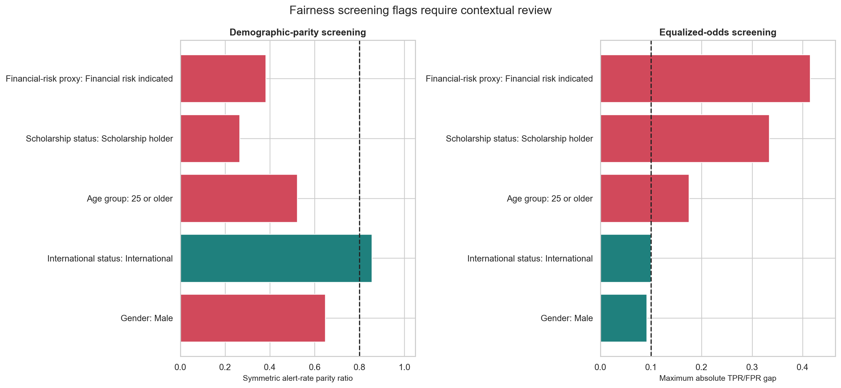
Figure 7. Fairness screening gaps at the locked 0.23 dropout-alert threshold.
Audit dimension | Compared group | Maximum TPR/FPR gap | Screen
Age group | 25 or older | 17.5% | Review
Financial-risk proxy | Financial risk indicated | 41.5% | Review
Scholarship status | Scholarship holder | 33.4% | Review
Gender x financial risk | Female | Financial risk indicated | 46.8% | Review
Gender x financial risk | Male | Financial risk indicated | 36.5% | Review
Gender x financial risk | Male | No immediate financial risk | 15.9% | Review

The audit produced 7 four-fifths screening flags and 6 equalized-odds screening flags. The largest TPR/FPR gap was 46.8% for Female | Financial risk indicated relative to Female | No immediate financial risk.
How to interpret the fairness results
The flags identify comparisons that require review. They are not legal findings and do not prove discrimination. Historical outcome differences may reflect unequal access or institutional conditions. The practical benefits and burdens of outreach, false positives, and missed students must be evaluated with affected stakeholders.

Key ethical limitations
- Race is unavailable, so racial fairness cannot be assessed.
- Gender is binary in the source data and may not represent student identity.
- The international group has only 24 held-out records and the scholarship group has only 19 actual dropouts, producing unstable estimates.
- Financial indicators do not fully measure income, wealth, caregiving, accessibility costs, or access to institutional support.
- Historical labels can encode structural and institutional inequities.
- Explanations and subgroup relationships are descriptive rather than causal.

6 Operational recommendation and governance
The model is suitable only for a controlled support pilot after local review. The pilot should test whether outreach improves access to support and student outcomes without imposing disproportionate burden. A current institutional cohort should validate performance, calibration, and fairness before any scale-up.
Control | Required practice | Evidence to monitor
Support-only policy | Limit alerts to offers of counseling, tutoring, and assistance | Contact reason and service offered
Human review | Confirm context before student contact | Overrides and review notes
Explanation and appeal | Provide plain-language reasons and a correction route | Corrections, complaints, and appeal outcomes
Calibration | Recalibrate on current institutional data | Brier score and calibration by cohort
Fairness monitoring | Track alert rate, recall, false-positive rate, and precision by group | Confidence intervals and sample sizes
Outcome monitoring | Measure uptake, workload, retention, and unintended harm | Pilot impact and burden indicators
Stop conditions | Pause when performance, fairness, or governance limits fail | Documented thresholds and accountable owner

Pilot sequence
- Prepare: confirm governance ownership, current data definitions, capacity, and prohibited uses.
- Validate: evaluate the locked workflow on a later local cohort and recalibrate probabilities.
- Pilot: use one cohort with limited counselors and optional, low-burden outreach.
- Measure: compare support uptake, workload, retention, calibration, and subgroup outcomes.
- Gate: advance, revise, or stop using predefined performance and fairness thresholds.
Financial value remains unquantified
The public dataset does not include intervention cost or retention value. Return on investment should be estimated only after the institution supplies support costs and the pilot measures credible retention uplift.

7 Reproducibility and open-source repository
Task 7 consolidates the user-edited and locally verified deliverables into an open-source-style repository. The code and notebooks use project-root discovery, so they can run from the repository root or the notebooks directory. Exact tested package versions are recorded in requirements.txt.
Path | Contents
src/ | Reusable Task 3-5 workflows, notebook builders, execution helpers, validators, and the pipeline runner
notebooks/ | Executed analytical notebooks and the Task 6 technical presentation notebook
data/ | Public raw data, UCI metadata, processed fixed splits, and the data dictionary workbook
models/ | Saved preprocessing, PCA, candidate models, locked model bundle, and SHAP array
configs/ | Saved modeling and fairness-audit configurations
reports/ | Task reports, HTML exports, JSON summaries, figures, tables, and this final report
presentations/ | Business PowerPoint and technical HTML presentation

Reproduction commands
python3 -m venv .venv
source .venv/bin/activate
python -m pip install -r requirements.txt
python src/run_pipeline.py --validate-only
python src/run_pipeline.py
python src/run_pipeline.py --execute-notebooks

Reproducibility controls
- Python 3.13.9 and exact tested library versions are documented.
- Random seed 42 and the fixed stratified split are saved.
- Preprocessing and feature selection are fitted inside model pipelines.
- Model comparison and threshold tuning use training data only.
- The locked test predictions, metrics, SHAP values, and fairness tables are committed.
- Validators confirm artifact completeness, calculations, notebook execution, and model-audit alignment.
The repository includes an MIT license for original code, separate UCI dataset attribution under CC BY 4.0, a contribution guide, a citation note, and a gitignore file that excludes local environments, caches, and notebook checkpoints.

8 Conclusion
The project demonstrates a complete machine learning workflow from problem framing and public-data selection through exploratory analysis, model comparison, held-out evaluation, explainability, fairness screening, stakeholder communication, and reproducible packaging. The selected Random Forest met the predefined held-out recall, precision, and ranking targets.
The technical result is promising for further study, but the governance conclusion is deliberately cautious. Fairness gaps, incomplete sensitive-attribute coverage, calibration needs, one-institution data, and uncertain intervention impact prevent unrestricted deployment. The next justified step is a monitored support pilot on a new local cohort, with explicit stop conditions and no automated adverse decisions.
Final decision
Proceed only to local validation and a controlled support pilot. Treat the risk score as one input to human review, measure whether support helps, and stop or revise the system when performance, fairness, or governance conditions are not met.

References
- Realinho, V., Machado, J., Baptista, L., and Martins, M. V. (2021). Predict Students' Dropout and Academic Success. UCI Machine Learning Repository. https://doi.org/10.24432/C5MC89
- UCI Machine Learning Repository. Dataset license: Creative Commons Attribution 4.0 International.
- Project artifacts. Task 1 Problem Understanding and Framing; Task 2 Data Collection and Understanding; Task 3 EDA and Feature Engineering; Task 4 Model Implementation; Task 5 Bias and Fairness Analysis; Task 6 Stakeholder Communication.
- scikit-learn documentation for cross-validation, pipeline construction, classification metrics, calibration, and model inspection.
- SHAP documentation and TreeExplainer implementation used for model-behavior explanations.

Artifact statement
This report synthesizes the project-specific analysis, tables, figures, code outputs, and author-edited task reports in this repository. Public dataset facts and third-party software are attributed above. All numerical results are traceable to committed JSON summaries and CSV tables.

