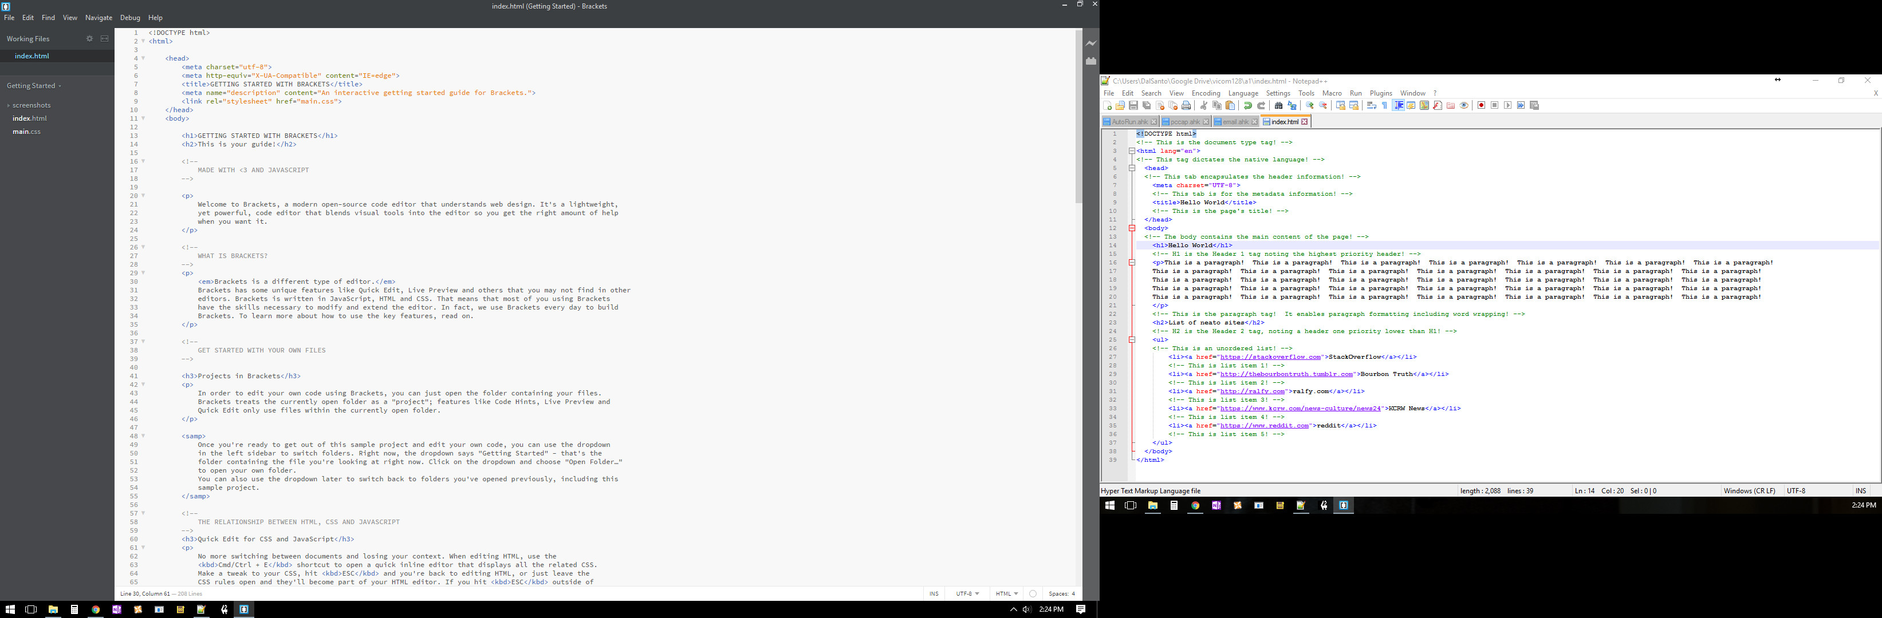
Bracket & Notepad++

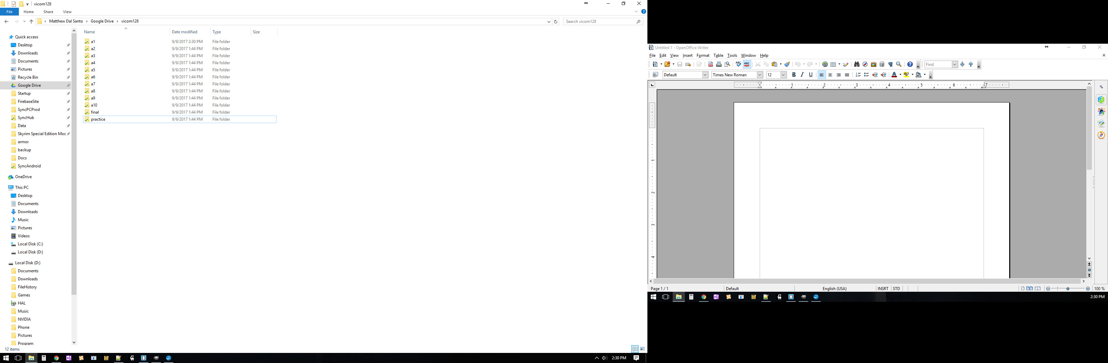
Root Directory

