**1, 2 y 3 Modelo Cargado**

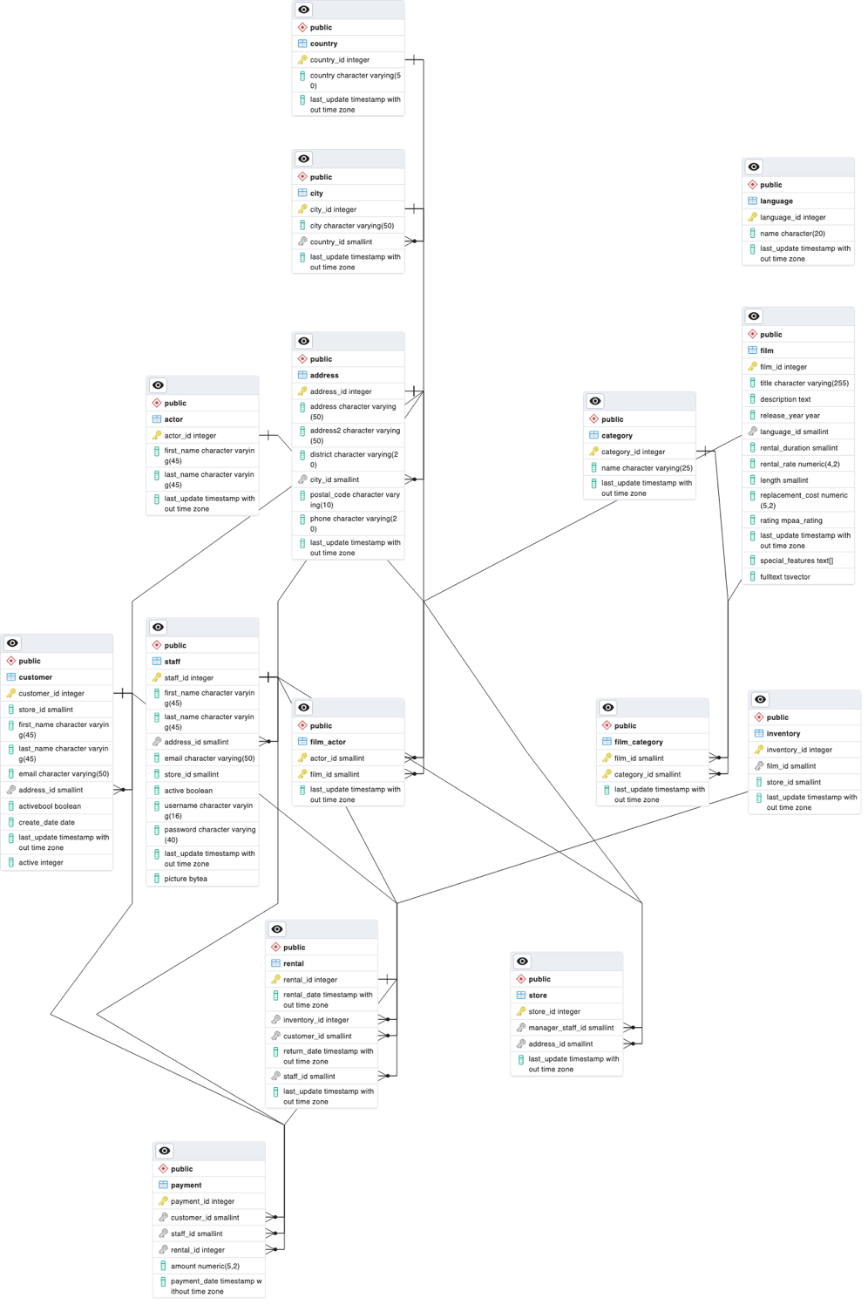

**4. Construye las siguientes consultas:**

• Aquellas usadas para insertar, modificar y eliminar un Customer, Staff y Actor.

-- Insertar un nuevo Customer

INSERT INTO customer (store_id, first_name, last_name, email, address_id, active, create_date)

VALUES (1, 'John', 'Doe', 'john.doe@example.com', 5, 1, CURRENT_TIMESTAMP);

-- Modificar un Customer existente (asumiendo que el customer_id es 1)

UPDATE customer

SET first_name = 'Jane', last_name = 'Doe', email = 'jane.doe@example.com'

WHERE customer_id = 1;

-- Eliminar un Customer (asumiendo que el customer_id es 1)

DELETE FROM customer

WHERE customer_id = 1;

-- Insertar un nuevo Staff

INSERT INTO staff (first_name, last_name, address_id, email, store_id, active, username, password)

VALUES ('Mike', 'Smith', 3, 'mike.smith@example.com', 2, 1, 'mike', 'password');

-- Modificar un Staff existente (asumiendo que el staff_id es 1)

UPDATE staff

SET first_name = 'Michael', last_name = 'Smith', email = 'michael.smith@example.com'

WHERE staff_id = 1;

-- Eliminar un Staff (asumiendo que el staff_id es 1)

DELETE FROM staff

WHERE staff_id = 1;

-- Insertar un nuevo Actor

INSERT INTO actor (first_name, last_name)

VALUES ('Bruce', 'Willis');

-- Modificar un Actor existente (asumiendo que el actor_id es 1)

UPDATE actor

SET first_name = 'Bruce', last_name = 'Lee'

WHERE actor_id = 1;

-- Eliminar un Actor (asumiendo que el actor_id es 1)

DELETE FROM actor

WHERE actor_id = 1;

• Listar todas las “rental” con los datos del “customer” dado un año y mes.

-- Listar todas las rentals para un año y mes específicos (por ejemplo, para marzo de 2006)

SELECT rental.*, customer.*

FROM rental

JOIN customer ON rental.customer_id = customer.customer_id

WHERE EXTRACT(YEAR FROM rental.rental_date) = 2006

AND EXTRACT(MONTH FROM rental.rental_date) = 3;

• Listar Número, Fecha (payment_date) y Total (amount) de todas las “payment”.

-- Listar todos los payments

SELECT payment_id AS Numero, payment_date AS Fecha, amount AS Total

FROM payment;

• Listar todas las “film” del año 2006 que contengan un (rental_rate) mayor a 4.0.

-- Listar todas las películas del año 2006 con rental_rate mayor a 4.0

SELECT *

FROM film

WHERE release_year = 2006

AND rental_rate > 4.0;

**5. Realiza un Diccionario de datos que contenga el nombre de las tablas y columnas, si éstas pueden ser nulas, y su tipo de dato correspondiente**.

Los campos marcados como "not null" son obligatorios y no pueden contener valores nulos, mientras que aquellos marcados como "nullable" pueden contener valores nulos.

Country Table

country_id: INTEGER, not null

country: VARCHAR(50), not null

last_update: TIMESTAMP WITH TIME ZONE, not null

City Table

city_id: INTEGER, not null

city: VARCHAR(50), not null

country_id: SMALLINT, not null

last_update: TIMESTAMP WITH TIME ZONE, not null

Address Table

address_id: INTEGER, not null

address: VARCHAR(50), not null

address2: VARCHAR(50), nullable

district: VARCHAR(20), not null

city_id: SMALLINT, not null

postal_code: VARCHAR(10), nullable

phone: VARCHAR(20), not null

last_update: TIMESTAMP WITH TIME ZONE, not null

Customer Table

customer_id: INTEGER, not null

store_id: SMALLINT, not null

first_name: VARCHAR(45), not null

last_name: VARCHAR(45), not null

email: VARCHAR(50), nullable

address_id: SMALLINT, not null

activebool: BOOLEAN, not null

create_date: DATE, not null

last_update: TIMESTAMP WITH TIME ZONE, nullable

active: INTEGER, nullable

Film Table

film_id: INTEGER, not null

title: VARCHAR(255), not null

description: TEXT, nullable

release_year: YEAR, nullable

language_id: SMALLINT, not null

rental_duration: SMALLINT, not null

rental_rate: NUMERIC(4,2), not null

length: SMALLINT, nullable

replacement_cost: NUMERIC(5,2), not null

rating: MPAA RATING, nullable

last_update: TIMESTAMP WITH TIME ZONE, not null

special_features: TEXT[], nullable

fulltext: TSVECTOR, not null

Payment Table

payment_id: INTEGER, not null

customer_id: SMALLINT, not null

staff_id: SMALLINT, not null

rental_id: INTEGER, not null

amount: NUMERIC(5,2), not null

payment_date: TIMESTAMP WITH TIME ZONE, not null

Rental Table

rental_id: INTEGER, not null

rental_date: TIMESTAMP WITH TIME ZONE, not null

inventory_id: INTEGER, not null

customer_id: SMALLINT, not null

return_date: TIMESTAMP WITH TIME ZONE, nullable

staff_id: SMALLINT, not null

last_update: TIMESTAMP WITH TIME ZONE, not null

Actor Table

actor_id: INTEGER, not null

first_name: VARCHAR(45), not null

last_name: VARCHAR(45), not null

last_update: TIMESTAMP WITH TIME ZONE, not null

Staff Table

staff_id: INTEGER, not null

first_name: VARCHAR(45), not null

last_name: VARCHAR(45), not null

address_id: SMALLINT, not null

email: VARCHAR(50), nullable

store_id: SMALLINT, not null

active: BOOLEAN, not null

username: VARCHAR(16), not null

password: VARCHAR(40), nullable

last_update: TIMESTAMP WITH TIME ZONE, not null

picture: BYTEA, nullable

Store Table

store_id: INTEGER, not null

manager_staff_id: SMALLINT, not null

address_id: SMALLINT, not null

last_update: TIMESTAMP WITH TIME ZONE, not null

Film_Actor Table

actor_id: SMALLINT, not null

film_id: SMALLINT, not null

last_update: TIMESTAMP WITH TIME ZONE, not null

Film_Category Table

film_id: SMALLINT, not null

category_id: SMALLINT, not null

last_update: TIMESTAMP WITH TIME ZONE, not null

Inventory Table

inventory_id: INTEGER, not null

film_id: SMALLINT, not null

store_id: SMALLINT, not null

last_update: TIMESTAMP WITH TIME ZONE, not null