**Meet Edison Robot Unit**

Table of Contents

EdPy Website 2

EdPy YouTube Tutorials 2

EdPy: Lesson 1 2

Reading 2

Questions to Answer 2

EdPy: Lesson 2 3

Reading 3

Questions to Answer 3

Performance Task: Button Controlled Edison 3

Task 3

Starting code 4

EdPy: Lesson 3 4

Reading 4

Questions to Answer 4

EdPy: Lesson 4 4

Reading 4

Questions to Answer 4

Performance Task: Around my foot 5

Task 5

EdPy: Lesson 5 5

Reading 5

Questions to Answer 5

Performance Task: Jingle Bells 5

Task 5

EdPy: Lesson 6 6

Reading 6

Questions to Answer 6

EdPy: Lesson 7 7

Reading 7

Questions to Answer 7

Performance Task: Beat the wall 7

Task 7

EdPy: Lesson 8 8

Reading 8

Questions to Answer 8

Performance Task: Stay in your lane 9

Task 9

EdPy: Lesson 9 9

Reading 9

Questions to Answer 9

EdPy: Lesson 10 10

Read This :-) 10

Reading 10

Questions to Answer 10

## EdPy Website

The Meet Edison python editor is available at: [EdPyApp.com](http://edpyapp.com/) and we are using Edison V2.0

## EdPy YouTube Tutorials

<https://www.youtube.com/playlist?list=PLT_zuaMZ7LC8fRYiFzUoJHRNWHhN3jW16>

## EdPy: Lesson 1

### Reading

EdPy-Lesson01.pdf

### Questions to Answer

|  |  |
| --- | --- |
| Where can you find the Documentation for Edison Programming? |  |
| What is in the Documentation? |  |
| What are comments (#) used for? |  |
| How do you download a program onto the Edison? (Give series of buttons on the website and robot.) |  |
|  |  |

## EdPy: Lesson 2

### Reading

EdPy-Lesson02.pdf

### Questions to Answer

|  |  |
| --- | --- |
| What is a function? |  |
| What are input parameters? |  |
| What is a syntax error? |  |
| Using Ed.DISTANCE_UNLIMITED as a parameter in the Ed.Drive function makes the robot's motors come on for an unlimited amount of time. This means there is probably a loop inside of the function definition.  Based on your prior knowledge, do you think it is a definite or indefinite loop? Why? |  |
| Paste your code here for Worksheet 2.3, Task 2, where Edison move forward and backwards between the lines. |  |
| What is an expression? |  |
| How are expressions evaluated? |  |
| What is a while loop used for? |  |
| What makes a program exit a while loop? |  |
| What is the importance of indentation in Python? |  |
|  |  |

## Performance Task: Button Controlled Edison

### Task

* Program your Edison to be button controlled.
* **Show me your Edison Robot when you complete this task.**

### Starting code

Starting code can be found on Worksheet 2.5 #3

"Now try adding some more code at the end of the program. The new code you write should make Edison drive backward after you press either the round or the triangle button again. In other words, your program should tell Edison to drive forward the first time a button is pressed, then backwards when a button is pressed again. Remember to include the colon and to indent your code inside the while loop."

## EdPy: Lesson 3

### Reading

EdPy-Lesson03.pdf

### Questions to Answer

|  |  |
| --- | --- |
| What is a variable? |  |
| What operator is used in Python to assign a value to a variable? |  |
| From prior knowledge, which operator actually tests for equality, but is sometimes confused with the assignment operator (=). |  |
| Give two examples of illegal variable names and why they are illegal. |  |
| On worksheet 3.3, what is the purpose of lines 14 and 15 in the code? |  |
| On worksheet 3.3, what is the purpose of line 13 in the code? |  |
|  |  |

## EdPy: Lesson 4

### Reading

EdPy-Lesson04.pdf

### Questions to Answer

|  |  |
| --- | --- |
| What is a for-loop used for? |  |
| Paste your code to make a Edison drive in a **square** here. |  |
| Paste your code to make Edison drive in a **triangle** here. |  |
| Paste your code to make Edison drive in a **hexagon** here. |  |
|  |  |

## Performance Task: Around my foot

### Task

* Program your Edison to drive in a circle around your stationary foot.
  + Edison's shape should look like a circle, not another shape.
  + Hint: a shape with many hundreds of very small sides can closely approximate a circle.
* **Show me your Edison Robot when you complete this task.**

## EdPy: Lesson 5

### Reading

EdPy-Lesson05.pdf

### Questions to Answer

|  |  |
| --- | --- |
| What does it mean that Edison plays sounds "in the background"? |  |
| On worksheet 5.1 Task #2, what is the purpose of the while loop on lines 13 and 14? |  |
| What happens if you remove the loop? |  |
| What is a String? |  |
| What is a Character? |  |
|  |  |

## Performance Task: Jingle Bells

### Task

* Program your Edison to play jingle bells when a button is pressed.

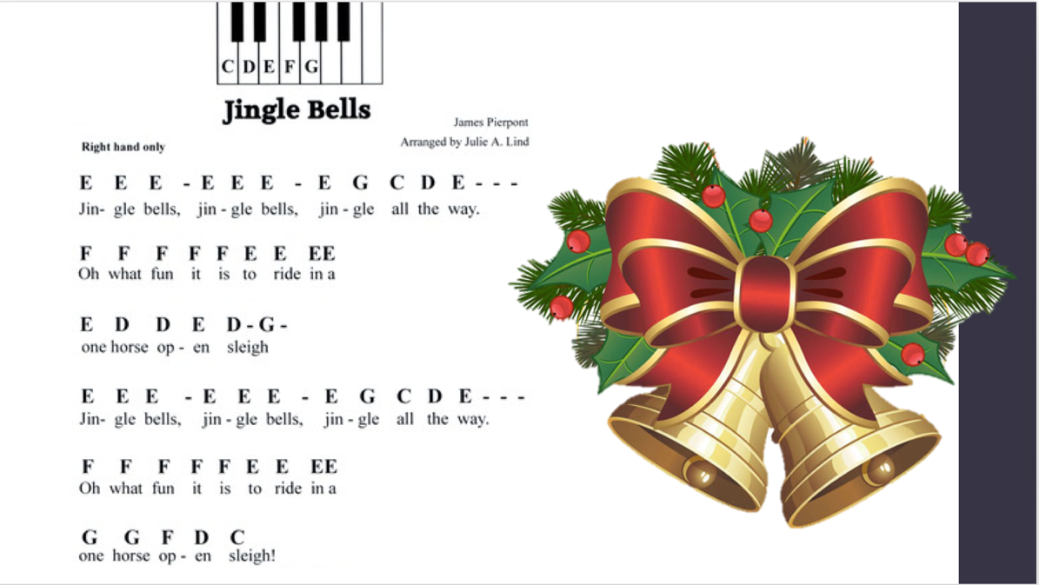

**Show me your Edison Robot when you complete this task.**

## EdPy: Lesson 6

### Reading

EdPy-Lesson06.pdf

### Questions to Answer

|  |  |
| --- | --- |
| What is the purpose of a flowchart? |  |
| What is an infinite loop? |  |
| Why is while True: an infinite loop? |  |
| In the code on Worksheet 6.1, what is the purpose of the TimeWait() function calls on lines 17 and 19? |  |
| What is a function? |  |
| How do you define a function? |  |
| What happens when you call a function? |  |
| Put your code for worksheet 6.3 #1 here. |  |
| Put your code for worksheet 6.3 #2 here. |  |
| Put your code for worksheet 6.3 #3 here. |  |
|  |  |

## EdPy: Lesson 7

### Reading

EdPy-Lesson07.pdf

### Questions to Answer

|  |  |
| --- | --- |
| What is Edison's infrared system made up of? |  |
| How does Edison detect obstacles using the infrared system? |  |
| What line of code do you need to turn on Edison's obstacle detection beam? |  |
| What happens if the robot's speed is too fast? |  |
| What is a logical error? |  |
| Give an example of a logical error (not the one in the text). |  |
| List the 5 errors in the code for Task 2 on Worksheet 7.3. | 1 -  2 -  3 -  4 -  5 - |
| What is an if statement used for? |  |
| What is an autonomous robot? |  |
| What happens after one of the if or elif blocks is evaluated to True (when the program runs any indented code inside of any part of the if statement structure)? |  |
|  |  |

## Performance Task: Beat the wall

### Task

* Program your Edison to autonomously navigate through a series of obstacles without moving them (it may knock into them slightly before backing up and away).
* There is an example in EdPyApp that may be useful starting code. If you start with this code, you will have to make modifications to it to accomplish the task.

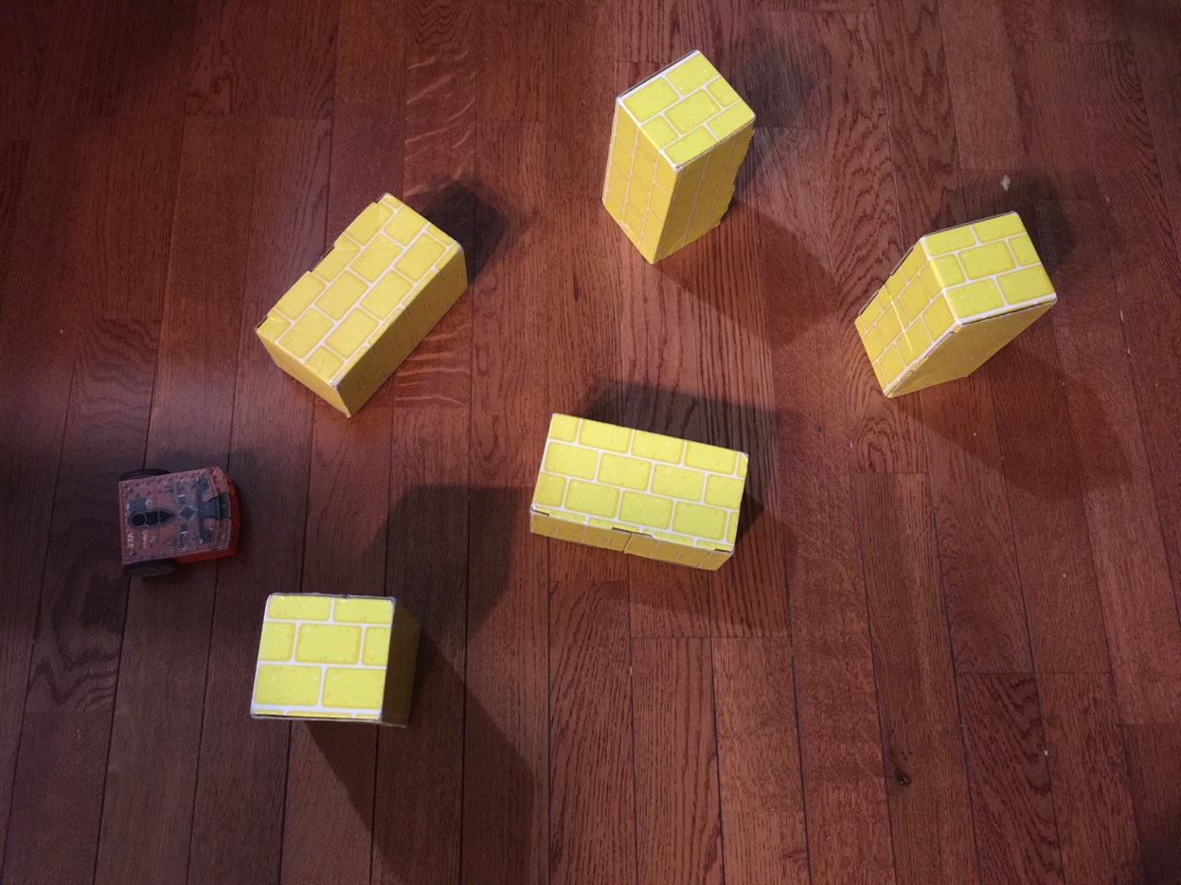

**Show me your Edison Robot when you complete this task.**

## EdPy: Lesson 8

### Reading

EdPy-Lesson08.pdf

### Questions to Answer

|  |  |
| --- | --- |
| What does the term debugging mean? |  |
| On Worksheet 8.2, a beep (line 19) is used for debugging purposes. How does the beep help in debugging? |  |
| What is pseudocode? |  |
| What is an algorithm? |  |
| Put your code that makes Edison follow a black line here: |  |
|  |  |

## Performance Task: Stay in your lane

### Task

* Program your Edison to autonomously drive down a curvy "street" made up of two black lines.
* There is an example in EdPyApp that may be useful starting code. If you start with this code, you will have to make modifications to it to accomplish the task.

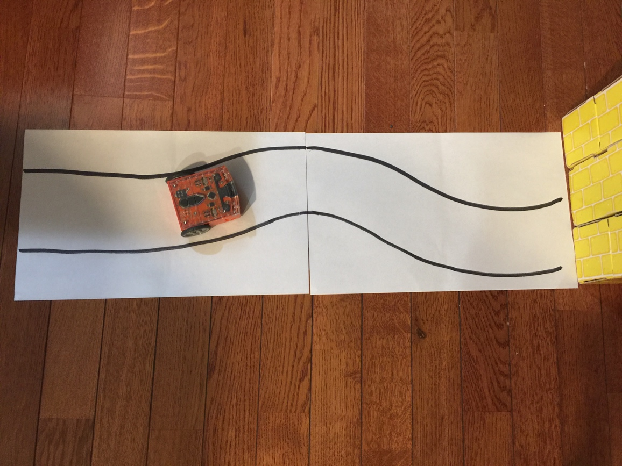

**Show me your Edison Robot when you complete this task.**

## EdPy: Lesson 9

### Reading

EdPy-Lesson09.pdf

### Questions to Answer

|  |  |
| --- | --- |
| What is the difference between ReadRightLightLevel() and ReadLeftLightLevel()? |  |
| How could you modify the program to turn both headlights on if EITHER light level is low? |  |
| Explain how the code on Worksheet 9.3 works. |  |
| Why is it useful to trace through your program code? |  |
|  |  |

## EdPy: Lesson 10

### Read This :-)

This lesson is optional. Doing the lesson earns zero points. HOWEVER, the topic discussed is Object Oriented Programming (OOP) and this is the way that code is actually written in the real world. This course we have written our code in a *procedural programming* way, rather than in an *object oriented programming* way, because I (and many other educators) believe it is a more friendly introduction to programming. In the real world, almost all code is written in an OOP manner, so it is essential to learn OOP concepts. This lesson is just a small introduction to the concept, which you will see in 141 in more depth. I highly recommend anyone considering a career in Computer Science or planning on taking to complete this short lesson on OOP as well as to do a little research on what OOP is. You don't need to master the concept, or even feel comfortable with the topic, but gaining even a fraction of exposure to OOP now will only help you in the future.

### Reading

EdPy-Lesson10.pdf

### Questions to Answer

|  |  |
| --- | --- |
| What is OOP? |  |
| What is an object? |  |
| What is a class? |  |
| What is the purpose of the __init__ function? |  |
| What is the syntax for creating an object from a class? |  |
| Read a little about [OOP on wikipedia](https://en.wikipedia.org/wiki/Object-oriented_programming). What's one thing you learned? |  |
| Describe what is happening in the Vampire code in Worksheet 10.1. |  |
| If you modify the Vampire Robot class, paste your code here. |  |
| What does your modified Vampire Robot do? |  |
|  |  |