Architecture-Related Diagrams
Municipal Reporting Portal

This document groups diagrams that describe the system at architecture level: component boundaries, deployment/physical infrastructure, scenario views and runtime interaction flow.
Selection note: Only the latest or clearest version of duplicated/superseded uploads is included. Duplicate component and deployment images, the older report-status state diagram, and earlier Report class drafts were not repeated.

Included diagrams
Diagram | View / Type | Purpose in the document
Component Diagram | Development / Component View | Shows the main internal modules and external service boundaries.
Deployment Diagram | Physical View | Shows the runtime nodes, cloud services, database, repository and client device.
Resident Service Request Use Case | Scenario View | Defines the resident complaint-submission scenario and included behaviours.
Worker Application Use Case | Scenario View | Shows how a resident applies to become a municipal worker.
Worker Use Case Diagram | Scenario View | Captures worker-level dashboard, claim, assignment and status-update functions.
Admin Use Case Diagram | Scenario View | Captures admin-level analytics, request management and task allocation functions.
Login and Complaint Sequence | Process View | Shows the runtime message flow between actor, frontend and backend.

Component Diagram - Municipal Reporting System
Diagram type: Component Diagram / Development View
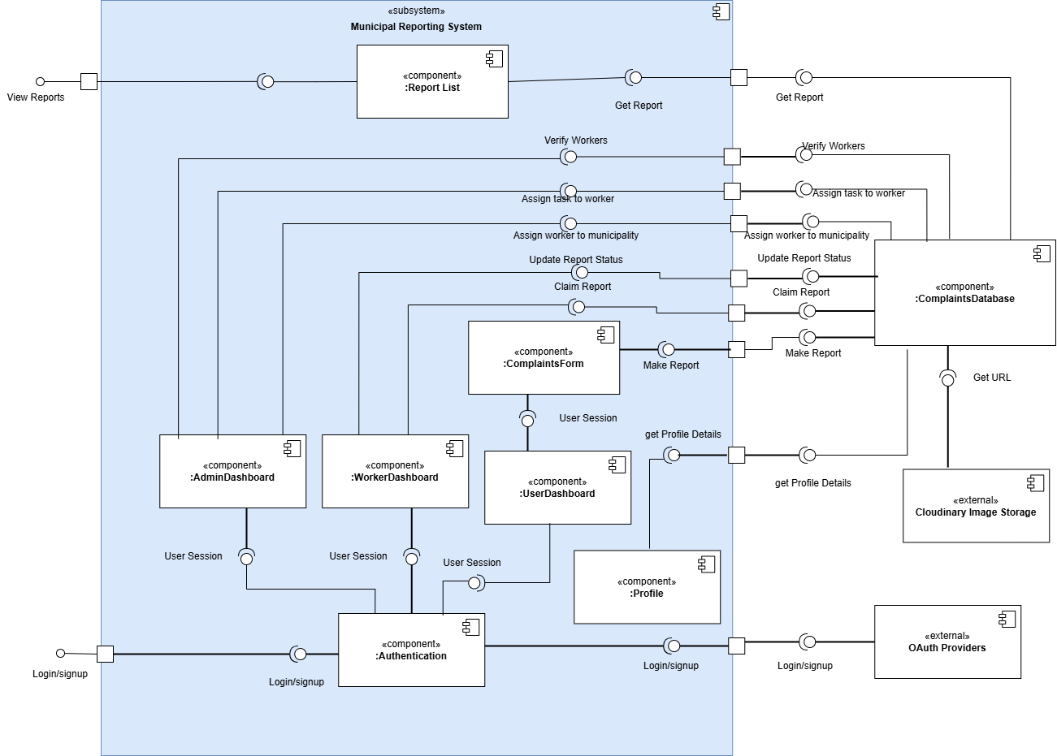
Figure 1. System component view showing dashboard components, authentication, profile, complaint form/report list, and integrations with the complaints database, OAuth providers and Cloudinary image storage.

Deployment Diagram - Runtime Infrastructure
Diagram type: Deployment Diagram / Physical View
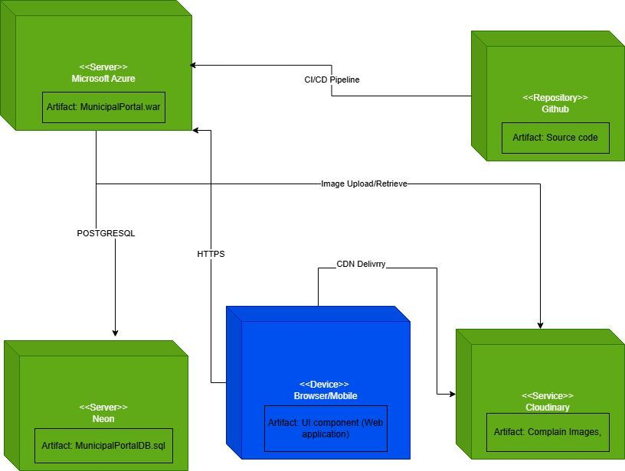
Figure 2. Physical deployment view showing the browser/mobile client, Microsoft Azure application server, Neon PostgreSQL database, GitHub source repository and Cloudinary image service.

Use Case Diagram - Resident Submits Complaint
Diagram type: Use Case Diagram / Scenario View
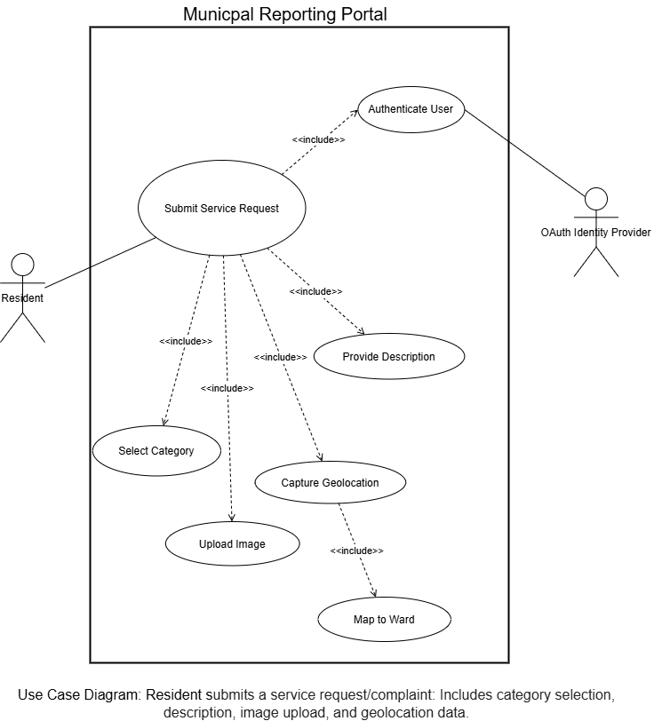
Figure 3. Scenario view for a resident submitting a service request, including authentication, category selection, description capture, image upload, geolocation capture and ward mapping.

Use Case Diagram - Resident Applies for Worker Role
Diagram type: Use Case Diagram / Scenario View
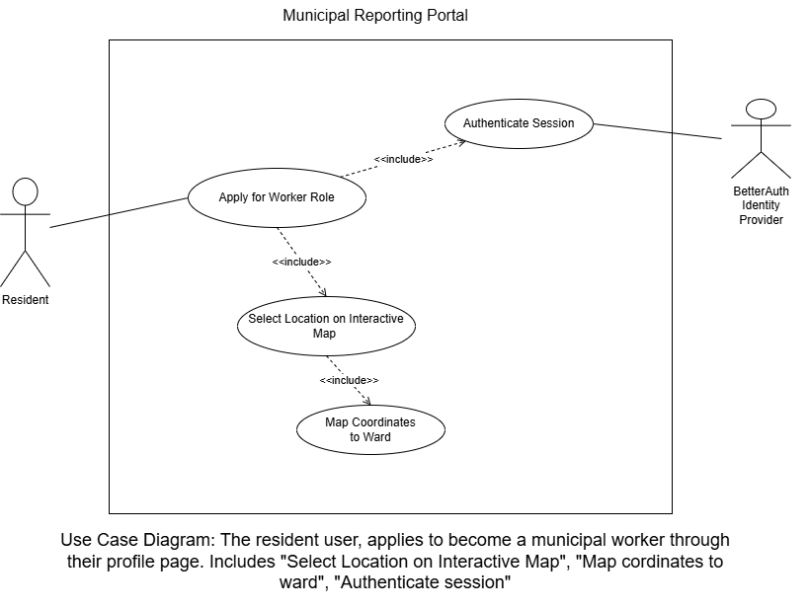
Figure 4. Scenario view showing a resident applying to become a municipal worker through the profile page, including session authentication and location-to-ward mapping.

Use Case Diagram - Worker Task Management
Diagram type: Use Case Diagram / Scenario View
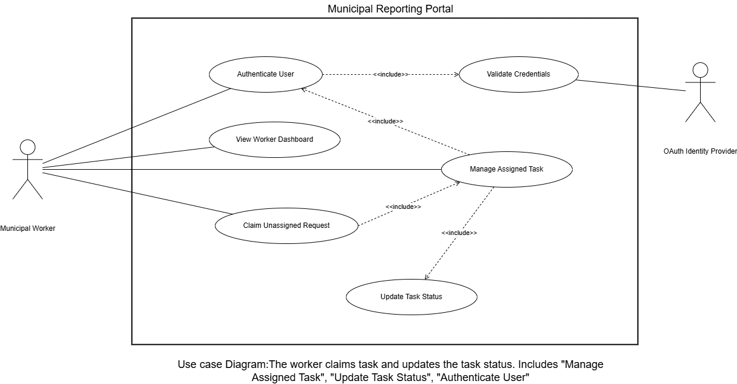
Figure 5. Worker scenario view showing authentication, dashboard access, claiming unassigned requests, managing assigned tasks and updating task status.

Use Case Diagram - Admin Task Allocation
Diagram type: Use Case Diagram / Scenario View
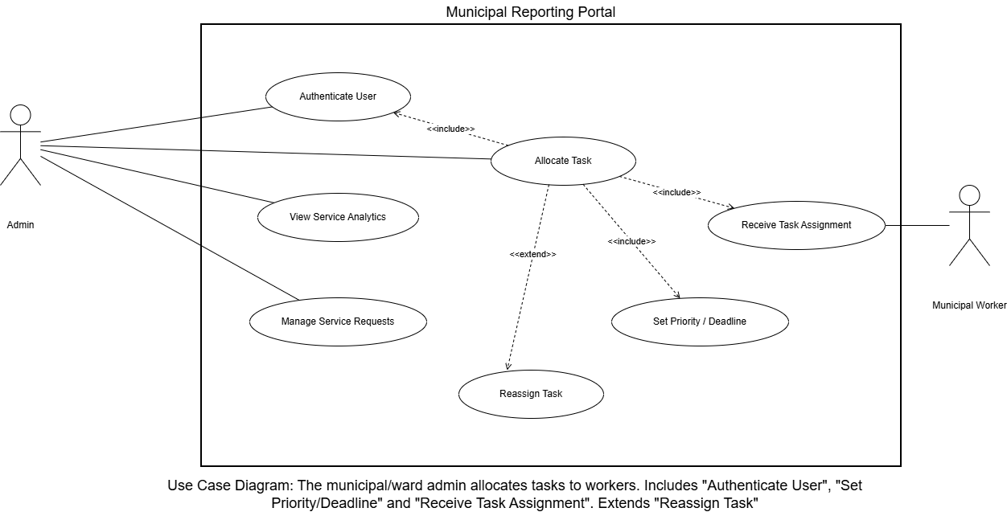
Figure 6. Admin scenario view showing service analytics, service-request management, task allocation, priority/deadline setting, reassignment and worker task receipt.

Sequence Diagram - Login and Complaint Submission
Diagram type: Sequence Diagram / Process View
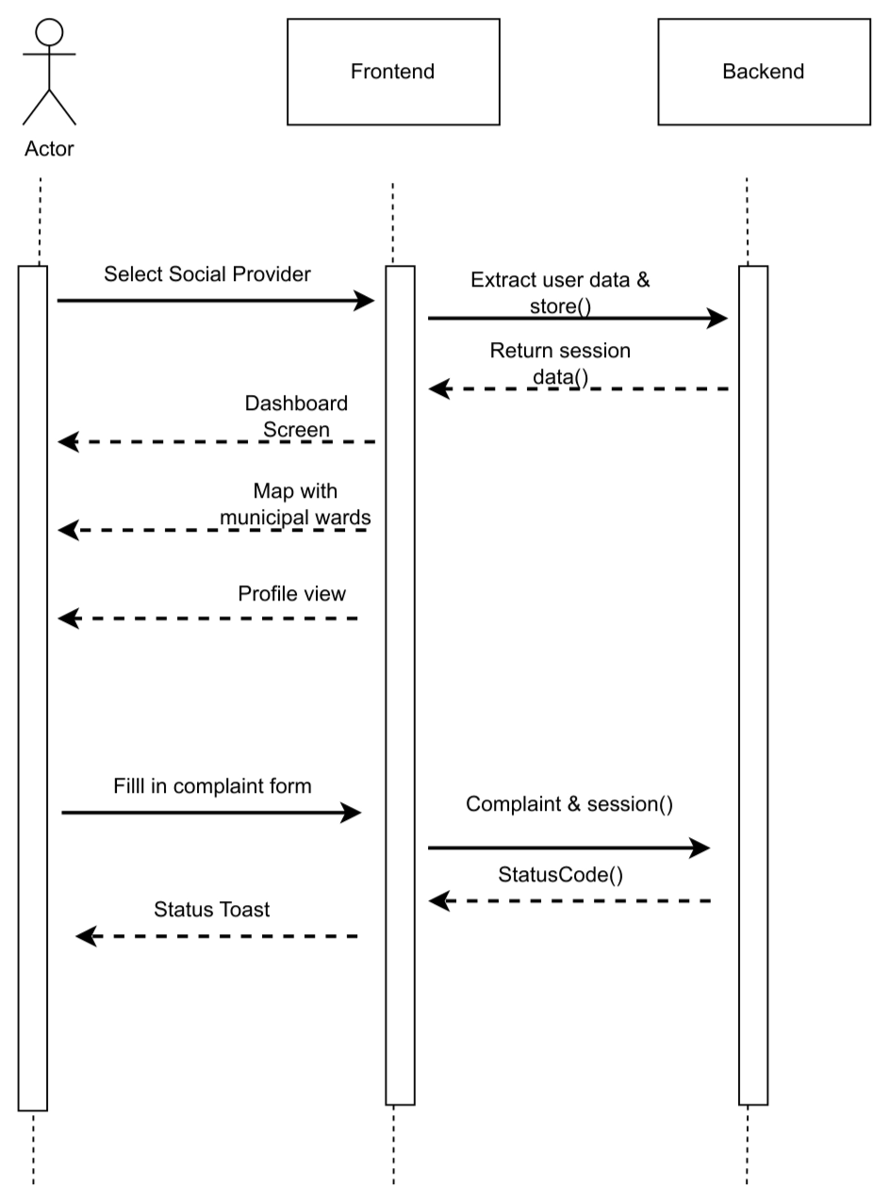
Figure 7. Process interaction view showing social-provider selection, user-data extraction, session creation, dashboard/profile/map responses and complaint submission from the frontend to the backend.

Component Diagram - Expanded System Structure
Diagram type: Component Diagram / Development View
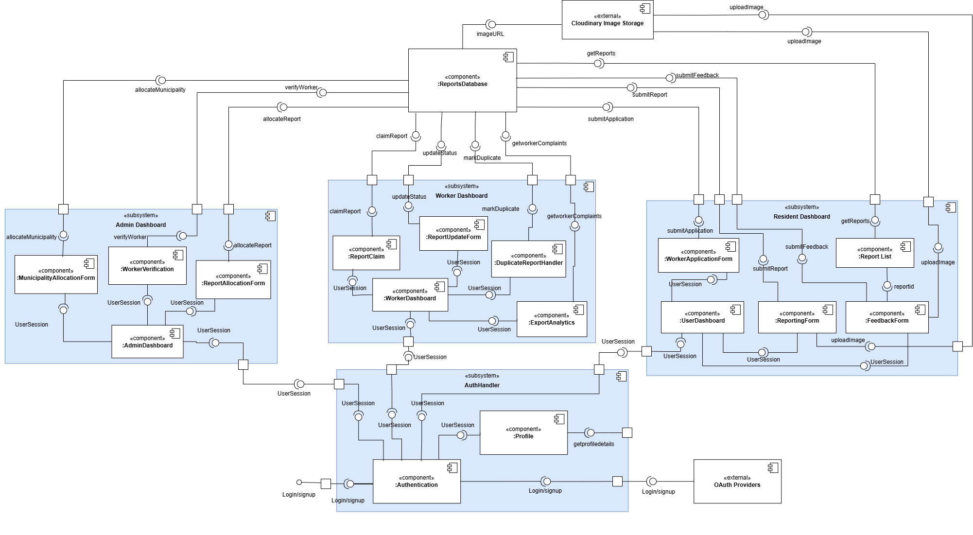
Figure 8. Expanded component view showing the Admin Dashboard, Worker Dashboard, Resident Dashboard and AuthHandler subsystems, their internal components, the ReportsDatabase, OAuth providers and Cloudinary image storage, together with the main report, feedback, worker-application and status-update interactions.

Sequence Diagram - Duplicate Complaint Handling
Diagram type: Sequence Diagram / Process View
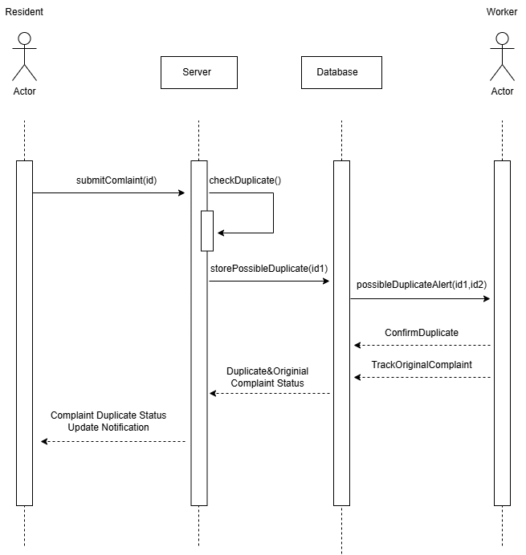
Figure 9. Duplicate-handling interaction sequence showing a resident submitting a complaint, the server checking for duplicates, the database storing a possible duplicate, a worker receiving the duplicate alert, confirming the duplicate, tracking the original complaint and the resident receiving a duplicate-status update notification.

