Municipal Reporting Web App
Testing Strategy and Evidence Document
TDD-style test planning, automated test coverage, validation tests, and screenshot evidence
Project | Municipal reporting web application
Prepared for | COMS 3009/28A Software Design
Version | 1.1 - final evidence draft
Date | 21 May 2026
Reference | S3 Testing lecture slides: TDD, unit testing, integration testing, system testing, quality testing, and acceptance testing

1. Purpose and Scope
This document describes the testing strategy used for the municipal reporting web application. It explains the testing levels, test design techniques, automated test coverage, validation evidence, and results documentation used to verify the system before final submission.
The strategy is presented using TDD-style principles. Expected behaviours were expressed as test cases and then validated through automated unit, component, route, integration, and acceptance-oriented tests. The document does not claim that every test was historically written before every implementation change; rather, it documents the testing work in a TDD-style format suitable for assessment.

2. System Under Test
The system under test is a municipal reporting portal for public users, residents, workers, and administrators. The application combines a public reporting interface with authenticated dashboards and role-based administrative controls.
Feature area | Description
Interactive map | Displays reports as coloured pins. Users can click pins to view complaint details and filter pins by status. The map is available to non-logged-in users.
Reports page | Allows users to view all reports and filter them by date, issue type, and municipality.
Contact page | Displays contact details for South African municipalities.
Tutorial | Guides new users through the main features of the application.
Admin functions | Admins approve or reject resident-to-worker requests, assign workers to municipalities and/or complaints, and view worker statistics.
Worker functions | Workers view assigned reports, completed reports, and worker-related dashboard information.
PDF export | Logged-in users can download a PDF export of the current screen.
Role-based access | Public, resident, worker, and admin users receive different access permissions.

3. Overall Testing Strategy
Testing was organised as a layered strategy rather than random manual checking. Lower-level tests verified isolated logic and components, while higher-level tests verified workflows across the frontend, API routes, authentication, and database behaviour.
Test level | Focus in the project | Purpose
Unit testing | Validation logic, route handlers, status updates, notification actions, guards, and utility behaviour. | Fast feedback and precise fault isolation.
Component testing | Allocation form, complaint form validation, dashboard cards, filters, buttons, and UI state changes. | Confirms individual interface behaviour.
Integration testing | Frontend actions connected to API requests, mocked database calls, authentication sessions, and role guards. | Confirms modules work together.
System / acceptance testing | Public map use, reports filtering, worker dashboard, admin assignment, PDF export, and blocked access scenarios. | Validates complete user-visible workflows.
Quality/security testing | Unauthorized sessions, forbidden roles, failed API requests, empty data, invalid IDs, and form validation. | Checks non-functional risks and failure handling.

4. TDD-style Test Design Techniques
The test cases were selected using the lecture testing heuristics: equivalence testing, boundary testing, control-flow testing, and state-based testing. These techniques improved coverage without requiring every possible input combination to be tested.
Technique | How it was applied
Equivalence / right-wrong input testing | Valid statuses, IDs, roles, employees, municipalities, complaint categories, and notification parameters were tested alongside invalid, missing, or unsupported values.
Boundary value testing | Missing required fields, empty results, no pending duplicates, disabled buttons before selection, missing complaint ID/status, and zero-result report lists were tested.
Error-handling testing | Database errors, network failures, non-ok API responses, unavailable routes, and rejected promises were tested to confirm controlled error responses.
Control-flow testing | Branches such as authenticated vs unauthenticated, authorized vs forbidden, successful vs failed request, found vs not found, and enabled vs disabled form state were exercised.
State-based testing | Complaint assignment, status changes, duplicate confirmation/rejection, pending duplicate review, and worker approval states were tested as state transitions.

5. Automated Test Coverage Summary
Automated tests were written with Jest-style assertions and mocks. External dependencies such as authentication sessions, database calls, notification functions, and fetch requests were mocked to isolate the unit or component under test.
Test area | Representative behaviours tested | Test type
Report status update route | Returns 400 for missing complaintid/status, returns 400 for invalid status, returns 404 when assignment is not found, updates status successfully, and returns 500 on database failure. | Route unit / error handling / boundary
Assigned reports route | Fetches assigned reports for the logged-in worker and returns a controlled 500 response when fetching fails. | Route unit / integration
Task allocation form | Sends POST to /api/assignments, sends correct complaintid and workerid, sends JSON headers, closes on success, does not close on API failure, logs network errors, and disables Allocate until required selection is made. | Component / boundary / error handling
Notification actions | Calls mark-all, mark-one, and create-notification handlers with the current user ID; rejects null sessions and missing user IDs as Unauthorized. | Unit / security
Authentication guard | Runs the handler for correct roles, rejects unauthenticated users, and rejects users with insufficient roles. | Security / control-flow
Duplicate routes | Confirms and rejects duplicates, validates invalid review IDs, handles already-reviewed/not-found records, returns empty pending duplicate lists, transforms pending duplicate data, and returns 500 on database failure. | Route unit / state-based / error handling

6. Feature-Level Acceptance Strategy
Scenario | Expected result
Public map access | A non-logged-in user can open the map, view complaint pins, click a pin, and filter visible pins by status.
Reports filtering | A user can filter reports by date, issue type, and municipality, with only matching reports displayed.
Complaint submission validation | Required complaint fields must be selected or filled before a complaint can be submitted.
Admin assignment | An admin can assign a worker to a complaint and priority only when required form selections are complete.
Worker dashboard | A worker can view worker information, assigned reports, completed reports, possible duplicates, and worker statistics.
Role protection | Users cannot perform actions outside their role; unauthenticated users and insufficient roles are rejected.

7. Screenshot Evidence
The following screenshots support the documented tests. They are included as visual evidence of role-based behaviour, validation rules, automated test output, and UI state changes.
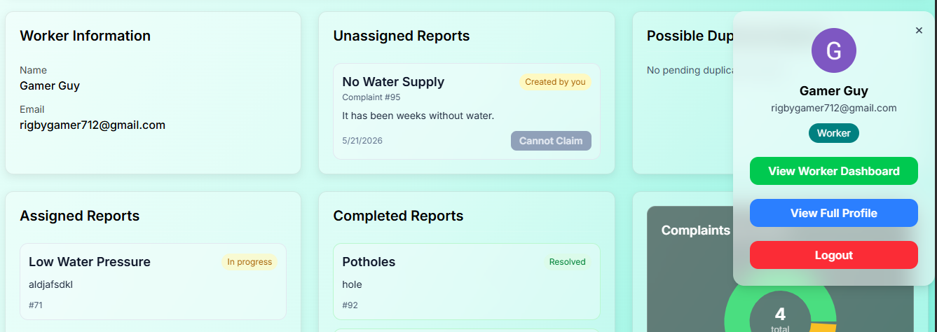
Figure 1. Worker dashboard evidence showing worker information, unassigned reports, assigned reports, completed reports, duplicate review area, and worker statistics.

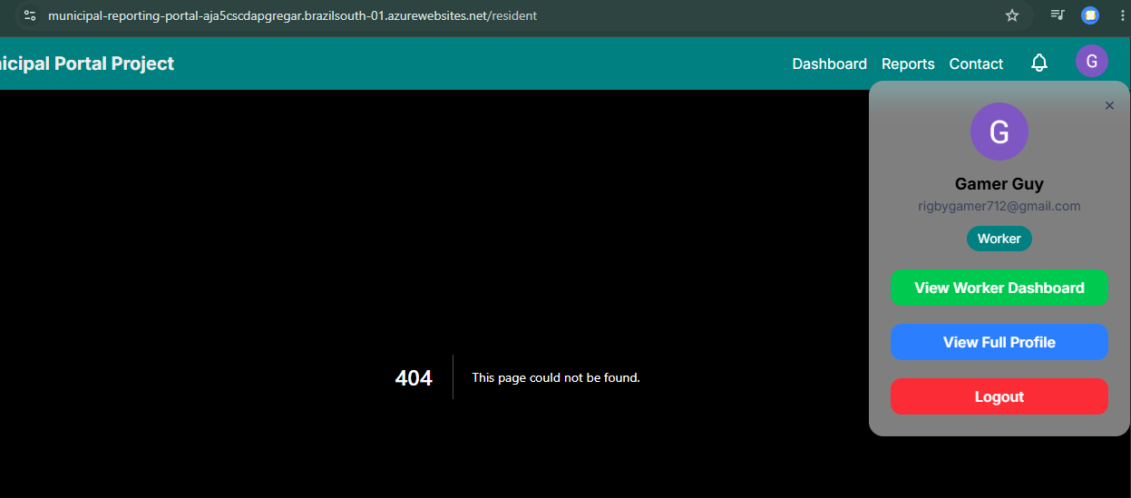
Figure 2. Negative route handling evidence showing an unavailable route returning a 404 page while the authenticated user menu remains visible.

8. Form State and Allocation Evidence
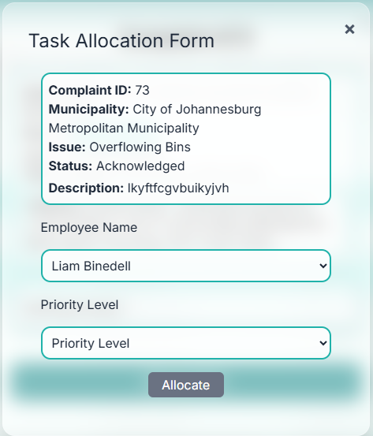 | 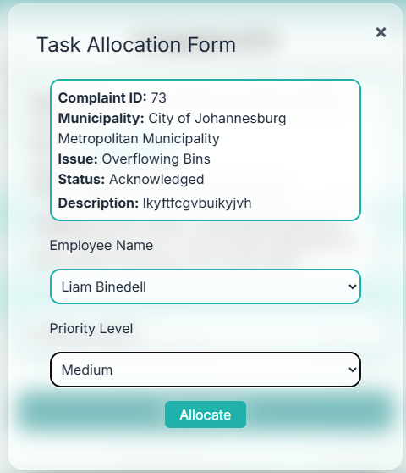
Figure 3. Allocation form with required fields incomplete; the Allocate action remains disabled. | Figure 4. Allocation form after valid employee and priority selections; the Allocate action becomes enabled.
These screenshots support boundary and control-flow testing of the allocation workflow. The form prevents submission while required selections are missing and only enables the allocation action after valid input is supplied.

9. Complaint Form Validation Evidence
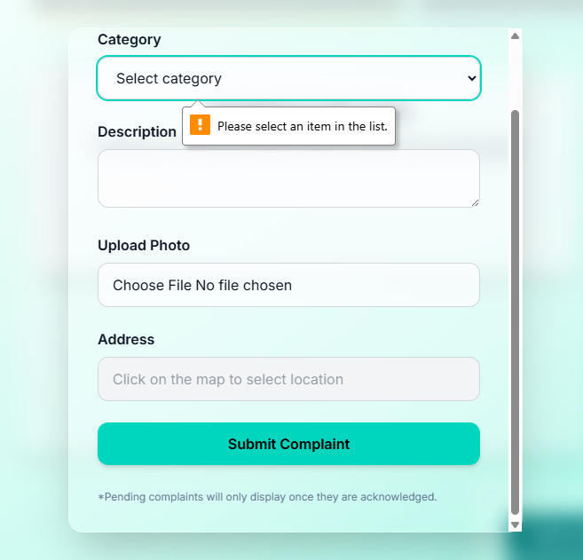 | 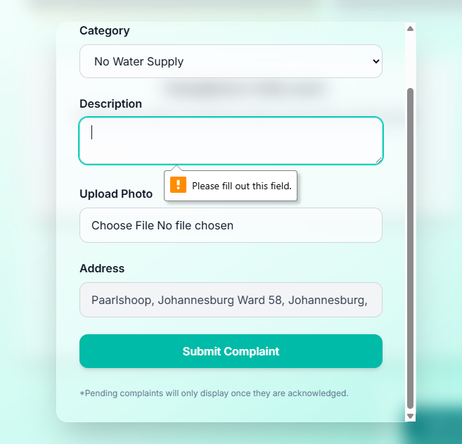
Figure 5. Complaint form category validation alert requiring the user to select a category. | Figure 6. Complaint form description validation alert requiring text input before submission.
These screenshots demonstrate right/wrong input testing and boundary validation for complaint submission. Required fields are enforced before the system accepts the complaint form.

10. Automated Coverage Evidence
The automated test run produced high overall coverage, with the captured report showing 94.28% statement coverage, 91.91% branch coverage, 97.47% function coverage, and 94.28% line coverage across all files. The route and library tests show especially strong coverage, while a small number of routes remained weaker and are recorded as known limitations.
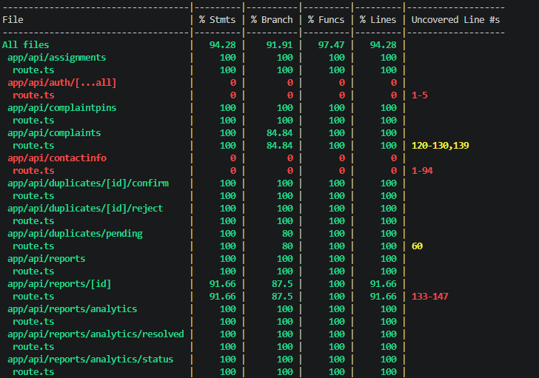
Figure 7. Jest coverage output showing overall coverage and route-level coverage for assignments, complaints, duplicates, and report routes.

10. Automated Coverage Evidence continued
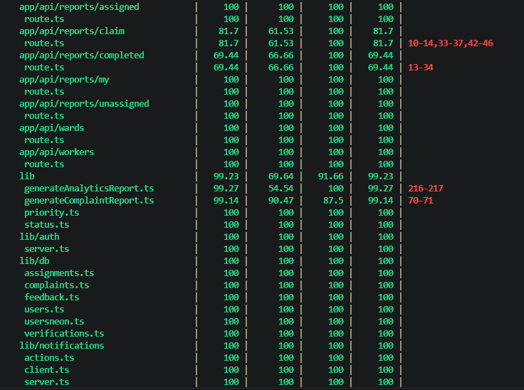
Figure 8. Coverage output showing report assignment routes, library modules, authentication helpers, database helpers, notifications, and server utilities.

11. Testing Results and Limitations
Result area | Outcome
Functional correctness | Core behaviours for report status updates, assigned reports, duplicate review, allocation submission, notification actions, role guards, and complaint validation were tested.
Negative and boundary cases | Missing fields, invalid IDs, invalid statuses, empty results, failed database calls, failed network requests, and unauthorized sessions were explicitly tested.
Security checks | The authentication guard tests confirmed that unauthenticated users and insufficient roles are rejected before protected handlers execute.
Known limitations | Testing does not prove the system is bug-free. Some lower-coverage routes remain as areas for future test expansion, and third-party authentication itself is treated as an external dependency.
Evidence plan | Screenshots of the test runner, UI validation states, dashboard states, route handling, and PDF exports should be kept with this report as final submission evidence.

12. Conclusion
The testing strategy used a systematic TDD-style approach that combined automated tests, mocked dependencies, input validation checks, error-handling tests, boundary tests, state-based tests, and role-based security tests. The evidence shows that the most important workflows were tested at multiple levels: isolated route/component behaviour, integrated application behaviour, and user-facing acceptance scenarios.

