Design-Related Diagrams
Municipal Reporting Portal

This document groups diagrams that describe detailed software design: class structures, state transitions and activity workflows for the municipal reporting portal.
Selection note: Only the latest or clearest version of duplicated/superseded uploads is included. Duplicate component and deployment images, the older report-status state diagram, and earlier Report class drafts were not repeated.

Included diagrams
Diagram | View / Type | Purpose in the document
Report Class Diagram | Class Diagram / Logical Design | Defines the main report data object, properties and accessors/mutators.
Feedback Class Diagram | Class Diagram / Logical Design | Defines complaint feedback data, rating, validation and conversion methods.
BetterAuth Class Structure | Class Diagram / Authentication Design | Shows user, session and account structures used by BetterAuth.
Report Status State Diagram | State Diagram | Shows the report lifecycle from creation to resolution.
Resident Complaint Activity | Activity Diagram | Models the resident workflow for logging in and submitting complaints.
Admin/Worker Workflow Activity | Activity Diagram | Models role-based flow from authentication through assignment and status update.
Worker Claim Activity | Activity Diagram | Models worker task-claim behaviour and rejection path.
Visitor Ward Browsing Activity | Activity Diagram | Models public dashboard browsing through ward selection, complaint list navigation and complaint-detail viewing.
Public Landing Wireframe | Wireframe / Interface Design | Shows the basic public portal shell with header, profile/menu control, main content area and footer.
Report List Wireframe | Wireframe / Interface Design | Shows the searchable/filterable table layout intended for report or complaint listings.
User Profile Wireframe | Wireframe / Interface Design | Shows the profile summary panel with user identity, contact details, district, role and logout action.
Authentication Wireframe | Wireframe / Authentication Design | Shows the OAuth-based login and sign-up options presented to users.
Dashboard Layout Wireframe | Wireframe / Interface Design | Shows KPI cards, an interactive map area and an additional details panel on the dashboard.
Admin Dashboard Wireframe | Wireframe / Admin Interface Design | Shows the administrator landing area and navigation blocks for complaints, users and workers.
Complaint Allocation Wireframe | Wireframe / Admin Interface Design | Shows the complaint details view and the action for allocating a complaint to a worker.
Resident Dashboard Prototype | Interface Prototype / Dashboard Design | Shows the dashboard prototype with category cards, logged/resolved statistics and a call-to-action to log a new query.

Class Diagram - Report Model (Part 1 of 3)
Diagram type: Class Diagram / Logical Design
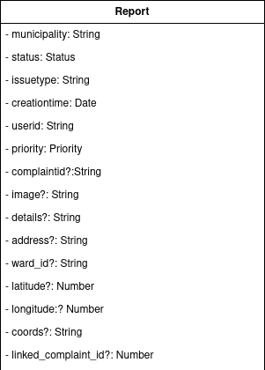
Figure 1. Report class diagram, part 1 of 3, showing the class header and primary report attributes such as status, issue type, user identifier, priority, location and linked complaint fields.

Class Diagram - Report Model (Part 2 of 3)
Diagram type: Class Diagram / Logical Design
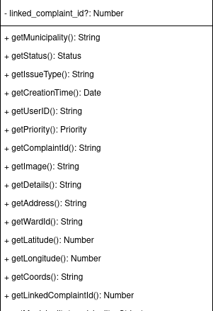
Figure 2. Report class diagram, part 2 of 3, showing key accessor methods for report identifiers, image, details, address, ward and location coordinates.

Class Diagram - Report Model (Part 3 of 3)
Diagram type: Class Diagram / Logical Design
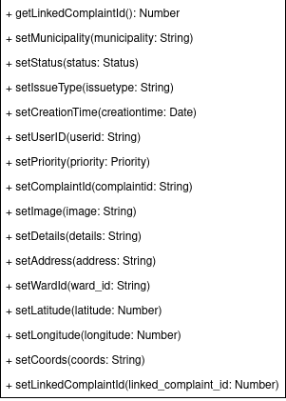
Figure 3. Report class diagram, part 3 of 3, showing mutator methods for status, issue type, creation time, user, priority, image, details, address, ward, coordinates and linked complaints.

Class Diagram - Feedback Model
Diagram type: Class Diagram / Logical Design
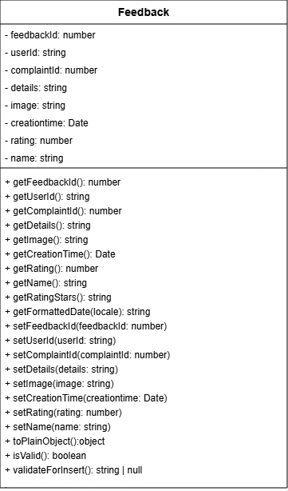
Figure 4. Feedback class design showing complaint feedback fields, rating handling, formatted-date access, object conversion and validation methods.

Class Diagram - BetterAuth Structure
Diagram type: Class Diagram / Authentication Design
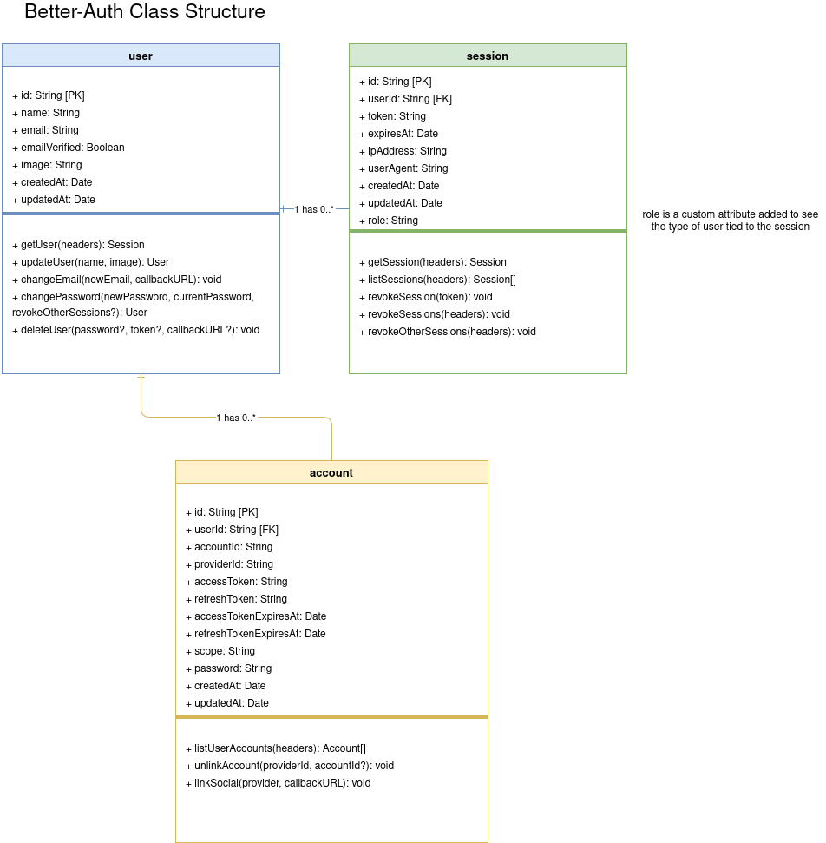
Figure 5. Authentication class structure showing BetterAuth user, session and account entities, including user-session and user-account relationships.

State Diagram - Report Status Lifecycle
Diagram type: State Diagram
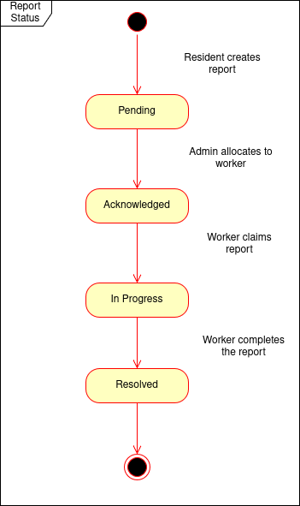
Figure 6. Report status lifecycle showing the transition from Pending to Acknowledged, then In Progress and finally Resolved as the resident, admin and worker complete their responsibilities.

Activity Diagram - Resident Complaint Submission
Diagram type: Activity Diagram
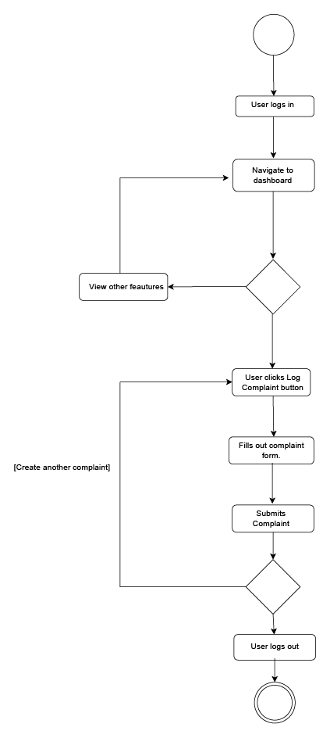
Figure 7. Resident activity flow showing login, dashboard navigation, feature branching, complaint form completion, submission, optional repeat complaint creation and logout.

Activity Diagram - Admin and Worker Task Flow
Diagram type: Activity Diagram
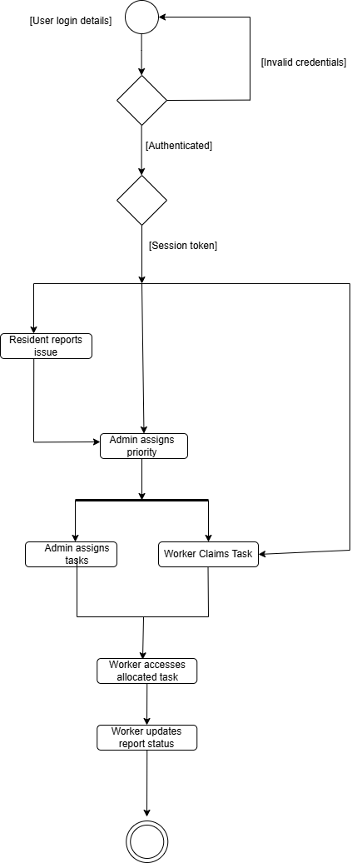
Figure 8. Role-based activity flow showing login validation, session token handling, resident issue reporting, admin prioritisation/allocation, worker claiming and worker report-status update.

Activity Diagram - Worker Claims Task
Diagram type: Activity Diagram
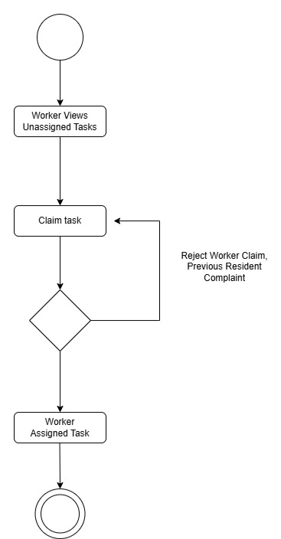
Figure 9. Worker claim workflow showing how a worker views unassigned tasks, attempts to claim a task, receives rejection when applicable, and becomes assigned when the claim is valid.

Activity Diagram - Visitor Ward Complaint Browsing
Diagram type: Activity Diagram
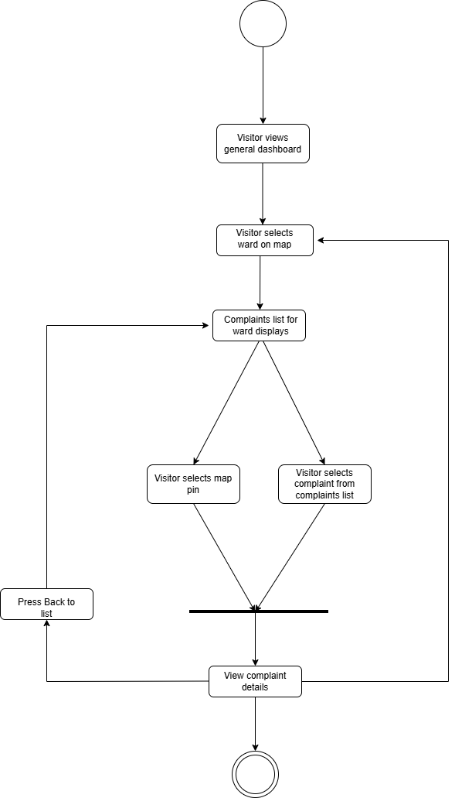
Figure 10. Visitor browsing workflow showing a visitor opening the public dashboard, selecting a ward on the map, viewing the complaints list for that ward, choosing either a map pin or a complaint from the list, viewing complaint details, and optionally navigating back to the list to continue browsing.

UI Wireframes and Interface Prototypes
The following design artefacts document the main user-interface layouts used by the municipal reporting portal, including public, resident, admin, authentication, profile, dashboard and complaint-allocation screens.

UI Wireframe - Public Landing Page
Diagram type: Wireframe / Interface Design
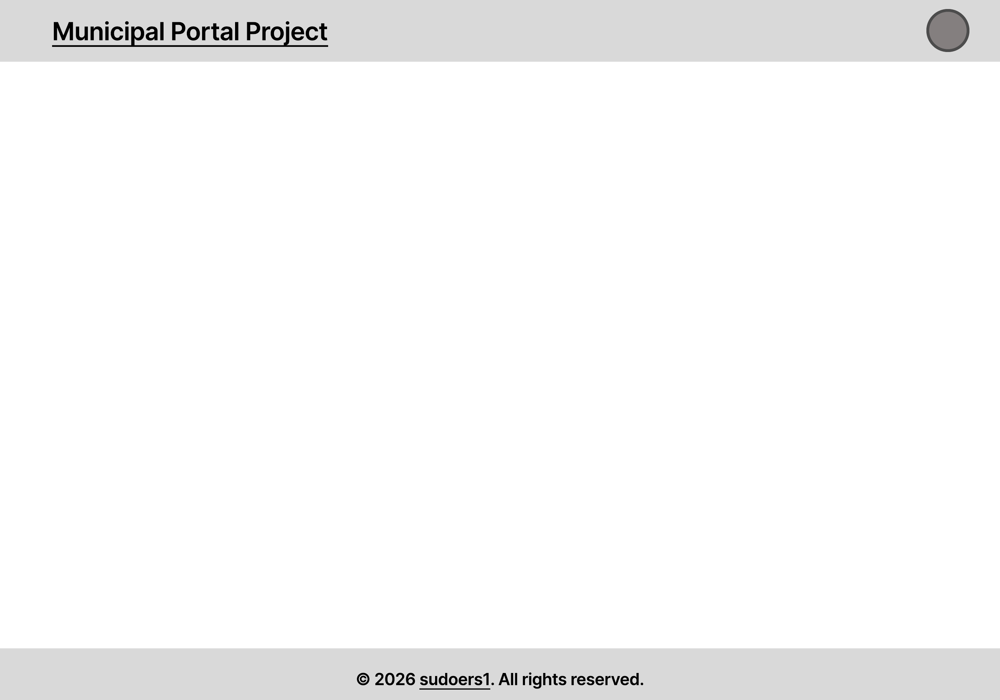
Figure 11. Public landing-page wireframe showing the municipal portal shell, including the header area, main content region and footer structure.

UI Wireframe - Report List Table
Diagram type: Wireframe / Interface Design
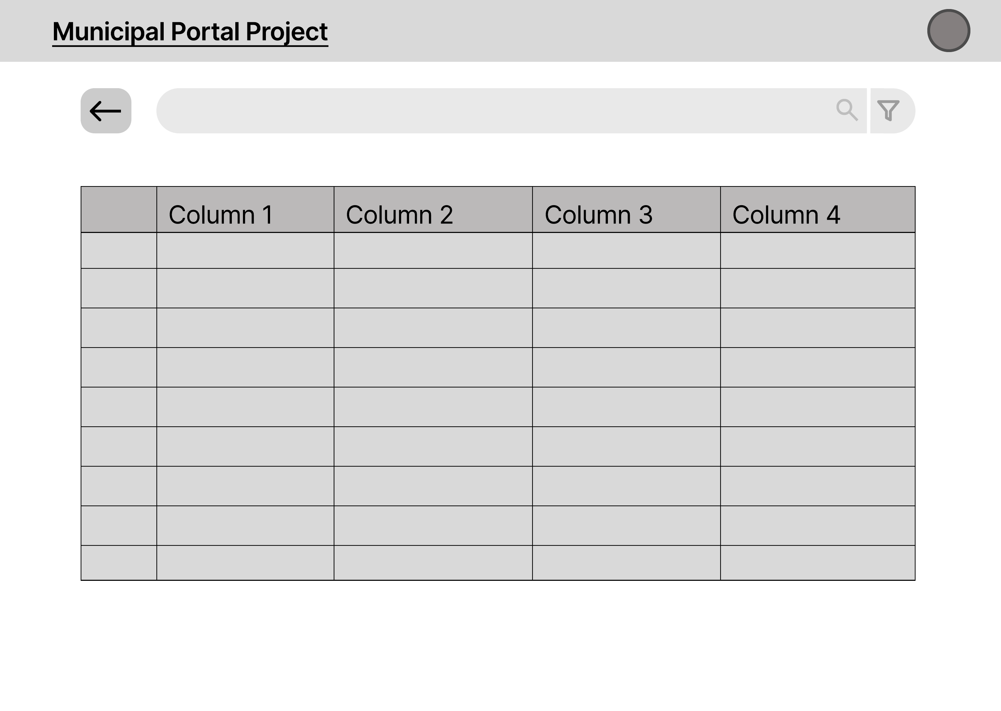
Figure 12. Report-list wireframe showing a table-based layout with search/filter controls and multiple data columns for browsing municipal portal records.

UI Wireframe - User Profile Panel
Diagram type: Wireframe / Interface Design
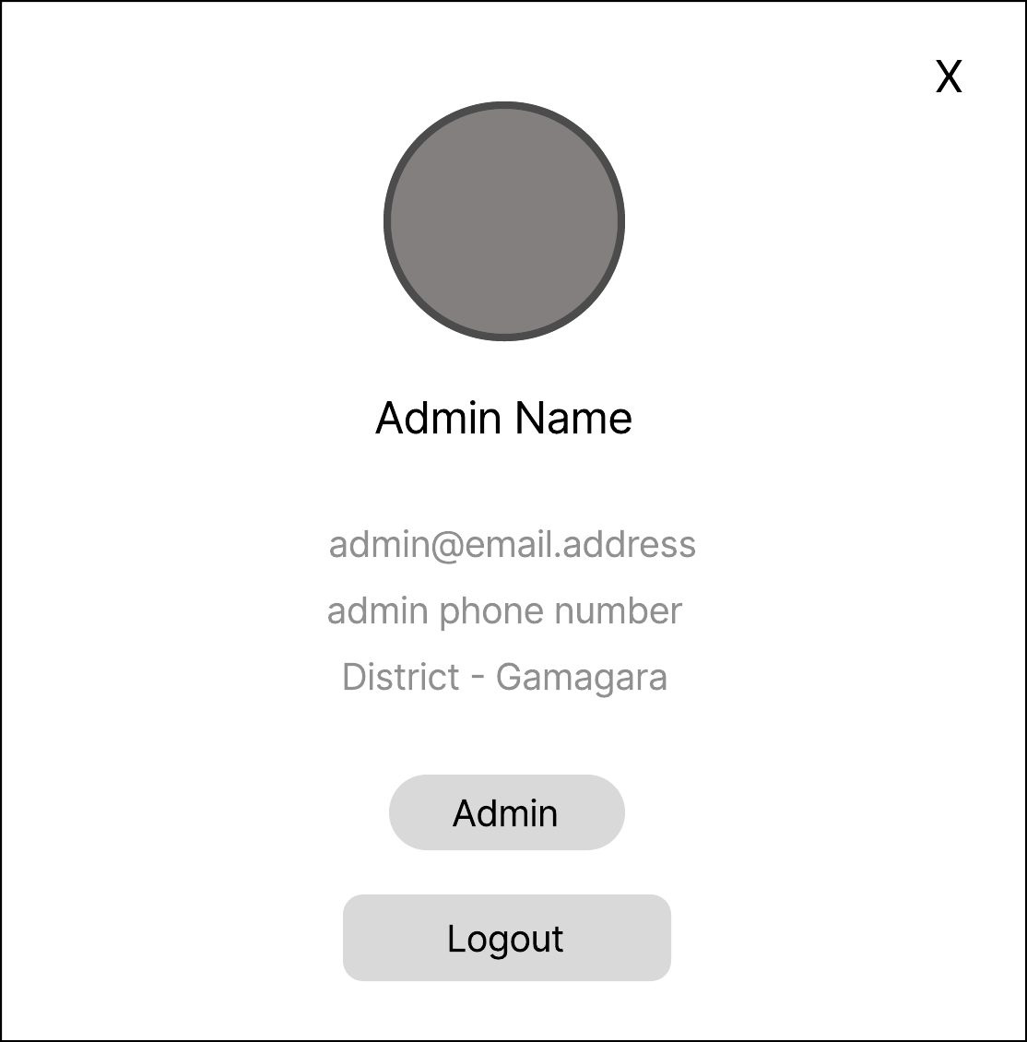
Figure 13. User profile wireframe showing the profile modal/panel with display image, administrator name, contact details, district, role indicator and logout action.

UI Wireframe - Login and Sign-Up Options
Diagram type: Wireframe / Authentication Design
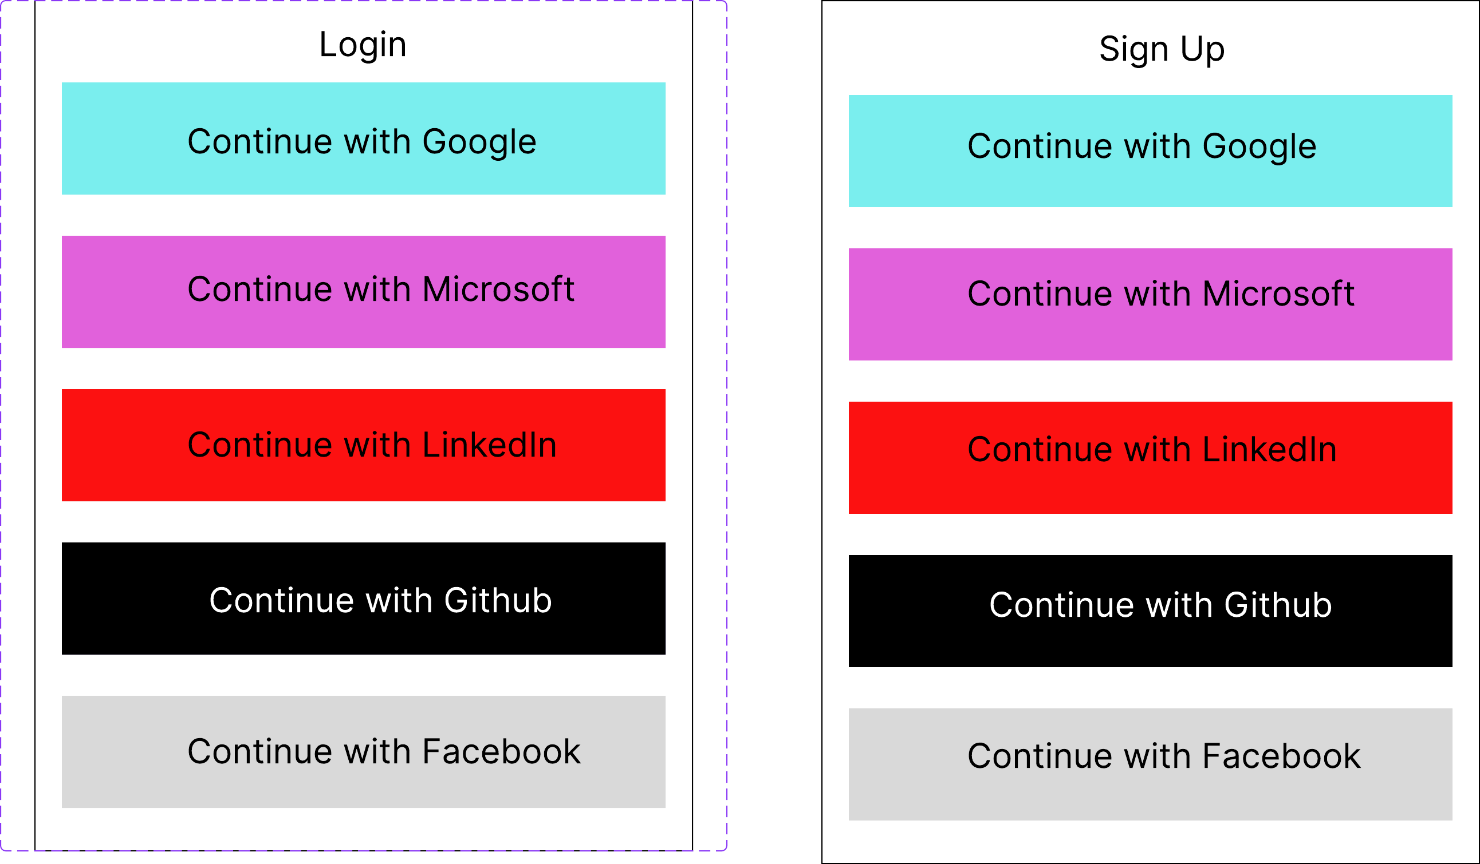
Figure 14. Authentication wireframe showing the login and sign-up screens with supported OAuth provider options including Google, Microsoft, LinkedIn, GitHub and Facebook.

UI Wireframe - Dashboard Layout
Diagram type: Wireframe / Interface Design
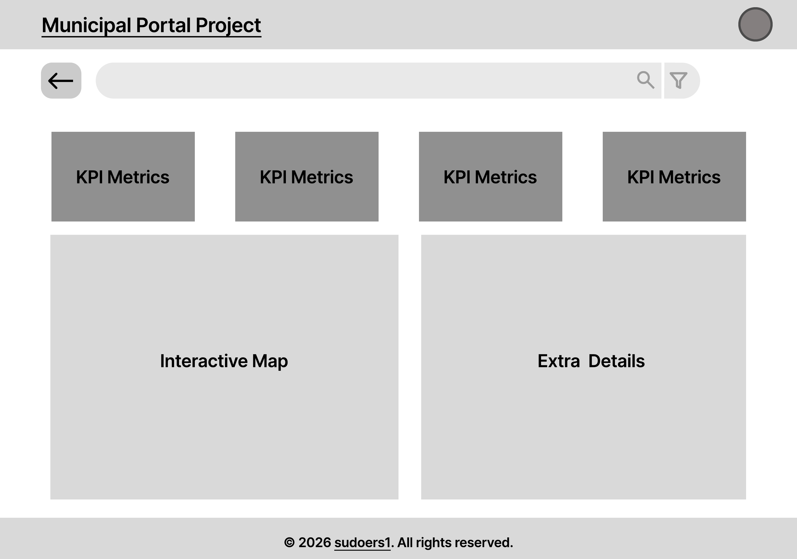
Figure 15. Dashboard layout wireframe showing KPI metric cards above an interactive map panel and extra details panel.

UI Wireframe - Admin Dashboard
Diagram type: Wireframe / Admin Interface Design
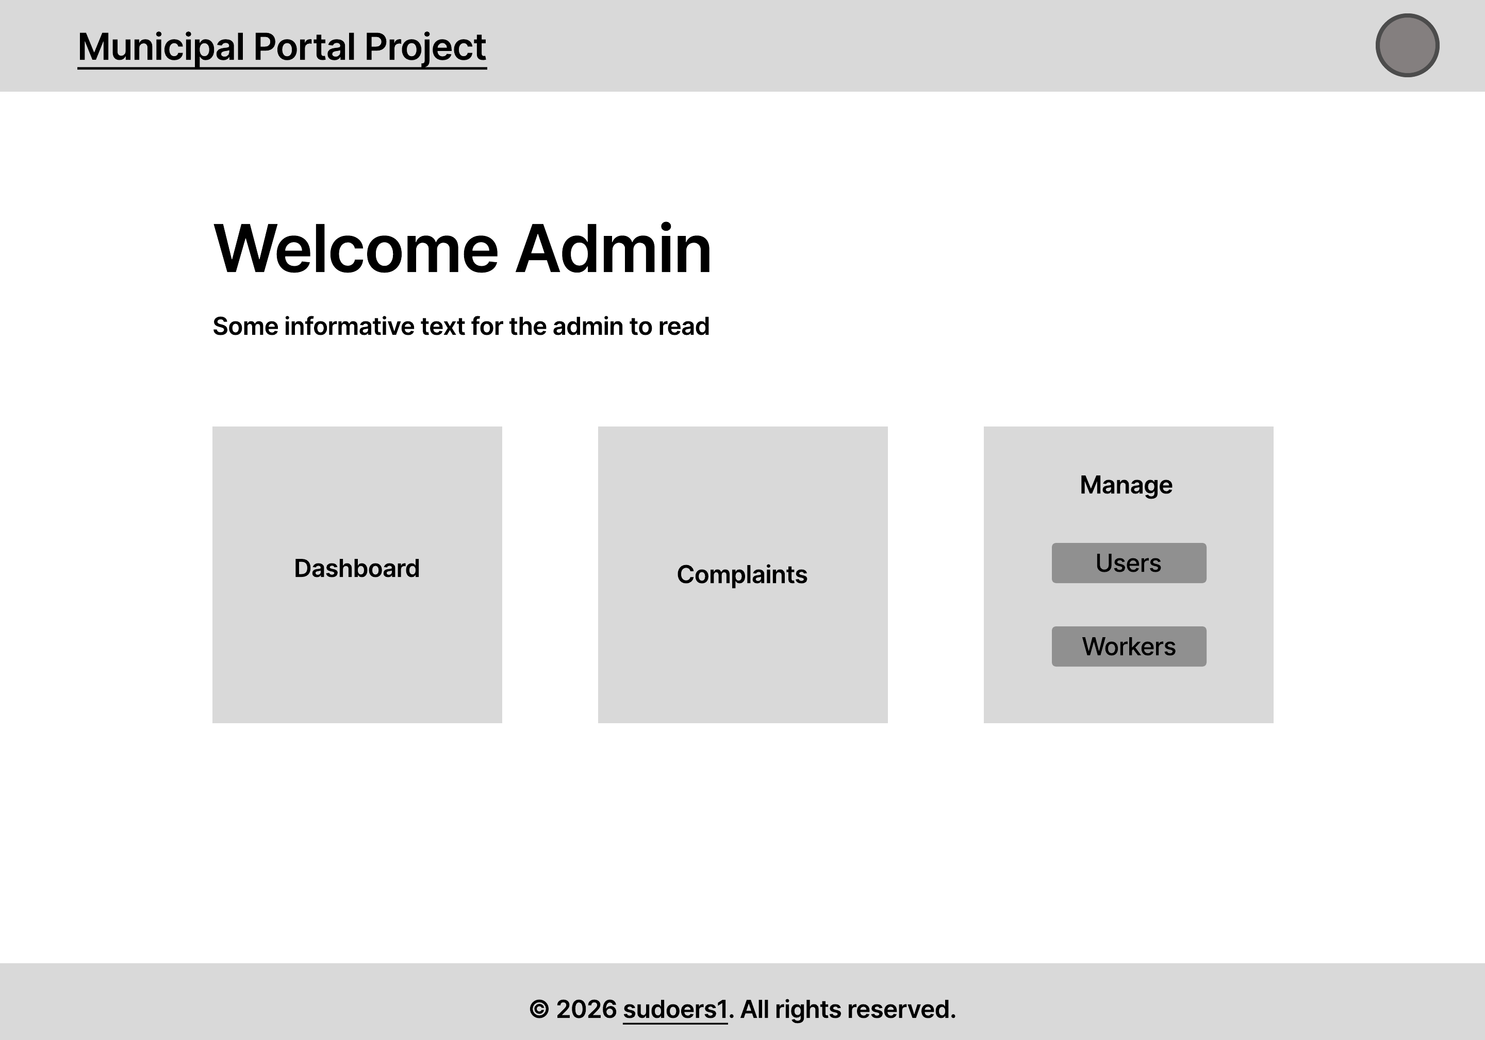
Figure 16. Admin dashboard wireframe showing the welcome area and navigation blocks for dashboard access, complaints and user/worker management.

UI Wireframe - Complaint Allocation Screen
Diagram type: Wireframe / Admin Interface Design
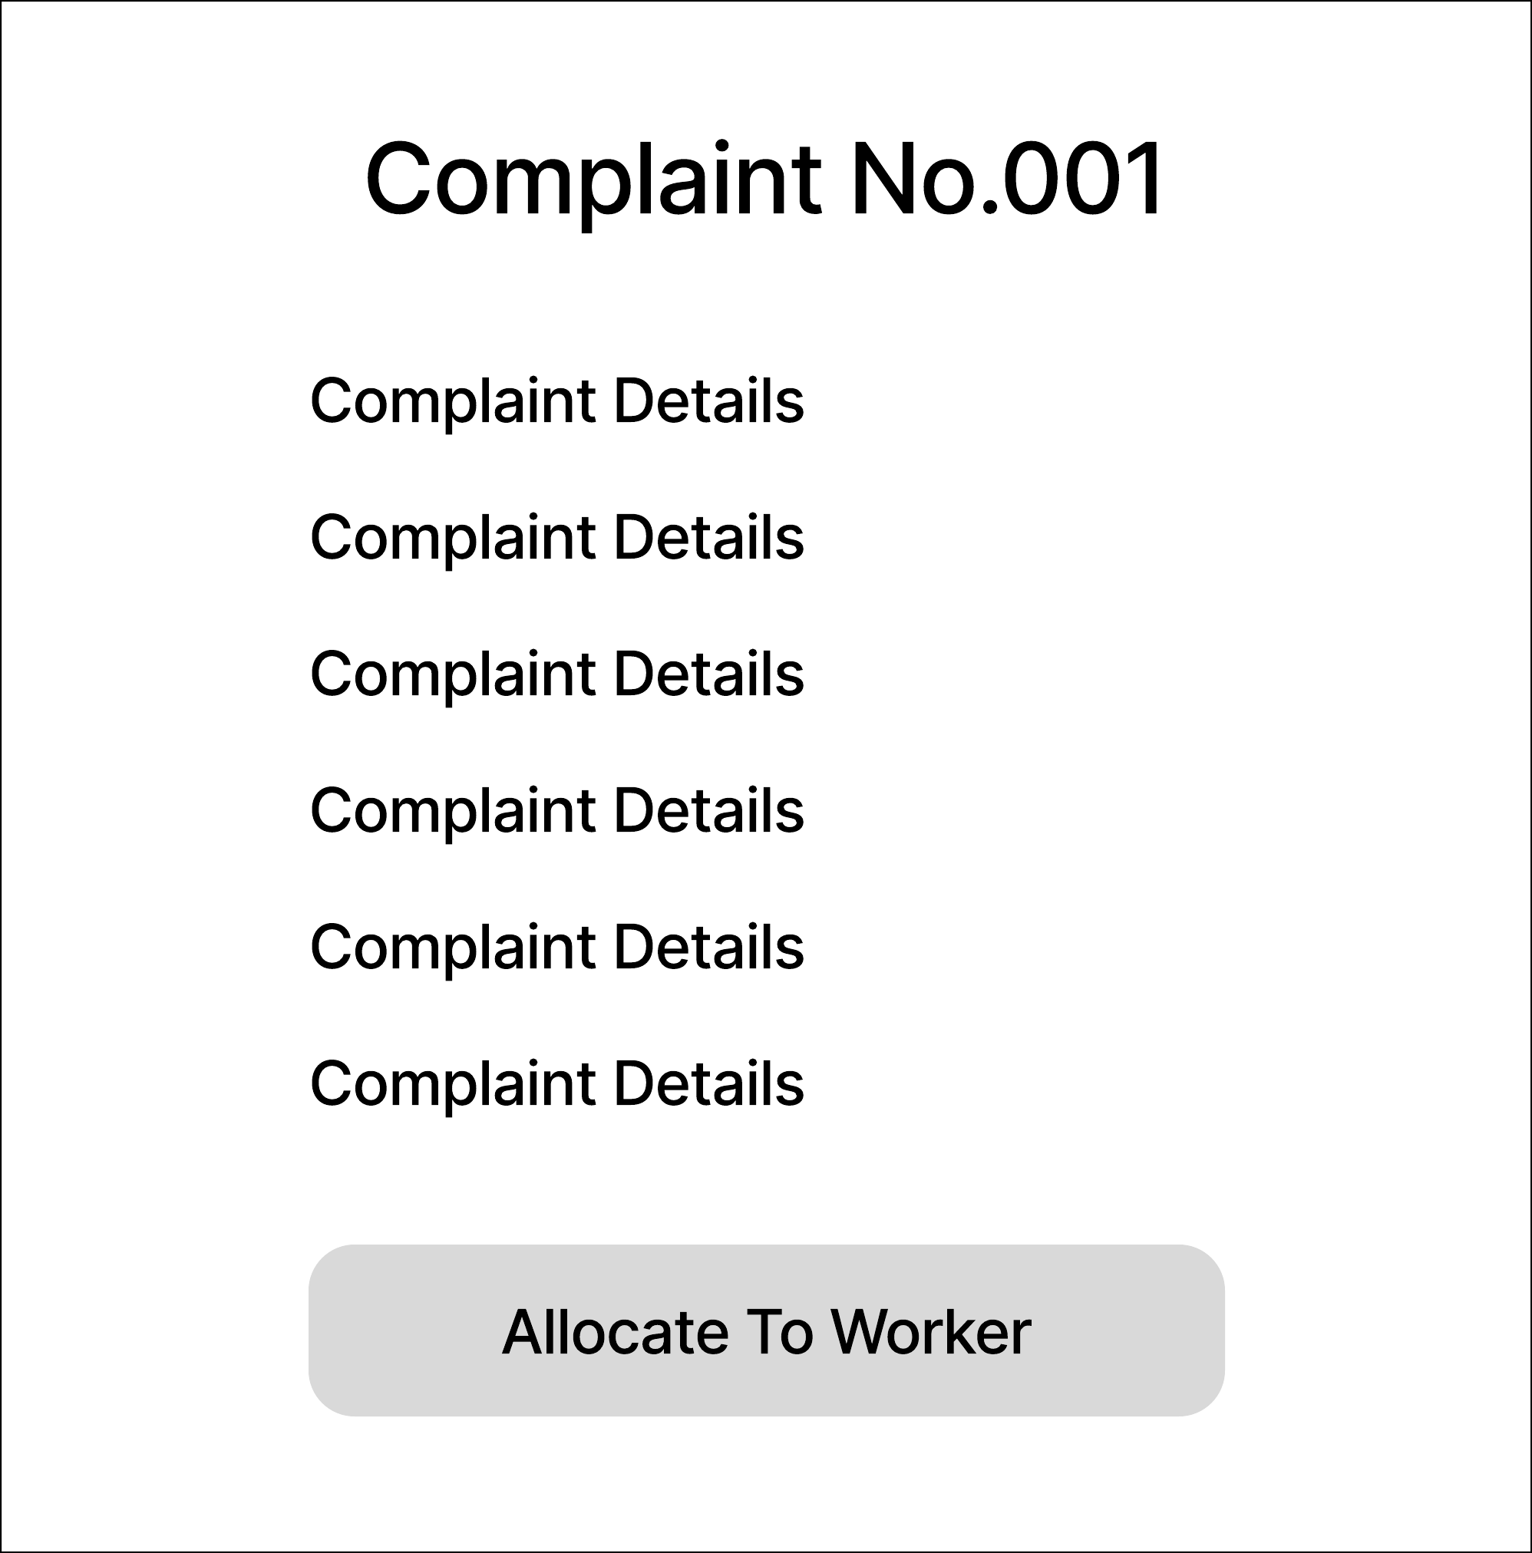
Figure 17. Complaint allocation wireframe showing complaint details and the primary action used by an administrator to allocate the complaint to a worker.

UI Prototype - Resident Dashboard
Diagram type: Interface Prototype / Dashboard Design
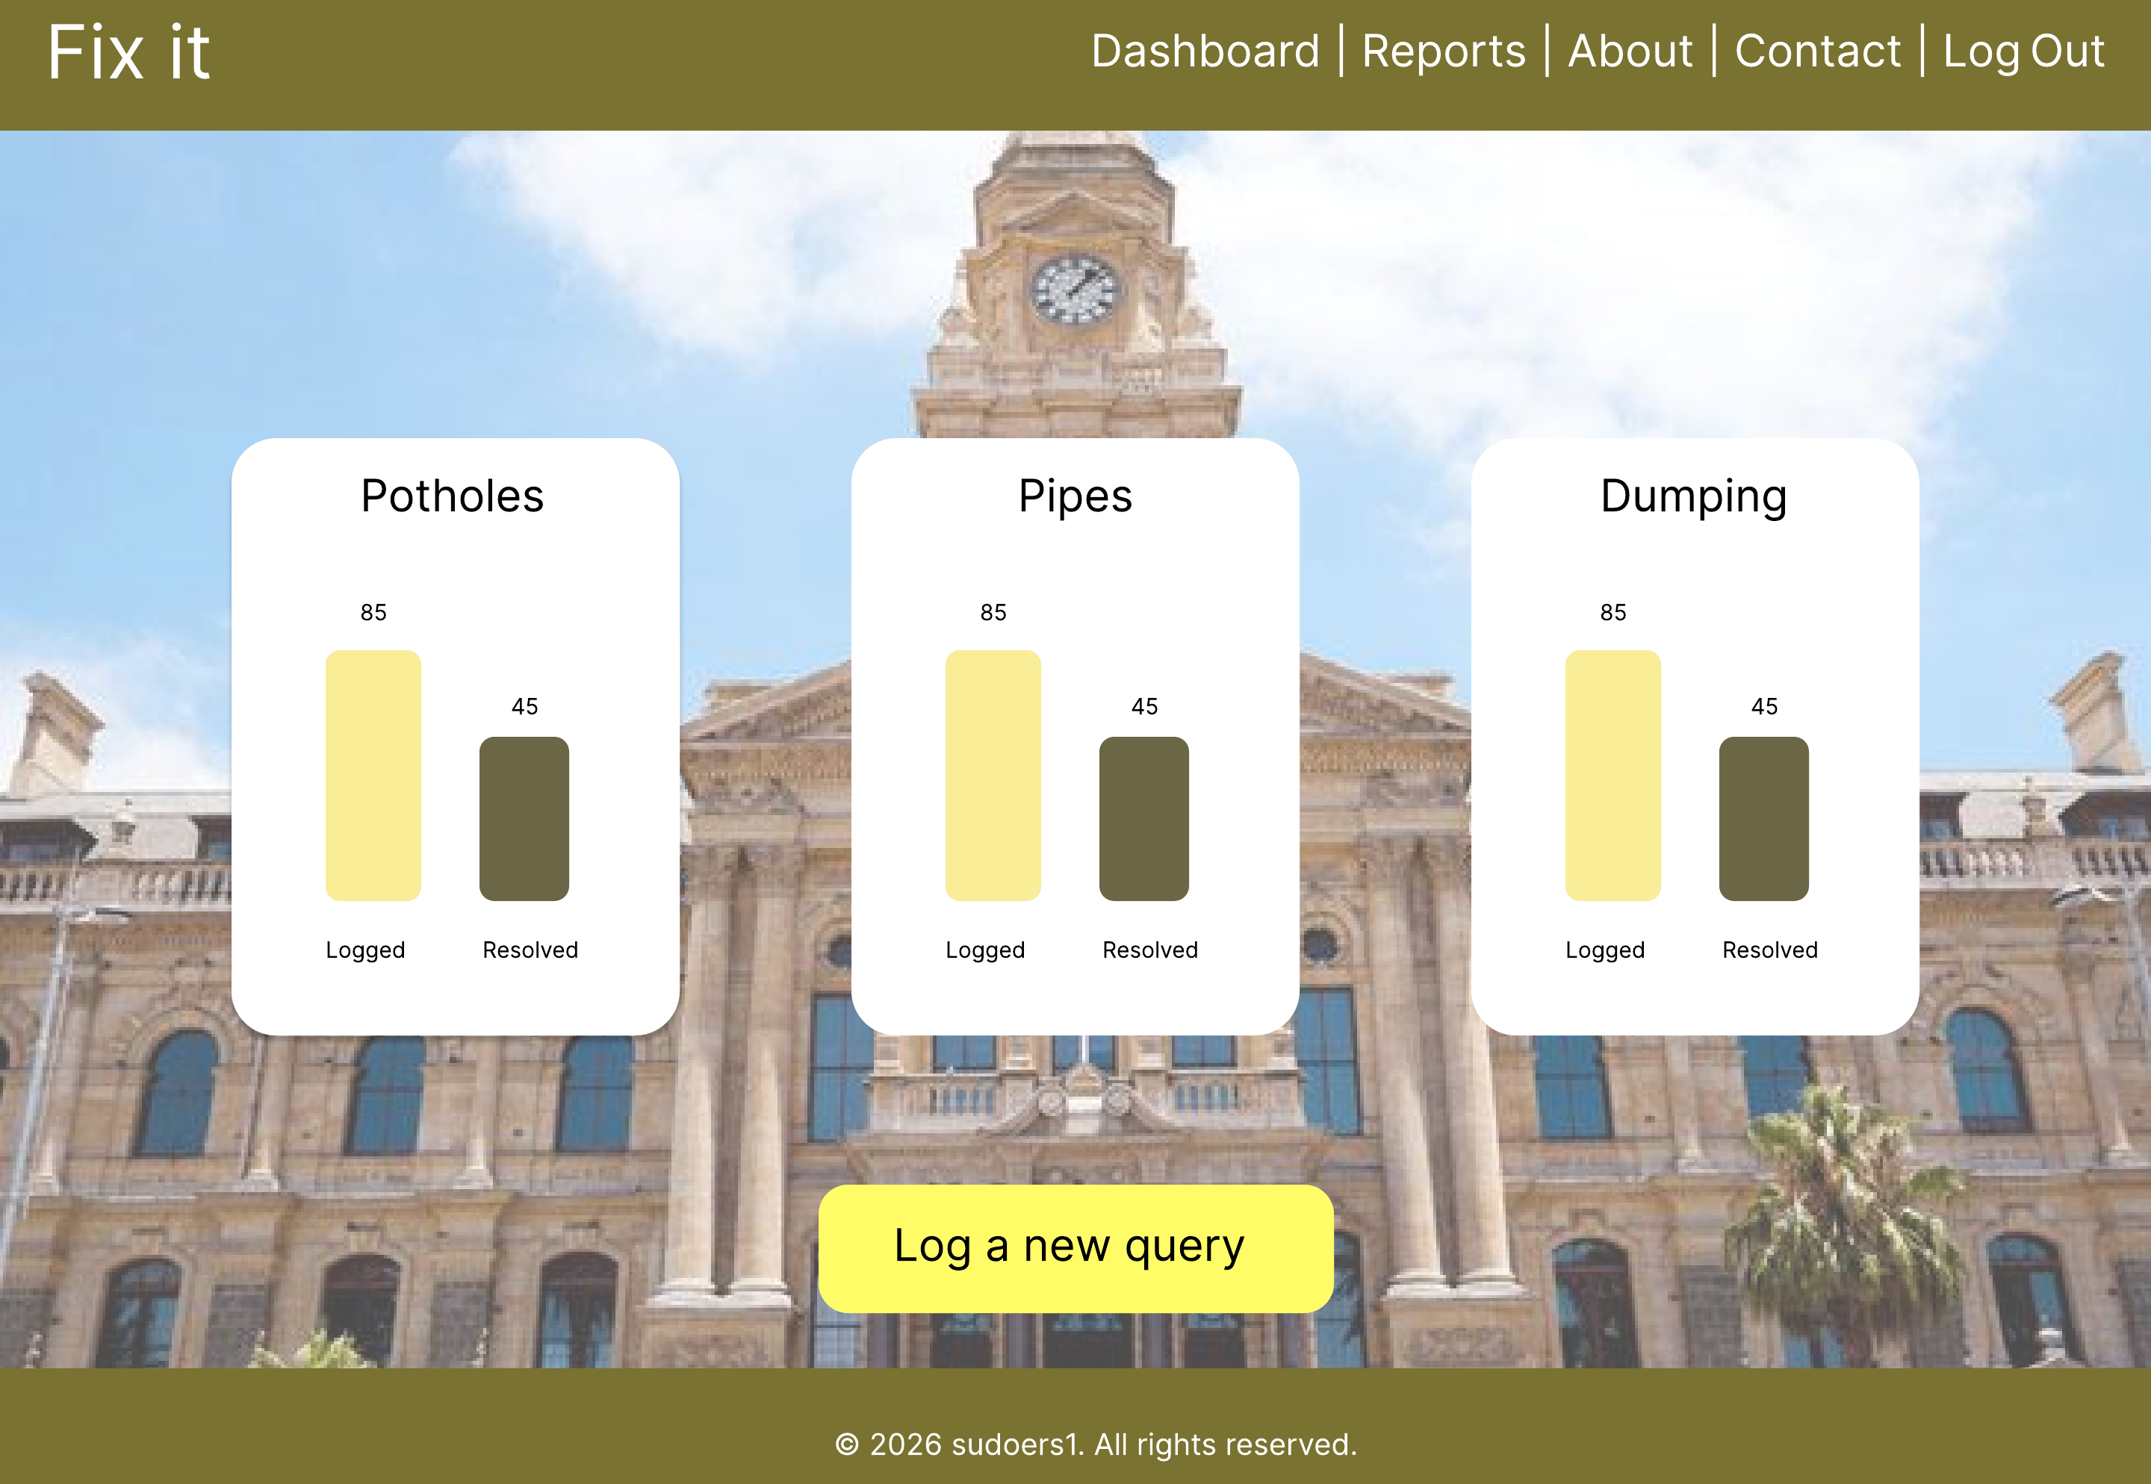
Figure 18. Resident dashboard prototype showing navigation links, category summary cards for potholes, pipes and dumping, logged/resolved counts and a call-to-action for logging a new query.

