**Lab Report 1**

**Image Processing Operations**

**Digital Image Processing**

**CSE438**

**Section:** 03

**Semester:** Spring 2025

**Submitted To:**

**Md. Asif Khan Rifat**

**Lecturer**

Department of Computer Science

and Engineering

**Submitted By:**

                                                                         Suddip Paul Arnab

**2022-1-60-356**

**Date of submission:** 3 March 2025

1. Determine the perimeter of an object by using 4 connected neighborhoods and 8 connected neighborhoods.

**Code**:

img = imread("Picture1.png");

imshow(img);

bin_img = imbinarize(img);

n4 = bwperim(bin_img, 4);

n8 = bwperim(bin_img, 8);

subplot(1,2,1),imshowpair(bin_img,n4,'montage');

title("4 Neighborhoods");

subplot(1,2,2),imshowpair(bin_img,n8,'montage');

title("8 Neighborhoods");

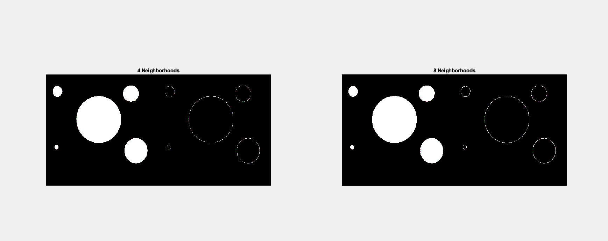

1. Create a binary image using a threshold.

**Code**:

img = imread("Picture2.png");

gray_img = rgb2gray(img);

imshow(gray_img);

binary_img1 = imbinarize(gray_img, 0.4);

binary_img2 = imbinarize(gray_img, 0.5);

binary_img3 = imbinarize(gray_img, 0.6);

subplot(2,2,1),imshow(binary_img1);

title("Threshold 0.4");

subplot(2,2,2),imshow(binary_img2);

title("Threshold 0.5");

subplot(2,2,3),imshow(binary_img3);

title("Threshold 0.6");

1. Determine the number of objects in the binary image generated in Question 2 using the concept of connectivity.

**Code**:

img = imread("Picture2.png");

gray_img = rgb2gray(img);

binary_img2 = imbinarize(gray_img, 0.5);

n4 = bwconncomp(binary_img2, 4);

n8 = bwconncomp(binary_img2, 8);

num_objects_4 = n4.NumObjects;

num_objects_8 = n8.NumObjects;

disp(["Number of objects with 4-connectivity: ", num2str(num_objects_4)]);

disp(["Number of objects with 8-connectivity: ", num2str(num_objects_8)]);

1. Find the Euclidean distance between two points of the image.

**Code**:

i3 = imread("Picture2.png");

imshow(i3);

title('Select two points on the image');

[x, y] = ginput(2);

distance = norm([x(2) - x(1), y(2) - y(1)]);

fprintf('The Euclidean distance between the points is: %.2f\n', distance);

hold on;

plot(x, y, 'r-', 'LineWidth', 2);

text(mean(x), mean(y), sprintf('Distance: %.2f', distance), 'Color', 'red', 'FontSize', 12, 'HorizontalAlignment', 'center');

hold off;

title('Distance Line Added');



1. Apply the following operations using Fig.1 and Fig.2:
2. Addition
3. Subtraction
4. Multiplication
5. Division

**Code**:

img1 = imread("Picture1.png");

img2 = imread("Picture2.png");

img2 = imresize(img2, size(img1(:,:,1)));

gray_img1 = rgb2gray(img1);

gray_img2 = rgb2gray(img2);

img_add = imadd(gray_img1, gray_img2);

img_subtract = imsubtract(gray_img1, gray_img2);

img_multiply = immultiply(gray_img1, gray_img2);

img_divide = imdivide(gray_img1, gray_img2);

figure;

subplot(2,2,1), imshow(img_add), title('Addition');

subplot(2,2,2), imshow(img_subtract), title('Subtraction');

subplot(2,2,3), imshow(img_multiply), title('Multiplication');

subplot(2,2,4), imshow(img_divide, []), title('Division');

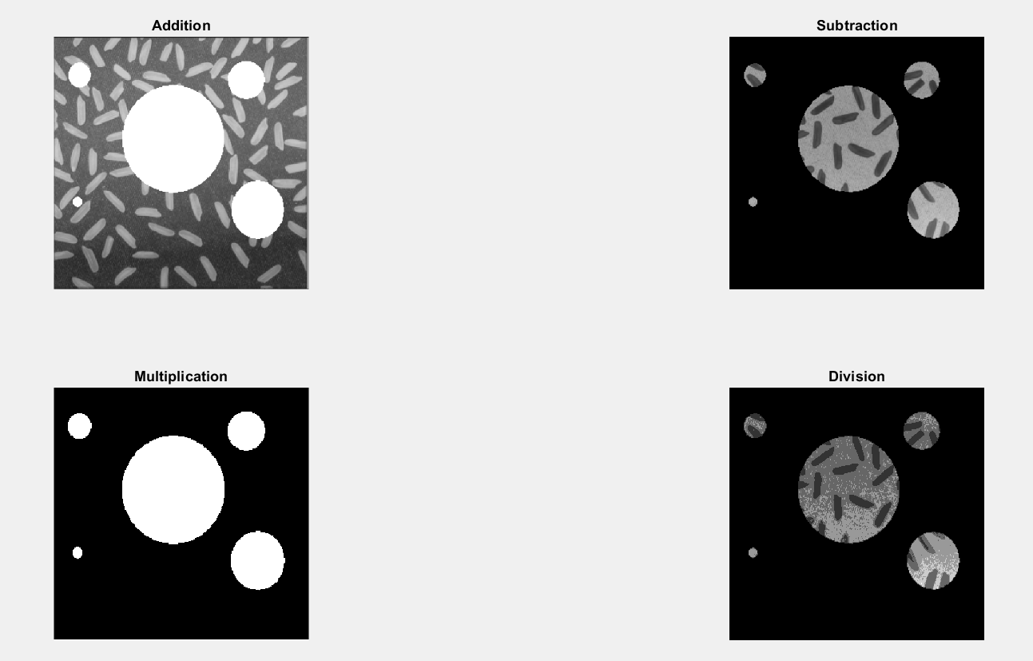

1. Apply the following operations using Fig.1 and Fig.2:
2. AND
3. OR
4. NOT

**Code**:

img1 = imread("Picture1.png");

img2 = imread("Picture2.png");

img2 = imresize(img2, size(img1(:,:,1)));

gray_img1 = rgb2gray(img1);

gray_img2 = rgb2gray(img2);

img_and = bitand(gray_img1, gray_img2);

img_or = bitor(gray_img1, gray_img2);

img_not1 = bitcmp(gray_img1);

img_not2 = bitcmp(gray_img2);

figure;

subplot(2,2,1), imshow(img_and), title('AND Operation');

subplot(2,2,2), imshow(img_or), title('OR Operation');

subplot(2,2,3), imshow(img_not1), title('NOT Operation of Picture1');

subplot(2,2,4), imshow(img_not2), title('NOT Operation of Picture2');

7. Adjust the contrast of the following image.

**Code**:

img3 = imread("Picture3.png");

gray_img3 = im2gray(img3);

num_of_levels = 128;

contrast_img = floor(gray_img3 / (256 / num_of_levels)) * (256 / num_of_levels);

figure;

subplot(1,2,1), imshow(gray_img3), title('Original Image');

subplot(1,2,2), imshow(contrast_img, []), title('Contrast Adjusted Image');

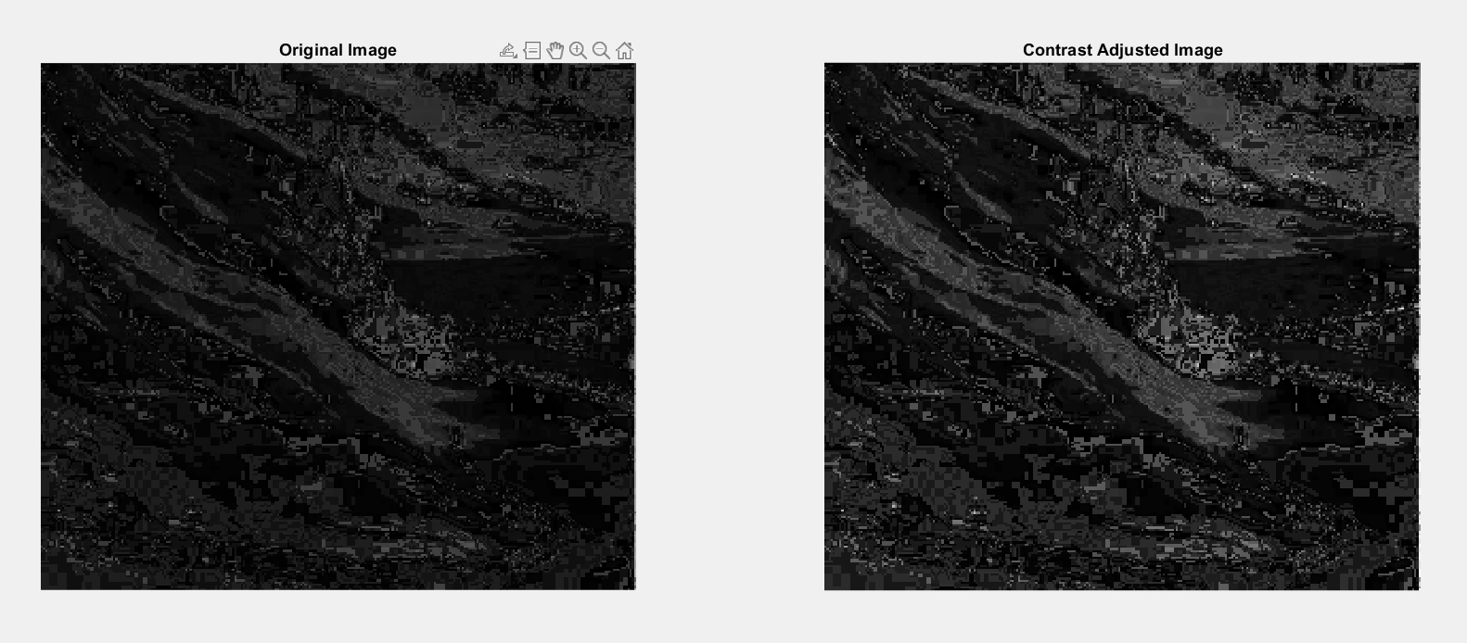

8. Brighten the following image

**Code**:

img4 = imread("Picture4.jpg");

gray_img4 = im2gray(img4);

brightness_increase = 100;

brightened_img = min(gray_img4 + brightness_increase, 255);

figure;

subplot(1,2,1), imshow(gray_img4), title('Original Image (Picture4)');

subplot(1,2,2), imshow(brightened_img, []), title('Brightened Image');

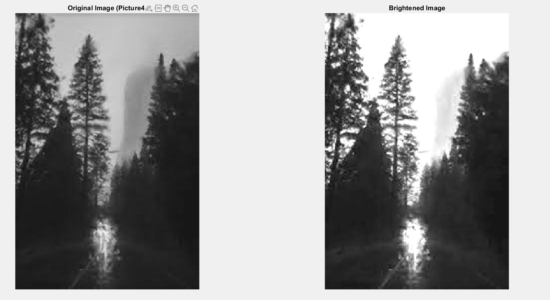

9. Quantize the Grayscale image by 8 levels.

**Code**:

img = imread("Picture5.png");

gray_img = im2gray(img);

quantized_img = gray_img;

[r, c] = size(quantized_img);

for i = 1:r

for j = 1:c

f = quantized_img(i, j);

if f <= 32

quantized_img(i, j) = 16;

elseif f > 32 && f <= 64

quantized_img(i, j) = 48;

elseif f > 64 && f <= 96

quantized_img(i, j) = 80;

elseif f > 96 && f <= 128

quantized_img(i, j) = 112;

elseif f > 128 && f <= 160

quantized_img(i, j) = 144;

elseif f > 160 && f <= 192

quantized_img(i, j) = 176;

elseif f > 192 && f <= 224

quantized_img(i, j) = 208;

else

quantized_img(i, j) = 240;

end

end

end

figure;

subplot(1,2,1), imshow(gray_img), title('Original Image');

subplot(1,2,2), imshow(quantized_img, []), title('Quantized Grayscale image by 8 levels');

10. Find the digital negative of the image.

**Code**:

img = imread("Picture6.png");

gray_img = im2gray(img);

negative_img = 255 - gray_img;

figure;

subplot(1,2,1), imshow(gray_img), title('Original Grayscale Image');

subplot(1,2,2), imshow(negative_img), title('Digital Negative Image');

