**Lab Report 2**

**Advanced Image Processing Operations**

**Digital Image Processing**

**CSE438**

**Section:** 03

**Semester:** Spring 2025

**Submitted To:**

**Md. Asif Khan Rifat**

**Lecturer**

Department of Computer Science

and Engineering

**Submitted By:**

                                                                         Suddip Paul Arnab

**2022-1-60-356**

**Date of submission:** 13 March 2025

1. Use contrast stretching on the image.

img = imread('Picture1.jpg');

gray_img = rgb2gray(img);

min_intensity = min(gray_img(:));

max_intensity = max(gray_img(:));

contrast_stretched_img = imadjust(gray_img, [min_intensity / 255, max_intensity / 255], [0 1]);

figure;

subplot(1, 2, 1);

imshow(gray_img);

title('Original Image');

subplot(1, 2, 2);

imshow(contrast_stretched_img);

title('Contrast Stretched Image');

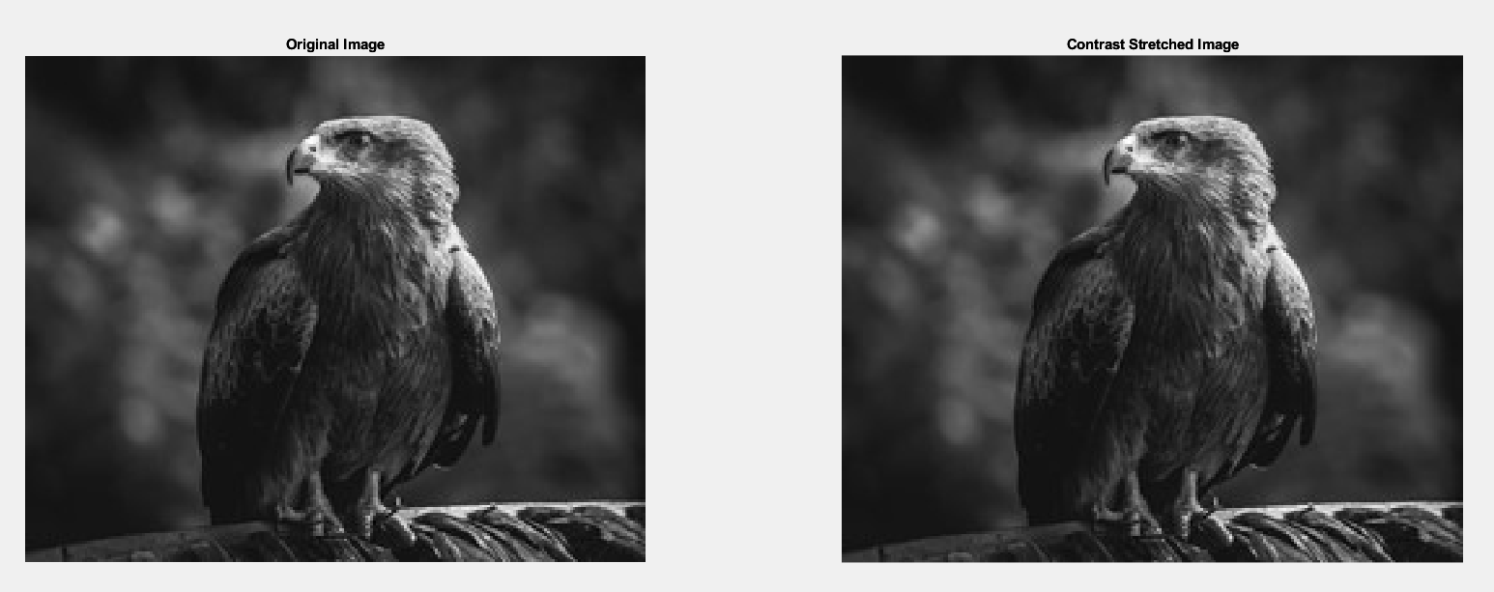

1. Apply bit plane slicing on the image.

img = imread("Picture2.jpg");

gray_img = im2gray(img);

[r, c] = size(gray_img);

bit_planes = zeros(r, c, 8);

for i = 1:8

bit_planes(:,:,i) = bitget(gray_img, 9-i);

end

figure;

subplot(3,3,1), imshow(gray_img), title('Original Grayscale Image');

for i = 1:8

subplot(3,3,i+1), imshow(bit_planes(:,:,i)), title(['Bit Plane ', num2str(9-i)]);

end

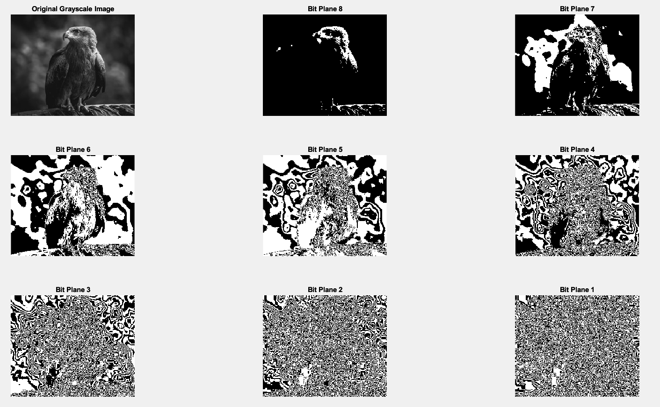

1. Change the contrast of the image using Logarithmic Transformation and Power-law Transformation.

img = imread("Picture3.png");

gray_img = rgb2gray(img);

normalized_image = double(gray_img) / 255;

c = 1;

gamma = 2;

log_transformed_image = c * log(1 + normalized_image);

gamma_transformed_image = c * (normalized_image .^ gamma);

figure;

subplot(1, 3, 1);

imshow(gray_img);

title('Original GrayScale Image');

subplot(1, 3, 2);

imshow(log_transformed_image, []);

title('Logarithmic Transformation');

subplot(1, 3, 3);

imshow(gamma_transformed_image, []);

title('Power-Law Transformation');

1. Adjust the histogram of the following image to match the reference image using histogram matching. Show the histogram of original, reference, and output images.

input_img = imread("Picture4.jpg");

reference_img = imread("Picture5.png");

input_gray = im2gray(input_img);

reference_gray = im2gray(reference_img);

matched_img = imhistmatch(input_gray, reference_gray);

figure;

subplot(3,2,1), imshow(input_gray), title('Original Input Image');

subplot(3,2,2), imhist(input_gray), title('Histogram of Input Image');

subplot(3,2,3), imshow(reference_gray), title('Reference Image');

subplot(3,2,4), imhist(reference_gray), title('Histogram of Reference Image');

subplot(3,2,5), imshow(matched_img), title('Histogram Matched Image');

subplot(3,2,6), imhist(matched_img), title('Histogram of Matched Image');

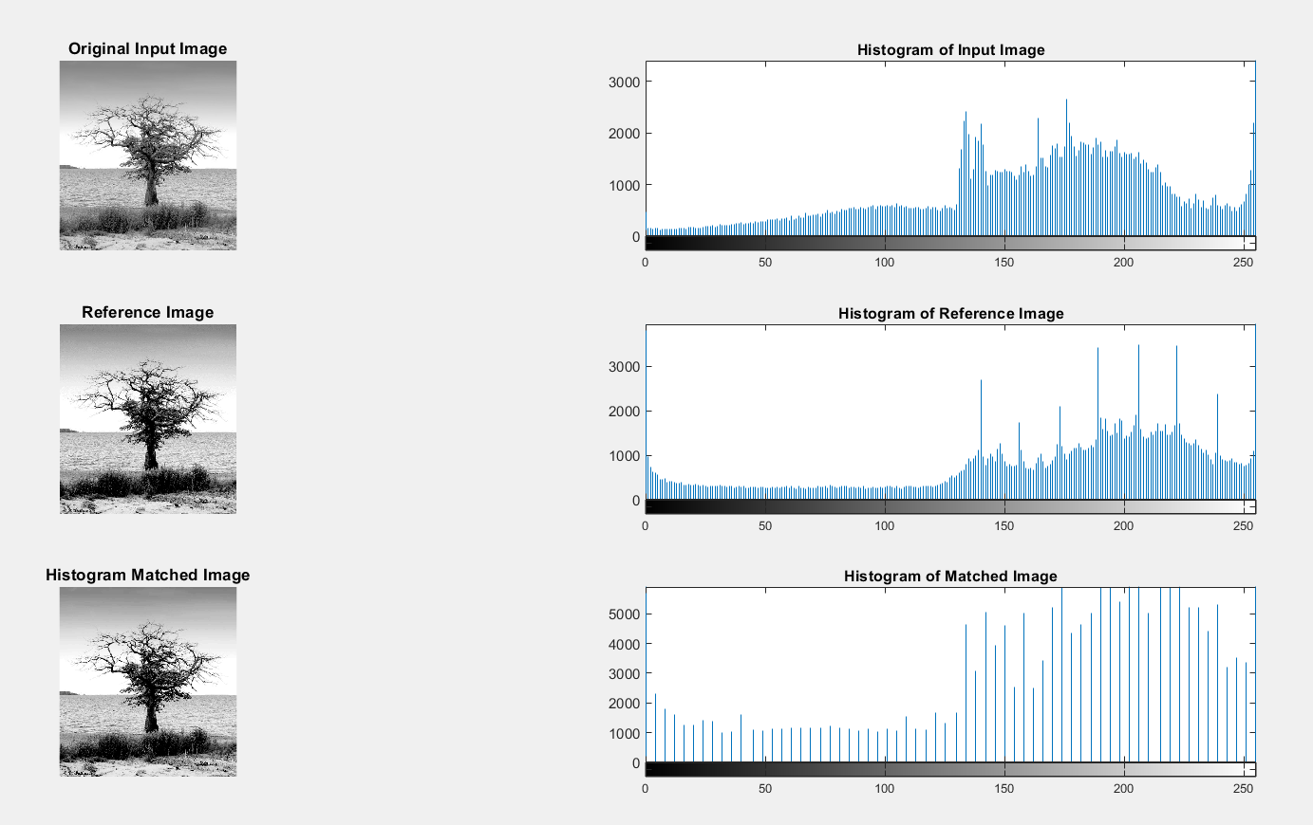

1. Change the contrast of the image using histogram equalization. Show the histogram of both input and output images.

img = imread('Picture6.jpg');

img = rgb2gray(img);

figure;

subplot(2, 2, 1);

imshow(img);

title('Original Image');

subplot(2, 2, 2);

imhist(img);

title('Histogram of Original Image');

equalized_img = histeq(img);

subplot(2, 2, 3);

imshow(equalized_img);

title('Equalized Image');

subplot(2, 2, 4);

imhist(equalized_img);

title('Histogram of Equalized Image');

