BUILD YOUR OWN INTERNET
(replace with hand written title)

Saturday, January 27th
Omni Commons Ballroom

What if the internet wasn't about connecting to Comcast, AT&T, Google, or Facebook?

What if it meant connecting directly with your friends, neighbors, and community...?

AGENDA
2:00pm - Introduction
2:15pm - Panel discussion
3:00pm - Hands-on workstations and demos
5:00pm - End / clean up

PANELISTS

Traci Rosenberg -

Kit Walsh -

Tim Pozar -

Preston Rhea -

Workstations
If you have trouble finding any of the stations, look for the matching signage

Crimp and Run:
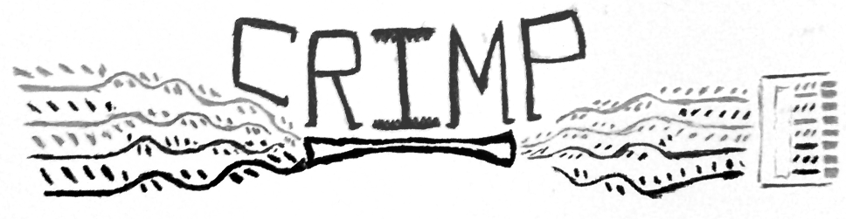

Wanna learn how the tubes of the internet are made?
It's easy, we'll teach you. Then run your freshly crimped cable up a ladder to a “roof”-mounted antennae.

Internet-in-a-box:
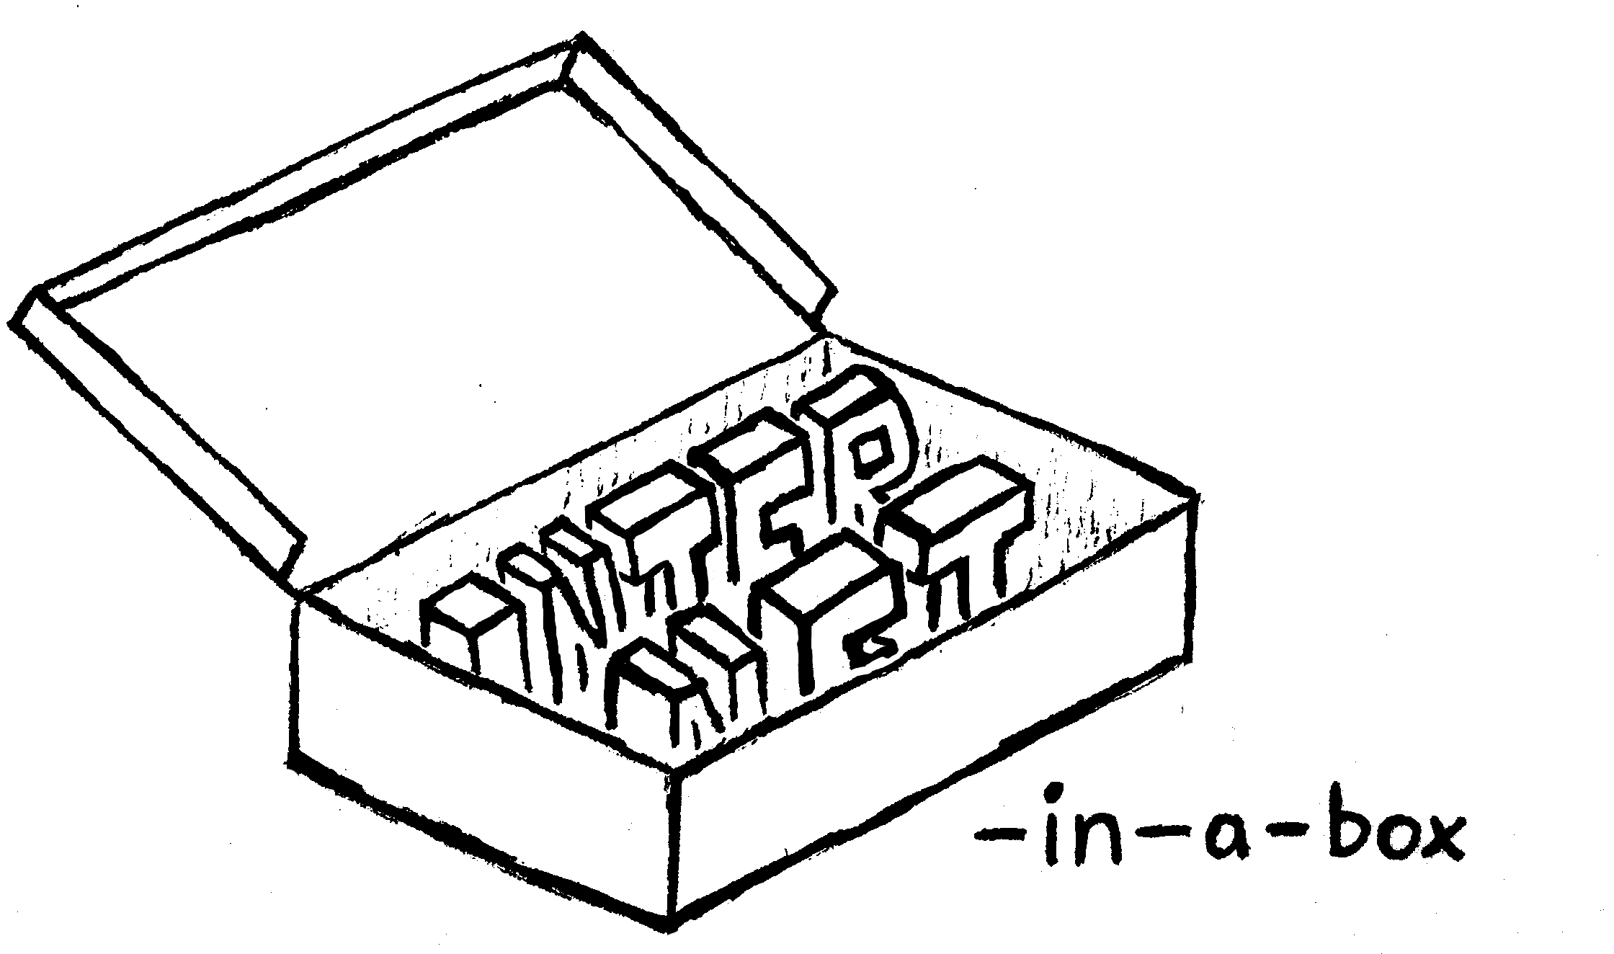
Imagine if you could fit the entire internet in to a single shoebox.
Well, maybe not a shoebox, but you get the idea.
See the hardware being used to build the People’s Open Network in action.

buildyourowninter.net:
We are not alone. There are community networks that popping up around the world. Some are thriving and others a just getting started. Figure where they are, what they are doing, and how they connect.

Make Your Own SWAG:
If you're willing to build your own internet, you might as well make your SWAG too! Stop by to punch buttons, cut stickers, and draw with crayons. Earn your SWAG and show people you care about the health of the internet.

disaster.radio:

A disaster-resilent communications network powered by the sun. When the critical infrastructure that so many of us take for granted goes away, how do we organize ourselves and our communities to respond? disaster.radio addresses this problem.

Garden Mesh: (fix image)
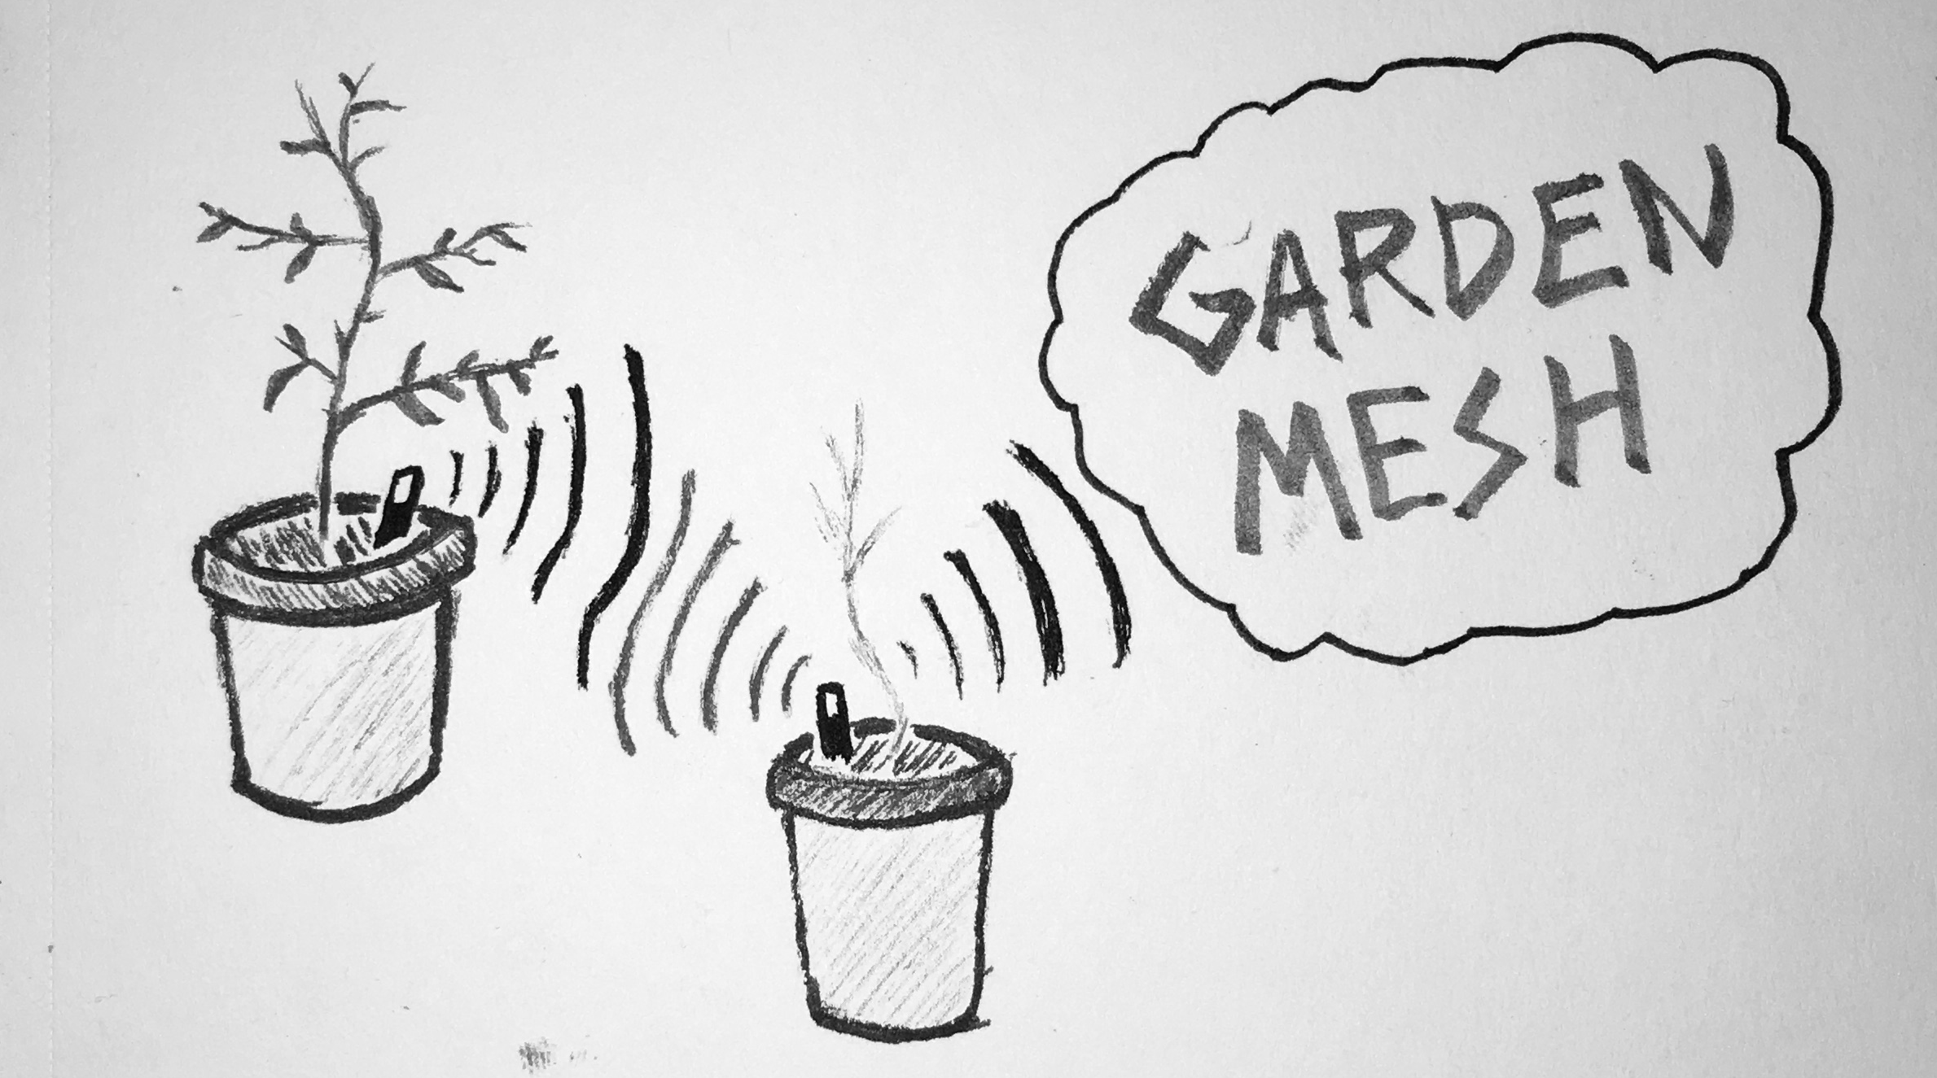
Mesh the plants! Find out how you can take control of your plants by collecting environmental data. Garden Mesh seeks to provide community support for local gardeners, growers, and horticulturists so you can build your own Internet of Plants (IoP).

Incentivized Mesh:

