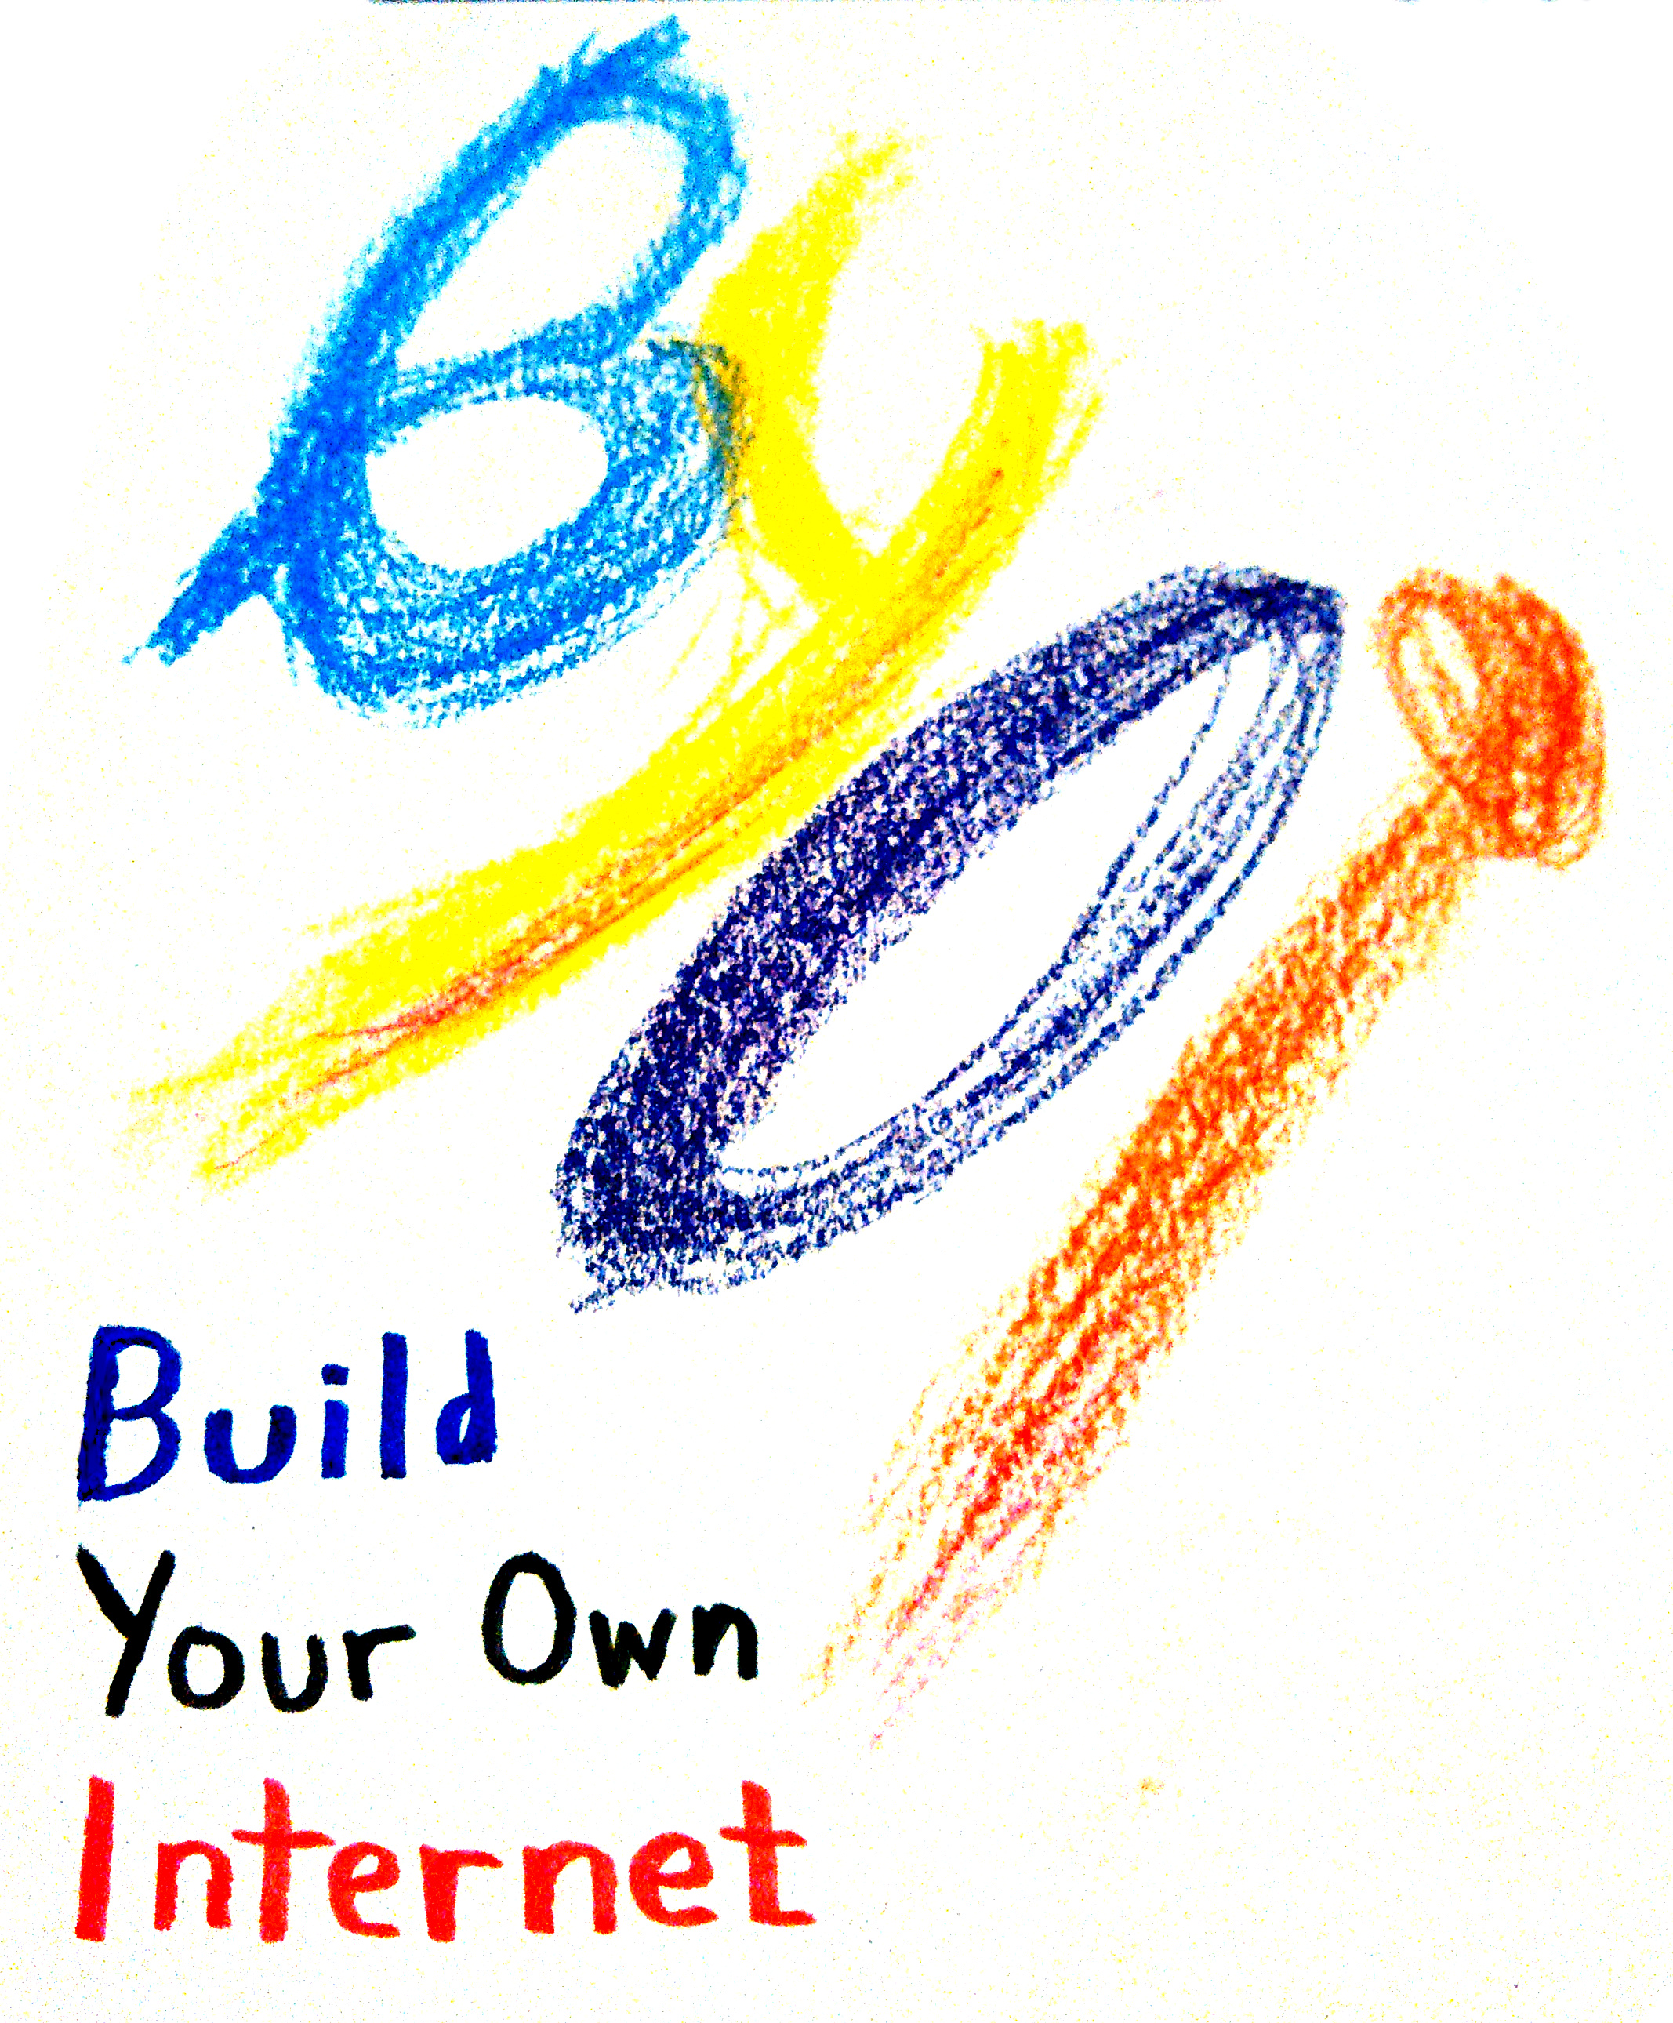

back of cover?
Blank? Logo? Licensing info?
Verison? Edition info

Table of Contents

Introduction

Why would Chicken cross the Ravine?

How to Crimp Ethernet Cable...

Public Relations: a step-by-step guide

The Three Flavors of Nodes

Digging a Tunnel

(and)

Saying Hi!

Today, the internet is controlled by a handful of corporate internet service providers (ISPs). Companies like Comcast, AT&T, and Verizon actively lobbied, and succeeded, in unraveling net neutrality protections in this country — rules that were critical for protecting the free and open internet. These are the same companies that are failing to provide affordable internet access to low-income communities across the Bay Area, preventing already disenfranchised peoples from participating in the lucrative tech economy.

Meanwhile, digital platform monopolies such as Google and Facebook, while supporters of net neutrality, have a business model based upon surveiling and collecting massive amounts of personal data on all of their users. These companies are far from transparent about what they are collecting and how they are using the information.

We need to build more resilient alternatives. We need to build an internet made up of local networks that are fundamentally open, democratic, and decentralized — networks that center around the needs and rights of the communities that rely on them.

The People’s Open Network is one such network, providing a liberating, people-powered alternative to the top-down, corporate status quo. It is a mesh network, meaning that the more who join the network, the more resilient it becomes. Even if one home drops out, the network will route around the damage — maintaining connections and enabling communication even if the Big Internet goes down due to an earthquake or censorship. We are not alone. Around the world, there are mesh networks that are thriving — from Catalonia to Detroit, Argentina to South Africa.

Our closely affiliated partner, Sudo Mesh, has developed free and open source firmware that enables people to mesh their connections through their wifi routers and share their internet bandwidth with others. The hardware to enable this, home routers and rood-mounted antennae, has become more affordable than ever, costing between $20-$80 per device.

We have the technology. Now it's up to us to connect with other members of the East Bay community to build this network. We need to talk to our neighbors, as well as local organizations and businesses, about the potential of community networks, like People's Open, and convince them to become a node on the network by setting up a router in their home or place of work.

This is how we build our own internet...
By empowering people with the knowledge, tools, and ideas so they can build their own.

