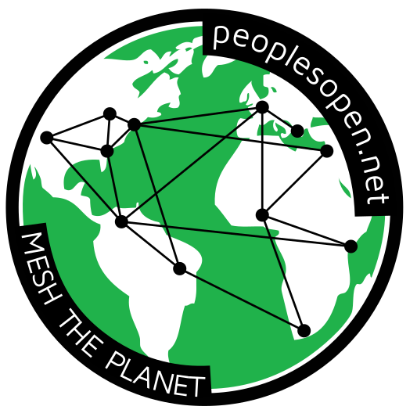
Want to Get Involved?
Mesh networks don't happen by themselves, they
require a ton of effort and a lot of collaboration.
If you want to help out, there are a few roles
that anyone (with the right motivation) can fulfill:

Community Organizer and/or Educator
Are you a people person? Would you like to help our network expand and provide access to those who need it most? Use your social skills to help get the word out. Talk to neighbors and local businesses about setting up a node in their buildings. Help plan events that raise awareness of community networks.

Legal Support and Grant Writing
Do you have expertise in law? Are you a good writer? Or do you want to learn how to raise funds or battle bureaucracy? Help us join the fight for digital liberties and equitable access to information. Learn more about our legal efforts at https://sudoroom.org/wiki/Mesh/Legal

Design and User Experience (UX)
Are you artistically inclined? There are multiple aspects of mesh networks that require creative design skills. Help improve our propaganda, re-design user interfaces, or create new diagrams and infographics. Current designs can be found at https://github.com/sudomesh/propaganda

Technical Support
Do you like scaling tall buildings? Are you a skilled troubleshooter? Help provide day-to-day management and maintenance of the mesh. Assist in the deployment of nodes and roof-mounted antennae! If you'd like to join the node mounting crew, e-mail us at nodemount@peoplesopen.net.

Multi-talented Engineer
Are you a hacker or programmer? Do you know how to use git? Fork our repos, modify some code (or just correct some text in a README file), build/deploy a new mesh service, or extend our firmware.
Email us: info@peoplesopen.net
Join us on IRC: irc.freenode.net #peoplesopen.net
Meet in-person: Tuesdays 7pm, Omni Commons, 4799 Shattuck, Oakland
People’s Open Network https://peoplesopen.net

Want to Get Involved?
Mesh networks don't happen by themselves, they
require a ton of effort and a lot of collaboration.
If you want to help out, there are a few roles
that anyone (with the right motivation) can fulfill:

Community Organizer and/or Educator
Are you a people person? Would you like to help our network expand and provide access to those who need it most? Use your social skills to help get the word out. Talk to neighbors and local businesses about setting up a node in their buildings. Help plan events that raise awareness of community networks.

Legal Support and Grant Writing
Do you have expertise in law? Are you a good writer? Or do you want to learn how to raise funds or battle bureaucracy? Help us join the fight for digital liberties and equitable access to information. Learn more about our legal efforts at https://sudoroom.org/wiki/Mesh/Legal

Design and User Experience (UX)
Are you artistically inclined? There are multiple aspects of mesh networks that require creative design skills. Help improve our propaganda, re-design user interfaces, or create new diagrams and infographics. Current designs can be found at https://github.com/sudomesh/propaganda

Technical Support
Do you like scaling tall buildings? Are you a skilled troubleshooter? Help provide day-to-day management and maintenance of the mesh. Assist in the deployment of nodes and roof-mounted antennae! If you'd like to join the node mounting crew, e-mail us at nodemount@peoplesopen.net.

Multi-talented Engineer
Are you a hacker or programmer? Do you know how to use git? Fork our repos, modify some code (or just correct some text in a README file), build/deploy a new mesh service, or extend our firmware.
Email us: info@peoplesopen.net
Join us on IRC: irc.freenode.net #peoplesopen.net
Meet in-person: Tuesdays 7pm, Omni Commons, 4799 Shattuck, Oakland
People’s Open Network https://peoplesopen.net

