MCA Assignment 1

Sudhanshu Mohan
2017110

Spectrogram:
1000 spectrograms for each integer
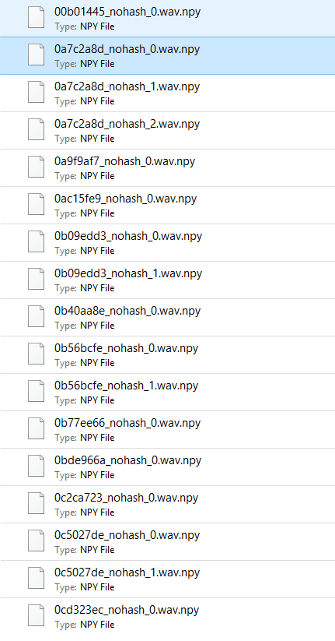

For Spectrogram, SVM with linear kernel
Accuracy:
0.8888888888888888

