Here is a complete, professional documentation structure for your project. You can copy this content into a Word document (Project_Report.docx) or a README.md file.
It is written in a formal academic/technical tone suitable for submission.

Project Documentation: Airtel Enterprise Billing System
Subject: Java Programming (Core Java, Swing, JDBC)
Project Type: Desktop Application (CRM & Billing)
Database: MySQL Relational Database

1. Abstract
The Airtel Enterprise Billing System is a robust, Java-based desktop application designed to automate the telecom billing process. It serves as a Customer Relationship Management (CRM) dashboard that allows telecom operators to manage subscriber details, calculate bill amounts based on usage (Calls & SMS), track outstanding dues, and generate invoice details dynamically. The system features a self-healing database architecture, ensuring seamless deployment without manual SQL configuration.

2. Technical Specifications

2.1. Technologies Used
- Language: Java (JDK 8 or higher)
- GUI Framework: Java Swing (JFrame, JTable, JPanel)
- Database: MySQL Server (8.0+)
- Connectivity: JDBC (Java Database Connectivity)
- Configuration: Java Properties File (db.properties)
- Architecture: Modular (Model-Service-View pattern)

2.2. Prerequisites
To run this application, the following components are required:
- Java Development Kit (JDK) installed.
- MySQL Server (XAMPP/WAMP or standalone) running on port 3306.
- MySQL Connector JAR (mysql-connector-java.jar) in the project classpath.

3. System Architecture
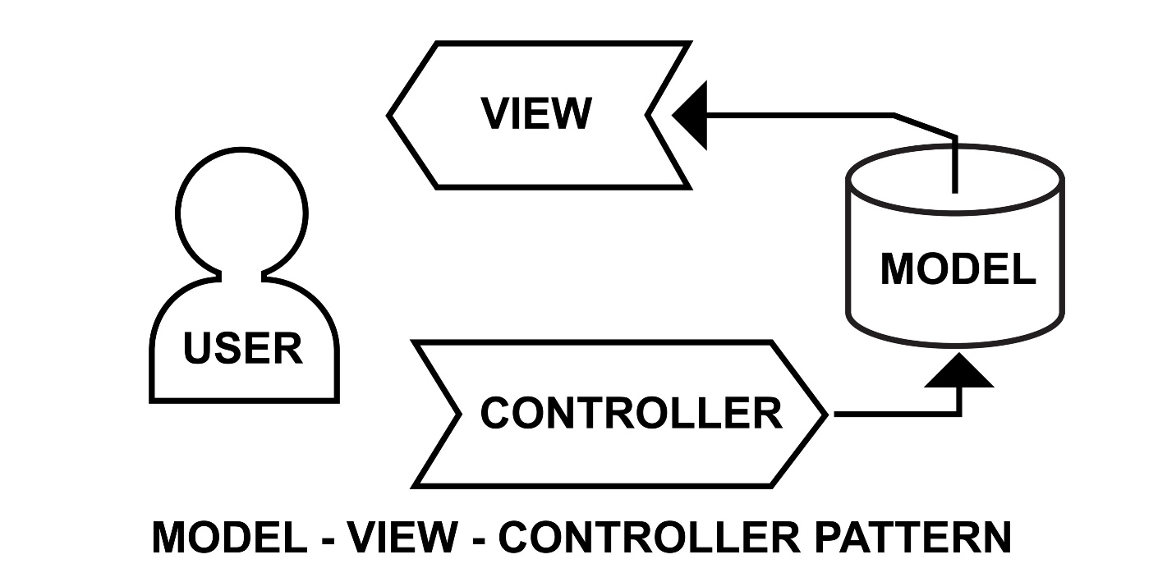
Shutterstock
The project follows a modular design pattern to ensure code readability and maintenance:

3.1. Class Structure
- Customer.java (The Model):
  - A Pure Old Java Object (POJO) that represents the Subscriber entity.
  - Encapsulates data such as Name, Phone, Account Number, Billing Period, and calculated costs.
  - Uses a Constructor to initialize data objects for transport between the Logic and UI layers.
- BillingService.java (The Controller/Logic):
  - Database Connection: Manages the JDBC connection using credentials from db.properties.
  - Auto-Setup Logic: Automatically detects if the Database or Table is missing and creates them (Self-Healing).
  - Business Logic: Contains the mathematical formulas for Tariff Calculation (Local/STD/ISD/SMS).
  - CRUD Operations: Handles SQL INSERT, UPDATE, and SELECT queries.
- BillingApp.java (The View/UI):
  - Provides the Graphical User Interface.
  - Inputs: Text Fields and ComboBoxes for user data entry.
  - Outputs: A dynamic JTable that renders database records in real-time.
  - Visual Feedback: Implements conditional formatting (Red/Green text) to indicate payment status (Pending/Paid).

4. Database Design
The system uses a relational database named AirtelBilling.

4.1. Table Schema: Subscribers
Column Name | Data Type | Constraint | Description
phone | VARCHAR(15) | PRIMARY KEY | Unique subscriber identifier.
account_number | VARCHAR(10) | - | Auto-generated 6-digit ID.
name | VARCHAR(50) | - | Customer Name.
email | VARCHAR(50) | - | Customer Email.
last_call_type | VARCHAR(10) | - | Type of last usage (Local/STD).
total_minutes | INT | - | Cumulative call duration.
total_sms | INT | - | Cumulative SMS count.
total_bill | DOUBLE | - | Lifetime bill amount.
outstanding_dues | DOUBLE | DEFAULT 0 | Current unpaid amount.
last_bill_date | VARCHAR(20) | - | Date of last transaction.
bill_period | VARCHAR(20) | - | Current Billing Cycle (e.g., NOV 2025).

5. Tariff & Logic Algorithms
The system applies the following "Airtel Maharashtra" standard rates for calculation:
A. Call Rates (Per Minute)
- Local: ₹ 0.80
- STD: ₹ 1.20
- ISD: ₹ 12.00
B. SMS Rates (Per Unit)
- Domestic: ₹ 1.00
- International: ₹ 5.00
C. Account Number Generation
The system uses the java.util.Random class to generate unique IDs:
Java
"ACC" + (100000 + rand.nextInt(900000)); // Example: ACC582049

6. Key Features

6.1. Intelligent Database Setup
Unlike standard apps that crash if the database is missing, this system uses CREATE DATABASE IF NOT EXISTS. This allows the application to be "Plug and Play" on any computer with MySQL installed, without manual SQL setup.

6.2. Secure Configuration
Database credentials (User/Password) are not hardcoded inside the Java files. They are stored in an external db.properties file. This enhances security and allows the password to be changed without recompiling the code.

6.3. Duplicate Handling (Upsert)
The system uses the SQL ON DUPLICATE KEY UPDATE command.
- Scenario: If a customer with an existing phone number is entered:
- Action: The system detects the duplicate, updates their existing record (adds new minutes/cost to the old total), and refreshes the due amount. It does not create a duplicate row.

6.4. Visual Status Tracking
The JTable renderer is overridden to visually cue the operator:
- <span style="color:red">Red Text:</span> Indicates Outstanding Dues > 0.
- <span style="color:green">Green Text:</span> Indicates Account is Fully Paid.

7. User Manual (How to Run)
Step 1: Configuration
Open the db.properties file and ensure your MySQL password is correct:
Properties
db.url=jdbc:mysql://localhost:3306/AirtelBilling
db.user=root
db.password=YOUR_PASSWORD
Step 2: Compilation
Open Command Prompt in the project folder and compile the code with the Connector JAR:
Bash
javac -cp ".;mysql-connector.jar" *.java
Step 3: Execution
Run the application:
Bash
java -cp ".;mysql-connector.jar" BillingApp
Step 4: Usage
- Enter Customer Name, Phone, and Email.
- Select Usage Type (Local/STD).
- Enter Minutes and SMS count.
- Click "CALCULATE & SAVE".
- To mark a bill as paid, select the row in the table and click "CLEAR DUES".

8. Future Scope
- PDF Export: Integration with iText library to download invoices as PDF.
- Live SMS Integration: Connecting to Twilio API for real-time SMS alerts.
- Login System: Adding Admin/User authentication modules.

Submitted By: [Your Name]
Date: [Current Date]

