
ACUMENUS
COPE · CONNECTED MENTAL-HEALTH PLATFORM

COPE Project Overview
Strategy Series — Current State, Native Mobile Plan & Competitive Enhancement
ACUM-COPE-001

Sanjay M. Udoshi, MD
Founder & Chief Medical Information Officer, Acumenus, Inc.
June 27, 2026
CONFIDENTIAL
© 2026 Acumenus, Inc. All rights reserved.

Table of Contents
About This Document 4
Executive Overview 5
Five truths that should drive decisions 5
The competitive opening 6
Where COPE's value is bottlenecked 6
What we will build 7
Five pillars, eight workstreams 7
Where to start — the first 120 days 8
Hard guardrails (anti-goals) 8
Part I — Current-State Assessment 10
1. Executive Snapshot 10
2. Architecture Overview 10
3. Backend API — What Exists 11
4. Data Model & Compliance Posture 12
5. Clinician Web Dashboard — What Exists 13
6. Patient Mobile App — What Exists (the replacement target) 13
7. Cross-Cutting Findings & Risks 14
8. Implications for the Strategy That Follows 15
Part II — Best Practices & Competitive Landscape (2024–2026) 16
Part A — Patient-Facing Best Practices 16
Part B — Clinician-Facing Best Practices, Interoperability & Regulatory 20
Part C — Native-Mobile Architecture Evidence (2025–2026) 25
Part III — Native iOS (Swift) & Android (Kotlin) Plan 27
1. Why Native, and Scope 27
2. Feature-Parity Matrix (native must reach or exceed this) 27
3. Backend Contract the Native Apps Consume 29
4. Architecture (the recommended shape) 30
5. Data & Offline Sync 31
6. Security on Device (HIPAA / OWASP MASVS L2+R) 32
7. Health-Platform Integration & Notifications 33
8. Accessibility, Release & Roadmap 34
Part IV — Competitive Enhancement Master Plan 36
0. Strategic Thesis — Win the Connected Loop 36
W1 — Close the Communication Loop (highest-priority product gap) 36
W2 — Engagement & Efficacy (retention is the make-or-break metric) 37
W3 — Passive Sensing & Digital Phenotyping (the data moat) 37
W4 — Safety, Productized (a trust + clinical differentiator) 38
W5 — Trust & Privacy as an Explicit Differentiator 38
W6 — Clinical Validation, Quality & Regulatory Readiness (the credibility gate) 39
W7 — Interoperability & EHR Embedding (kill the swivel-chair) 39
W8 — Enterprise Readiness & the Collaborative-Care Billing Play 40
Consolidated Roadmap (sequenced, dependency-aware) 42
Success Metrics (how we'll know it's working) 43
What COPE Should NOT Do (anti-goals) 43
Appendix A — Consolidated References & Sources 44
Orienting source 44
Patient-facing evidence (Part II.A) 44
Clinician, regulatory & enterprise evidence (Part II.B) 44
Native-mobile architecture evidence (Part II.C) 45
Appendix B — Verify-Before-Implementation Checklist 46

About This Document
This overview consolidates the COPE strategy series into a single reference. It answers a four-part charge: (1) deeply examine COPE as it actually exists today; (2) research current best practices for clinician/patient mental-health communication and care; (3) plan fully native iOS (Swift) and Android (Kotlin) applications; and (4) set out a comprehensive plan to enhance every aspect of COPE so that it can supersede its competitors.
It is written for a mixed audience — clinical, technical, and business stakeholders. The Executive Overview that follows is a self-contained synthesis. The four detailed parts behind it preserve the full source analyses for readers who need the evidence, architecture, and implementation detail in depth. A consolidated references appendix collects the external sources cited throughout.
Section | What it covers | Primary audience
Executive Overview | Integrated thesis, the market opening, five decision-relevant truths, the recommended build, and the path forward | All readers
Part I — Current-State Assessment | Evidence-based examination of the codebase as it really is, with strengths, gaps, and risks | Technical / clinical
Part II — Best Practices & Competitive Landscape | Cited 2024–2026 evidence: patient-facing practice, clinician/regulatory practice, and native-mobile architecture | Clinical / business
Part III — Native iOS & Android Plan | Full native-rebuild architecture, security, health-platform integration, and a phased roadmap | Technical
Part IV — Competitive Enhancement Master Plan | Eight workstreams, a sequenced roadmap, success metrics, and explicit anti-goals | All readers
Appendix A — References & Sources | Consolidated, linked source list for every major external claim | All readers

Method note. This series draws on a deep multi-surface codebase examination (API, web, mobile, database/migrations, documentation, and prototype) plus three parallel research streams — roughly 60+ web searches and fetches plus PubMed — covering patient-facing practice, clinician/regulatory practice, and native-mobile architecture. Every major external claim in Part II carries an inline citation. Items the research flagged 'verify at implementation time' are marked in Parts II and III (for example, LOINC codes for ISI/ASRM/WHODAS, library versions, and vendor BAA/HIPAA dates).

Executive Overview
COPE is far more mature than its README admits — a v1.1a research-grade clinical platform (20 migrations / 52 tables, 70+ endpoints, real-time alerts, BAA-gated AI, OMOP CDM + FHIR R4, Stanley-Brown crisis plans, OIDC SSO). Its value is bottlenecked at the client tier: the patient app is a roughly 65%-complete Expo build, and the clinician console is desktop-only.
The market has a clean white space. Consumer trackers (Daylio, eMoods) are islands with no care-team link; clinical platforms (Lyra, Spring) are employer-gated and thin on daily tracking; teletherapy incumbents (BetterHelp, Talkspace) are FTC-scarred on privacy. COPE's winning move is to own the trusted, clinically-connected loop between a patient's daily life and their care team — delivered through best-in-class native apps, closed by secure two-way communication, measurement-based care, and safety planning, and sold into health systems via the collaborative-care billing its architecture already fits.
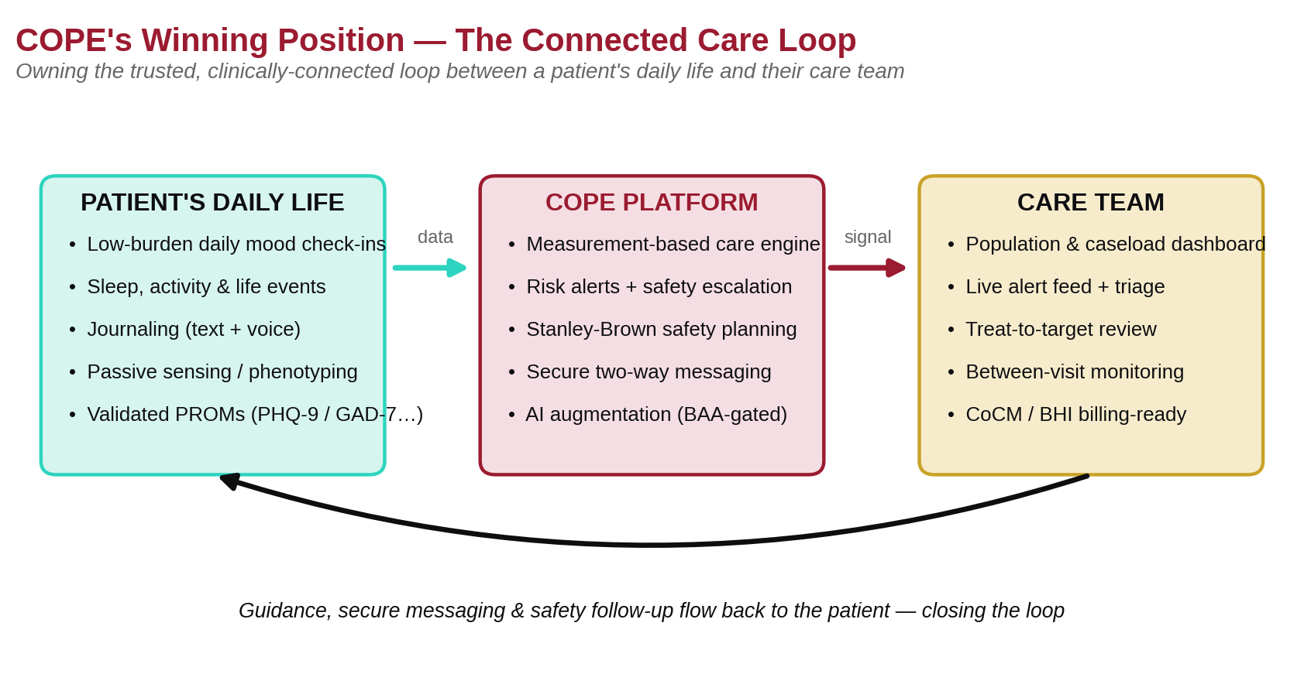
Figure 1. COPE's strategic position — owning the connected care loop between a patient's daily life and their care team.

Five truths that should drive decisions
- The backend is the launch pad, not the bottleneck. Native apps can light up capabilities that already exist server-side — passive health, validated assessments, crisis plans, AI insights, and FHIR/OMOP export. The platform's constraint is the client tier, not the server.
- Communication is the #1 product gap and the stated focus. COPE has no clinician-to-patient messaging today; building the secure, data-rich, safety-aware loop is the single highest-leverage feature.
- Verification — not features — is the credibility gap. The documentation claims '80%+ test coverage'; the API has roughly 3%. Clinical alert thresholds are provisional and unsigned. For an FDA SaMD posture this must be fixed before a pilot. It is the biggest non-feature differentiator available.
- The regulated-device trigger is specific and known. FDA's reissued January 2026 CDS guidance makes time-critical, near-term (≤24h) suicide-risk alerts the feature most likely to make COPE a Class II device. Everything else (transparent dashboards, trends, non-urgent suggestions) likely stays Non-Device CDS. Design accordingly; plan a PCCP if/when AI/ML or near-term alerting ships.
- The business model is collaborative care. COPE's registry + PHQ-9/GAD-7 treat-to-target + caseload review is literally the infrastructure CoCM/BHI billing requires (99492–99494, 99484), plus RTM for self-report monitoring — a concrete ROI story consumer apps cannot tell.

The competitive opening
Across the market, no incumbent occupies the top-right quadrant: high daily-life tracking depth combined with a real clinical / care-team connection. Consumer mood trackers win on tracking depth but connect to no one. Employer-gated clinical platforms have outcomes infrastructure but thin daily tracking. Wellness and teletherapy apps sit lower on both axes — and the teletherapy segment carries sector-wide privacy distrust. COPE's clinical depth (including a bipolar-optimized mania pole) plus its existing dashboard and alerting put the top-right quadrant within reach.
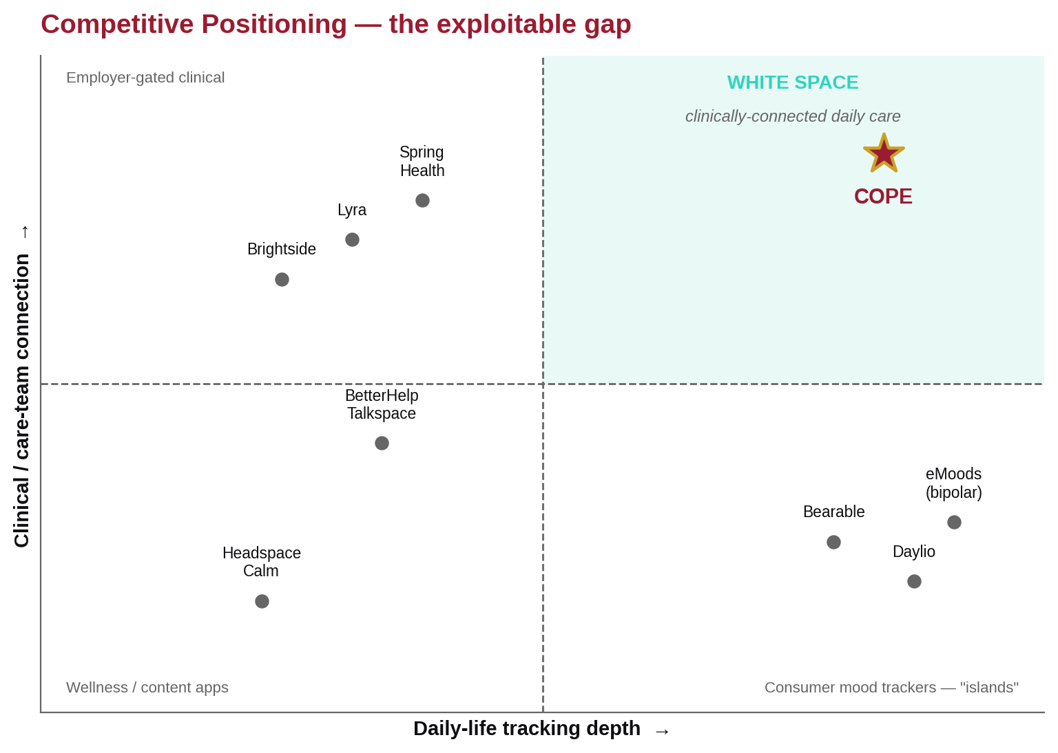
Figure 2. Competitive positioning. The exploitable white space is clinically-connected daily care — where no incumbent sits today.

Where COPE's value is bottlenecked
The three client surfaces are at very different maturities. The backend API is broad and well-structured; the clinician web console is high-quality but desktop-only; and the patient mobile app — the replacement target — is roughly 65% complete. Rebuilding the patient tier natively is the highest-leverage move available, and the backend is ready for it.
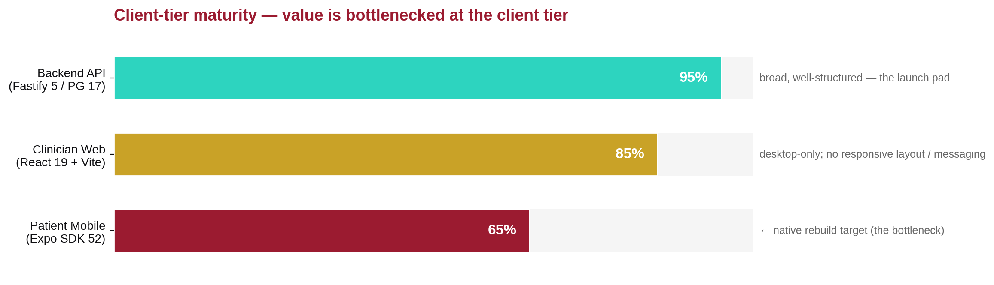
Figure 3. Client-tier maturity. The platform's value is bottlenecked at the patient mobile client, which the native program targets.

What we will build
The recommended native architecture is a Kotlin Multiplatform (KMP) shared `commonMain` core — clinical scoring, validation, networking, and the offline-sync engine — behind fully native SwiftUI (iOS) and Jetpack Compose (Android) UIs. The one thing that must never diverge between platforms is clinical assessment scoring; KMP lets the team write and unit-test it once.
- Offline-first, encrypted local store — GRDB/Room + SQLCipher, reusing COPE's existing /sync protocol, hardened to append-only for clinical records.
- Deep health-platform integration — HealthKit (State of Mind + native PHQ-9/GAD-7, sleep stages, HRV, mobility) and Health Connect (MindfulnessSession, HRV, sleep), with background delivery.
- Crisis-grade native notifications and one-tap mood logging via widgets, Control Center, Siri, and watch surfaces.
- Built to OWASP MASVS L2+R and WCAG 2.2 AA — roughly 7–9 months to a pilot-ready patient app on both platforms, with the clinician companion following.

Five pillars, eight workstreams
The enhancement plan is organized into five strategic pillars — Communication; Engagement & Efficacy; Safety; Trust & Privacy; and Clinical Validation & Interoperability — which decompose into eight sequenced workstreams (W1–W8). Long-lead items (clinical sign-off in W6; SOC 2 / HITRUST in W8) start immediately and run in parallel with the native build.
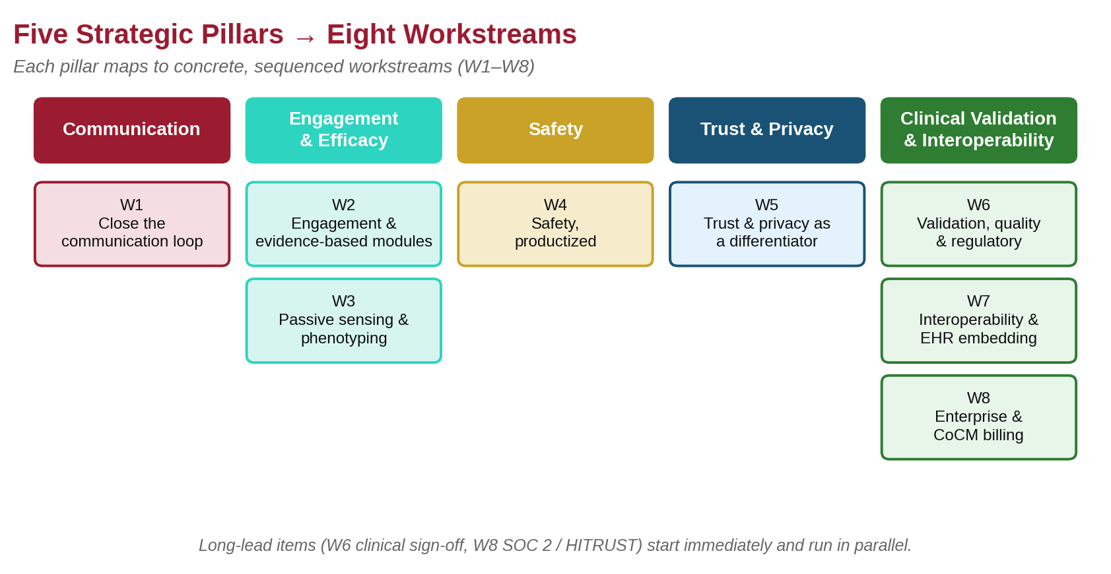
Figure 4. The strategy on a page — five pillars decomposing into eight workstreams.

Where to start — the first 120 days
- Now (long-lead, start immediately): engage a clinical advisor to sign off alert thresholds (decision OQ-004); stand up a real automated test suite with a measured-coverage CI gate; begin SOC 2 Type II, then HITRUST.
- Build: the messages backend (W1) plus the native foundation, auth, and check-in (phases P0–P2); field-level encryption, audit-log immutability, and prompt-injection hardening (W5).
- Decide & sequence: confirm KMP versus fully-native (the team's Kotlin appetite); confirm the collaborative-care go-to-market as the primary enterprise wedge.
Beyond the first 120 days, the work sequences across four horizons: foundations and credibility (months 0–4); the connected loop and engagement (months 3–8); enterprise and interoperability (months 6–14); and outcomes and scale (12+ months). The full, dependency-aware roadmap appears in Part IV.

Hard guardrails (anti-goals)
Some moves are explicitly off the table because they carry regulatory, ethical, or business risk that would undermine the strategy:
- No standalone 'AI therapist.' AI is augmentation only, with mandatory human escalation.
- No PDT-style standalone prescribed-treatment business as the core model — the reimbursement trap that bankrupted Pear Therapeutics.
- No guilt-based engagement mechanics — they backfire for depressed users.
- No interruptive alerts for routine data — reserve interruption for actionable, validated signals.
- No third-party ad or tracking SDKs, ever — privacy is a marketed differentiator.
- No non-additive changes to the protected authentication system.
Bottom line. COPE already has the hard part — a research-grade clinical backend with interoperability and safety scaffolding most competitors lack. The strategy is to expose that value through best-in-class native apps, close the communication loop, prove it with clinical validation, and sell it through collaborative-care billing. The detailed parts that follow show exactly how.

Part I — Current-State Assessment
Version assessed: v1.1a · Author: Engineering review · Date: June 27, 2026
Scope. This is a candid, evidence-based examination of the COPE platform as it exists today. It is the foundation for the competitive strategy, native-app plan, and enhancement master plan that follow (Parts II–IV). Where the documentation and the code disagree, the code is treated as truth and the discrepancy is flagged.

1. Executive Snapshot
COPE is substantially more mature than its `README` (v0.4a) suggests. The codebase is at v1.1a: 20 database migrations, roughly 52 tables, 70+ REST endpoints, a real-time WebSocket alert system, a compliance-gated AI-insights pipeline, OMOP CDM research export, FHIR R4 read endpoints, Stanley-Brown crisis safety plans, first-party rotating-token auth with OIDC SSO, and a cohort builder. This is a research-grade clinical platform, not a prototype.
The three client surfaces are at very different maturities:
Surface | Stack | Maturity | Headline gap
Backend API | Fastify 5 / Node 22 / PG 17 | High — broad, well-structured | Low automated test coverage; provisional clinical thresholds
Clinician web | React 19 + Vite | High for desktop | No responsive/mobile layout; no direct messaging
Patient mobile | Expo SDK 52 / RN 0.76 | ~65% feature-complete | Charts, background sync, intake wizard, journal detail unfinished

The single most important strategic fact. The backend already supports far more than either client surface exposes. The platform's value is currently bottlenecked at the client tier — especially the patient mobile app. Rebuilding that tier natively is the highest-leverage move available, and the backend is ready for it.

2. Architecture Overview
COPE is a monorepo (npm workspaces + Turbo) with apps/{api,web,mobile} and packages/{db,shared}. Three clients (patient mobile, clinician web, and a background worker) talk to a Fastify 5 API over REST and WebSocket; the API is backed by PostgreSQL 17 (with row-level security), Redis (pub/sub + BullMQ job queues), and a set of external services.
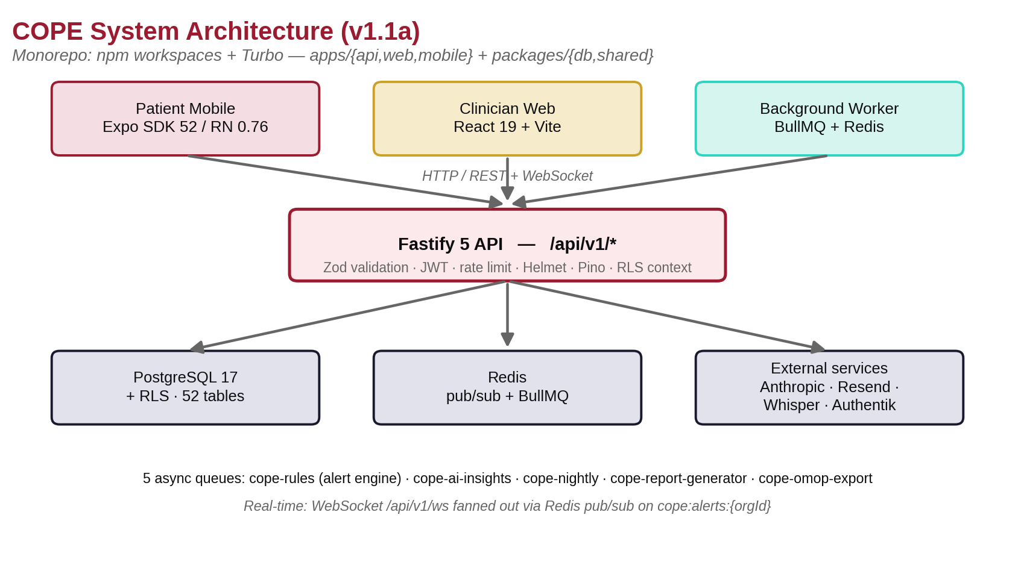
Figure 5. COPE system architecture (v1.1a). Three clients over a Fastify API, backed by PostgreSQL 17 + RLS, Redis, and external services.
- Contract source of truth: @cope/shared exports Types, Zod Schemas, and Constants (MOOD_COLORS, ALERT_THRESHOLDS, CRISIS_CONTACTS, SCALE_LOINC_MAP, WS_EVENTS, LIMITS).
- Data access: postgres.js raw SQL templates (no ORM). RLS is enforced in the database; every request calls setRlsContext(userId, role), which sets app.current_user_id / app.current_user_role for policy evaluation.
- Async work: five BullMQ queues — cope-rules (alert engine), cope-ai-insights, cope-nightly (02:00 ET scheduler), cope-report-generator, and cope-omop-export.
- Real-time: a WebSocket at /api/v1/ws, fanned out across instances via Redis pub/sub on cope:alerts:{orgId} channels.

3. Backend API — What Exists
The API is the platform's strongest asset: roughly 28 route modules and about 9,300 lines of route code, grouped by domain.

3.1 Endpoint inventory (abridged)
- Auth (/auth): bcrypt login (clinicians + patients), register-demo, change-password, TOTP MFA (enroll/activate/verify), rotating refresh tokens (RFC 6819 reuse detection), logout, me, and OIDC SSO (providers, oidc/redirect, oidc/callback, oidc/exchange).
- Patients (/patients, /patients/me): caseload, detail, mood-heatmap, care-team management, and patient self-service profile/catalogues.
- Daily entries (/daily-entries): upsert + submit, with 21 clinical-domain columns (mood, mania [ASRM-informed], anxiety [GAD-2], anhedonia, C-SSRS suicidal-ideation screener, substance [AUDIT-C], social/cognitive/appetite/stress, sleep, exercise, life events).
- Assessments (/assessments): PHQ-9, GAD-7, ISI, C-SSRS, ASRM, WHODAS, QIDS-SR with LOINC mapping and a FHIR QuestionnaireResponse export per assessment.
- Journal, Medications, Alerts, Safety/Crisis, Notifications, Consent, Catalogues, Sync (offline pull/push), Invites, Reports, Clinicians (notes/caseload/snapshot), Admin (users + audit log), Research (exports/cohorts/OMOP concepts), Search (pg_trgm), Voice (Whisper), Health-Data (HealthKit/Health Connect ingest), Files, and FHIR R4 (Patient/$everything, Observation, MedicationRequest, QuestionnaireResponse, Condition, CarePlan, Consent, metadata).

3.2 Alert rules engine (RULE-001 … RULE-008)
The engine covers mood decline versus baseline, missed check-ins, trigger escalation, safety-symptom → CRITICAL + auto-`crisis` status (DB trigger handle_safety_symptom), medication non-adherence, sleep disruption, exercise decline, and LLM journal-sentiment. All numeric thresholds are provisional engineering defaults (ALERT_THRESHOLDS in @cope/shared) and explicitly require licensed-clinician sign-off before any pilot (decision OQ-004).

3.3 AI / insights pipeline
- Provider-agnostic llmClient dispatches to Anthropic Claude (BAA-gated) or local Ollama / MedGemma (no BAA needed).
- Double gate: AI_INSIGHTS_ENABLED=true and ANTHROPIC_BAA_SIGNED=true; otherwise a rule-based fallback. Per-patient ai_insights consent is checked before any inference.
- Jobs: weekly summary, trend narrative, anomaly detection, nightly deep analysis (structured findings + clinical trajectory), and an interactive clinician AI chat (ai_discussions).
- A HIPAA preamble + a de-identified clinical snapshot is included in every prompt; token cost is recorded in ai_usage_log.

4. Data Model & Compliance Posture

4.1 Domains (52 tables across 20 migrations)
Identity/auth; clinical setup (ICD-10, RxNorm meds); daily entries plus sleep/exercise/adherence logs; wellness/triggers/symptoms catalogues + logs; safety events; journaling; alerts + routing + notification prefs/logs; validated assessments (LOINC-coded); passive health snapshots (HealthKit/Health Connect: steps, HR, HRV, sleep stages, SpO₂); AI insights + usage + discussions; crisis safety plans (Stanley-Brown, versioned); cohorts + snapshots + research exports + OMOP CDM mapping (person-id assignment, high-water-mark incremental export); an append-only audit log; immutable consent records; clinician notes/appointments/reports; and population snapshots + correlation cache + risk history.

4.2 Interoperability
- FHIR R4 read endpoints are live today; assessment QuestionnaireResponse export works.
- OMOP CDM export pipeline with Safe-Harbour de-identification (18 identifiers), consent-gated omop_person_id assignment, and nightly incremental export.
- Medical coding embedded: SNOMED-CT (symptoms/triggers), RxNorm/NDC (meds), LOINC (assessments), ICD-10 (diagnoses).

4.3 Compliance decisions (all resolved in DECISIONS.md, OQ-001…010)
Decision | Resolution
OQ-002 — Market & device class | US market; COPE is likely SaMD Class II (it captures suicidal ideation and generates clinical-decision-influencing alerts). Formal regulatory assessment + HIPAA SRA still required pre-pilot.
OQ-004 — Alert thresholds | Provisional — licensed-clinician sign-off is a hard gate before pilot.
OQ-005 — Age | 18+ only in v1.0 (state minor-consent law complexity deferred).
OQ-007 — AI | Behind a BAA + env gate; prompts use aggregates, not raw PHI.
OQ-001 — Journal encryption | Server-side at rest; end-to-end encryption deferred to v2.0.
Crisis defaults | 988 Suicide & Crisis Lifeline; Crisis Text Line 741741.

5. Clinician Web Dashboard — What Exists
- Stack: React 19 + Vite 6, React Router v7, TanStack Query v5, lightweight pub/sub stores (auth/ui/theme), Recharts, lucide-react icons, and Sentry with PHI scrubbing.
- Pages: Dashboard (population KPIs + mood heatmap + live alert feed), Patients (caseload roster + invites), Patient Detail (7 tabs: overview, mood trends, journal, notes, alerts, medications, AI insights), Alerts, Trends, Reports, Cohort builder (admin), Admin, and Login/Register/MFA/OIDC-callback.
- Real-time: useAlertSocket with exponential-backoff reconnect; the dashboard refetches on ALERT_CREATED.
- Design-system discipline (a notable strength): a completed 'readability remediation' replaced 102 emoji and ad-hoc SVGs with a sized <Icon> vocabulary, migrated 491 inline font-sizes to --text-* tokens, and enforces the contract in CI (scripts/check-readability.sh + an ESLint ban on numeric fontSize). This is unusually rigorous and should be preserved as a platform asset.
Gaps. Desktop-only (260px fixed sidebar, no responsive/hamburger); no direct clinician-to-patient messaging; Reports/Audit-log/LDAP partially scaffolded; no component unit tests (E2E only); an aggressive 30s staleTime; and no caseload pagination (a risk at 500+ patients).

6. Patient Mobile App — What Exists (the replacement target)
- Stack: Expo SDK 52 / RN 0.76.9, Expo Router v4, WatermelonDB (offline), TanStack Query, Zustand, Expo SecureStore + LocalAuthentication (biometric), Expo Notifications, and react-native-health + react-native-health-connect.
- Built & functional: onboarding/login/MFA, a consent wizard, a 9-step daily check-in (full multi-domain including C-SSRS branching + safety modal), medications + adherence, journal (text + voice capture), an insights tab (text summaries), profile, a biometric lock (5-min timeout), push registration, passive-health ingest, and full PHQ-9/GAD-7/ASRM/ISI/C-SSRS questionnaires. WatermelonDB pull/push sync works in the foreground.
- Maturity ≈ 65%. Unfinished: the intake wizard (blocks self-serve enrollment), the journal detail/edit view (route is a stub), background sync (foreground-only today), trend charts (Victory Native not integrated — text only), medication/assessment local reminders (not firing), the voice-transcription flow, offline encryption of the local DB, and server-wins conflict resolution with no UI.
Design intent. From MOBILE_PLAN.md and the prototype: clinically-informed, low-burden daily probes (PHQ-2/GAD-2 daily, full scales weekly), a bipolar-optimized mania pole, safety-first crisis resources on every relevant screen, and passive phenotyping. Fonts: Fraunces (display) + Figtree (body); teal #2a9d8f primary; mood gradient red→blue.

7. Cross-Cutting Findings & Risks

7.1 Strengths to protect
- Clinical depth — multi-domain daily entries, seven validated instruments, a bipolar mania pole, and AUDIT-C/PSQI/PSS sub-items. Few competitors track this richly.
- Interoperability-ready — FHIR R4 + OMOP CDM + standard code systems already wired. This is a genuine enterprise moat most consumer apps lack.
- Compliance scaffolding — an append-only audit log, immutable consent history, RLS isolation, BAA-gated AI, Safe-Harbour de-identification, and refresh-token reuse detection.
- Safety architecture — a DB-level safety-symptom trigger, Stanley-Brown crisis plans, and C-SSRS.
- Design-system rigor enforced in CI (web).

7.2 Material risks & honest gaps
# | Finding | Severity | Notes
R1 | Test coverage discrepancy | High | The API review found ~2/63 test files (~3%); the DEVLOG claims '80%+'. Treat coverage as largely unverified and prioritize a real test suite.
R2 | Alert thresholds & risk score unvalidated | High (regulatory) | Provisional values requiring clinical sign-off (OQ-004) before pilot. The risk-scoring model needs validation + bias review.
R3 | No clinician-to-patient messaging | High (product) | Communication is one-directional (journal share, notes, assessment requests). This is the #1 feature gap versus the stated focus.
R4 | PHI at rest | Medium-High | Relies on DB/host encryption; no field-level encryption for journals/notes; the mobile local DB is unencrypted.
R5 | Prompt-injection surface | Medium | User journal/notes are concatenated into LLM snapshots without sanitization.
R6 | No automated SI escalation beyond the alert | Medium | A C-SSRS at/above threshold raises a CRITICAL alert but triggers no automated emergency-contact / care-pathway workflow.
R7 | Web is desktop-only | Medium | No responsive layout; clinicians increasingly expect tablet/phone access.
R8 | Mobile not release-ready | Medium | ~65% complete; the native rebuild (Part III) supersedes finishing it.
R9 | Operational hardening gaps | Medium | No DLQ monitoring, request tracing, audit-log immutability enforcement, report TTL cleanup, or OpenAPI docs.

7.3 Documentation versus reality
The DEVLOG and V1.1_DEVELOPMENT_PLAN describe all six phases as 'complete' with '80%+ coverage.' The code shows the features are largely present but test coverage and several mobile features are not. This gap matters for an FDA SaMD posture, where verification evidence is part of the regulatory record. Recommendation: reconcile the docs to ground truth and stand up a measured-coverage CI gate.

8. Implications for the Strategy That Follows
- The backend is the launch pad, not the bottleneck. Native apps (Part III) can light up capabilities that already exist server-side (passive health, assessments, crisis plans, AI insights).
- Communication is the biggest product gap and the explicit focus — so it becomes a tentpole of the enhancement plan (Part IV): secure async + structured between-visit messaging.
- Clinical validation + verification is the biggest non-feature gap — threshold sign-off, a real test suite, and a regulatory/quality workstream are prerequisites to 'supersede competitors' credibly.
- Interoperability + measurement-based care are the moat — lean into FHIR/SMART-on-FHIR, collaborative-care billing, and EHR embedding where consumer competitors cannot follow.

Part II — Best Practices & Competitive Landscape (2024–2026)
Author: Research synthesis (web + PubMed, citations inline) · Date: June 27, 2026
Scope. The external evidence base for the strategy. Part A covers the patient side (engagement, efficacy, safety, MBC, communication, UX/equity, competitors, AI). Part B covers the clinician side (measurement-based care, workflow, interoperability, regulatory, billing, enterprise). Part C distills the native-mobile architecture evidence used in Part III. Every major claim is cited. The orienting source is Torous, Linardon, Goldberg et al., 'The evolving field of digital mental health,' World Psychiatry 2025;24(2):156–174 (DOI · PMC12079407).

Part A — Patient-Facing Best Practices

A1. The engagement problem (real, severe, central)
Clinical trials see up to ~60% of users fail to complete prescribed modules and ~70% disengage within weeks; real-world 30-day retention for popular mental-health apps can be ~3%, with daily-active around 4% (AJMC; HCPLive). 'High uptake, poor adherence' is the defining pattern. Engagement correlates with outcomes but only modestly — a 2025 meta-analysis (28 studies) found pooled r = 0.16 (95% CI 0.09–0.21, PMC12747297). Content quality matters more than screen time.
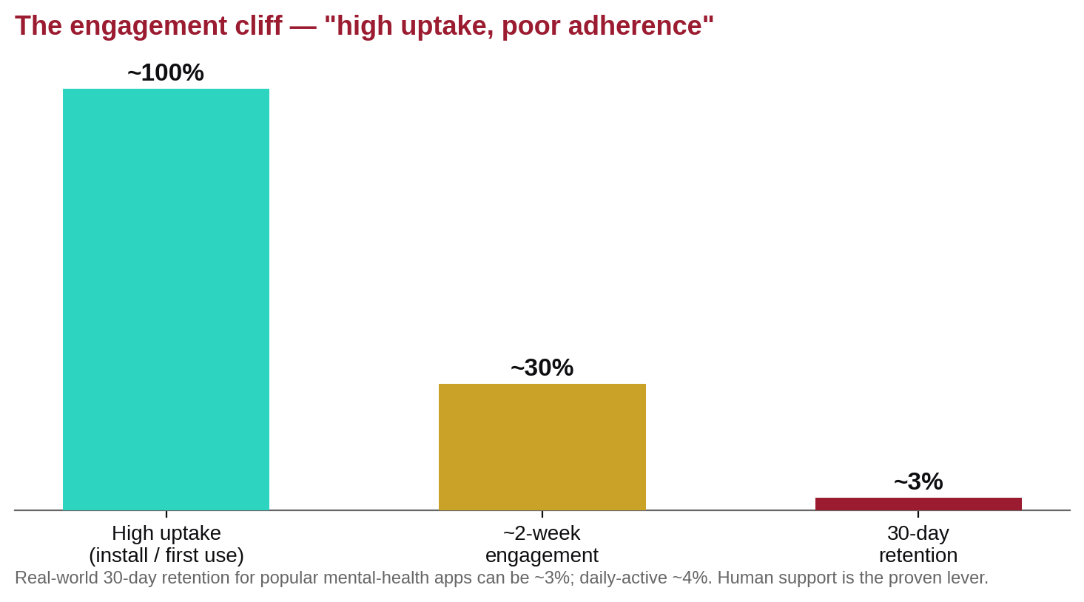
Figure 6. The engagement cliff. Real-world mental-health apps show high uptake but steep drop-off; human support is the most consistent retention lever.
What demonstrably improves retention (Torous 2025 + reviews):
- Human support ('supported' > self-guided) — the most consistent driver of adherence and effect.
- Digital navigators — non-clinician helpers who onboard, troubleshoot, and tailor content; they raise engagement and equity (Springer 10.1007/s41347-025-00569-0). Directly applicable to a clinician-connected app like COPE.
- Personalized notifications, gamification, peer support, and JITAIs — promising.
Notifications & streaks — nuance, not 'more is better.' Personalized, context-aware nudges help short-term, but frequent alerts cause fatigue and can inhibit intrinsic habit formation (habit RCT; micro-randomized work, PMC6293241). Streaks build habit but create guilt/pressure that backfires for depressed users — favor forgiving streaks (freeze days, miss-tolerant), self-scheduled reminders, and progress framing over loss-aversion.

A2. Evidence-based modules to embed (not a standalone AI therapist)
- Digital CBT-I (sleep) is the strongest single bet and a leading indicator for both depression and bipolar relapse: a moderate QoL effect (SMD 0.47), equivalent to face-to-face (Alimoradi 2022, 10.1016/j.smrv.2022.101646); durable 12-month gains in a 2025 RCT (10.1038/s41746-025-01847-0).
- Behavioral activation translates well to mobile with low friction; 2025 review (PMC12227033); a 2024 BA-app RCT showed a large effect (d≈1.03, 10.3390/bs15111496).
- JITAIs / EMIs (in-the-moment, context-triggered micro-interventions): a 2025 meta-analysis g=0.15, durable to 6 months (BMJ Ment Health 10.1136/bmjment-2025-301641); also an equity lever (Annu Rev Public Health 10.1146/annurev-publhealth-071723-103909).
The PDT/FDA market is a cautionary tale. Rejoyn (Otsuka/Click) became the first FDA-cleared PDT for MDD (Apr 2024) but with a modest effect (MADRS −8.78 vs −6.66, FDA Roundup). Pear Therapeutics (reSET/Somryst) went bankrupt in 2023 over reimbursement failure (Psychiatry Advisor). Takeaway: a clinician-connected monitoring/wellness product (not a standalone prescribed treatment) embeds the same evidence-based modules while avoiding the reimbursement trap that killed Pear.

A3. Safety: suicide risk, crisis, guardrails
- The Stanley-Brown Safety Planning Intervention is the evidence-based standard, moving to smartphone format (SPRC). The plan must be instantly accessible in crisis, support regular review, and ideally get consent to involve support people. COPE already implements this (migration 013) — a real asset.
- 988 is the integration point (17.7M+ contacts since July 2022); hardcode 988 (call/text/chat) + Crisis Text Line 741741 as one-tap, always-visible actions (COPE already does in @cope/shared).
- C-SSRS digital screens have limited predictive accuracy (AUC ~0.62–0.65) and false positives carry real harms (PMC9811343). Treat a positive as a trigger for safety planning + human escalation, never standalone risk stratification.

A4. Measurement-based care from the patient side
- MBC works and patients accept digital PROMs. Remote-IOP MBC correlated with PHQ-9/GAD-7/WHO-5 improvement (n=405; JMIR Form Res 2024); app PROM capture matched paper and was preferred (87% easier than visits; PMC8054360). This directly validates COPE's daily-entry + assessment model.
- EMA + passive sensing / digital phenotyping is the frontier: passive signals (mobility, screen-on, actigraphy/sleep) track affect, and bidirectional mobility↔mood links matter for bipolar (PMC11662189). Correlations are modest — best for relapse-signal, not diagnosis. Two constraints: EMA reactivity (asking about mood changes it → keep prompts brief/sparse) and privacy (granular, revocable consent; on-device where possible).

A5. Patient-clinician communication & between-visit monitoring (COPE's wedge)
- Secure messaging + on-demand data sharing + progress tools improve attendance and follow-through (iCANotes 2025).
- Tech-enabled collaborative care beats usual care — a 2024 multisite RCT (Lancet Digital Health) via real-time data + escalation pathways. The winning 2026 model is hybrid: async messaging + video + in-person escalation in one pathway (Validic 2026).
- Shared decision-making via secure async + pre-visit symptom capture is validated but under-implemented (JMIR 2024). Patients expect responsiveness and control over what's shared. COPE's journal-sharing + alert-feed architecture is well-aligned; the missing piece is the messaging + trustworthy escalation loop.

A6. UX, accessibility, equity
- Trauma-informed design beyond WCAG: reduce cognitive load (fewer options, plain language), give control and predictability, be transparent, and avoid a clinical/aggressive tone (Sage/PMC12304634).
- Cognitive load for depressed users is a first-order constraint — favor progressive disclosure, Daylio-low-friction check-ins, and forgiving flows.
- Cultural/linguistic adaptation pays off measurably: deep participatory adaptation is associated with dropout <11% and adherence >75%, versus a median ~18% attrition in less-adapted tools (JMIR Ment Health/PMC12850045).

A7. Competitive landscape & the exploitable gap
The market went pandemic-boom → 'post-hype reality' shakeout (Second Opinion).
Segment | Players | Strength | Weakness COPE exploits
Meditation / wellness (B2C/employer) | Headspace (70M+; 'Therapy by Headspace' 2025), Calm / Calm Health | Content, brand | No clinical depth, no clinician connection
Employer/payer clinical (B2B) | Lyra (AI matching, outcomes-based pricing, ~$340/member savings), Spring Health, Brightside | Outcomes infra, payer integration | Employer-gated; thin daily patient-side tracking/journaling
Teletherapy (B2C, troubled) | BetterHelp (declining; $7.8M FTC settlement), Talkspace, Cerebral | Scale, access | Distrusted on privacy sector-wide
Mood trackers (B2C, nearest analog) | Daylio, Bearable, eMoods (bipolar gold standard), Sanvello, Wysa | Great UX / data depth | Islands — no care-team link, no MBC loop, no safety escalation

The wedge. A polished, trauma-informed daily tracker that (a) feeds validated PROMs into a clinician dashboard with alerting, (b) closes the between-visit monitoring + secure-messaging loop, (c) bakes in safety planning + 988, (d) wins on privacy/HIPAA transparency against the FTC-scarred field, and (e) owns the bipolar niche (eMoods leads tracking but connects to no one).

A8. AI in mental health apps (2025–2026): heavy scrutiny
- The reckoning: the APA warned federal regulators (Feb 2025) about AI chatbots posing as therapists, especially sycophancy (APA); Character.AI faces wrongful-death suits; and Woebot shut its CBT chatbot June 30, 2025 (telehealth.org).
- FDA stance (Nov 2025): 1,200+ AI devices authorized, zero for mental health; the Digital Health Advisory Committee (Nov 6, 2025) signaled a risk-based, total-product-lifecycle framework — inclusive premarket evidence, equitable performance across populations/languages, built-in human escalation, misuse controls, explainability, and postmarket drift/bias/hallucination/sycophancy monitoring (FDA DHAC).
Recommendations for COPE: (1) no open-ended 'AI therapist' — use LLMs for augmentation (journaling reflection, clinician-facing summarization, draft clinician-reviewed check-ins, content personalization); (2) keep AI rule-bounded on anything clinical; (3) require crisis-detection → human escalation (never an AI dead-end); (4) be transparent that it is AI; (5) guard against sycophancy. COPE's existing BAA-gated, consent-checked, rule-fallback pattern is already a defensible posture.

Part B — Clinician-Facing Best Practices, Interoperability & Regulatory
Currency flags (these changed the landscape recently). FDA reissued the CDS + General Wellness guidances Jan 6, 2026; most of HTI-2 was withdrawn Dec 29, 2025; the Continuing Appropriations Act, 2026 (Feb 3, 2026) extended Medicare telehealth flexibilities through Dec 31, 2027; and CMS added 2026 RPM/RTM short-duration codes and (Jan 2025) Digital Mental Health Treatment codes G0552–G0554.

B1. Measurement-based care (MBC) — strong but fidelity-dependent
- Evidence: Guo 2015 (Am J Psychiatry, N=120): MBC vs standard care achieved remission 73.8% vs 28.8%, response 86.9% vs 62.7%, and faster time-to-response (PMID 26315978). But the effect is fidelity-dependent; 'just collecting scores' is non-significant (JCP).
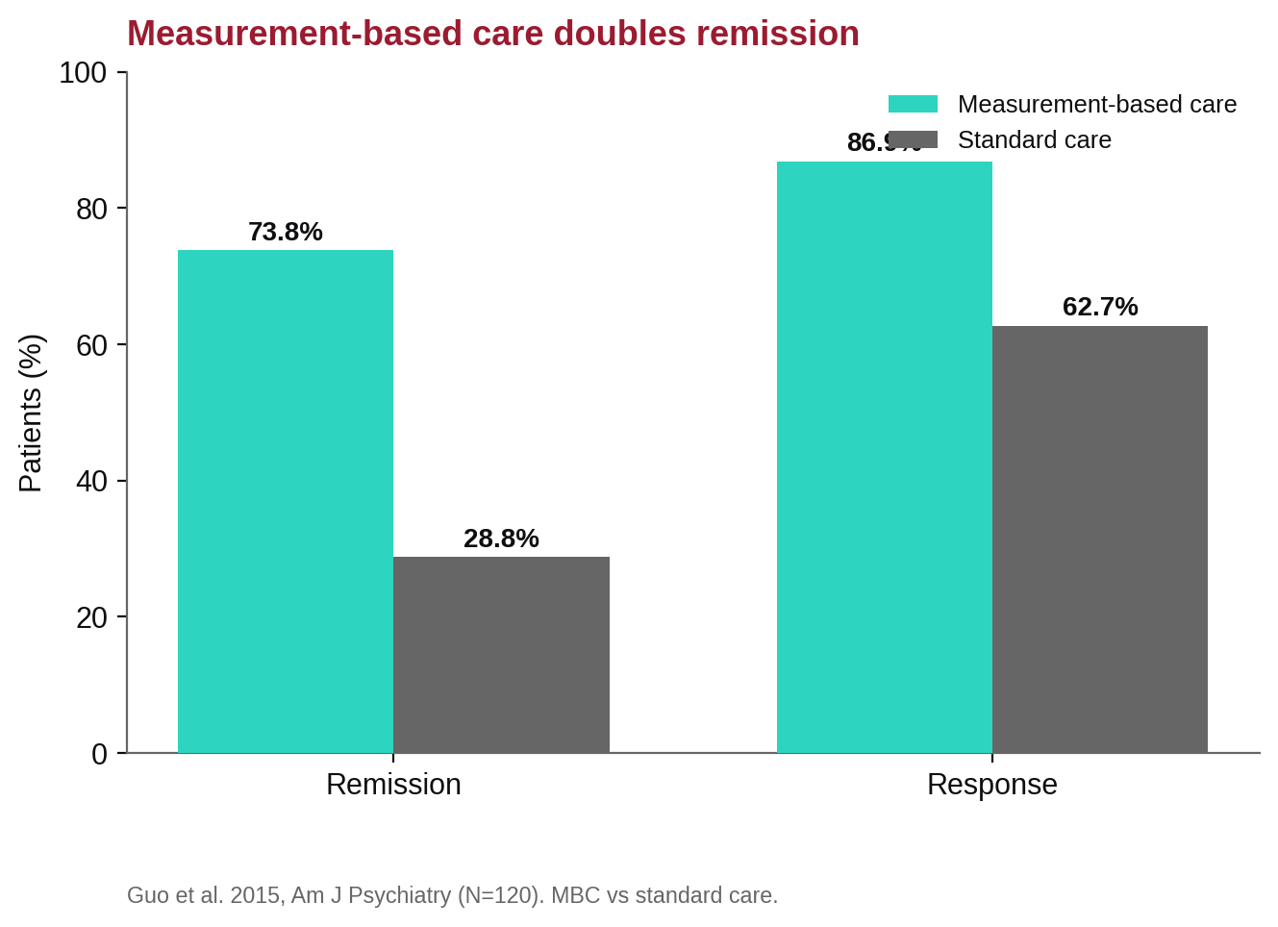
Figure 7. Measurement-based care roughly doubles remission versus standard care (Guo et al. 2015, N=120).
- The robust signal is the feedback-system literature: de Jong 2021 (58 studies; g≈0.14–0.15, larger for 'Not-On-Track,' ~20% dropout reduction); Rognstad 2022 (d=0.14 overall, d=0.29 for at-risk); and Lambert's OQ work — feedback more than doubled positive outcomes for at-risk cases (22.3%→55.5%, PMID 26641368).
- Design implication: the clinician-facing panel captures most of the benefit — prioritize surfacing deterioration / not-on-track patients. COPE's nightly snapshots + risk history already compute this.
Validated numbers to encode (use exactly):
Metric | PHQ-9 (0–27) | GAD-7 (0–21)
Severity bands | 5 / 10 / 15 / 20 | 5 / 10 / 15
Reliable change / MCID | 5 points | 4 points
Response | ≥50% reduction | ≥50% reduction
Remission | < 5 | < 5

- Prefer the Reliable Change Index over a flat 50% rule for individual monitoring (Kroenke 2001; Löwe 2004, PMID 15550799; Spitzer/Löwe 2006).
- Why adoption is low: time/workflow/administrative burden + poor EHR integration; telehealth broke the 'share-the-paper-measure' workflow (PMC10923014). Facilitators: training, clinic champions, and EHR/feedback-system integration.

B2. Clinical workflow & dashboards
- The CoCM registry is the canon (UW AIMS Center): track outcomes at patient and caseload level, summarize against a treat-to-target goal, and enable Systematic Caseload Review prioritizing patients not improving / new / complex (AIMS). Treat-to-target: aim for ≥50% reduction, re-measure each contact, and change the plan at 10–12 weeks if not improving (AIMS T2T).
- Documentation burden is the clinician's lived reality: ~2 hours of EHR work per 1 hour of care (Sinsky 2016, 10.7326/M16-0961); 5.9 of 11.4 workday hours in the EHR (Arndt 2017). Ambient AI scribes cut burnout 51.9%→38.8% in 30 days (JAMA Netw Open 2025, PMC12492056) — but with occasional clinically significant inaccuracies.
- Dashboard design evidence: clinicians rank easy navigation, trend/history, simplicity, and clarity at the top; 'AI predictive analytics' ranked 13th (PMC11618005). EHR usability is famously bad (SUS 45.9, an 'F'; each +1 SUS point = 3% lower burnout odds, Melnick 2020). Clarity and trend history beat AI sophistication.
- Alert fatigue is the central CDS risk: clinicians override 49–96% of interruptive alerts. Levers: tier by severity, route by role, non-interruptive by default, mine override reasons, and kill alerts never acted on ('Getting Rid of Stupid Stuff,' NEJM 2018). Reserve interruption for genuinely actionable, validated signals (C-SSRS-positive, reliable deterioration) — never routine entry.

B3. Interoperability (FHIR / SMART / ONC / CMS)
- FHIR R4 (4.0.1) is locked for US regulation; current US Core = STU 9.0.0, but the 2026 regulatory floor is USCDI v3 / US Core 6.1.0 (HTI-1); the Cures API criterion is §170.315(g)(10).
- SMART App Launch v2.2.0 for EHR embedding: EHR launch + standalone + Backend Services (asymmetric JWT), OAuth2/OIDC + PKCE, .well-known/smart-configuration, and v2 granular scopes.
- Information-blocking disincentives are LIVE (effective Jul 31, 2024): clinicians risk a zero MIPS Promoting Interoperability score; ONC publicly posts violators.
- TEFCA is live with 11 QHINs (Epic Nexus, eHealth Exchange, Health Gorilla, Oracle HIN…).
- HTI-1 DSI (live since Jan 1, 2025): certified IT must surface 31 source attributes for Predictive DSIs + Intervention Risk Management — the de-facto 'model card' buyers will expect (see B7). HTI-2 was largely withdrawn Dec 29, 2025 — do not build to its withdrawn proposals.
- Behavioral-health FHIR pattern: capture QuestionnaireResponse (US Core) → derive a scored Observation (category=survey, LOINC) via HL7 SDC extraction. Confirmed LOINC: PHQ-9 total 44261-6, GAD-7 total 70274-6, C-SSRS 93245-9 / screener 93373-9. ISI/ASRM/WHODAS LOINC are not authoritatively pinned — verify at loinc.org. Use CarePlan (safety plans), RiskAssessment (algorithmic risk), Communication (messaging), and Provenance (required for exchange). Watch the US Behavioral Health Profiles IG (HL7/SAMHSA/ASTP).
- Epic/Oracle practical path: Epic via fhir.epic.com → sandbox → prod → Showroom/Connection Hub; Oracle via the CernerCare code Console; both require OAuth2/OIDC + PKCE + US Core mapping, with per-site provisioning (apps don't auto-activate across health systems).

B4. Regulatory (FDA SaMD + HIPAA)
The CDS device line is COPE's central risk. Software is Non-Device CDS only if it meets all four §520(o)(1)(E) criteria. The reissued Jan 6, 2026 CDS guidance (PDF) folds time-critical analysis into an automation-bias test.
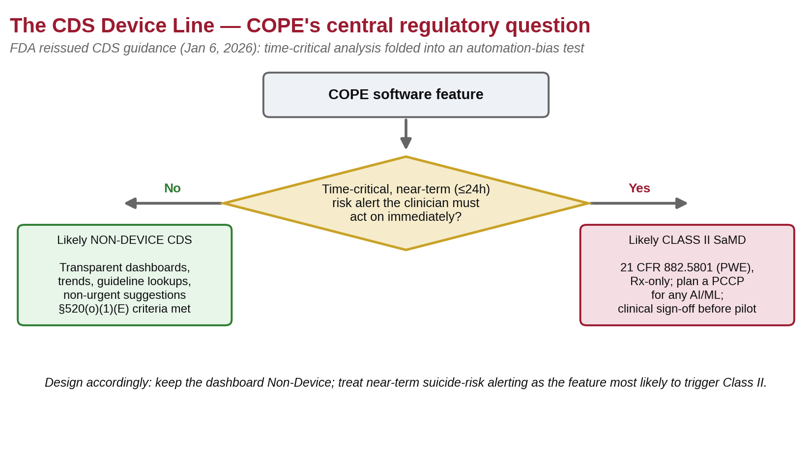
Figure 8. The CDS device line. Time-critical, near-term suicide-risk alerting is the feature most likely to make COPE a Class II device.
What makes COPE a regulated Class II device: time-critical near-term risk alerts the clinician must act on immediately (an urgent suicide-risk alarm), black-box recommendations, and compressed-timeframe risk prediction — enforcement discretion is explicitly withdrawn for predictions over a 'compressed timeframe' (FDA's example: the next 24 hours), which re-captures high-acuity suicide alerting. Net: a transparent dashboard of scores/trends/guidelines is likely Non-Device CDS; time-critical near-term suicide alerts are the single feature most likely to trigger Class II — exactly what COPE's own rules flag for clinical sign-off before pilot.
- Class II pathway: 21 CFR 882.5801 'Computerized behavioral therapy device,' Class II, Rx-only, product code PWE. Cleared examples: reSET/Somryst, Rejoyn (De Novo 2024), Daylight, NightWare, Freespira. ~62% via 510(k), ~38% via De Novo.
- PCCP for AI/ML: FDA final guidance Dec 4, 2024 — Description of Modifications + Modification Protocol + Impact Assessment (media/166704); plus a Jan 7, 2025 draft AI lifecycle guidance. No generative-AI mental-health device is FDA-authorized to date (DHAC Nov 6, 2025 stressed human oversight, crisis escalation, and hallucination/sycophancy/drift).
- HIPAA: audit controls are already REQUIRED (45 CFR 164.312(b)). The Dec 27, 2024 Security Rule NPRM (still proposed) would make nearly everything required (removing 'addressable'), mandate MFA and encryption at rest + in transit, require an asset inventory / network map, 6-month vulnerability scans + annual pen tests, and 72-hour restoration. Build to the NPRM now. BAAs are required with every CSP touching PHI — even encrypted 'no-view' hosting — and flow down to subcontractors.

B5. Communication & telehealth policy
- Behavioral-health telehealth is the most stable regime — PERMANENT: no geographic restriction, the patient's home is a permanent originating site, and audio-only is permanently allowed. The only catch: the in-person requirement is waived through Dec 31, 2027 (it returns Jan 1, 2028 unless Congress acts).
- Secure messaging: OCR's COVID enforcement discretion ended May 2023 — full HIPAA + BAA mandatory with any vendor touching PHI. Best practice: transport/at-rest encryption, audit logs, strong auth, and closed-system design; async versus sync per APA/ATA.
- Billing message time: online digital E/M 99421/99422/99423 (physicians) and 98970/98971/98972 (therapists), patient-initiated, established patient, on a 7-day rolling window; virtual check-in 98016. There is no federally mandated response-time SLA — SLAs are organizational policy.

B6. Collaborative & stepped care (COPE's enterprise wedge)
- CoCM (IMPACT) is the most evidence-based model: Unützer 2002 (JAMA, N=1,801) — 45% vs 19% achieved ≥50% reduction at 12 months (OR 3.45, PMID 12472325); 90+ RCTs support CoCM. Five principles: team-based, population/registry-based, measurement-based treat-to-target, evidence-based, and accountable.
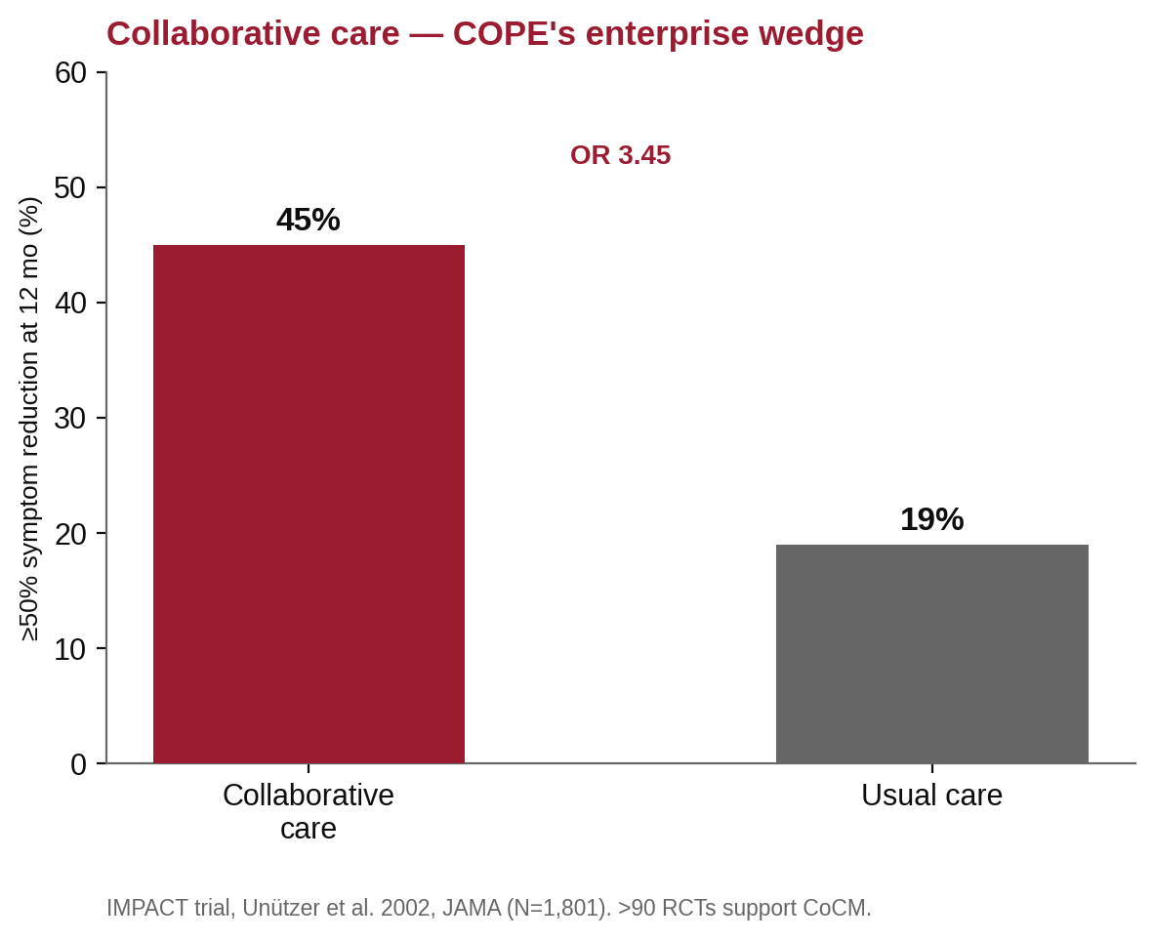
Figure 9. Collaborative care versus usual care (IMPACT, Unützer 2002). COPE's registry + treat-to-target dashboard is the infrastructure CoCM billing requires.
- The billing maps onto COPE's architecture: CoCM 99492/99493/99494/G2214, BHI 99484. CMS's six required elements — a treating-provider order, a behavioral health care manager, a psychiatric consultant, a registry with ≥1 validated measure (PHQ-9/GAD-7), a time log, and no duplicate E/M — are literally COPE's feature set. A registry + treat-to-target dashboard is the product CoCM billing requires. (Note: RHC/FQHC G0511 ended Sept 30, 2025 → individual codes + new G0568/G0569/G0570.)
- RTM is the right family for a self-report behavioral app (it allows non-physiologic self-reported data and is therapist-billable): 98975 (setup), 98978 (monitoring supply), 98980/98981 (20-min mgmt) + new 2026 short-duration codes. RPM requires auto device-uploaded physiologic data. FDA-cleared DTx uses the dedicated G0552–G0554 pathway (which requires 21 CFR 882.5801 clearance).

B7. Clinical decision support & suicide-risk prediction
- State of the art: MHRN/Kaiser (Simon/Coley) 90-day models prompt C-SSRS at predicted risk ≥~3%; the VA's REACH VET flags the top ~0.1% — a 2025 JAMA Netw Open evaluation found fewer attempts/admissions but no reduction in suicide mortality.
- Pitfalls: Belsher 2019 (JAMA Psychiatry): good AUC but PPV ≤0.01 — at base rates, ~58 true positives versus ~49,942 false positives (PMID 30865249). A 2025 BMC Medicine review of 167 models found calibration assessed in only 9% and all developed models at high risk of bias. Bias is documented: Coley 2021 — suicide models performed poorly for Black and AI/AN patients (PMC8082428).
- Responsible presentation: risk is a flag that prompts assessment, never a verdict; trigger safety planning at any level; surface 988 + 741741; show limitations/fairness caveats inline; log clinician acknowledgment; calibrate thresholds to limit false positives; and publish an HTI-1-style 31-attribute 'model card' + Intervention Risk Management voluntarily — both ethical and procurement-winning.

B8. Enterprise readiness (what health systems/payers require to buy)
- Security/compliance ladder: SOC 2 Type II (table stakes, not HIPAA-specific) → HITRUST CSF v11 (healthcare-specific; tiers e1→i1→r2 gold standard; with a 2024 AI Security add-on) → BAA (legally required; encryption, MFA, RBAC, immutable audit logs, breach notification, subcontractor flow-down).
- Enterprise identity: SAML 2.0 SSO + OIDC/OAuth2 + SCIM 2.0 provisioning (≈mandatory at 1000+ seats), multi-tenant isolation, MFA, and audit logging. Buyers screen via Shared Assessments SIG / VSA. COPE already has OIDC (Authentik) + MFA — SAML + SCIM are the gaps.
- Encryption TLS 1.2+/1.3 + AES-256; immutable audit logs with anomalous-access alerting; US data residency is often required. HHS 405(d) HICP attestation can mitigate OCR penalties (safe harbor).
- Clinical-value validation (a payer differentiator): PHTI (Peterson/ICER framework), DiMe V3+, ATA accreditation.
Verify before implementation. LOINC for ISI/ASRM/WHODAS; exact US Core must-support lists for your cert version; the current QHIN roster; and whether the HIPAA Security Rule NPRM has been finalized.

Part C — Native-Mobile Architecture Evidence (2025–2026)
Scope. Condensed evidence base for the native build (full detail + stack table in Part III). Apple/Google docs are JS-rendered; version specifics flagged 'verify' should be re-confirmed at implementation time.
- iOS: SwiftUI-first (Apple's strategic direction; a UIKit escape hatch only for pathological media-heavy lists). MVVM-lite with the Observation framework (@Observable, iOS 17+) — cuts 30–50% of Combine boilerplate; reserve TCA for the multi-step assessment + safety-plan state machines. Swift 6.2 strict concurrency + 'Approachable Concurrency' (default @MainActor isolation on). Native URLSession async/await (not Alamofire — fewer deps for a HIPAA audit). Local SPM-package modularization.
- iOS data/offline: avoid SwiftData for the sync layer (slower, no FTS, CloudKit-only sync, iOS-26 migration regressions). Use GRDB.swift (FTS5 for journal search, SQLCipher AES-256) via Point-Free's SQLiteData wrapper. Evaluate PowerSync (bi-directional Postgres↔SQLite, Swift SDK, Sync Rules that map onto COPE's RLS; HIPAA/SOC 2 claimed Jan 2026 — verify).
- Android: Jetpack Compose is the unambiguous default (Google's 'Compose First,' May 2026; scroll parity reached Dec 2025; M3 1.4 SecureTextField for PHI). Google's layered + UDF architecture, ViewModel + StateFlow + collectAsStateWithLifecycle(), with scoring/thresholds in domain use cases. Hilt + KSP DI; Retrofit + OkHttp + kotlinx.serialization; Navigation 3 (stable Nov 2025); Now-in-Android modularization.
- Android data/offline: Room 2.8 + KSP (keep DAOs suspend/Flow for the Room 3.0 KMP rewrite), WorkManager for sync (expedited work for crisis assessments), Proto DataStore for non-PHI config. Jetpack Security Crypto is DEPRECATED (2025) — use SQLCipher (sqlcipher-android 4.6+ with SupportOpenHelperFactory) + Google Tink, with keys in Keystore/StrongBox.
- Health platforms: HealthKit now has State of Mind (HKStateOfMind, valence/labels) and native PHQ-9/GAD-7 types (huge for COPE), plus sleep stages, HRV (SDNN), mindful minutes, and mobility; background via HKObserverQuery + enableBackgroundDelivery. Health Connect 1.1 (stable Nov 2025) has MindfulnessSessionRecord, HRV (RMSSD), and sleep/steps/HR — but no mood/valence equivalent (build your own). SensorKit is research/IRB-only — for commercial passive sensing use HealthKit + CoreMotion (+ consented CoreLocation) / Health Connect + Activity Recognition, processing derived features on-device.
- Security (HIPAA/MASVS): Keychain/Keystore + Secure Enclave/StrongBox; biometrics bound to a crypto operation (not presence-only); AES-256 at rest; cert/SPKI pinning; Play Integrity / best-effort jailbreak detection (gate sensitive actions, server-verified); FLAG_SECURE + app-switcher blur to hide PHI; auto-logoff ~2–5 min; no PHI in logs/payloads/analytics; no hardcoded secrets (proxy 3rd-party keys via backend). Target OWASP MASVS L2 + R.
- Push/background: APNs .timeSensitive for reminders, .critical (an Apple-reviewed entitlement) for clinically-validated crisis only; FCM HTTP v1 data-only + channels (crisis_alerts HIGH). Never put PHI in a payload/banner. Quick-log surfaces: WidgetKit interactive widgets + Control Center + Siri + a watch complication (iOS); a Glance widget + a Wear Tile (Android) — one shared LogMood intent.
- Accessibility/release: WCAG 2.2 AA including 3.3.8 Accessible Authentication (allow paste + biometric — interacts with COPE's forced-password-change modal) and 3.2.6 Consistent Help (fixed 988 placement). Apple Accessibility Nutrition Labels + in-app account deletion; Google Play Medical Device labeling + an org-account + a health declaration (relevant to the SaMD posture).
- Shared strategy (KMP): a KMP shared commonMain core + fully native SwiftUI/Compose UIs; skip Compose Multiplatform for v1. Share the clinical assessment scoring (divergence = a patient-safety bug), validation, networking (Ktor), and the offline DB/sync engine (SQLDelight). Use SKIE for Swift interop, and OpenAPI Generator off the Fastify spec to keep TS/Swift/Kotlin DTOs in sync (codegen shares shapes; KMP shares behavior).
Bottom line. A KMP-shared-core + native-UI architecture, GRDB/Room + SQLCipher offline, deep HealthKit/Health Connect integration, crisis-grade native notifications, and quick-log widgets — built to MASVS L2+R and WCAG 2.2 AA — is the technical foundation for a best-in-class, defensible app.

Part III — Native iOS (Swift) & Android (Kotlin) Plan
Author: Mobile architecture plan · Date: June 27, 2026
Scope. A complete plan to replace the Expo/React-Native patient app with fully native iOS (Swift/SwiftUI) and Android (Kotlin/Jetpack Compose) apps, plus a companion native clinician experience. The backend (apps/api) and @cope/shared contract stay; only the patient (and new clinician-mobile) client tier is rebuilt natively. Architecture/security/release sections draw on the research in Part II, Part C.

1. Why Native, and Scope

1.1 Rationale
The current Expo app is ~65% complete and functional, but the goal is native apps that can supersede competitors. Native is justified here by concrete, COPE-specific needs:
Driver | Why RN/Expo is limiting | Native advantage
Deep health-platform integration | react-native-health / react-native-health-connect lag native APIs and background delivery | First-class HealthKit (HKObserverQuery, background delivery, sleep stages, HRV, mobility/gait) & Health Connect (incl. Mental Wellbeing records)
On-device privacy/ML (digital phenotyping) | passive sensing + on-device inference are awkward in RN | Native sensors, Core ML / on-device models, and background tasks done right
Crisis-grade reliability & UX | bridge jank, cold-start latency, notification edge cases | Native time-sensitive/critical notifications, instant safety-plan access, smooth low-cognitive-load UX
Widgets / watch / Live Activities | limited or none in Expo managed | WidgetKit + watchOS complications + Android widgets + Wear OS for one-tap mood logging
Security posture for SaMD/HIPAA | encrypted local store, jailbreak/root detection, and cert pinning are add-ons | Keychain/Keystore, biometric, attestation, and an encrypted DB are native-first
App Store / Play medical-app trust | acceptable, but native signals quality | Best-in-class accessibility, performance, and store-review outcomes

1.2 Scope of the native program
- Patient app — iOS (Swift) + Android (Kotlin): full parity with today's Expo app, plus the unfinished features and new differentiators (see Part IV).
- Clinician companion — iOS + Android (Phase 2): read-first triage + secure messaging + alert triage + safety-plan review. (The full clinician console remains the web app, made responsive in Part IV.)
- Shared backend & contract unchanged: native apps consume the existing /api/v1/* REST + WS and the @cope/shared semantics (mood colors, thresholds, crisis contacts, LOINC map, WS events).
Non-goals (v1 native). No re-platforming the web console to native; no new backend auth model (reuse bcrypt + rotating refresh + MFA + OIDC exactly as-is — it is protected per project rules).

2. Feature-Parity Matrix (native must reach or exceed this)
Status legend: Done = exists in Expo today · Partial = partial in Expo · Backend-ready = backend-supported but not in the mobile client · New (native) = new in native (Part IV).
Domain | Capability | Expo today | Native target
Auth | bcrypt login, MFA (TOTP), invite registration, OIDC SSO, forced password change | Done | + passkeys/WebAuthn (new), biometric unlock
Onboarding | consent wizard | Done | Done
 | clinical intake wizard | Partial (stub) | Complete
Daily check-in | 9-step multi-domain (mood/mania/anxiety/anhedonia/SI/substance/social/cognitive/appetite/stress/sleep/exercise/life-events) | Done | + adaptive (skip mania for unipolar), split AM/PM, low-cognitive-load
Safety | C-SSRS branch + safety modal + crisis resources | Done | + one-tap safety plan, 988 call/text/chat, means-restriction
 | crisis safety plan (Stanley-Brown) view/sign | Backend-ready | Patient-facing plan
Assessments | PHQ-9, GAD-7, ASRM, ISI, C-SSRS questionnaires | Done | + WHODAS, QIDS-SR (backend ready)
 | 'pending/due' surfacing | Partial | Scheduled + reminders
Medications | list, adherence toggle, add med, history | Done | + local reminders firing, side-effect capture
Journal | list, create, voice capture, share-with-care-team | Done | + detail/edit view (stub today), rich text, prompts, search
Insights | server stats summary | Partial (text only) | + trend charts (Swift Charts / Compose), correlations
 | AI insights (BAA-gated) | Partial | Augmentation-only, consent-gated
Passive health | steps/HR/HRV/sleep ingest → /health-data/sync | Done | + sleep stages, mobility, mindful minutes, background delivery
Offline | WatermelonDB pull/push | Done (foreground only) | Encrypted local DB + background sync + conflict UI
Notifications | push registration | Done | + local check-in/med reminders, time-sensitive/critical for crisis
Comms | journal share, assessment requests (inbound) | Done | + secure 2-way messaging (new, Part IV)
Quick-log | — | — | New: widgets / watch / Live Activities for 1-tap mood
Security | biometric lock, SecureStore | Done | + encrypted DB, cert pinning, jailbreak/root detection
A11y | labels present | Partial | VoiceOver/TalkBack, Dynamic Type, WCAG, trauma-informed

3. Backend Contract the Native Apps Consume
No backend changes are required for parity. The native apps target the existing API. Key surfaces:
- Auth: POST /auth/login → (optional mfa_pending) → POST /auth/mfa/verify; POST /auth/refresh (rotating, reuse-detected); POST /auth/change-password; OIDC via GET /auth/oidc/redirect + POST /auth/oidc/exchange. Tokens: 15-min access, 7-day refresh.
- Daily entries: GET /daily-entries/today, POST /daily-entries, PATCH /daily-entries/:id/submit.
- Assessments: POST /assessments, GET /assessments/pending, GET /assessments/:id/fhir.
- Medications: GET /medications/today, POST /medications, POST /medications/:id/logs.
- Journal: POST /journal, GET /journal, PATCH /journal/:id, PATCH /journal/:id/share.
- Safety: GET /safety/resources, GET /safety/my-plan, POST /safety/my-plan/sign.
- Insights: GET /insights/me?days=30, GET /insights/me/ai… (gated), GET /insights/me/risk-scores.
- Passive health: POST /health-data/sync (batch upsert), GET /health-data/me.
- Catalogues/consent/notifications/voice: GET /catalogues/{triggers,symptoms,strategies}, GET|POST /consent, GET|PUT /notifications/prefs, POST /voice/transcribe.
- Offline sync: GET /sync/pull?last_pulled_at=…&schema_version=… and POST /sync/push — patient-only, WatermelonDB-style changesets over daily_entries, journal_entries, and the daily_entry_{triggers,symptoms,strategies} join tables (the server returns server_id + updated_at).
Contract requirement for native. The sync protocol is WatermelonDB-shaped today (created/updated/deleted arrays keyed by table, last_pulled_at unix-ms). Native clients will implement the same wire protocol against their own local stores (GRDB/Room), so the backend /sync endpoints need no changes. Where native adds new offline entities (e.g., messages), extend the changeset object additively (backend rule #12: additions only).

3.1 Recommended additive backend touch-points (small, optional)
These are not required for parity but unlock native differentiators (detailed in Part IV):
- A messages resource + /messages endpoints + a WS message.created event (secure 2-way comms).
- A schema_version bump path in /sync for new offline tables.
- A per-device push-token model already exists (patient_notification_preferences.push_token) — extend it to allow APNs + FCM token types and multiple devices.

4. Architecture (the recommended shape)

4.1 Headline decision: KMP shared core + fully native UIs
Adopt Kotlin Multiplatform (KMP) for a shared `commonMain` core behind fully native SwiftUI (iOS) and Jetpack Compose (Android) UIs. Skip Compose Multiplatform for v1 (not yet native-feeling on iOS; a weak XCTest evidence trail for a regulated app).
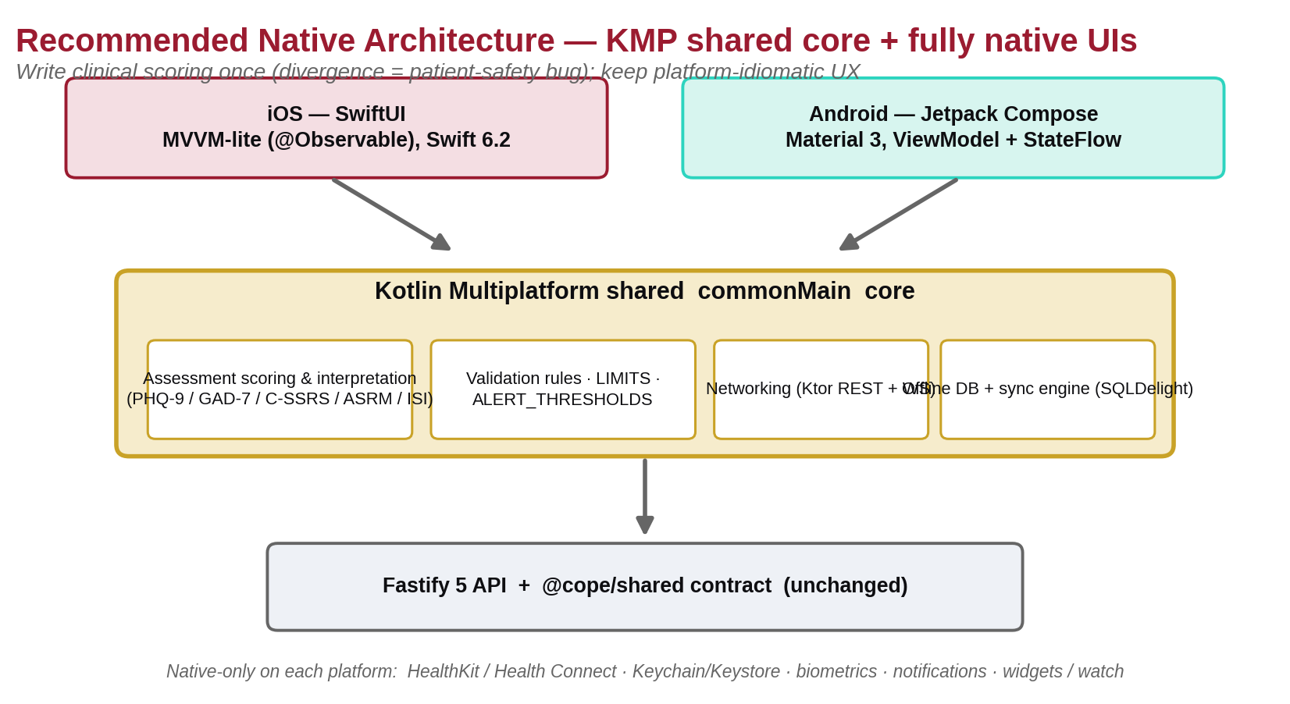
Figure 10. Recommended native architecture — a KMP shared core (scoring, validation, networking, offline-sync) behind fully native SwiftUI and Compose UIs.
Why (COPE-specific): the one thing that must not diverge between platforms is clinical assessment scoring (PHQ-9/GAD-7/ISI/C-SSRS/ASRM/WHODAS) and the ALERT_THRESHOLDS/validation rules — divergence is a patient-safety defect. KMP lets the team write and unit-test that once. Native UIs keep platform-idiomatic UX, accessibility, and deep OS integration (HealthKit/Health Connect, biometrics, notifications, widgets).
- Share in `commonMain`: assessment scoring + interpretation, validation rules (Zod-equivalent, LIMITS, ALERT_THRESHOLDS), networking (Ktor REST + WS against the Fastify API), the offline DB + sync engine (SQLDelight), and the crisis safety-plan model + 988/741741 constants.
- Keep native: all UI, HealthKit/Health Connect, biometrics/Keychain/Keystore, notifications, and widgets/watch.
The 'three type definitions' problem. TS (@cope/shared), Swift, Kotlin. KMP collapses iOS+Android to one Kotlin source (3→2); close the gap to TS with OpenAPI Generator off the Fastify JSON-Schema spec to emit TS+Swift+Kotlin DTOs in CI. (Codegen syncs shapes; KMP shares behavior.) If the team has zero Kotlin appetite, fall back to fully-native + OpenAPI codegen — accepting a third hand-maintained scoring implementation that must be cross-tested.

4.2 iOS module/architecture
- SwiftUI-first, MVVM-lite with @Observable (@MainActor @Observable models for screens with real logic: assessment scoring, sync status, safety plan); bind directly for trivial screens. Reserve TCA for the multi-step check-in/assessment + safety-plan state machines if exhaustive testability is wanted.
- Swift 6.2 strict concurrency + Approachable Concurrency (default @MainActor isolation on; an actor for the sync/DB boundary). A URLSession async/await client with an actor-isolated token-refresh interceptor matching COPE's rotating refresh tokens. URLSessionWebSocketTask in an actor exposing AsyncStream (with heartbeat + backoff + re-auth/resubscribe).
- Local SPM packages: CopeCore/Models (mirror @cope/shared), DesignSystem, Persistence, Networking, and Feature{CheckIns,Journal,Assessments,SafetyPlan,Meds,Insights,Messaging,CareTeam}; a thin app target as composition root. DI via Factory (or swift-dependencies if SQLiteData is adopted).

4.3 Android module/architecture
- Jetpack Compose + Material 3 (BOM 2025.12+), Google's layered + UDF, ViewModel + a single uiState StateFlow (stateIn(..., WhileSubscribed(5000), Loading)), collectAsStateWithLifecycle(). Scoring + thresholds live in domain-layer use cases.
- Coroutines + Flow; Hilt + KSP DI; Retrofit + OkHttp + kotlinx.serialization; an OkHttp WebSocket in a callbackFlow with backoff; Navigation 3 (stable).
- Now-in-Android modularization: :app + :feature:* + :core:{data,database,network,datastore,designsystem,model,domain,security}; isolate the PHI-touching :core:security/:core:database.

4.4 KMP core stack
Kotlin 2.x · Ktor ~3.5 (REST+WS) · SQLDelight ~2.3 · kotlinx-serialization/coroutines/datetime · multiplatform-settings · Koin (core DI) · SKIE (required) to turn Kotlin sealed classes → exhaustive Swift enums, suspend → Swift async, and Flow → AsyncSequence.

5. Data & Offline Sync

5.1 Local persistence
- iOS: GRDB.swift (FTS5 full-text journal search; mature, fast) via the SQLiteData wrapper — not SwiftData (no FTS, CloudKit-only sync, migration regressions).
- Android: Room 2.8 + KSP, DAOs suspend/Flow-only (ready for the Room 3.0 KMP rewrite).
- KMP option: SQLDelight as the shared store so the sync engine itself is shared commonMain.

5.2 Sync engine — reuse COPE's existing protocol, harden it
The backend /sync/pull + /sync/push already speak a WatermelonDB-shaped changeset (created/updated/deleted per table, last_pulled_at unix-ms, server_id+updated_at). The native engine implements the same wire protocol → no backend change for parity.
- Pattern: the local DB is the single source of truth; lazy writes (write local, enqueue sync) so nothing is lost offline; a WebSocket invalidation channel triggers pulls; an outbox queues pushes.
- Conflict resolution: field-level last-write-wins using server-authoritative timestamps for single-author records (check-ins, assessments, meds). For co-edited free text (a shared safety plan; a journal edited offline on two devices) use an explicit merge UI or CRDT — never silently drop PHI.
- Clinical-record discipline (SaMD): make assessments/journal entries append-only / versioned (created_at/updated_at/server_version), never overwrite — preserving the audit trail.
- Optional accelerator: evaluate PowerSync (bi-directional Postgres↔SQLite, Swift + Kotlin SDKs, Sync Rules mapping onto COPE's RLS / app.current_user_id; verify its Jan-2026 HIPAA/SOC 2 status). If adopted it can replace the hand-rolled outbox; otherwise keep the protocol above.

5.3 New offline entities
Messaging (W1 of Part IV) adds a messages table to the changeset — bump schema_version and extend the changeset object additively (backend rule: additions only).

6. Security on Device (HIPAA / OWASP MASVS L2+R)
Control | iOS | Android
Secrets/tokens | Keychain (…WhenUnlockedThisDeviceOnly + .biometryCurrentSet); wrap with Secure Enclave | Keystore (TEE/StrongBox) + key attestation (server-verified)
Biometric unlock | LocalAuthentication bound to a Keychain/Enclave crypto op (not evaluatePolicy alone) | BiometricPrompt + CryptoObject, BIOMETRIC_STRONG, setInvalidatedByBiometricEnrollment(true)
DB at rest | SQLCipher (GRDBCipher) AES-256 + NSFileProtectionComplete; key in Keychain/Enclave | SQLCipher (sqlcipher-android 4.6+ SupportOpenHelperFactory) + key in Keystore. Jetpack Security deprecated
Field encryption | CryptoKit AES.GCM | Google Tink (Aead/StreamingAead)
Transport | ATS on + SPKI pinning (URLSessionDelegate/TrustKit, ≥1 backup pin) | Network Security Config <pin-set> + OkHttp CertificatePinner, cleartextTrafficPermitted=false
Integrity/tamper | best-effort jailbreak detection (MASVS-RESILIENCE) | Play Integrity (server-verified); gate sensitive actions, not launch
Screen privacy | blur overlay on resignActive (app-switcher) | FLAG_SECURE on every PHI window
Session | auto-logoff ~2–5 min inactivity → clear in-memory PHI, re-auth (biometric); reuse COPE's 5-min biometric pattern | (same)
Hygiene | no PHI in logs/crash/analytics; no hardcoded secrets (proxy 3rd-party keys via backend); MobSF/secret-scan in CI | (same)

This directly advances Part IV's W5 (Trust & Privacy) and the SaMD/HIPAA posture (Part I §4 and the Dec-2024 HIPAA NPRM expectations in Part II, B4).

7. Health-Platform Integration & Notifications

7.1 HealthKit (iOS)
- State of Mind (HKStateOfMind: valence −1…+1, emotion labels, life-context associations) — a native mood signal COPE can both read and write (mirror in-app mood logs to Health).
- Native PHQ-9 & GAD-7 types (licensed from Pfizer) — read/write COPE's assessments to HealthKit.
- Passive: sleepAnalysis (stages), stepCount/appleExerciseTime, mindfulSession, heartRate/restingHeartRate, HRV heartRateVariabilitySDNN, and mobility. Background via HKObserverQuery + enableBackgroundDelivery + HKAnchoredObjectQuery. Permissions are per-type/direction and cannot detect a denied read → design for empty results. Sync derived snapshots to POST /health-data/sync (exists).

7.2 Health Connect (Android)
- Stable connect-client 1.1 (Nov 2025): SleepSessionRecord, steps/exercise, HeartRateRecord/RestingHeartRateRecord, HeartRateVariabilityRmssdRecord (RMSSD — note iOS uses SDNN), and the new MindfulnessSessionRecord. No mood/valence equivalent → COPE owns the mood schema on Android. Granular permissions + READ_HEALTH_DATA_IN_BACKGROUND/READ_HEALTH_DATA_HISTORY; a mandatory Play health declaration ('Mental and behavioral health').

7.3 Passive sensing / digital phenotyping (feeds Part IV, W3)
SensorKit is research/IRB-only — avoid for commercial. Use HealthKit + CoreMotion (+ consented CoreLocation) on iOS and Health Connect + Activity Recognition + SensorManager on Android. Process features on-device; transmit derived indicators, not raw traces; with granular, revocable per-signal consent.

7.4 Notifications
- iOS APNs: .timeSensitive for medication/check-in reminders (an auto-grantable entitlement); .critical (the Apple-reviewed critical-alerts entitlement) reserved for clinically-validated crisis events only; a Notification Service Extension composes a PHI-free banner.
- Android FCM HTTP v1: data-only messages → the client composes a generic banner; channels (crisis_alerts HIGH, med_reminders, checkin_reminders, sync_status LOW); POST_NOTIFICATIONS runtime permission; crisis baseline = IMPORTANCE_HIGH heads-up (full-screen-intent is opt-in only).
- Local reminders: iOS UNCalendarNotificationTrigger; Android AlarmManager.setAlarmClock() / setExactAndAllowWhileIdle() (handle the SCHEDULE_EXACT_ALARM prompt on 14+).
- Background sync: iOS BGTaskScheduler + a background URLSession + silent push; Android WorkManager (expedited work for a just-submitted C-SSRS crisis assessment).
HIPAA rule. Never put PHI in any payload/banner — neutral copy only ('Time to check in,' 'New secure message'); details only after in-app auth. Keep PHI out of payloads regardless of vendor BAA status.

7.5 Quick-log surfaces (a differentiator — Part IV, W2)
One shared LogMood path exposed via: iOS interactive WidgetKit widget (Button(intent:)), a Control Center control (iOS 18), Siri AppShortcutsProvider ('Log my mood in COPE'), and a watchOS complication + independent watch app. Android: a Glance home-screen widget + a Wear OS Tile/complication. One-tap mood logging is the highest-frequency, lowest-friction engagement loop.

8. Accessibility, Release & Roadmap

8.1 Accessibility (WCAG 2.2 AA + trauma-informed)
- iOS: .accessibilityLabel/Hint/Value/Traits, Dynamic Type to the largest sizes, honor accessibilityReduceMotion; complete the Accessibility Nutrition Labels (becoming mandatory).
- Android: Modifier.semantics, 48dp targets, sp text, WCAG contrast; test TalkBack + Scanner.
- Most relevant criteria for depressed/anxious users: 3.3.8 Accessible Authentication (allow paste + biometric — must accommodate COPE's forced-password-change modal), 3.2.6 Consistent Help (fixed 988/Crisis-Text-Line placement), 3.3.7 Redundant Entry (don't re-ask in assessments). UX: a low-stimulus calm palette (preserve Fraunces/Figtree + teal #2a9d8f), one primary action per screen, paged assessments, and autosave/undo for journals.

8.2 Store & compliance
- Apple: 1.4.1 (medical accuracy — submit any FDA clearance docs), 5.1.1 (in-app account deletion; submit as a legal entity), 5.1.3 (no ad/data-mining use of health data). Verify 988/741741 are correct in-app (shipped apps have had wrong crisis numbers).
- Google Play: a health declaration, Medical Device labeling (a verified label if cleared, else a 'not a medical device' disclaimer — relevant to the SaMD posture), an organization account (migrate by ~Jan 28, 2026), in-app + web account deletion, and a Data Safety form (health data, App-functionality only, no ad sharing, encrypted in transit).

8.3 CI/CD
iOS: Xcode Cloud primary (managed signing/notarization, TestFlight) + thin Fastlane for screenshots/metadata/privacy-label sync (note: fastlane match cert creation has been degraded since May 2025; it still syncs existing). Android: Fastlane supply or Gradle Play Publisher, Play App Signing, staged rollout (internal→closed→open→prod). Generate SLSA provenance / an SBOM per build for SaMD auditability. Keep the KMP commonTest scoring tests in the gate.

8.4 Native build roadmap (parallelizable with the backend workstreams in Part IV)
Phase | Focus | Exit criteria
P0 — Foundations (3–4 wk) | KMP core skeleton, OpenAPI DTO codegen, design system, modules, CI (Xcode Cloud + Play), SKIE | Build pipelines green; shared scoring lib unit-tested in commonTest
P1 — Auth & shell (3–4 wk) | Login + MFA + OIDC + forced password change, Keychain/Keystore, biometric unlock, secure session/auto-logoff | Parity with Expo auth; MASVS storage/auth checks pass
P2 — Daily check-in (4–6 wk) | Full multi-domain check-in (adaptive: skip mania for unipolar), C-SSRS branch + safety modal, offline writes | Check-in parity; offline create/submit works
P3 — Offline + sync (3–4 wk) | GRDB/Room + SQLCipher, sync engine on /sync, background sync, conflict UI | Multi-device sync correct; encrypted-at-rest verified
P4 — Assessments, meds, journal (4–6 wk) | All scales, med adherence + local reminders, journal detail/edit + voice + prompts + FTS search | Feature parity + finished gaps from Expo
P5 — Insights, health, safety plan (3–4 wk) | Trend charts (Swift Charts/Compose), HealthKit/Health Connect ingest, patient safety-plan view/sign | Charts shipped; passive data flowing; safety plan accessible
P6 — Differentiators (4–6 wk) | Quick-log widgets/watch, secure messaging UI (W1), engagement mechanics (W2), notifications hardening | Widgets live; messaging usable; time-sensitive/critical notifications working
P7 — A11y, store, launch (3–4 wk) | WCAG 2.2 AA audit, nutrition/Data-Safety labels, store review, staged rollout | Both apps approved; pilot-ready
P8 — Clinician companion (later) | Read-first triage + alert/messaging + safety-plan review | Clinician mobile parity for triage

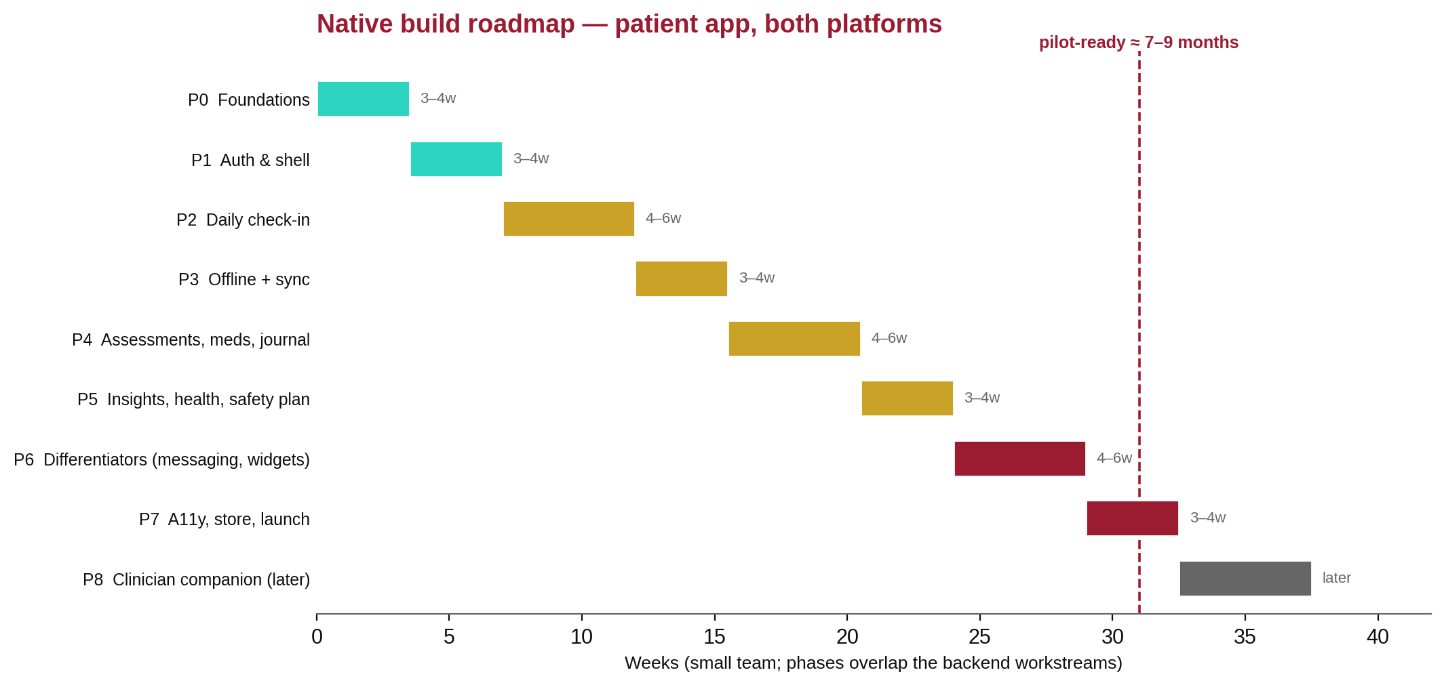
Figure 11. Native build roadmap. Roughly 7–9 months to a pilot-ready patient app on both platforms with a small team, overlapping the backend workstreams in Part IV.
Verify before committing (carried from research). SQLiteData version (Swift Package Index); PowerSync Cloud HIPAA date; FCM Google Cloud BAA coverage; the Play org-account migration deadline; current Compose BOM/library versions; and LOINC for ISI/ASRM/WHODAS.

Part IV — Competitive Enhancement Master Plan
Author: Product & engineering strategy · Date: June 27, 2026
Scope. The plan to enhance all aspects of COPE to supersede competitors. It synthesizes the current-state assessment (Part I) and the evidence/landscape (Part II). Each workstream has: thesis → what to build → why it wins → effort/sequence. The regulatory, interoperability, and enterprise workstreams (W6–W8) draw on Part II, Part B.

0. Strategic Thesis — Win the Connected Loop
The market has a structural gap (Part II, A7):
- Consumer trackers (Daylio, Bearable, eMoods) have great UX but are islands — no care-team connection, no measurement-based-care loop, no safety escalation.
- Employer/payer clinical platforms (Lyra, Spring) have outcomes infrastructure but are employer-gated and thin on daily patient-side tracking/journaling.
- Teletherapy incumbents (BetterHelp, Talkspace, Cerebral) are distrusted on privacy (FTC actions).
COPE's winning position: the trusted clinical loop between a patient's daily life and their care team. A trauma-informed daily tracker whose data flows into a clinician dashboard with alerting, closed by secure two-way communication, validated PROMs, and safety planning — and which wins on privacy/HIPAA transparency and clinical depth (especially bipolar) where consumer apps cannot follow.
Five pillars (each a workstream below): Communication; Engagement & Efficacy; Safety; Trust/Privacy; and Clinical Validation & Interoperability (see Figure 4 for the pillar-to-workstream map).

W1 — Close the Communication Loop (highest-priority product gap)
Thesis. COPE's #1 missing capability and the explicit focus. Communication today is one-directional (journal share, clinician notes, assessment requests). The evidence (Part II, A5) shows that tech-enabled collaborative care with real-time data + escalation beats usual care (Lancet Digital Health 2024), and the winning 2026 model is hybrid (async + video + in-person escalation).
What to build.
- Secure asynchronous messaging (patient ↔ care team), care-team-scoped (not per-clinician, matching the OQ-009 journal model). A new messages table + /messages REST + WS message.created; native + web UI.
- Structured between-visit check-ins — a clinician sends a templated prompt ('How's the new dose?'), the patient responds with text + optional structured data; threads attach to the patient timeline.
- Pre-visit summary & shared agenda — an auto-generated trend digest + patient-set agenda items for the next appointment (the shared-decision-making pattern, Part II, A5).
- Escalation pathway, productized — when a safety alert fires, messaging surfaces a clear, time-bound clinician action with an audit trail; the patient sees a trustworthy 'your team has been notified' state (never a dead end).
- (Phase 2) Telehealth video — integrate a HIPAA-BAA video vendor (e.g., Daily/Twilio; Twilio creds already in .env), launched from the appointment record.
Why it wins. It converts COPE from a tracker into a care relationship. No consumer tracker has it; teletherapy apps have messaging but not the data-rich, safety-aware loop.
Guardrails. Messaging is not a crisis channel — it must show response-time expectations and route emergencies to 988 / the safety plan. Full audit logging (HIPAA). Clear consent + minimum-necessary scoping.
Effort/sequence. Backend messages + WS: M. Native + web UI: M. Telehealth: L (Phase 2). Sequence: the first major post-native workstream (or parallel with the native build, since it is backend-led).

W2 — Engagement & Efficacy (retention is the make-or-break metric)
Thesis. Real-world 30-day retention can be ~3% (Part II, A1). Engagement → outcomes is real but modest; human support + digital navigators + embedded evidence-based modules are the proven levers.
What to build.
- Digital-navigator role — a non-clinician 'care guide' surface in the web console + an in-app onboarding/troubleshooting concierge. The highest-evidence retention lever, and it fits COPE's clinician model.
- Forgiving engagement mechanics — gentle streaks with 'freeze'/grace days, progress framing (not loss-aversion), self-scheduled reminders, and split AM (sleep) / PM (mood/activity) prompts. Avoid guilt mechanics that backfire for depressed users.
- Embedded evidence-based micro-modules (not a standalone AI therapist): digital CBT-I (the strongest single bet; sleep is a bipolar/depression leading indicator); behavioral activation (activity scheduling tied to mood correlations COPE already computes); and JITAIs/EMIs (context-triggered micro-interventions using passive + EMA signals — e.g., a coping-skill nudge when mobility + mood drop together).
- Personalized, context-aware notifications — timing-optimized, capped to avoid fatigue; per-patient learning of the best send time.
- Insights that motivate — 'when you exercised, mood was +X' (COPE's patient_correlation_cache already backs this) rendered as native trend charts.
Why it wins. It directly attacks the dropout problem competitors lose on; the modules are evidence-based and avoid the PDT reimbursement trap (Part II, A2 — Pear's collapse).
Effort/sequence. Mechanics + notifications: S–M (mostly client). CBT-I/BA modules: M–L each (content + logic). JITAIs: L (needs the passive-signal pipeline, W3/native). Sequence: mechanics first, modules iteratively.

W3 — Passive Sensing & Digital Phenotyping (the data moat)
Thesis. Passive signals (sleep, mobility, activity, HRV) track affect and relapse risk, with bidirectional mobility↔mood links especially relevant to bipolar (Part II, A4). COPE already has passive_health_snapshots + ingest; native unlocks the full signal set + on-device processing.
What to build.
- Full native health integration — HealthKit sleep stages, HRV, gait/mobility, mindful minutes; Health Connect equivalents including Mental Wellbeing; background delivery (Part III §7).
- On-device digital-phenotyping features — derive sleep-regularity, activity-variance, and social/mobility proxies on-device; sync derived features, not raw location (privacy-first).
- Relapse-signal detection — feed derived features into the rules engine (additive RULE-009+): e.g., >2h sleep drop + reduced mobility + elevated ASRM → an early hypomania warning. Provisional; requires clinical sign-off (OQ-004 discipline).
- Patient-controlled, revocable, granular consent — per-signal toggles; transparent 'what we use and why' (EMA reactivity + privacy constraints, Part II, A4).
Why it wins. A clinically-connected phenotyping loop is something no consumer tracker offers and no teletherapy app instruments. It deepens the bipolar moat.
Effort/sequence. Native integration: M (part of the native build). On-device features + relapse rules: L. Sequence: integrate during the native build; rules after clinical validation.

W4 — Safety, Productized (a trust + clinical differentiator)
Thesis. COPE already has Stanley-Brown plans (migration 013), C-SSRS, the DB safety-symptom trigger, and 988 constants — ahead of most competitors. The gap is the workflow around a positive signal.
What to build.
- One-tap safety surface everywhere — the patient safety plan + 988 (call/text/chat) + Crisis Text Line always ≤1 tap; means-restriction guidance; reasons-for-living.
- Automated, audited escalation — on a C-SSRS/SI threshold or safety symptom: a CRITICAL alert (exists) + care-team notification with a response SLA + the patient sees 'your team is notified' + immediate resources. An optional emergency-contact pathway (consent-gated).
- Collaborative safety planning in-app — patient + clinician co-edit, version, and sign the plan (the backend supports versioning + signatures already).
- Crisis-aware AI guardrails — any AI surface detects crisis language → hands off to a human + resources, never a dead-end loop (Part II, A8; FDA DHAC expectations).
Why it wins. Safety done right is both an ethical mandate and a procurement differentiator for health systems; consumer apps treat it as a static resource list.
Effort/sequence. Surfaces + escalation UX: M. Co-editing: S (backend ready). Sequence: with W1 (it shares the escalation/messaging plumbing). Thresholds need clinical sign-off before pilot.

W5 — Trust & Privacy as an Explicit Differentiator
Thesis. The entire teletherapy sector is FTC-scarred (BetterHelp $7.8M; sector-wide allegations, Part II, A7). COPE can make privacy a marketed feature, not just a compliance checkbox.
What to build.
- Field-level encryption for the highest-sensitivity PHI (journals, notes, messages) — closes risk R4.
- An encrypted local store on device (native) + jailbreak/root detection + cert pinning (Part III §6).
- Transparent data practices — in-app 'what we collect, who sees it, how to revoke,' plus honest App Store Privacy Nutrition Labels / Play Data Safety; no third-party ad SDKs, ever.
- Prompt-injection hardening for AI snapshots (closes risk R5) — sanitize/segment user free-text before it enters any LLM context.
- Audit-log immutability (append-only enforced; closes part of R9) and patient-facing access logs ('who viewed your data').
Why it wins. A direct contrast to the incumbents' privacy failures; it resonates with both patients and enterprise buyers (ties to W8).
Effort/sequence. Field encryption + audit immutability: M. Device hardening: M (native). Prompt hardening: S. Sequence: early — it gates enterprise sales and the SaMD posture.

W6 — Clinical Validation, Quality & Regulatory Readiness (the credibility gate)
Thesis. To supersede competitors credibly as SaMD, COPE must close the verification gap (risk R1: ~3% real test coverage versus '80%' claimed) and the clinical-threshold gap (risk R2, OQ-004). This is the biggest non-feature differentiator: defensible, validated, auditable.
What to build / do.
- Clinical advisory sign-off on every threshold (RULE-001…008, assessment cutoffs, risk score) with a documented rationale tied to literature (reliable-change indices for PHQ-9/GAD-7) — a prerequisite to pilot.
- A real automated test suite — rules-engine unit tests, auth/MFA/refresh integration tests, daily-entry→alert E2E, de-identification compliance tests, native UI tests; and a measured-coverage gate in CI (CI already runs typecheck + CodeQL + dep-scan; add coverage).
- Risk-score validation + a bias/fairness review (FDA DSI/HTI-1 transparency expectations, Part II, B7).
- A regulatory workstream — formal SaMD classification + a HIPAA Security Risk Assessment + (if pursued) a 510(k)/De Novo path with a Predetermined Change Control Plan for any AI/ML (Part II, B4).
- Reconcile the docs to ground truth — the DEVLOG 'all phases complete / 80% coverage' claims must match reality for an FDA-grade quality record.
Why it wins. Validated, auditable safety + outcomes is exactly what payers/health-systems buy and what consumer apps lack.
Effort/sequence. Tests + CI gate: M, start immediately. Clinical sign-off: M (external, long-lead — start now). Regulatory: L (a parallel track).

W7 — Interoperability & EHR Embedding (kill the swivel-chair)
Thesis. COPE already has FHIR R4 read endpoints + OMOP CDM + standard code systems — a real moat. The next step is bidirectional, embeddable interoperability so COPE lives inside the EHR, not beside it. Information-blocking disincentives are live (Part II, B3); EHR integration is now table stakes.
What to build.
- SMART on FHIR App Launch v2.2.0 — EHR launch + standalone + Backend Services (asymmetric JWT), OAuth2/OIDC + PKCE, .well-known/smart-configuration, v2 granular scopes. Target Epic (fhir.epic.com → Showroom/Connection Hub) and Oracle Health (the CernerCare code Console).
- Conform to the regulatory floor — USCDI v3 / US Core 6.1.0 (advance to STU 9.0.0 via SVAP).
- Assessment → FHIR pattern done right — capture QuestionnaireResponse → derive a scored Observation (category=survey, LOINC) via HL7 SDC. Encode confirmed LOINC (PHQ-9 44261-6, GAD-7 70274-6, C-SSRS 93245-9/93373-9); verify ISI/ASRM/WHODAS LOINC before shipping.
- FHIR write + key resources — extend beyond read-only to CarePlan (safety/treatment plans), RiskAssessment (algorithmic risk), Communication (messaging/outreach), and Provenance (required). Track the US Behavioral Health Profiles IG.
- TEFCA-awareness — design for QHIN-mediated exchange as it matures (11 QHINs live).
Why it wins. Embedding in Epic/Oracle removes the #1 clinician objection (swivel-chair / documentation burden, Part II, B2) and is something no consumer competitor can do. It also satisfies info-blocking expectations for institutional buyers.
Effort/sequence. SMART launch + US Core conformance: L. FHIR write + resources: M. Sequence: after W1/W6, as the enterprise go-to-market track.

W8 — Enterprise Readiness & the Collaborative-Care Billing Play
Thesis. The strongest mental-health businesses are B2B (Lyra, Spring). COPE's registry + treat-to-target dashboard is literally the infrastructure CoCM/BHI billing requires (Part II, B6) — a concrete ROI story consumer trackers can't tell. Pair it with the enterprise security ladder to be buyable.
What to build / do.
- Productize the CoCM registry — COPE already has the registry, PHQ-9/GAD-7, caseload review, and psychiatric-consultant notes. Add: explicit treat-to-target tracking (≥50% reduction, plan-change prompt at 10–12 weeks), a behavioral-health-care-manager workflow, a CoCM time log, and billing-ready summaries for 99492/99493/99494/G2214 + BHI 99484.
- RTM support — model 98975/98978/98980/98981 (the correct family for self-reported behavioral data) so practices can bill between-visit monitoring; (the DTx pathway G0552–G0554 only if a module is FDA-cleared under 21 CFR 882.5801).
- Encode the validated MBC numbers (Part II, B1) — PHQ-9 reliable change 5 pts / remission <5; GAD-7 MCID 4 pts / remission <5; prefer the Reliable Change Index over a flat 50% for individuals; flag deterioration / not-on-track, not routine entries (alert-fatigue discipline).
- The enterprise security ladder — SOC 2 Type II → HITRUST i1/r2, a BAA program, SAML 2.0 SSO + SCIM 2.0 provisioning (COPE has OIDC + MFA already; SAML + SCIM are the gaps), US data residency, immutable audit logs with anomalous-access alerting, and 405(d) HICP attestation.
- Clinical-value validation — pursue PHTI / DiMe V3+ evaluation to differentiate with payers.
Why it wins. It turns COPE's existing clinical depth into a reimbursable, auditable, enterprise-sellable product — the durable business model the troubled B2C teletherapy players lack.
Effort/sequence. CoCM/RTM productization: M (mostly UI + reporting over existing data). SOC 2 → HITRUST: L (long-lead, start early). SAML/SCIM: M. Validation: L (parallel).

Consolidated Roadmap (sequenced, dependency-aware)
Effort key. S ≈ 1–2 weeks · M ≈ 1–2 months · L ≈ 3–6 months · all assume the native build (Part III) proceeds in parallel. Clinical sign-off (W6) and SOC 2/HITRUST (W8) are long-lead — start immediately.
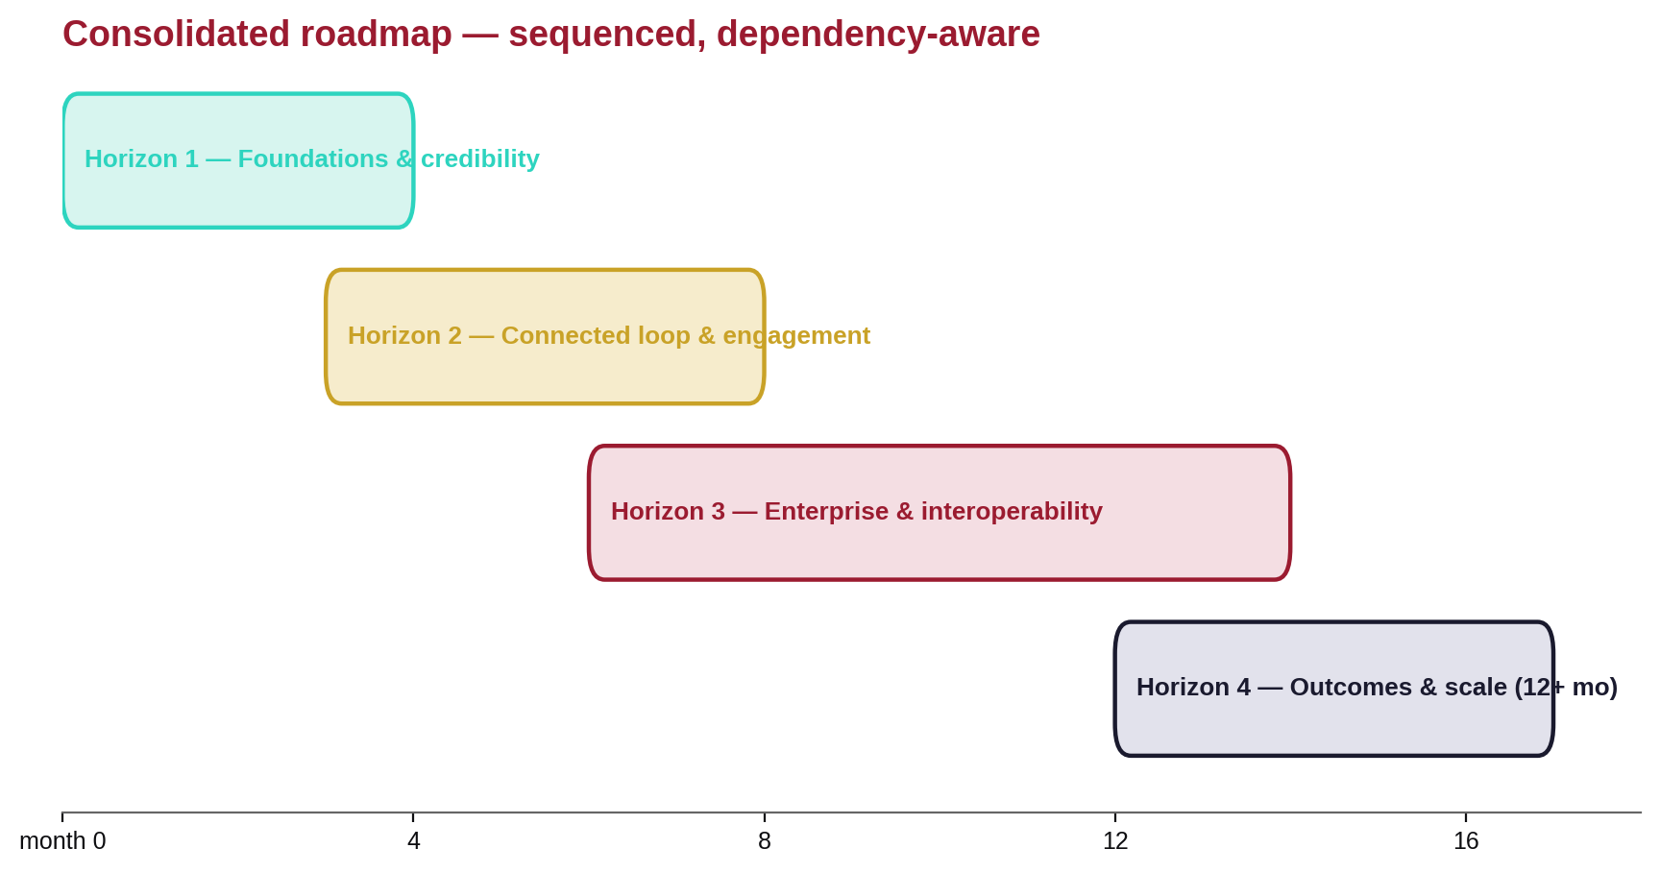
Figure 12. The consolidated roadmap across four overlapping horizons, from foundations and credibility to outcomes and scale.

Horizon 1 — Foundations & credibility (months 0–4)
- W6 (start now): a real test suite + a measured-coverage CI gate; clinical advisory engagement for threshold sign-off; reconcile docs to ground truth.
- W5: field-level encryption (journals/notes/messages), audit-log immutability, prompt-injection hardening.
- W1 (backend-led): the messages table + /messages + WS message.created.
- Native build Phases 1–2 (Part III): foundation, auth, daily check-in parity.

Horizon 2 — The connected loop & engagement (months 3–8, overlapping)
- W1: secure messaging UI (native + web), structured between-visit check-ins, pre-visit summary, productized escalation.
- W4: one-tap safety surfaces, automated audited escalation, in-app collaborative safety planning.
- W2: forgiving engagement mechanics, personalized notifications, the digital-navigator surface, the first CBT-I/BA module.
- W3: full native HealthKit/Health Connect; on-device derived features.
- Native build Phases 3–6: full feature parity + widgets/watch quick-log.

Horizon 3 — Enterprise & interoperability (months 6–14, overlapping)
- W8: CoCM registry productization + RTM; SAML/SCIM; SOC 2 Type II → HITRUST.
- W7: SMART on FHIR v2.2 launch (Epic/Oracle), US Core conformance, FHIR write + key resources.
- W6: the regulatory track — SaMD classification, a HIPAA SRA to the Dec-2024 NPRM, a PCCP if AI/ML shipped.
- W3: relapse-signal rules (post clinical validation); W2: JITAIs.

Horizon 4 — Outcomes & scale (12+ months)
- Clinical-value validation (PHTI/DiMe); an outcomes-based pricing story; telehealth video; bipolar-relapse early-warning as a flagship, validated differentiator; and multi-language + cultural adaptation (a dropout lever).

Success Metrics (how we'll know it's working)
Pillar | Leading metric | Target signal
Engagement | 30-day retention; weekly active check-in rate | Beat the ~3% real-world benchmark by an order of magnitude in connected-care cohorts
Communication | % patients with ≥1 two-way thread/month; clinician response within policy SLA | Majority active; SLA adherence auditable
Clinical (MBC) | % at-risk patients surfaced & actioned; time-to-response | Faster response/remission vs. baseline (Guo-style)
Safety | Time from SI/safety signal → clinician acknowledgment | Minutes, fully audited; zero AI dead-ends
Trust | Privacy incidents; audit completeness | Zero; immutable, patient-visible access logs
Enterprise | SOC 2 Type II + HITRUST achieved; EHR live integrations; CoCM-billable orgs | Certifications obtained; ≥1 Epic/Oracle integration; reimbursement demonstrated
Quality | Measured test coverage; thresholds clinically signed off | Coverage gate enforced; 100% of clinical thresholds signed off pre-pilot

What COPE Should NOT Do (anti-goals)
- No standalone 'AI therapist' — regulatory + ethical risk (Part II, A8/B4). AI = augmentation only.
- No PDT-style standalone prescribed-treatment business as the core model — the reimbursement trap that bankrupted Pear (Part II, A2). Be the connected-care platform; pursue FDA clearance only for specific modules where it unlocks reimbursement (G0552–G0554).
- No guilt-based engagement mechanics — they backfire for depressed users (Part II, A1).
- No interruptive alerts for routine data — reserve interruption for actionable validated signals (B2).
- No third-party ad/tracking SDKs, ever — privacy is a marketed differentiator (W5).
- No changes to the protected auth system beyond additive enhancements (project rule).

Appendix A — Consolidated References & Sources
Every major external claim in Part II is supported by a source below. Citations also appear inline at the point of use; this appendix collects them for convenience. Links were valid as of the research date (June 2026); a handful of items flagged 'verify' in Parts II–III should be re-confirmed at implementation time.

Orienting source
- Torous, Linardon, Goldberg et al. — 'The evolving field of digital mental health,' World Psychiatry 2025;24(2):156–174. DOI 10.1002/wps.21299 · PMC12079407

Patient-facing evidence (Part II.A)
- Uptake, adherence & attrition — AJMC; HCPLive.
- Engagement–outcome meta-analysis (28 studies, r=0.16, 2025) — PMC12747297.
- Digital navigators raise engagement & equity — Springer 10.1007/s41347-025-00569-0.
- Notifications/habit formation — habit RCT; micro-randomized work, PMC6293241.
- Digital CBT-I — Alimoradi 2022, 10.1016/j.smrv.2022.101646; 2025 RCT, 10.1038/s41746-025-01847-0.
- Behavioral activation — 2025 review, PMC12227033; 2024 BA-app RCT, 10.3390/bs15111496.
- JITAIs / EMIs — BMJ Ment Health 10.1136/bmjment-2025-301641; Annu Rev Public Health 10.1146/annurev-publhealth-071723-103909.
- PDT cautionary tale — FDA Roundup Apr 2 2024 (Rejoyn); Pear Therapeutics, Psychiatry Advisor.
- Safety planning — Stanley-Brown, SPRC; C-SSRS digital accuracy, PMC9811343.
- Patient-side MBC — Remote-IOP MBC, JMIR Form Res 2024; app PROM capture, PMC8054360.
- Passive sensing / mobility–mood (bipolar) — PMC11662189.
- Communication & between-visit care — iCANotes 2025; Validic 2026 trends; shared decision-making, JMIR 2024.
- UX / equity — trauma-informed design, PMC12304634; cultural adaptation, PMC12850045.
- Market shakeout — Second Opinion.
- AI scrutiny — APA; Woebot shutdown, telehealth.org; FDA DHAC.

Clinician, regulatory & enterprise evidence (Part II.B)
- MBC outcomes — Guo 2015, PMID 26315978; JCP MBC; Lambert OQ, PMID 26641368.
- PHQ-9/GAD-7 reliable change — Löwe 2004, PMID 15550799; adoption barriers, PMC10923014.
- Registry & treat-to-target — AIMS registries; AIMS treat-to-target.
- Documentation burden & scribes — Sinsky 2016, 10.7326/M16-0961; ambient AI scribes, PMC12492056.
- Dashboard design — PMC11618005.
- FDA CDS / SaMD — reissued CDS guidance PDF; PCCP guidance, media/166704.
- Collaborative care (IMPACT) — Unützer 2002, PMID 12472325.
- Suicide-risk prediction pitfalls & bias — Belsher 2019, PMID 30865249; Coley 2021, PMC8082428.

Native-mobile architecture evidence (Part II.C)
Primary sources are the official Apple (HealthKit, SwiftUI, Swift concurrency, App Store Review) and Google (Jetpack Compose, Health Connect, Play policy) developer documentation, plus the GRDB.swift, SQLCipher, SKIE, Ktor, SQLDelight, and PowerSync project docs. Because these pages are JavaScript-rendered, exact version numbers and entitlement details flagged 'verify' in Part III should be re-confirmed at implementation time.

Appendix B — Verify-Before-Implementation Checklist
Items the research explicitly flagged for confirmation at implementation time, consolidated from Parts II and III:
Area | Item to verify
Clinical coding | LOINC codes for ISI, ASRM, and WHODAS (PHQ-9 44261-6, GAD-7 70274-6, C-SSRS 93245-9/93373-9 are confirmed).
Interoperability | Exact US Core must-support lists for your certification version; the current QHIN roster.
Regulatory | Whether the HIPAA Security Rule NPRM (Dec 27, 2024) has been finalized; current CDS guidance status.
iOS data | SQLiteData package version (Swift Package Index); PowerSync Cloud HIPAA/SOC 2 status (claimed Jan 2026).
Android | Current Jetpack Compose BOM / library versions; the Play organization-account migration deadline.
Cloud / BAA | FCM (Google Cloud) BAA coverage for any service touching PHI.
Clinical thresholds | All provisional ALERT_THRESHOLDS and the risk score require licensed-clinician sign-off before pilot (OQ-004).

Closing note. COPE already holds the asset that is hardest to build: a research-grade clinical backend with interoperability, safety scaffolding, and a collaborative-care data model. The work ahead is to expose that value through best-in-class native apps, close the communication loop, prove it with clinical validation, and sell it through the collaborative-care billing its architecture already fits. Executed in the sequence above, that is a credible path to superseding the competition.
— End of COPE Project Overview —

