
ACUMENUS
ZEPHYRUS · HOSPITAL OPERATIONS INTELLIGENCE

Hummingbird
Consolidated Implementation Plan
The native mobile companion to Zephyrus — Android · iOS · shared Kotlin Multiplatform core
ACUM-ENG-HMB-001

Sanjay M. Udoshi, MD
Founder, Acumenus, Inc.
Planning v2 · June 30, 2026
CONFIDENTIAL
© 2026 Acumenus, Inc. All rights reserved.

Native mobile companion to Zephyrus. The web app answers “what is happening across the hospital, and why?” on wall displays and workstations. This document is the single authoritative plan for the phone: it states the cross-cutting invariants once (Part II), sequences the work as six self-contained phases (Part III), specifies the per-persona screen buildout grounded in seeded demo data (Part IV), and backs all of it with a full parity matrix and reference appendices (Part V).
Status Planning v2 · 2026-06-30. Bounded by the locked authentication rules in .claude/rules/auth-system.md — all backend work described here is strictly additive. Deep-dive docs (00–07) and the seven-stream code audit (research/) provide field-level detail.

Contents
Part I — Strategy & Context 4
1. Executive summary 4
2. Why a companion, not a port 5
3. What the audit found 5
4. Personas — all levels of the delivery system 6
Part II — The Invariants 7
5. Architecture 7
6. Real-time & offline model 7
7. The Mobile BFF & auth model 8
8. Design-system parity 9
9. Earned-urgency notifications 9
10. Security & HIPAA gates 9
11. The shared core every worker gets 10
Part III — The Phased Plan 11
Phase 0 — Foundation 11
Phase 1 — Frontline workers & bed flow 12
Phase 2 — Decisions & the OR board 13
Phase 3 — Awareness breadth 14
Phase 4 — Net-new backend features 14
Phase 5 — Hardening & GA 15
Part IV — Persona Screen Buildout 17
12. The gap this plan closes 17
13. Design contract for persona screens 17
14. Persona screen catalog 18
15. BFF endpoint buildout 24
16. Data-plausibility prerequisites 25
17. Client integration (iOS + Android) 26
18. Persona buildout - phased TODO 27
19. Test & validation strategy 27
20. Risks & open questions 28
Part V — Reference 29
Appendix A — Full feature-parity matrix 29
Appendix B — Backend change log 31
Appendix C — Risk register 31
Appendix D — Team & timeline 31
Appendix E — Program definition of done 32
Document map 32
PART I

Strategy & Context

1. Executive summary
Hummingbird is the glance-and-act surface of Zephyrus. The web app answers “what is happening across the hospital, and why?” on wall displays and workstations. Hummingbird answers a sharper question for a worker mid-shift, in a hand, in three seconds:
“What needs me, right now — and can I do it in two taps?”
One native app per platform adapts its home, its unified “For You” action queue, and its notification defaults to the signed-in worker — from the transporter moving a patient to the CMO glancing at house status between meetings.
The headline decisions
Decision | Choice | Rationale
UI | Native per platform (Compose + SwiftUI) | Glanceability and feel are the product; native widgets, Live Activities, Critical Alerts
Shared code | KMP domain + data core, bridged via SKIE | Clinical/status logic is “defensible” — it must not drift between two codebases
Backend access | A versioned mobile BFF (/api/mobile/v1/*) | The web /api is chatty, inconsistently authed, PHI-rich
Auth | Sanctum tokens (+ OIDC/PKCE path), additive | Move off session cookies without touching the locked flow
Real-time | Push-first, websocket-when-foregrounded, poll fallback | Battery + correctness; never hold a background socket
Offline | Offline-aware (cache reads, queue non-critical writes) | Spotty hospital Wi-Fi; block safety-critical writes offline
Notifications | Server-side four-tier “earned-urgency” router | Alarm fatigue is a clinical-safety failure, not a UX nit
Design | One DTCG token source → Compose + SwiftUI + CSS | One design system, three platforms, zero drift
The plan in one picture
P0 Foundation ###### auth · push · BFF · tokens · RBAC · assignment model
P1 Frontline ###### Transport · EVS · RTDC beds/barriers · For-You · notif v1
P2 Decisions ######## Ops approvals · Command/Brief · OR board · huddles
P3 Awareness ###### ED signals · Staffing · transfers · watch/widgets
P4 Net-new ######## PI/PDSA · ED actions · integration health
P5 Hardening/GA ###### security + clinical-safety review · perf · rollout
~9–12 months to GA for a focused team; usable internal pilots from end of P1. Phases P1–P2 can overlap once the BFF pattern is set.
The sequencing logic (why this order)
Three platform gaps gate everything, so they come first (P0). Then we build on live data with low backend risk for fast value — RTDC, Ops approvals, Transport, EVS all run on existing endpoints (P1–P2). Features that require net-new backend (ED clinician actions, Process Improvement) are deferred (P4) because their web surfaces are mock/stub today; we still ship their glanceable signals earlier where the data already exists (P3). Hardening and the safety/security gates that GA legally depends on close the program (P5).

2. Why a companion, not a port
Zephyrus is a dense, instrument-rich operations bridge built for multi-panel study. Most of that does not belong on a phone under time pressure. Every web capability is triaged against the glance-and-act question into one treatment:
Flag | Meaning | Mobile treatment
GLANCE | Read at a glance; situational awareness | Home tiles, widgets, Live Activities
ACT | A worker would act on it from a phone | First-class flows + notification actions
NOTIFY | A discrete event worth a push | The earned-urgency taxonomy
WEB | Too analytical/dense for phone | Deep-link to web; not rebuilt
Rule of thumb If a task needs more than ~3 visible panels, a keyboard, or sustained study (utilization analytics, process mining, simulation authoring, blueprint modeling, admin), it stays on the web and Hummingbird offers a one-tap deep link.
This plan honors the Zephyrus canon on mobile: Rigorous · Composed · Defensible; earned urgency (color and pushes are rationed); status never by color alone; dark-default, tabular-nums, gold focus; replace the EHR, don’t reskin it. It is not a shrunk dashboard, not a consumer health app, and never an alarm-fatigue pager.

3. What the audit found
A seven-stream parallel audit (95 models, ~106 API endpoints, all four workflows + supporting domains + platform) produced five findings that shape the entire sequence.
Per-domain readiness (this drives phasing)
Domain | Data model | API contract | Live data | Real-time | Verdict
RTDC | ✓ rich | ✓ /api/rtdc/* | ✓ event-sourced | ✓ Reverb WS | Flagship — build first
Ops / AI approvals | ✓ ops.* | ✓ /api/ops/* | ✓ production-grade | — | Reuse endpoints verbatim
Transport / EVS / Staffing | ✓ | ✓ endpoints | ✓ event logs | — | Textbook mobile workers
Perioperative | ✓ rich | ✓ /api/cases,blocks | △ mostly mock UI | ✗ local timers | Ready data, no surface
Command Center | ✓ | ✓ /api/command-center/* | ✓ | — | Strain index + Exec Brief
Emergency Dept | △ 2 tables | ✗ 0 ED endpoints | △ via Command/Analytics | ✗ | Glance now, act later (NEW)
Process Improvement | △ models only | ✗ stub | ✗ empty stubs | ✗ | Net-new backend
The three platform gaps that gate everything
- No mobile auth. Session-cookie only; Sanctum is installed but dormant (User lacks HasApiTokens, zero auth:sanctum routes). OIDC/Authentik exists but also lands a web session. → token auth is net-new (additive).
- No push infrastructure. Zero APNs/FCM, no device registry, no notifier. Only Reverb websockets (foreground) + one demo SSE. → push is net-new.
- Inconsistent API auth & shape. Several operational endpoints (cases, blocks, rooms, providers, analytics, improvement/*) carry no `auth` middleware; no uniform envelope; PHI interleaved with operational data. → a BFF is required.
Full detail: research/ (02-rtdc, 03-perioperative, 04-improvement-and-ops, 05-platform-auth-realtime-design, 06-supporting-domains-and-api, 01-emergency-department, 07-mobile-best-practices).

4. Personas — “all levels of the delivery system”
One app, role-adaptive home. Zephyrus treats its audience as one product switched by a workflow_preference (a preference, not a hard permission); Hummingbird honors that and extends down to the frontline mobile worker the web under-serves.
# | Persona | Altitude | Phase | Home emphasis
P1 | Transporter / Porter | Frontline worker | 1 | My trips + available jobs
P2 | EVS Technician | Frontline worker | 1 | My bed-turns + next dirty bed
P3 | Bedside / Charge Nurse | Frontline unit | 1–2 | My unit: census, barriers, incoming
P4 | OR Circulating / Charge Nurse | Frontline OR | 2 | Live room board + my cases
P5 | Nursing Supervisor / Bed Manager | Ops leader | 1 | House bed-need + pending requests
P6 | Patient-Flow / Capacity Lead | Ops leader | 2 | Capacity vs demand + approvals inbox
P7 | Perioperative Manager | Ops leader | 2–3 | OR day at a glance
P8 | PI / Quality Lead | Ops leader | 4 | My PDSA cycles + barrier trends
P9 | Executive (CMO/COO/CNO) | Executive | 2 | One quiet strain index + Brief
P10 | Staffing Coordinator | Ops leader | 3 | Open requests + below-safe units
The altitude model
How “earned urgency” expresses per level: a frontline worker’s home is a task list; a unit’s home is my unit / my cases; an ops leader’s home is the house / my domain; an executive’s home is a single strain index that stays quiet until it shouldn’t. Full per-persona journeys: reference/02-core-functionality-by-role.md.
PART II

The Invariants

These decisions are constant across all phases. They are stated once here; each phase references them rather than re-deciding.

5. Architecture
Native UI per platform over a shared KMP domain/data core. This single decision must be made now — committing to shared Kotlin logic puts Kotlin/Native in the iOS build, and deciding late forces an expensive re-architecture. If the org rejects KMP, the floor is two fully-separate apps bound by the API contract + a shared conformance test spec.
PRESENTATION (native) Android: Compose + ViewModel (MVVM-UDF; MVI for dense boards)
iOS: SwiftUI + @Observable (TCA only for true state machines)
→ widgets · Live Activities/Dynamic Island · Watch/Wear

SHARED (KMP) domain models · use-cases · status rules · urgency scoring · validation
data repositories · Ktor BFF client · SQLDelight cache · outbox ·
sync engine · Reverb/Pusher realtime · token store
tokens generated from DTCG (see §8)

PLATFORM (expect/actual) Keychain/Keystore · biometrics · APNs/FCM · BGTasks/WorkManager

- Android: Compose (Material3 themed to Zephyrus tokens, not default Material), Hilt, Coroutines/Flow, Ktor, SQLDelight, DataStore, WorkManager, FCM, Glance widgets, Wear.
- iOS: SwiftUI + Observation, Swift Concurrency, Ktor-via-shared (or URLSession actual), SQLDelight, Keychain, BGTaskScheduler, APNs (+ Critical Alerts, ActivityKit), WidgetKit, watchOS. SKIE generates idiomatic Swift over the KMP module.
- Feature modules are vertical slices depending only on shared/domain + shared/data + core-ui. The For-You feature composes every domain through one ForYouFeed use-case in shared/domain — the single home of the earned-urgency ranking.
Module/repo structure and the full stack rationale: reference/03-architecture.md.

6. Real-time & offline model
Three-mode real-time (mirrors the web’s Reverb posture and extends it for battery):
App state | Transport | Behavior
Foreground, screen on | Reverb WS (Pusher protocol) | Live tiles; re-snapshot all visible queries on (re)connect — Reverb does not replay
Background / locked | Push (APNs/FCM) | Silent push → WorkManager/BGTask delta-sync; visible push for NOTIFY events
No connectivity | Poll on resume + cache | Stale badge; reconcile outbox
We never hold a websocket in the background. Public WS channels are PHI-free (counts/ids only); any future PHI-on-wire needs PrivateChannel + token channel auth.
Offline-aware, not offline-first
- Reads: cache-then-network; emit cached immediately with an as-of timestamp, refresh, re-emit; on failure keep cache + show a stale badge (never a blank screen).
- Non-critical writes (acknowledge, claim routine job, routine status): optimistic local apply + outbox; flush on reconnect.
- Safety-critical writes (approve an action, place a bed, complete an isolation bed-turn, advance a case past a clinical gate): require connectivity; if offline, the action is disabled with an explicit reason — never silently queued.
- Conflicts: last-write-wins + field-merge + server version/ETag; 409 surfaces “changed since you loaded — review,” never a blind overwrite. No CRDTs.

7. The Mobile BFF & auth model
*A versioned BFF (`/api/mobile/v1/) is the only surface the apps talk to.** It reuses existing models/services and **delegates all mutations** to the existing lifecycle services (OperationalActionLifecycleService, the RTDC engine, the Transport/EVS/Staffing *OperationsService`s) — it reshapes, it does not re-implement.
BFF rules
- One screen → one call where practical; uniform envelope { data, meta:{as_of,stale,version}, links:{web} }.
- `auth:sanctum` on everything; role-scoped and PHI-minimized (tokenized/initials in lists; full PHI only on an explicit authorized detail call, never in lists or notifications).
- ETag/cursor/updated_since for concurrency and delta sync.
Auth (additive — never touches the locked flow)
Add HasApiTokens to User; issue Sanctum personal access tokens with role-matched abilities; provide an OIDC+PKCE path reusing Authentik for SSO orgs. The token endpoints honor `must_change_password` by returning a scoped change-challenge (the temp-password/Resend/superuser flow is preserved verbatim). Tokens live in Keychain/Keystore gated by biometrics; short-lived access + rotating refresh; idle auto-lock; server-side revoke for remote wipe.
RBAC
Reads stay broad (house status is for everyone at their altitude, PHI-gated); writes get Laravel Policies so a device can only act within role/assignment (only the assigned transporter progresses a trip; only an authorized approver decides an action). This requires the assignment model (Phase 0). The contract: api-contract/hummingbird-bff.v1.yaml (OpenAPI 3.1, validated). Full spec: reference/04-backend-requirements.md.

8. Design-system parity
One DTCG token source → three platforms, verified non-divergent in CI. The web keeps its Tailwind setup; design-tokens/tokens.json generates Compose + SwiftUI equivalents via Style Dictionary and a CI job diffs resolved values against tailwind.config.js + .impeccable/design.json — a mismatch fails the build.
The tokens encode the Zephyrus canon: the Two-System Rule (operational blue/slate #2563EB/#3B82F6 vs. brand crimson #9B1B30 + gold #C9A227 focus-only), the rationed status ramp (teal #2DD4BF / amber #E5A84B / coral #E85A6B / sky #60A5FA dark), Figtree weights 400/500/600 only, dark-default, the 4px grid. Signature components (KpiTile with its 3px status stripe + arrow + label, StatusChip dot-not-color-alone, Panel quiet-lift) are built once per platform from these tokens. Pipeline + samples: design-tokens/.

9. Earned-urgency notifications
A notification is the most expensive signal Hummingbird can send. The taxonomy is a clinical-safety component with acceptance criteria — a mis-tuned one causes alarm fatigue (staff silence the app and miss the real breach). Four tiers:
Tier | Meaning | iOS | Android | Quiet hours
T1 Critical breach | Threshold breach / safety event, act now | Critical Alert (entitlement) | Full-screen intent | Overrides (capped)
T2 Actionable | Assigned to you to act on soon | Time-Sensitive + actions | High-importance + actions | Deferred unless STAT
T3 Awareness | Worth knowing, not urgent | Passive | Default/low | Silenced
T4 Digest | Periodic summary | Scheduled | Scheduled low | Silenced
Principles
- Severity earned per event (most state changes are GLANCE, silent).
- Route to the person who can act (needs the assignment model).
- The action is in the notification (Approve/Claim/Acknowledge from the lock screen, zero app-open).
- Respect the human (per-tier opt-in, quiet hours, per-shift budget, dedupe/coalesce).
- No PHI ever (generic copy, CI payload linter).
- Escalate, don’t repeat (unacked T1/T2 → re-deliver → next responsible → web command center, fully logged).
The complete event→tier→audience→action taxonomy: reference/05-notifications-earned-urgency.md.

10. Security & HIPAA gates
Security is a release gate, not a backlog. The cheapest, highest-impact wins, done first: no PHI in notifications/logs/app-switcher snapshots, biometric-gated token storage + auto-lock, TLS + cert pinning with no PHI on public channels.
Plus: encrypted local cache (SQLCipher), FLAG_SECURE/privacy-view, jailbreak/root + attestation (App Attest/Play Integrity), MDM/remote-wipe, action-level RBAC, tamper-evident audit logging, BAA-covered or PHI-free SDKs only, and WCAG 2.2 AA (status-never-by-color, dynamic type, VoiceOver/TalkBack, 44pt targets). The seven non-negotiable release-gate criteria are in reference/06-security-hipaa.md §9 and are written into the program Definition of Done.

11. The shared core every worker gets
Regardless of role/phase, every persona’s app is built from the same primitives — only the feed sources and ranking weights change:
- Secure entry — token login, biometric unlock, auto-lock, forced-change honored.
- Role-aware home — the altitude’s most important truth, glanceable; workflow switcher.
- The “For You” queue — one prioritized, cross-domain list of what needs this worker, ranked by earned-urgency score, each card carrying its primary action inline.
- Rationed, actionable notifications (§9).
- House/unit status glance — role-scoped, PHI-gated; tile + widget + (phased) Live Activity/complication.
- Directory & search — the web’s ⌘K as a search screen.
- Profile/preferences & deep links — default workflow, notification tiers, quiet hours, theme; “Open in Zephyrus” for every WEB-deferred path.
This is why one app spans the porter and the CMO: shared primitives, role-tuned feed.
PART III

The Phased Plan

Each phase is a self-contained work package: thesis · why now · backend · mobile · features & personas · notifications · exit criteria. All phases assume the Invariants (Part II).

Phase 0 — Foundation
~6–8 WEEKS · THE UNBLOCK
Thesis
A signed-in worker on both platforms can authenticate with biometrics, hit a secured BFF, receive a push, and see one real RTDC tile. Nothing user-facing ships, but everything after depends on it.
Why now
The three gating gaps (§3) block 100% of features. Building them first is the only rational sequence.
Backend
- Sanctum token auth: HasApiTokens on User; POST /api/auth/token{,/refresh,/revoke} + /auth/change-password — additive, honoring must_change_password. OIDC+PKCE path stubbed.
- mobile_devices registry + push service (APNs .p8 HTTP/2 + FCM v1) behind a PushNotifier contract; queued via Horizon.
- BFF scaffold (/api/mobile/v1/*): uniform envelope, role-scoping, PHI-minimization, /me, /realtime/config, /rtdc/census.
- Assignment model — user_id FKs on owners (today Barrier.owner/RtdcPlan.owner are free-text) + a user_unit pivot. Prerequisite for both the For-You queue and notification routing.
- RBAC Policy layer; remediate the auth-less operational endpoints (a standing security issue regardless of mobile).
Mobile (both platforms)
- Repo + CI scaffold; KMP `shared` skeleton (domain/data/platform); SKIE bridge.
- Design-token pipeline wired (DTCG → Compose/SwiftUI); core-ui primitives (KpiTile, StatusChip, Panel). (Already started — `design-tokens/`.)
- Auth flow: token + biometric unlock + auto-lock + Keychain/Keystore; cert pinning.
- BFF client (Ktor), SQLDelight cache, outbox skeleton, push registration.
Features / personas
None user-facing (foundation).
Notifications
Delivery pipeline stood up; one test push.
Exit criteria Auth regression suite green (locked flow unchanged); a device receives a test push; one live /rtdc/census tile renders on iOS and Android via the BFF; security checklist §1–§3 pass.

Phase 1 — Frontline workers & bed flow
~6–8 WEEKS · HIGHEST, FASTEST VALUE
Thesis
Transporters and EVS techs run their jobs from the phone; bed managers place beds and clear barriers on the move; everyone gets a working For-You queue and rationed pushes.
Why now
All LIVE endpoints, clean lifecycles, lowest backend risk, and the clearest mobile win (transporter/EVS are mobile users; bed managers want placement off-workstation).
Backend
- BFF: RTDC (/rtdc/census, /house, /bed-requests + /{id}/decision, /barriers + /{id}/resolve), Transport (/queue, /{id}/status|assign|handoff), EVS (/queue, /{id}/status).
- Add `BarrierUpdated` broadcast (barriers don’t broadcast today, unlike census/huddle).
- Server-side evaluators for events with no native trigger: SLA breach (needed_at/at_risk), capacity deficit (bed_need>0, available→0), barrier aging, unplaced bed request. Wire into the notification router v1 (tiers, routing via assignment model, quiet hours, budget).
Mobile
- Transport (P1): claim → run trip (17-status) → structured handoff; STAT push.
- EVS (P2): claim → start (SOP/PPE for isolation) → complete (notifies bed manager).
- RTDC beds & barriers (P3/P5): live unit census + safe capacity (Reverb WS); pending bed requests + transparent placement decision (accept/edit/reject); log/resolve barriers.
- For-You queue v1 across these domains; first widget / Live Activity (active trip; unit/house status glance).
Features / personas
P1 Transporter, P2 EVS, P3 Charge Nurse (beds/barriers), P5 Bed Manager — activated.
Notifications
STAT transport/isolation bed-turn assigned (T1); new pending bed request, unplaced bed, aging barrier, SLA at-risk (T2); bed-turn completed (T3).
Exit criteria A transporter claims a STAT job from the lock screen in < 10 s; a bed manager places a bed from a push; evaluators fire correctly within the per-shift budget.

Phase 2 — Decisions & the OR board
~8–10 WEEKS · THE MARQUEE OPS-LEADER + OR PHASE
Thesis
Ops leaders approve and assign operational actions on the go; executives get a single quiet strain screen + Brief; OR staff get a live board, case tracking, and safety-note SLAs.
Why now
Ops approvals reuse /api/ops/* verbatim (highest value, near-zero backend), and the OR data/contract already exist (needs only three bug-fixes). This is the decision-making heart of the product.
Backend
- BFF: Ops (/ops/inbox, /approvals/{id}/decision, /actions/{id}/{assign,start,complete}) delegating to OperationalActionLifecycleService; Command Center (/command/house, /brief); OR (/or/board, /cases/today, /cases/{id}, /{id}/status, safety-notes, milestones, transport).
- Fix the OR backend bugs first: ORCaseController@store writes string status not status_id; analytics SQL references non-existent or_cases.actual_start/end_time (route via orlog+case_metrics); reference endpoints filter is_active but the column is active_status.
- Add the huddle action-items API (RtdcPlan table exists with no API/UI today).
Mobile
- Ops approvals (P6): approve/reject/assign/start/complete + agent-inbox glance tiles.
- Command Center / Exec Brief (P9): strain index (0–4), hero KPIs with trust badges, the server-composed brief; sparse exec notifications.
- Perioperative (P4/P7): live room board + my cases + single-case tracking; advance status; safety-note SLA acknowledge; pre-op milestone ack; transport-to-OR.
- RTDC huddles (P3/P6): unit-huddle steps (WS-synced) + huddle action-items.
- Dynamic Island / Live Activity for room board + house strain; iOS Critical Alerts + Android full-screen-intent wired for T1 only (apply for entitlements now — they gate GA).
Features / personas
P4 OR Nurse, P6 Capacity Lead, P7 Periop Manager, P9 Executive — activated; P3 gains huddles.
Notifications
Recommendation awaiting approval, action expiring/overdue, safety-note SLA, pre-op milestone incomplete (T2; Crit safety-note + house-status escalation T1); case delayed, first-case late start, cancellation (T2/T3).
Exit criteria A capacity lead approves an action from a notification; an OR nurse acknowledges an overdue safety note; the exec home is a single quiet strain screen that escalates correctly.

Phase 3 — Awareness breadth
~6–8 WEEKS
Thesis
The glanceable signals that already exist as data — ED boarding/diversion/surge, staffing gaps — reach the right leaders; at-a-glance coverage extends to watch and widgets.
Why now
These are GLANCE/NOTIFY built on existing computed metrics; they broaden situational awareness without the net-new backend that ED actions and PI need.
Backend
- BFF: ED signals (/ed/signals — boarding, diversion, LWBS, surge from Command/Analytics); Staffing (/staffing/requests, /{id}/status); regional/inter-facility transfer.
- Diversion endpoint + `DiversionUpdated` broadcast (model exists, no API/broadcast today).
- Evaluators: ED boarding band (≥6), ESI 1–2 LWBS, surge; staffing below-minimum-safe.
Mobile
- ED glanceable signals (P9/P5): boarding, diversion, LWBS, surge tiles; ESI 1–2 LWBS as T1.
- Staffing (P10): open requests, below-safe alerts, create/source/assign/fill.
- Watch / Wear complications for house/unit status; widget breadth.
Features / personas
P10 Staffing Coordinator — activated; P5/P9 gain ED awareness.
Notifications
ED diversion active, ESI 1–2 LWBS, unit below minimum-safe (T1); ED boarding band crossing, boarder dwell >4h, surge critical, staffing unfilled/escalated (T2).
Exit criteria ED breaches page the right leaders within budget; a staffing coordinator fills a gap from mobile; glance surfaces cover house status across widgets/watch.

Phase 4 — Net-new backend features
~8–10 WEEKS · BACKEND-LED
Thesis
The domains that are mock/stub on the web today get real backend, then their mobile-worthy slices.
Why now
These require net-new backend (Process Improvement returns empty stubs; PDSA write routes referenced by the web don’t exist; ED has no clinician write path). Doing them last lets the high-value live-data features ship first and de-risks the net-new work.
Backend
- Build the missing PI/PDSA write paths; ED boarder-dwell evaluator and (if scoped) a net-new ED clinician write path; integration-health alerts (connector-down, dead-letter spike); simulation read (results/promoted recommendations — authoring stays web).
Mobile
- PI/PDSA (P8): cycle ownership + stage advance + barrier ack.
- ED actions: boarder-dwell breaches; live-board/triage acknowledgements if the write path exists.
- Integration health glance + alerts for ops/admin.
Features / personas
P8 PI/Quality Lead — activated; ED gains limited actions.
Notifications
PDSA stage due, barrier assigned (T2); boarder dwell >4h (T2); connector down / dead-letter spike (T2/T3, ops/admin).
Exit criteria PI leads manage PDSA on mobile; ED dwell breaches notify; ops sees feed health.

Phase 5 — Hardening & GA
~4–6 WEEKS
Thesis
The app passes its safety, security, performance, and accessibility gates and rolls out behind flags.
Work
- Full security + clinical-safety reviews (notification-taxonomy sign-off); penetration test; PHI-leak audit; accessibility audit (WCAG 2.2 AA).
- Performance/battery tuning (WS lifecycle, background sync, BFF payload sizes).
- Offline-edge hardening (409/conflict UX, outbox reconciliation, stale-badge correctness).
- Store readiness (privacy nutrition labels, Critical Alerts entitlement approval, data-safety form); pilot → phased rollout behind feature flags.
Exit criteria All release-gate criteria pass; pilot units validate time-to-act and notification budgets; GA.
PART IV

Persona Screen Buildout
Parts I-III set the invariants and the six-phase program. This part is the concrete buildout that operationalizes them: ten per-persona screen packages, grounded in the seeded demo data, each wired to a specific BFF endpoint and validated end-to-end against the deterministic seed. It restates no strategy - it adds the screens the personas actually need.
Relationship to the plan. This part operationalizes the persona specification (Functionality-by-Role) and sequences it against the feature-parity matrix and the BFF contract. Wave order follows backend readiness, mapping onto Phases 1-4 of Part III. The only net-new backend is ED-actions and PI/PDSA, which land last.

12. The gap this plan closes
Hummingbird ships today at Phase 0 / early Phase 1: two screens only - Home (an RTDC census glance) and For You (a three-source queue of bed requests, barriers, and at-capacity units). Persona awareness is cosmetic: Role.swift enumerates eight personas and RoleExperience re-titles the home, re-scopes the census, and re-filters the queue - but every persona still sees the same two screens. A transporter, an OR nurse, a CMO, and an EVS tech all land on the same census list. The persona's actual job - claim a trip, watch the OR board, read the strain index, clean the next dirty bed - has no surface.
The BFF serves only three domains (rtdc/census, for-you, eddy/*). The richer pillar data - OR, transport, EVS, staffing, command center, PI - is live in the web backend but not yet reshaped onto /api/mobile/v1/*. Meanwhile the demo seeders already populate every pillar with realistic, deterministic data: named surgeons, OR rooms running cases, six open discharge barriers, two staffing gaps, eight transport jobs, six EVS turns, five active PDSA cycles. The data exists; the persona screens to show it do not. This plan builds those screens.
Mostly wiring, not new architecture. The OpenAPI contract already drafts most paths we need (/or/board, /transport/queue, /evs/queue, /ops/inbox, /command/brief, /rtdc/house, /rtdc/bed-requests, /rtdc/barriers). The work is wiring them to existing live services and building the screens - except ED-actions and PI/PDSA, which are net-new backend on the web too and land last.

13. Design contract for persona screens
Every persona screen obeys the project non-negotiables and the "one app, many homes" doctrine. Seven principles govern the buildout - all reused from the canon, none reinvented:
Principle | What it means on every persona screen
One screen -> one BFF call | The home call aggregates; no chatty fan-out from the device. The BFF reshapes existing web services - it never re-implements them.
Role-aware Home = the altitude's single truth | Glanceable in 3 s. Dark by default, tabular-nums on every metric, status never by colour alone (always an arrow, icon, or label).
For-You stays the universal primitive | New domains feed it (transport STAT, EVS isolation turn, safety-note SLA, approval pending), tier-ranked by earned urgency. The queue component is unchanged; only its sources grow.
Primary action inline | The common verb (Claim, Resolve, Approve, Acknowledge, Start, Complete) is one tap from the card - zero extra navigation.
PHI-minimized | Lists and notifications carry counts, refs, and status only. Patient identifiers appear on an explicit, authorized detail call - never in a list, never in a push.
Deep-link to web for desktop work | Analytics, process mining, block-utilization tables, the Monday review - links.web hands off in one tap rather than cramming a table onto the phone.
Status vocabulary rationed | teal = optimal, amber = watch, coral = breach (earned), sky = info. Coral is the most expensive ink; reserve it for true breaches.
The "screen package" pattern. Each persona gets a package, not a one-off screen. The client routes a confirmed role to its package via an extension of the existing RoleExperience (iOS) and its Android twin; Home composition and the primary feature tab become data-driven by role.
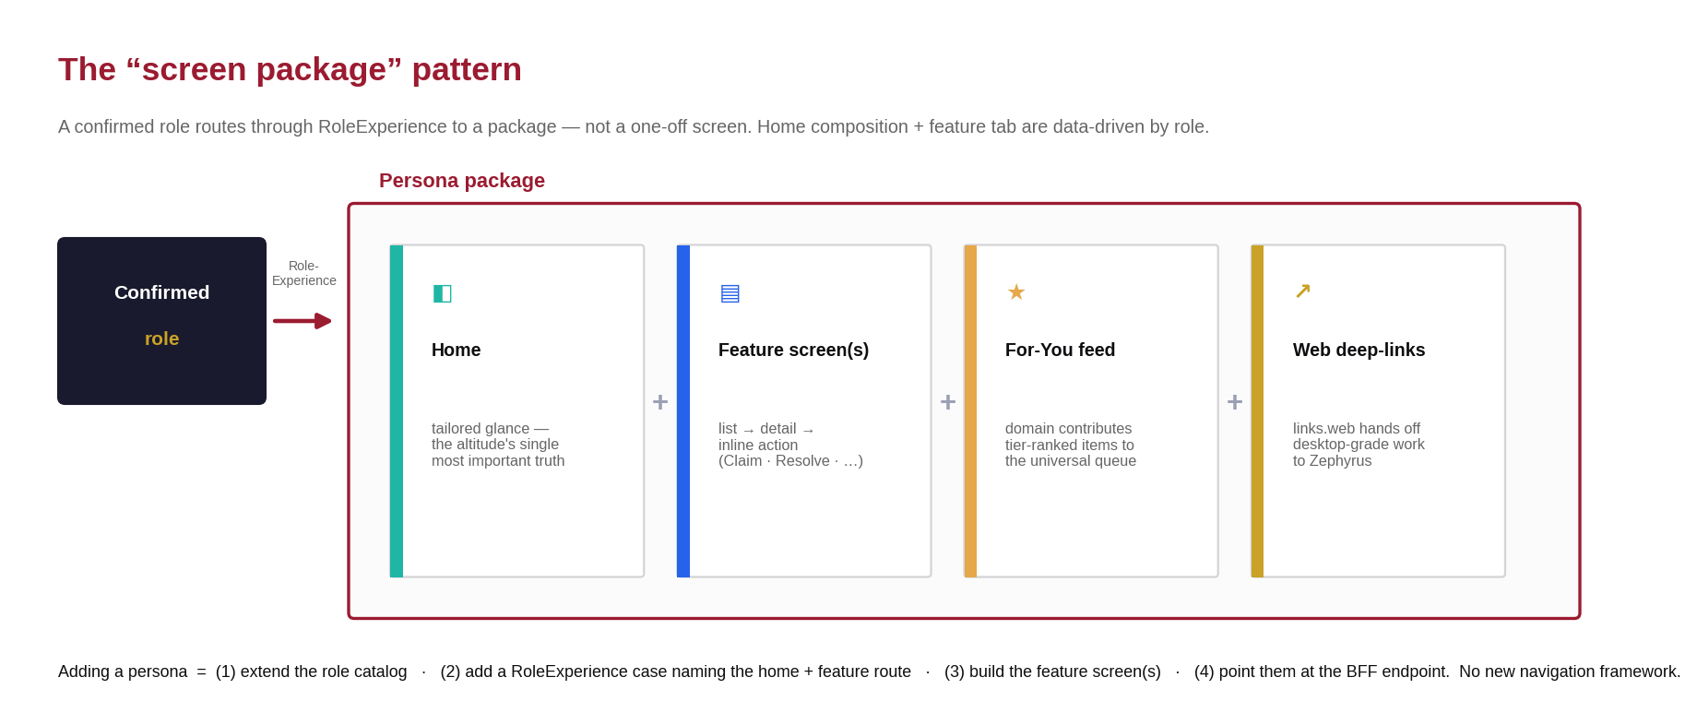
Figure 4.1 - The persona screen-package pattern: Home + feature screen(s) + For-You feed + web deep-links.

14. Persona -> screen catalog
Ten personas across four waves. Wave order follows backend readiness - live endpoints first. Each persona below lists its Home, feature screens, the exact demo data it renders today, the BFF endpoint, the inline action(s), the web deep-link, and the acceptance criteria - what "built + validated" means against the seed.
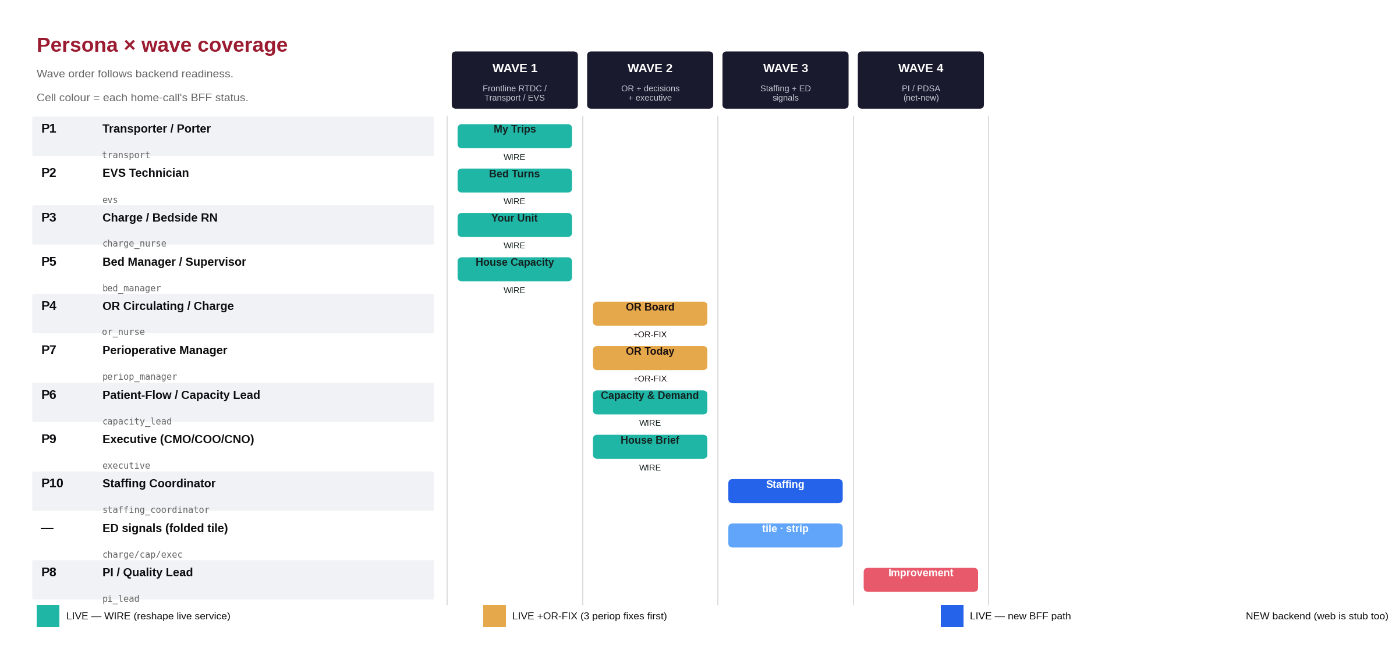
Figure 4.2 - Persona x wave coverage, coloured by the backend readiness of each persona's home BFF call.
Legend. WIRE = contract path exists, reshape a live web service. +OR-FIX = needs the three perioperative backend fixes first. NEW = net-new backend (the web surface is a stub too).

Wave 1 - Frontline workers & unit / house RTDC (all live endpoints)
Four clear mobile wins riding entirely on live RTDC / Transport / EVS services. RoleExperience already stubs transport, evs, charge_nurse, and bed_manager.
P1 - Transporter / Porter
Frontline mobile - role: transport - Home: My Trips
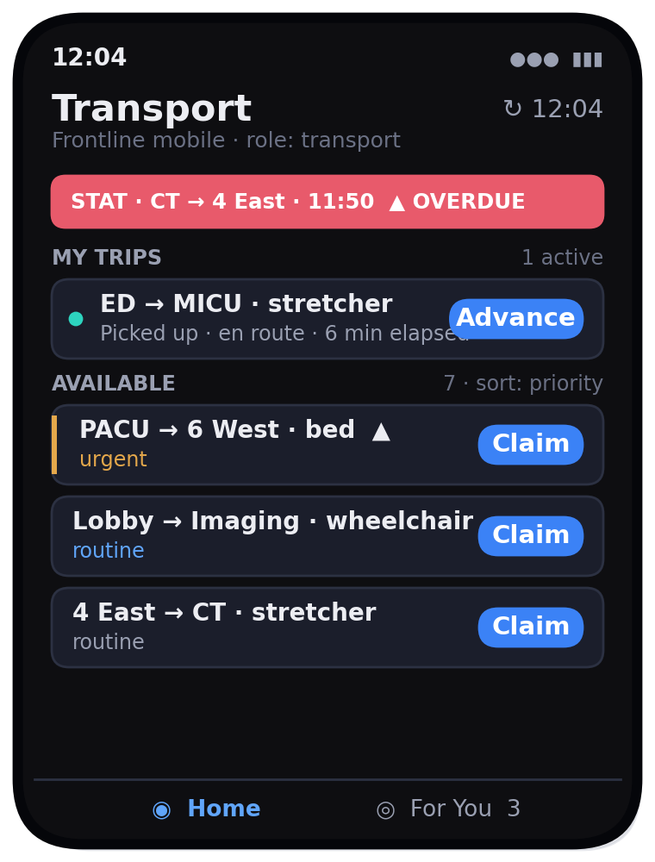 | Feature screens Job detail with the lifecycle stepper (dispatched -> arrived -> picked_up -> en_route -> arrived -> handoff), one big primary button per state; structured-handoff sheet (handoff_to, summary, outstanding_risks[] -> Complete).  Seeded data prod.transport_requests - 8 active (mixed inpatient / transfer / discharge / ems, some STAT / overdue), 14 historical for "completed today"; transport_events drive the stepper.  BFF GET /transport/queue (WIRE -> TransportOperationsService); POST /transport/requests/{id}/status; .../handoff.  For-You STAT / at-risk jobs assigned or offered to me.  Deep-link /transport/dispatch.  Acceptance Home shows >=1 STAT banner, 7-8 available jobs, >=1 overdue; Claim moves a job into My Trips; the full stepper completes a trip, removes it, and increments "completed today."
P2 - EVS Technician
Frontline mobile - role: evs - Home: Bed Turns
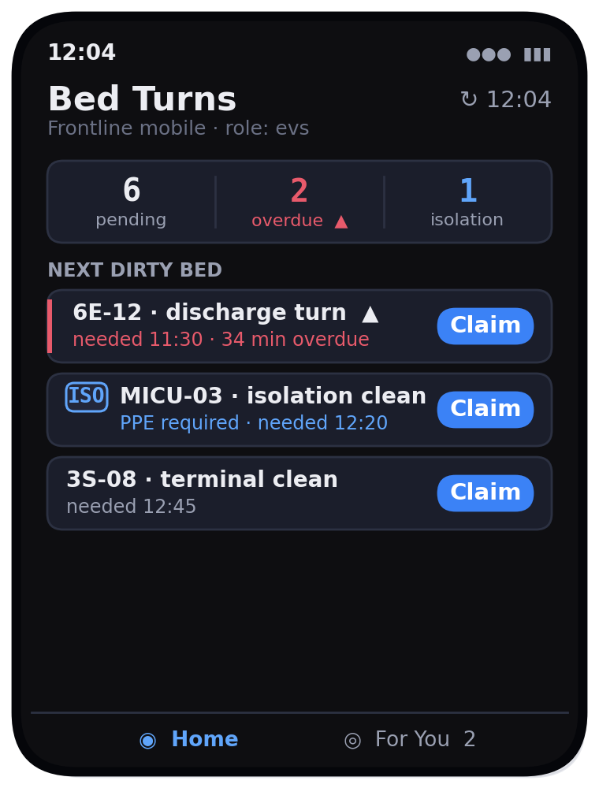 | Feature screens Turn detail: Claim -> Start (stamps started_at, shows isolation SOP / PPE) -> Complete (stamps completed_at). Completing notifies the bed manager - the bed becomes placeable.  Seeded data prod.evs_requests - 6 requests (discharge_turnover, isolation_clean, terminal_clean, bed_clean), 2 overdue, >=1 isolation_required driving the PPE prompt.  BFF GET /evs/queue (WIRE -> EvsOperationsService); POST /evs/requests/{id}/status.  For-You Isolation turns, STAT turns, SLA at-risk.  Deep-link None - frontline is fully native here.  Acceptance Home leads with the most-overdue dirty bed; an isolation turn shows a PPE / SOP step on Start; Complete removes it and emits the beds.changed event the bed manager re-snapshots on.
P3 - Bedside / Charge Nurse
Frontline unit - role: charge_nurse / bedside_nurse - Home: Your Unit
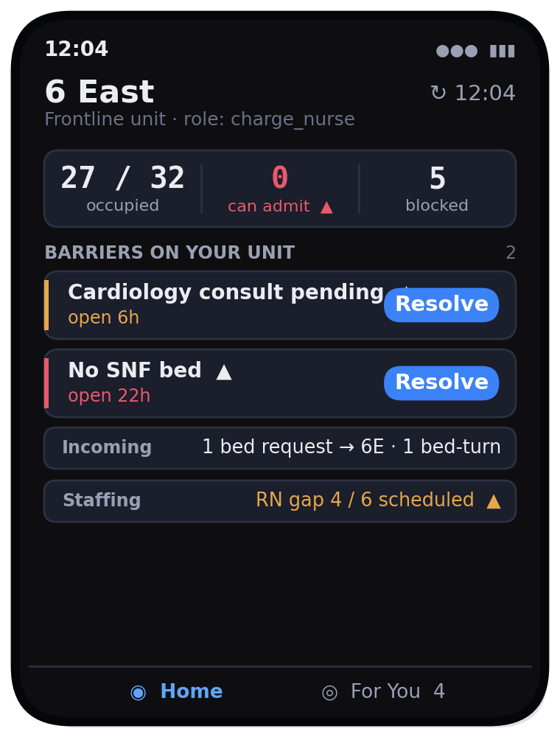 | Feature screens Unit detail (exists - enhanced with barriers + inbound + a staffing strip); barrier-resolve sheet; New Bed Request form; unit-huddle step entry (P2).  Seeded data census for the pinned unit; prod.barriers filtered to the unit (6 open house-wide); prod.bed_requests inbound; prod.staffing_plans (6E is a seeded gap: 4 / 6 RN).  BFF GET /rtdc/census + /rtdc/house (WIRE); GET /rtdc/barriers; POST /rtdc/barriers/{id}/resolve; POST /rtdc/bed-requests.  For-You Aging barriers on my unit, incoming transports, bed-turn completions, unit tipping into deficit.  Deep-link /rtdc/unit-huddle.  Acceptance Home pins the role's unit; resolving a barrier removes it from both the unit card and For-You; the seeded 6E RN gap renders amber with an arrow + "4 / 6."
P5 - Nursing Supervisor / Bed Manager
Ops leader - role: bed_manager / house_supervisor - Home: House Capacity
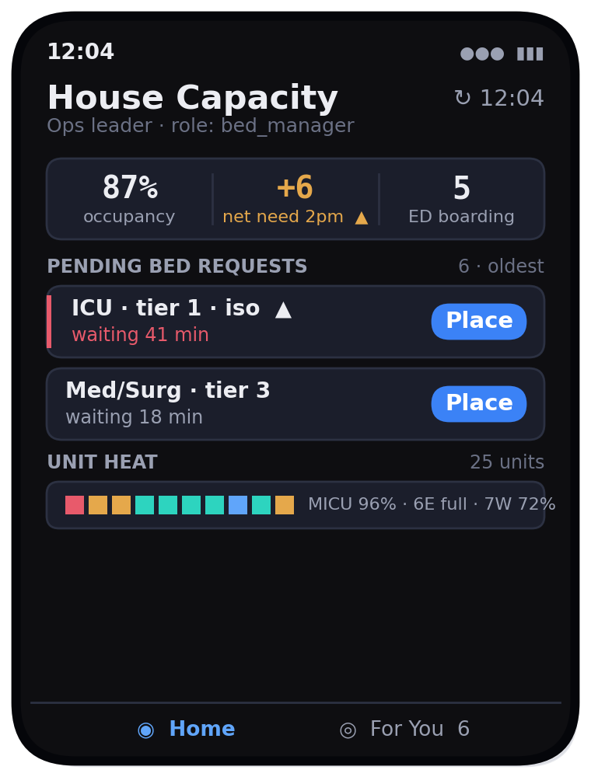 | Feature screens House-heat grid (all 25 units, status-stripe + label); placement worklist -> Bed-Placement decision screen with the transparent score + rationale and Accept / Edit / Reject; barriers-across-units triage.  Seeded data house roll-up from census_snapshots + rtdc_predictions (by_2pm / by_midnight, bed_need); prod.bed_requests (6 pending) + bed_placement_decisions (~45-65 min median latency); ED boarding (5) via ed_visits where bed_assigned_at IS NULL.  BFF GET /rtdc/house (WIRE); GET /rtdc/bed-requests; POST /rtdc/bed-requests/{id}/decision; GET /rtdc/barriers.  For-You Pending bed requests, placement contention, new / aging barriers house-wide, capacity breach, EVS bed-turn completed (placeable now).  Deep-link /rtdc/bed-placement, /rtdc/global-huddle.  Acceptance Home shows the seeded 6 pending requests oldest-first; opening one shows a recommended bed + score; Accept records a bed_placement_decision and clears it from the queue.

Wave 2 - OR board, decisions & executive (live; OR needs 3 backend fixes)
Blocking backend fixes (must land before P4). ORCaseController@store writes string status not status_id; analytics SQL references non-existent actual_start / end_time (route via orlog + case_metrics); reference endpoints filter is_active but the column is active_status. Track these as the first Wave-2 backend tasks - or the board renders garbage.
P4 - OR Circulating / Charge Nurse
Frontline OR - NEW role: or_nurse - Home: OR Board
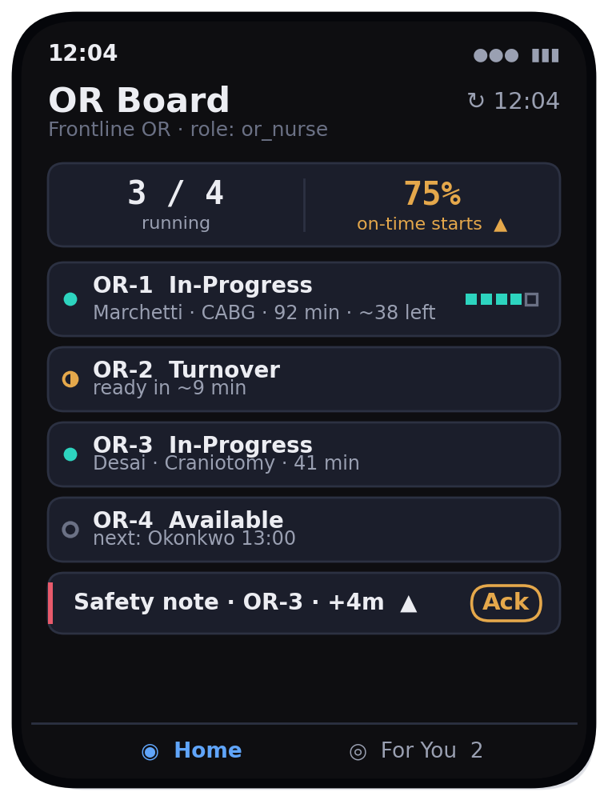 | Feature screens Case detail with the wheels-clock timeline (or_in -> procedure_start -> procedure_end -> or_out) and progress %; advance case status; safety-note create / ack (SLA Crit 15m / High 30m / Med 60m / Low 120m); pre-op milestone ack (H&P / Consent / Labs); case-transport ready / complete.  Seeded data prod.or_cases for today across OR-1..OR-4 in Main OR Suite, joined to or_logs (clock) and case_metrics (turnover 24-34 min); surgeons Marchetti, Okonkwo, Wexler, Desai, Castellano; 1 same-day cancellation; FCOTS 75% (3 of 4 first cases on time).  BFF GET /or/board (WIRE +OR-FIX); POST /or/cases/{id}/status; + safety-note / milestone / transport bodies (contract TODO).  For-You Safety-note SLA breaches, "you're up next," pre-op milestone incomplete.  Deep-link /operations/room-status, /operations/cases.  Acceptance Board renders 4 rooms with the correct derived state from the wheels clock at the current hour; an in-progress case shows live elapsed / remaining; the seeded overdue safety note appears coral in For-You with an inline Ack.
P7 - Perioperative Manager
Ops leader - NEW role: periop_manager - Home: OR Today
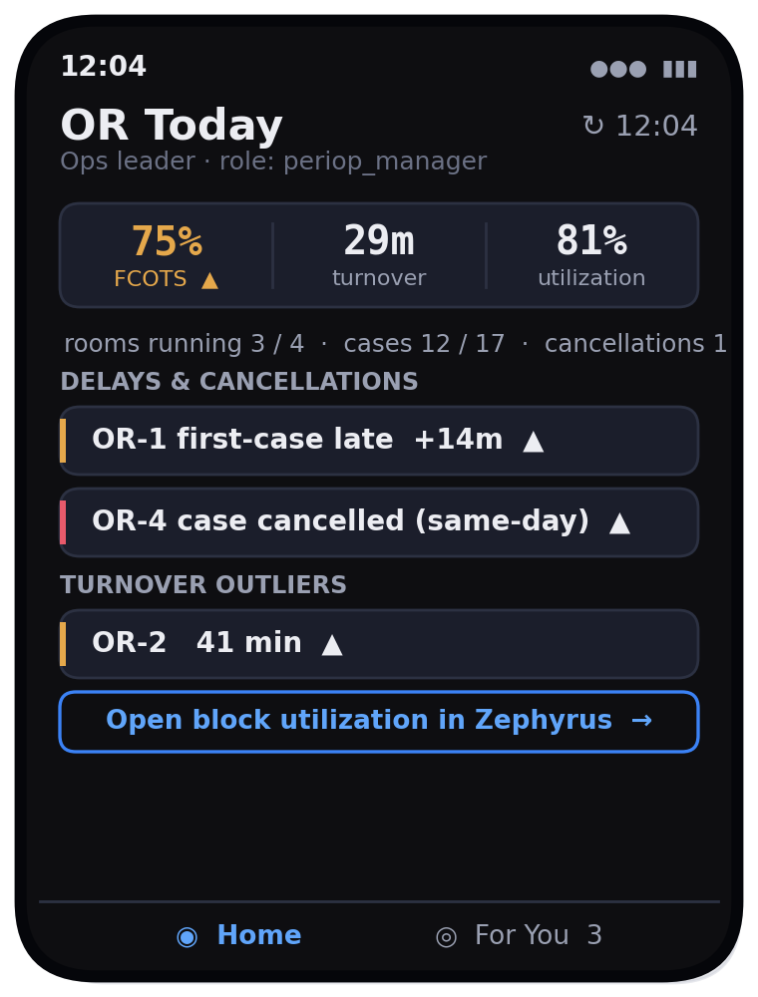 | Feature screens Shares the OR Board (a read / triage lens); delays & cancellations list; turnover outliers; a single block-utilization tile that deep-links to web for the full by-service / room analytics (not rebuilt on mobile).  Seeded data case_metrics (turnover, late-start, prime-time), block_utilization (scheduled vs actual, 70-95% / room / day), or_cases (today's done / remaining, 1 cancel), FCOTS 75% from the latest seeded day.  BFF GET /or/board (shared) + GET /or/performance (NEW small reshape of case_metrics + block_utilization).  For-You First-case late starts, cancellations, turnover breaches, OR staffing gaps.  Deep-link /analytics/block-utilization, /analytics/turnover-times, /analytics/or-utilization.  Acceptance Home shows FCOTS 75% (amber, arrow), avg turnover ~29m, 1 cancellation; the block-utilization tile deep-links and the web page opens authenticated.
P6 - Patient-Flow / Capacity Lead
Ops leader - NEW role: capacity_lead - Home: Capacity & Demand
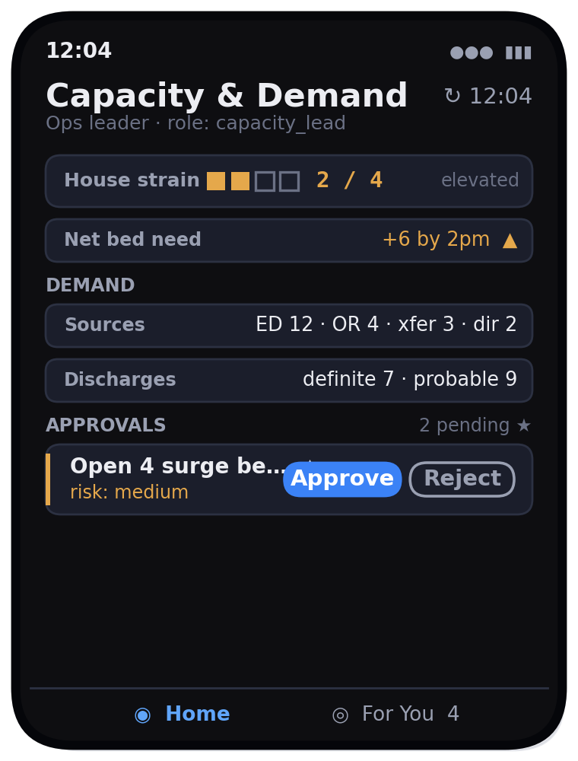 | Feature screens Demand-capacity by unit (predictions); Ops approvals inbox -> approval detail (title, risk, rationale -> Approve / Reject + reason, optional Assign); huddle action items; surge / diversion status.  Seeded data rtdc_predictions (demand sources, weighted discharges), census roll-up for strain; Eddy / ops recommendations + operational actions (EddySeeder / CommandCenterDemoSeeder); diversion_events (2 historical -> "no active diversion").  BFF GET /command/house (strain + demand); GET /ops/inbox; POST /ops/approvals/{id}/decision; POST /ops/actions/{id}/{transition} - all WIRE, reusing OperationalActionLifecycleService verbatim.  For-You Actions awaiting my approval, surge alert, huddle to facilitate, stale-feed qualified metrics.  Deep-link /ops/agent-inbox, /rtdc/global-huddle.  Acceptance Home shows a 0-4 strain index with a non-colour cue; the approvals inbox shows seeded pending action(s); Approve transitions the action and removes it (and emits to web).
P9 - Executive (CMO / COO / CNO)
Executive - NEW role: executive - Home: House Brief
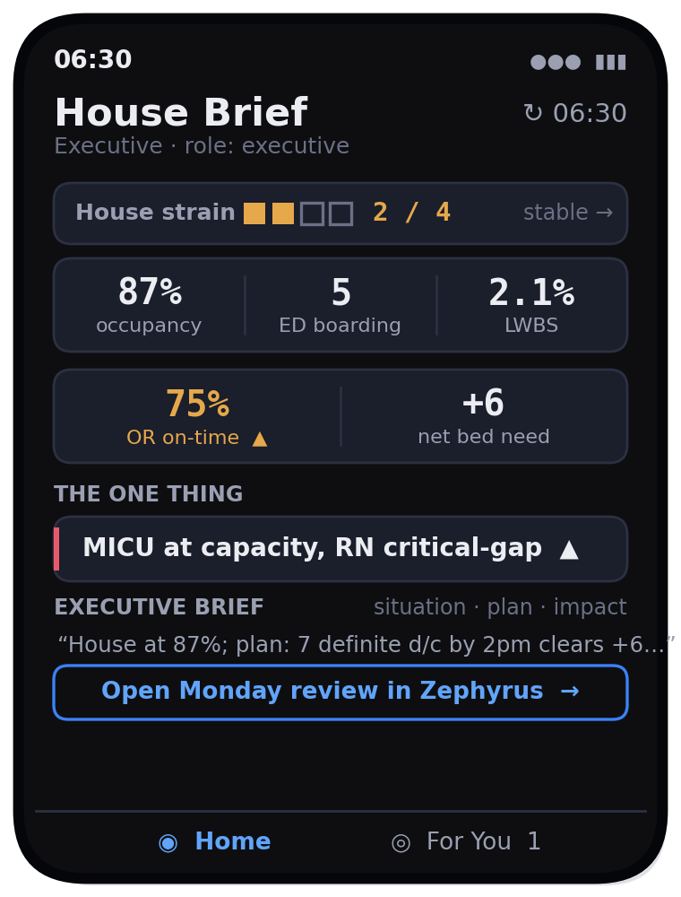 | Feature screens Strain detail (drivers: occupancy, LOS, barriers, staffing); Executive Brief (server-composed situation / plan / impact / confidence); drill-once into a hero KPI; deep-link to the web Monday review.  Seeded data Command Center strain + hero KPIs + 24h forecast; the server-composed brief from the Executive Briefing agent (EddySeeder corpus); "the one thing" = the single most material breach (seeded MICU critical-gap + at-capacity).  BFF GET /command/house; GET /command/brief (WIRE - contract exists).  For-You House-status escalation, the single most material breach, "morning brief ready" (sparse, high-bar).  Deep-link /dashboard (Command Center, ?role=executive), /ops/executive-brief.  Acceptance Home stays calm (no coral) under nominal seed; forcing a breach promotes "the one thing" to coral with an arrow; the brief renders the seeded narrative; tabular KPIs carry trust / trajectory affordances.

Wave 3 - Staffing + ED signals (live, lower mobile-first priority)
P10 - Staffing Coordinator
Ops leader - NEW role: staffing_coordinator - Home: Staffing
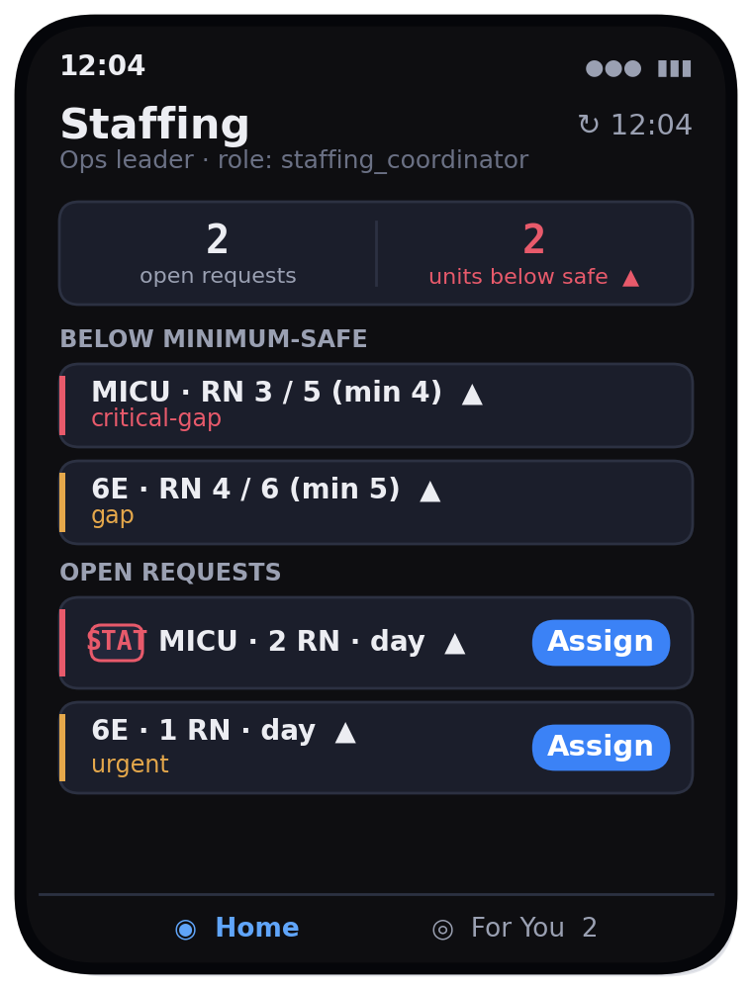 | Feature screens Gap board (staffing_plans by status); open-requests worklist -> create / source / assign / fill.  Seeded data prod.staffing_plans (MICU critical_gap 3 / 5 RN, 6E gap 4 / 6 RN), prod.staffing_requests (2: one stat, one urgent), staffing_events.  BFF GET /staffing/plans; GET /staffing/requests; POST /staffing/requests/{id}/... (NEW BFF paths -> live /api/staffing/*).  For-You New gap below safe minimum, unfilled / escalated requests.  Deep-link /staffing (Staffing Office).  Acceptance Home shows the 2 seeded gaps with min-safe context and arrows; an Assign action transitions a request through the lifecycle.
ED signals - a folded tile, not a standalone persona
Injected into the house / exec homes and the For-You queue - ED actions are deferred to Wave 4
Renders ed_visits signals - boarding count (5, bed_assigned_at IS NULL), LWBS rate (~15% of ~70 / 24h), door-to-provider median, and an ESI 1-2 LWBS safety flag; diversion_events show no active diversion. All available via Command Center today; folds into GET /command/house (add GET /ed/signals if a dedicated tile is wanted). An ESI 1-2 LWBS produces a NOTIFY-tier For-You item.

Wave 4 - PI / PDSA (net-new backend; the web is a stub too)
P8 - PI / Quality Lead
Ops leader - NEW role: pi_lead - Home: Improvement
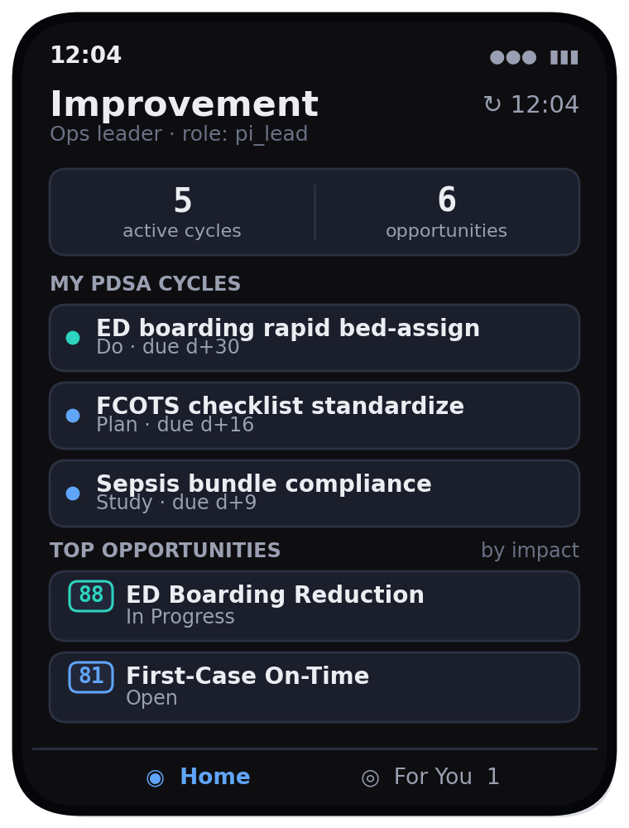 | Feature screens PDSA list -> cycle detail (objective, stage, owner, baseline / current / target, barriers); opportunity board (ranked by estimated_impact); barrier-trend tile; resource library (deep-link). Bottleneck / root-cause / process-mining stays web.  Seeded data prod.pdsa_cycles (5 active: ED boarding, DC-before-noon, FCOTS checklist, sepsis bundle, barrier huddle; 2 completed), prod.improvement_opportunities (6, impact 88 -> 41), prod.improvement_resources (6), prod.barriers trend by category.  BFF GET /improvement/pdsa; GET /improvement/opportunities; POST /improvement/pdsa/{id}/advance (NEW - requires building the PDSA write API on the web first; model exists, routes do not).  For-You PDSA stage due, barrier assigned to me, intervention metric moved.  Deep-link /improvement/pdsa, /improvement/opportunities, /improvement/bottlenecks.  Acceptance Home lists the 5 active cycles with stage + age; opportunities rank by impact; once the write API lands, advancing a stage persists and notifies.

15. BFF endpoint buildout
The contract already drafts the Wave-1/2 paths; they need route wiring plus a controller that reshapes the live service into the envelope. Wave-3/4 paths are added to the contract as their backends land. All require auth:sanctum + ability:mobile:read; mutations add mobile:act.
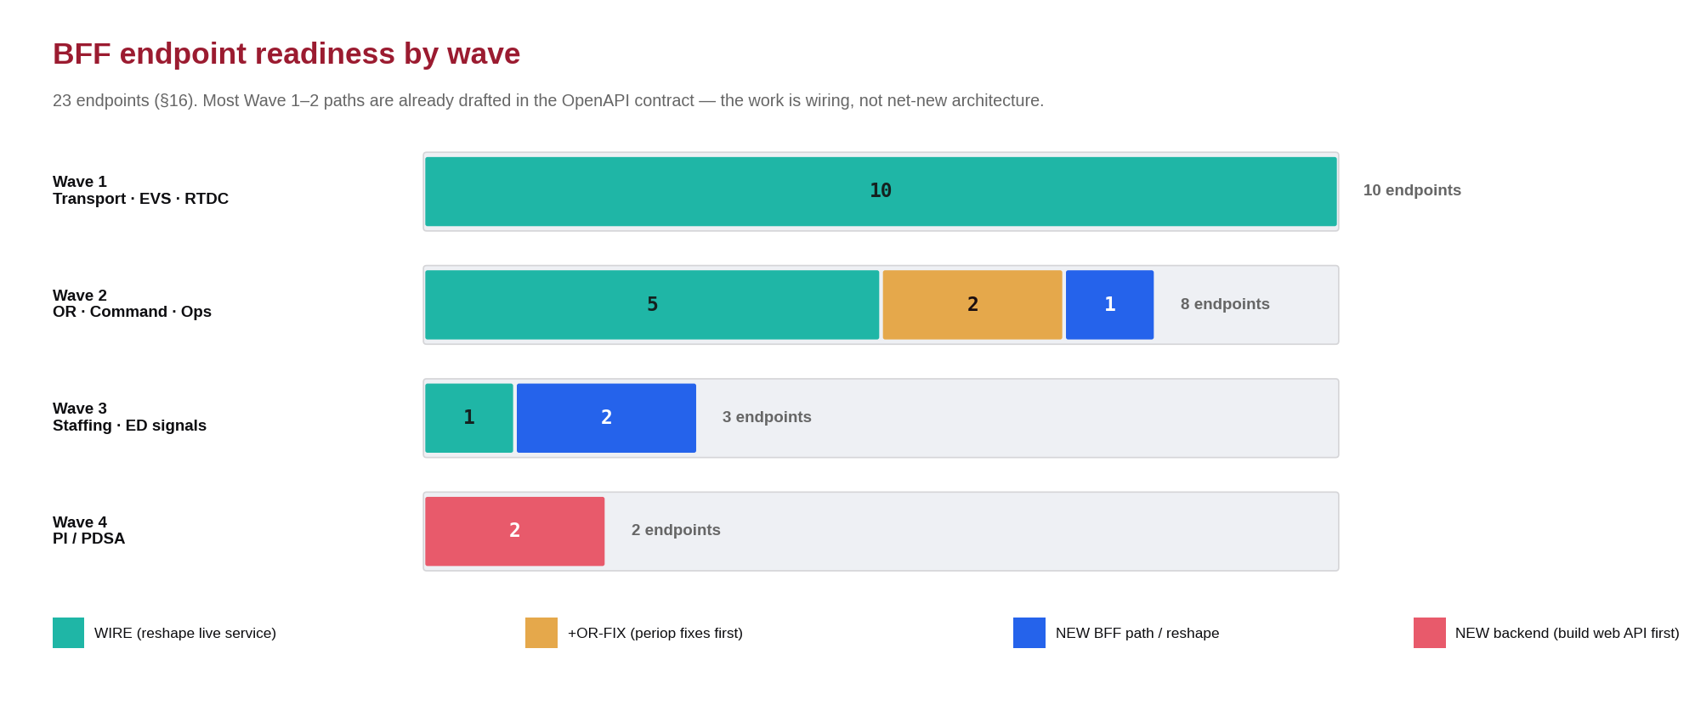
Figure 4.3 - BFF endpoint readiness by wave (n = 23). Most Wave 1-2 paths are already drafted in the contract.
Endpoint | Method | Reshapes | Status | Wave
/transport/queue | GET | TransportOperationsService | WIRE | 1
/transport/requests/{id}/status | POST | same | WIRE (act) | 1
/transport/requests/{id}/handoff | POST | same | WIRE (act) | 1
/evs/queue | GET | EvsOperationsService | WIRE | 1
/evs/requests/{id}/status | POST | same | WIRE (act) | 1
/rtdc/house | GET | census roll-up + RtdcPrediction | WIRE | 1
/rtdc/bed-requests | GET | BedRequest + BedPlacementDecision | WIRE | 1
/rtdc/bed-requests/{id}/decision | POST | RTDC engine | WIRE (act) | 1
/rtdc/barriers | GET | Barrier | WIRE | 1
/rtdc/barriers/{id}/resolve | POST | RTDC engine | WIRE (act) | 1
/or/board | GET | ORCase + ORLog + Room | WIRE +OR-FIX | 2
/or/cases/{id}/status | POST | case lifecycle | +OR-FIX (act) | 2
/or/performance | GET | CaseMetrics + BlockUtilization | NEW reshape | 2
/command/house | GET | CommandCenterController | WIRE | 2
/command/brief | GET | Executive Brief | WIRE | 2
/ops/inbox | GET | Ops/* recommendations + actions | WIRE | 2
/ops/approvals/{id}/decision | POST | OperationalActionLifecycleService | WIRE (act) | 2
/ops/actions/{id}/{transition} | POST | same | WIRE (act) | 2
/staffing/plans, /staffing/requests | GET | StaffingPlan / Request | NEW path | 3
/staffing/requests/{id}/... | POST | staffing service | NEW path (act) | 3
/ed/signals (optional) | GET | Command Center / analytics | WIRE | 3
/improvement/pdsa, /opportunities | GET | PdsaCycle / ImprovementOpportunity | NEW backend | 4
/improvement/pdsa/{id}/advance | POST | NEW PDSA write API | NEW backend | 4
Naming reconciliation (do first). The live route is /for-you but the contract says /foryou - pick one (recommend matching the working client) and update both apps; add /foryou/{itemId}/ack. Confirm /me returns roles[] rich enough to pre-select the new roles. Every list endpoint is PHI-minimized with a { data, meta:{as_of,stale,version}, links:{web} } envelope, updated_since + cursor support, and a links.web deep-link target.

16. Data-plausibility prerequisites
DATA-PLAUSIBILITY.md shows the live DB currently renders some implausible numbers. Screens that "plausibly take advantage of the demo data" require these fixed before their wave ships:
# | Prerequisite | Detail and what it blocks | Status
1 | Re-seed to intended state | Seeders target ~87% occupancy, 12 pending requests, 5 ED boarding, 6 barriers, 2 staffing gaps. The live snapshot diverged (132 occupied vs ~432 intended). Run migrate:fresh --seed against the demo DB and re-verify. | Gated
2 | ED bed inventory | ED has 148 bed rows vs staffed_bed_count = 40. Set ED's true capacity or prune phantom available beds. Blocks P3 (ED charge) + P5 house heat. | Open
3 | Stray active encounters | 143 active encounters vs 132 occupied beds; ~11 units show "0 occupied, 1 active enc." Reconcile encounters.status='active' with beds.status='occupied'. Blocks every census-derived screen. | Open
4 | Headroom-vs-total display | census now returns staffed_bed_count, occupied, available, blocked, can_admit (separate), and a status from occupied / staffed; iOS CensusRollup matches. | Fixed
5 | Unit type labels | PICU / NICU typed med_surg won't show in critical-care scopes; Behavioral Health mislabeled. Adjust units.type if intensivist scoping matters. | Minor
Already fixed in this branch (verified 2026-06-30). The headroom-vs-total display (#4). The "6E 500% / ED No data" symptom in DATA-PLAUSIBILITY.md was a remote-DB audit predating the current code - no code change needed; the residual ED / encounter issues are pure data. Deliverable: a seed-and-verify checklist run (the read-only diagnostic queries) that must come back clean per wave.

17. Client integration (iOS + Android, in lockstep)
The architecture is persona-ready; the integration points are small and known.
17.1 Extend the role catalog. iOS Role.swift: add or_nurse, periop_manager, capacity_lead, executive, staffing_coordinator, pi_lead (id, title, subtitle, SF Symbol, unitBound); keep matching(serverRoles:). Android: mirror in the role catalog used by AuthViewModel / onboarding (Android role routing is partial today - bring it to iOS parity in Wave 0/1).
17.2 Route to a feature package, not just census scope. Today RoleExperience returns { homeTitle, homeFocus, censusScope, queueFilter }. Extend it with a home: HomeKind and featureTab: FeatureRoute? so a role selects which screen package renders:
enum HomeKind { case census(CensusScope) // P3, P5 (existing)
case transportJobs // P1
case evsTurns // P2
case orBoard // P4, P7
case capacityDemand // P6
case houseBrief // P9
case staffing // P10
case improvement } // P8
MainTabView renders Home from HomeKind; the second tab stays For You for everyone. A role with a distinct workspace (transport, EVS, OR, staffing, PI) gets that as its Home, with the census glance demoted to a tile; house / ops / exec roles keep census-style homes.
17.3 Build feature screens (mirror both platforms). Reuse the existing design-system components (KpiTile, Panel, StatusChip, RetryableMessage) - no new primitives. Each screen: one BFF call, RetryableMessage on error, meta.stale -> a "stale" chip, links.web -> an "Open in Zephyrus" row.
Package | iOS (Features/...) | Android (ui/...)
Transport | Transport/{TransportJobsView, JobDetailView, HandoffSheet} | transport/{TransportJobsScreen, JobDetailScreen, HandoffSheet}
EVS | EVS/{BedTurnsView, TurnDetailView} | evs/{BedTurnsScreen, TurnDetailScreen}
OR | OR/{RoomBoardView, CaseDetailView, SafetyNoteSheet} | or/{RoomBoardScreen, CaseDetailScreen}
Capacity / Ops | Capacity/{CapacityDemandView, ApprovalsInboxView, ApprovalDetailView} | capacity/*
Executive | Executive/{HouseBriefView, StrainDetailView} | executive/*
Staffing | Staffing/{StaffingView, RequestDetailView} | staffing/*
Improvement | Improvement/{ImprovementView, PdsaDetailView} | improvement/*
17.4 Networking + models. Add DTOs for each new envelope (TransportJob, EvsTurn, ORRoom, ORCase, Approval, StrainBrief, StaffingPlan, PdsaCycle) + APIClient methods per endpoint. Mutations send meta.version; on 409 surface "changed since you loaded," re-snapshot. Realtime: subscribe to the role's PHI-free channel (hospital.beds for census; add or.board / domain channels as the backend broadcasts them); re-snapshot on every reconnect (Reverb doesn't replay); keep the 15 s poll fallback.
17.5 For-You feed growth (backend, one place). Extend ForYouController to compose the new domains (transport STAT, EVS isolation / overdue, safety-note SLA, approval pending, staffing gap, PDSA-stage-due), each tier-ranked by earned urgency and carrying an inline action verb. The client queue component is unchanged.

18. Persona buildout - phased TODO
The buildout maps onto the program's phases. Wave 0 is the one-time foundation that blocks everything; Waves 1-4 ride backend readiness.
Wave | Key task | Status
0 | Add 6 missing roles to Role.swift + tailored RoleExperience cases (iOS build passes) | Done
0 | Census display semantics - verified already correct in this branch | Done
0 | Android role parity - port Role / RoleExperience / onboarding to iOS parity | Open
0 | HomeKind / featureTab - land with the first bespoke Home (Wave 1 Transport) | Open
0 | Re-seed demo DB + DB fixes - blocked on env (shared remote DB, Docker down) | Blocked
0 | Reconcile /for-you <-> /foryou path naming | Open
1 | BFF: wire transport / EVS / RTDC paths; envelope + conformance tests | Open
1 | iOS + Android: Transport & EVS packages; enhance Unit (P3) + House (P5) homes | Open
1 | For-You: add transport / EVS / RTDC sources with tier ranking + inline actions | Open
2 | Backend: land the 3 perioperative fixes (status_id; analytics columns; active_status) | Open
2 | BFF: /or/*, /command/*, /ops/* paths | Open
2 | iOS + Android: OR, Capacity / Ops, Executive packages + 4 new roles | Open
3 | BFF /staffing/* (+ /ed/signals); Staffing package + role; ED-signals tile | Open
4 | Backend: build PDSA read + write API; Improvement package + pi_lead role | Open
all | OpenAPI conformance, Feature tests green, push categories, update parity matrix | Ongoing

19. Test & validation strategy
Validation is deterministic - every acceptance target assumes the freshly re-seeded demo DB.
Backend / BFF (fast, deterministic). Conformance: lint + validate against hummingbird-bff.v1.yaml; every new path returns the envelope, honours mobile:read / mobile:act, and returns 409 on a stale meta.version. Feature tests: one per endpoint asserting the seeded shape (/transport/queue returns 8 active with >=1 STAT; /or/board returns 4 rooms with derived states; /staffing/plans returns MICU critical_gap). PHI-guard test: no patient identifiers or free-text in any list payload or push body.
Client (per-persona, on a visible simulator + emulator). Run the iOS Simulator and Android emulator visibly on screen, never headless. For each persona: (1) launch with the persona forced (HB_AUTOLOGIN=1 HB_ROLE=<id>, + HB_OPEN_UNIT for unit-bound); (2) glance check - Home renders the seeded numbers, correct title, tabular metrics, status with arrow / icon, calm by default; (3) action check - exercise the inline verb end-to-end and confirm the item clears from Home and For-You and the change round-trips; (4) honest-empty check; (5) deep-link check; (6) capture a GIF of each glance -> action loop (persona-<id>-loop.gif).
Acceptance gate - a wave is "done + validated" when: every persona in the wave passes its Section-14 acceptance line on both platforms; the BFF conformance + Feature tests are green; the DATA-PLAUSIBILITY diagnostics for that wave's screens return clean; there are no console errors on the glance -> action loop; and the For-You queue tier-ranks the wave's new sources correctly (most-urgent first).
Regression. Re-run the existing 214 Feature tests + the Home / For-You persona-filter tests each wave; snapshot-diff the two original screens to confirm no regression as HomeKind routing lands.

20. Risks & open questions
Risk / open question | Mitigation
OR backend fixes are a hard gate for Wave 2 | Sequence the three ORCase / analytics / reference fixes as the first Wave-2 backend tasks, or the board renders garbage.
PI / PDSA is genuinely net-new (web routes don't exist) | It is correctly last; don't let its novelty pull it forward and stall the live-data waves.
Reverb edge proxy not wired at the Apache edge | Production Reverb (:8080) isn't proxied today, so realtime falls back to 15 s polling. New live boards feel best on WS - decide whether to fix the proxy in Wave 2 or accept polling for the demo.
Android role-routing parity | iOS RoleExperience is ahead; Wave 0 must bring Android to parity so personas validate on both platforms, not iOS-only.
Server role vocabulary | /me.roles[] must carry enough signal to pre-select the 6 new roles; confirm web role names map via matching(serverRoles:), or add an explicit mapping table.
Demo vs. real divergence | All acceptance targets assume the deterministic seed. If a demo runs against drifted data, re-seed first - the Section-16 gate exists for this reason.
In one paragraph. Hummingbird already has the skeleton for persona-driven mobile (role catalog, RoleExperience, a uniform PHI-minimized BFF envelope, a universal For-You queue) and the web backend already has live, seeded data for every pillar - but only 2 of 10 personas have real screens. This part builds the missing 8 persona packages (Home + feature screens + For-You feed + deep-links), wiring the already-contracted BFF paths to existing live services in four readiness-ordered waves (frontline RTDC / transport / EVS -> OR + decisions + exec -> staffing / ED -> PI / PDSA), gated on a one-time data-plausibility cleanup, and validates each persona end-to-end against the deterministic seed on visible iOS + Android simulators.
PART V

Reference

Appendix A — Full feature-parity matrix
Maps every web data element/function to a mobile treatment, satisfying “map to all data elements and functionality.” GLANCE / ACT / NOTIFY / WEB · backend LIVE / MOCK / NEW / WS · phase. Field-level detail per domain: reference/01-feature-parity-matrix.md and research/.

RTDC — Real-Time Demand & Capacity (flagship)
Capability | Treatment | Backend | Phase
Unit census + acuity-adjusted safe capacity | GLANCE·NOTIFY | LIVE·WS | 1
Hospital bed-need roll-up (net/deficit) | GLANCE·NOTIFY | LIVE·WS | 1
Bed (status/isolation/gender) | GLANCE | LIVE | 1
Bed request — list / create | GLANCE·ACT·NOTIFY | LIVE | 1
Bed placement decision — accept/edit/reject (transparent score) | ACT | LIVE | 1
Barrier to discharge — list / log / resolve | GLANCE·ACT·NOTIFY | LIVE | 1
Huddle (unit/service/global) + steps | GLANCE·ACT | LIVE·WS | 2
Huddle action items (owner/due) | ACT·NOTIFY | NEW | 2
Discharge prediction / reconciliation / GMLOS | GLANCE | LIVE | 2
Care-journey milestone | GLANCE | LIVE | 2
Diversion event | GLANCE·NOTIFY | NEW | 3
Discharge readiness / priorities | GLANCE·ACT | NEW (mock) | 3
RTDC deep analytics / trends | WEB | MOCK | —

Perioperative (ready data, greenfield surface)
Capability | Treatment | Backend | Phase
OR case (service/surgeon/room/status) | GLANCE·ACT·NOTIFY | LIVE | 2
Wheels clock (ORLog, 13 timestamps) | GLANCE | LIVE | 2
Case status — advance (Sched→InProg→Delay→Comp) | ACT·NOTIFY | LIVE (fix store) | 2
Room status board (derived) | GLANCE·NOTIFY | LIVE | 2
Case timing (progress %/variance) | GLANCE·NOTIFY | LIVE | 2
Safety note — create/ack (SLA 15/30/60/120m) | GLANCE·ACT·NOTIFY | LIVE | 2
Pre-op milestone — ack (H&P/Consent/Labs) | ACT·NOTIFY | LIVE | 2
Case transport — ready/complete | ACT·NOTIFY | LIVE | 2
Provider directory / reference data | GLANCE / lookup | LIVE | 2
Block/primetime/turnover/provider/service analytics; forecasts | WEB | LIVE/MOCK | —

Ops / AI & Command Center (“approvals on the go”)
Capability | Treatment | Backend | Phase
Recommendation (title/risk/rationale) | GLANCE·NOTIFY | LIVE | 2
Operational action lifecycle (draft→…→completed, expires +8h) | GLANCE·ACT·NOTIFY | LIVE | 2
Approve / reject approval ★ | ACT·NOTIFY | LIVE | 2
Assign / start / complete (override/expire P3) | ACT | LIVE | 2/3
Agent inbox summary | GLANCE | LIVE | 2
House strain/surge index (0–4) + hero KPIs + 24h forecast | GLANCE·NOTIFY | LIVE | 2
Executive Brief (situation/plan/impact/confidence) | GLANCE·NOTIFY | LIVE | 2
Intervention/metric trust/lineage/freshness | GLANCE | LIVE | 3
Data-quality finding (stale feed) | GLANCE·NOTIFY | LIVE | 3
Simulation author / ops graph / process mining | WEB | LIVE | —

Emergency Department (glance now, act later)
Capability | Treatment | Backend | Phase
ED boarding count (≤6) · LWBS % · door-to-provider/LOS · surge | GLANCE·NOTIFY | LIVE (Command/Analytics) | 3
Active diversion · ESI 1–2 LWBS (safety) | GLANCE·NOTIFY | LIVE/NEW | 3
Boarder dwell >4h since admit decision | NOTIFY | NEW | 4
Live ED board / triage / disposition | ACT | NEW | 4+
ED flow/wait/resource/acuity/arrival analytics | WEB | MOCK | —

Transport · EVS · Staffing (mobile workers)
Capability | Treatment | Backend | Phase
Transport request + 17-status lifecycle; claim/progress/assign | GLANCE·ACT·NOTIFY | LIVE | 1
Transport structured handoff (to/summary/docs/risks) | ACT·NOTIFY | LIVE | 1
Regional / inter-facility transfer | GLANCE·ACT | LIVE | 3
EVS bed-turn + 5-status; claim/start/complete; isolation SOP | GLANCE·ACT·NOTIFY | LIVE | 1
Staffing plan (gap/min-safe) + request; create/source/assign/fill | GLANCE·ACT·NOTIFY | LIVE | 3

Process Improvement · Patient Flow/FHIR/Integration · Platform
Capability | Treatment | Backend | Phase
PDSA cycle (plan/do/study/act) — own/advance; barrier ack | GLANCE·ACT·NOTIFY | NEW | 4
Bottleneck / root-cause / process mining / 4D navigator | WEB | MOCK | —
Flow encounter/event/occupancy; patient identity; FHIR; ambient | feeds census/board | LIVE | 1–2
Integration source/health/connector; dead-letter | GLANCE·NOTIFY (admin) | LIVE | 4
Facility blueprint / space modeling | WEB | LIVE | —
Auth · biometric · workflow switcher · profile/prefs · search · directory | ACT·GLANCE | LIVE + NEW | 0–2
Admin (users, auth providers) | WEB | LIVE | —
Coverage assertion Every audited model maps to a row above or its domain’s WEB bucket. The domains carrying the most NEW backend (ED actions, PI/PDSA, RTDC huddle action-items & discharge-readiness) are precisely those that are mock/stub on the web today — net-new product, not a mobile gap — which is why they land in P3–P4.

Appendix B — Backend change log
Consolidated additive backend work (detail: reference/04-backend-requirements.md):
Area | Work | Phase
Auth | HasApiTokens; /auth/token{,/refresh,/revoke}, /auth/change-password (honor must_change_password); OIDC+PKCE path; token abilities | 0
Push | mobile_devices registry; APNs .p8 + FCM v1 PushNotifier; notification router | 0→1
BFF | /api/mobile/v1/* scaffold; per-domain endpoints rolled out P1–P4; uniform envelope; PHI-minimization | 0–4
Assignment/RBAC | user_id FKs on owners + user_unit pivot; Laravel Policies; remediate auth-less endpoints | 0
Broadcasts | BarrierUpdated (P1); DiversionUpdated (P3); WS config endpoint | 1–3
Evaluators | SLA / capacity deficit / barrier aging / unplaced bed (P1); ED boarding/LWBS/surge, staffing min-safe (P3); boarder dwell, integration health (P4) | 1–4
Bug fixes | OR store status_id; analytics actual_start/end_time → orlog/metrics; reference active_status | before 2
Net-new | huddle action-items API (P2); PI/PDSA write paths, ED write path, simulation read (P4) | 2–4

Appendix C — Risk register
Risk | Sev | Mitigation
KMP commitment decided late → costly re-architecture | High | Decide now (§5). Floor: separate apps + mandated OpenAPI contract + shared conformance spec
Earned-urgency mis-tuned → alarm fatigue or missed breach (safety) | High | Treat taxonomy as clinical-safety; configurable bands; clinical sign-off gate; track T1 precision + per-shift budget
PHI leak (notifications/logs/snapshots/SDKs) | High | PHI-free push by design + CI payload linter + FLAG_SECURE/privacy view + BAA/PHI-free SDKs; PHI-leak audit gate
Auth additivity breaks the locked flow | High | Strict additive design; auth regression suite as a P0 gate; never touch protected files
Net-new backend gates ED/PI slips features | Med | Sequence last (P4); ship glanceable signals first (P3); deep-link-to-web fallback
Push reliability on battery-constrained devices | Med | Push-first + delta-sync; never hold a bg socket; poll-on-resume fallback; real-device testing
Apple Critical Alerts / Android FSI permission delays | Med | Apply early in P2; degrade T1 to high-importance until granted
Web endpoints currently auth-less = security finding | Med | Remediate in P0; BFF is the only mobile surface
Reference/OR backend bugs block P2 | Low | Fix list scheduled before P2 (Appendix B)

Appendix D — Team & timeline
Role | Count | Focus
iOS (Swift/SwiftUI) | 2 | native UI, widgets/Live Activities, watch
Android (Kotlin/Compose) | 2 | native UI, Glance widgets, Wear
KMP / shared | 1 | domain/data/sync/tokens (pairs with both)
Backend (Laravel) | 1–2 | BFF, auth, push, evaluators, RBAC, broadcasts
Design | 1 | token parity, mobile component specs, glanceability
QA / security | 1 | conformance + security/PHI gates
Clinical-safety advisor | part | notification taxonomy + tier sign-off
PM / EM | 1 | sequencing, store, rollout
Timeline: ~9–12 months to GA; internal pilots from end of P1; P1–P2 overlap once the BFF pattern is set.

Appendix E — Program definition of done
- The parity matrix is fully reconciled: every GLANCE/ACT/NOTIFY row shipped or explicitly deferred with a tracked backend ticket; every WEB row has a working deep link.
- All seven security release-gate criteria pass (reference/06-security-hipaa.md §9), notably: zero PHI leaves the boundary (notifications/logs/snapshots/analytics); auth additivity proven by a green regression suite over the locked flow; biometric + auto-lock + remote-revoke; cert pinning with rotation; action RBAC unbeatable by a tampered client; audit trail on every mutation; named security + clinical-safety sign-off.
- The notification taxonomy meets its precision/budget criteria in pilot and has clinical-safety sign-off.
- One design system, three platforms — verified non-divergent by the token CI check.

Document map
This consolidated plan is the front door. Detail lives in:
Deep-dive planning docs
- 00 Vision/Scope/Personas · 01 Feature-Parity Matrix · 02 Functionality by Role · 03 Architecture
- 04 Backend & API · 05 Notifications · 06 Security/HIPAA · 07 Roadmap & Phasing
Scaffolding (begun)
- design-tokens/ — DTCG source + Style Dictionary + samples.
- api-contract/hummingbird-bff.v1.yaml — validated OpenAPI 3.1.
Evidence — the seven-stream code audit
research/ (01–07: ED, RTDC, Perioperative, Improvement/Ops, Platform, Supporting domains, Mobile best practices).

