**A**

**MINI PROJECT REPORT**

**ON**

**ONLINE COLLEGE MAGAZINE**

*A project report submitted to the*

***Jawaharlal Nehru Technological University***

*In partial fulfillment for the award*

***Bachelor of Technology***

***In***

**COMPUTER SCIENCE AND ENGINEERING**

***Submitted by***

**M.VINAY KUMAR - 16RJ1A05C8**

***Under the esteemed guidance of***

**Mr. K. KISHORE**



**MALLA REDDY INSTITUTE OF TECHNOLOGY**

**(Affiliated to JNTU, Hyderabad | Approved by AICTE, New Delhi)**

**Accredited by NBA, Certificated by ISO 9001:2015**

**Maisammaguda, Dhullapally, Via: Kompally, Hyderabad - 500100**

**2016 - 2020**

** MALLA REDDY INSTITUTE OF TECHNOLOGY**

**(Sponsored by Malla Reddy Educational Society)**

**Accredited by NBA, Certificated by ISO 9001:2015**

**Approved by AICTE & Affiliated to JNTU, Hyderabad**

Maisammaguda, Dhullapally Post, (Via: Kompally), Secunderabad - 500100.

**CERTIFICATE**

This is to certify that major project work entitled **“ONLINE COLLEGE MAGAZINE”** is a bonafide work carried by **M.Vinay Kumar** **(16RJ1A05C8)** of **COMPUTER SCIENCE AND ENGINEERING DEPARTMENT** in **MALLA REDDY INSTITUTE OF TECHNOLOGY** and submitted to **JNT UNIVERSITY, Hyderabad** in the partial fulfillment of the requirement for the award of **BACHELOR OF TECHNOLOGY**.

**Project Guide Project Coordinator Head of Department Mr. K.Kishore Dr. Sateesh Nagavarapu** **Dr. K.UmaPavan Kumar**

**Assistant Professor Associate Professor Associate Professor**

**External Examiner**

**ACKNOWLEGEMENT**

I am happy to express our deep sense of gratitude to the **Principal** of the college **Dr. K.Srinivasa Rao , Professor, Malla Reddy Institute of Technology** for having provided me the adequate facilities to pursue my project.

I would like to thank **Dr. K. UmaPavan Kumar, Associate Professor and Head, Department of Computer Science and Engineering, Malla Reddy Institute of Technology,** for having provided the freedom to me the facilities available in the department, especially the laboratories and library.

I am also grateful to our project coordinator, **Dr. Sateesh Nagavarapu**, **Associate professor**, **Department of Computer Science and Engineering**, **Malla Reddy Institute of Technology**, for extending his support and assisting me throughout my project work.

I am very grateful to my project guide, **Mr. K. Kishore**, **Assistant Professor, Department of Computer Science and Engineering**, **Malla Reddy Institute of Technology**, for his extensive patience and guidance throughout my project work.

I sincerely thank all the **Teaching and Non-teaching staff** of the department of **Computer Science and Engineering**, also like to thank my **Classmates** for their timely suggestions, healthy criticism and motivation during the course of my project work. I thank my **parents** who were the backbone behind my deeds.

Finally, I express my immense gratitude with pleasure to all **individuals** who have either directly or indirectly contributed to my need at right time for the development and success of my project work.

**DECLARATION**

I hereby declare that the project entitle **“ONLINE COLLEGE MAGAZINE”** submitted to **Malla Reddy Institute of Technology**, affiliated to Jawaharlal Nehru Technological University Hyderabad (**JNTUH**) for the award of the degree of **Bachelor of Technology** in **Computer Science and Engineering** is a result of work done by me .It is further declared that the project report or any part thereof has not been previously submitted to any University or Institute for the award of degree or diploma.

M.VINAY KUMAR - 16RJ1A05C8

**ABSTRACT**

The objective is to design and develop a system for the processing of creating and managing an online college magazine where college students and faculties can post and read various articles. Articles can be searched by anybody in the world.

**INDEX**

|  |  |  |
| --- | --- | --- |
| **S.NO.** | **TITLES** | **PAGE NO.** |
|  | **List of Figures** | viii |
|  | **List of Screen shots** | ix |
| **1** | **Introduction** | 1 |
|  | 1.1 Existing System & Its Disadvantages | 1 |
|  | 1.2 Proposed System & Its Advantages | 1 |
| **2** | **Objective** | 2 |
| **3** | **System Analysis** | 3 |
|  | 3.1 Study Of The System | 3 |
|  | 3.2 Input & Output Representation | 3 |
|  | 3.3 Process Models Used With Justification | 6 |
|  | 3.4 System Architecture | 13 |
| **4** | **Feasibility Study** | 14 |
|  | 4.1 Economical Feasibility | 14 |
|  | 4.2 Technical Feasibility | 14 |
|  | 4.3 Social Feasibility | 14 |
| **5** | **Requirement Specifications** | 15 |
|  | 5.1 Functional Requirements Specification (Modules) | 15 |
|  | 5.2 Software Requirements | 16 |
|  | 5.3 Hardware Requirements | 16 |
|  | 5.3.1 Introduction To Python | 16 |
|  | 5.3.2 Django | 18 |
|  | 5.3.3 Sqlite3 | 22 |
|  | 5.3.4 Html | 26 |
|  | 5.3.5 Java Script | 27 |
|  | 5.3.6 Pycharm | 28 |
| **6** | **System Design** | 30 |
|  | 6.1 Introduction | 30 |
|  | 6.2 Data Flow Diagrams | 30 |
|  | 6.3 Uml Diagrams | 34 |
|  | 6.3.1 Use case Diagram | 35 |
|  | 6.3.2 Class Diagram | 36 |
|  | 6.3.3 Sequence Diagram | 37 |
|  | 6.3.4 Activity Diagram | 38 |
|  | 6.4 E-R Diagram | 41 |
|  | 6.5 Normalization | 41 |
| **7** | **Implementation Coding** | 43 |
|  | **7**.1 Guest | 43 |
|  | **7**.2 Admin | 44 |
|  | **7**.3 Moderator | 45 |
|  | **7**.4 Member | 45 |
| **8** | **System Testing** | 47 |
|  | 8.1 Introduction | 47 |
|  | 8.2 Testing Strategies | 49 |
| **9** | **System Security** | 50 |
|  | 9.1 Introduction | 50 |
|  | 9.2 Security In Software | 50 |
| 10 | **Output Screens** | 51 |
| 11 | **Conclusion** | 53 |
| 12 | **Bibliography** | 54 |

**LIST OF FIGURES**

|  |  |  |
| --- | --- | --- |
| **S.NO.** | **TITLES** | **PAGE NO.** |
| 1 | Fig 3.3.1 SDLC(Spiral model) | 6 |
| 2 | Fig 3.3.2 Requirements Gathering stage | 7 |
| 3 | Fig 3.3.3 Analysis Stage | 8 |
| 4 | Fig 3.3.4 Designing Stage | 9 |
| 5 | Fig 3.3.5 Development (Coding) Stage | 10 |
| 6 | Fig 3.3.6 Integration & Test Stage | 11 |
| 7 | Fig 3.3.7 Installation & Acceptance Test | 12 |
| 8 | Fig 3.4 System Architecture | 13 |
| 9 | Fig 5.3.2.1 Django working 1 | 19 |
| 10 | Fig 5.3.2.2 Django working 2 | 19 |
| 11 | Fig 6.2.1 DFD Content Level | 20 |
| 12 | Fig 6.2.2 DFD Level 0 | 31 |
| 13 | Fig 6.2.3 DFD Level 1 | 32 |
| 14 | Fig 6.2.4 DFD Level 2 | 33 |
| 15 | Fig 6.3.1 Usecase Diagram | 35 |
| 19 | Fig 6.3.2 Class Diagram | 36 |
| 20 | Fig 6.3.3 Sequence Diagram | 37 |
| 21 | Fig 6.3.4.1 Member Activity Diagram | 38 |
| 22 | Fig 6.3.4.2 Moderator Activity Diagram | 39 |
| 23 | Fig 6.3.4.3 Admin Activity Diagram | 40 |
| 24 | Fig 6.4 E-R Diagram | 41 |

**LIST OF SCREEN SHOTS**

|  |  |  |
| --- | --- | --- |
| **S.NO.** | **TITLES** | **PAGE NO.** |
| 1 | Guest Module | 51 |
| 2 | Member Module | 51 |
| 3 | Moderator Module | 52 |
| 4 | Admin Module | 52 |

**1.INTRODUCTION**

**1.1 Existing System:**

The present systems are maintained manually with information being stored in traditional ways. This makes the management of data complex.

In this system all students make it to the printed magazine and no user friendly interactive place where students/faculties can share their ideas.

**Disadvantages**

* data can be lost
* requires human power
* wastage of paper

**1.2 Proposed System:**

The proposed system maintains all information in a centralized database. The system allows to conduct all operations effectively and efficiently. Where students and faculties share their ideas through Articles, thus promoting literary insight. Articles can be searched by anybody in the world. Factors behind the motivation of the system are Not all students make it to the printed magazine, creativity of students needs to be nurtured and a user friendly system.

**Advantages**

* Articles can be searched by members , moderators , admin .
* The system allows to conduct all operations effectively and efficiently.
* Large number of data can be stored without any missing of information .

**2.OBJECTIVE**

* Online college magazine is web project where students/faculties can post and read various articles .
* Every students/faculties can view and post their ideas because this is not a printed magazine .
* So we can post and share articles easily .This method takes less time and effort.
* Articles can be searched by anybody in the world.
* Creativity of students needs to be nurtured and Creating a user-friendly interactive place where students/faculties can share their ideas.

**3.SYSTEM ANALYSIS**

**3.1 Study Of The System**

To provide flexibility to the users, the interfaces have been developed that are accessible through a browser. The GUI’S at the top level have been categorized as

1. Administrative user interface
2. The operational or generic user interface

The ‘administrative user interface’ concentrates on the consistent information that is practically, part of the organizational activities and which needs proper authentication for the data collection. These interfaces help the administrators with all the transactional states like Data insertion, Data deletion and Date updation along with the extensive data search capabilities.

The ‘operational or generic user interface’ helps the end users of the system in transactions through the existing data and required services. The operational user interface also helps the ordinary users in managing their own information in a customized manner as per the included flexibilities

**3.2 Input & Output Representation**

Input design is a part of overall system design. The main objective during the input design is as given below:

* To produce a cost-effective method of input.
* To achieve the highest possible level of accuracy.
* To ensure that the input is acceptable and understood by the user.

**Input Stages:**

The main input stages can be listed as below:

* Data recording
* Data transcription
* Data conversion
* Data verification
* Data control
* Data transmission
* Data validation
* Data correction

**Input Types:**

It is necessary to determine the various types of inputs. Inputs can be categorized as follows:

* External inputs, which are prime inputs for the system.
* Internal inputs, which are user communications with the system.
* Operational, which are computer department’s communications to the system?
* Interactive, which are inputs entered during a dialogue.

**Input Media:**

At this stage choice has to be made about the input media. To conclude about the input media consideration has to be given to;

* Type of input
* Flexibility of format
* Speed
* Accuracy
* Verification methods
* Rejection rates
* Ease of correction
* Storage and handling requirements
* Security
* Easy to use
* Portability

Keeping in view the above description of the input types and input media, it can be said that most of the inputs are of the form of internal and interactive. As Input data is to be the directly keyed in by the user, the keyboard can be considered to be the most suitable input device.

**Output Design:**

In general are:

* External Outputs whose destination is outside the organization.
* Internal Outputs whose destination is with in organization and they are the User’s main interface with the computer. Outputs from computer systems are required primarily to communicate the results of processing to users. They are also used to provide a permanent copy of the results for later consultation. The various types of outputs
* Operational outputs whose use is purely with in the computer department.
* Interface outputs, which involve the user in communicating directly with the system.

**Output Definition**

# The outputs should be defined in terms of the following points:

* + - Type of the output
    - Content of the output
    - Format of the output
    - Location of the output
    - Frequency of the output
    - Volume of the output
    - Sequence of the output

It is not always desirable to print or display data as it is held on a computer. It should be decided as which form of the output is the most suitable.

For Example

* Will decimal points need to be inserted
* Should leading zeros be suppressed.

**Output Media:**

In the next stage it is to be decided that which medium is the most appropriate for the output. The main considerations when deciding about the output media are:

* The suitability for the device to the particular application.
* The need for a hard copy.
* The response time required.
* The location of the users
* The software and hardware available.

Keeping in view the above description the project is to have outputs mainly coming under the category of internal outputs. The main outputs desired according to the requirement specification are:

The outputs were needed to be generated as a hard copy and as well as queries to be viewed on the screen. Keeping in view these outputs, the format for the output is taken from the outputs, which are currently being obtained after manual processing. The standard printer is to be used as output media for hard copies.

**3.3 PROCESS MODEL USED WITH JUSTIFICATION**

**SDLC (Spiral Model):**

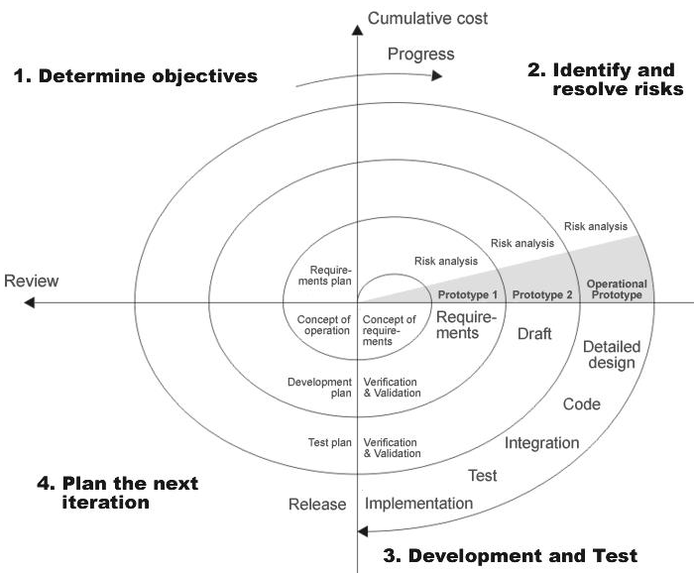

Fig 3.3.1 SDLC(Spiral model)

SDLC is nothing but Software Development Life Cycle. It is a standard which is used by software industry to develop good software.

**Stages in SDLC:**

* Requirement Gathering
* Analysis
* Designing
* Coding
* Testing
* Maintenance

**Requirements Gathering** **stage:**

The requirements gathering process takes as its input the goals identified in the high-level requirements section of the project plan. Each goal will be refined into a set of one or more requirements. These requirements define the major functions of the intended application, define operational data areas and reference data areas, and define the initial data entities. Major functions include critical processes to be managed, as well as mission critical inputs, outputs and reports. A user class hierarchy is developed and associated with these major functions, data areas, and data entities. Each of these definitions is termed a Requirement. Requirements are identified by unique requirement identifiers and, at minimum, contain a requirement title and textual description.

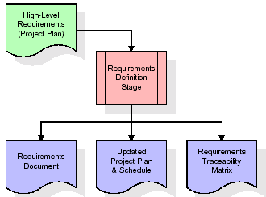

Fig 3.3.2 Requirements Gathering stage

These requirements are fully described in the primary deliverables for this stage: the Requirements Document and the Requirements Traceability Matrix (RTM). The requirements document contains complete descriptions of each requirement, including diagrams and references to external documents as necessary. Note that detailed listings of database tables and fields are *not* included in the requirements document.

The title of each requirement is also placed into the first version of the RTM, along with the title of each goal from the project plan. The purpose of the RTM is to show that the product components developed during each stage of the software development lifecycle are formally connected to the components developed in prior stages.

In the requirements stage, the RTM consists of a list of high-level requirements, or goals, by title, with a listing of associated requirements for each goal, listed by requirement title. In this hierarchical listing, the RTM shows that each requirement developed during this stage is formally linked to a specific product goal. In this format, each requirement can be traced to a specific product goal, hence the term requirements traceability.

The outputs of the requirements definition stage include the requirements document, the RTM, and an updated project plan.

* Feasibility study is all about identification of problems in a project.
* No. of staff required to handle a project is represented as Team Formation, in this case only modules are individual tasks will be assigned to employees who are working for that project.
* Project Specifications are all about representing of various possible inputs submitting to the server and corresponding outputs along with reports maintained by administrator

**Analysis Stage:**

The planning stage establishes a bird's eye view of the intended software product, and uses this to establish the basic project structure, evaluate feasibility and risks associated with the project, and describe appropriate management and technical approaches.

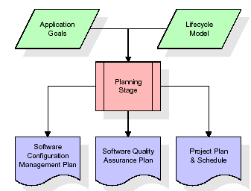

Fig 3.3.3 Analysis Stage

The most critical section of the project plan is a listing of high-level product requirements, also referred to as goals. All of the software product requirements to be developed during the requirements definition stage flow from one or more of these goals. The minimum information for each goal consists of a title and textual description, although additional information and references to external documents may be included. The outputs of the project planning stage are the configuration management plan, the quality assurance plan, and the project plan and schedule, with a detailed listing of scheduled activities for the upcoming Requirements stage, and high level estimates of effort for the out stages.

**Designing Stage:**

The design stage takes as its initial input the requirements identified in the approved requirements document. For each requirement, a set of one or more design elements will be produced as a result of interviews, workshops, and/or prototype efforts. Design elements describe the desired software features in detail, and generally include functional hierarchy diagrams, screen layout diagrams, tables of business rules, business process diagrams, pseudo code, and a complete entity-relationship diagram with a full data dictionary. These design elements are intended to describe the software in sufficient detail that skilled programmers may develop the software with minimal additional input.

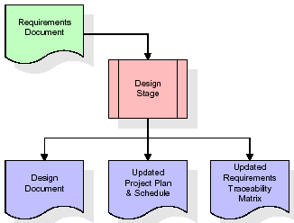

Fig 3.3.4 Designing Stage

When the design document is finalized and accepted, the RTM is updated to show that each design element is formally associated with a specific requirement. The outputs of the design stage are the design document, an updated RTM, and an updated project plan.

**Development (Coding) Stage:**

The development stage takes as its primary input the design elements described in the approved design document. For each design element, a set of one or more software artifacts will be produced. Software artifacts include but are not limited to menus, dialogs, data management forms, data reporting formats, and specialized procedures and functions. Appropriate test cases will be developed for each set of functionally related software artifacts, and an online help system will be developed to guide users in their interactions with the software.

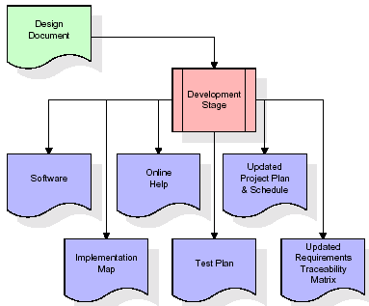

Fig 3.3.5 Development (Coding) Stage

The RTM will be updated to show that each developed artifact is linked to a specific design element, and that each developed artifact has one or more corresponding test case items. At this point, the RTM is in its final configuration. The outputs of the development stage include a fully functional set of software that satisfies the requirements and design elements previously documented, an online help system that describes the operation of the software, an implementation map that identifies the primary code entry points for all major system functions, a test plan that describes the test cases to be used to validate the correctness and completeness of the software, an updated RTM, and an updated project plan.

**Integration & Test Stage:**

During the integration and test stage, the software artifacts, online help, and test data are migrated from the development environment to a separate test environment. At this point, all test cases are run to verify the correctness and completeness of the software. Successful execution of the test suite confirms a robust and complete migration capability. During this stage, reference data is finalized for production use and production users are identified and linked to their appropriate roles. The final reference data (or links to reference data source files) and production user list are compiled into the Production Initiation Plan.

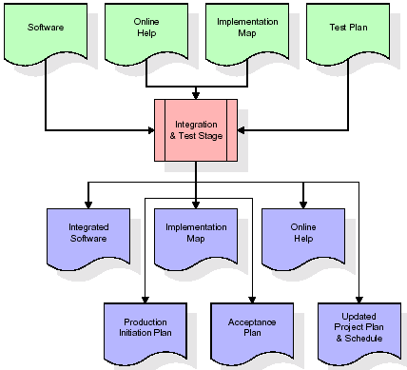

Fig 3.3.6 Integration & Test Stage

The outputs of the integration and test stage include an integrated set of software, an online help system, an implementation map, a production initiation plan that describes reference data and production users, an acceptance plan which contains the final suite of test cases, and an updated project plan.

**Installation & Acceptance Test:**

During the installation and acceptance stage, the software artifacts, online help, and initial production data are loaded onto the production server. At this point, all test cases are run to verify the correctness and completeness of the software. Successful execution of the test suite is a prerequisite to acceptance of the software by the customer.

After customer personnel have verified that the initial production data load is correct and the test suite has been executed with satisfactory results, the customer formally accepts the delivery of the software.

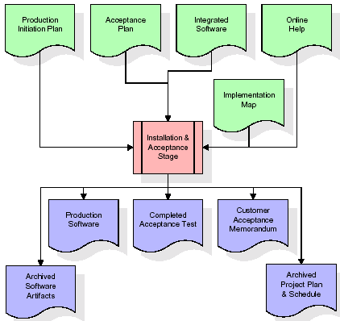

Fig 3.3.7 Installation & Acceptance Test

The primary outputs of the installation and acceptance stage include a production application, a completed acceptance test suite, and a memorandum of customer acceptance of the software. Finally, the PDR enters the last of the actual labor data into the project schedule and locks the project as a permanent project record. At this point the PDR "locks" the project by archiving all software items, the implementation map, the source code, and the documentation for future reference.

**Maintenance:**

Outer rectangle represents maintenance of a project, Maintenance team will start with requirement study, understanding of documentation later employees will be assigned work and they will under go training on that particular assigned category.

For this life cycle there is no end, it will be continued so on like an umbrella (no ending point to umbrella sticks).

**3.4 SYSTEM ARCHITECTURE**

**Architecture flow:**

Below architecture diagram represents mainly flow of requests from users to database through servers. In this scenario overall system is designed in three tires separately using three layers called presentation layer, business logic layer and data link layer. This project was developed using 3-tire architecture.

**Business Logic Layer**

**Presentation Layer**

**Request**

**Response**

**Data Link**

**Layer**

**Data Base**

Fig 3.4 System Architecture

**4.FEASIBILITY STUDY**

The feasibility of the project is analyzed in this phase and business proposal is put forth with a very general plan for the project and some cost estimates. During system analysis the feasibility study of the proposed system is to be carried out. This is to ensure that the proposed system is not a burden to the company. For feasibility analysis, some understanding of the major requirements for the system is essential.

Three key considerations involved in the feasibility analysis are,

* Economical Feasibility
* Technical Feasibility
* Social Feasibility

**4.1 Economical Feasibility**

This study is carried out to check the economic impact that the system will have on the organization. The amount of fund that the company can pour into the research and development of the system is limited. The expenditures must be justified. Thus the developed system as well within the budget and this was achieved because most of the technologies used are freely available. Only the customized products had to be purchased.

### 4.2 Technical Feasibility

This study is carried out to check the technical feasibility, that is, the technical requirements of the system. Any system developed must not have a high demand on the available technical resources. This will lead to high demands on the available technical resources. This will lead to high demands being placed on the client. The developed system must have a modest requirement, as only minimal or null changes are required for implementing this system.

**4.3 Social Feasibility**

The aspect of study is to check the level of acceptance of the system by the user. This includes the process of training the user to use the system efficiently. The user must not feel threatened by the system, instead must accept it as a necessity. The level of acceptance by the users solely depends on the methods that are employed to educate the user about the system and to make him familiar with it. His level of confidence must be raised so that he is also able to make some constructive criticism, which is welcomed, as he is the final user of the system.

**5. REQUIREMENT SPECIFICATIONS**

**5.1 Functional Requirements Specification**

This application consists following modules.

**Modules:**

1. Guest/Anonymous
2. Registered Members(Students/faculty)
3. Moderators
4. Administrators
5. **Guest / Anonymous:**

Guests can read articles but can’t post articles unless they sign in as registered users.

1. **Registered Members(Students/faculty):**

College students /faculties can only register as members (through unique IDs) and Alumni registration to be supported. Registered members ,Moderators and Administrators are allowed to post articles. Registered users ,Moderators , and Admins will have their own profile, where they can edit info for the world to see.

1. **Moderators:**

Moderators will have associated categories, according to which to be validated articles will be posted to them on their profiles. On rejection, he will have to provide a reason for the same, which will be forwarded to the concerned user. Automatic mails to be sent on rejection/acceptance of articles.

1. **Administrator:**

Admin can add / delete moderators. Progress report of moderators will be available to her / him. Admin has all the privileges a moderator has. Can post news which will be visible at the home page.

**5.2 SOFTWARE REQUIREMENTS**:

* Technology : PYTHON
* Framework : Django
* Web Technologies : Html, JavaScript, CSS
* IDE : Pycharm
* Web Server : Django Server
* Database : SQLite3

**5.3** **HARDWARE REQUIREMENTS**:

* Hardware : Pentium
* Speed : 1.1 GHz
* RAM : 1GB
* Hard Disk : 20 GB

**5.3.1. Introduction To Python**

Python is a general-purpose interpreted, interactive, object-oriented, and high-level programming language. An [interpreted language](https://en.wikipedia.org/wiki/Interpreted_language), Python has a design philosophy that emphasizes code [readability](https://en.wikipedia.org/wiki/Readability) (notably using [whitespace](https://en.wikipedia.org/wiki/Whitespace_character) indentation to delimit [code blocks](https://en.wikipedia.org/wiki/Code_block) rather than curly brackets or keywords), and a syntax that allows programmers to express concepts in fewer [lines of code](https://en.wikipedia.org/wiki/Source_lines_of_code) than might be used in languages such as [C++](https://en.wikipedia.org/wiki/C%2B%2B)or [Java](https://en.wikipedia.org/wiki/Java_(programming_language)). It provides constructs that enable clear programming on both small and large scales. Python interpreters are available for many [operating systems](https://en.wikipedia.org/wiki/Operating_system). [CPython](https://en.wikipedia.org/wiki/CPython" \o "CPython), the [reference implementation](https://en.wikipedia.org/wiki/Reference_implementation) of Python, is [open source](https://en.wikipedia.org/wiki/Open_source) software and has a community-based development model, as do nearly all of its variant implementations. CPython is managed by the non-profit [Python Software Foundation](https://en.wikipedia.org/wiki/Python_Software_Foundation). Python features a [dynamic type](https://en.wikipedia.org/wiki/Dynamic_type) system and automatic [memory management](https://en.wikipedia.org/wiki/Memory_management). It supports multiple [programming paradigms](https://en.wikipedia.org/wiki/Programming_paradigm), including [object-oriented](https://en.wikipedia.org/wiki/Object-oriented_programming), [imperative](https://en.wikipedia.org/wiki/Imperative_programming), [functional](https://en.wikipedia.org/wiki/Functional_programming) and [procedural](https://en.wikipedia.org/wiki/Procedural_programming), and has a large and comprehensive [standard library](https://en.wikipedia.org/wiki/Standard_library).

Python is a [multi-paradigm programming language](https://en.wikipedia.org/wiki/Multi-paradigm_programming_language). [Object-oriented programming](https://en.wikipedia.org/wiki/Object-oriented_programming) and [structured programming](https://en.wikipedia.org/wiki/Structured_programming) are fully supported, and many of its features support [functional programming](https://en.wikipedia.org/wiki/Functional_programming) and [aspect-oriented programming](https://en.wikipedia.org/wiki/Aspect-oriented_programming) (including by [meta programming](https://en.wikipedia.org/wiki/Metaprogramming) and [meta objects](https://en.wikipedia.org/wiki/Metaobject" \o "Metaobject) (magic methods)). Many other paradigms are supported via extensions, including [design by contract](https://en.wikipedia.org/wiki/Design_by_contract) and [logic programming](https://en.wikipedia.org/wiki/Logic_programming).

Python uses [dynamic typing](https://en.wikipedia.org/wiki/Dynamic_typing), and a combination of [reference counting](https://en.wikipedia.org/wiki/Reference_counting) and a cycle-detecting garbage collector for [memory management](https://en.wikipedia.org/wiki/Memory_management). It also features dynamic [name resolution](https://en.wikipedia.org/wiki/Name_resolution_(programming_languages))([late binding](https://en.wikipedia.org/wiki/Late_binding)), which binds method and variable names during program execution.

Python's design offers some support for [functional programming](https://en.wikipedia.org/wiki/Functional_programming) in the [Lisp](https://en.wikipedia.org/wiki/Lisp_(programming_language)) tradition. It has filter(), map(), and reduce() functions; [list comprehensions](https://en.wikipedia.org/wiki/List_comprehension), [dictionaries](https://en.wikipedia.org/wiki/Associative_array), and sets; and [generator](https://en.wikipedia.org/wiki/Generator_(computer_programming)) expressions. The standard library has two modules (itertools and functools) that implement functional tools borrowed from [Haskell](https://en.wikipedia.org/wiki/Haskell_(programming_language)) and [Standard ML](https://en.wikipedia.org/wiki/Standard_ML).

The language's core philosophy is summarized in the document The [Zen of Python](https://en.wikipedia.org/wiki/Zen_of_Python) , which includes [aphorisms](https://en.wikipedia.org/wiki/Aphorism) such as:

* Beautiful is better than ugly
* Explicit is better than implicit
* Simple is better than complex
* Complex is better than complicated
* Readability counts

Rather than having all of its functionality built into its core, Python was designed to be highly [extensible](https://en.wikipedia.org/wiki/Extensibility). This compact modularity has made it particularly popular as a means of adding programmable interfaces to existing applications. Van Rossum's vision of a small core language with a large standard library and easily extensible interpreter stemmed from his frustrations with [ABC](https://en.wikipedia.org/wiki/ABC_(programming_language)), which espoused the opposite approach.

While offering choice in coding methodology, the Python philosophy rejects exuberant syntax (such as that of [Perl](https://en.wikipedia.org/wiki/Perl)) in favor of a simpler, less-cluttered grammar. As [Alex Martelli](https://en.wikipedia.org/wiki/Alex_Martelli) put it: "To describe something as 'clever' is not considered a compliment in the Python culture." Python's philosophy rejects the Perl "[there is more than one way to do it](https://en.wikipedia.org/wiki/There_is_more_than_one_way_to_do_it)" approach to language design in favour of "there should be one—and preferably only one—obvious way to do it".

Python's developers strive to avoid [premature optimization](https://en.wikipedia.org/wiki/Premature_optimization), and reject patches to non-critical parts of the [CPython](https://en.wikipedia.org/wiki/CPython" \o "CPython) reference implementation that would offer marginal increases in speed at the cost of clarity. When speed is important, a Python programmer can move time-critical functions to extension modules written in languages such as C, or use [PyPy](https://en.wikipedia.org/wiki/PyPy" \o "PyPy), a [just-in-time compiler](https://en.wikipedia.org/wiki/Just-in-time_compilation). [Cython](https://en.wikipedia.org/wiki/Cython" \o "Cython) is also available, which translates a Python script into C and makes direct C-level API calls into the Python interpreter.

An important goal of Python's developers is keeping it fun to use. This is reflected in the language's name—a tribute to the British comedy group [Monty Python](https://en.wikipedia.org/wiki/Monty_Python)—and in occasionally playful approaches to tutorials and reference materials, such as examples that refer to spam and eggs (from a [famous Monty Python sketch](https://en.wikipedia.org/wiki/Spam_(Monty_Python))) instead of the standard [foo and bar](https://en.wikipedia.org/wiki/Foobar).

A common [neologism](https://en.wikipedia.org/wiki/Neologism) in the Python community is pythonic, which can have a wide range of meanings related to program style. To say that code is pythonic is to say that it uses Python idioms well, that it is natural or shows fluency in the language, that it conforms with Python's minimalist philosophy and emphasis on readability. In contrast, code that is difficult to understand or reads like a rough transcription from another programming language is called unpythonic.Users and admirers of Python, especially those considered knowledgeable or experienced, are often referred to as Pythonists, Pythonistas, and Pythoneer*s*.

The largest new feature in Python 3.7 is a new fundamental data type: Unicode strings. Unicode uses 16-bit numbers to represent characters instead of the 8-bit number used by ASCII, meaning that 65,536 distinct characters can be supported.

**5.3.2 Django**

Django is a high-level Python Web framework that encourages rapid development and clean, pragmatic design. Built by experienced developers, it takes care of much of the hassle of Web development, so you can focus on writing your app without needing to reinvent the wheel. It’s free and open source.

Django's primary goal is to ease the creation of complex, database-driven websites. Django emphasizes [reusability](https://en.wikipedia.org/wiki/Reusability) and "pluggability" of components, rapid development, and the principle of [don't repeat yourself](https://en.wikipedia.org/wiki/Don%27t_repeat_yourself). Python is used throughout, even for settings files and data models.

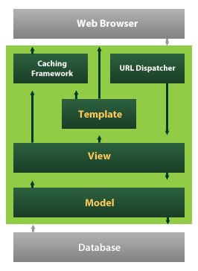

Fig 5.3.2.1 Django working 1

Django also provides an optional administrative [create, read, update and delete](https://en.wikipedia.org/wiki/Create,_read,_update_and_delete) interface that is generated dynamically through [introspection](https://en.wikipedia.org/wiki/Introspection_(computer_science)) and configured via admin models

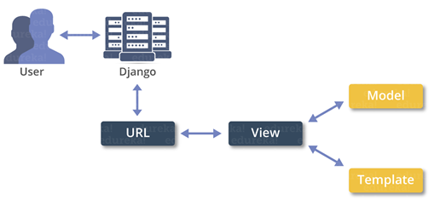

Fig 5.3.2.2 Django working 2

Despite having its own nomenclature, such as naming the callable objects generating the [HTTP](https://en.wikipedia.org/wiki/HTTP) responses "views", the core Django framework can be seen as an [MVC](https://en.wikipedia.org/wiki/Model-view-controller) architecture. It consists of an [object-relational mapper](https://en.wikipedia.org/wiki/Object-relational_mapping) (ORM) that mediates between [data models](https://en.wikipedia.org/wiki/Data_modeling)(defined as Python classes) and a [relational database](https://en.wikipedia.org/wiki/Relational_database) ("**M**odel"), a system for processing HTTP requests with a [web templating system](https://en.wikipedia.org/wiki/Web_template_system)("**V**iew"), and a [regular-expression](https://en.wikipedia.org/wiki/Regular_expression)-based [URL](https://en.wikipedia.org/wiki/Uniform_Resource_Locator) dispatcher ("**C**ontroller").

Also included in the core framework are:

* a lightweight and standalone web server for development and testing
* a form serialization and validation system that can translate between [HTML](https://en.wikipedia.org/wiki/HTML) forms and values suitable for storage in the database
* a template system that utilizes the concept of [inheritance](https://en.wikipedia.org/wiki/Inheritance_(object-oriented_programming)) borrowed from object-oriented programming
* a [caching](https://en.wikipedia.org/wiki/Web_cache) framework that can use any of several cache methods
* support for [middleware](https://en.wikipedia.org/wiki/Middleware) classes that can intervene at various stages of request processing and carry out custom functions
* an internal dispatcher system that allows components of an application to communicate events to each other via pre-defined signals
* an [internationalization](https://en.wikipedia.org/wiki/Internationalization_and_localization) system, including translations of Django's own components into a variety of languages
* a [serialization](https://en.wikipedia.org/wiki/Serialization) system that can produce and read [XML](https://en.wikipedia.org/wiki/XML) and/or [JSON](https://en.wikipedia.org/wiki/JSON) representations of Django model instances
* a system for extending the capabilities of the template engine
* an interface to Python's built-in [unit test](https://en.wikipedia.org/wiki/Unit_test) framework

Django's configuration system allows third party code to be plugged into a regular project, provided that it follows the reusable app conventions. More than 2500 packages are available to extend the framework's original behaviour, providing solutions to issues the original tool didn't tackle: registration, search, [API](https://en.wikipedia.org/wiki/Application_Programming_Interface) provision and consumption, [CMS](https://en.wikipedia.org/wiki/Content_Management_System), etc.

This extensibility is, however, mitigated by internal components dependencies. While the Django philosophy implies loose coupling, the template filters and tags assume one engine implementation, and both the auth and admin bundled applications require the use of the internal [ORM](https://en.wikipedia.org/wiki/Object-relational_mapping). None of these filters or bundled apps are mandatory to run a Django project, but reusable apps tend to depend on them, encouraging developers to keep using the official stack in order to benefit fully from the apps ecosystem

Django can be run in conjunction with [Apache](https://en.wikipedia.org/wiki/Apache_HTTP_Server), [Nginx](https://en.wikipedia.org/wiki/Nginx) using [WSGI](https://en.wikipedia.org/wiki/Web_Server_Gateway_Interface), [Gunicorn](https://en.wikipedia.org/wiki/Gunicorn" \o "Gunicorn), or [Cherokee](https://en.wikipedia.org/wiki/Cherokee_(Webserver)) using flup (a Python module). Django also includes the ability to launch a [FastCGI](https://en.wikipedia.org/wiki/FastCGI" \o "FastCGI)server, enabling use behind any web server which supports FastCGI, such as [Lighttpd](https://en.wikipedia.org/wiki/Lighttpd" \o "Lighttpd) or [Hiawatha](https://en.wikipedia.org/wiki/Hiawatha_(web_server)). It is also possible to use other [WSGI](https://en.wikipedia.org/wiki/Web_Server_Gateway_Interface)-compliant web servers. Django officially supports four database backends: [PostgreSQL](https://en.wikipedia.org/wiki/PostgreSQL), [MySQL](https://en.wikipedia.org/wiki/MySQL), [SQLite](https://en.wikipedia.org/wiki/SQLite), and [Oracle](https://en.wikipedia.org/wiki/Oracle_Database). [Microsoft SQL Server](https://en.wikipedia.org/wiki/Microsoft_SQL_Server) can be used with django-mysql on [Microsoft](https://en.wikipedia.org/wiki/Microsoft) [operating systems](https://en.wikipedia.org/wiki/Operating_systems), while similarly external backends exist for [IBM Db2](https://en.wikipedia.org/wiki/IBM_Db2), [SQL Anywhere](https://en.wikipedia.org/wiki/SQL_Anywhere) and [Firebird](https://en.wikipedia.org/wiki/Firebird_(database_server)). There is a [fork](https://en.wikipedia.org/wiki/Fork_(software_development)) named django-nonrel, which supports [NoSQL](https://en.wikipedia.org/wiki/NoSQL_(concept)) databases, such as [MongoDB](https://en.wikipedia.org/wiki/MongoDB) and [Google App Engine](https://en.wikipedia.org/wiki/Google_App_Engine)'s Datastore.

Django may also be run in conjunction with [Jython](https://en.wikipedia.org/wiki/Jython" \o "Jython) on any [Java EE](https://en.wikipedia.org/wiki/Java_EE) application server such as [GlassFish](https://en.wikipedia.org/wiki/GlassFish" \o "GlassFish) or [JBoss](https://en.wikipedia.org/wiki/JBoss). In this case django-jython must be installed in order to provide [JDBC](https://en.wikipedia.org/wiki/JDBC) drivers for database connectivity, which also can provide functionality to compile Django in to a .war suitable for deployment.

[Google App Engine](https://en.wikipedia.org/wiki/Google_App_Engine) includes support for Django version 1.x.x as one of the bundled frameworks.

For developing a Django project, no special tools are necessary, since the source code can be edited with any conventional [text editor](https://en.wikipedia.org/wiki/Text_editor). Nevertheless, editors specialized on [computer programming](https://en.wikipedia.org/wiki/Computer_programming) can help increase the productivity of development, e.g., with features such as [syntax highlighting](https://en.wikipedia.org/wiki/Syntax_highlighting). Since Django is written in Python, text editors which are aware of Python syntax are beneficial in this regard.

[Integrated development environments](https://en.wikipedia.org/wiki/Integrated_development_environment) (IDE) add further functionality, such as [debugging](https://en.wikipedia.org/wiki/Debugging), [refactoring](https://en.wikipedia.org/wiki/Code_refactoring), and [unit testing](https://en.wikipedia.org/wiki/Unit_testing). As with plain editors, IDEs with support for Python can be beneficial. Some IDEs that are specialized on Python additionally have integrated support for Django projects, so that using such an IDE when developing a Django project can help further increase productivity.

Django is a free and open source Python web framework that helps to develop maintainable and secured websites rapidly. It deals with the difficulties of web development, so you can completely focus on building your application. The Django project's performance, community, and stability have grown excessively over the past decade.

Django is compatible with all the projects irrespective of its size, whether it is small or big one. Because of its scalability, it is ideal for startups and also serves extraordinary for sites with hundreds of users a moment, like or Discus.

Some of the popular websites functioned by Django web framework are Pinterest, Instagram, Mozilla Support, Reddit Gifts, Coordinato, Chess etc.

**5.3.3 SQLite**

SQLite is an in-process library that implements a [self-contained](https://www.sqlite.org/selfcontained.html), [serverless](https://www.sqlite.org/serverless.html), [zero-configuration](https://www.sqlite.org/zeroconf.html), [transactional](https://www.sqlite.org/transactional.html) SQL database engine. The code for SQLite is in the [public domain](https://www.sqlite.org/copyright.html) and is thus free for use for any purpose, commercial or private. SQLite is the [most widely deployed](https://www.sqlite.org/mostdeployed.html) database in the world with more applications than we can count, including several [high-profile projects.](https://www.sqlite.org/famous.html)

SQLite is an embedded SQL database engine. Unlike most other SQL databases, SQLite does not have a separate server process. SQLite reads and writes directly to ordinary disk files. A complete SQL database with multiple tables, indices, triggers, and views, is contained in a single disk file. The database [file format](https://www.sqlite.org/fileformat2.html) is cross-platform - you can freely copy a database between 32-bit and 64-bit systems or between [big-endian](http://en.wikipedia.org/wiki/Endianness) and [little-endian](http://en.wikipedia.org/wiki/Endianness) architectures. These features make SQLite a popular choice as an [Application File Format](https://www.sqlite.org/appfileformat.html). SQLite database files are a [recommended storage format](https://www.sqlite.org/locrsf.html) by the US Library of Congress. Think of SQLite not as a replacement for [Oracle](http://www.oracle.com/database/index.html) but as a replacement for [fopen()](http://man.he.net/man3/fopen)

SQLite is a compact library. With all features enabled, the [library size](https://www.sqlite.org/footprint.html) can be less than 600KiB, depending on the target platform and compiler optimization settings. (64-bit code is larger. And some compiler optimizations such as aggressive function inlining and loop unrolling can cause the object code to be much larger.) There is a trade-off between memory usage and speed. SQLite generally runs faster the more memory you give it. Nevertheless, performance is usually quite good even in low-memory environments. Depending on how it is used, SQLite can be faster.

SQLite is [very carefully tested](https://www.sqlite.org/testing.html) prior to every release and has a reputation for being very reliable. Most of the SQLite source code is devoted purely to testing and verification. An automated test suite runs millions and millions of test cases involving hundreds of millions of individual SQL statements and achieves [100% branch test coverage](https://www.sqlite.org/testing.html#coverage). SQLite responds gracefully to memory allocation failures and disk I/O errors. Transactions are [ACID](http://en.wikipedia.org/wiki/ACID) even if interrupted by system crashes or power failures. All of this is verified by the automated tests using special test harnesses which simulate system failures. Of course, even with all this testing, there are still bugs. But unlike some similar projects (especially commercial competitors) SQLite is open and honest about all bugs and provides [bugs lists](http://www.sqlite.org/src/rptview?rn=1) and minute-by-minute [chronologies](http://www.sqlite.org/src/timeline) of code changes.

The SQLite code base is supported by an [international team](https://www.sqlite.org/crew.html) of developers who work on SQLite full-time. The developers continue to expand the capabilities of SQLite and enhance its reliability and performance while maintaining backwards compatibility with the [published interface spec](https://www.sqlite.org/c3ref/intro.html), [SQL syntax](https://www.sqlite.org/lang.html), and database [file format](https://www.sqlite.org/fileformat2.html). The source code is absolutely free to anybody who wants it, but [professional support](https://www.sqlite.org/prosupport.html) is also available.

The SQLite project was started on [2000-05-09](https://www.sqlite.org/src/timeline?c=2000-05-29+14:26:00). The future is always hard to predict, but the intent of the developers is to support SQLite through the year 2050. Design decisions are made with that objective in mind.

We the developers hope that you find SQLite useful and we entreat you to use it well: to make good and beautiful products that are fast, reliable, and simple to use. Seek forgiveness for yourself as you forgive others. And just as you have received SQLite for free, so also freely give, paying the debt forward.

# **Features Of SQLite**

* [Transactions](https://www.sqlite.org/transactional.html) are atomic, consistent, isolated, and durable (ACID) even after system crashes and power failures.
* [Zero-configuration](https://www.sqlite.org/zeroconf.html) - no setup or administration needed.
* [Full-featured SQL](https://www.sqlite.org/fullsql.html) implementation with advanced capabilities like [partial indexes](https://www.sqlite.org/partialindex.html), [indexes on expressions](https://www.sqlite.org/expridx.html), [JSON](https://www.sqlite.org/json1.html), [common table expressions](https://www.sqlite.org/lang_with.html), and [window functions](https://www.sqlite.org/windowfunctions.html). ([Omitted features](https://www.sqlite.org/omitted.html))
* A complete database is stored in a [single cross-platform disk file](https://www.sqlite.org/onefile.html). Great for use as an [application file format](https://www.sqlite.org/appfileformat.html).
* Supports terabyte-sized databases and gigabyte-sized strings and blobs. (See [limits.html](https://www.sqlite.org/limits.html).)
* Small code [footprint](https://www.sqlite.org/footprint.html): less than 600KiB fully configured or much less with optional features omitted.
* Simple, easy to use [API](https://www.sqlite.org/cintro.html).
* Fast: In some cases, SQLite is [faster than direct filesystem I/O](https://www.sqlite.org/fasterthanfs.html)
* Written in ANSI-C. [TCL bindings](https://www.sqlite.org/tclsqlite.html) included. Bindings for dozens of other languages available separately.
* Well-commented source code with [100% branch test coverage](https://www.sqlite.org/testing.html#coverage).
* Available as a [single ANSI-C source-code file](https://www.sqlite.org/amalgamation.html) that is [easy to compile](https://www.sqlite.org/howtocompile.html) and hence is easy to add into a larger project.
* [Self-contained](https://www.sqlite.org/selfcontained.html): no external dependencies.
* Cross-platform: Android, *BSD, iOS, Linux, Mac, Solaris, VxWorks, and Windows (Win32, WinCE, WinRT) are supported out of the box. Easy to port to other systems.
* Sources are in the [public domain](https://www.sqlite.org/copyright.html). Use for any purpose.
* Comes with a standalone [command-line interface](https://www.sqlite.org/cli.html) (CLI) client that can be used to administer SQLite databases.

## Suggested Uses For SQLite:

* **Database For The Internet Of Things.** SQLite is popular choice for the database engine in cell phones, PDAs, MP3 players, set-top boxes, and other electronic gadgets. SQLite has a small code footprint, makes efficient use of memory, disk space, and disk bandwidth, is highly reliable, and requires no maintenance from a Database Administrator.
* **Application File Format.** Rather than using fopen() to write XML, JSON, CSV, or some proprietary format into disk files used by your application, use an SQLite database. You'll avoid having to write and troubleshoot a parser, your data will be more easily accessible and cross-platform, and your updates will be transactional. **Website Database.** Because it requires no configuration and stores information in ordinary disk files, SQLite is a popular choice as the database to back small to medium-sized websites.
* **Stand-in For An Enterprise RDBMS.** SQLite is often used as a surrogate for an enterprise RDBMS for demonstration purposes or for testing. SQLite is fast and requires no setup, which takes a lot of the hassle out of testing and which makes demos perky and easy to launch.

**Dr.E.F.Codd’s Rules**

These rules are used for valuating a product to be called as relational database management systems. Out of 12 rules, a RDBMS product should satisfy at least 8 rules + rule called rule 0 that must be satisfied.

**RULE 0: Foundation Rule**

For any system to be advertised as, or claimed to be relational DBMS should manage database with in it self, with out using an external language.

**RULE 1: Information Rule**

All information in relational database is represented at logical level in only one way as values in tables.

**RULE 2: Guaranteed Access**

Each and every data in a relational database is guaranteed to be logically accessibility by using to a combination of table name, primary key value and column name.

**RULE 3: Systematic Treatment of Null Values**

Null values are supported for representing missing information and inapplicable information. They must be handled in systematic way, independent of data types.

**RULE 4: Dynamic Online Catalog based Relation Model**

The database description is represented at the logical level in the same way as ordinary data so that authorized users can apply the same relational language to its interrogation as they do to the regular data.

**RULE 5: Comprehensive Data Sub Language**

A relational system may support several languages and various models of terminal use. However there must be one language whose statement can express all of the following:

Data Definitions, View Definitions, Data Manipulations, Integrity, Constraints, Authorization and transaction boundaries.

**RULE 6: View Updating**

Any view that is theoretical can be updatable if changes can be made to the tables that effect the desired changes in the view.

**RULE 7: High level Update, Insert and Delete**

The capability of handling a base relational or derived relational as a single operand applies not only retrieval of data also to its insertion, updating, and deletion.

**RULE 8: Physical Data Independence**

Application program and terminal activities remain logically unimpaired whenever any changes are made in either storage representation or access method.

**RULE 9: Logical Data Independence**

Application programs and terminal activities remain logically unimpaired whenever any changes are made in either storage representation or access methods.

**RULE 10: Integrity Independence**

Integrity constraints specific to particular database must be definable in the relational data stored in the catalog, not in application program.

**RULE 11: Distributed Independence**

Whether or not a system supports database distribution, it must have a data sub-language that can support distributed databases without changing the application program.

**RULE 12: Non Sub-Version**

If a relational system has low level language, that low language cannot use to subversion or by pass the integrity rules and constraints expressed in the higher level relational language.

**5.3.4 HTML**

Hypertext Markup Language(HTML), the languages of the world wide web(WWW), allows users to produces web pages that included text, graphics and pointer to other web pages (Hyperlinks).

HTML is not a programming language but it is an application of ISO Standard 8879,SGML(Standard Generalized Markup Language),but

Specialized to hypertext and adapted to the Web. The idea behind Hypertext one point to another point. We can navigate through the information based on out interest and preference. A markup language is simply a series of items enclosed within the elements should be displayed.

Hyperlinks are underlined or emphasized works that load to other documents or some portions of the same document.

Html can be used to display any type of document on the host computer, which can be geographically at a different location. It is a versatile language and can be used on any platform or desktop.HTML provides tags(special codes) to make the document look attractive.

HTML provides are not case-sensitive. Using graphics ,fonts ,different sizes, color, etc.. can enhance the presentation of the document. Anything

That is not a tag is part of the document it self.

**Basic Html Tags**:

<!-- --> Specific Comments.

<A>………</A> Creates Hypertext links.

<B>………</B> makes text bold

<Big>……..</Big> Formats text in large-font

<Body>…….</Body> contains all tags and text in the Html-document

<Center>……</Center> align center

<DD>………..</DD> Definition of a term.

<TABLE>……</TABLE> creates table

<Td>………..</Td> indicates table data in a table.

<Tr>………..</Tr> designates a table row

<Th>……….</Th> creates a heading in a table.

##### **Advantages:-**

* + A HTML document is small and hence easy to send over the net .It is small because it does not include formatted information.
  + HTML is platform independent
  + HTML tags are not case-sensitive.

**5.3.5 JAVA SCRIPT**

JavaScript is a compact , object-based scripting language for developing client and server internet applications. Netscape Navigator 2.0 interprets JavaScript statements embedded directly in an HTML page. and Livewire enables you to create server-based applications similar to common gateway interface(cgi) programs.

In a client application for Navigator, JavaScript statements embedded in an HTML Page can recognize and respond to user events such as mouse clicks form

Input, and page navigation.

For example, you can write a JavaScript function to verify that users enter valid information into a form requesting a telephone number or zip code . Without any network transmission, an Html page with embedded Java Script can interpret the entered text and alert the user with a message dialog if the input is invalid or you can use JavaScript to perform an action (such as play an audio file, execute an applet, or communicate with a plug-in) in response to the user opening or exiting a page.

**5.3.6 PyCharm**

PyCharm is an [integrated development environment](https://en.wikipedia.org/wiki/Integrated_development_environment) (IDE) used in [computer programming](https://en.wikipedia.org/wiki/Computer_programming), specifically for the [Python](https://en.wikipedia.org/wiki/Python_(programming_language)) language. It is developed by the Czech company [JetBrains](https://en.wikipedia.org/wiki/JetBrains).[[2]](https://en.wikipedia.org/wiki/PyCharm#cite_note-2) It provides code analysis, a graphical debugger, an integrated unit tester, integration with [version control systems](https://en.wikipedia.org/wiki/Revision_control) (VCSes), and supports web development with [Django](https://en.wikipedia.org/wiki/Django_(web_framework)).

PyCharm is [cross-platform](https://en.wikipedia.org/wiki/Cross-platform), with [Windows](https://en.wikipedia.org/wiki/Windows), [macOS](https://en.wikipedia.org/wiki/MacOS) and [Linux](https://en.wikipedia.org/wiki/Linux) versions. The Community Edition is released under the [Apache License](https://en.wikipedia.org/wiki/Apache_License),[[3]](https://en.wikipedia.org/wiki/PyCharm#cite_note-community-3) and there is also Professional Edition with extra features, released under a [proprietary license](https://en.wikipedia.org/wiki/Proprietary_software).

**Features**

* Coding assistance and [analysis](https://en.wikipedia.org/wiki/Code_analysis), with [code completion](https://en.wikipedia.org/wiki/Autocomplete), syntax and error highlighting, linter integration, and quick fixes
* Project and code navigation: specialized project views, file structure views and quick jumping between files, classes, methods and usages
* Python [refactoring](https://en.wikipedia.org/wiki/Refactoring): including rename, extract method, introduce variable, introduce constant, pull up, push down and others
* Support for web frameworks: [Django](https://en.wikipedia.org/wiki/Django_(web_framework)), [web2py](https://en.wikipedia.org/wiki/Web2py) and [Flask](https://en.wikipedia.org/wiki/Flask_(web_framework))
* Integrated Python [debugger](https://en.wikipedia.org/wiki/Debugger)
* Integrated [unit testing](https://en.wikipedia.org/wiki/Unit_testing), with line-by-line [code coverage](https://en.wikipedia.org/wiki/Code_coverage)
* [Google App Engine](https://en.wikipedia.org/wiki/Google_App_Engine) Python development
* Version control integration: unified user interface for  [Mercurial](https://en.wikipedia.org/wiki/Mercurial), [Git](https://en.wikipedia.org/wiki/Git_(software)), [Subversion](https://en.wikipedia.org/wiki/Apache_Subversion), [Perforce](https://en.wikipedia.org/wiki/Perforce) and [CVS](https://en.wikipedia.org/wiki/Concurrent_Versions_System) with change lists and merge

It competes mainly with a number of other Python-oriented IDEs, including [Eclipse](https://en.wikipedia.org/wiki/Eclipse_(software))'s [PyDev](https://en.wikipedia.org/wiki/PyDev" \o "PyDev), and the more broadly focused [Komodo IDE](https://en.wikipedia.org/wiki/Komodo_IDE).

**Intelligent Coding Assistance**

PyCharm provides smart code completion, code inspections, on-the-fly error highlighting and quick-fixes, along with automated code refactoring’s and rich navigation capabilities.

**Smart Code Navigation**

Use smart search to jump to any class, file or symbol, or even any IDE action or tool window. It only takes one click to switch to the declaration, super method, test, usages, implementation, and more.

**Fast and Safe Refactoring’s**

Refactor your code the intelligent way, with safe Rename and Delete, Extract Method, Introduce Variable, Inline Variable or Method, and other refactoring’s. Language and framework-specific refactoring’s help you perform project-wide changes.

## Built-in Developer Tools

PyCharm’s huge collection of tools out of the box includes an integrated debugger and test runner; Python profiler; a built-in terminal; integration with major VCS and built-in database tools; remote development capabilities with remote interpreters; an integrated ssh terminal; and integration with Docker and Vagrant.

## Web Development

In addition to Python, PyCharm provides first-class support for various Python web development frameworks, specific template languages, JavaScript, CoffeeScript, TypeScript, HTML/CSS, AngularJS, Node.js, and more.

## Scientific Tools

PyCharm integrates with IPython Notebook, has an interactive Python console, and supports Anaconda as well as multiple scientific packages including Matplotlib and NumPy.

## Customizable and Cross-platform IDE

Use PyCharm on Windows, Mac OS and Linux with a single license key. Enjoy a fine-tuned workspace with customizable color schemes and key-bindings, with VIM emulation available.

**6.SYSTEM DESIGN**

**6.1 Introduction**

Systems design is the process or art of defining the architecture, components, modules, interfaces, and data for a system to satisfy specified requirements. One could see it as the application of systems theory to product development. There is some overlap and synergy with the disciplines of systems analysis, systems architecture and systems engineering.

**6.2 Data Flow Diagram:**

* The DFD is also called as bubble chart. It is a simple graphical formalism that can be used to represent a system in terms of input data to the system, various processing carried out on this data, and the output data is generated by this system.
* The data flow diagram (DFD) is one of the most important modeling tools. It is used to model the system components. These components are the system process, the data used by the process, an external entity that interacts with the system and the information flows in the system.
* DFD shows how the information moves through the system and how it is modified by a series of transformations. It is a graphical technique that depicts information flow and the transformations that are applied as data moves from input to output.
* DFD is also known as bubble chart. A DFD may be used to represent a system at any level of abstraction. DFD may be partitioned into levels that represent increasing information flow and functional detail.

**Context level :**

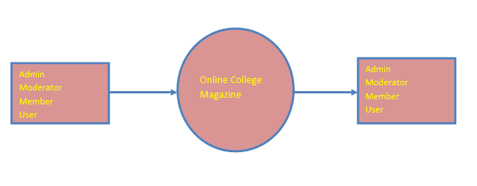

Fig 6.2.1 DFD Content Level

**Level 0:**

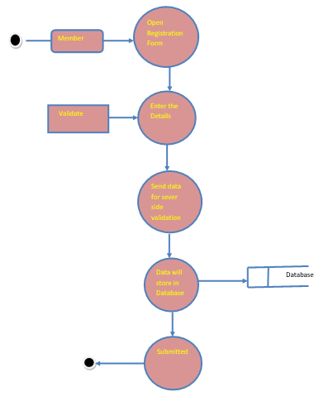

Fig 6.2.2 DFD Level 0

**Level 1:**

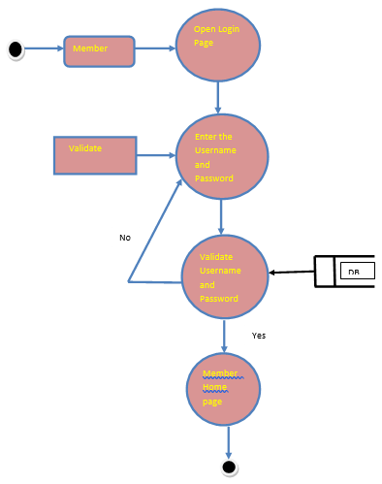

Fig 6.2.3 DFD Level 1

**Level 2:**

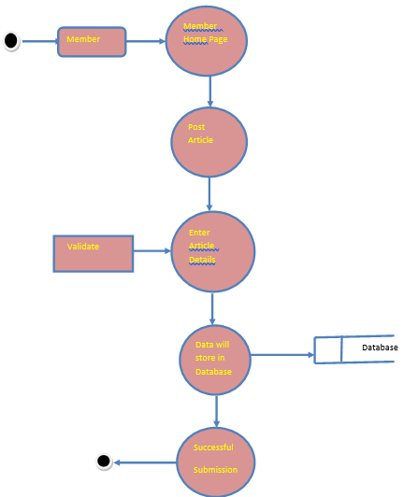

Fig 6.2.4 DFD Level 2

**6.3 UML Diagrams**

**Unified Modeling Language:**

The Unified Modeling Language allows the software engineer to express an analysis model using the modeling notation that is governed by a set of syntactic semantic and pragmatic rules.

A UML system is represented using five different views that describe the system from distinctly different perspective. Each view is defined by a set of diagram, which is as follows.

* + User Model View
    1. This view represents the system from the users perspective.
    2. The analysis representation describes a usage scenario from the end-users perspective.
  + Structural model view
    1. In this model the data and functionality are arrived from inside the system.
    2. This model view models the static structures.
* Behavioral Model View

It represents the dynamic of behavioral as parts of the system, depicting the interactions of collection between various structural elements described in the user model and structural model view.

* Implementation Model View

In this the structural and behavioral as parts of the system are represented as they are to be built.

* Environmental Model View

In this the structural and behavioral aspects of the environment in which the system is to be implemented are represented.

UML is specifically constructed through two different domains they are:

* UML Analysis modeling, this focuses on the user model and structural model views of the system.
* UML design modeling, which focuses on the behavioral modeling, implementation modeling and environmental model views.

**6.3.1 Use Case diagram**

A use case diagram in the Unified Modeling Language (UML) is a type of behavioral diagram defined by and created from a Use-case analysis. Its purpose is to present a graphical overview of the functionality provided by a system in terms of actors, their goals (represented as use cases), and any dependencies between those use cases. The main purpose of a use case diagram is to show what system functions are performed for which actor. Roles of the actors in the system can be depicted.

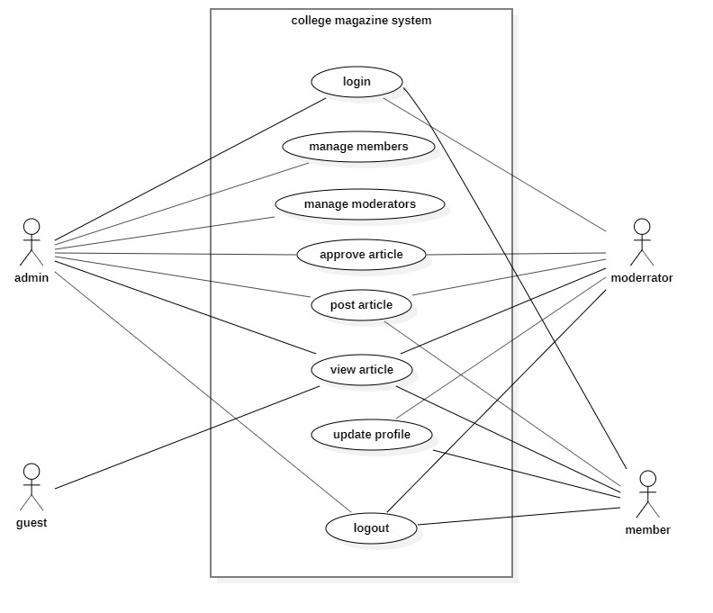

Fig 6.3.1 usecase diagram

**6.3.2 Class Diagram**

In software engineering, a class diagram in the Unified Modeling Language (UML) is a type of static structure diagram that describes the structure of a system by showing the system's classes, their attributes, operations (or methods), and the relationships among the classes. It explains which class contains information.

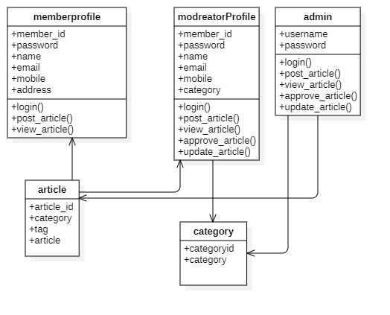

Fig 6.3.2 Class Diagram

**6.3.3 Sequence Diagram**

A sequence diagram in Unified Modeling Language (UML) is a kind of interaction diagram that shows how processes operate with one another and in what order. It is a construct of a Message Sequence Chart. Sequence diagrams are sometimes called event diagrams, event scenarios, and timing diagrams.

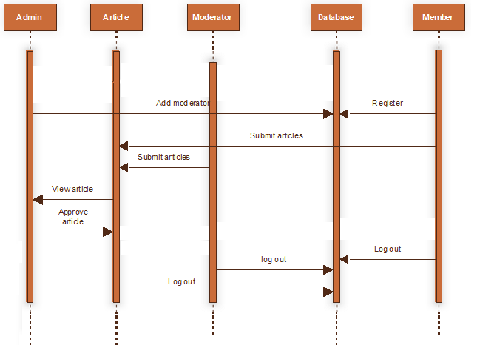

Fig 6.3.3 Sequence Diagram

**6.3.4 Activity Diagram:**

Activity diagrams are graphical representations of workflows of stepwise activities and actions with support for choice, iteration and concurrency. In the Unified Modeling Language, activity diagrams can be used to describe the business and operational step-by-step workflows of components in a system. An activity diagram shows the overall flow of control.

**Activity for member:**

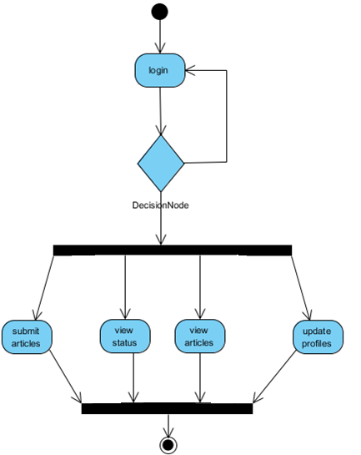

Fig 6.3.4.1 Member Activity Diagram

**Activity for moderator:**

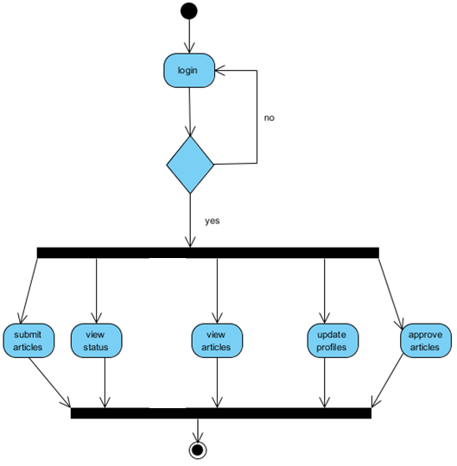

Fig 6.3.4.2 Moderator Activity Diagram

**Activity for admin:**

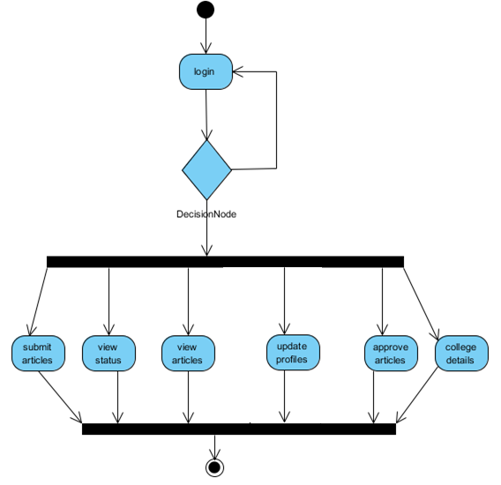

Fig 6.3.4.3 Admin Activity Diagram

**6.4 ER-Diagram**

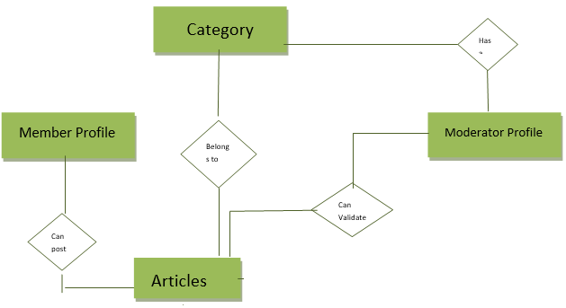

Fig 6.4 E-R Diagram

**6.5 Normalization**

A Database is a collection of interrelated data stored with a minimum of redundancy to serve many applications. The database design is used to group data into a number of tables and minimizes the artificiality embedded in using separate files. The tables are organized to:

* Reduced duplication of data.
* Simplify functions like adding, deleting, modifying data etc..,
* Retrieving data
* Clarity and ease of use
* More information at low cost

# **Normal Forms**

Normalization is built around the concept of normal forms. A relation is said to be in a particular normal form if it satisfies a certain specified set of constraints on the kind of functional dependencies that could be associated with the relation. The normal forms are used to ensure that various types of anomalies and inconsistencies are not introduced into the database.

**First Normal Form:**

A relation R is in first normal form if and only if all underlying domains contained atomic values only.

**Second Normal Form:**

A relation R is said to be in second normal form if and only if it is in first normal form and every non-key attribute is fully dependent on the primary key.

**Third Normal Form:**

A relation R is said to be in third normal form if and only if it is in second normal form and every non key attribute is non transitively depend on the primary key.

**7.IMPLEMENTAION CODING**

**7.1 Guest**

<!DOCTYPE html>

<html lang="en">

<head>

<meta charset="UTF-8">

<title>Guest</title>

<meta name="viewport" content="width=device-width, initial-scale=1">

<link rel="stylesheet" href="https://maxcdn.bootstrapcdn.com/bootstrap/4.3.1/css/bootstrap.min.css">

<script src="https://ajax.googleapis.com/ajax/libs/jquery/3.4.1/jquery.min.js"></script>

<script src="https://cdnjs.cloudflare.com/ajax/libs/popper.js/1.14.7/umd/popper.min.js"></script>

<script src="https://maxcdn.bootstrapcdn.com/bootstrap/4.3.1/js/bootstrap.min.js"></script>

</head>

<body style="background-color: #99ccff;">

{% include 'logo.html' %}

{% include 'menu.html' %}

<div class="table-responsive rounded">

<center><h1>GUEST</h1></center>

<table border="1" class="table table-dark table-bordered table-striped table-hover ">

<tr>

<th>Article ID</th>

<th>Category</th>

<th>Tag</th>

<th>Article</th>

</tr>

{% for x in object_list %}

<tr>

<td> {{ x.articleid }}</td>

<td> {{ x.category }}</td>

<td> {{ x.tag }}</td>

<td> {{ x.article }}</td>

</tr>

{% endfor %}

</table>

</div>

</body>

</html>

**7.2 Admin login**

<!DOCTYPE html>

<html lang="en">

<head>

<meta charset="UTF-8">

<title>Admin Login</title>

<meta name="viewport" content="width=device-width, initial-scale=1">

<link rel="stylesheet" href="https://maxcdn.bootstrapcdn.com/bootstrap/4.3.1/css/bootstrap.min.css">

<script src="https://ajax.googleapis.com/ajax/libs/jquery/3.4.1/jquery.min.js"></script>

<script src="https://cdnjs.cloudflare.com/ajax/libs/popper.js/1.14.7/umd/popper.min.js"></script>

<script src="https://maxcdn.bootstrapcdn.com/bootstrap/4.3.1/js/bootstrap.min.js"></script>

</head>

<body style="background-color: #99ccff;">

{% include 'logo.html' %}

{% include 'menu.html' %}

<form action="/admincheck/" method="post" class="m-2 ">

{% csrf_token %}

<div class="container card p-3">

<h2>Admin Login</h2>

<label>Username</label>

<input type="text" placeholder="USERNAME" name="uname" required class=" form-group form-control " >

<label>Password</label>

<input type="password" placeholder="PASSWORD" name="upass" required class=" form-group form-control" >

<button type="submit" class="btn btn-primary"> Login </button>

</form>

</div>

<center>

{% if msg %}

<font class="alert alert-danger">

{{ msg }}

</font>

{% endif %}

</center>

</body>

</html>

**7.3 Moderator Login**

<!DOCTYPE html>

<html lang="en">

<head>

<meta charset="UTF-8">

<title>Admin Login</title>

<meta name="viewport" content="width=device-width, initial-scale=1">

<link rel="stylesheet" href="https://maxcdn.bootstrapcdn.com/bootstrap/4.3.1/css/bootstrap.min.css">

<script src="https://ajax.googleapis.com/ajax/libs/jquery/3.4.1/jquery.min.js"></script>

<script src="https://cdnjs.cloudflare.com/ajax/libs/popper.js/1.14.7/umd/popper.min.js"></script>

<script src="https://maxcdn.bootstrapcdn.com/bootstrap/4.3.1/js/bootstrap.min.js"></script>

</head>

<body style="background-color: #99ccff;">

{% include 'logo.html' %}

{% include 'menu.html' %}

<form action="/moderatorlogin/" method="post" class="m-2 ">

{% csrf_token %}

<div class="container card p-3">

<h2> Moderator Login</h2>

<label>User ID</label>

<input type="number" placeholder="USERID" name="userid" required class=" form-group form-control ">

<label>Password</label>

<input type="password" placeholder="PASSWORD" name="password" required class=" form-group form-control">

<button type="submit" class="btn btn-primary"> Login </button>

</div>

</form>

</body>

</html>

**7.4 Member Registration**

<!DOCTYPE html>

<html lang="en">

<head>

<meta charset="UTF-8">

<title>Member registration</title>

<meta name="viewport" content="width=device-width, initial-scale=1">

<link rel="stylesheet" href="https://maxcdn.bootstrapcdn.com/bootstrap/4.3.1/css/bootstrap.min.css">

<script src="https://ajax.googleapis.com/ajax/libs/jquery/3.4.1/jquery.min.js"></script>

<script src="https://cdnjs.cloudflare.com/ajax/libs/popper.js/1.14.7/umd/popper.min.js"></script>

<script src="https://maxcdn.bootstrapcdn.com/bootstrap/4.3.1/js/bootstrap.min.js"></script>

</head>

<body style="background-color: #99ccff;" >

{% include 'logo.html' %}

{% include 'menu.html' %}

<br> <br>

<form method="post">

{% csrf_token %}

<div class="table-responsive rounded container">

<h2>Registration</h2>

<table border="1" class="table table-dark table-bordered table-striped table-hover ">

<tr><td>Member Name:</td><td> {{ form.member_name }}</td></tr>

<tr><td>Member ID:</td><td> {{ form.member_id}}</td></tr>

<tr><td>Password:</td><td><input type="password" name="password"> </td></tr>

<tr><td>Email ID:</td><td> {{ form.email_id}}</td></tr>

<tr><td>Address:</td><td> {{ form.address}}</td></tr>

<tr><td>Mobile num: </td><td>{{ form.mobile_num}}</td></tr>

<tr> <td><input type="submit" value="register" class="btn btn-primary"></td></tr>

</table>

</div>

</form>

</body>

</html>

**8.SYSTEM TEST**

**8.1 Introduction**

The purpose of testing is to discover errors. Testing is the process of trying to discover every conceivable fault or weakness in a work product. It provides a way to check the functionality of components, sub assemblies, assemblies and/or a finished product It is the process of exercising software with the intent of ensuring that the Software system meets its requirements and user expectations and does not fail in an unacceptable manner. There are various types of test. Each test type addresses a specific testing requirement.

### TYPES OF TESTS

**Unit testing**

Unit testing involves the design of test cases that validate that the internal program logic is functioning properly, and that program inputs produce valid outputs. All decision branches and internal code flow should be validated. It is the testing of individual software units of the application .it is done after the completion of an individual unit before integration. This is a structural testing, that relies on knowledge of its construction and is invasive. Unit tests perform basic tests at component level and test a specific business process, application, and/or system configuration. Unit tests ensure that each unique path of a business process performs accurately to the documented specifications and contains clearly defined inputs and expected results.

**Integration Testing**

Integration tests are designed to test integrated software components to determine if they actually run as one program. Testing is event driven and is more concerned with the basic outcome of screens or fields. Integration tests demonstrate that although the components were individually satisfaction, as shown by successfully unit testing, the combination of components is correct and consistent. Integration testing is specifically aimed at exposing the problems that arise from the combination of components.

**Functional test**

Functional tests provide systematic demonstrations that functions tested are available as specified by the business and technical requirements, system documentation, and user manuals.

Functional testing is centered on the following items:

Valid Input : identified classes of valid input must be accepted.

Invalid Input : identified classes of invalid input must be rejected.

Functions : identified functions must be exercised.

Output : identified classes of application outputs must be exercised.

Systems/Procedures : interfacing systems or procedures must be invoked.

Organization and preparation of functional tests is focused on requirements, key functions, or special test cases. In addition, systematic coverage pertaining to identify Business process flows; data fields, predefined processes, and successive processes must be considered for testing. Before functional testing is complete, additional tests are identified and the effective value of current tests is determined.

**System Test**

System testing ensures that the entire integrated software system meets requirements. It tests a configuration to ensure known and predictable results. An example of system testing is the configuration oriented system integration test. System testing is based on process descriptions and flows, emphasizing pre-driven process links and integration points.

**White Box Testing**

White Box Testing is a testing in which in which the software tester has knowledge of the inner workings, structure and language of the software, or at least its purpose. It is purpose. It is used to test areas that cannot be reached from a black box level.

**Black Box Testing**

Black Box Testing is testing the software without any knowledge of the inner workings, structure or language of the module being tested. Black box tests, as most other kinds of tests, must be written from a definitive source document, such as specification or requirements document, such as specification or requirements document. It is a testing in which the software under test is treated, as a black box .you cannot “see” into it. The test provides inputs and responds to outputs without considering how the software works.

**Unit Testing**

Unit testing is usually conducted as part of a combined code and unit test phase of the software lifecycle, although it is not uncommon for coding and unit testing to be conducted as two distinct phases.

**8.2 Test strategy and approach**

Field testing will be performed manually and functional tests will be written in detail.

**Test objectives**

* All field entries must work properly.
* Pages must be activated from the identified link.
* The entry screen, messages and responses must not be delayed.

**Features to be tested**

* Verify that the entries are of the correct format
* No duplicate entries should be allowed
* All links should take the user to the correct page.

# **Integration Testing**

Software integration testing is the incremental integration testing of two or more integrated software components on a single platform to produce failures caused by interface defects.

The task of the integration test is to check that components or software applications, e.g. components in a software system or – one step up – software applications at the company level – interact without error.

**Acceptance Testing**

User Acceptance Testing is a critical phase of any project and requires significant participation by the end user. It also ensures that the system meets the functional requirements.

**Test Results**

All the test cases mentioned above passed successfully. No defects encountered.

**9.SYSTEM SECURITY**

**9.1 Introduction**

Setting Up Authentication For Web Applications

To configure authentication for a Web Application, use the <login-config> element of the web.xml deployment descriptor. In this element you define the security realm containing the user credentials, the method of authentication, and the location of resources for authentication.

**9.2 SECURITY IN SOFTWARE**

To set up authentication for Web Applications:

Open the web.xml deployment descriptor in a text editor or use the Administration Console. Specify the authentication method using the <auth-method> element. The available options are:

**BASIC**

Basic authentication uses the Web Browser to display a username/password dialog box. This username and password is authenticated against the realm.

**FORM**

Form-based authentication requires that you return an HTML form containing the username and password. The fields returned from the form elements must be: j_username and j_password, and the action attribute must be j_security_check. Here is an example of the HTML coding for using FORM authentication:

<form method="POST" action="j_security_check">

   <input type="text" name="j_username">  
   <Input type="password" name="j_password">

</form>

The resource used to generate the HTML form may be an HTML page, a JSP, or a servlet. You define this resource with the <form-login-page> element.

The HTTP session object is created when the login page is served. Therefore, the session.is New() method returns FALSE when called from pages served after successful authentication.

**10.OUTPUT SCREENS**

**Guest Module**

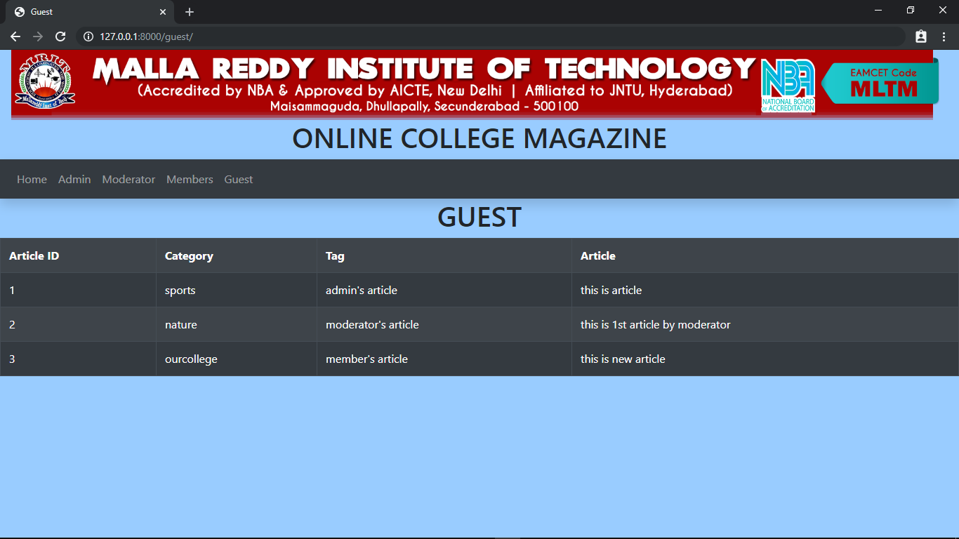

**Member Module**

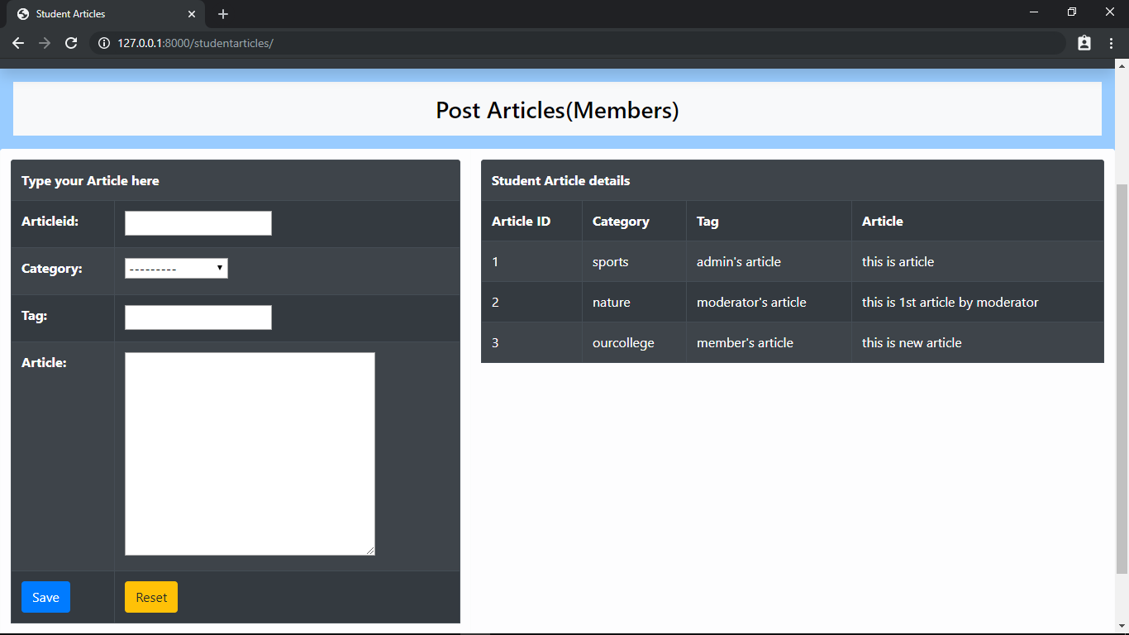

**Moderator Module**

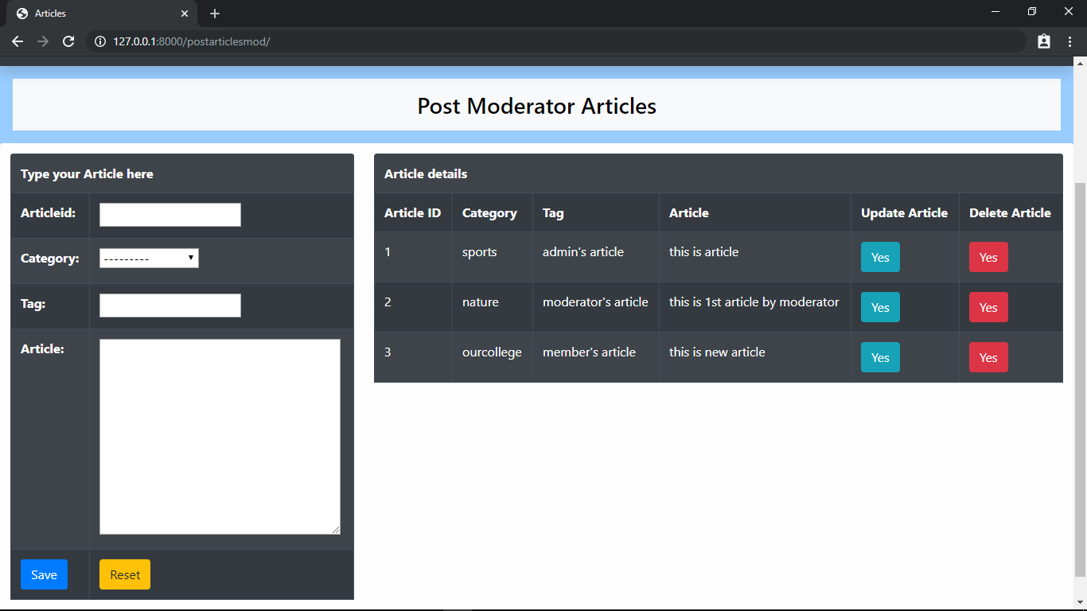

**Admin Module**

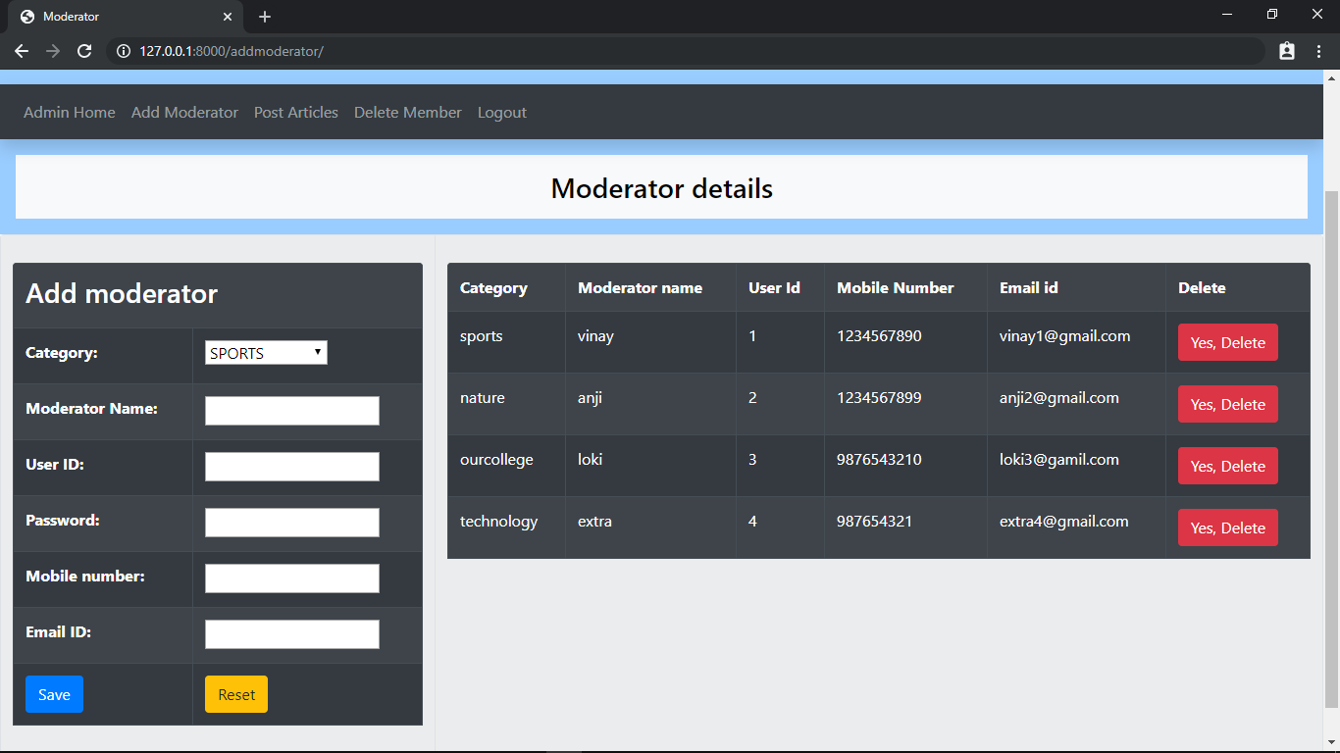

**11.CONCLUSION**

College students and faculties can post and read various articles .So we can post and share articles easily .This method takes less time and effort. Articles can be searched by anybody in the world. In this all students not make it to the printed magazine. Creativity of students needs to be nurtured and Creating a user-friendly interactive place where students/faculties can share their ideas.

**12. BIBLIOGRAPHY**

**HTML**

<https://devdocs.io/html/>

**Python**

<https://docs.python.org/3/>

**Django**

<https://docs.djangoproject.com/en/2.2/>

