Program 9
Step 1: Inatalize through Spring

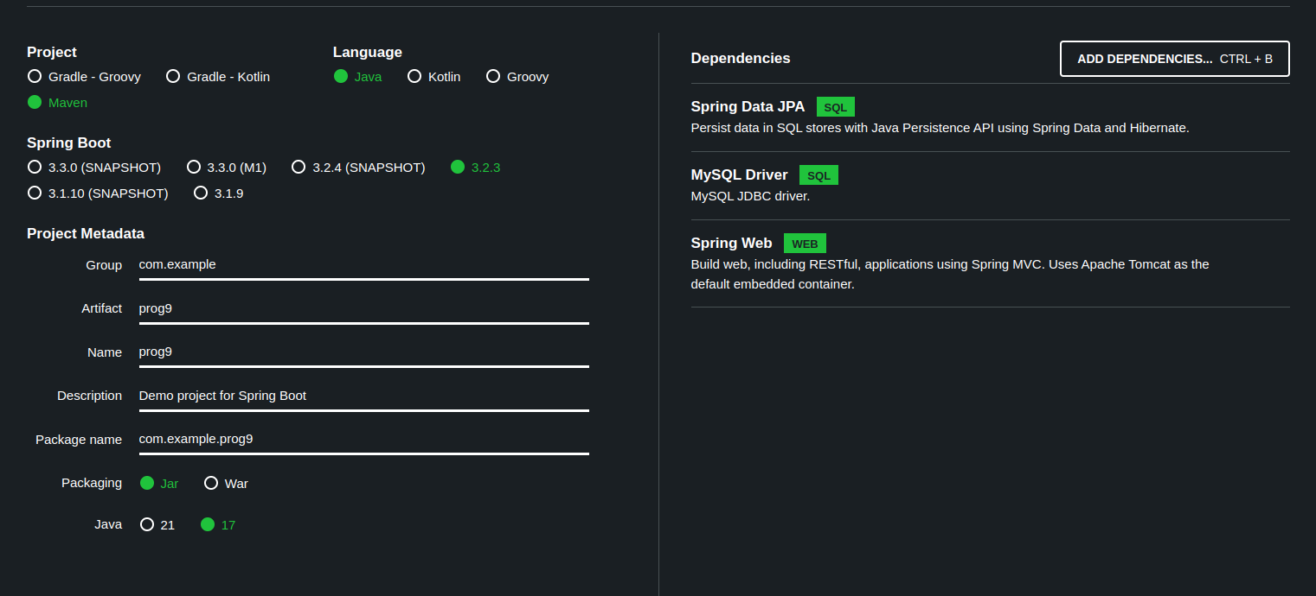

Step 2: Import the maven existing project.

Step 3: Class Student.java

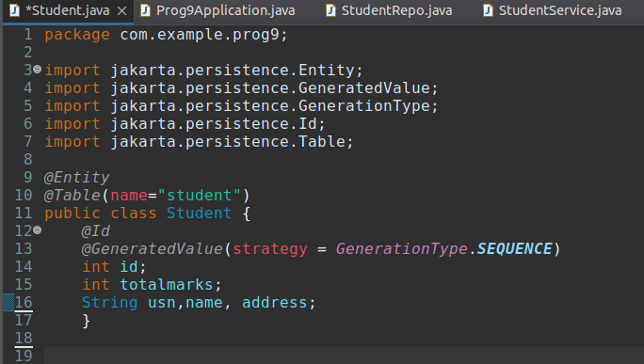
Generate getter and setters methods and toString()

Class StudentRepo.java

Create interface and add JpaRepository.org.springframework

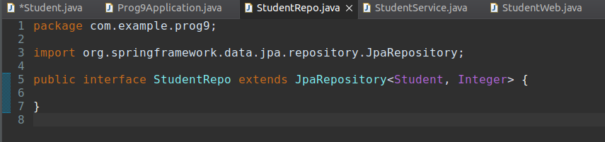

Class StudentService.java

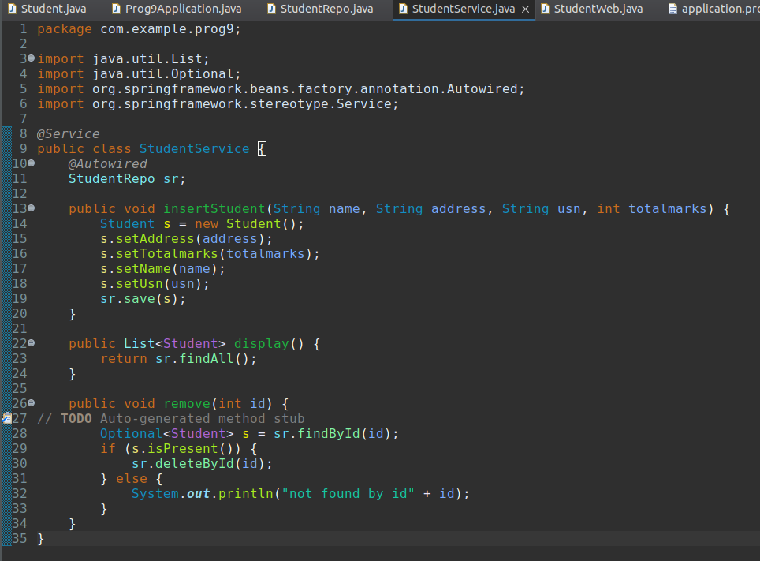

Class StudentWeb.java

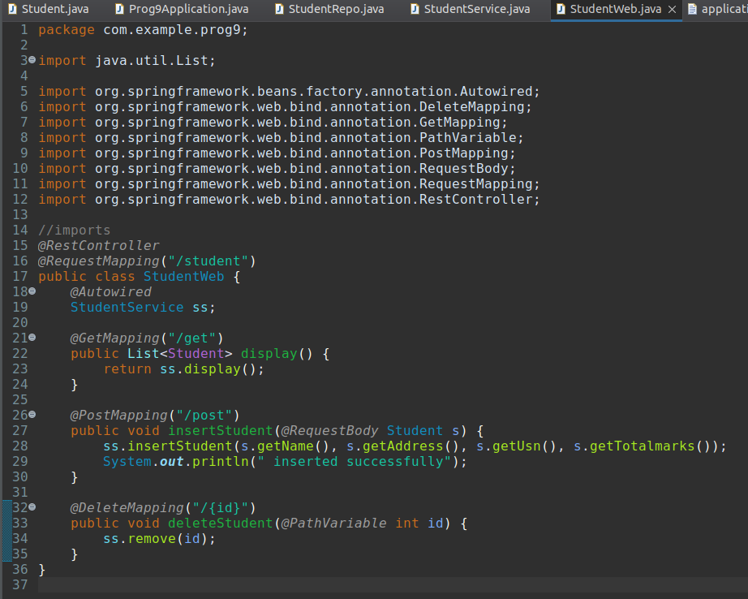

Class MainProgram.java

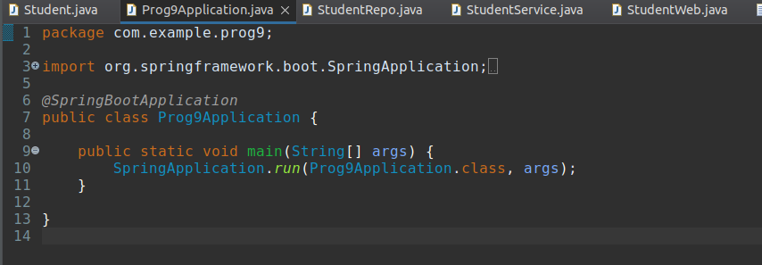

application.properties

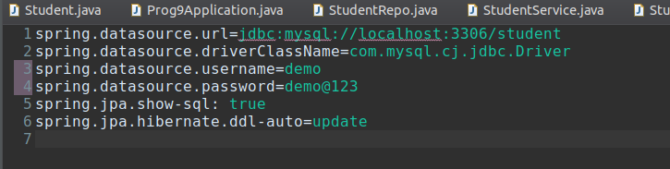

Step 4: Install the maven packages in the system i.e maven install

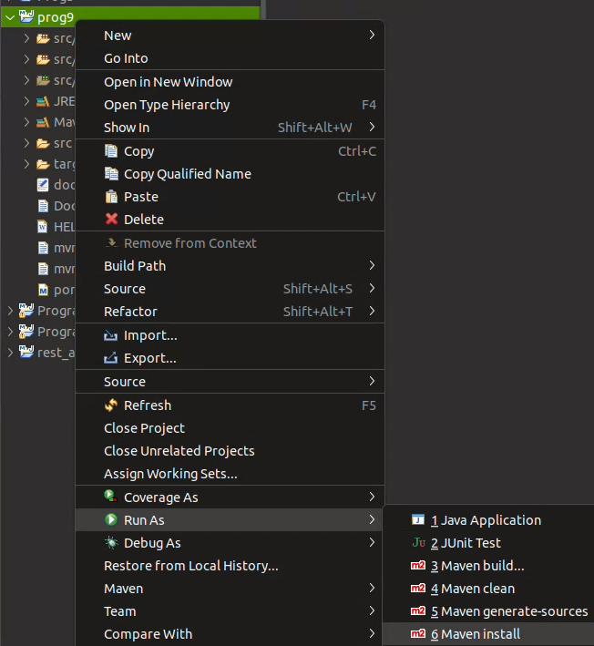

Step 5: Create a Dockerfile

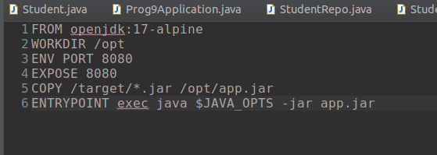

Step 6: Buid the docker image

$sudo docker build --build-arg JAR_FILE=target/*.jar -t myorg/myapp .

Step 6: Create docker-compose.yml

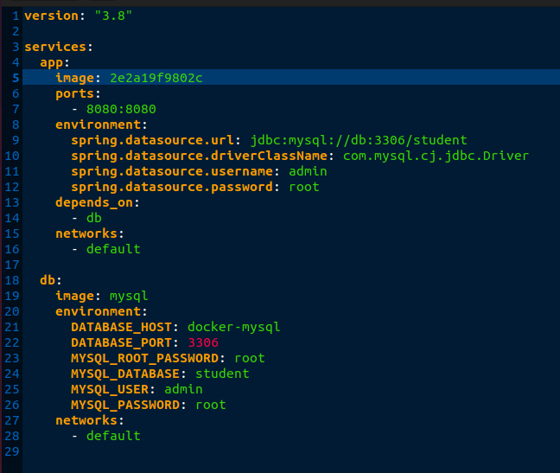

Step 7: Verify the image

$sudo docker images

Step 7: After bulding the image add the image name or image ID to the docker-compose.yml and add the mysql username and password

i.e image: <imageID>

Step 8: Run the docker compose command

$sudo docker compose up

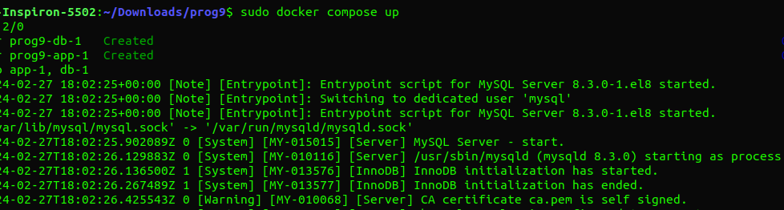
Step 9: Verify wheather MySQL image is created or not

$sudo docker images

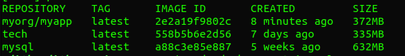

Step 10: Check the running container

$sudo docker container ls -a

