Mass Variations

Exercise Sheet 3

Elaboration of:
Family name, first name | Student number
Sudur Bhattarai | 2514652
Li Maike | 2564550
Date of issuance | 08. February 2024
Delivery until | 19. February 2024
If necessary 1. resubmission to
If necessary 2. resubmission to

Feedback for teachers:
Time required for processing | 3 days
Motivation; 1 (low) … 10 (high) | 8
Level of difficulty of the exercise; 1 (low) … 10 (high) | 2

Feedback for students:
Estimated time required for processing
Estimated level of difficulty of the exercise; 1 (low) … 10 (high)
Evaluation of "clean work"; 1 (scribble) … 10 (very clean)
Technical correctness; 1 (low) … 10 (high)
Scientific work; 1 (underdeveloped) … 10 (very pronounced)
Comment:

Form of the elaboration

You have to submit a pdf-document, which is created based on this template and therefore contains the title page and feedback, the written elaboration of the exercise sheet and the exercise.

The name (pdf file) must be clearly defined, e.g.
LVLV_BlattNr_ii__nnnvvv.pdf.
LVLV: Name of the course
ii: consecutive number, is incremented within the semester
nnnvvv: first 3 letters of surname, followed by the first 3 letters of surname
Letters of the first name.

This elaboration should contain the description of the solution including necessary formulas and graphics. Finally, the results are to be discussed and analysed.

If calculation routines were created during processing, e.g. using MATLAB or Excel, these must also be uploaded to ILIAS.

Resubmission

A maximum of two resubmissions is possible per exercise sheet. Workouts cannot be accepted due to errors in content or for formal reasons. Formal reasons for resubmissions are:
- Late submission of the exercise sheet. If, for important reasons, it is not possible to process an exercise sheet within the scheduled time, this must be communicated to the trainer in good time.
- Incomplete processing of the exercise sheet. All subtasks and questions must be answered.
- Insufficient form of elaboration.

Feedback

Regular feedback is essential to improve teaching. Therefore, please complete the Feedback for Teachers section on the cover page of each exercise sheet.

Geodetic Institute Winter-semester 2023/2024
Karlsruher Institute of Technology (KIT) Date of issuance: 08.02.2024
Delivery until: 19.02.2024

Name: Sudur Bhattarai
Mass Variations Name: Maike Li
Exercise 3: Isostatic reductions

Isostasy: State of hydrostatic equilibrium of the Earth's crust or lithosphere. Mass surpluses due to the topography in the continental area or mass deficits in the oceanic area are each balanced out by compensation masses. The phenomenon of isostasy was first discovered in 1749 by P. Bouguer, who noticed that the mass attraction of the Andes was significantly smaller than expected. This observation was confirmed as part of the colonial survey in India (1800-1870): The impact of the masses of the Himalayas on the vertical deviation was significantly smaller than calculated from the visible masses.

Pratt-Hayford-Model
Describe the isostatic model according to Pratt-Hayford in
a1) planar approximation
a2) spherical approximation

Calculate and plot the following effects for one vertical mass column of height H
a3) Density contrast for a1) and a2)
a4) Isostatic effect on gravity based on a3)
Use and adapt the given m-file for the gravity effect of a prism at point P(H)

Airy-Heiskanen-Model
Describe the isostatic model according to Airy-Heiskanen in
b1) planar approximation
b2) spherical approximation

Calculate the following effects for one vertical mass column of height H
b3) Root depth b1) and b2)
b4) isostatic effect on gravity based on b3)
Use and adapt the given m-file for the gravity effect of a prism at point P(H)

Use the following constants:
0m ≤ H ≤ 10000m in steps of 1000m
D = 100 km
T = 31 km
Radius of the Earth (MSL) R = 6371 km
Constant density of the crust: ρ₀ = 2670 kg/m³
Constant density of the mantle: ρ_{M} = 3270 kg/m³
Newton's gravitational constant is: G = 6,672 ⋅10⁻¹¹ m³⋅kg⁻¹⋅s⁻².

Your elaboration includes:
- Front matter
- Exercise sheet
- Describtion of the isostatic models according to Pratt-Hayford and Airy-Heiskanen
- Discussion of the results with plots and tables

Answer
Isostasy or isostatic equilibrium is the state of gravitational equilibrium between Earth's crust (or lithosphere) and mantle such that the crust "floats" at an elevation that depends on its thickness and density. This concept is invoked to explain how different topographic heights can exist at Earth's surface. Although originally defined in terms of continental crust and mantle, it has subsequently been interpreted in terms of lithosphere and asthenosphere, particularly with respect to oceanic island volcanoes, such as the Hawaiian Islands.

Although Earth is a dynamic system that responds to loads in many different ways, isostasy describes the important limiting case in which crust and mantle are in static equilibrium. Certain areas (such as the Himalayas and other convergent margins) are not in isostatic equilibrium and are not well described by isostatic models.

Pratt-Hayford-Model Describe the isostatic model according to Pratt-Hayford in
a1) planar approximation
Pratt-Hayford-Model, different topographic heights are accommodated by lateral changes in rock density. The basis of the model is Pascal's law, and particularly its consequence that, within a fluid in static equilibrium, the hydrostatic pressure is the same on every point at the same elevation (surface of hydrostatic compensation)
 | ℎ1 ⋅ 𝜌1 = ℎ2 ⋅ 𝜌2 = ℎ3 ⋅ 𝜌3 = . . . ℎ𝑛 ⋅ 𝜌n | (1.1)

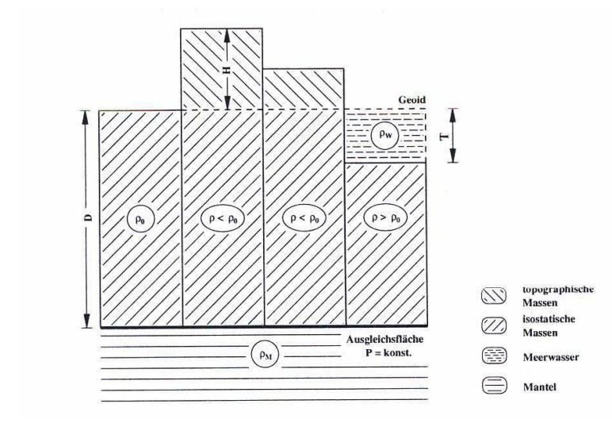
Fig 1: Pratt-Hayford-Model (planar approximation)

For the simplified picture shown, Fig 1, the density of vertical mass column 𝜌 is calculated as follows:
(1.2)

 | 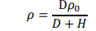 | (1.3)

where ρ₀ is the density of the crust (2670 kg/m³)

In the case of negative topography (a marine basin), the balancing of lithospheric columns gives:
(1.4)

 |  |  |  | (1.5)
 |  | 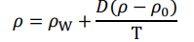 | (1.6)
Where 𝜌0 is the density of the crust (ca. 2670 kg/m³). 𝜌𝑊 is the density of the water (ca. 1000 kg/m³).

a2) spherical approximation
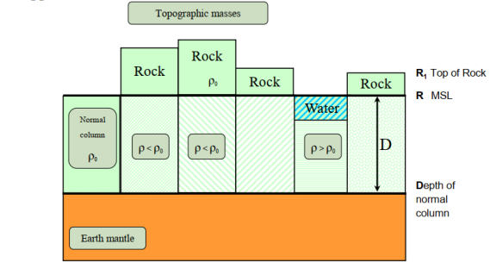
Fig 2: Pratt-Hayford-Model (Spherical Approximation)
For the simplified picture shown, fig 2, the density of vertical mass column 𝜌 is calculated as follows:
(1.7)

 | 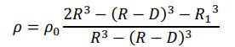 | (1.8)
Where 𝜌0 is the density of the crust (ca. 2670 kg/m³).

In the case of negative topography (a marine basin), the balancing of lithospheric columns gives:
1.9

 | 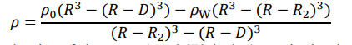 | (1.10)

Where 𝜌0 is the density of the crust (ca. 2670 kg/m³). 𝜌𝑊 is the density of the water (ca. 1000 kg/m³), 𝑅2 is the bottom of the sea.
Calculate and plot the following effects for one vertical mass column of height H

a3) Density contrast for a1) and a2)

Table 1: Density Contrast for Planar and spherical approximation for PH Model
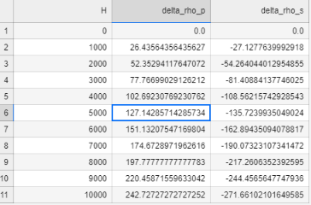
Where,
delta_rho_p = Density Constrast for planar approximation for Pratt-Hayford-Model
delta_rho_s = Density Constrast for Spherical approximation for Pratt-Hayford-Model
H = 0m ≤ H ≤ 10000m in steps of 1000m

For planar approximation of the Pratt-Hayford-Model, the following relationships were used to deduce density constrast:
- Density of isostatic masses:
 | 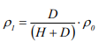 | (1.11)

- Density contrast:
 | 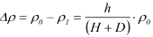 | (1.12)

For spherical approximation of the Pratt-Hayford-Model, the following relationships were used to deduce density contrast, eq (1.8) is used to deduce the density contrast
 | Δρ = ρ - ρ₀ | (1.13)

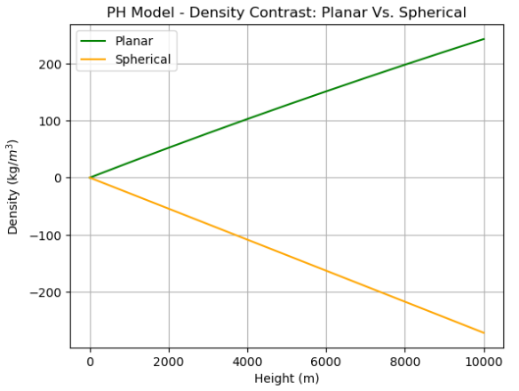
Fig 3: Density Contrast Plot for Planar and Spherical Approximation of Pratt-Hayford-Model
a4) Isostatic effect on gravity based on a3)
Use and adapt the given m-file for the gravity effect of a prism at point P(H)

Isostatic effect on gravity for spherical and planar approximation are calculated separately for PH model using the following relation:
For Planar approximation: | Δg_iso_p = G*D*Δ ρ_{p} | (1.14)
Density contrast-Planar = Δ ρ_{p}

For spherical approximation: | Δg_iso_s = G*D*Δ ρs | (1.14)
Density contrast-Spherical = Δ ρ_{s}
Table 2: Isostatic effect on gravity for Planar and spherical approximation for PH Model
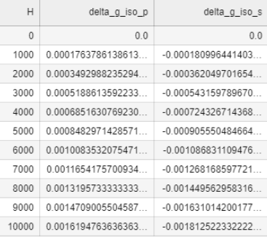
Where,
delta_g_iso_p = Isostatic effects on gravity for planar approximation for Pratt-Hayford-Model
delta_g_iso_s = Isostatic effects on gravity for Spherical approximation for Pratt-Hayford-Model
H = 0m ≤ H ≤ 10000m in steps of 1000m

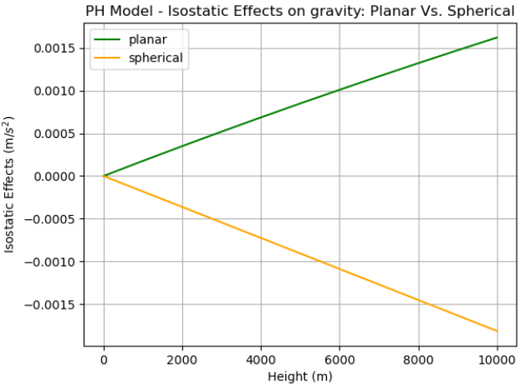
Fig 4: Isostatic effect on gravity plot for Planar and Spherical Approximation of Pratt-Hayford-Model

Airy-Heiskanen-Model
Describe the isostatic model according to Airy-Heiskanen in
b1) planar approximation
Airy-Heiskanen-Model, different topographic heights are accommodated by changes in crustal thickness, in which the crust has a constant density.
The basic of the model is also the same as Prade Hayford Model, Pascal’s law.
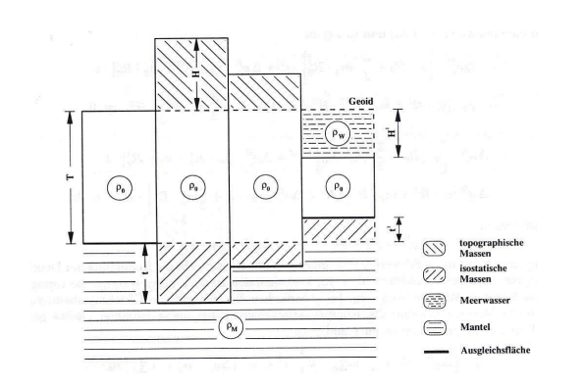
Fig 5: Planar approximation for Airy-Heiskanen-Model
.
(2.1)
For the simplified picture shown, fig 3, the depth of the mountain belt roots (t) is calculated as follows:
(2.2)

(2.3)

 | 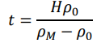 | (2.4)
where 𝜌𝑀 is the density of the mantle (ca. 3270 kg/m³) and 𝜌0 is the density of the crust (ca. 2670 kg/m³).
In the case of negative topography (a marine basin), the balancing of lithospheric columns gives:
(2.5)

(2.6)

 | 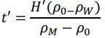 | (2.7)
where 𝜌𝑀 is the density of the mantle (ca. 3270 kg/m³) and 𝜌0 is the density of the crust (ca. 2670 kg/m³). 𝜌𝑊 is the density of the water (ca. 1000 kg/m³).

b2) spherical approximation
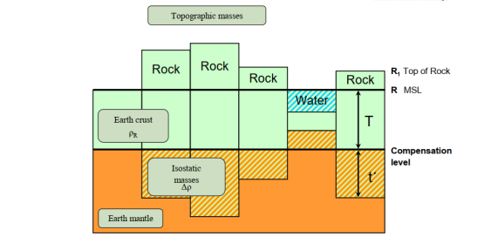
Fig 6: Spherical approximation for Airy-Heiskanen-Model
For the simplified picture shown, fig 4, the depth of the mountain belt roots (t’) is calculated as follows:
 | 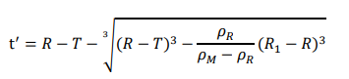 | (2.8)
Where 𝜌R is the density of the crust (ca. 2670 kg/m³). 𝜌𝑀 is the density of the mantle (ca. 3270 kg/m³).

Calculate the following effects for one vertical mass column of height H

b3) Root depth b1) and b2)

Root depth for planar and spherical approximation of Airy-Heiskanen-Model are calculated respectively from eq(2.7) and eq(2.8)
Table 3: Root depths for Planar and spherical approximation for AH Model
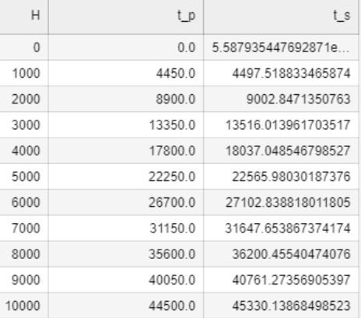
Where,
t_p = Root Depths for planar approximation for Airy-Heiskanen-Model
t_s = Root Depths for Spherical approximation for Airy-Heiskanen-Model
H = 0m ≤ H ≤ 10000m in steps of 1000m

b4) isostatic effect on gravity based on b3)
Use and adapt the given m-file for the gravity effect of a prism at point P(H)
Table 4: Isostatic effect on gravity for Planar and spherical approximation for AH Model
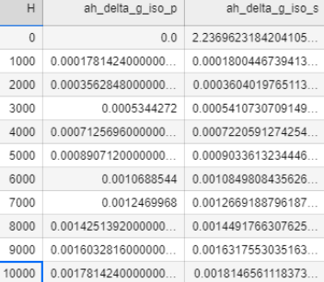
Where,
ah_delta_g_iso_p = Isostatic effects on gravity for planar approximation for Airy-Heiskanen-Model
ah_g_iso_s = Isostatic effects on gravity for Spherical approximation for Airy-Heiskanen-Model
H = 0m ≤ H ≤ 10000m in steps of 1000m

Feedback in data processing:
Data Processing was not that much difficult after understanding all the concepts and formulae. I did data processing in Python as I am quite handy in it.
Talking about, how i did data processing,
- I made a loop of 0m ≤ H ≤ 10000m in steps of 1000m, where I calculated density contrast / root depths (for AH model) and isostatic effects for both the PH and AH models by giving the respective formulas to calculate the corresponding particular things. The formula to calculate these things was used from the lecture slide of Prof. Seitz.
- These calculated density contrasts, isostatic effects, and root depths are then plotted separately w.r.t the models.

