Project Title: Deploy Angular Application in Docker Container

DESCRIPTION
Deploy the Angular application in Docker. The Angular application should be built with the Angular CLI along with Docker Compose for development and production

Problem Statement Scenario:
HTQual Technology Solutions hired you as a MEAN Stack Developer. The organization decided to implement DevOps to develop and deliver the products. Since HTQual is an Agile organization, they follow Scrum methodology to develop the projects incrementally. The Company decided to develop their website on Mean stack. Since you are the MEAN stack developer, you have to demonstrate that deploying the Angular application on Docker is always the best approach to develop a project and test it incrementally. You agreed upon the following:
• Setting up an image for code development
• Build the application in Docker and host it in Docker Hub
• List the advantages, disadvantages, and document the tasks involved
Your goal is to demonstrate the Angular application and run it in Docker container.

You must use the following tools:
• Docker – To package the application in a Docker container
• Node.js – To support the Angular application with the required node modules
• Angular CLI – To execute and bundle the dependencies together
• Linux (Ubuntu) – As a base operating system to start and execute the project
Following requirements should be met:
• Document the step-by-step process from the initial installation to the final production
• Run the Angular application successfully in the Docker container
• Use Docker Compose to manage the Angular application running inside the Docker container

Let’s start the Project

To create angular project we need nodejs & angular cli

Install nodejs on ubuntu:

$curl -sL https://deb.nodesource.com/setup_14.x | sudo -E bash -
$sudo apt-get install -y nodejs

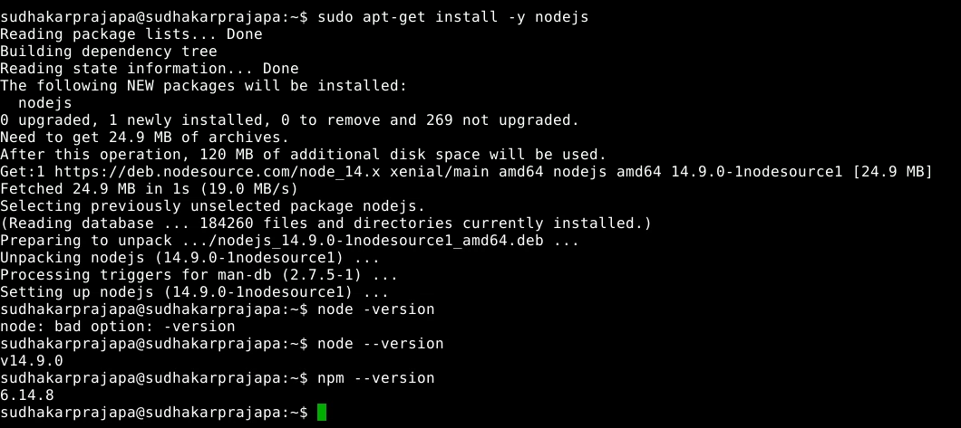

Install angular CLI
Now let’s install angular CLI using npm package manager:
$npm install -g @angular/cli

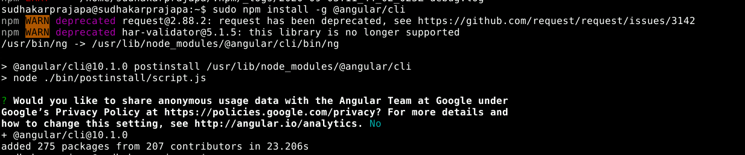

We have successfully installed Angular CLI on Ubuntu

$ng version

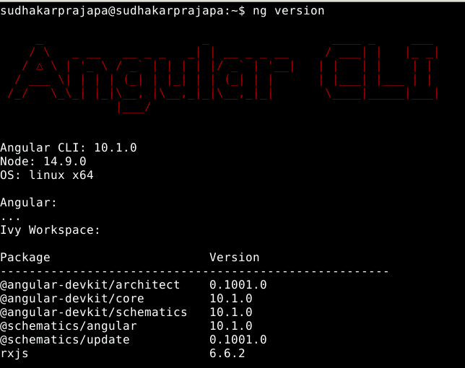

Create Angular Project
Let’s create angular project, name it as ng-docker-app
Angular CLI commands to create the Angular app & run on development server
$ng new ng-docker-app
$cd ng-docker-app
$ng serve

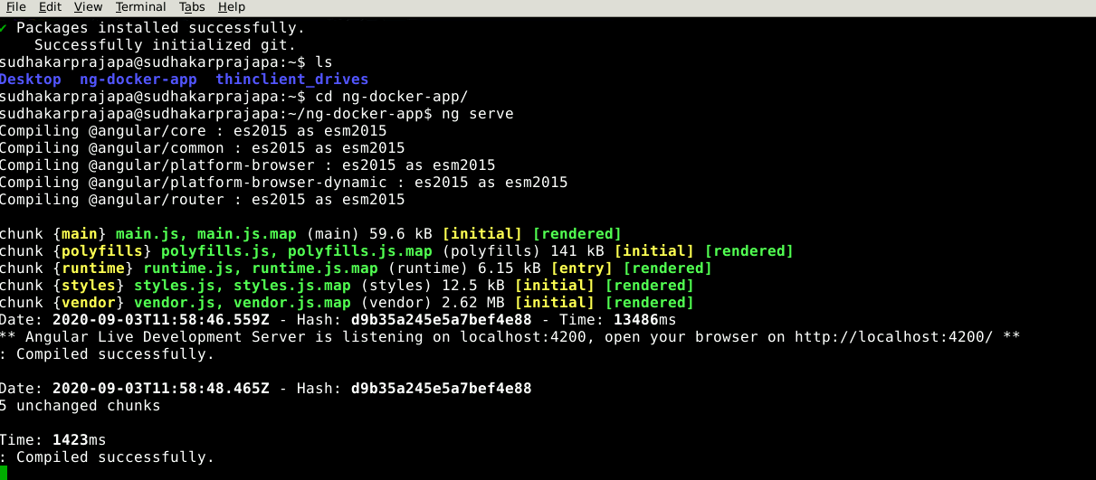

Running Angular App
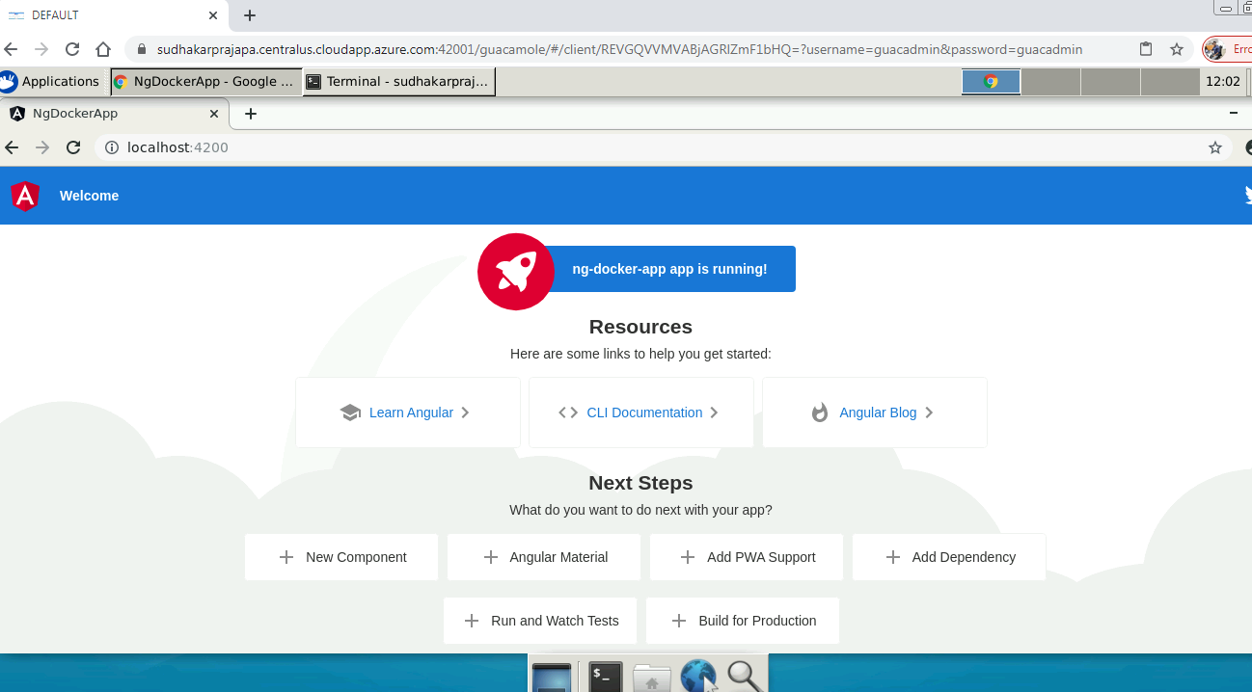

To run the ng-docker-app application in Docker container we need docker and we have to create Dockerfile to create image of ng-docker-app.

Let’s first install the Docker
Install Docker
Refer official docker doc and install https://docs.docker.com/engine/install/ubuntu/
Setup the repository:
Update the apt package index and install packages to allow apt to use a repository over HTTPS
$ sudo apt-get update

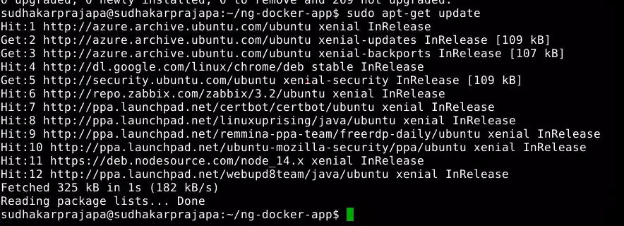
$sudo apt-get install apt-transport-https ca-certificates curl gnupg-agent software-properties-common

Add Docker’s official GPG key & verify:
$curl -fsSL https://download.docker.com/linux/ubuntu/gpg | sudo apt-key add –

Use the following command to set up the stable repository
$ sudo add-apt-repository "deb [arch=amd64] https://download.docker.com/linux/ubuntu $(lsb_release -cs) stable"

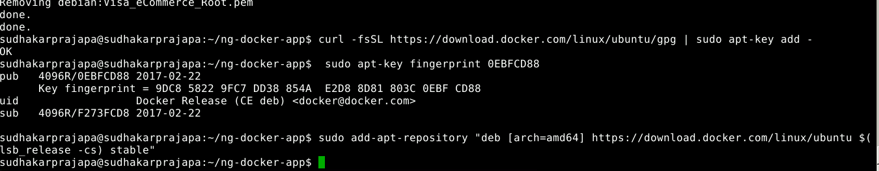

Install docker engine

$sudo apt-get update
$sudo apt-get install docker-ce docker-ce-cli containerd.io

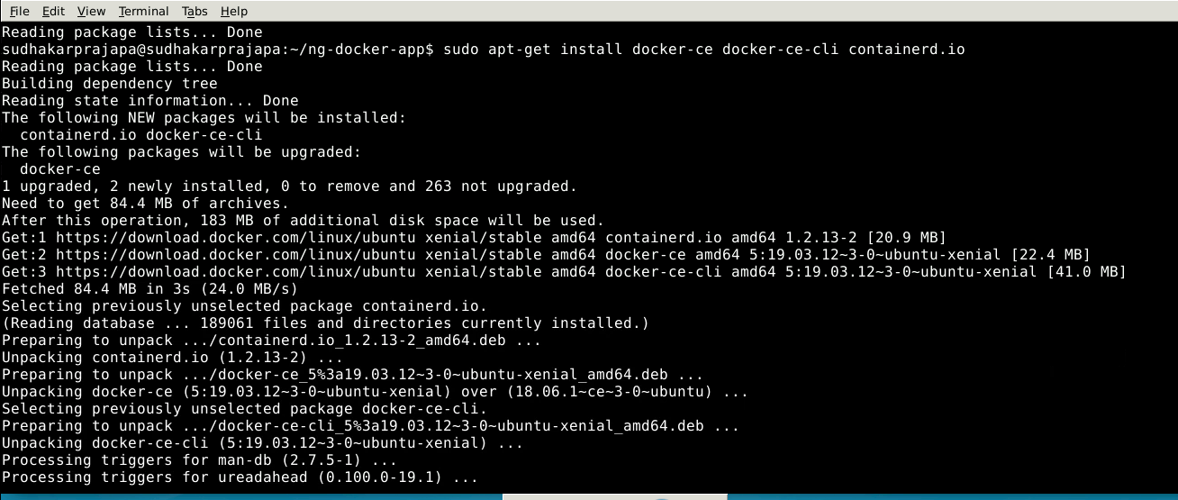

Verify that Docker Engine is installed correctly by running the hello-world image.

$sudo docker run hello-world

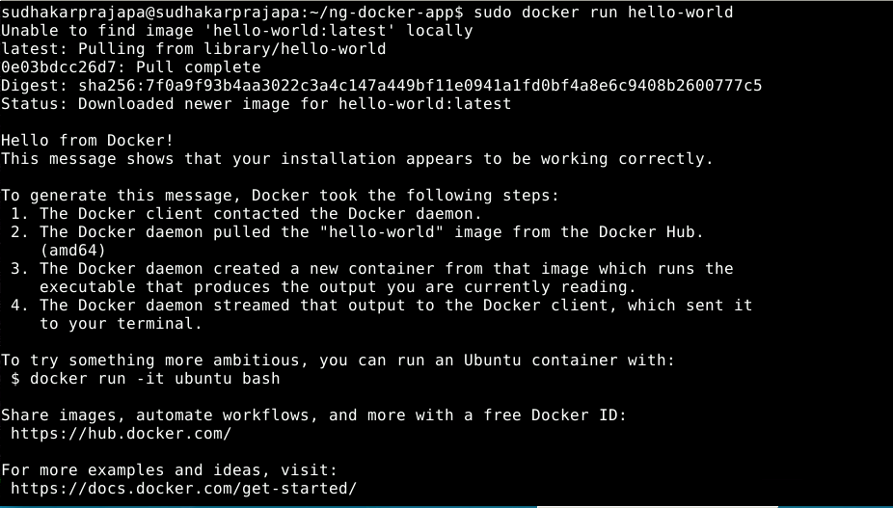

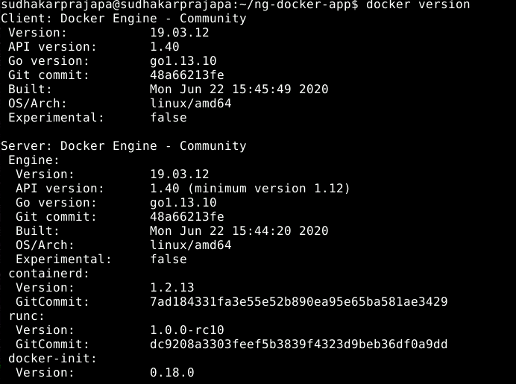

Great!! We have installed docker, now we have to create Dockerfile to containerize app.
Dockerise Angular Project

Create Dockerfile in our ng-docker-app folder
Now in the terminal change directory to your ng-docker-app folder and create a file name “Dockerfile” without any file extension using any dev editor & write below instructions.

$vi Dockerfile
In Stage 1 we are copying our app code in the “app” folder and installing app dependencies from package.json file and creating production build using node:10-alpine image.
In Stage 2 we are using the nginx server image to create the nginx server and deploy our app on it by copying build items from /app/dist/ng-docker-app to nginx server at /usr/share/nginx/html location. Expose the port 80 for nginx server

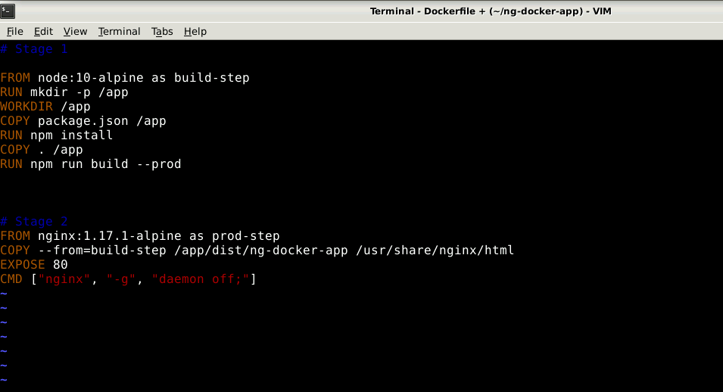

Now let’s build the image
Build Docker image
$docker build –t sudz/ng-docker-app .
First time this process will take time. Build is created successfully and tagged as sudz/ng-docker-app:latest
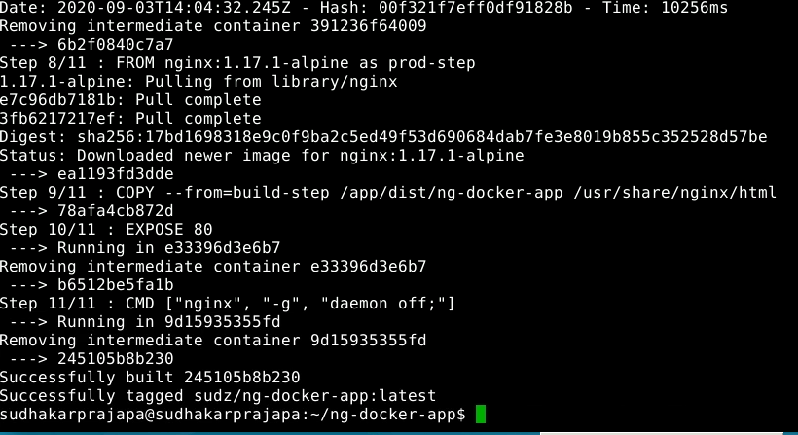
Hit the docker images command and you can see the your images
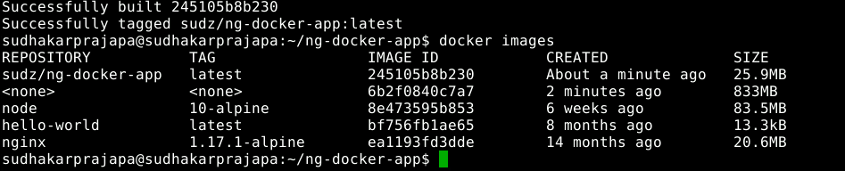

Now run the ng-docker-app application in Docker container using below command, check in your browser by just typing localhost
$docker run -d -p 80:80/tcp --name ng-docker-app sudz/ng-docker-app:latest
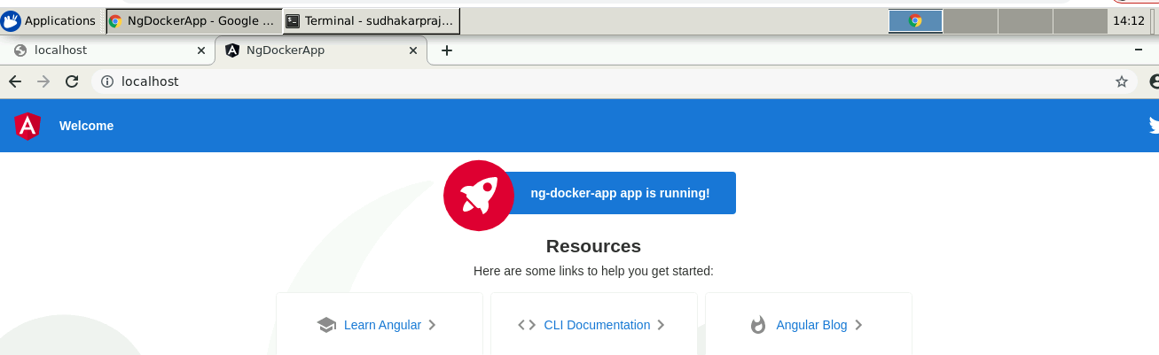

Finally it’s time to run this application using docker-compose, Let first install the docker-compose in ubuntu
Install Docker Compose
$sudo apt install docker-compose
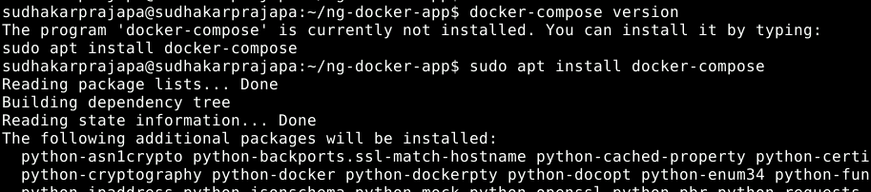
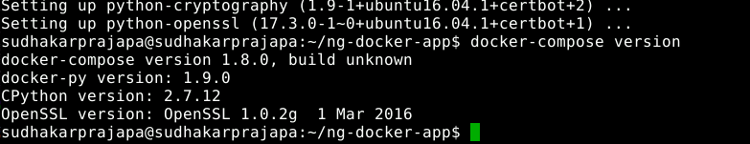

Create docker-compose.yml
Create the docker-compose yml and add the instructions mentioned in screenshots
$touch docker-compose.yml
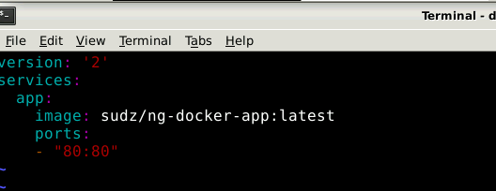

Now use Docker Compose to manage the Angular application running inside the Docker container
$ docker-compose up
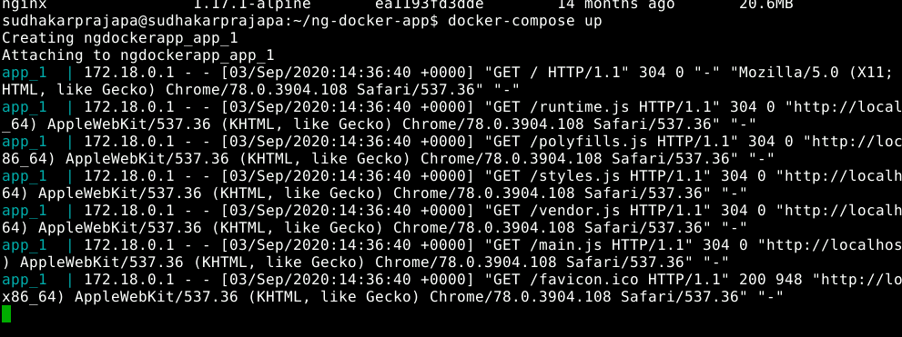

Use –d to run in detached mode
$ docker-compose up –d
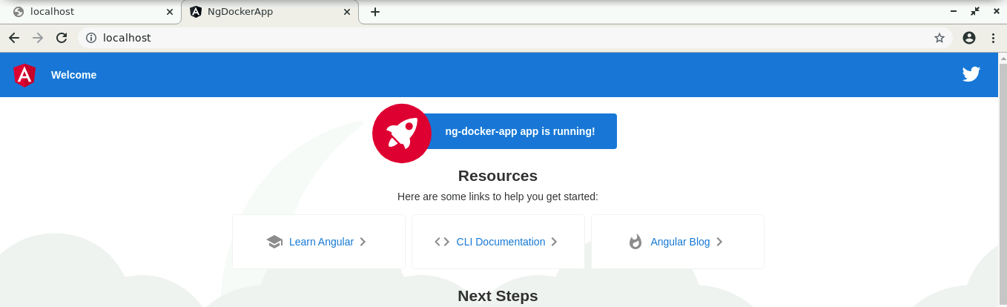

Stop the container using docker-compose down
$ docker-compose up –d
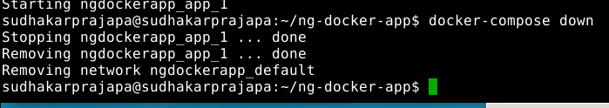

Our project is ready now to host in Docker Hub, Let complete the final step.
Push to Docker Hub
You have to login to docker hub using your credential
$docker login—username=yourusername
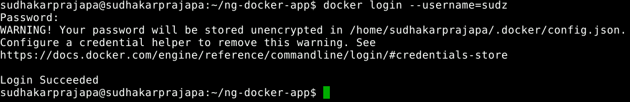
$docker push sudz/ng-docker-app:latest
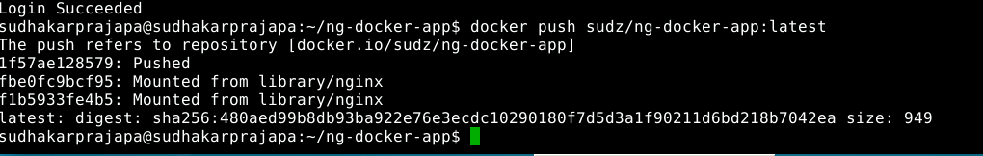

Hurrah!!! our application is hosted in Docker Hub
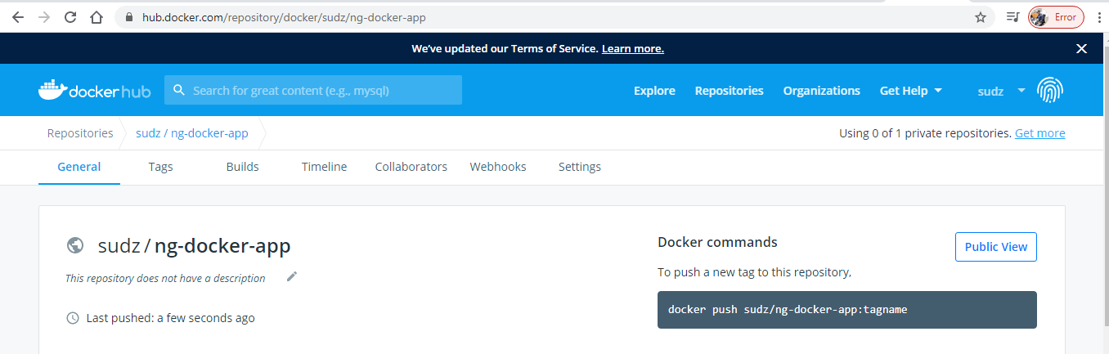

https://hub.docker.com/repository/docker/sudz/ng-docker-app

I have also pushed this project to github, refer below link
https://github.com/sudzp/ng-docker-app

