[Cran/Date Paleo Power Bars](http://carolynmaul.com/crandate-paleo-power-bars/" \o "Permalink to Cran/Date Paleo Power Bars)

*by*[*CarolynMaul*](http://carolynmaul.com/author/carolynmaul/)*• September 28, 2013 •*[*Newsletter*](http://carolynmaul.com/category/newsletter/)*•*[*0 Comments*](http://carolynmaul.com/crandate-paleo-power-bars/#respond)

I just whipped up some **Cranberry Date Paleo Power Bars**so they would be ready to eat after our Crossfit Workout at 11am.

It took[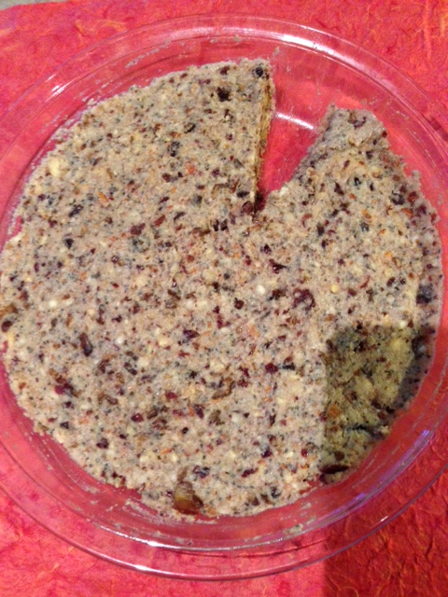](http://carolynmaul.com/wordpress2/wp-content/uploads/2013/09/download.jpg) about 5 minutes to do this, I think the hardest part was washing the Chia seeds out of my food processor!

Here’s what I used:

* 1C Raw Brazil nuts
* 1/2C Raw almonds
* 1/3C Chia seeds and Flax meal mix
* ⅔ C Pitted Dates
* ⅓ C Dried Cranberries
* 4 Packets organic Stevia
* 1t Vanilla extract
* 3T water

Here’s what I did:

1. Place nuts, flax, chia, dates, cranberries, stevia, and vanilla in food processor.
2. Pulse until mostly ground, then start adding water until your mixture forms a ball.
3. Remove from food processor and press into a 8×8 baking dish or pie pan.
4. I like these chilled, sliced, and then served.