Karen's Flax Seed "Bagels"

[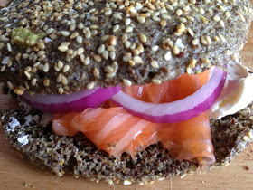](http://4.bp.blogspot.com/-Xvjj6fTQKgY/UjTDZ9GmAXI/AAAAAAAACsg/5coc9jdvvqE/s1600/IMG_0796.jpg)

I call these bagels in quotes because they do the "job" that bagels do, as far as the satisfaction (and I punctuate them with a variety of seeds) to make them like my personal fav, everything! They have none of the calories and carbohydrates that bagels have. They also don't have quite the chewiness of a bagel, but to me they are a welcome replacement because they are low in carbohydrates and much more nutritious than standard bagels.  
They are rich in omega 3 fatty acids, b vitamins and fiber among other fantastic and essential nutrients  
according to Laura Dolson of about.com.  
This recipe was inspired by Jorge Cruise but I decided it would make an awesome "bagel" substitute.  
You be the judge.  
It is my go to treat when I want a bagel with cream cheese and smoked salmon.  
I even shared them with  the illustrious Tory Johnson and her awesome husband recently and they loved them.  
So now that I have made my personal "shift" too, these are a great tool in my culinary arsenal.  
  
Here is the recipe  
  
Ingredients  
  
1 cup of ground flax seeds, I use a dedicated coffee grinder to accomplish this but you can buy them already ground.  
1 Tbs. baking powder  
3 large eggs  
  
Topping  
  
1pinch Fleur de Sel  
1 tsp. sesame seeds  
1 tsp. poppy seeds  
1 tsp. caraway seeds  
1/2 tsp. cumin seeds  
1/2 tsp. fennel seeds  
1 large clove fresh garlic  
  
Filling for "Bagels"  
  
4 oz. cream cheese  
8 oz. smoked salmon, I used Wild King  
1 small thinly sliced red onion, optional  
  
Method  
  
Preheat the oven to 375 degrees. Line a sheet pan with parchment paper.  
In a medium sized bowl combine the ground flax seeds with the baking powder, with a wire whisk.  
Add the eggs one at a time until fully incorporated with the wire whisk.  
Place one forth of the batter on the sheet pan and spread it into 4 disk like "bagels", about 3-1/2 -4 inches wide, using a small offset spatula to smooth the top.

[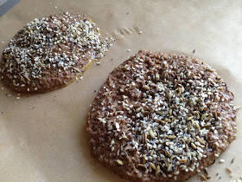](http://1.bp.blogspot.com/--f7cwbL2dQM/UjTHEA4eI6I/AAAAAAAACss/PyCARsf4QmM/s1600/IMG_2046.jpg)

Combine all of the seeds and salt together and sprinkle approximately 1 tsp. of the seeds  
evenly over each disk. Using a microplane grate the garlic over each disk, tapping the microplane firmly over each one to distribute the freshly grated garlic.  
Place into the preheated oven.  
Bake for 10 minutes until the "bagels" are firm to the touch.  
Remove from the oven and with a large metal spatula place "bagels" on a wire rack to cool completely.  
When they are cool. Split the "bagels" in half, horizontally using a thin blade sharp knife.  
Spread the cream cheese over both halves of all four bagels. Top with the salmon and onion if you like and serve.  
  
Serves 4