Pan Seared Salmon with Pumpkin Seed-Cilantro Pesto

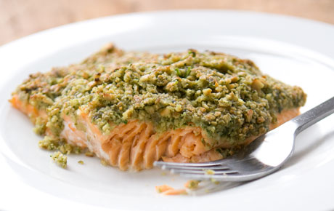

Ingredients

* 2 1/2 teaspoons tsp plus 1/4 cup extra-virgin olive oil, divided
* 1/2 cup shelled pumpkin seeds (pepitas)
* 1/2 cup (firmly packed) cilantro leaves and stems
* 1/2 teaspoon cracked coriander seeds
* 1/2 garlic clove, coarsely chopped
* 1 tablespoon (or more) fresh lime juice
* Kosher salt and freshly ground black pepper
* 4 6-ounce salmon fillets (preferably wild)
* 1 lime, cut into 4 wedges

Preparation

* Heat 1 1/2 tsp oil in a large nonstick skillet over medium-high heat. Add pumpkin seeds; sauté until beginning to brown and pop, about 2 minutes. Transfer seeds to paper towels to drain; let cool. Reserve skillet.
* Pulse 6 Tbsp pumpkin seeds, cilantro, coriander seeds, and garlic in a food processor until coarsely chopped. With machine running, gradually add 1 Tbsp lime juice, 1/4 cup oil, then 1/4 cup water, blending until coarse purée forms. Season pesto to taste with salt, pepper, and more lime juice, if desired.
* Heat remaining 1 tsp. oil in reserved skillet over medium heat. Season salmon fillets with salt and pepper. Add to skillet and cook until just opaque in center, 3-4 minutes per side. Place fillets on plates. Spoon pesto over. Garnish with remaining pumpkin seeds. Serve with lime wedges.