**Sugo Calabrese**

Posted on [January 30, 2011](http://italian-ate.com/2011/01/30/sugo-calabrese/) by [fjbnyc](http://italian-ate.com/author/fjbnyc/" \o "View all posts by fjbnyc)

[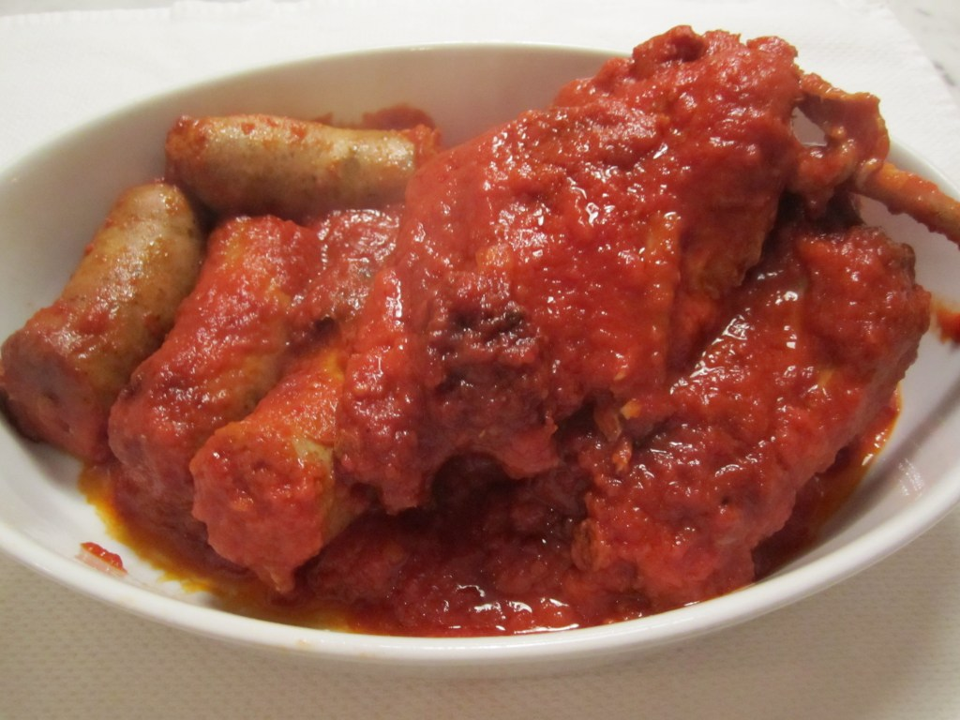](http://italianatedotcom.files.wordpress.com/2011/01/img_0361.jpg)

This dish is straight from my mother’s home town in Calabria.  Even in the summertime, the sauce is a staple which is served on pasta several days a week.  When my mother and I spent three months in Calabria many years ago, my aunt showed me how to make the sauce and we had it almost daily.  My aunt always used pork spareribs to flavor the *sugo*, so that’s what I’m doing tonight. In addition, I’ve added some pork sausage.

In most of Italy, pasta is served every day at lunch.  In my mother’s region, the predominant pasta is *pasta asciutta*, or dried pasta.  This can take any of a variety of shapes–*rigatoni, fusilli, spaghetti, etc.*–but always dried semolina pasta.

Because Italians are very dogmatic when it comes to which sauce goes on which pasta, the*pasta asciutta* generally gets either a red sauce or an oil and garlic-based sauce.

Meat is not usually the main attraction at a Calabrese lunch, but they love to put a little bit of meat (usually pork) in the red sauce and simmer it until it’s falling off the bone.  The sauce is used to dress the pasta, and the meat is eaten as the second course, or *secondo*.  With the second course there is usually a vegetable or salad.  Tonight, we’ll eat this meal Italian-style.  For our first course, we’re having *bucatini* dressed with the sauce, then for our second course we’ll have spareribs, sausage, and some of last night’s meatballs, with some soft sauteed broccoli (see yesterday’s post for recipe) on the side.

The sauce needs to perk on low heat for about two hours, and the aroma alone is reason enough to make it–it reminds me of my childhood and my mother’s cooking.

[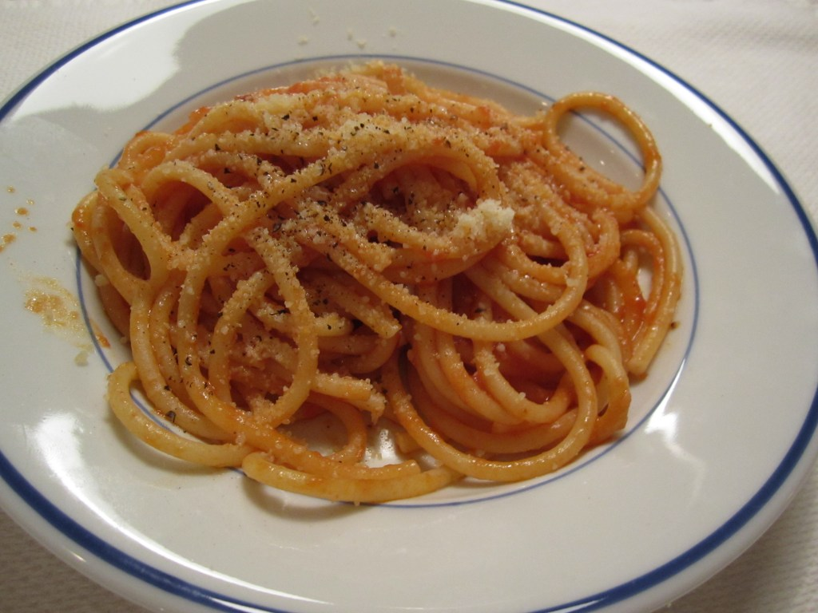](http://italianatedotcom.files.wordpress.com/2011/01/img_0360.jpg)

[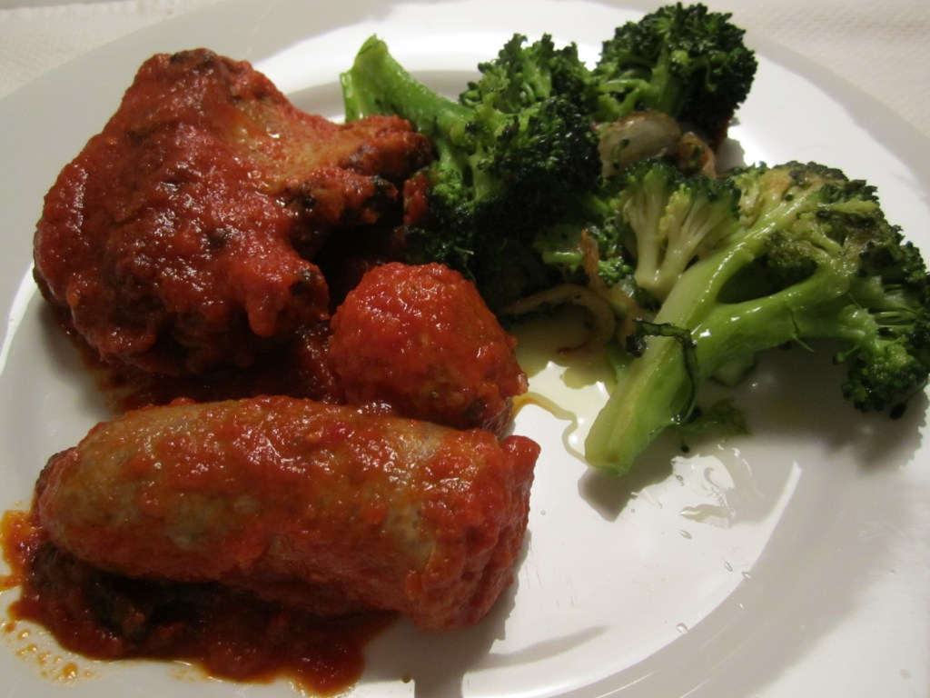](http://italianatedotcom.files.wordpress.com/2011/01/img_0362.jpg)

*Sugo Calabrese*

Serves 4 -6

1 rack baby back ribs, divided into 4 pieces

8 pieces of sweet Italian sausage

3 28-0z cans whole peeled tomatoes, pureed in the blender (do not use tomato puree–it’s an entirely different flavor from whole peeled tomatoes, even though you have to puree them!)

1 small onion, peeled and diced

1/4 of a green pepper, cut into 4 large pieces

6 tbls olive oil

2 bay leaves

salt and pepper to taste

Place whole sausages in boiling water and simmer for about 15 minutes.  Remove and set aside.

Heat half the olive oil in a heavy dutch oven and, on high heat,  brown the spareribs on both sides.  Remove and set aside.  Add the sausages and brown briefly on all sides, then remove and set aside.

Pour off all of the oil in the pot but do not wipe out the brown bits.  Add the remainder of the fresh oil and onions and green pepper.  Lower flame and saute for about 10 minutes.

Add the tomatoes and bring to a simmer.  Add back the spareribs and simmer, partially covered for 2 hours.  Add the sausage and simmer another 20 minutes.

Keeps in the refrigerator a week and can be frozen indefinitely.