PROJECT 1 REPORT-SUEDA BİLEN 150117044

ANSWER FOR QUESTION 1:

I took file and separated content of it.I created structs and inserted the binary search tree for words.There is my output:

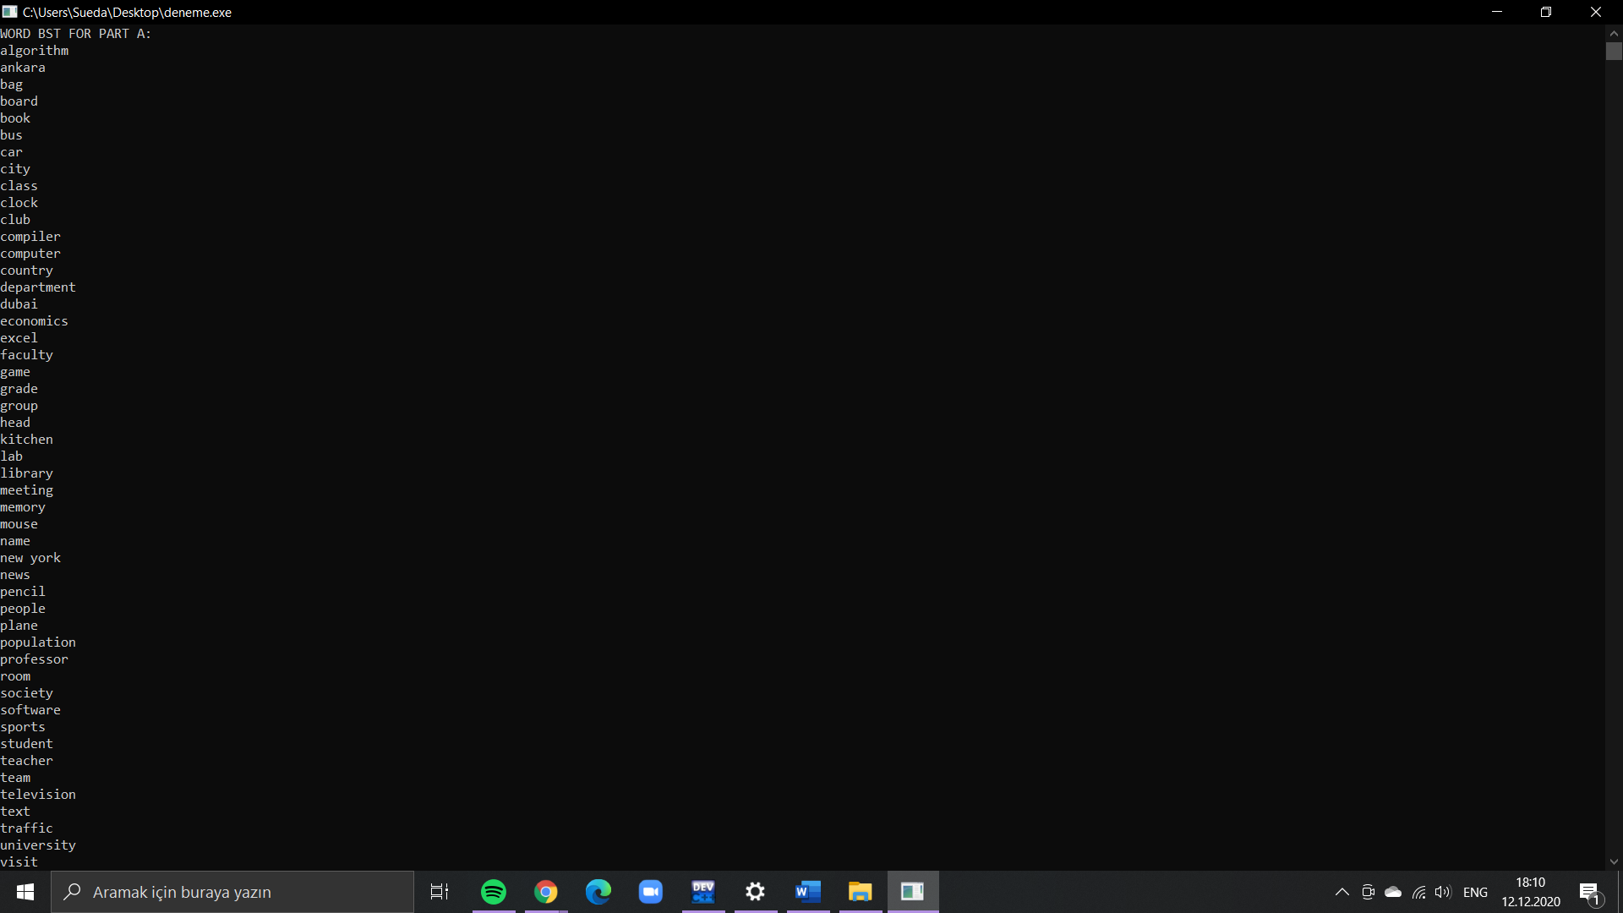

ANSWER FOR QUESTION 2:

I implemented the formula (depth+1)\*freq to my code.My result is 18995

ANSWER FOR QUESTION 3:

For this part, I made a binary search tree for frequencies.Then I found max recursively after finding it I inserted to binary tree as a node after that I deleted it from the bst.There is my output:

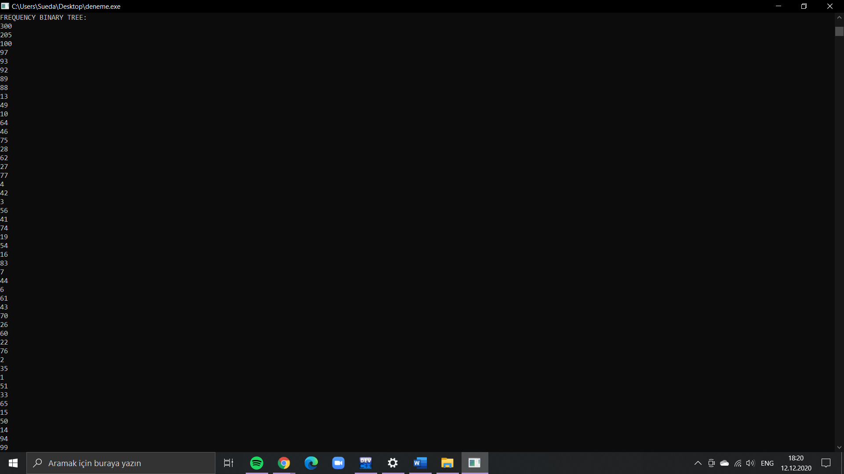

ANSWER FOR QUESTION 4:

I implemented the formula (depth+1)\*freq to my code.My result is 5963.

ANSWER FOR QUESTION 5:

After I reorganized the tree my total access time is decreased.Binary tree implementation is more accessible than binary search tree because its organized according to maximum frequency.