**Fall 2020 – CSE3055 Database Systems**

**Project Step 3**

|  |
| --- |
| Logical database design and mapping & Physical design and database implementation + (Req. analysis & Concep. db. des.) |

Group Members:

150117007 – Edanur Öztürk

150117033 – Feyza Nur Bulgurcu

150117044 – Sueda Bilen

Project Description and Scope:

The database system holds product ,customer ,wholesaler ,employee ,bill, and shopping infos.

Our goal with this project was ,creating a practical ,applicable and arrangable database for a local mini market .We made our database based on our goal .It stores the customer infos and their preferences of buying products in shopping and shoppingInfo tables .There are wholesalers who supply products to the mini market therefore the database keeps data of wholesalers and the products that supplied from the wholesaler.

Our objective was observing choices and keeping the data of the customers who live around Cerrahpasa .After implementing the database we satisfied that objective .The database demonstrates the most purchased products by customers, the most preferred product type by customers and average customer age for keeping track of preferences from view tables. We included every requirement in step1 and 2.

Data and Requirement Analysis:

As business process ,firstly Mini Market owner makes deals with wholesalers .Wholesalers supply products determined day of each week .Owner calculates the prices of the products .After that ,customers come and buy products.

According to them ,we thought keeping bill of products that market owner ordered by wholesalers in Product table .Unfortunately , this condition should be normalized to the 3rd normal form .Then we keep the data of products and wholesaler separately ,also we have tables for Bill and Bill Information that determines the relation between owner, wholesaler and products.

After that ,we thought about keeping shopping information of customers for accessing preferences in the Customer table. Likewise other condition ,in this step we needed to normalize customer table to the 3rd normal form .Then, we keep the data of products and customers separately ,also we have tables for Shopping and Shopping Info to hold information of purchased products.

System keeps stock records for frequently bought products so that we don't have a stock-out problem later .We have planned to use trigger to handle this problem so every time a product entered to system that trigger can increase the stock by taking quantity of entered product .Also ,every time a product purchased to system that trigger can decrease the stock by taking quantity of purchased product.

Diagram of whole database:

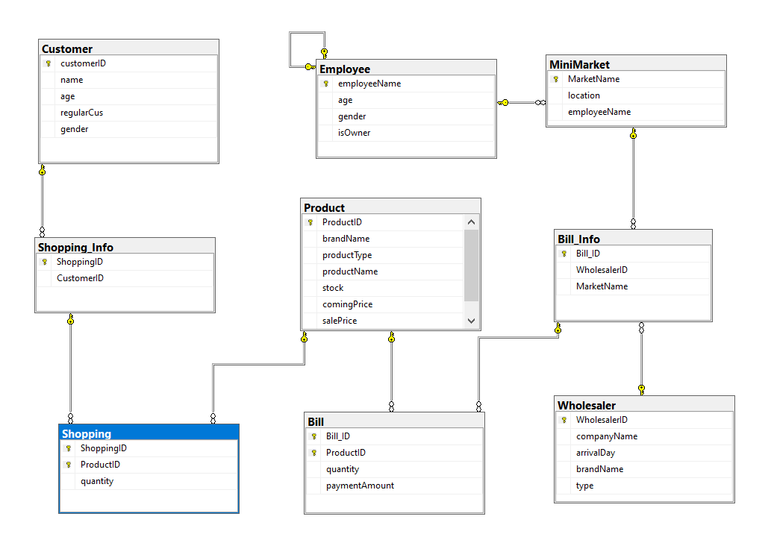

Tables:

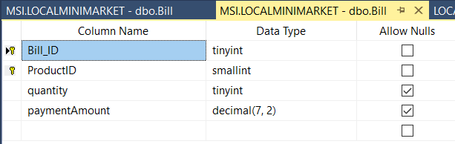

Bill Table:This table keeps data of bills ,calculates payment amount according to quantities and product table’s coming price value.

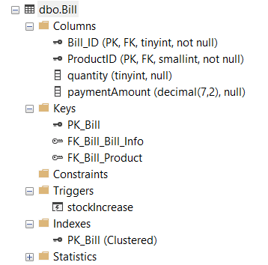

Information about indexes, primary key, foreign key.(Above)

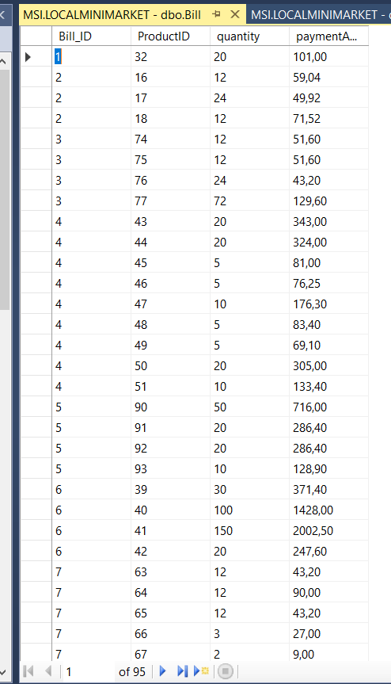

Figure1:General table

In this table,salePrice is a computed column like shown below.

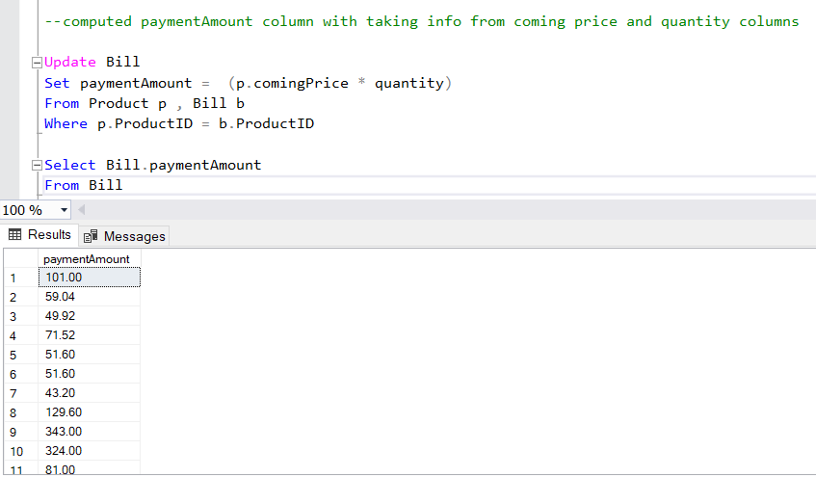

Bill_Info Table:

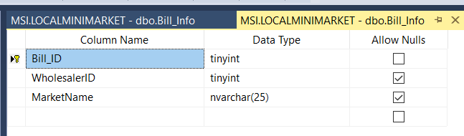

This table keeps relation between wholesaler,market. 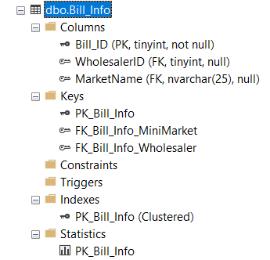

Information about indexes, primary key, foreign key.(Above)

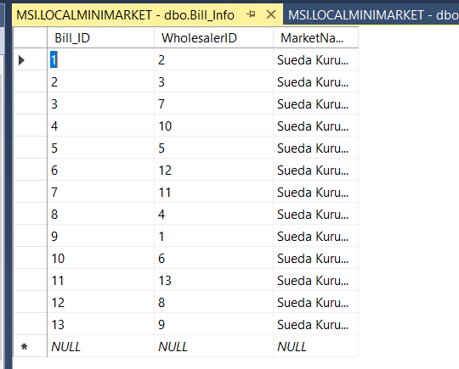Figure:General Table

Customer Table:

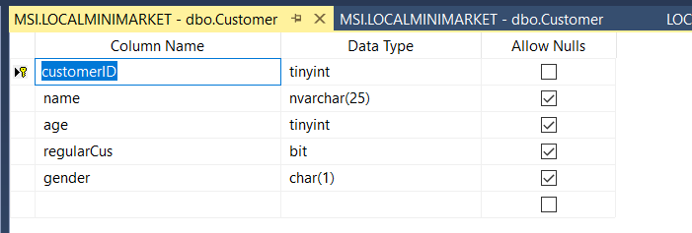

This table holds data of customer with name,age,gender values.

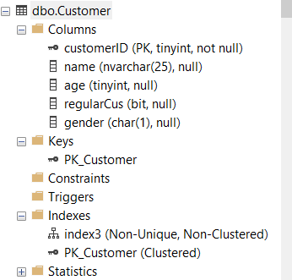

Information about indexes, primary key, foreign key.(Above)

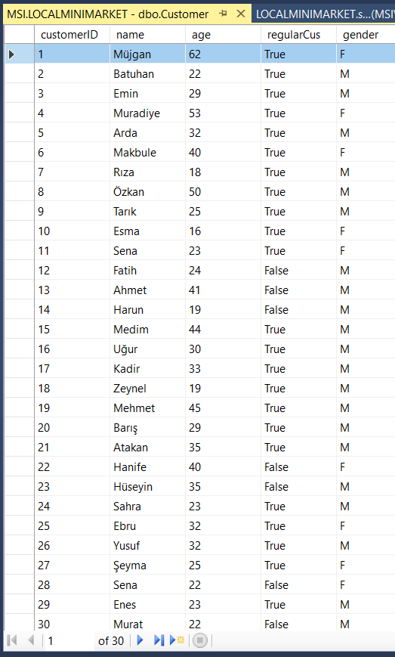 Figure:General Table

Nonclustured index for Customer’s name.

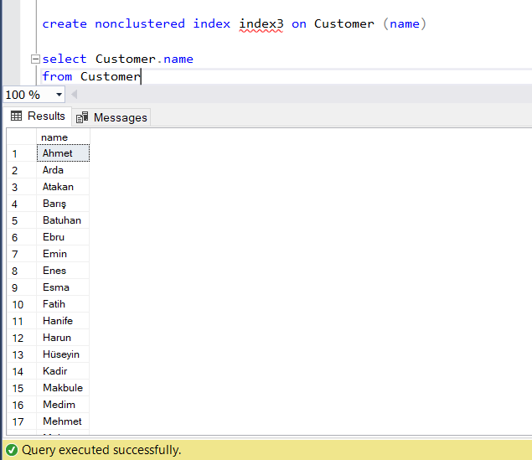

Employee Table:

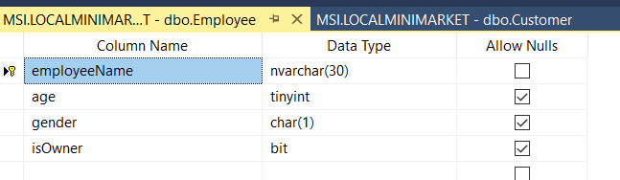

Employee table to hold informations of employees.

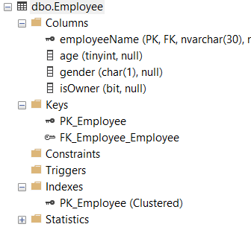

Information about indexes, primary key, foreign key.(Above)

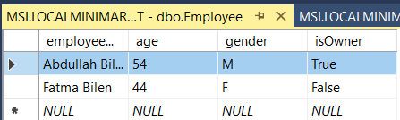

Figure:General Table

MiniMarket Table:

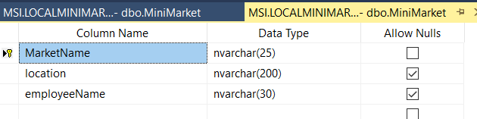

This table holds information of minimarket.

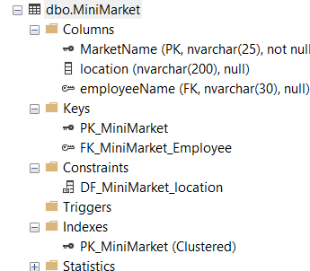

Information about indexes, primary key, foreign key.(Above)

There is a default key of location also.

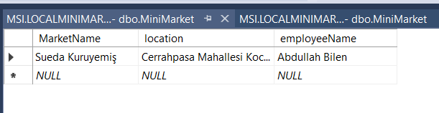

Product Table:

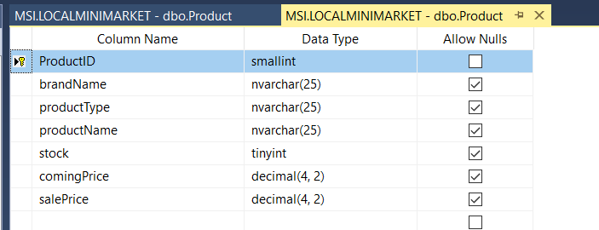

This table holds informations of products.

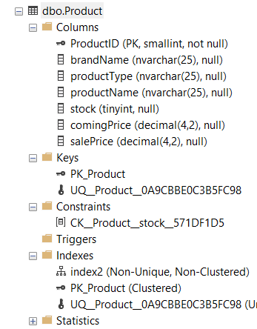

Information about indexes, primary key, foreign key.(Above)

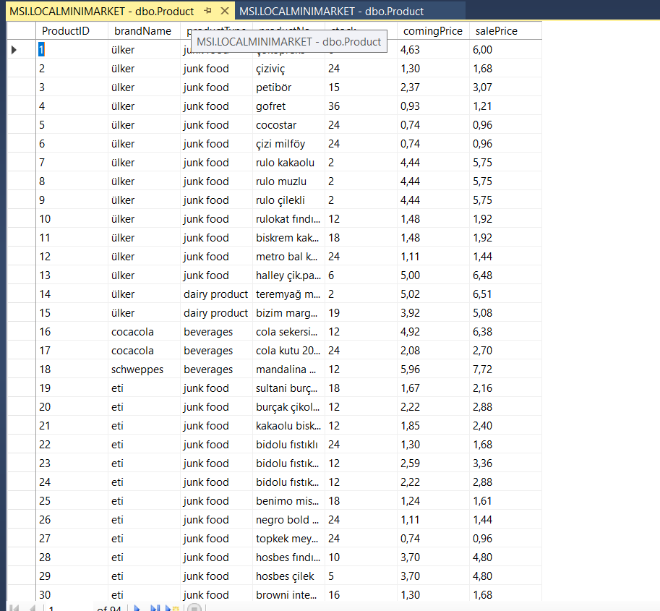

Figure: General Table

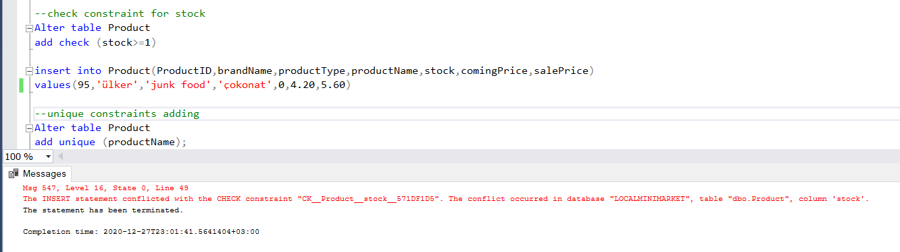

Check constraint defined.This error occurred because we tried to insert stock value as 0,then check constaint didn’t accept it because of stock should be higher than zero condition.

Unique key added.

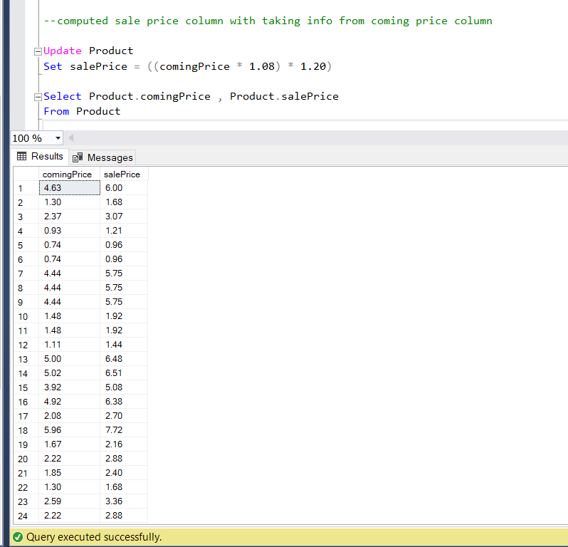

Computed salePrice column.This column computed from comingPrice values.

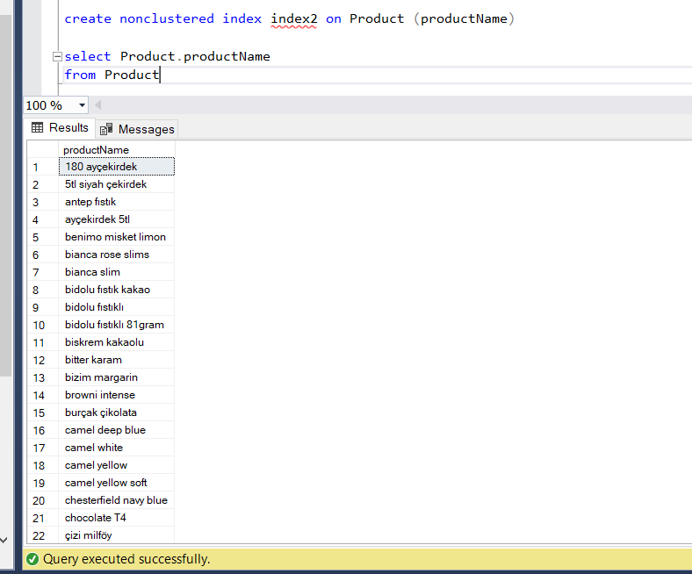

Index for productName to find easily and minimize executing time.

Shopping Table:

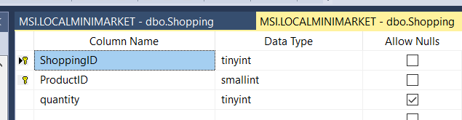

This table keeps data of every shopping.

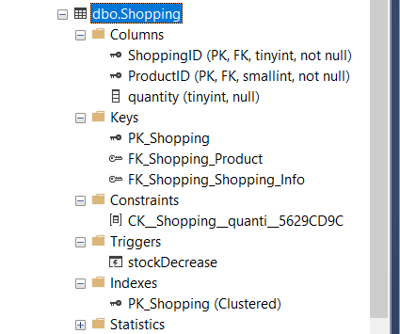

Information about indexes, primary key, foreign key.(Above)

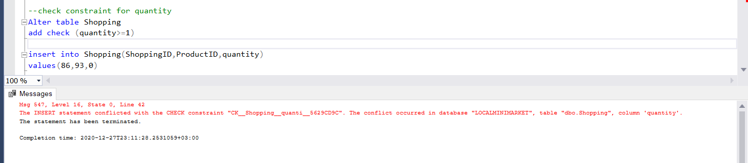

Check constraint added for checking quantity of product ,if we try to add an product with quantity equals to 0 then check constraint will give an error.

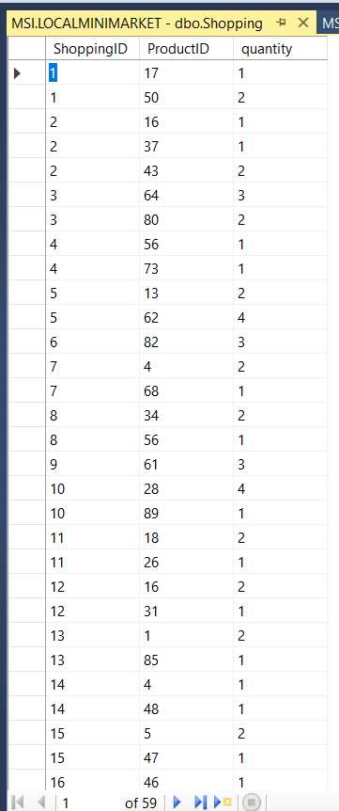

Figure : General Table

Shopping_Info Table:

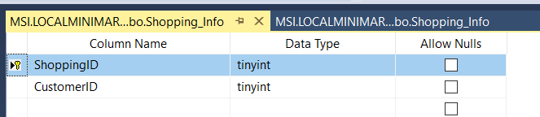

This table keeps data of customer and shopping ids.

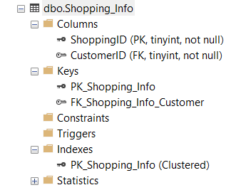

Information about indexes, primary key, foreign key.(Above)

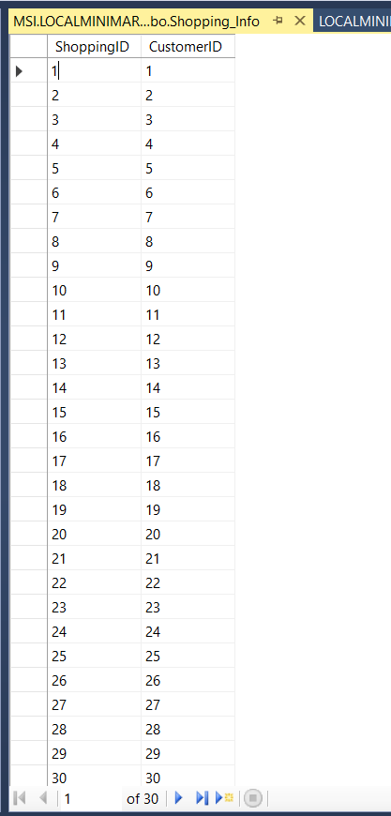

Figure : General Table

Wholesaler Table:

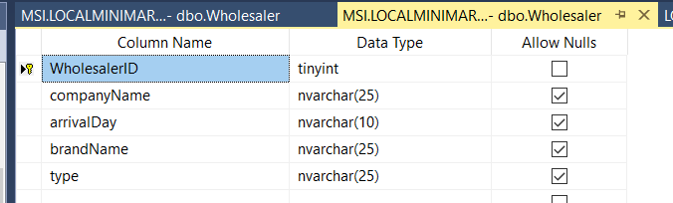

This table holds information of wholesalers.

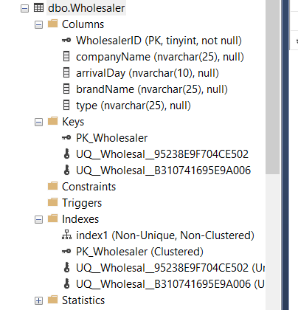

Information about indexes, primary key, foreign key.(Above)

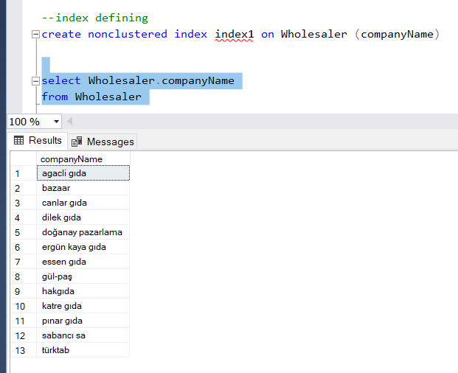

Nonclustured Index for companyName.To reach easily and minimizing execute time.

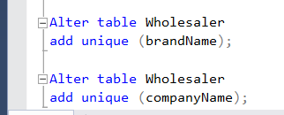

Unique key added.

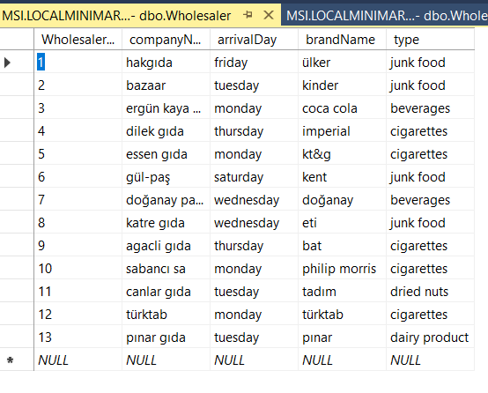

Figure : General Table

Views:

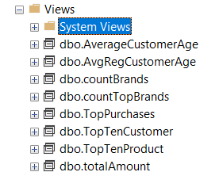

1.AverageCustomerAge:

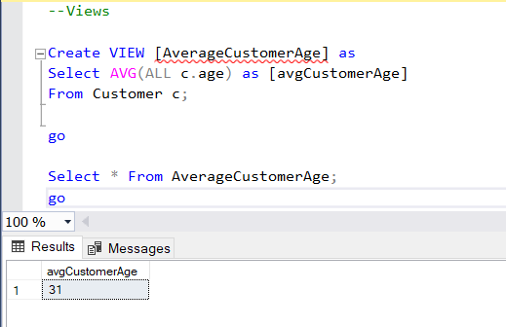

This view calculates average age of all customers.

2.AvgRegCustomerAge:

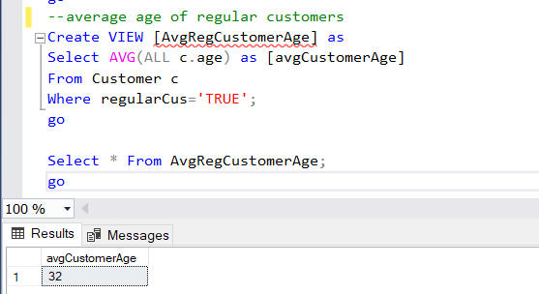

This view calculates average age of regular customers.

3.countBrands:

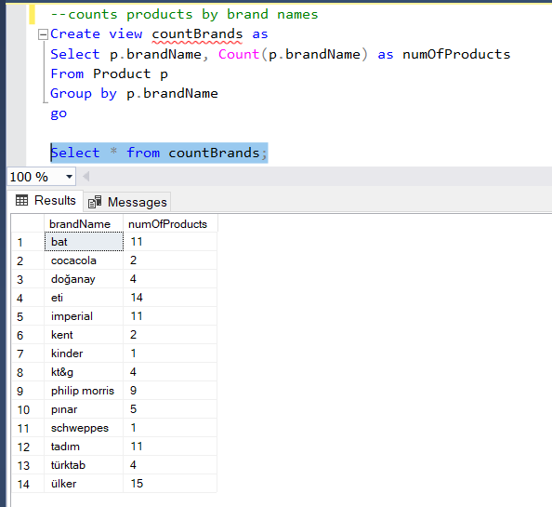

This view counts products by their brand names.

4.countTopBrands

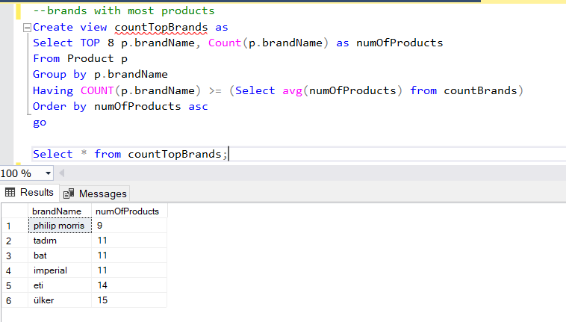

This view counts brands with the most products.

5.TopPurchases:

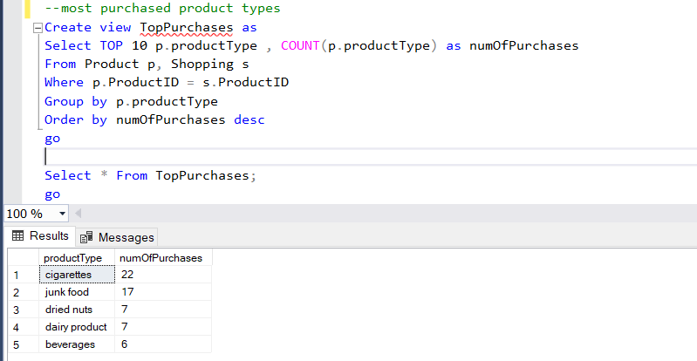

This view shows most purchased product types.

6.TopTenCustomer: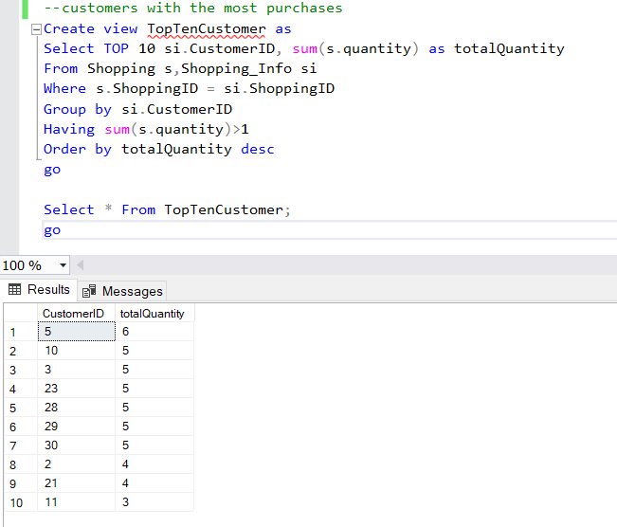

This view shows customers with the most purchases.

7.TopTenProduct:

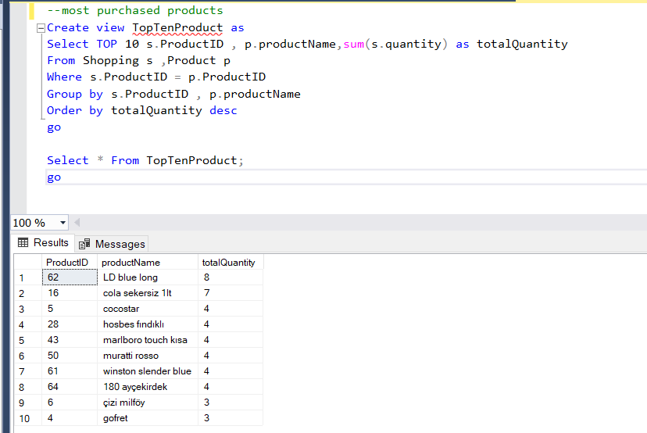

This view shows most purchased products.

8.TotalAmount

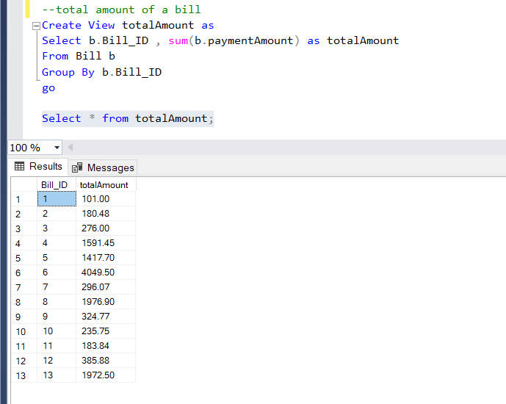

This view calculates total amount of a bill.

Triggers:

1.stockIncrease

When minimarket purchases products from wholesaler,these product purchases are inserting to Bill table.This trigger works when a purchase happened and it increases the stock of that product with ordered quantity.

Before triggering:

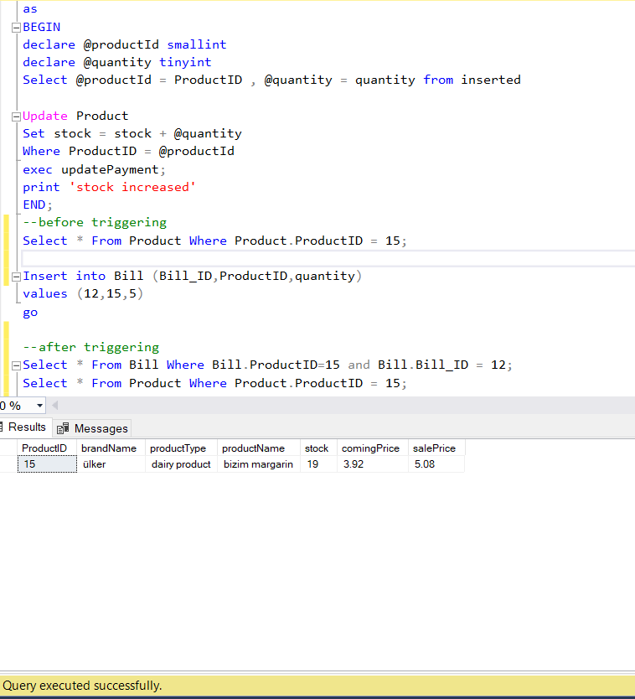

After triggering:

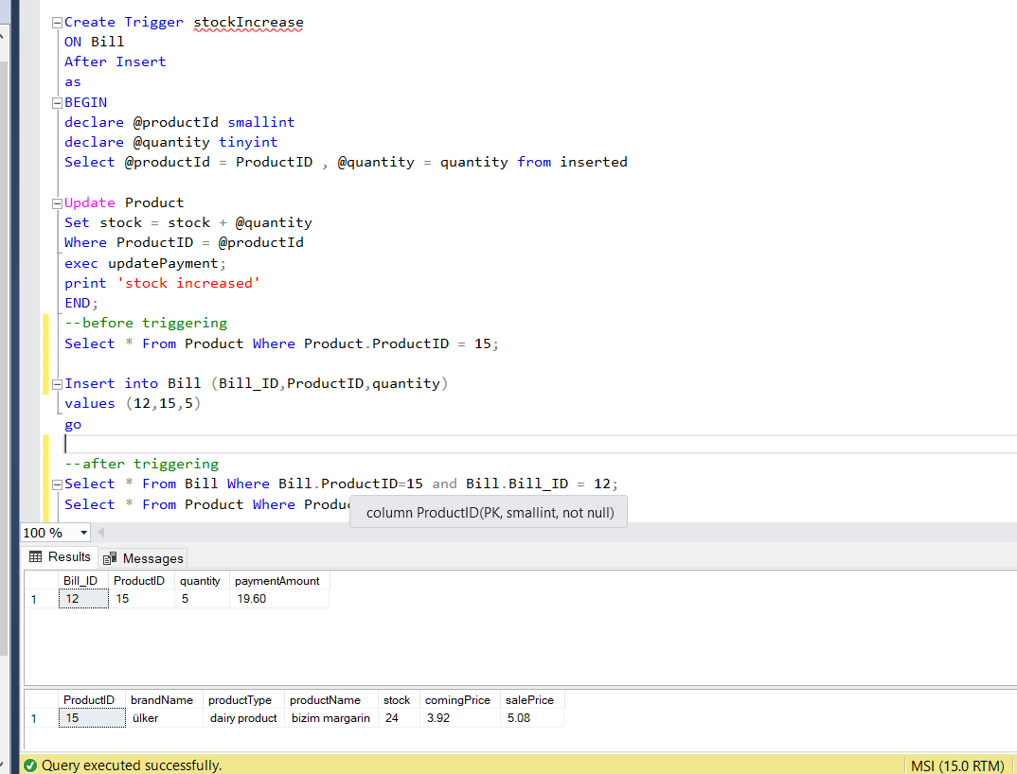

2.stockDecrease:When customer purchases products from minimarket,these product purchases are inserting to Shopping table.This trigger works when a purchase happened and it decreases the stock of that product with ordered quantity.

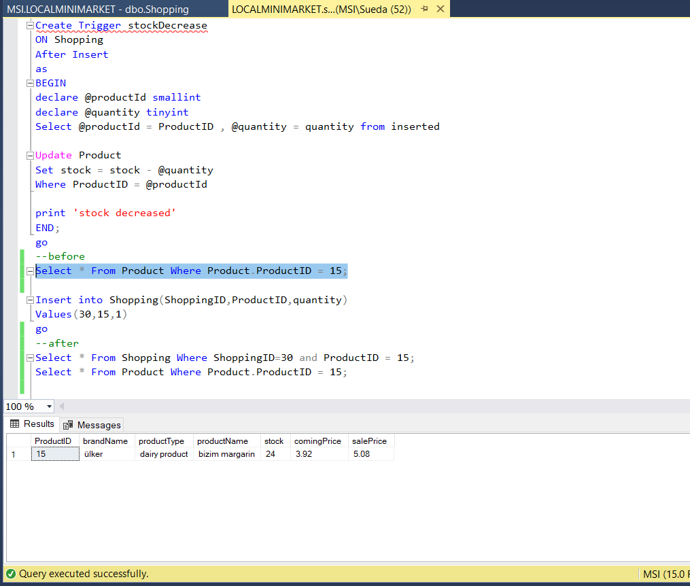 Before Triggering

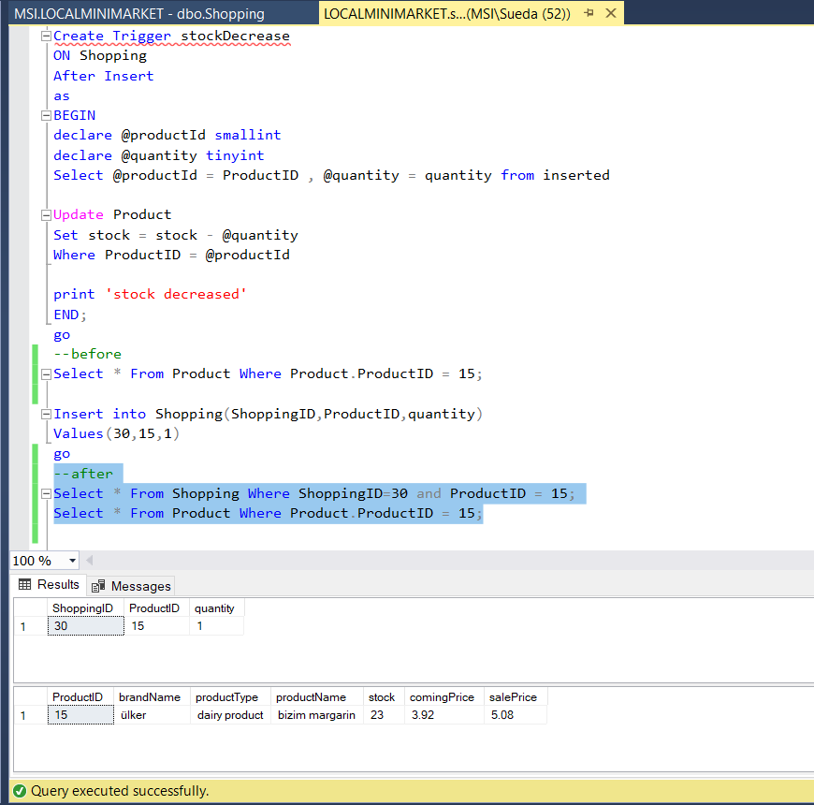 After Triggering

Store Procedures:

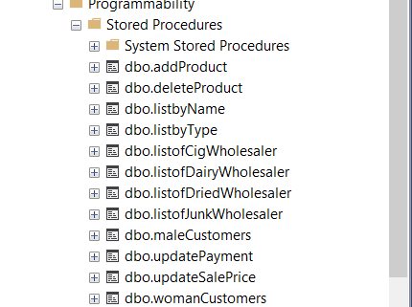

1.updateSalePrice

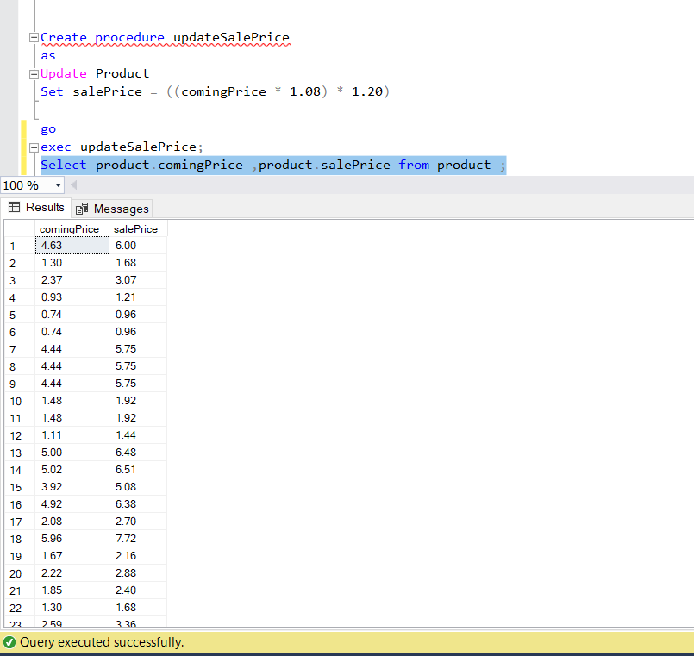

Updates sale prices by taking coming prices.

2.updatePayment

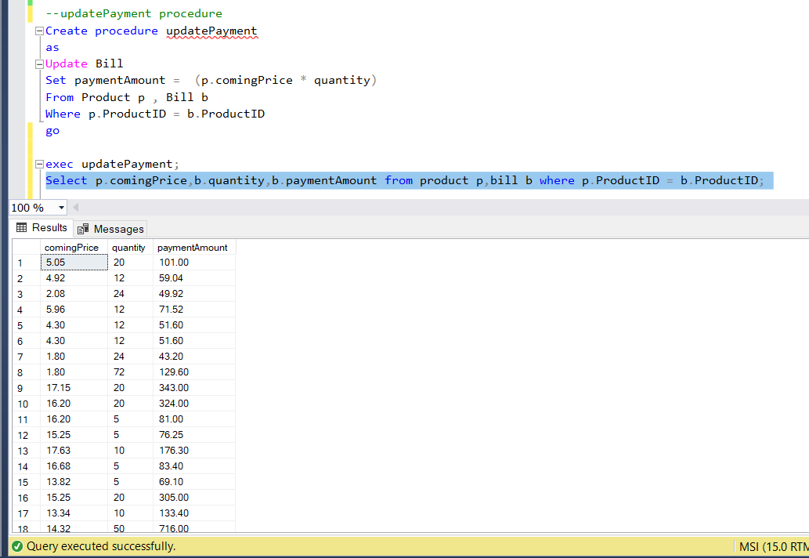

Updates payment by taking coming price and quantity values.

3.womanCustomers

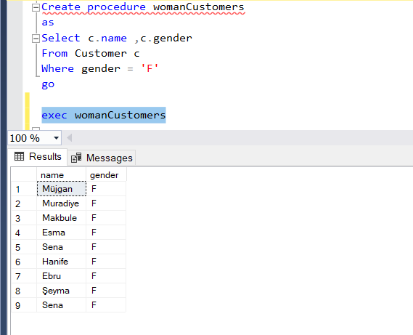

Lists woman customers.

4.maleCustomers

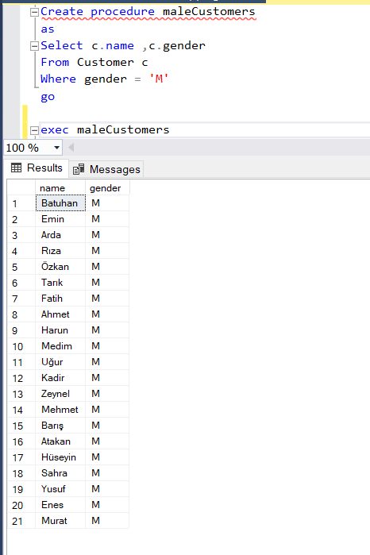

Lists male customers.

5.listbyType

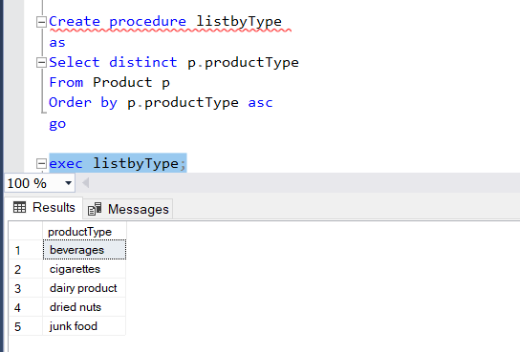

Lists products by their product types.

6.listofCigWholesaler

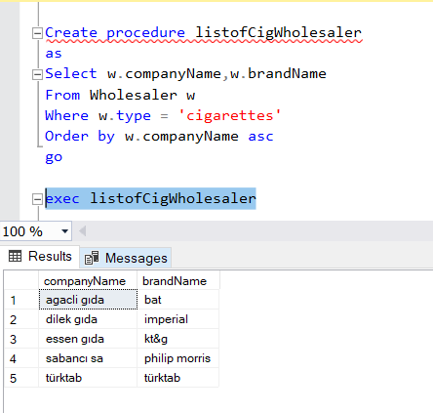

Lists wholesalers which sells cigarettes.

6.listofJunkWholesaler

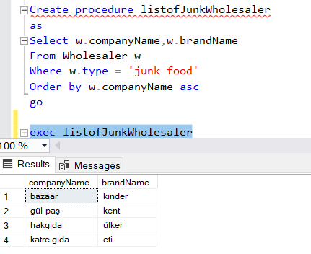

Lists wholesalers which sells junk food.

7.listofBevWholesaler:

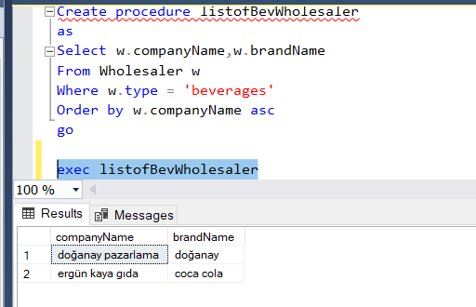

Lists wholesalers which sells beverages.

8.listofDairyWholesaler

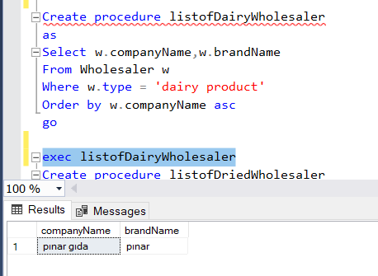

Lists wholesalers which sells dairy product.

9.listofDriedWholesaler

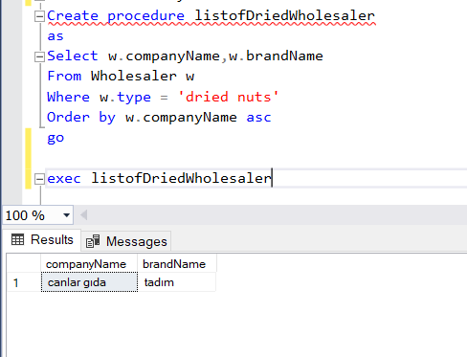

Lists wholesalers which sells dried nuts.

10.mostBusyDay

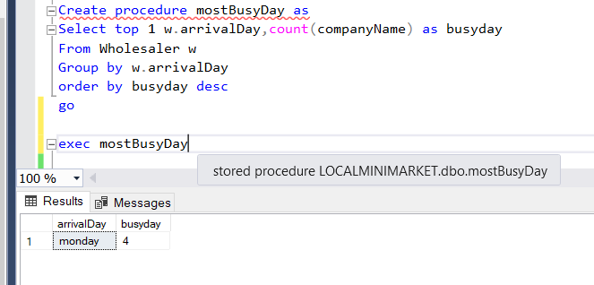

Finds most busy day which is the day many wholesaler comes to take orders.

11.addProduct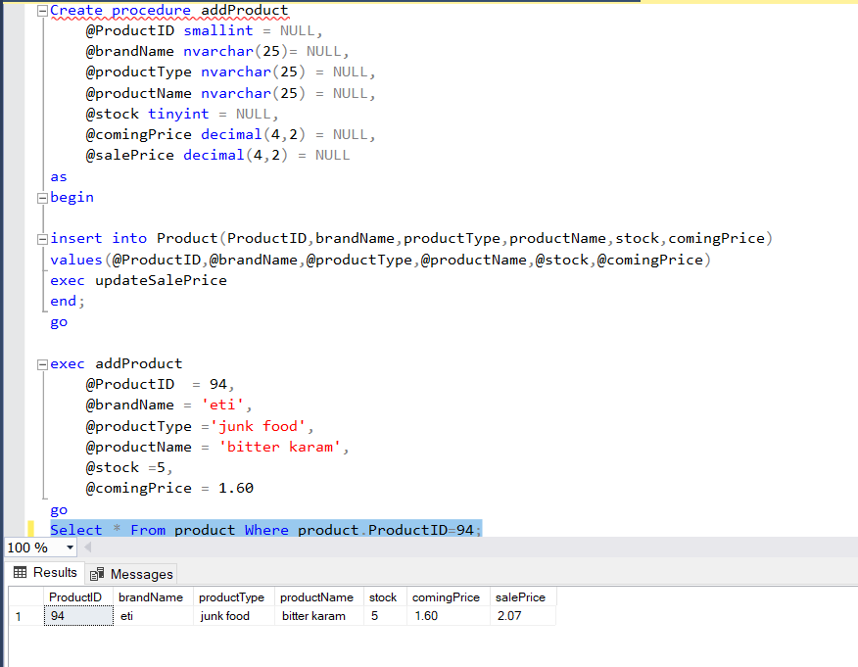

This stored procedure is to adding new product to the product table.

12.deleteProduct

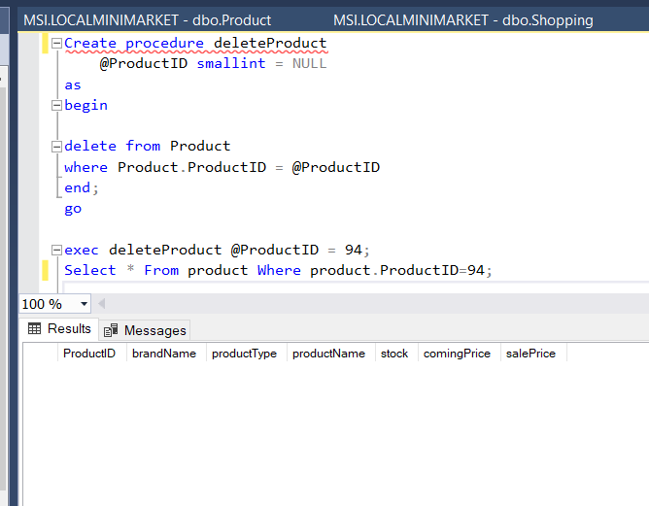

This stored procedure deletes a product from the product table.