Fellsmere AES Supporting Material

AES Technical

2023-01-19

# 1 Deliverables:

* Develop growth model
* Develop production plan
* Perform system mass balance equations
* Develop prototype system

# 2 Growth Modeling

Growth model based on data supplied from SyAqua Americas 95th st.facility.

***Litopenaeus vannamei*** growth characteristics:

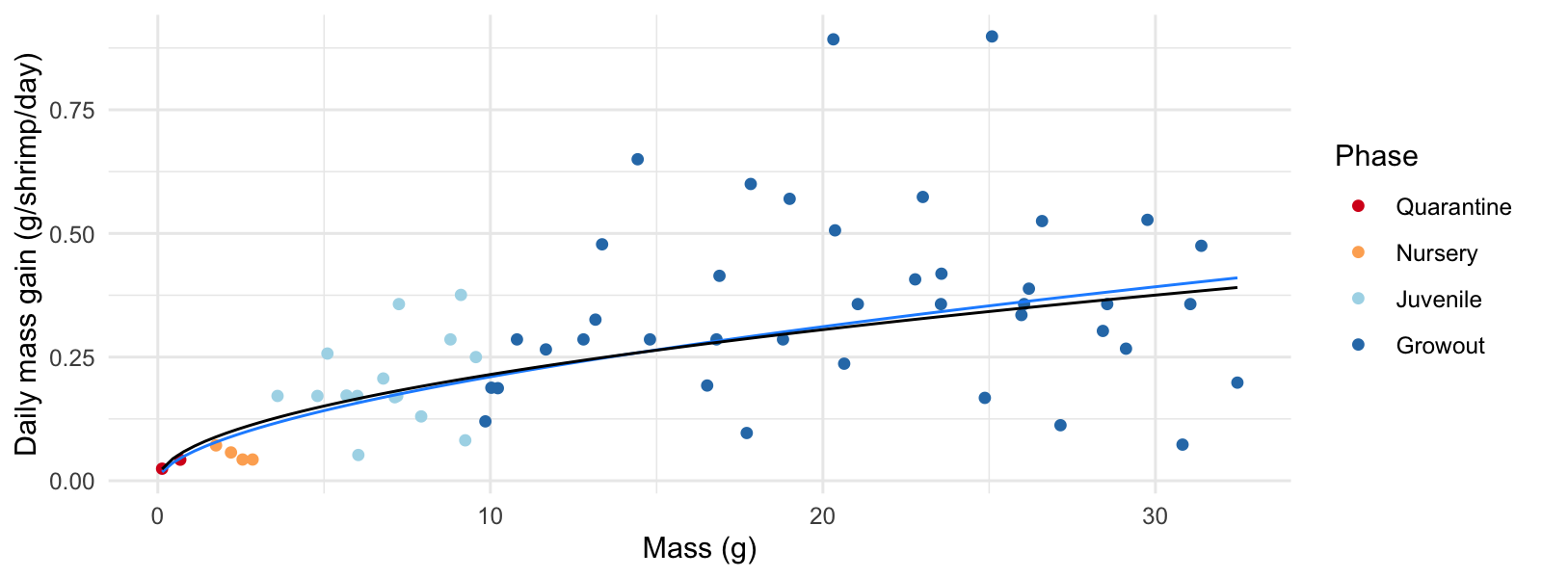

Figure 2.1: Daily growth rate by mass - datapoints from SyAqua 95thst (blue - arithmetric model, black - geometric model).

From the growth model, an estimate of white-leg shrimp body mass - as a function of time from introduction - can be calculated.

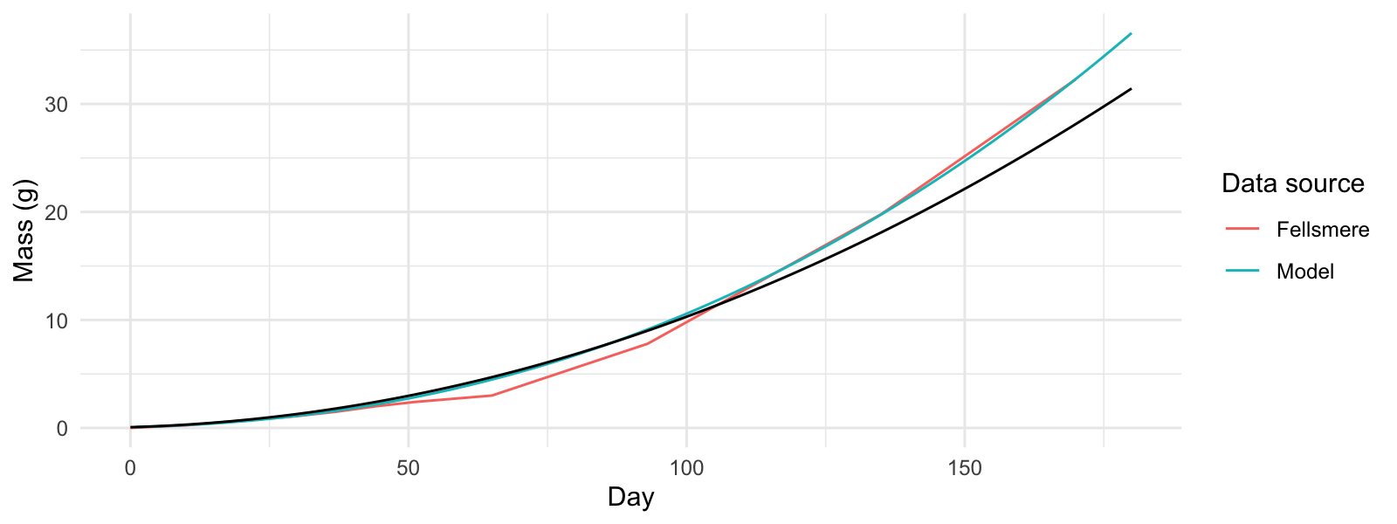

Figure 2.2: Estimated shrimp mass at time from introduction (blue - arithmetic model, black - geometric model).

Projected day to attain key bodyweights:

* Estimated growth day for 1.2g shrimp: Day 31
* Estimated growth day for 3g shrimp: Day 53
* Estimated growth day for 5g shrimp: Day 69
* Estimated growth day for 10g shrimp: Day 97
* Estimated growth day for 32g shrimp: Day 169

# 3 95th st. 2022 Operation modelling and review

Review production plan(s) to achieve:

* 95th st. 2022.Day 168 harvest 2200 individual 32g shrimp per raceway.
* 95th st. 2022. Day 182 harvest 600 individual 32g shrimp per raceway.

Definitions:

* Phase - life stage or treatment process (Quarantine, Nursery, Juvenile, Growout, Depurate).
* System - a single tank/ raceway in isolation or a group or tanks supported by a water processing unit.
* Facility - collection of systems and phases in operation at same time (not including quarantine as located at separate facility).

### 3.0.1 System Occupation 95thst 2022:

* Quarantine 30 days.
* Nursery 30 days.
* Juvenile 30 days.
* Grow-out up to 120 days.
* Depuration 4 days.

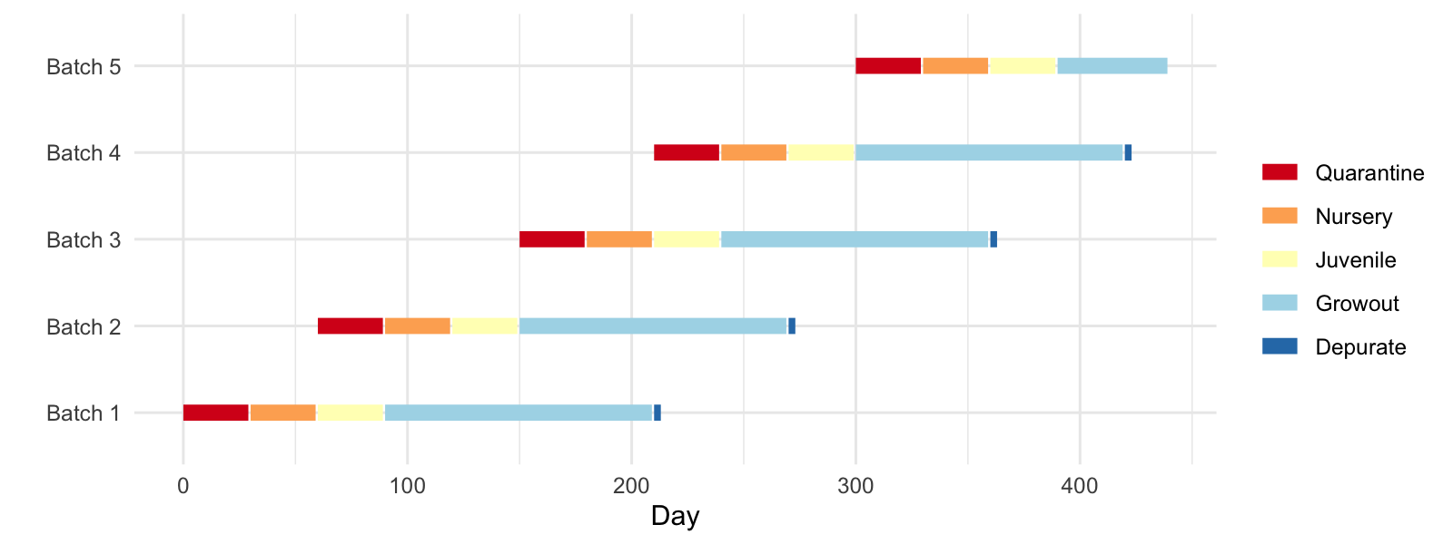

Figure 3.1: 95th st (2022). Production schematic.

## 3.1 System Loading 95th st. 2022

Parameters used:

* Quarantine survival 80 %
* Nursery survival 80 %
* Juvenile survival 80 % (95thst 2022 only)
* Growout survival 80 %

### 3.1.1 95th st. 2022 phase designations:

* Quarantine - initial population of 35000 individuals of body-weight 0.07 : 1.2
* Nursery - divide 19500, 1.2g, shrimp between 3 independently operating system(s), raise to 3g.
* Juvenile - rear 15000, 3g, shrimp within 1 system(s), raise to 10g.
* Growout - rear 11000, 10g, shrimp within 2 system(s), raise to 32g.
* Depuration - purge up to 1600, 32g shrimp - split between 4 tank(s), operated by 1 treatment system(s).

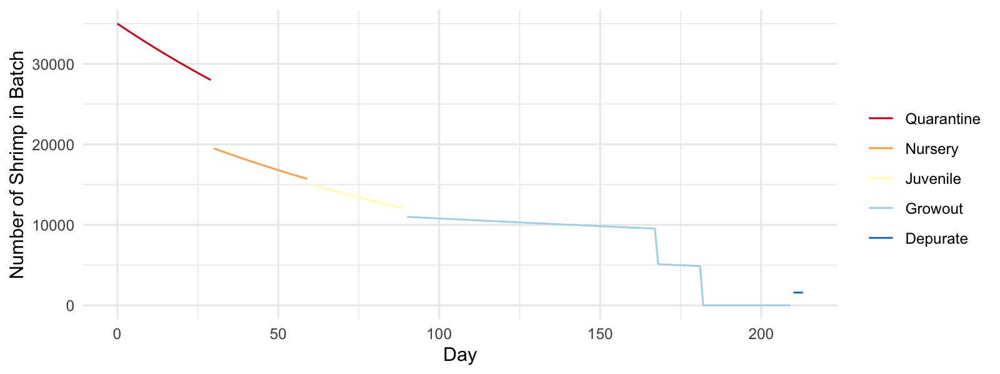

Figure 3.2: Total number of individuals per phase (95th st. 2022).

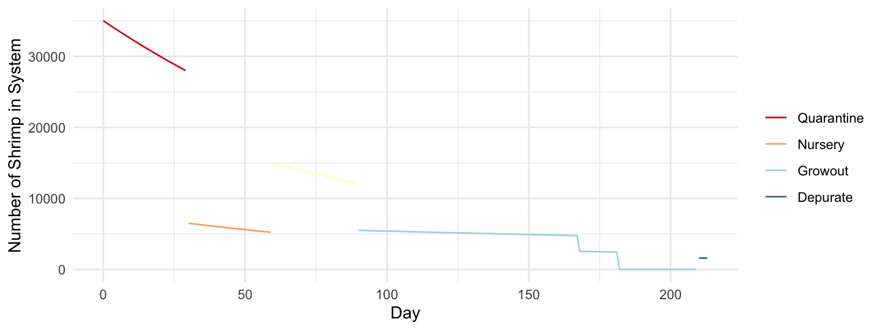

Figure 3.3: Total number of individuals per system (95th st. 2022).

The following feeding models were developed to estimate system loading across the production cycle through the developmental phases:

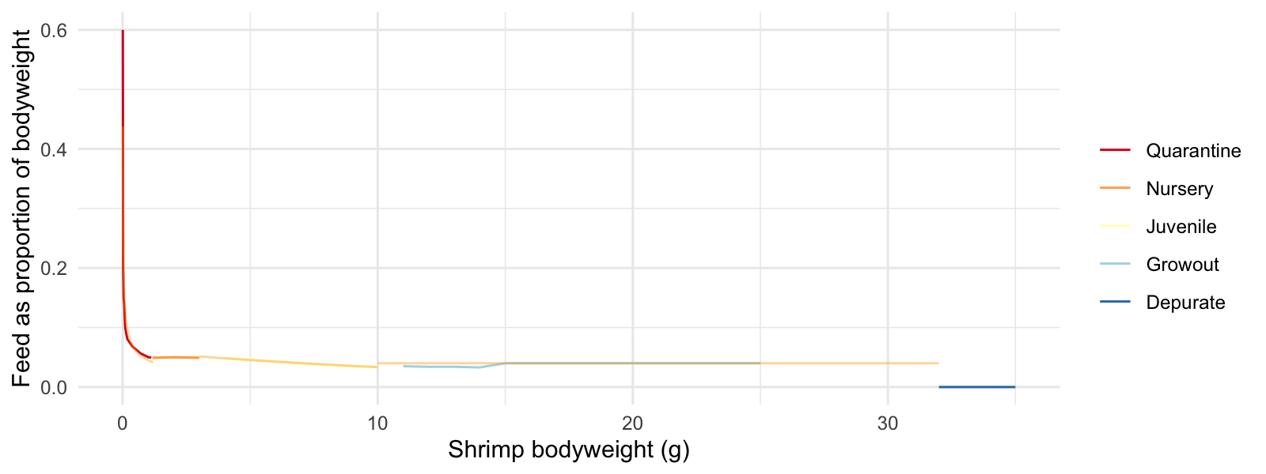

Figure 3.4: Feeding model - overlaid on feed tables.

### 3.1.2 Feed and protein maximum and average facility loading rates.

Table 3.1: 95th st. 2022 facility loading rates (overlapping batches where appropriate).

| Max n | Feed avg (Kg/day) | Feed max (Kg/day) | Protein avg (Kg/day) | Protein max (Kg/day) |
| --- | --- | --- | --- | --- |
| 35,404.87 | 9.29 | 17.05 | 3.35 | 5.97 |

### 3.1.3 Feed and protein maximum and average loading rates per day per system.

Table 3.2: 95th st. 2022 System loading rates.

| System | Max n | Feed avg (Kg/day) | Feed max (Kg/day) | Protein avg (Kg/day) | Protein max (Kg/day) |
| --- | --- | --- | --- | --- | --- |
| quarantine | 35,000.00 | 0.85 | 1.31 | 0.43 | 0.66 |
| nursery | 6,500.00 | 0.65 | 0.98 | 0.26 | 0.39 |
| juvenile | 15,000.00 | 3.35 | 3.72 | 1.34 | 1.49 |
| growout | 5,500.00 | 2.83 | 5.93 | 0.99 | 2.08 |
| depurate | 1,600.00 | 0.00 | 0.00 | 0.00 | 0.00 |

## 3.2 Water Quality Defining Parameters

Based on feed inputs, the following parameters (inputs or requirements) can be modelled:

* TAN–N Total ammonia nitrogen produced (ionised ammonia + un-ionised ammonia NH4+–N + NH3–N)
* TSS Total suspended solids produced
* CO2 Carbon dioxide produced
* O2D Oxygen demand
* Alk Alkalinity demand
* Carb Carbohydrate demand

## 3.3 Nitrogen Management

TAN–N loading

### 3.3.1 95th st. 2022 TAN–N summary

Table 3.3: 95th st. 2022 Facility loading rates (overlapping batches where appropriate).

| Max TAN (Kg/day) | Avg TAN (Kg/day) |
| --- | --- |
| 0.86 | 0.49 |

Table 3.4: 95th st. 2022 System loading rates.

| System | Max TAN (Kg/day) | Avg TAN (Kg/day) |
| --- | --- | --- |
| quarantine | 0.09 | 0.06 |
| nursery | 0.06 | 0.04 |
| juvenile | 0.21 | 0.19 |
| growout | 0.30 | 0.14 |
| depurate | 0.08 | 0.08 |

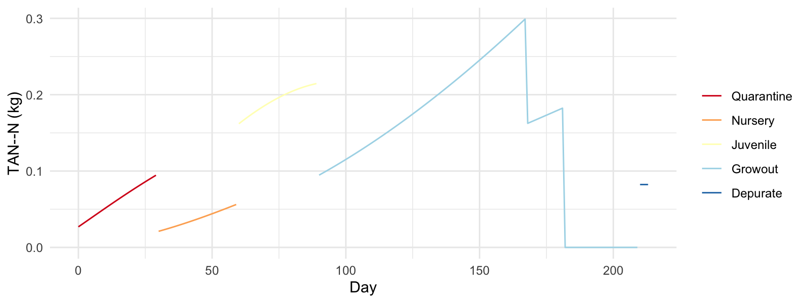

Figure 3.5: 95th st. 2022 System TAN–N profile.

Ammonia removal from intensive aquaculture production can be managed by three distinct pathways:

* Photoautotrophic (algal)
* Autotrophic (bacterial)
* Heterotrophic (bacterial)

Of relevance in the production process at SyAqua Americas are autotrophic (quarantine and depuration/ purging) and heterotrophic (nursery, juvenile and grow-out) pathways.

Chemoautotrophic pathway (simplified) NH4+ + O2 + alkalinity → NO2- → NO3- + CO2 + small amount of bacterial biomass

Heterotrophic pathway (simplified) NH4+ + O2 + alkalinity + organic C → large amount of bacterial biomass + CO2

The carbon/ nitrogen ratio influences the relative proportion of autotrophic/ heterotrophic bacterial community and therefore may be used as a management tool for determination of nitrogen removal pathway.

Stoichiometric equations predict that for every g of ammonia-nitrogen converted to microbial biomass (by heterotrophic bacteria), 15.17 g of carbohydrates or 6.07 g of organic carbon is consumed. Organic carbon can be made available from livestock feed constituents and supplementary carbohydrate additions e.g. molasses or other source.

NH4+ – N within the quarantine systems would typically be removed primarily by the chemoautotrophic pathway, utilising a fixed film moving-bed bioreactor. The volume of the biomedia would be dictated by the surface area and the maximum potential daily NH4+ – N loading.

Suggested minimum quarantine biomedia surface areas are as follows (based on a 24 hr metabolic period and clearwater operating system):

95th st. 2022; 236m2

NH4+ – N within the depuration/ purging systems would typically be managed by water exchange and minimal nitrification/ ammonia sequestration from bacteria present in the sand filter/ water column.

The chart below indicates theoretical carbohydrate additions required to supplement organic carbon supplied in feed (nursery/ juvenile/ grow-out stages only).

Calculations based upon:

TAN produced * bacterial carbohydrate demand - carbohydrate in feed

Feed input * protein proportion * 0.144 * 15.17 - (feed input * 0.1089 / 0.4)

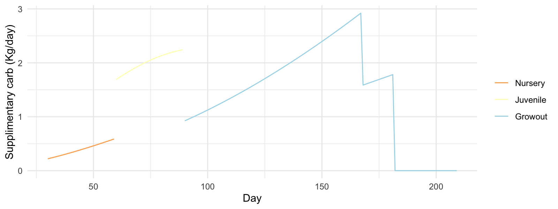

Figure 3.6: 95th st. 2022 Theoretical supplimentary carbohydrate requirement (per System).

## 3.4 Solids Management

Solids within the production process will be comprised of uneaten feed, faeces and bacterial biomass.

The literature indicates a total suspended solids (TSS) concentration of 200-300 mg/l is typical within biofloc operation, and levels of up to 500 mg/l may be acceptable without reduction of welfare or growth of shrimp.

Solids concentration will increase in zero exchange systems and active management techniques may be required to maintain optimal levels of TSS.

TSS accumulation can be modelled according to system management based on feed input for chemoautotrophic-managed nitrogen pathways or feed input and bacterial biomass synthesised for heterotrophic-managed nitrogen pathways.

Solids profile not currently awailable from SyAqua.  
Generic biofloc solids profile as follows: < 48 m 53%, 48-100 m 12%, > 100 m 36%  
Generic clearwater RAS solids profile (trout): < 40 m 10%, 40-100 m 40%, > 100 m 50%

Settling velocities (caveat - estimated specific gravity of waste particle 1050kg/m3, density of seawater at 30oC 1018 kg/m3):

$$V = {2r^2 * g * (d_p - d_m)} \over {9 * \rho}$$

48 0.0000472171 m/s  
75 0.000115276 m/s  
100 0.000204935 m/s

Flowrate in settling tank : V = 4.666534^{-4}m/s or 0.0466653 cm/s

Table 3.5: 95th st. 2022 Particle settling efficiency at operational flowrate of settling tank.

| Particle Size mu m | Settling Velocity m/s | Percentage Efficiency |
| --- | --- | --- |
| 48.00000 | 0.00005 | 10.11824 |
| 75.00000 | 0.00012 | 24.70273 |
| 100.00000 | 0.00020 | 43.91597 |
| 250.00000 | 0.00128 | 100.00000 |

Approximation for settling tank efficiency TE = 24.13 %

Table 3.6: 95th st. 2022 Facility loading rates (Kg/day TSS modelled for clearwater CW and biofloc BF).

| Max TSS CW | Avg TSS CW | Max TSS BF | Avg TSS BF |
| --- | --- | --- | --- |
| 4.26 | 2.32 | 11.20 | 6.22 |

Table 3.7: 95th st. 2022 System loading rates (Kg/day TSS modelled for clearwater CW and biofloc BF).

| System | Max TSS CW | Avg TSS CW | Max TSS BF | Avg TSS BF |
| --- | --- | --- | --- | --- |
| quarantine | 0.33 | 0.21 | 0.33 | 0.21 |
| nursery | 0.24 | 0.16 | 0.70 | 0.47 |
| juvenile | 0.93 | 0.84 | 2.66 | 2.39 |
| growout | 1.48 | 0.71 | 3.90 | 1.87 |
| depurate | 0.00 | 0.00 | 0.02 | 0.02 |

A cumulative TSS sum may give an indication of the timing within the production run that the desired TSS will be achieved. From this point onwards, solids will require either continuous or periodic removal to maintain TSS within acceptable limits.

Calculations based upon full tanks:

* Nursery 15 m3
* Juvenile (95th 2022) 80 m3
* Growout 80 m3

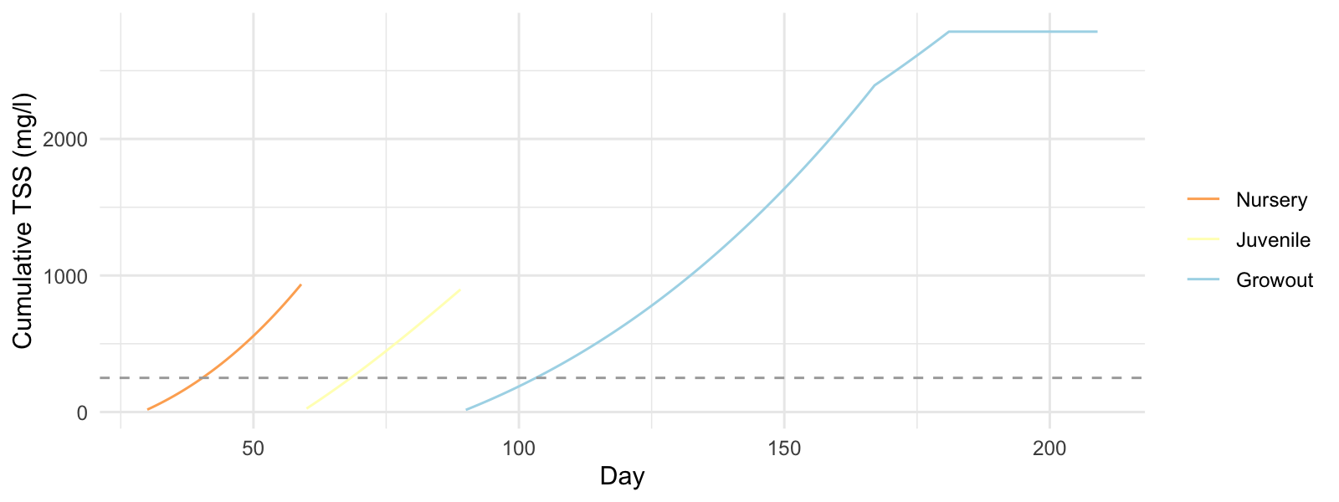

Figure 3.7: 95th st. 2022 Cumulative TSS accumulation - without solids management (per System).

Drum Filter Flow Requirements/ or other solids removal device operating at 21% efficiency:

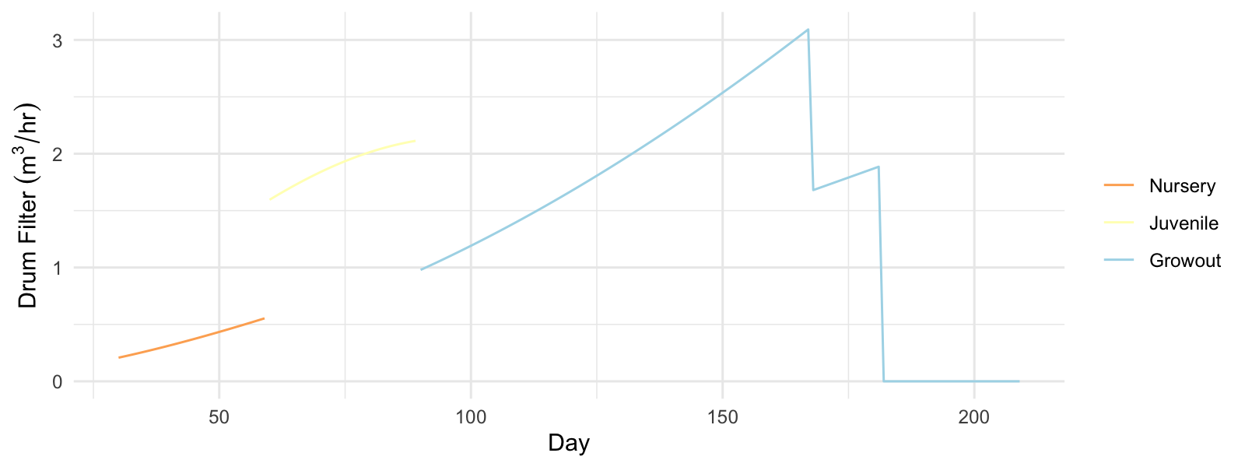

Figure 3.8: 95th st. 2022 Drum filter flow requirements to maintain 250 mg/l TSS (per System).

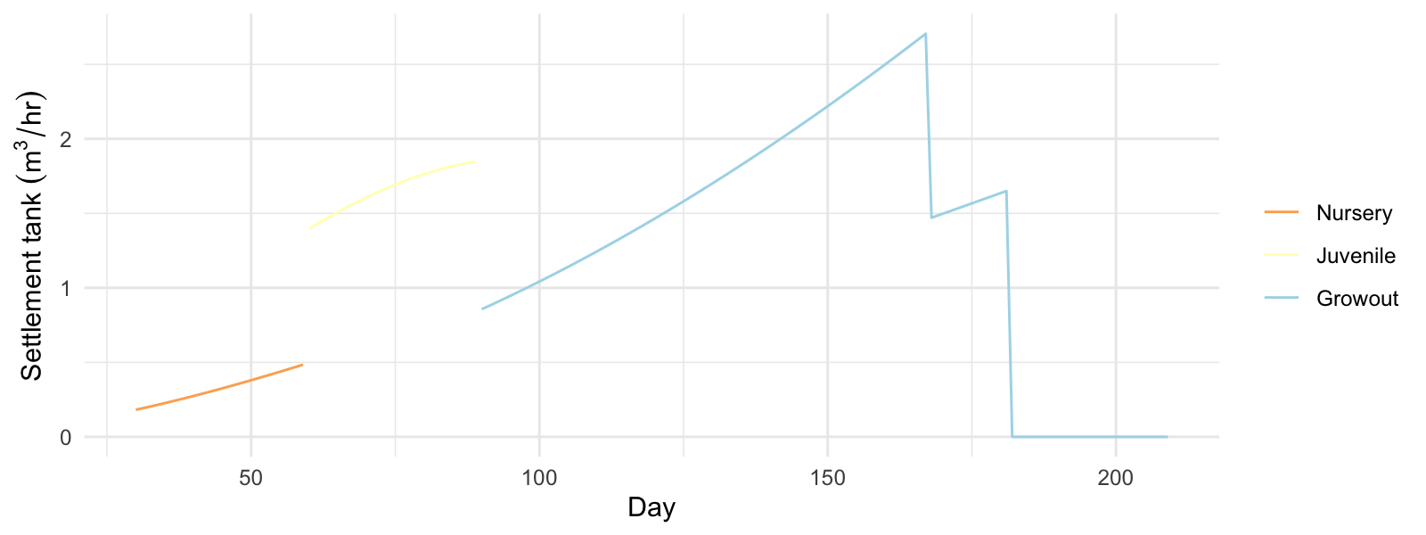

Figure 3.9: 95th st. 2022 Settlement tank flow requirements to maintain 250 mg/l TSS (per System).

Table 3.8: 95th st. 2022 Estimated system drum filter (DF) and settlement tank (ST) required flowrates m3/hr.

| system | Max Flow DF | Avg Flow DF | Max Flow ST | Avg Flow ST |
| --- | --- | --- | --- | --- |
| nursery | 0.55 | 0.37 | 0.48 | 0.32 |
| juvenile | 2.11 | 1.90 | 1.85 | 1.66 |
| growout | 3.09 | 1.88 | 2.71 | 1.64 |

Drum Filter Water Usage

Drum filter water usage calculations based upon 50 litres consumed for cleaning per kilo of feed supplied using a 100 $$m mesh (under normal fish farm conditions). Adjusted here to reflect additional bacterial biomass produced under biofloc conditions. For comparison clearwater drumfilter water use calculated based upon 200 litres consumed per kilo of feed using a 30 $$m mesh. Note - solids profile does not seem to warrant a change of mesh size from 30 to 100 $$m. Therefore water consumption rates could be a multiple of four times greater by utilising 30 $$m mesh.

Table 3.9: 95th st. 2022 Estimated facility drum filter water use m3/day (clearwater CW and biofloc BF).

| Max Volume CW | Avg Volume CW | Max Volume BF | Avg Volume BF |
| --- | --- | --- | --- |
| 3.41 | 1.86 | 2.24 | 1.24 |

Table 3.10: 95th st. 2022 System drum filter water use m3/day.

| System | Max Use CW | Avg Use CW | Max Use BF | Avg Use BF |
| --- | --- | --- | --- | --- |
| nursery | 0.20 | 0.13 | 0.14 | 0.09 |
| juvenile | 0.74 | 0.67 | 0.53 | 0.48 |
| growout | 1.19 | 0.57 | 0.78 | 0.47 |

## 3.5 Oxygen

Oxygen demand - for specification of emergency oxygen requirements/ oxygen supply systems or air supply volume (air volumes estimated with a 5% oxygen transfer efficiency rate)

Table 3.11: 95th st. 2022 Facility oxygen requirement (Kg/day).

| Max oxy | Avg oxy |
| --- | --- |
| 8.31 | 4.64 |

Table 3.12: 95th st. 2022 System oxygen demand (Kg/day).

| System | System max OD | System avg OD |
| --- | --- | --- |
| quarantine | 0.76 | 0.49 |
| nursery | 0.51 | 0.34 |
| juvenile | 1.94 | 1.75 |
| growout | 2.89 | 1.39 |
| depurate | 1.23 | 1.23 |

Air demand based upon aeration at atmospheric pressure and a transfer efficiency of 5%

Table 3.13: 95th st. 2022 System air demand to supply required oxygen m3/day.

| System | Max air demand | Avg air demand |
| --- | --- | --- |
| quarantine | 58.46 | 38.06 |
| nursery | 39.12 | 26.24 |
| juvenile | 149.36 | 134.28 |
| growout | 222.41 | 106.57 |
| depurate | 94.52 | 94.52 |

## 3.6 Alkalinity

For every g of ammonia-nitrogen converted to nitrate-nitrogen (chemoautotrophic pathway), 7.05 g of alkalinity (1.69 g inorganic carbon) is consumed.

For every g of ammonia-nitrogen converted to microbial biomass (heterotrophic pathway), 3.57 g of alkalinity (0.86 g inorganic carbon) is consumed.

Alkalinity also plays a role in pH buffering capacity

The following tables indicate the average and maximum alkalinity demands and will be followed by charts predicting daily alkalinity consumption in tanks/ process units.

Table 3.14: 95th st. 2022 Facility alkalinity requirement (Kg/day).

| Max Alk | Avg Alk |
| --- | --- |
| 3.07 | 1.74 |

Table 3.15: 95th st. 2022 System alkalinity demand (Kg/day).

| System | System max Alk | System avg Alk |
| --- | --- | --- |
| quarantine | 0.67 | 0.43 |
| nursery | 0.20 | 0.13 |
| juvenile | 0.77 | 0.69 |
| growout | 1.07 | 0.51 |
| depurate | 0.58 | 0.58 |

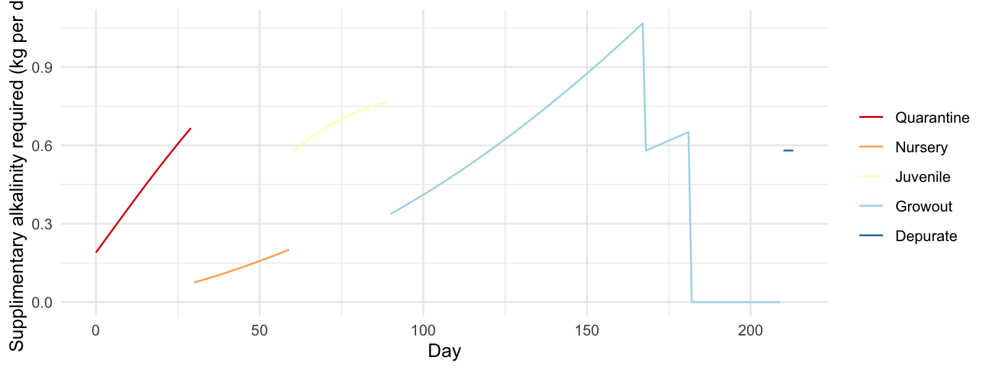

Figure 3.10: 95th st. 2022 Theoretical supplimentary alkalinity requirement (kg per System).

## 3.7 CO2

Literature suggests dissolved CO2 should remain below 7mg/l - 10mg/l

Tables below summarise daily CO2 production for overall facility and tank/ process units

Table 3.16: 95th st. 2022 Facility CO2 loading (Kg/day).

| Max Loading | Avg Loading |
| --- | --- |
| 11.43 | 6.38 |

Table 3.17: 95th st. 2022 System CO2 loading (Kg/day).

| System | Max Loading | Avg Loading |
| --- | --- | --- |
| quarantine | 1.04 | 0.68 |
| nursery | 0.70 | 0.47 |
| juvenile | 2.67 | 2.40 |
| growout | 3.98 | 1.90 |
| depurate | 1.69 | 1.69 |

Flow requirements to maintain CO2 levels at a maximum of 10mg/l (for pH values above 7.5 with alkalinity ~ 150 mg/l, no degassing required, aeration expected to prevent buildup of CO2)

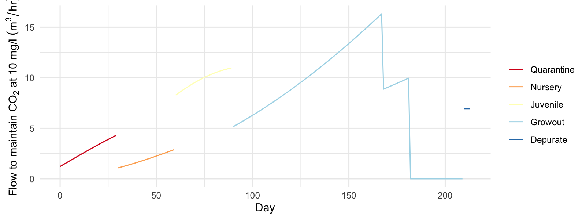

Figure 3.11: 95th st. 2022 System flow rate required to degas CO2 to 10 mg/l.

## 3.8 Summary Charts of Water Chemsitry Data RW4 95th st. 2022

### 3.8.1 TAN Levels RW4 2022

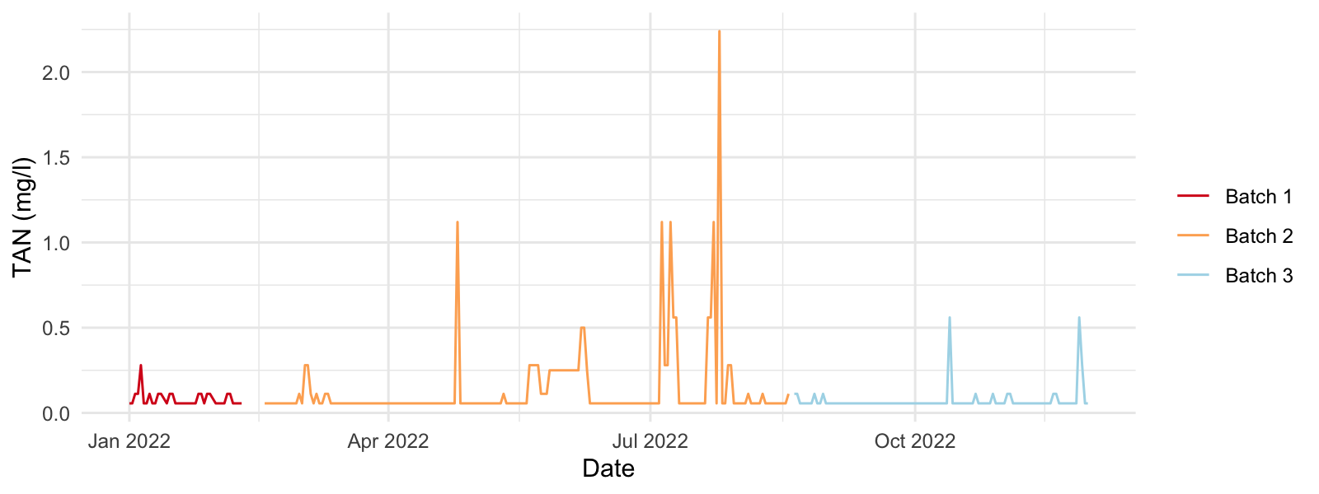

Figure 3.12: TAN levels in RW 4 2022.

Comments: Sub-optimal variation in TAN levels, indication of variable rate of ammonia removal. Majority of time TAN is within acceptable level < 1.0 mg/l. Consider organic carbon addition according to feed protein loading to maintain a steady state carbon source for bacteria to process ammonia.

### 3.8.2 Unionised Ammonia

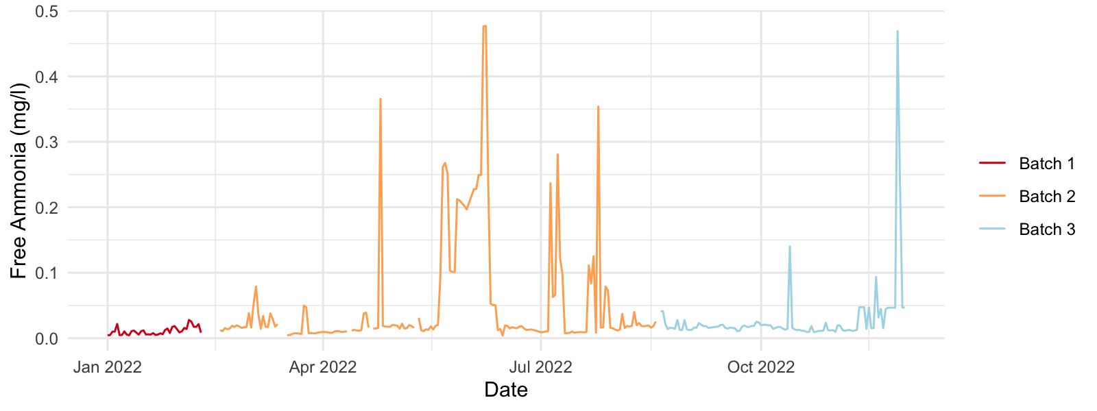

Figure 3.13: Free ammonia levels in RW 4 2022.

Comments: High variability in level of unionised ammonia. Influenced by both TAN and pH. Instances of levels exceeding 0.3mg/l, majority of time within acceptable range.

### 3.8.3 Nitrite RW4 2022

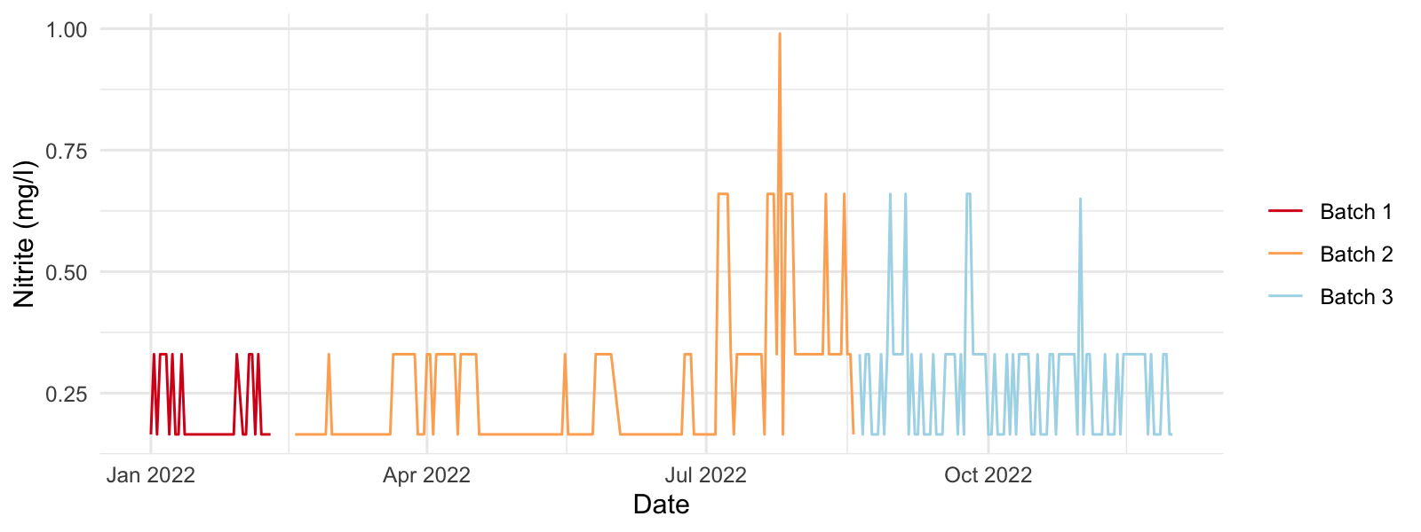

Figure 3.14: Nitrite levels in RW 4 2022.

Comments. For a heterotrophic managed nitrogen removal system, production of nitrite expected to be low (realistically a small proportion of ammonia will be converted to nitrite and nitrate by the autotrophic pathway). Management of optimal C:N ratio and solids removal to optimise heterotrophic domination of ammonia removal.

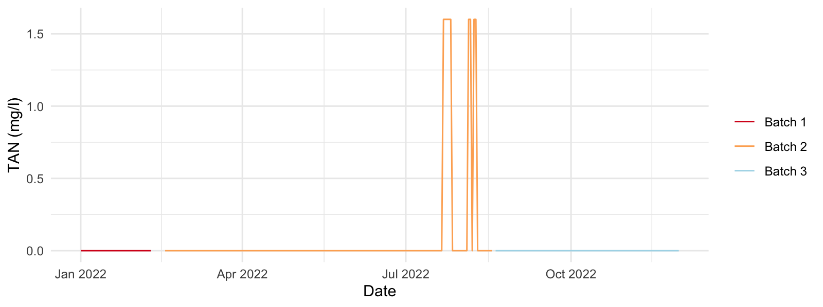

(#fig:molassesUse, )Molasses inputs in RW 4 2022.

Comments: Information indicating that molasses added when solids level below 1ml in imhoff cone. Not consistent with requirement modelling above based on stoichiometry indicates addition of carbon source according to protein addition from feed.

### 3.8.4 Alkalinity RW4 2022

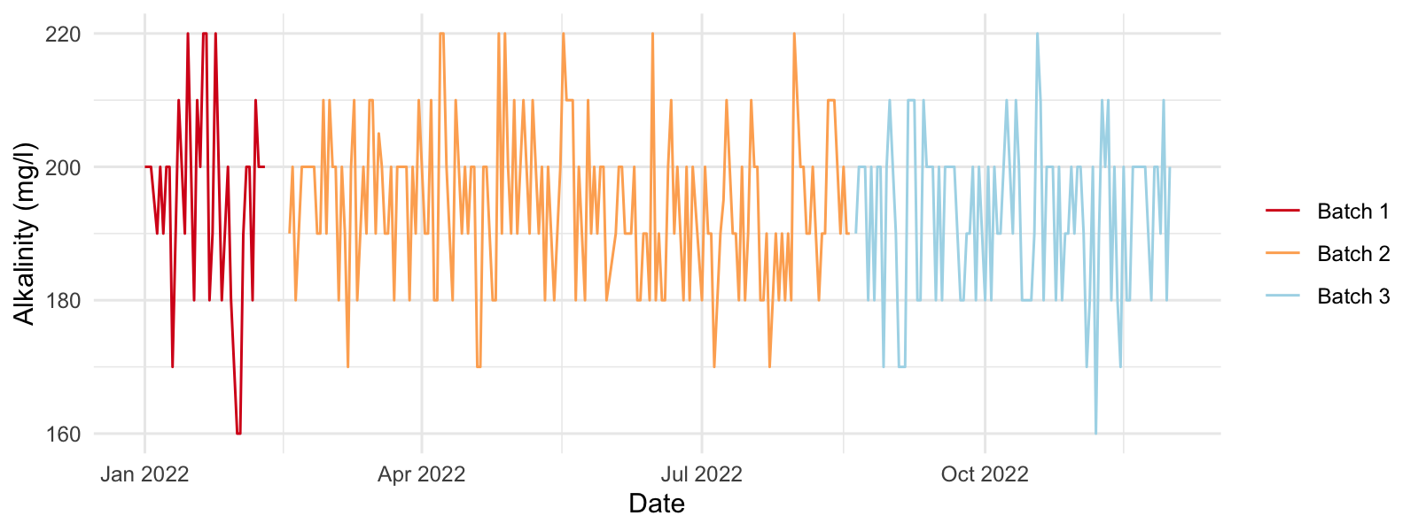

Figure 3.15: Alkalinity levels in RW 4 2022.

Comments: Alkalinity appears to be well managed.

### 3.8.5 pH RW4 2022

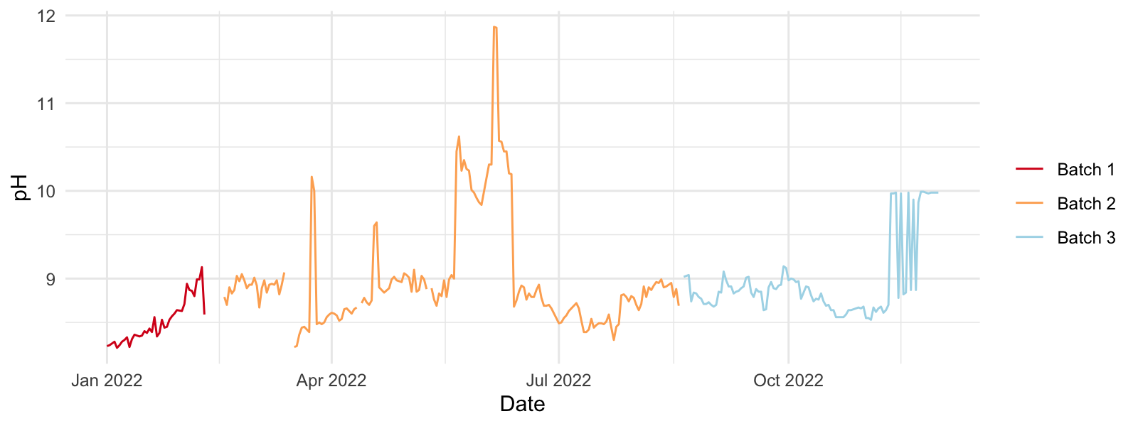

Figure 3.16: pH levels in RW 4 2022.

Comments: High variability in pH level (bearing in mind pH is an on exponential scale). pH influences proportion of unionised:ionised ammonia. Consider pH management techniques (alkalinity & pH dosing system)

### 3.8.6 Salinity RW4 2022

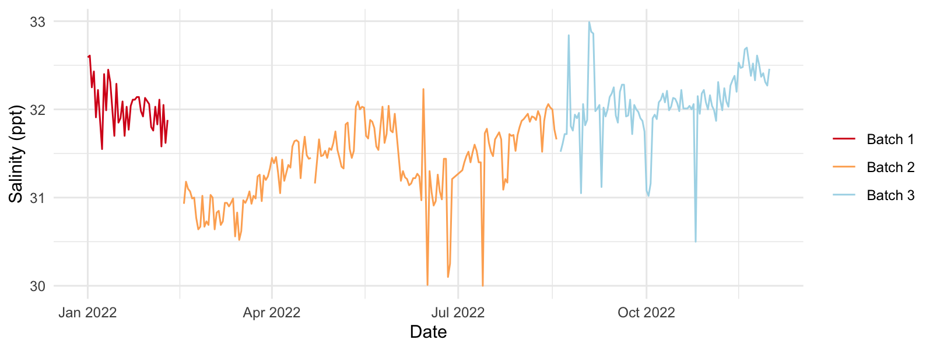

Figure 3.17: Salinity levels in RW 4 2022.

Comments: Salinity appears to be well managed

### 3.8.7 Dissolved Oxygen RW4 2022

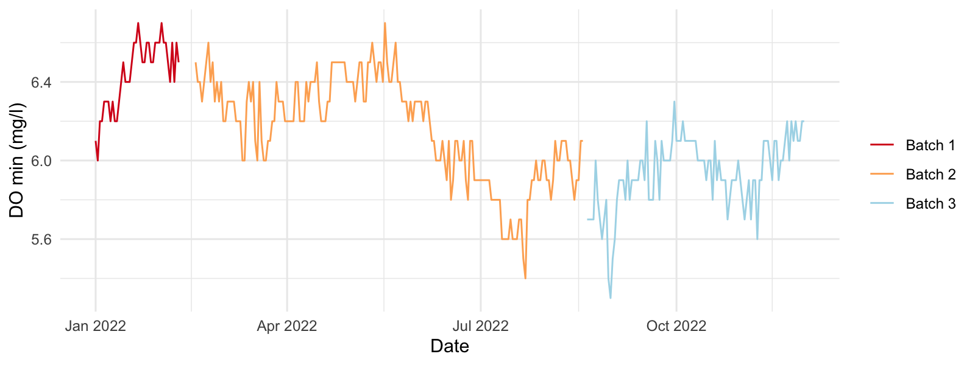

Figure 3.18: Dissolved oxygen levels in RW 4 2022.

Comments: Oxygen levels appear to be higher during the first half of the production year. All values within acceptable range > 5mg/l

### 3.8.8 Solids RW4 2022

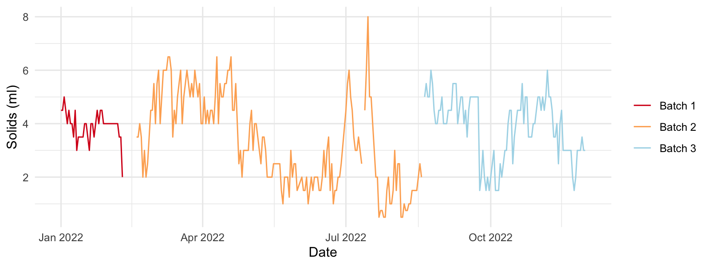

Figure 3.19: Solids levels in RW 4 2022.

Comments: High range of solids variability. Lack of knowledge on how to interpret volume of solids in imhoff cone in terms of TSS. Further sample analysis required to achieve this and then define an acceptable operating range.

### 3.8.9 Settling Tank Operation RW4 2022

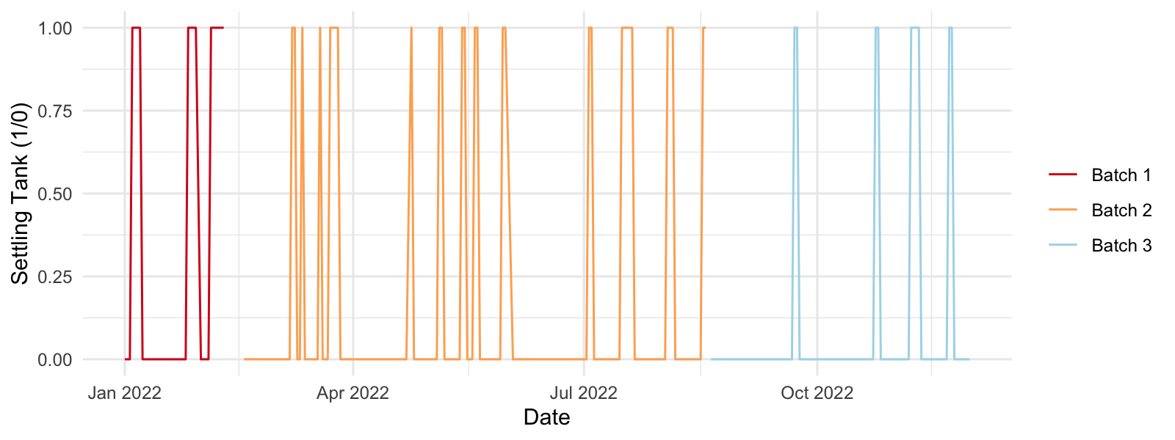

Figure 3.20: Settling tank operation in RW 4 2022.

Comments : During 2022 the settling tank in RW4 was operated for a total of 53 days from a production period of 319 days. Total discharge water from this settling tank was 106 m3. Average water use for solids removal from RW4 0.332 m3/day.

Settling tank operation appears to be determined by reaching a maximum permitted level of solids in the imhoff cone. Suggest optimisation by having a smaller permitted range of solids, achieve by more frequent use of settling vessel (consider volume and flow rate accordingly). Pumping water into a settling tank will incur mechanical disruption, reduce particle size and efficiency of settlement device - avoid unless unfeasible.Decrease inlet water velocity as far as possible, without permitting settlement within pipework. Density of waste should be determined for correct calculation of settlement rate/ flow in settlement tank.

### 3.8.10 Total Feed Input RW4 2022

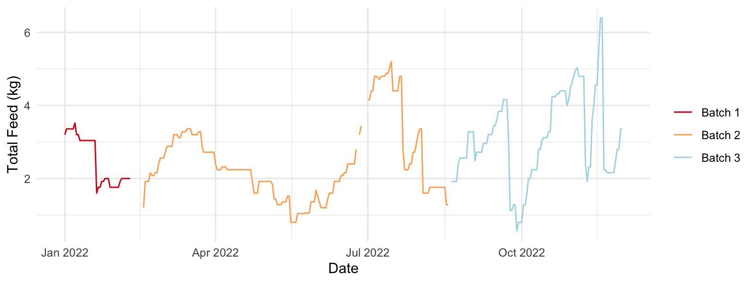

Figure 3.21: Total daily feed input in RW 4 2022.

### 3.8.11 Estimated Nitrate levels bsed on cumulative Nitrite calculation

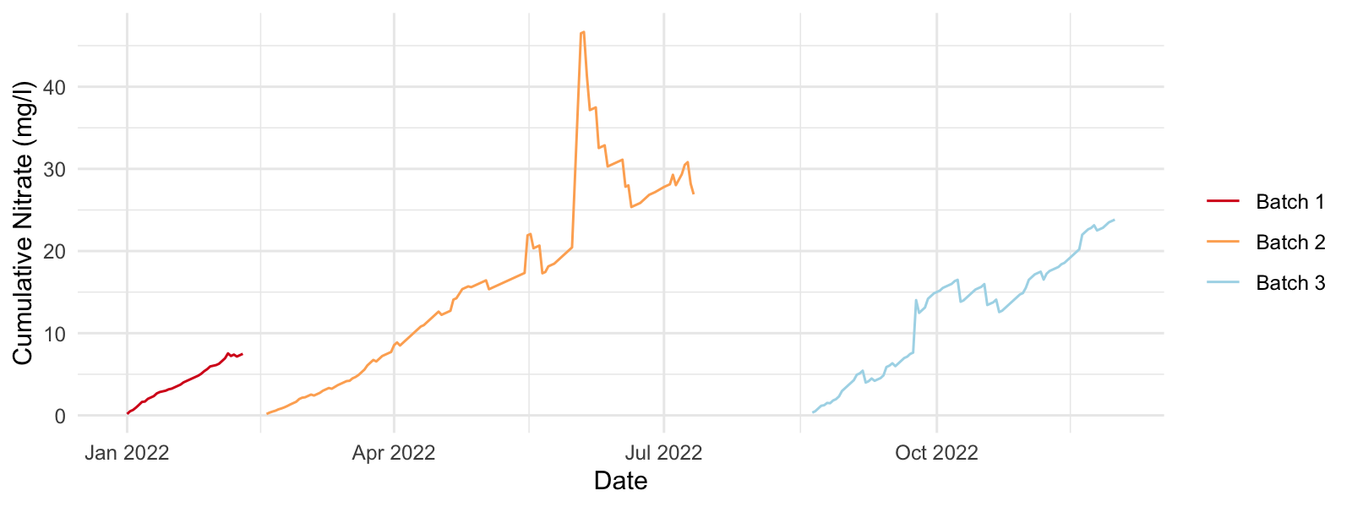

Figure 3.22: Estimated nitrate levels in RW 4 2022.

Comments: Accumulation of nitrate has been calculated based on assumption of water discharged at end of a batch. Under these conditions nitrate appears to remain within acceptable levels. Consider periodic monitoring of nitrate to confirm this.

### 3.8.12 Rainfall / Evapo-transpiration Blue Cypress Lake

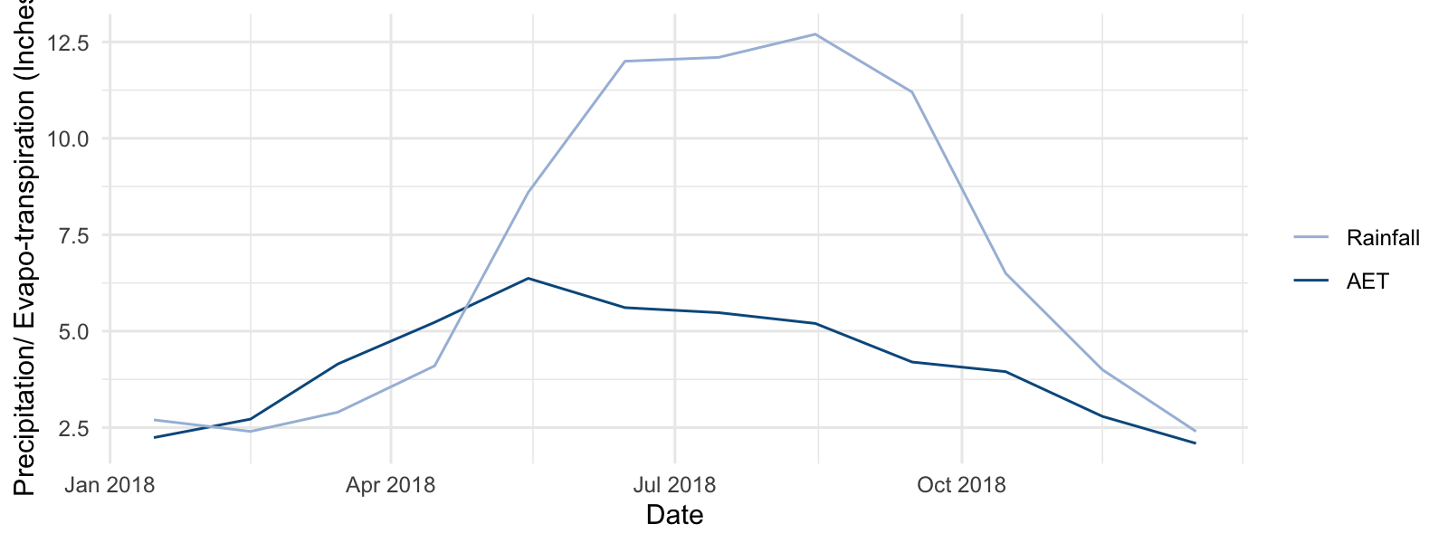

Figure 3.23: Mean monthly precipitation/ evapo-transpiration rates for Blue Cypress Lake, Florida, USA.

Comments: Generally, precipitation greater than evapotranspiration - not favourable for removal of discharge water by evaporation.

### 3.8.13 95th st. 2022 Water Budget

### 3.8.14 Summary of Water Use 2022

Table 3.18: 95th st. 2022 Facility saltwater budget (m3 /year).

| Status | Volume |
| --- | --- |
| delivery | 2,327.00 |
| required | 1,387.20 |

Table 3.19: 95th st. 2022 Projected Facility saltwater budget (with drum filter use) (m3 /year).

| Status | Volume |
| --- | --- |
| delivery | 2,327.00 |
| required | 1,542.20 |

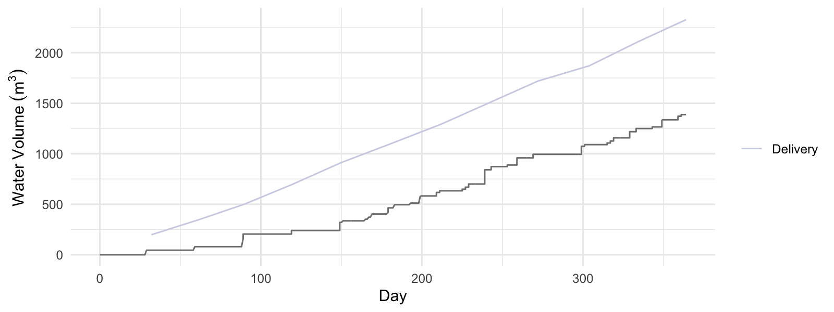

Figure 3.24: Cumulative water delivery and expected water requirements 95th st. 2022

Total discharge water 2022 (95th st. delivered to 101st st) 798 m3

Comments: Water requirement appears to follow same gradient as water delivery. Discharge water volume appears to be low in comparison to water delivered/ used. Confirm.

# 4 95th st. 2023 Operation modelling

Review production plan(s) to achieve:

* 95th st. 2023. Day 168 harvest 1200 individual 32g shrimp per raceway.
* 95th st. 2023. Day 182 harvest 1000 individual 32g shrimp per raceway.
* 95th st. 2023. Day 196 harvest 600 individual 32g shrimp per raceway.

### 4.0.1 System Occupation:

* Quarantine 30 days.
* Nursery 60 days.
* Grow-out up to 120 days.
* Depuration 4 days.

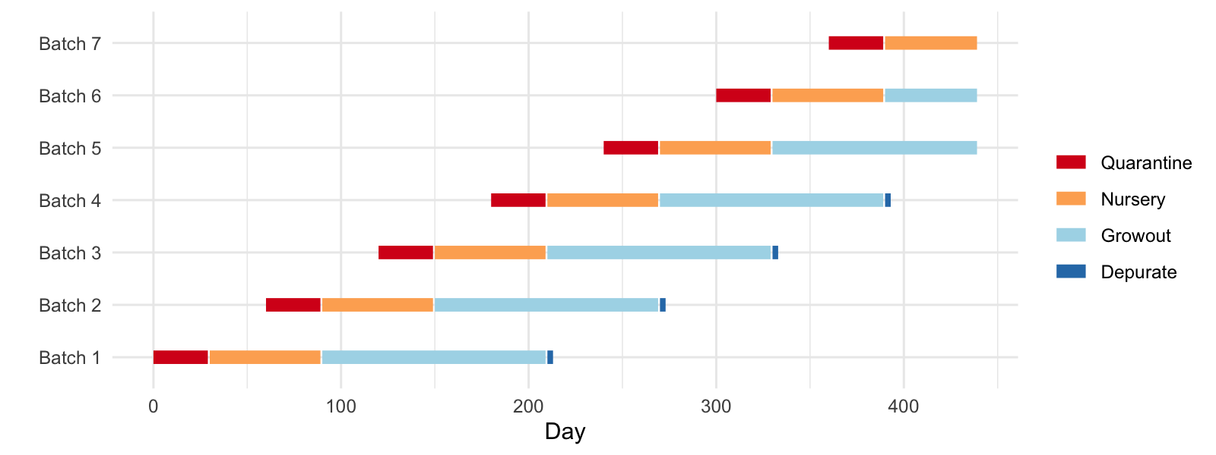

Figure 4.1: 95th st (2023). Production schematic.

## 4.1 System Loading

### 4.1.1 95th st. 2023 phase designations:

* Quarantine - initial population of 65000 individuals of body-weight 0.07 : 1.2
* Nursery - divide 44000, 1.2g, shrimp between 2 independently operating system(s), raise to 10g.
* Growout - rear 16500, 10g, shrimp within 3 system(s), raise to 32g.
* Depuration - purge up to 1600, 32g shrimp - split between 4 tank(s), operated by 1 treatment system(s).

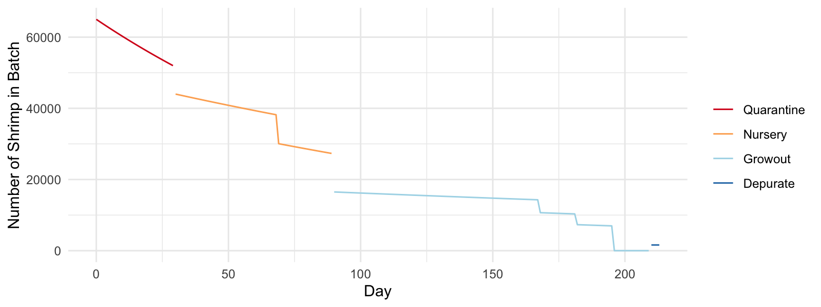

Figure 4.2: Total number of individuals per phase (95th st. 2023).

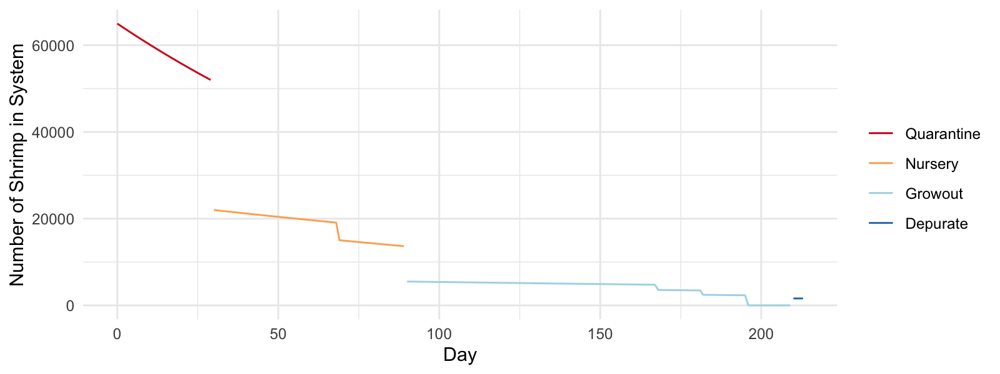

Figure 4.3: Total number of individuals per system (95th st. 2023).

### 4.1.2 95th st. (2023) Facility Loading:

### 4.1.3 Feed and protein maximum and average loading rates per day per system (phase).

Table 4.1: 95th st. 2023 facility loading rate (overlapping batches where appropriate).

| Max n | Feed avg (Kg/day) | Feed max (Kg/day) | Protein avg (Kg/day) | Protein max (Kg/day) |
| --- | --- | --- | --- | --- |
| 76,858.05 | 22.26 | 32.23 | 8.10 | 11.64 |

### 4.1.4 Feed and protein maximum and average loading rates per day per system.

Table 4.2: 95th st. 2023 System loading rates.

| System | Max n | Feed avg (Kg/day) | Feed max (Kg/day) | Protein avg (Kg/day) | Protein max (Kg/day) |
| --- | --- | --- | --- | --- | --- |
| quarantine | 65,000.00 | 1.59 | 2.44 | 0.79 | 1.22 |
| nursery | 22,000.00 | 3.07 | 4.25 | 1.23 | 1.70 |
| growout | 5,500.00 | 3.44 | 5.93 | 1.20 | 2.08 |
| depurate | 1,600.00 | 0.00 | 0.00 | 0.00 | 0.00 |

### 4.1.5 Nitrogen Management

TAN–N loading

Table 4.3: 95th st. 2023 Facility loading rates (overlapping batches where appropriate).

| Max TAN (Kg/day) | Avg TAN (Kg/day) |
| --- | --- |
| 1.68 | 1.17 |

Table 4.4: 95th st. 2023 System loading rates.

| System | Max TAN (Kg/day) | Avg TAN (Kg/day) |
| --- | --- | --- |
| quarantine | 0.18 | 0.11 |
| nursery | 0.24 | 0.18 |
| growout | 0.30 | 0.17 |
| depurate | 0.08 | 0.08 |

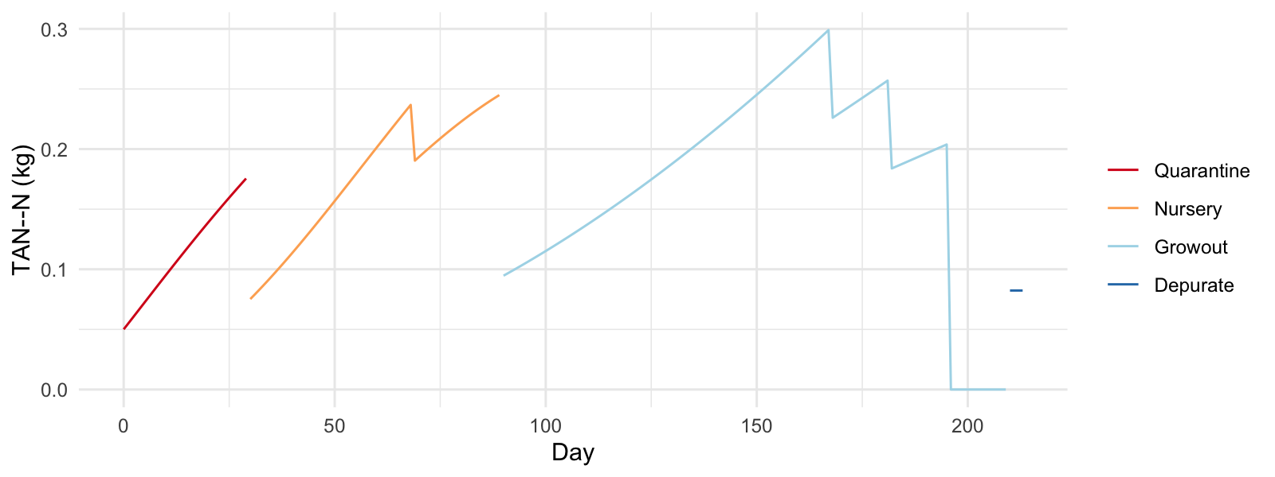

Figure 4.4: 95th st. 2023 System TAN–N profile.

Suggested minimum quarantine biomedia surface areas are as follows (based on a 24 hr metabolic period):

95th st. 2023; 439m2

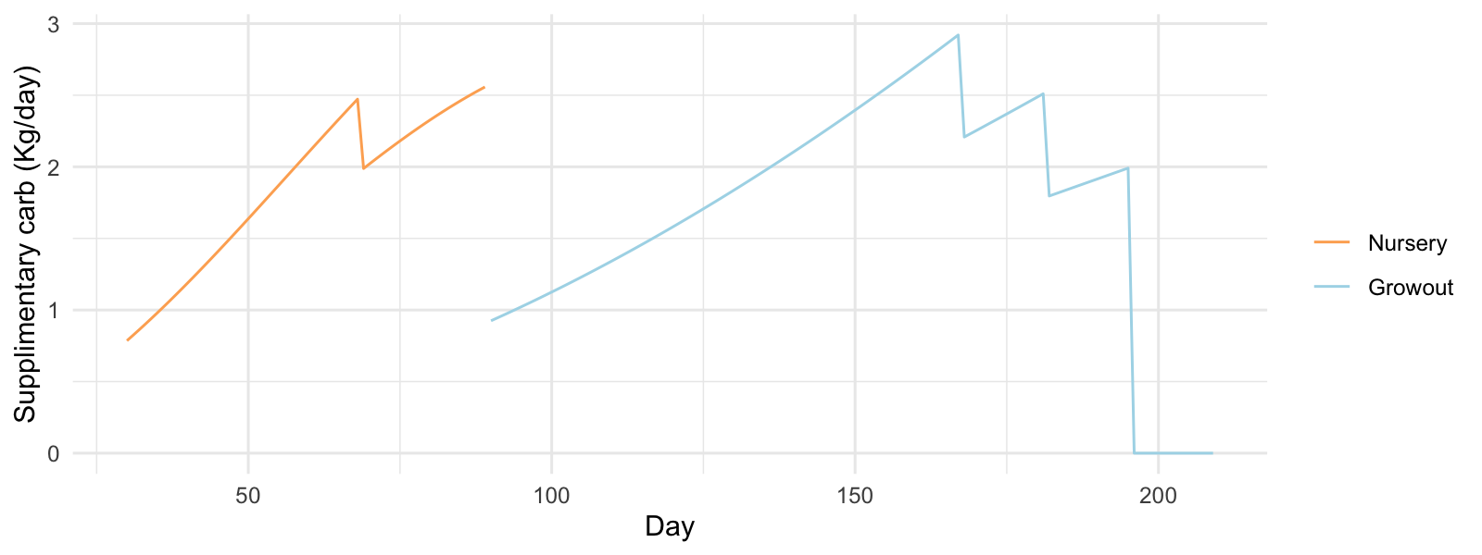

Figure 4.5: 95th st. 2023 Theoretical supplimentary carbohydrate requirement (per System).

### 4.1.6 Solids Management

Table 4.5: 95th st. 2023 Facility loading rates (Kg/day TSS modelled for clearwater CW and biofloc BF).

| Max TSS CW | Avg TSS CW | Max TSS BF | Avg TSS BF |
| --- | --- | --- | --- |
| 8.06 | 5.57 | 21.58 | 14.97 |

(#tab:TssLoadingTable_Primo)95th st. 2023 System loading rates (Kg/day TSS modelled for clearwater CW and biofloc BF).

| System | Max TSS CW | Avg TSS CW | Max TSS BF | Avg TSS BF |
| --- | --- | --- | --- | --- |
| quarantine | 0.61 | 0.39 | 0.61 | 0.39 |
| nursery | 1.06 | 0.76 | 3.04 | 2.17 |
| growout | 1.48 | 0.86 | 3.90 | 2.27 |
| depurate | 0.00 | 0.00 | 0.02 | 0.02 |

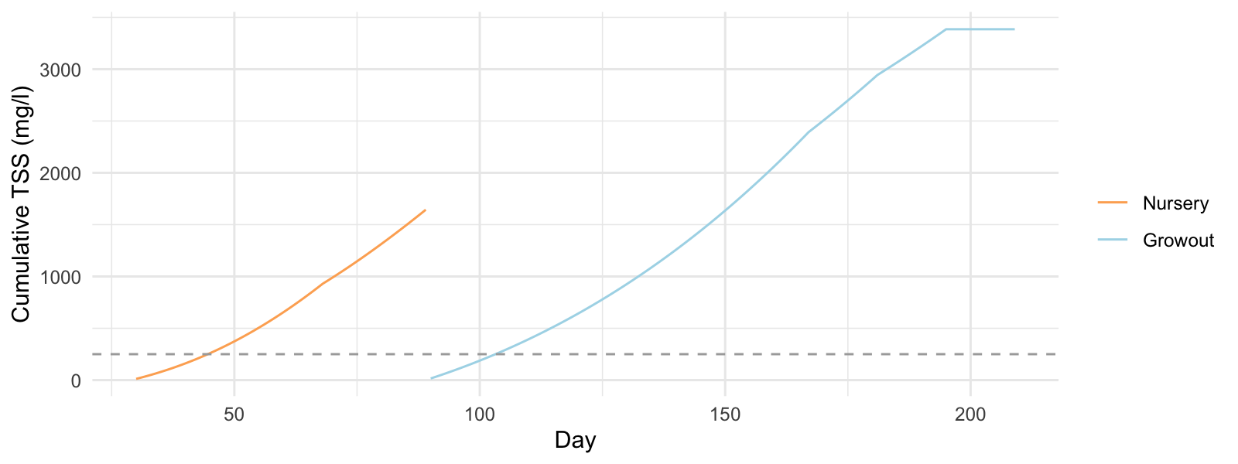

Figure 4.6: 95th st. 2023 Cumulative TSS accumulation - without solids management (per System).

Drum Filter Flow Requirements/ or other solids removal device operating at 21% efficiency:

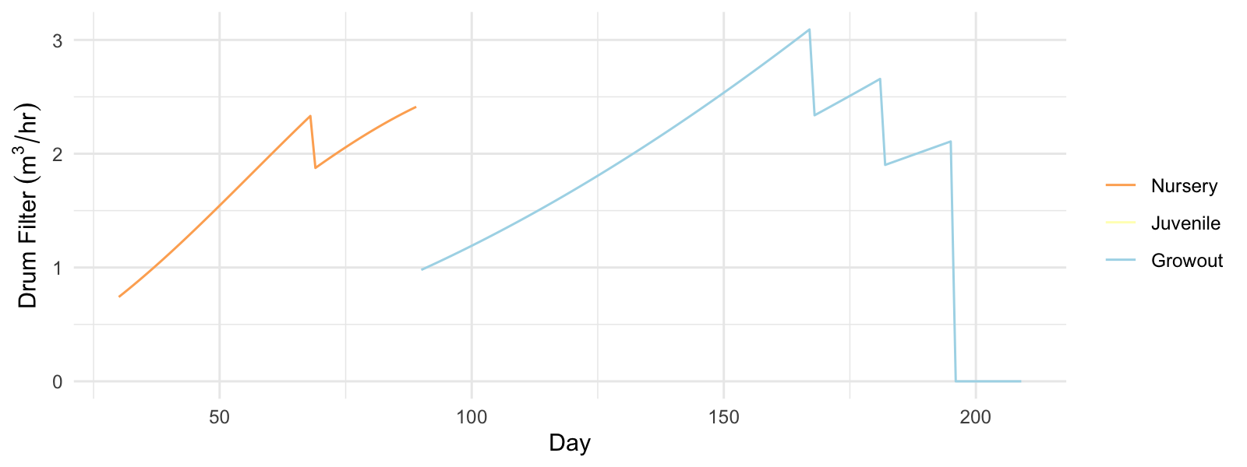

Figure 4.7: 95th st. 2023 Drum filter flow requirements to maintain 250 mg/l TSS (per System).

Table 4.6: 95th st. 2023 Estimated facility drum filter water use m3/day (clearwater CW and biofloc BF).

| Max Use CW | Avg Use CW | Max Use BF | Avg Use BF |
| --- | --- | --- | --- |
| 6.45 | 4.45 | 4.32 | 2.99 |

Table 4.7: 95th st. 2023 System drum filter water use m3/day (clearwater CW and biofloc BF).

| System | Max Use CW | Avg Use CW | Max Use BF | Avg Use BF |
| --- | --- | --- | --- | --- |
| nursery | 0.85 | 0.61 | 0.61 | 0.43 |
| growout | 1.19 | 0.69 | 0.78 | 0.50 |

### 4.1.7 Oxygen

Oxygen demand - for specification of emergency oxygen requirements/ oxygen supply systems or air supply volume (air volumes estimated with a 5% oxygen transfer efficiency rate)

Table 4.8: 95th st. 2023 Facility oxygen requirement (Kg/day).

| Max oxy | Avg oxy |
| --- | --- |
| 15.95 | 11.10 |

Table 4.9: 95th st. 2023 System oxygen demand (Kg/day).

| System | System max OD | System avg OD |
| --- | --- | --- |
| quarantine | 1.41 | 0.90 |
| nursery | 2.22 | 1.59 |
| growout | 2.89 | 1.68 |
| depurate | 1.23 | 1.23 |

Table 4.10: 95th st. 2023 System air demand to supply required oxygen m3/day.

| System | Max air demand | Avg air demand |
| --- | --- | --- |
| quarantine | 108.57 | 69.53 |
| nursery | 170.50 | 121.97 |
| growout | 222.41 | 129.52 |
| depurate | 94.52 | 94.52 |

### 4.1.8 Alkalinity

Table 4.11: 95th st. 2023 Facility alkalinity requirement (Kg/day).

| Max Alk | Avg Alk |
| --- | --- |
| 5.98 | 4.18 |

Table 4.12: 95th st. 2023 System alkalinity demand (Kg/day).

| System | System max Alk | System avg Alk |
| --- | --- | --- |
| quarantine | 1.24 | 0.79 |
| nursery | 0.87 | 0.63 |
| growout | 1.07 | 0.62 |
| depurate | 0.58 | 0.58 |

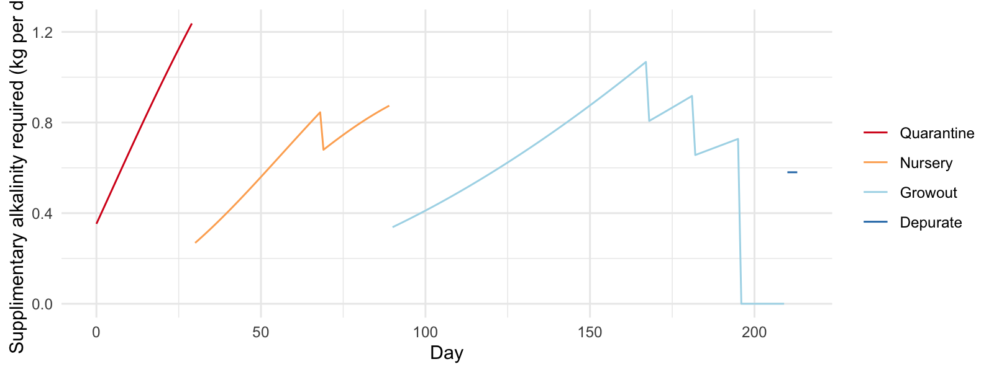

Figure 4.8: 95th st. 2023 Theoretical supplimentary alkalinity requirement (kg per System).

### 4.1.9 CO2

Table 4.13: 95th st. 2023 Facility CO2 loading (Kg/day).

| Max Loading | Avg Loading |
| --- | --- |
| 21.93 | 15.27 |

Table 4.14: 95th st. 2023 System CO2 loading (Kg/day).

| System | Max Loading | Avg Loading |
| --- | --- | --- |
| quarantine | 1.94 | 1.24 |
| nursery | 3.05 | 2.18 |
| growout | 3.98 | 2.32 |
| depurate | 1.69 | 1.69 |

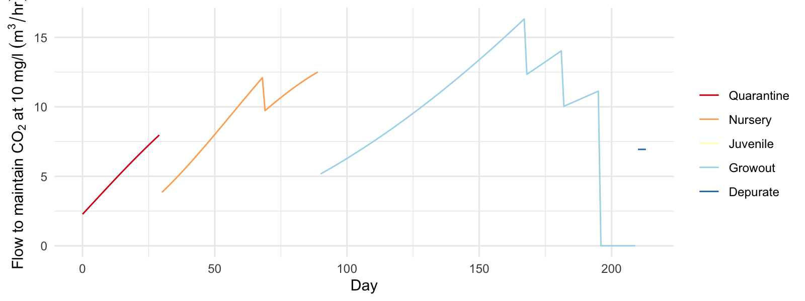

Figure 4.9: 95th st. 2023 System flow rate required to degas CO2 to 10 mg/l.

# 5 101st st. 2024 Operation Modelling

Review production plan(s) to achieve:

* 101st st. Day 168 harvest 1200 individual 32g shrimp per raceway.
* 101st st. Day 182 harvest 600 individual 32g shrimp per raceway.
* 101st st. Day 196 harvest 600 individual 32g shrimp per raceway.

### 5.0.1 System Occupation 101stst 2024:

* Quarantine 30 days.
* Nursery 60 days.
* Grow-out up to 120 days.
* Depuration 7 days.

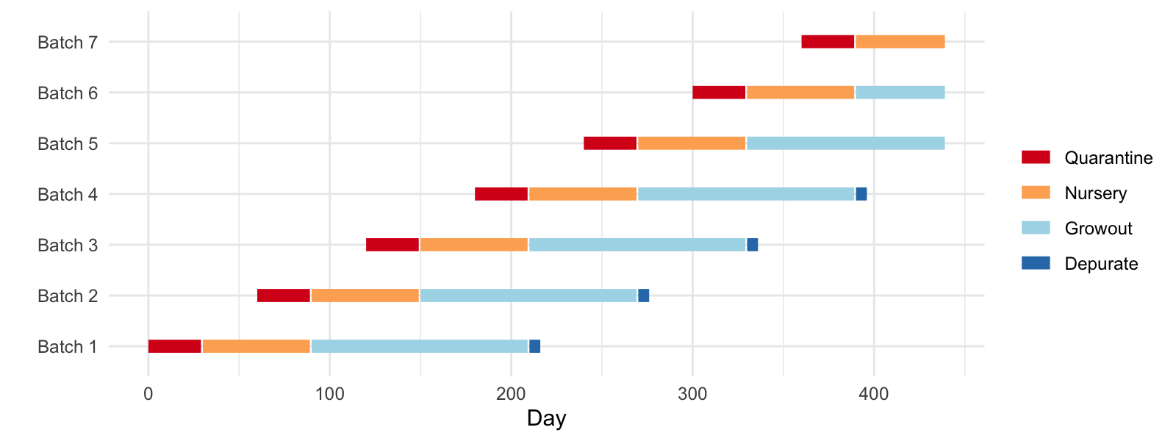

Figure 5.1: 101st st (2024). Production schematic.

## 5.1 System Loading

## 5.2 101st st. 2024 phase designations:

* Quarantine - initial population of 65000- 100000 individuals of body-weight 0.07 : 1.2
* Nursery - divide 46000 - 69000, 1.2g, shrimp between 2 independently operating system(s), raise to 10g.
* Growout - rear 20800 - 31200, 10g, shrimp within 4 - 6 system(s), raise to 32g.
* Depuration - purge up to 1600, 32g shrimp - split between 4 tank(s), operated by 1 treatment system(s).

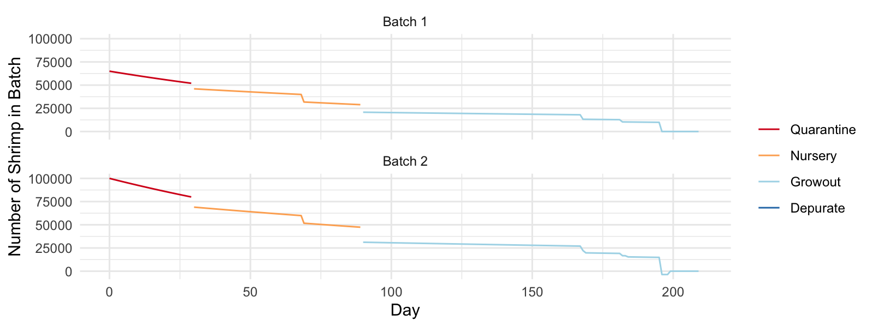

Figure 5.2: Total number of individuals per phase (101st st. 2024).

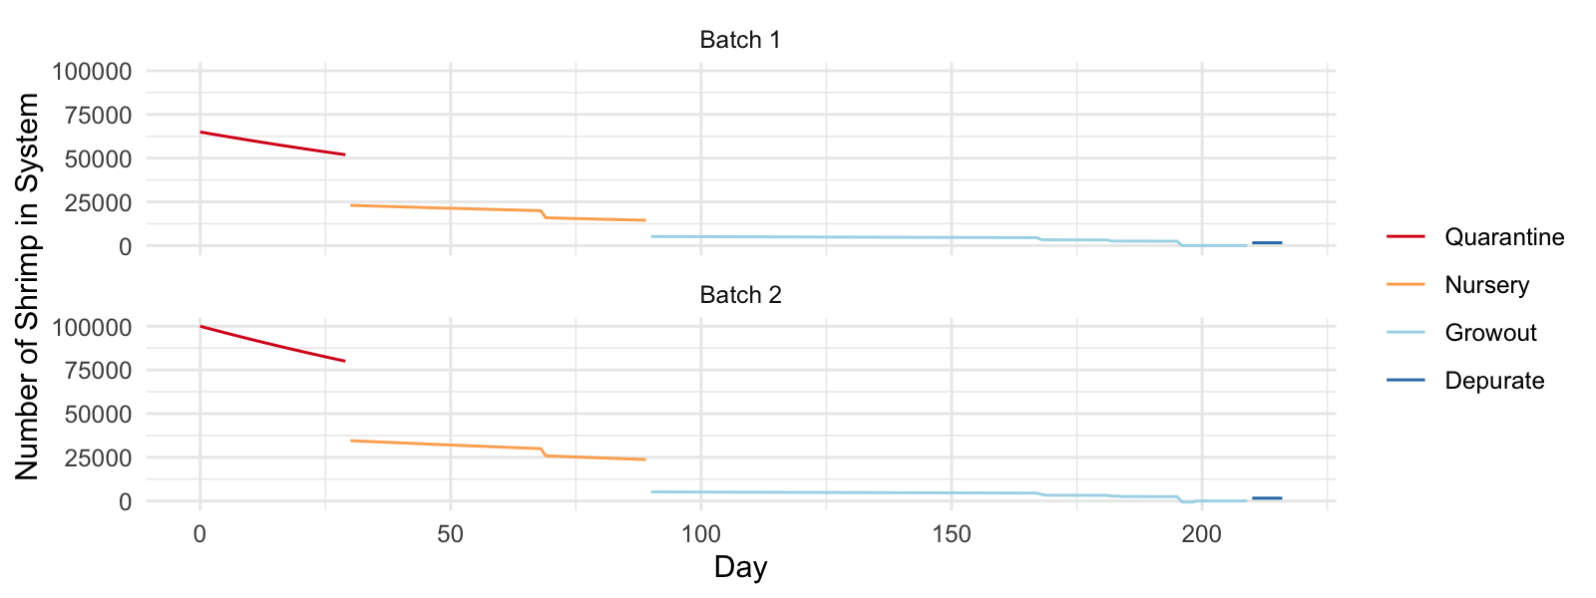

Figure 5.3: Total number of individuals per system (101st st. 2024).

### 5.2.1 Feed and protein maximum and average facility loading rates.

Table 5.1: 101st st. 2024 facility loading rates (overlapping batches where appropriate).

| Max n | Feed avg (Kg/day) | Feed max (Kg/day) | Protein avg (Kg/day) | Protein max (Kg/day) |
| --- | --- | --- | --- | --- |
| 119,306.13 | 33.09 | 53.49 | 11.98 | 19.35 |

### 5.2.2 Feed and protein maximum and average loading rates per system.

Table 5.2: 101st st. 2024 system loading rates (four raceway strategy).

| System | Max n | Feed avg (Kg/day) | Feed max (Kg/day) | Protein avg (Kg/day) | Protein max (Kg/day) |
| --- | --- | --- | --- | --- | --- |
| quarantine | 65,000.00 | 1.59 | 2.44 | 0.79 | 1.22 |
| nursery | 23,000.00 | 3.22 | 4.50 | 1.29 | 1.80 |
| growout | 5,200.00 | 3.29 | 5.61 | 1.15 | 1.96 |
| depurate | 1,600.00 | 0.00 | 0.00 | 0.00 | 0.00 |

Table 5.3: 101st st. 2024 system loading rates (six raceway strategy).

| System | Max n | Feed avg (Kg/day) | Feed max (Kg/day) | Protein avg (Kg/day) | Protein max (Kg/day) |
| --- | --- | --- | --- | --- | --- |
| quarantine | 100,000.00 | 2.44 | 3.75 | 1.22 | 1.88 |
| nursery | 34,500.00 | 5.02 | 7.37 | 2.01 | 2.95 |
| growout | 5,200.00 | 3.27 | 5.61 | 1.15 | 1.96 |
| depurate | 1,600.00 | 0.00 | 0.00 | 0.00 | 0.00 |

## 5.3 Nitrogen Management

### 5.3.1 101st st. 2024 TAN–N summary

Table 5.4: 101st st. 2024 Facility loading rates (overlapping batches where appropriate).

| Max TAN (Kg/day) | Avg TAN (Kg/day) |
| --- | --- |
| 2.79 | 1.73 |

Table 5.5: 101st st. 2024 System loading rates.

| System | System max TAN A | System avg TAN A | System max TAN B | System avg TAN B |
| --- | --- | --- | --- | --- |
| quarantine | 0.18 | 0.11 | 0.27 | 0.18 |
| nursery | 0.26 | 0.19 | 0.42 | 0.29 |
| growout | 0.28 | 0.17 | 0.28 | 0.17 |
| depurate | 0.08 | 0.08 | 0.08 | 0.08 |

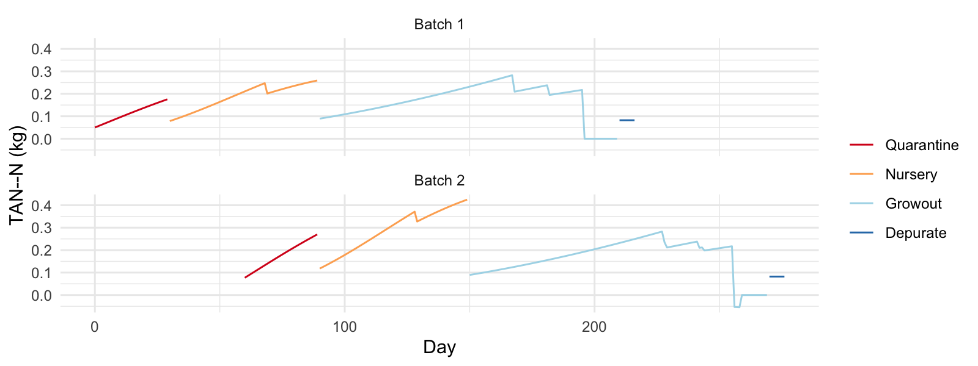

Figure 5.4: 101st st. 2024 System TAN–N profile.

Suggested minimum quarantine biomedia surface areas are as follows (based on a 24 hr metabolic period):

101st st. 2024; 439m2

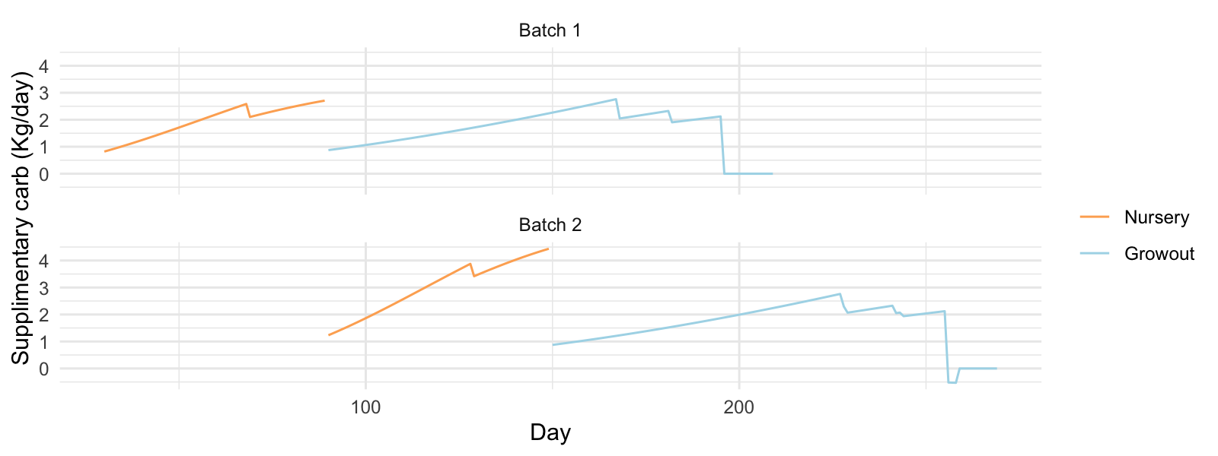

Figure 5.5: 101st st. 2024 Theoretical supplimentary carbohydrate requirement (per System).

## 5.4 Solids Management

Table 5.6: 101st st. 2024 Facility loading rates (Kg/day TSS modelled for clearwater CW and biofloc BF).

| Max TSS CW | Avg TSS CW | Max TSS BF | Avg TSS BF |
| --- | --- | --- | --- |
| 13.37 | 8.27 | 35.86 | 22.20 |

Table 5.7: 101st st. 2024 System loading rates (Kg/day modelled for clearwater operation).

| System | System max TSS A | System avg TSS A | System max TSS B | System avg TSS B |
| --- | --- | --- | --- | --- |
| quarantine | 0.61 | 0.40 | 0.94 | 0.61 |
| nursery | 1.13 | 0.81 | 1.84 | 1.26 |
| growout | 1.40 | 0.82 | 1.40 | 0.82 |
| depurate | 0.00 | 0.00 | 0.00 | 0.00 |

Table 5.8: 101st st. 2024 System loading rates (Kg/day modelled for biofloc operation).

| System | System max TSS A | System avg TSS A | System max TSS B | System avg TSS B |
| --- | --- | --- | --- | --- |
| quarantine | 0.61 | 0.40 | 0.94 | 0.61 |
| nursery | 3.22 | 2.30 | 5.27 | 3.59 |
| growout | 3.68 | 2.16 | 3.68 | 2.15 |
| depurate | 0.02 | 0.02 | 0.02 | 0.02 |

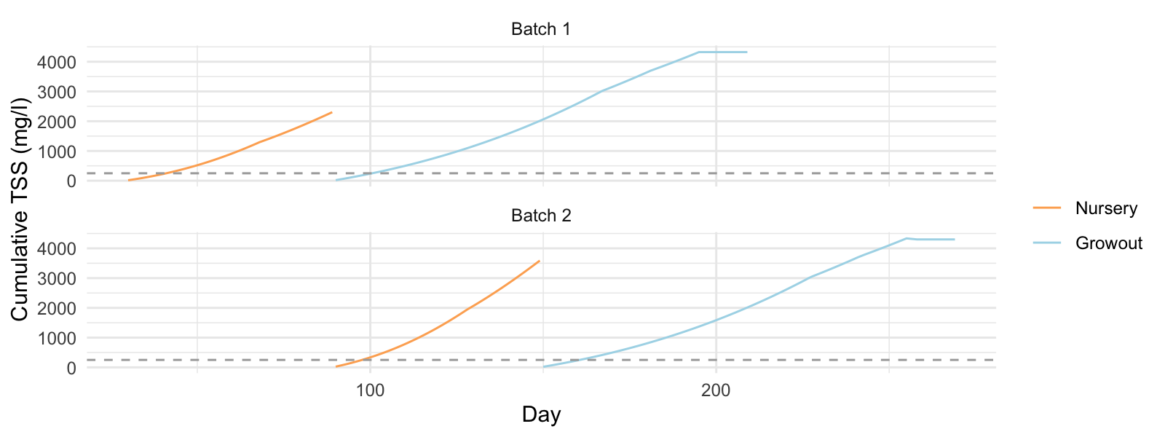

Figure 5.6: 101st st. 2024 Cumulative TSS accumulation - without solids management (per System).

Drum Filter Flow Requirements/ or other solids removal device operating at 21% efficiency:

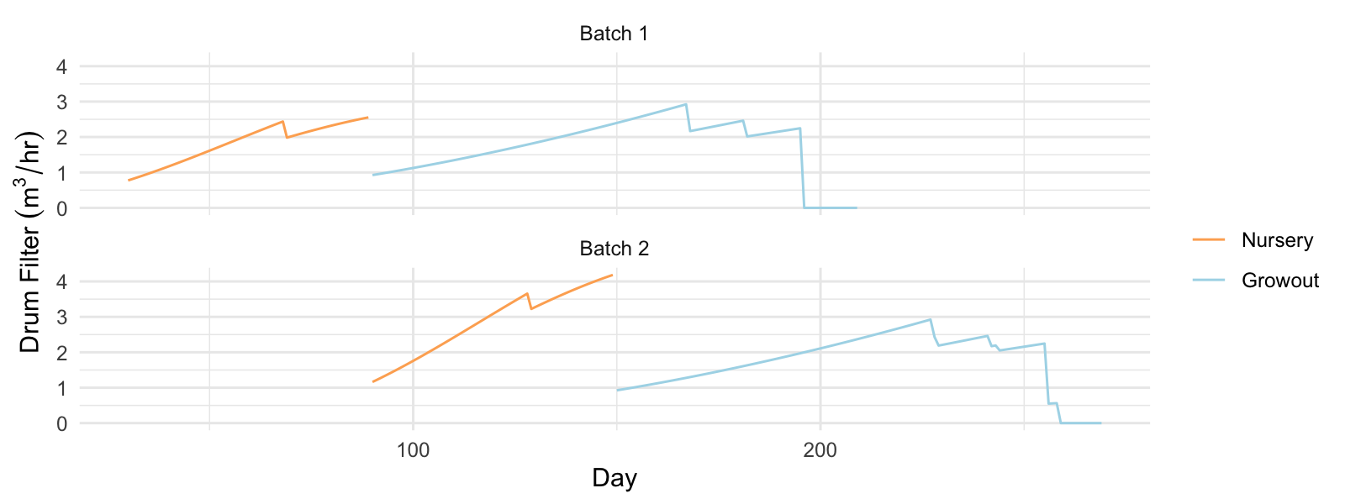

Figure 5.7: 101st st. 2024 Drum filter flow requirements to maintain 250 mg/l TSS (per System).

Table 5.9: 101st st. 2024 Facility drum filter water use m3/day (clearwater CW and biofloc BF).

| Max Use CW | Avg Use CW | Max Use BF | Avg Use BF |
| --- | --- | --- | --- |
| 10.70 | 6.62 | 7.17 | 4.44 |

Table 5.10: 101st st. 2024 Estimated system drum filter water use (as clearwater system) m3/day.

| System | Max Use A | Avg Use A | Max Use B | Avg Use B |
| --- | --- | --- | --- | --- |
| nursery | 0.90 | 0.64 | 1.47 | 1.00 |
| growout | 1.12 | 0.66 | 1.12 | 0.65 |

Table 5.11: 101st st. 2024 Estimated system drum filter water use (as biofloc system) m3/day.

| System | Max Use A | Avg Use A | Max Use B | Avg Use B |
| --- | --- | --- | --- | --- |
| nursery | 0.64 | 0.46 | 1.05 | 0.72 |
| growout | 0.74 | 0.49 | 0.74 | 0.47 |

## 5.5 Oxygen

Table 5.12: 101st st. 2024 Facility oxygen requirement (Kg/day).

| Max oxy | Avg oxy |
| --- | --- |
| 26.49 | 16.48 |

Table 5.13: 101st st. 2024 System oxygen demand (Kg/day).

| System | System max OD A | System avg OD A | System max OD B | System avg OD B |
| --- | --- | --- | --- | --- |
| quarantine | 1.41 | 0.92 | 2.17 | 1.41 |
| nursery | 2.35 | 1.68 | 3.84 | 2.62 |
| growout | 2.73 | 1.60 | 2.73 | 1.60 |
| depurate | 1.23 | 1.23 | 1.23 | 1.23 |

Table 5.14: 101st st. 2024 System air demand to supply required oxygen m3/day.

| System | Max air demand A | Avg air demand | Max air demand B | Avg air demand B |
| --- | --- | --- | --- | --- |
| quarantine | 108.57 | 70.69 | 167.03 | 108.75 |
| nursery | 180.51 | 129.22 | 295.72 | 201.31 |
| growout | 210.28 | 123.40 | 210.28 | 122.75 |
| depurate | 94.52 | 94.52 | 94.52 | 94.52 |

## 5.6 Alkalinity

Table 5.15: 101st st. 2024 Facility alkalinity requirement (Kg/day).

| Max Alk | Avg Alk |
| --- | --- |
| 9.95 | 6.20 |

Table 5.16: 101st st. 2024 System alkalinity demand (Kg/day).

| System | System max Alk A | System avg Alk A | System max Alk B | System avg Alk B |
| --- | --- | --- | --- | --- |
| quarantine | 1.24 | 0.81 | 1.90 | 1.24 |
| nursery | 0.93 | 0.66 | 1.52 | 1.03 |
| growout | 1.01 | 0.59 | 1.01 | 0.59 |
| depurate | 0.58 | 0.58 | 0.58 | 0.58 |

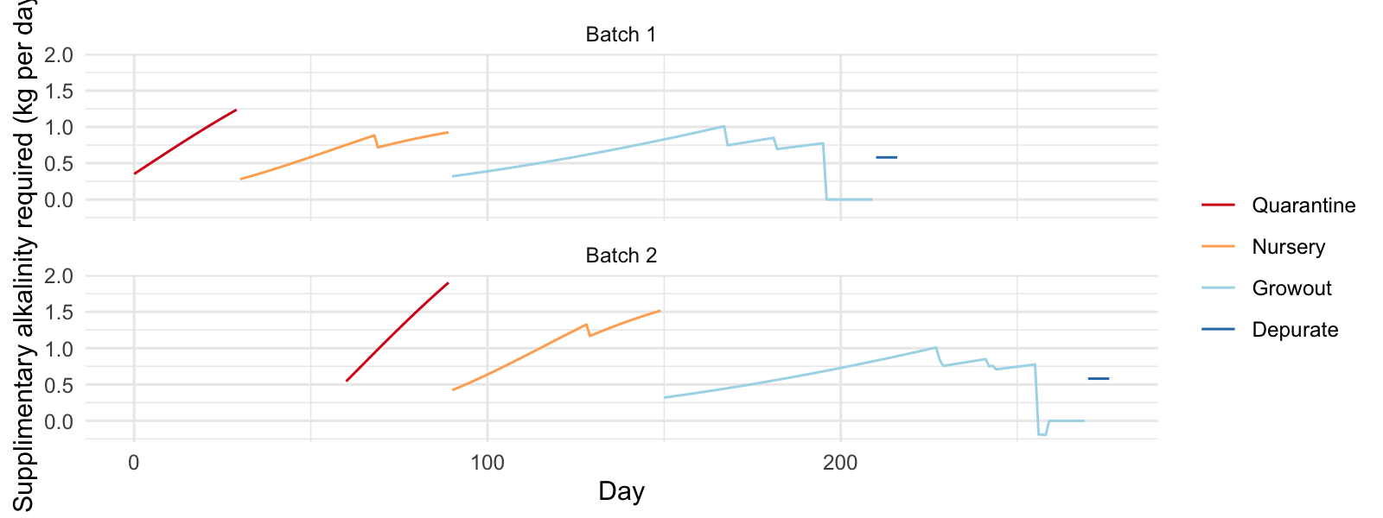

Figure 5.8: 101st st. 2024 Theoretical supplimentary alkalinity requirement (kg per System.

## 5.7 CO2

Table 5.17: 101st st. 2024 Facility CO2 loading (Kg/day).

| Max Loading | Avg Loading |
| --- | --- |
| 36.43 | 22.66 |

Table 5.18: 101st st. 2024 System CO2 loading (Kg/day).

| System | Max Loading A | Avg Loading A | Max Loading B | Avg Loading B |
| --- | --- | --- | --- | --- |
| quarantine | 1.94 | 1.26 | 2.99 | 1.94 |
| nursery | 3.23 | 2.31 | 5.29 | 3.60 |
| growout | 3.76 | 2.21 | 3.76 | 2.19 |
| depurate | 1.69 | 1.69 | 1.69 | 1.69 |

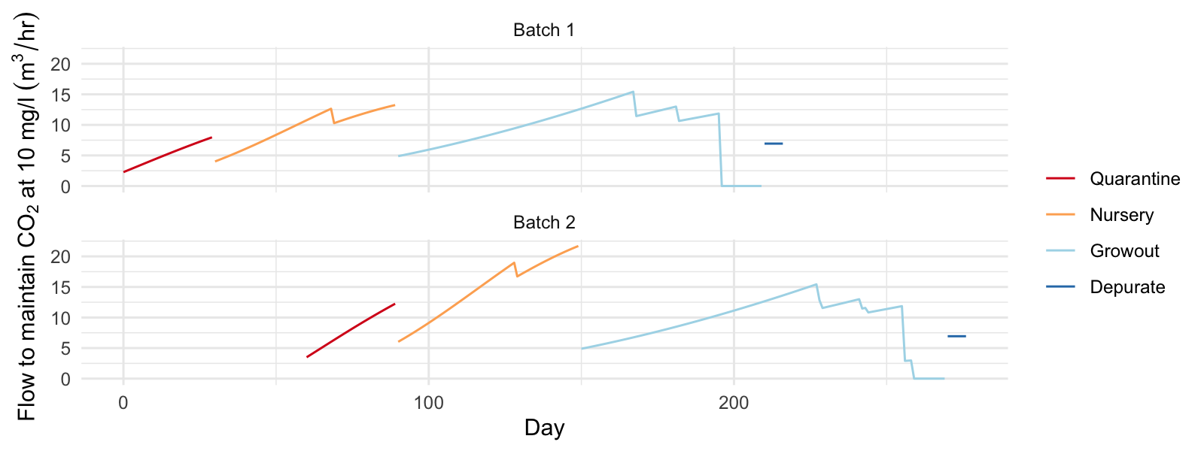

Figure 5.9: 101st st. 2024 System flow rate required to degas CO2 to 10 mg/l.