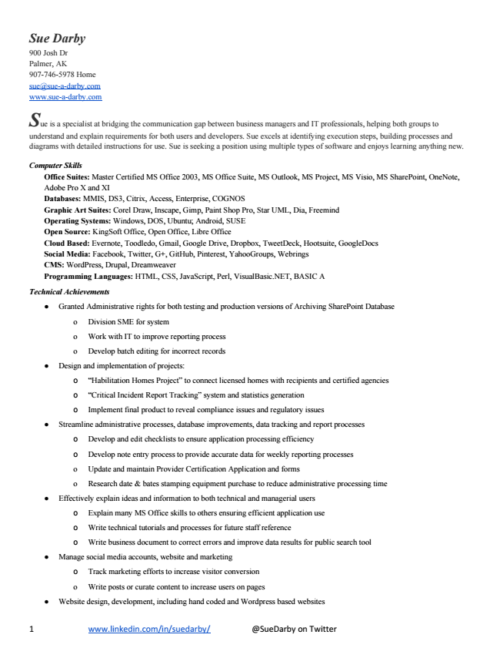

Sue Darby 900 Josh Dr Palmer, AK 907­746­5978 Home sue@sue­a­darby.com www.sue­a­darby.com S

ue is a specialist at bridging the communication gap between business managers and IT professionals, helping both groups to understand and explain requirements for both users and developers. Sue excels at identifying execution steps, building processes and diagrams with detailed instructions for use. Sue is seeking a position using multiple types of software and enjoys learning anything new.

***Computer Skills***

Office Suites: Master Certified MS Office 2003, MS Office Suite, MS Outlook, MS Project, MS Visio, MS SharePoint, OneNote, Adobe Pro X and XI Databases: MMIS, DS3, Citrix, Access, Enterprise, COGNOS Graphic Art Suites: Corel Draw, Inscape, Gimp, Paint Shop Pro, Star UML, Dia, Freemind Operating Systems: Windows, DOS, Ubuntu; Android, SUSE Open Source: KingSoft Office, Open Office, Libre Office Cloud Based: Evernote, Toodledo, Gmail, Google Drive, Dropbox, TweetDeck, Hootsuite, GoogleDocs Social Media: Facebook, Twitter, G+, GitHub, Pinterest, YahooGroups, Webrings CMS: WordPress, Drupal, Dreamweaver Programming Languages: HTML, CSS, JavaScript, Perl, VisualBasic.NET, BASIC A

***Technical Achievements***

● Granted Administrative rights for both testing and production versions of Archiving SharePoint Database

o Division SME for system

o Work with IT to improve reporting process

o Develop batch editing for incorrect records

● Design and implementation of projects:

o “Habilitation Homes Project” to connect licensed homes with recipients and certified agencies

o “Critical Incident Report Tracking” system and statistics generation

o Implement final product to reveal compliance issues and regulatory issues

● Streamline administrative processes, database improvements, data tracking and report processes

o Develop and edit checklists to ensure application processing efficiency

o Develop note entry process to provide accurate data for weekly reporting processes

o Update and maintain Provider Certification Application and forms

o Research date & bates stamping equipment purchase to reduce administrative processing time

● Effectively explain ideas and information to both technical and managerial users

o Explain many MS Office skills to others ensuring efficient application use

o Write technical tutorials and processes for future staff reference

o Write business document to correct errors and improve data results for public search tool

● Manage social media accounts, website and marketing

o Track marketing efforts to increase visitor conversion

o Write posts or curate content to increase users on pages

● Website design, development, including hand coded and Wordpress based websites

1 www.linkedin.com/in/suedarby/ @SueDarby on Twitter

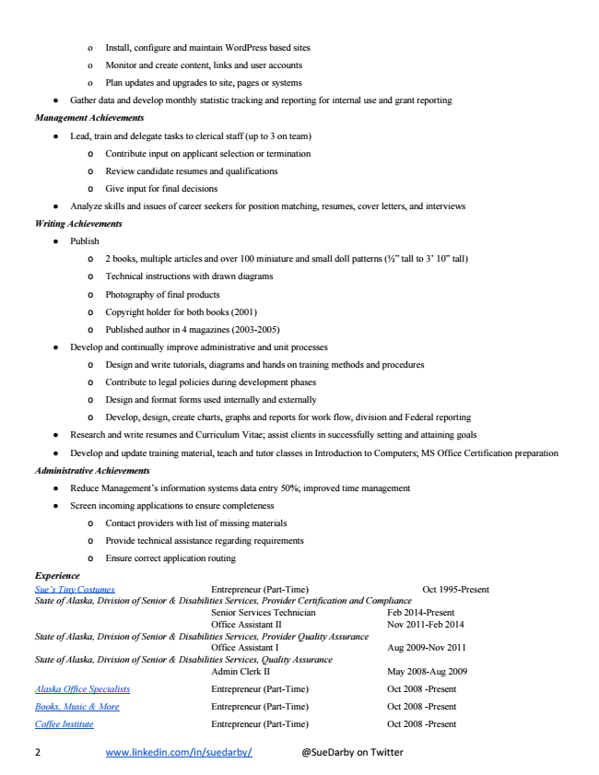

o Install, configure and maintain WordPress based sites

o Monitor and create content, links and user accounts

o Plan updates and upgrades to site, pages or systems

● Gather data and develop monthly statistic tracking and reporting for internal use and grant reporting

***Management Achievements***

● Lead, train and delegate tasks to clerical staff (up to 3 on team)

o Contribute input on applicant selection or termination

o Review candidate resumes and qualifications

o Give input for final decisions

● Analyze skills and issues of career seekers for position matching, resumes, cover letters, and interviews

***Writing Achievements***

● Publish

o 2 books, multiple articles and over 100 miniature and small doll patterns (1⁄2” tall to 3’ 10” tall)

o Technical instructions with drawn diagrams

o Photography of final products

o Copyright holder for both books (2001)

o Published author in 4 magazines (2003­2005)

● Develop and continually improve administrative and unit processes

o Design and write tutorials, diagrams and hands on training methods and procedures

o Contribute to legal policies during development phases

o Design and format forms used internally and externally

o Develop, design, create charts, graphs and reports for work flow, division and Federal reporting

● Research and write resumes and Curriculum Vitae; assist clients in successfully setting and attaining goals

● Develop and update training material, teach and tutor classes in Introduction to Computers; MS Office Certification preparation

***Administrative Achievements***

● Reduce Management’s information systems data entry 50%; improved time management

● Screen incoming applications to ensure completeness

o Contact providers with list of missing materials

o Provide technical assistance regarding requirements

o Ensure correct application routing

*Experience Sue’s Tiny Costumes Entrepreneur (Part­Time) Oct 1995­Present State of Alaska, Division of Senior & Disabilities Services, Provider Certification and Compliance*

*Senior Services Technician Feb 2014­Present Office Assistant II Nov 2011­Feb 2014 State of Alaska, Division of Senior & Disabilities Services, Provider Quality Assurance*

*Office Assistant I Aug 2009­Nov 2011 State of Alaska, Division of Senior & Disabilities Services, Quality Assurance*

Admin Clerk II May 2008­Aug 2009

Alaska Office Specialists Entrepreneur (Part­Time) Oct 2008 ­Present

Books, Music & More Entrepreneur (Part­Time) Oct 2008 ­Present

Coffee Institute Entrepreneur (Part­Time) Oct 2008 ­Present

2 www.linkedin.com/in/suedarby/ @SueDarby on Twitter

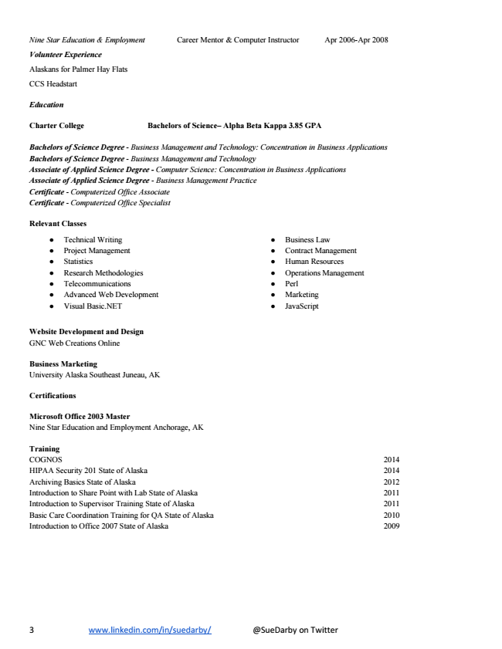

Nine Star Education & Employment Career Mentor & Computer Instructor Apr 2006­Apr 2008

***Volunteer Experience***

Alaskans for Palmer Hay Flats

CCS Headstart

***Education***

**Charter College Bachelors of Science– Alpha Beta Kappa 3.85 GPA**

*Bachelors of Science Degree ­ Business Management and Technology: Concentration in Business Applications Bachelors of Science Degree ­ Business Management and Technology Associate of Applied Science Degree ­ Computer Science: Concentration in Business Applications Associate of Applied Science Degree ­ Business Management Practice Certificate ­ Computerized Office Associate Certificate ­ Computerized Office Specialist*

**Relevant Classes**

● Technical Writing

● Project Management

● Statistics

● Research Methodologies

● Telecommunications

● Advanced Web Development

● Visual Basic.NET

● Business Law

● Contract Management

● Human Resources

● Operations Management

● Perl

● Marketing

● JavaScript

**Website Development and Design GNC Web Creations Online**

Business Marketing University Alaska Southeast Juneau, AK

**Certifications**

Microsoft Office 2003 Master Nine Star Education and Employment Anchorage, AK

Training COGNOS 2014 HIPAA Security 201 State of Alaska 2014 Archiving Basics State of Alaska 2012 Introduction to Share Point with Lab State of Alaska 2011 Introduction to Supervisor Training State of Alaska 2011 Basic Care Coordination Training for QA State of Alaska 2010 Introduction to Office 2007 State of Alaska 2009

3 www.linkedin.com/in/suedarby/ @SueDarby on Twitter