Problem 1
Write a Python function, is_multiple(n, m), that takes two integer values and return True if n is multiple of m, that is, n = mi for some integer i, and False otherwise.
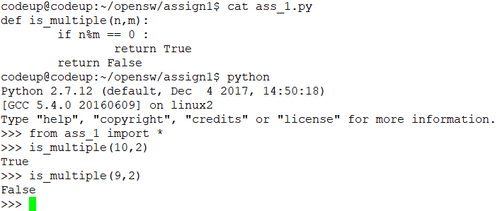

Problem 2
Write a Python function, is_even(k), that takes an integer value and return True if k is even, and False otherwise. However, your function cannot use the muliplication, modulo, or division operators.
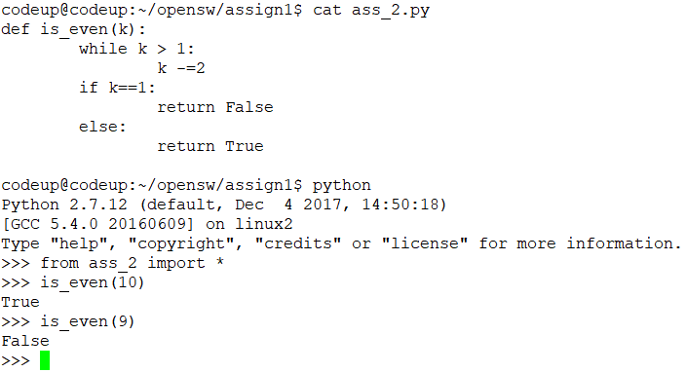

Problem 3
Python allows negative integers to be used as indices into a sequence, such as string. If string s has length n, and expression s[k] is used for index −n ≤ k ≤ 0, what is the equivalent index j ≥ such that s[j] references the same element?
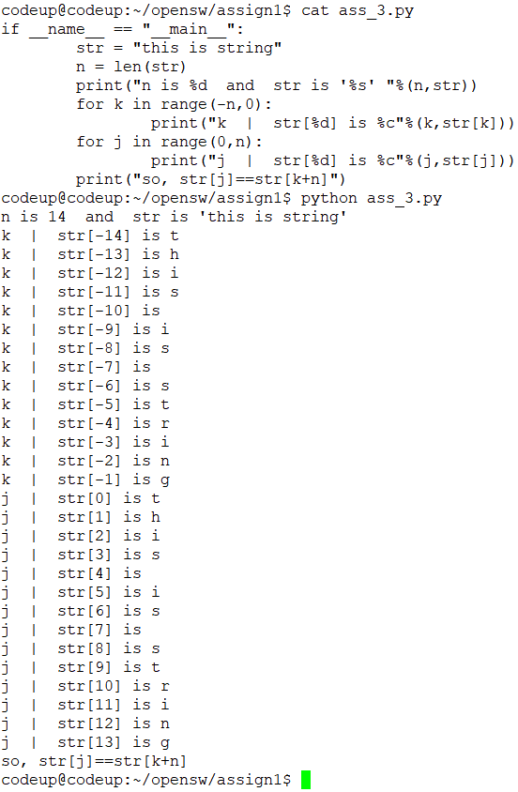

Problem 4
Write a program that takes two arrays(list) a and b of length n storing int values, return the dot product of a and b. That is, it returns an array(list) c of length n such that c[i] = a[i] · b[i], for i = 0, 1, · · · , n − 1.
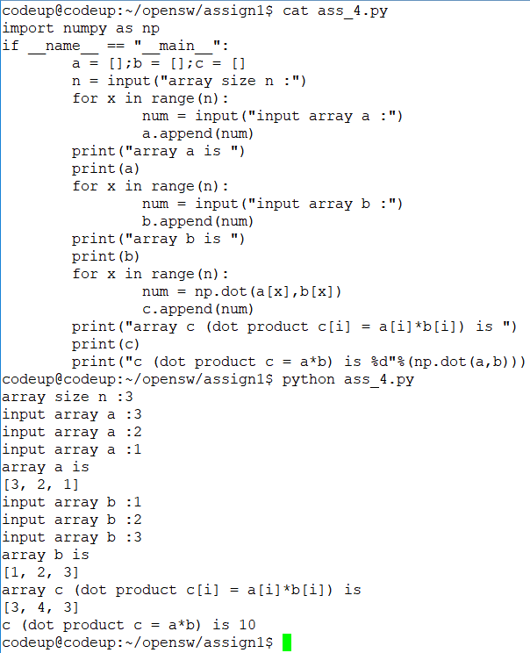
Problem 5
Explain the difference between mutable objects and immutable objects and give some examples.
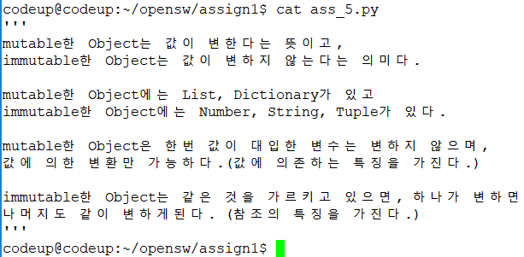
Problem 6
Write a function called convert_pound that converts pounds to kilograms. One pound is equal to 0.454 kilograms.
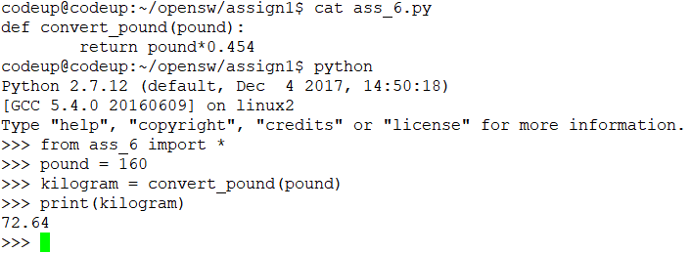

Problem 7
Explain why we use a module in software development and how to structure a module in Python.
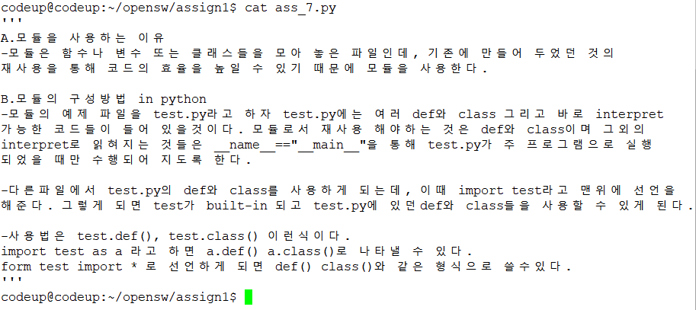

Problem 8
Consider the following statement, which creates a list of populations of countries in eastern Asia (China, DPR Korea, Hong Kong, Mongolia, Republic of Korea, Japan and Taiwan), in millions: country populations = [1500, 33, 7, 45, 49, 101, 21]. Write a function to compute the population average of those countries.
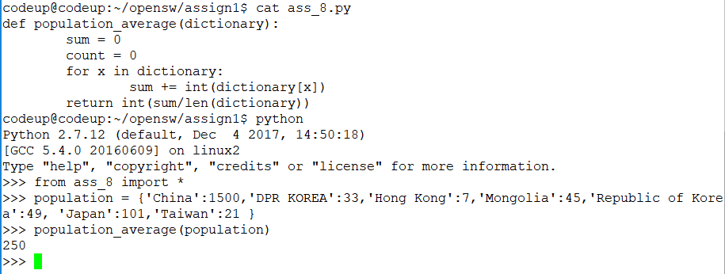

Problem 9
Suppose the file alkaline_metals.txt contains this: 4 9.012 12 24.305 20 20.078 38 87.62 56 137.327 88 226 Write a for loop to read the contents of alkaline_metals.txt, and store it in a nested list with each element of the list contains the atomic number and atomic weight for an element(Hint: use string.split()).
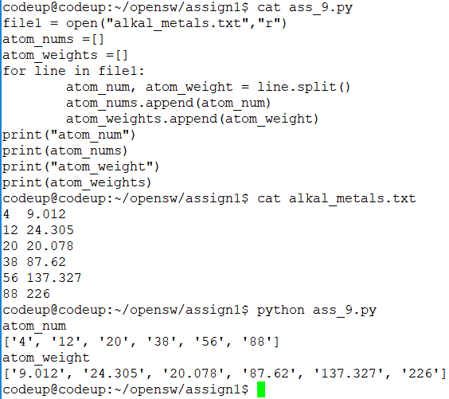
Problem 10
Design and implement a program that
step 1 asks the user for a temperature in Fahrenheit degrees and reads the number
step 2 computes the correspodning temperature in Celsius degrees
step 3 prints out the temperature in the Celsius scale.
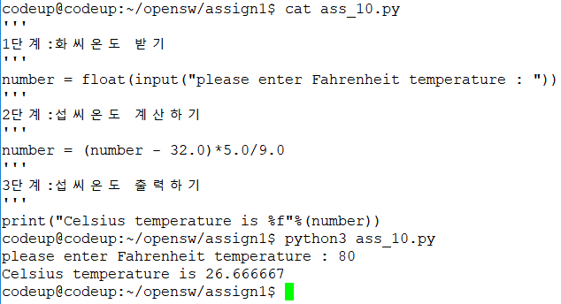

Problem 11
Modify your solution of Problem 10 such that the Fahrenheit temperature is read from the command line.
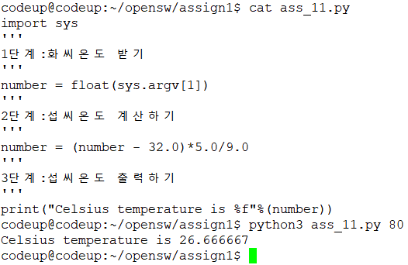

Problem 12
Some object is moving along a path in the plane. At n points of time we have recorded the corresponding (x, y) positions of the object: (x0, y0),(x1, y2), · · · ,(xn−1, yn−1). The total length L of the path from (x0, y0) to (xn−1, yn−1) is the sum of all the individual line segments ((xi−1, yi−1) to (xi , yi), i = 1, · · · , n − 1):
L = nX−1 i=1 p (xi − xi−1) 2 + (yi − yi−1) 2
Make a function pathlength(x, y) for computing L according to the formula. The arguments x and y hold all the x0, · · · , xn−1 and y0, · · · , yn−1 coordinates, respectively. Test the function on a triangular path with the four points (1, 1),(2, 1),(1, 2), and (1, 1).
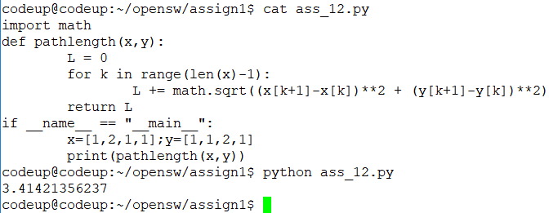
Problem 13
The value of π equals the circumference of a circle with radius 1/2. Suppose we approximate the circumference by a polygon through N + 1 points on the circle. The length of this polygon can be found using the pathlength function from the above exercise. Compute N + 1 points (xi , yi) along a circle with radius 1/2 according to the formulas xi = 1 2 cos(2πi/N), yi = 1 2 sin(2πi/N), i = 0, · · · , N. Call the pathlength function and write out the error in the approximation of π for N = 2k, k = 2, 3, · · · , 10
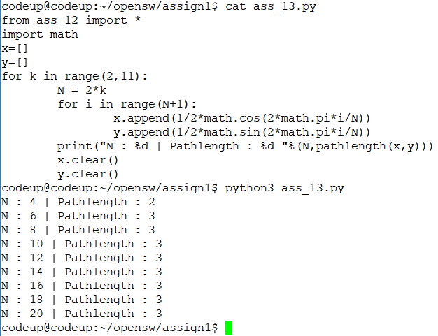
Problem 14
Make six conversion functions between temperatures in Celsius, Kelvin, and Fahrenheit: C2F(degree) F2C(degree) C2K(degree) K2C(degree) F2K(degree) K2F(degree) Collect these functions in a module convert_temp. Make some sample calls to the functions from an interactive Python shell.
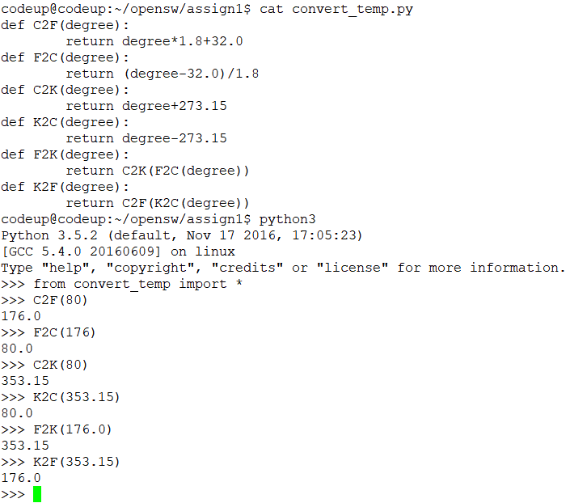
Problem 15
Extend the module built in Problem 14 with a main program in the test block. This main program should read the first command- line argument as a numerical value of a temperature Assignment № 1 Page 3 and the second argument as a temperature scale: C, K, F. Write out the temperature in the other two scales. For example, if 21.3 C is given on the command line, the output should be 70.34 F 294.45 K.
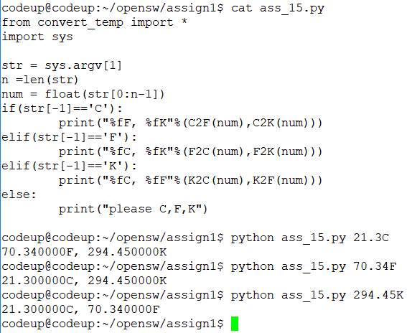
Problem 16
Write a program that counts words, delimiters, and lines for any paragraph in English.
