Cohort A — Hazard Ratios and Cumulative Incidence (Competing-Risks Analysis)
Methods. In the propensity-score-matched cohort (1:1, n=4,102 after requiring ≥1 day of follow-up), time-to-event analyses were performed for each of five individual comorbidities and two pre-specified composite endpoints: (i) Major Cardiovascular Events (MCE) — the first occurrence of myocardial infarction (Angina/MI), stroke (cerebral infarction or hemorrhage), or pulmonary embolism after the index date; and (ii) Any-of-5 — the first occurrence of any of the five comorbidities (Angina/MI, hypertension, diabetes, stroke, or pulmonary embolism) after the index date. The primary event was the first incident diagnosis; death prior to the primary event was treated as a competing event; remaining patients were censored at last follow-up. Cause-specific hazard ratios (HR) were estimated by Cox proportional-hazards regression treating the competing event as censoring. Subdistribution hazard ratios (sHR) were estimated using the Fine-Gray model implemented as time-varying Cox regression on the Geskus (2011) IPCW-reweighted dataset. Robust standard errors were used. Cumulative incidence functions were estimated non-parametrically with the Aalen-Johansen estimator, which adjusts for the competing risk of death. Patients with prevalent disease at the index date were excluded from the corresponding analysis to define an at-risk population. Time is reported in days; figures display years from index date.

Table 1. Hazard Ratios — Composite Endpoints and Individual Comorbidities (PSM 1:1 cohort)
Outcome | Vaccinated  events/n | Non-vaccinated  events/n | Competing  (death) | Cause-specific HR | Cause-specific p | Fine-Gray sHR | Fine-Gray p
Angina/MI (협심증/심근경색) | 3/2051 | 1/2051 | 29 | - | - | - | -
Hypertension (고혈압) | 8/2041 | 7/2045 | 29 | 1.491 (0.531–4.182) | 0.448 | 1.508 (0.546–4.165) | 0.428
Diabetes (당뇨) | 22/2037 | 22/2041 | 29 | 1.301 (0.717–2.359) | 0.387 | 1.307 (0.723–2.362) | 0.375
Stroke (뇌출혈/뇌경색) | 0/2051 | 0/2051 | 29 | - | - | - | -
PE (폐색전증) | 0/2051 | 1/2051 | 29 | - | - | - | -
★ MCE (MI / Stroke / PE) | 3/2051 | 2/2051 | 29 | 1.965 (0.310–12.454) | 0.473 | 1.979 (0.330–11.867) | 0.455
★ Any of 5 comorbidities | 30/2027 | 30/2035 | 29 | 1.304 (0.782–2.175) | 0.308 | 1.313 (0.791–2.180) | 0.292

Footnote: Cause-specific hazard ratios (HR) treat death as right-censoring; Fine-Gray subdistribution hazard ratios (sHR) keep subjects with a competing event in the risk set with IPCW-decreasing weights (Geskus 2011). Robust standard errors are reported. With very low competing-event rates (death <0.5%), cause-specific and Fine-Gray estimates are expected to be similar. Outcomes with no events in either group cannot be estimated and are reported as "-". Prevalent (baseline) cases were excluded from each outcome-specific analysis to define an at-risk population.

Figure 1. Cumulative Incidence (Aalen-Johansen) and Hazard Ratios
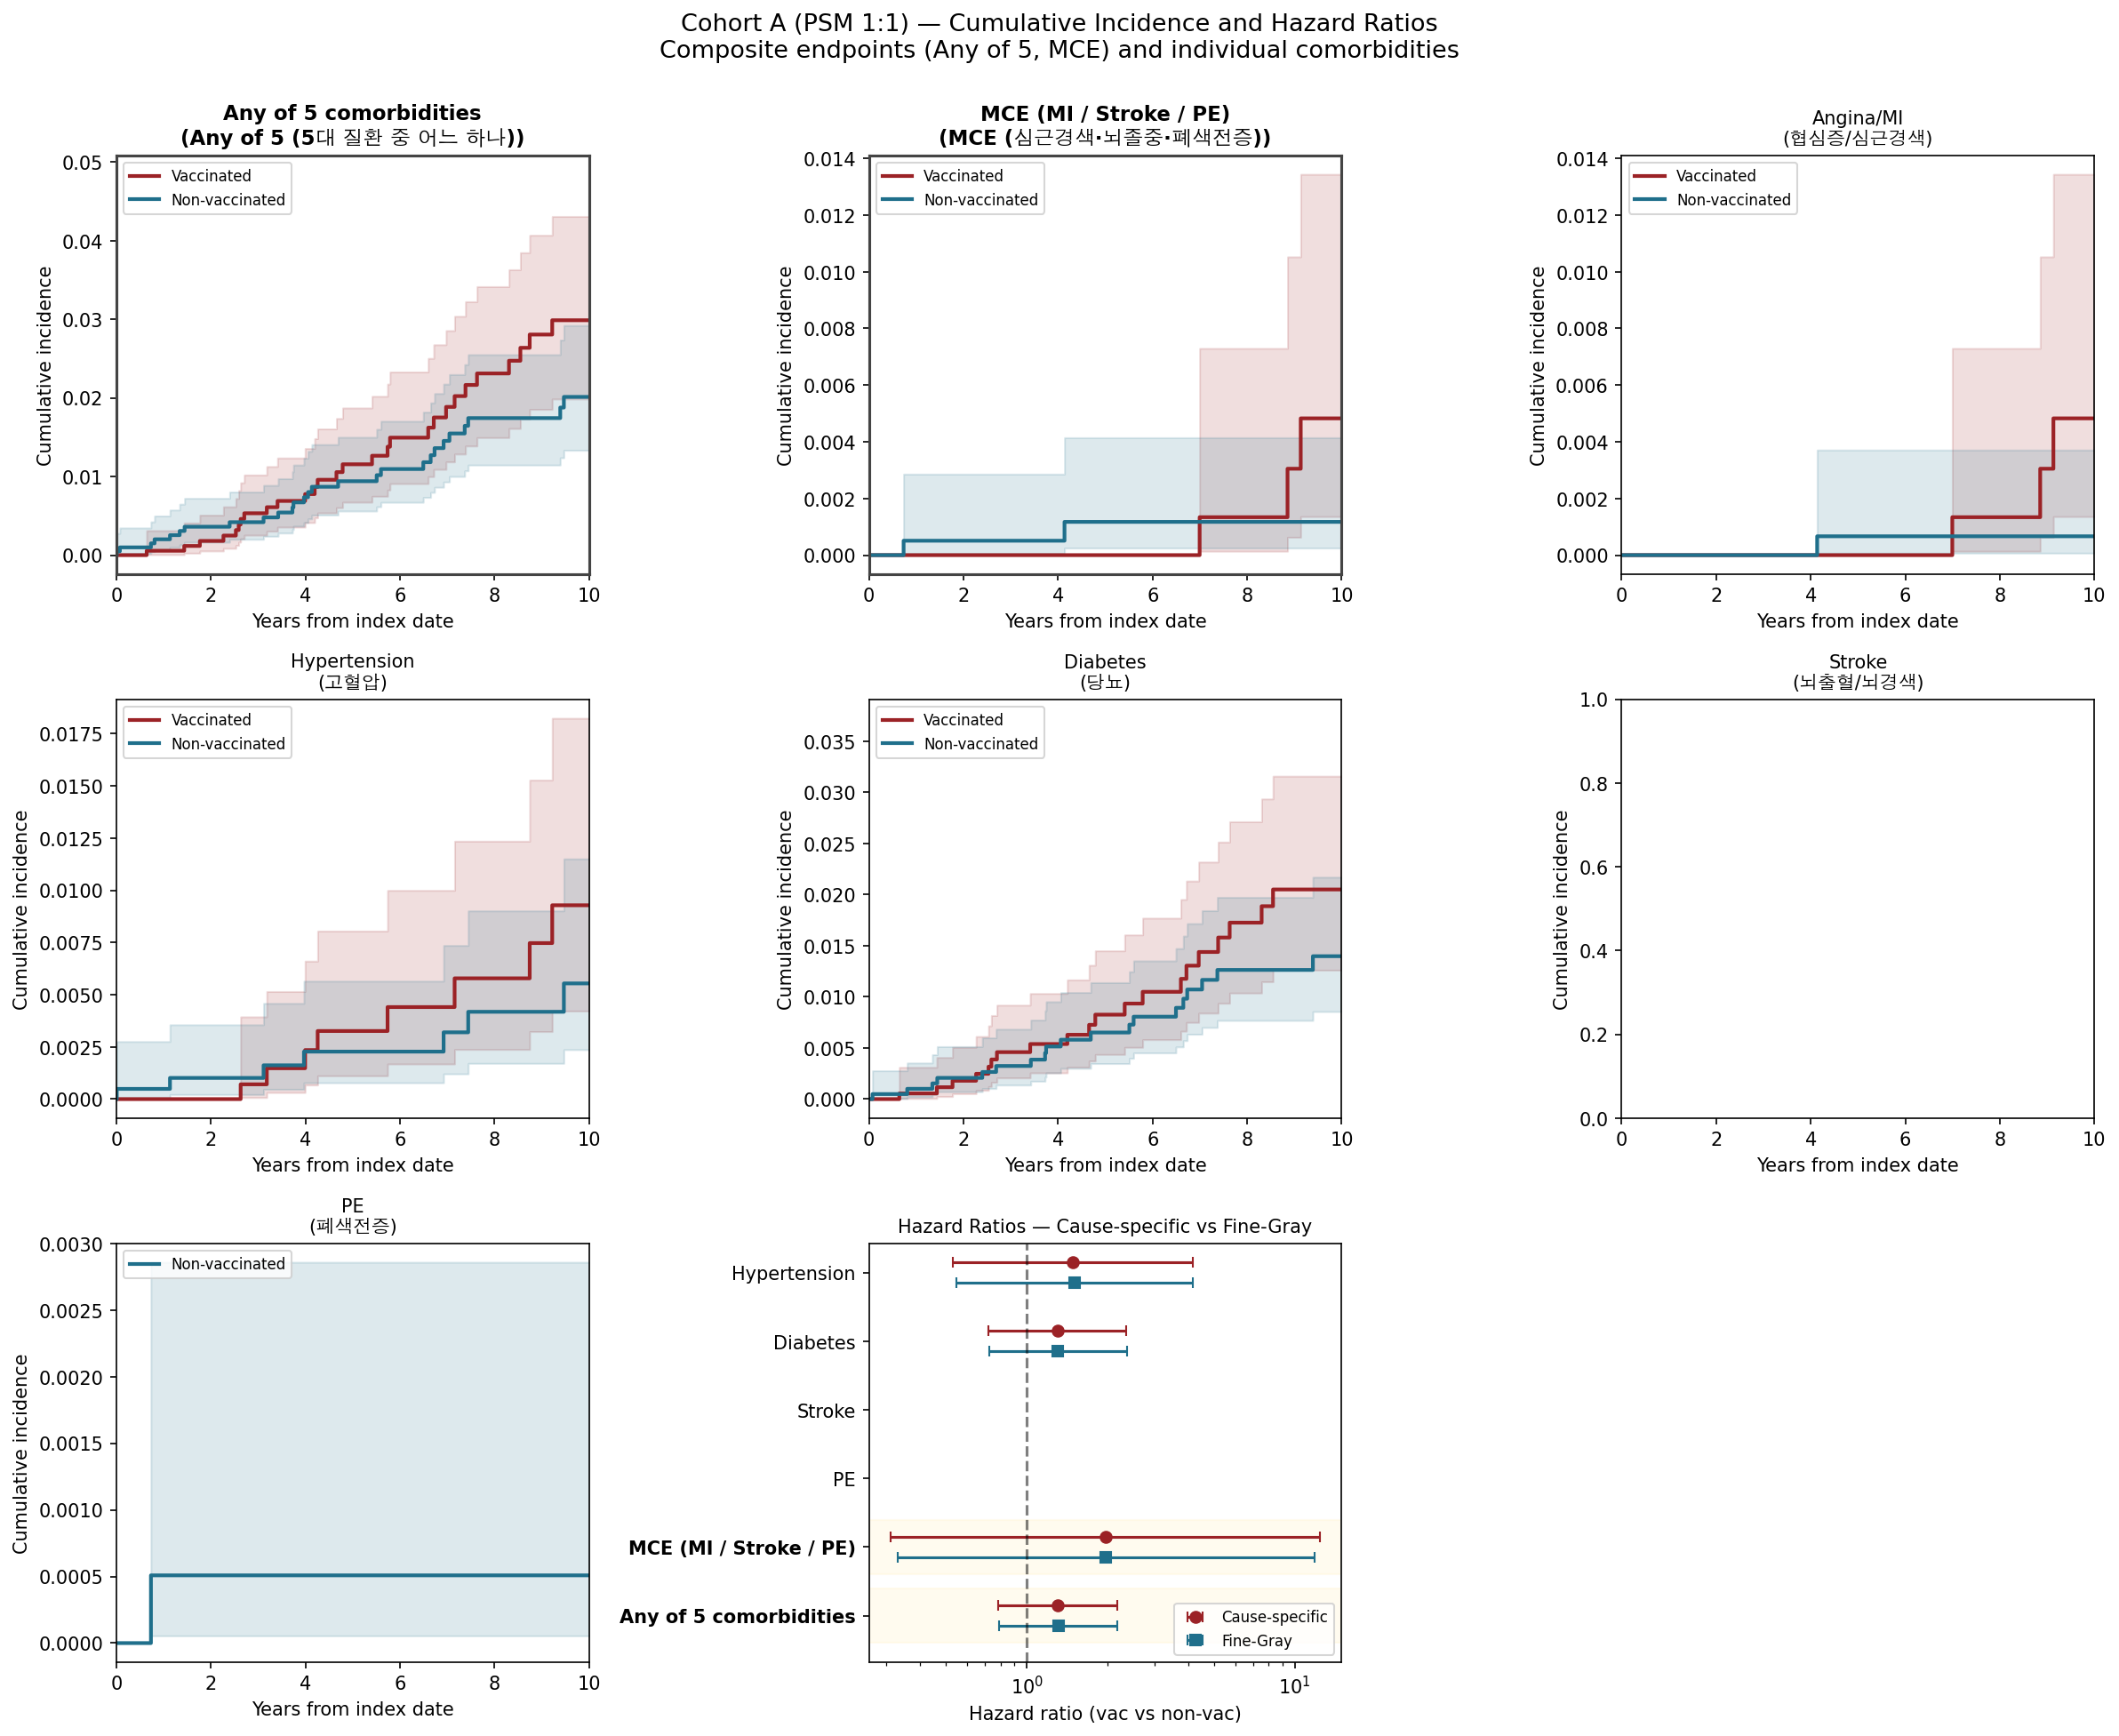
Cumulative incidence functions (CIF) are estimated by the Aalen-Johansen estimator with death as the competing event; shaded areas show 95% pointwise confidence intervals. The bottom-right panel displays cause-specific and Fine-Gray subdistribution HRs (point estimate and 95% CI) on the log scale; the dashed vertical line at HR=1 represents the null. Time axis: years from index date.

