Cohort A — Propensity Score Matching (1:1)
Methods. Propensity scores were estimated by logistic regression with vaccination status as the outcome and the following covariates: age at index, BMI, SBP, DBP (with mean imputation and missing indicators), smoking status (Never/Former/Current/Unknown — Unknown as reference), and residence in Seoul. Pre-matching non-vaccinated controls were assigned a pseudo index date randomly sampled from the vaccinated group's vaccine-date distribution (seed=42). One-to-one nearest-neighbour matching on the logit of the propensity score without replacement was performed using a caliper of 0.2 × SD(logit PS) (Austin 2011). Covariate balance was assessed by absolute standardized mean differences (|SMD|<0.10 considered well-balanced).

Table 1. Covariate balance — Pre vs Post PSM
Variable | Pre-matching |  | Pre |SMD| | Post-matching |  | Post |SMD|
 | Vac (n=2156) | Ctl (n=25553) |  | Vac (n=2110) | Ctl (n=2110)
Age at index, years | 33.46 ± 9.18 | 46.30 ± 14.57 | 1.055 | 33.69 ± 9.14 | 33.15 ± 11.32 | 0.053
BMI, kg/m² | 22.74 ± 2.29 | 23.18 ± 4.08 | 0.135 | 22.78 ± 2.26 | 22.77 ± 2.35 | 0.006
Systolic BP, mmHg | 115.95 ± 9.37 | 118.71 ± 7.08 | 0.332 | 116.13 ± 9.30 | 115.79 ± 9.59 | 0.036
Diastolic BP, mmHg | 72.27 ± 7.74 | 73.69 ± 6.40 | 0.200 | 72.39 ± 7.69 | 72.08 ± 7.12 | 0.041
Logit(PS) | -1.70 ± 1.16 | -3.26 ± 1.24 | 1.294 | -1.75 ± 1.13 | -1.75 ± 1.13 | 0.002
Residence in Seoul | 34.3% | 28.8% | 0.117 | 34.4% | 34.3% | 0.001
BMI missing | 60.0% | 85.1% | 0.586 | 61.1% | 62.8% | 0.034
SBP missing | 53.9% | 83.6% | 0.678 | 55.1% | 57.5% | 0.049
DBP missing | 53.9% | 83.7% | 0.678 | 55.1% | 57.5% | 0.049
Smoking: Never | 31.3% | 19.9% | 0.263 | 30.2% | 28.5% | 0.039
Smoking: Former | 0.5% | 0.3% | 0.023 | 0.5% | 0.5% | 0.000
Smoking: Current | 1.7% | 0.7% | 0.094 | 1.5% | 1.4% | 0.008
Smoking: Unknown | 66.5% | 79.0% | 0.284 | 67.8% | 69.7% | 0.040

Table 2. Comorbidity comparison after PSM
Comorbidity | Vaccinated (n=2110) | Non-vaccinated (n=2110) | Odds ratio | p-value | Significant (α=0.05)
Baseline comorbidity (before index)
협심증/심근경색 | 0 (0.0%) | 1 (0.0%) | 0.00 | 1.000
고혈압 | 10 (0.5%) | 5 (0.2%) | 2.00 | 0.301
당뇨 | 14 (0.7%) | 10 (0.5%) | 1.40 | 0.540
뇌출혈/뇌경색 | 0 (0.0%) | 0 (0.0%) | nan | 1.000
폐색전증 | 0 (0.0%) | 0 (0.0%) | nan | 1.000
Composite (any of 5) | 24 (1.1%) | 15 (0.7%) | 1.61 | 0.198
New-onset comorbidity (after index, baseline-free)
협심증/심근경색 | 3/2110 (0.14%) | 3/2109 (0.14%) | 1.00 | 1.000
고혈압 | 8/2100 (0.38%) | 4/2105 (0.19%) | 2.01 | 0.266
당뇨 | 22/2096 (1.05%) | 25/2100 (1.19%) | 0.88 | 0.770
뇌출혈/뇌경색 | 0/2110 (0.00%) | 0/2110 (0.00%) | nan | 1.000
폐색전증 | 0/2110 (0.00%) | 0/2110 (0.00%) | nan | 1.000

Figure 1. Love plot
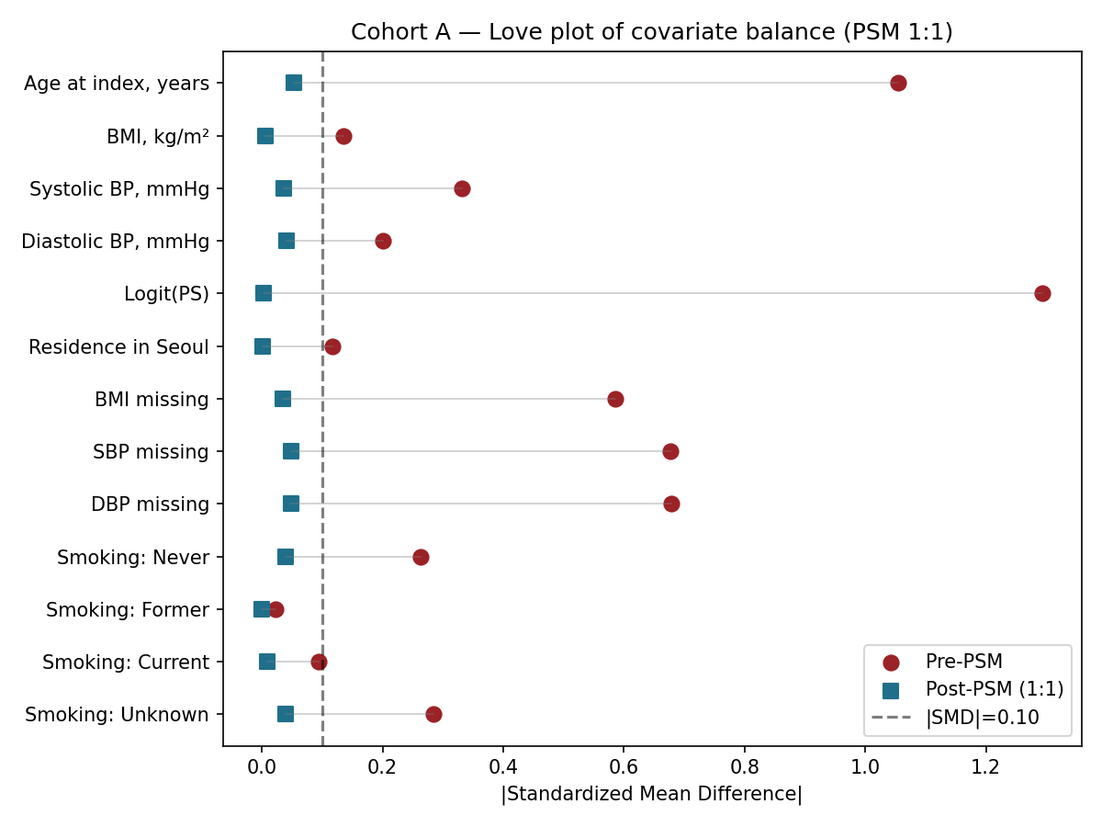
Footnote: Continuous variables shown as mean ± SD; binary variables as %. |SMD|: absolute standardized mean difference. Caliper = 0.2 × SD(logit PS). Logit(PS) is shown as a sanity check that the propensity score itself is balanced after matching.

