Supplementary Materials

Long-term safety and post-surgical efficacy of HPV vaccination in women with cervical intraepithelial lesions

Table S1. Pre-matching baseline characteristics
Table S2. Propensity score model coefficients (Cohort A)
Table S3. Sensitivity analyses for Cohort B
Table S4. Age- and follow-up-stratified subgroup analyses (Cohort B, recurrence)
Table S5. Number-at-risk tables
Table S6. Vaccine-type detailed results
Table S7. Schoenfeld residual test results
Table S8. Pseudo-index assignment sensitivity analysis (Cohort A)
Figure S1. Love plot — Cohort A
Figure S2. Love plot — Cohort B
Figure S3. Propensity-score density distributions
Figure S4. Age × follow-up subgroup forest plot (Cohort B)
Figure S5. Schoenfeld residual plots — Cohort A
Figure S6. Schoenfeld residual plots — Cohort B

Table S1. Pre-matching baseline characteristics of the source population before propensity-score matching (Cohort A) and before fine matching (Cohort B).

[Cohort A (pre-matching)]
Variable | Vaccinated (n=2,156) | Non-vaccinated (n=30,813) | p | |SMD|
Demographics
Age at index, years | 33.46 ± 9.18 | 46.90 ± 14.50 | <0.001 | 1.11
Birth year | 1982.32 ± 10.10 | 1968.93 ± 13.91 | <0.001 | 1.10
Index year | 2015.73 ± 4.11 | 2015.77 ± 4.11 | 0.703 | 0.01
Residence in Seoul | 739 (34.3%) | 9031 (29.3%) | <0.001 | 0.11
Anthropometry & Vital signs (closest to index, ±1 yr)
Height, cm | 161.37 ± 5.32 | 158.56 ± 6.63 | <0.001 | 0.47
Weight, kg | 57.51 ± 9.74 | 57.82 ± 9.73 | 0.373 | 0.03
BMI, kg/m² | 22.12 ± 3.53 | 23.34 ± 10.32 | <0.001 | 0.16
Systolic BP, mmHg | 112.98 ± 13.20 | 119.74 ± 17.43 | <0.001 | 0.44
Diastolic BP, mmHg | 70.74 ± 11.20 | 74.18 ± 15.67 | <0.001 | 0.25
Smoking status
Never | 675 (31.3%) | 6582 (21.4%) | <0.001 | 0.23
Former | 10 (0.5%) | 100 (0.3%) | 0.248 | 0.02
Current | 37 (1.7%) | 246 (0.8%) | <0.001 | 0.08
Unknown | 1434 (66.5%) | 23885 (77.5%) | <0.001 | 0.25
Pre-existing comorbidities (before index)
Angina/MI | 0 (0.0%) | 12 (0.0%) | 1.000 | 0.03
Hypertension | 10 (0.5%) | 115 (0.4%) | 0.468 | 0.01
Diabetes mellitus | 14 (0.6%) | 128 (0.4%) | 0.122 | 0.03
Stroke | 0 (0.0%) | 8 (0.0%) | 1.000 | 0.02
Pulmonary embolism | 0 (0.0%) | 1 (0.0%) | 1.000 | 0.01
Composite (any of 5) | 24 (1.1%) | 227 (0.7%) | 0.071 | 0.04
Follow-up
Follow-up, days | 2134.52 ± 1733.35 | 2058.48 ± 2146.15 | 0.053 | 0.04
Mortality during follow-up | 6 (0.3%) | 283 (0.9%) | <0.001 | 0.08

[Cohort B (pre-matching)]
Variable | Vaccinated (n=566) | Non-vaccinated (n=6,324) | p | |SMD|
Demographics
Age at index, years | 36.40 ± 9.40 | 49.31 ± 12.94 | <0.001 | 1.14
Birth year | 1979.96 ± 10.11 | 1968.29 ± 13.07 | <0.001 | 1.00
Index year | 2016.32 ± 4.24 | 2017.53 ± 4.01 | <0.001 | 0.29
Residence in Seoul | 164 (29.0%) | 1320 (20.9%) | <0.001 | 0.19
Height, cm | 161.21 ± 5.39 | 157.99 ± 6.51 | <0.001 | 0.54
Weight, kg | 57.47 ± 9.65 | 58.12 ± 9.72 | 0.227 | 0.07
BMI, kg/m² | 22.12 ± 3.54 | 23.56 ± 9.25 | <0.001 | 0.20
Systolic BP, mmHg | 113.22 ± 13.44 | 117.45 ± 15.68 | <0.001 | 0.29
Diastolic BP, mmHg | 72.17 ± 11.04 | 73.36 ± 11.60 | 0.040 | 0.10
Smoking status
Never | 207 (36.6%) | 3380 (53.4%) | <0.001 | 0.34
Former | 3 (0.5%) | 31 (0.5%) | 0.756 | 0.01
Current | 17 (3.0%) | 146 (2.3%) | 0.310 | 0.04
Unknown | 339 (59.9%) | 2767 (43.8%) | <0.001 | 0.33
Pre-existing comorbidities (before index)
Angina/MI | 0 (0.0%) | 9 (0.1%) | 1.000 | 0.05
Hypertension | 5 (0.9%) | 132 (2.1%) | 0.057 | 0.10
Diabetes mellitus | 4 (0.7%) | 154 (2.4%) | 0.005 | 0.14
Stroke | 0 (0.0%) | 11 (0.2%) | 1.000 | 0.06
Pulmonary embolism | 0 (0.0%) | 4 (0.1%) | 1.000 | 0.04
Composite (any of 5) | 9 (1.6%) | 262 (4.1%) | 0.001 | 0.15
Surgery type
Conization | 545 (96.3%) | 4965 (78.5%) | <0.001 | 0.56
Hysterectomy | 21 (3.7%) | 1359 (21.5%) | <0.001 | 0.56
Age at surgery, years | 36.81 ± 9.41 | 48.67 ± 12.91 | <0.001 | 1.05
Surgery year | 2016.72 ± 4.22 | 2016.89 ± 3.87 | 0.330 | 0.04
Surgery → index, days | -149.37 ± 954.96 | 232.33 ± 381.31 | <0.001 | 0.53
Follow-up
Follow-up, days | 2082.03 ± 1615.73 | 1623.30 ± 1491.23 | <0.001 | 0.29
Mortality during follow-up | 1 (0.2%) | 73 (1.2%) | 0.030 | 0.12
Abbreviations: BMI, body-mass index; BP, blood pressure; SMD, standardised mean difference.

Table S2. Logistic regression coefficients for propensity score estimation (Cohort A).
Covariate | Mean (Vac) | Mean (Non-vac) | β | Std β | OR
age_at_index | 33.51 | 46.30 | -0.0781 | -1.1427 | 0.925
bmi | 22.71 | 23.18 | -0.0218 | -0.0867 | 0.978
bmi_miss | 0.59 | 0.85 | 0.0464 | 0.0174 | 1.047
sbp | 115.95 | 118.72 | -0.0066 | -0.0481 | 0.993
sbp_miss | 0.53 | 0.84 | -0.7555 | -0.2943 | 0.470
dbp | 72.22 | 73.71 | -0.0005 | -0.0031 | 1.000
dbp_miss | 0.53 | 0.84 | -0.7906 | -0.3078 | 0.454
is_seoul | 0.34 | 0.29 | 0.0288 | 0.0131 | 1.029
smoke_Never | 0.32 | 0.20 | 0.6398 | 0.2599 | 1.896
smoke_Former | 0.00 | 0.00 | 0.4427 | 0.0255 | 1.557
smoke_Current | 0.02 | 0.01 | 0.5130 | 0.0448 | 1.670
Reference category for smoking: Unknown. OR, odds ratio.

Table S3. Sensitivity analyses for Cohort B: restricted follow-up and adjusted vs. unadjusted Cox models.
[Lesion recurrence]
Analysis | N | Events | HR (95% CI) | p
Baseline | 948 | 61 | 0.76 (0.41–1.40) | 0.374
Landmark (180 days) | 920 | 39 | 0.73 (0.33–1.59) | 0.428
Landmark (365 days) | 885 | 30 | 0.71 (0.29–1.74) | 0.457
Restricted FU (2 years) | 948 | 39 | 0.60 (0.27–1.37) | 0.226
Restricted FU (3 years) | 948 | 44 | 0.81 (0.40–1.64) | 0.559
Restricted FU (5 years) | 948 | 55 | 0.77 (0.41–1.47) | 0.428
Exclude Early (Exclude events before 180 days) | 926 | 39 | 0.73 (0.33–1.59) | 0.428
Exclude Early (Exclude events before 365 days) | 917 | 30 | 0.71 (0.29–1.74) | 0.457
HR, hazard ratio; CI, confidence interval; FU, follow-up.

[HPV reinfection]
Analysis | N | Events | HR (95% CI) | p
Baseline | 948 | 592 | 0.92 (0.77–1.11) | 0.400
Landmark (180 days) | 666 | 315 | 1.20 (0.95–1.53) | 0.132
Landmark (365 days) | 507 | 170 | 1.17 (0.84–1.62) | 0.353
Restricted FU (2 years) | 948 | 472 | 0.89 (0.72–1.09) | 0.253
Restricted FU (3 years) | 948 | 511 | 0.89 (0.73–1.09) | 0.249
Restricted FU (5 years) | 948 | 559 | 0.92 (0.76–1.11) | 0.378
Exclude Early (Exclude events before 180 days) | 673 | 317 | 1.19 (0.94–1.51) | 0.153
Exclude Early (Exclude events before 365 days) | 526 | 170 | 1.17 (0.84–1.62) | 0.353
HR, hazard ratio; CI, confidence interval; FU, follow-up.

Table S4. Exploratory subgroup analyses of lesion recurrence by age group and follow-up duration (Cohort B).
Stratum | N | Ev (Vac) | Ev (Ctl) | HR (95% CI) | p
All ages, 1 yr | 1108 | 7 | 31 | 0.78 (0.35–1.75) | 0.546
All ages, 2 yr | 1108 | 7 | 39 | 0.62 (0.28–1.37) | 0.236
All ages, 4 yr | 1108 | 10 | 48 | 0.72 (0.37–1.42) | 0.342
All ages, Full follow-up | 1108 | 13 | 57 | 0.80 (0.44–1.44) | 0.452
<40 years, 1 yr | 686 | 2 | 12 | 0.57 (0.13–2.55) | 0.465
<40 years, 2 yr | 686 | 2 | 16 | 0.43 (0.10–1.86) | 0.259
<40 years, 4 yr | 686 | 3 | 22 | 0.48 (0.14–1.60) | 0.230
<40 years, Full follow-up | 686 | 5 | 26 | 0.69 (0.27–1.79) | 0.445
40–49 years, 1 yr | 326 | 1 | 16 | 0.25 (0.03–1.86) | 0.175
40–49 years, 2 yr | 326 | 1 | 18 | 0.22 (0.03–1.64) | 0.139
40–49 years, 4 yr | 326 | 3 | 21 | 0.54 (0.17–1.77) | 0.313
40–49 years, Full follow-up | 326 | 3 | 26 | 0.45 (0.14–1.45) | 0.182
≥50 years, 1 yr | 96 | 4 | 3 | 4.11 (0.84–20.05) | 0.080
≥50 years, 2 yr | 96 | 4 | 5 | 2.60 (0.66–10.32) | 0.173
≥50 years, 4 yr | 96 | 4 | 5 | 2.60 (0.66–10.32) | 0.173
≥50 years, Full follow-up | 96 | 5 | 5 | 3.23 (0.90–11.54) | 0.071
Ev, events; Vac, vaccinated; Ctl, control; HR, hazard ratio; CI, confidence interval. Age-adjusted Cox models with cluster-robust standard errors.

Table S5. Number at risk at yearly intervals for survival curve analyses.
Outcome | Group | 0 | 1 | 2 | 3 | 4 | 5 | 6 | 7 | 8 yr
A – Any-of-5 | Vac | 2027 | 1721 | 1514 | 1324 | 1138 | 961 | 835 | 730 | 635
A – Any-of-5 | Ctl | 2035 | 1898 | 1763 | 1643 | 1498 | 1347 | 1202 | 1042 | 914
A – MCE (MI/Stroke/PE) | Vac | 2051 | 1742 | 1533 | 1342 | 1151 | 974 | 850 | 746 | 653
A – MCE (MI/Stroke/PE) | Ctl | 2051 | 1916 | 1781 | 1661 | 1518 | 1362 | 1215 | 1056 | 928
A – Angina/MI | Vac | 2051 | 1742 | 1533 | 1342 | 1151 | 974 | 850 | 746 | 653
A – Angina/MI | Ctl | 2051 | 1917 | 1782 | 1661 | 1518 | 1362 | 1215 | 1056 | 928
A – Hypertension | Vac | 2041 | 1733 | 1524 | 1335 | 1145 | 968 | 843 | 740 | 647
A – Hypertension | Ctl | 2045 | 1911 | 1775 | 1654 | 1510 | 1358 | 1212 | 1053 | 925
A – Diabetes | Vac | 2037 | 1730 | 1523 | 1331 | 1144 | 967 | 842 | 737 | 642
A – Diabetes | Ctl | 2041 | 1905 | 1771 | 1649 | 1505 | 1353 | 1207 | 1047 | 919
A – Stroke | Vac | 2051 | 1742 | 1533 | 1342 | 1151 | 974 | 850 | 747 | 654
A – Stroke | Ctl | 2051 | 1917 | 1782 | 1661 | 1518 | 1363 | 1216 | 1057 | 929
A – PE | Vac | 2051 | 1742 | 1533 | 1342 | 1151 | 974 | 850 | 747 | 654
A – PE | Ctl | 2051 | 1916 | 1781 | 1661 | 1518 | 1363 | 1216 | 1057 | 929
B – Lesion recurrence | Vac | 241 | 228 | 209 | 181 | 149 | 106 | 89 | 74 | 60
B – Lesion recurrence | Ctl | 867 | 805 | 730 | 657 | 547 | 406 | 338 | 282 | 233
B – HPV reinfection | Vac | 241 | 138 | 114 | 97 | 78 | 56 | 47 | 40 | 32
B – HPV reinfection | Ctl | 867 | 455 | 384 | 326 | 260 | 192 | 158 | 136 | 116
Vac, vaccinated; Ctl, control/non-vaccinated.

Table S6. Vaccine-type detailed results: pairwise subgroup hazard ratios and interaction-model results (Cohort B).
A. Pairwise subgroup analysis
Vaccine (Outcome) | n Vac | n Ctl | Ev Vac | Ev Ctl | HR (95% CI) | p
Gardasil9 (recurrence) | 128 | 463 | 5 | 28 | 0.61 (0.24–1.60) | 0.3173
Cervarix (recurrence) | 77 | 273 | 6 | 19 | 1.13 (0.45–2.85) | 0.7882
Gardasil (recurrence) | 36 | 131 | 2 | 10 | 0.76 (0.17–3.49) | 0.7262
Gardasil9 (hpv) | 128 | 463 | 85 | 315 | 0.91 (0.72–1.16) | 0.4344
Cervarix (hpv) | 77 | 273 | 53 | 157 | 1.28 (0.93–1.74) | 0.1255
Gardasil (hpv) | 36 | 131 | 11 | 74 | 0.40 (0.21–0.75) | 0.0041

B. Interaction model (likelihood-ratio test)
Outcome | LRT χ² | df | p | Gardasil 9 HR (95% CI) | Cervarix HR (95% CI) | Gardasil HR (95% CI)
Lesion recurrence | χ²=0.27 | 2 | 0.8747 | 0.76 (0.29–1.97) | 0.97 (0.38–2.43) | 0.63 (0.14–2.87)
HPV reinfection | χ²=6.60 | 2 | 0.0368 | 1.10 (0.90–1.33) | 1.11 (0.81–1.51) | 0.49 (0.26–0.93)
LRT, likelihood-ratio test. Reference category for vaccine type: Gardasil 9 (nonavalent). Ev, events; Vac, vaccinated; Ctl, control.

Table S7. Proportional-hazards assumption assessment by Schoenfeld residual rank test.
Cohort | Outcome | HR (95% CI) | p (HR) | Schoenfeld p
A | Any-of-5 (cause-specific) | 1.26 (0.75–2.12) | 0.38 | 0.34
A | MCE (cause-specific) | 1.96 (0.31–12.44) | 0.47 | 0.05
A | Diabetes (cause-specific) | 1.25 (0.68–2.28) | 0.48 | —
A | Hypertension (cause-specific) | 1.49 (0.53–4.18) | 0.45 | —
B | Lesion recurrence | 0.76 (0.43–1.33) | 0.34 | 0.59
B | HPV reinfection | 0.97 (0.83–1.14) | 0.71 | 0.12
HR, hazard ratio; CI, confidence interval; MCE, Major Cardiovascular Events. "—" indicates test not performed (insufficient events). Cluster-robust standard errors used throughout.

Table S8. Pseudo-index assignment sensitivity analysis for the Any-of-five composite (Cohort A).
Strategy | n Vac | n Ctl | Ev Vac | Ev Ctl | HR (95% CI) | p
Random sample (primary) | 2030 | 2038 | 29 | 30 | 1.26 (0.75–2.12) | 0.377
Time-matched (calendar year) | 2054 | 2064 | 30 | 27 | 1.27 (0.75–2.15) | 0.378
Risk-set sampling | 1096 | 1102 | 13 | 13 | 1.21 (0.55–2.66) | 0.627
HR, hazard ratio; CI, confidence interval; Ev, events; Vac, vaccinated; Ctl, control.

Figure S1. Love plot showing absolute standardised mean differences before and after propensity-score matching (Cohort A).
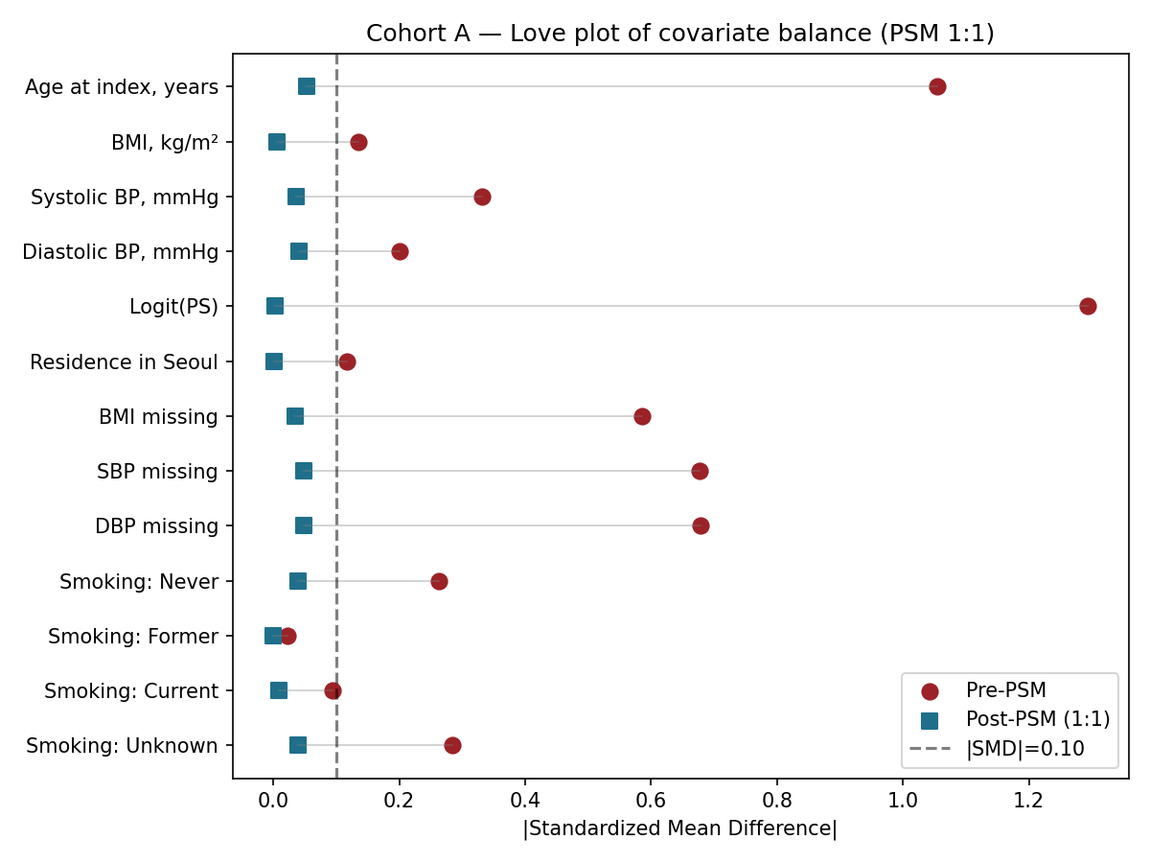

Figure S2. Love plot showing absolute standardised mean differences before and after fine matching (Cohort B).
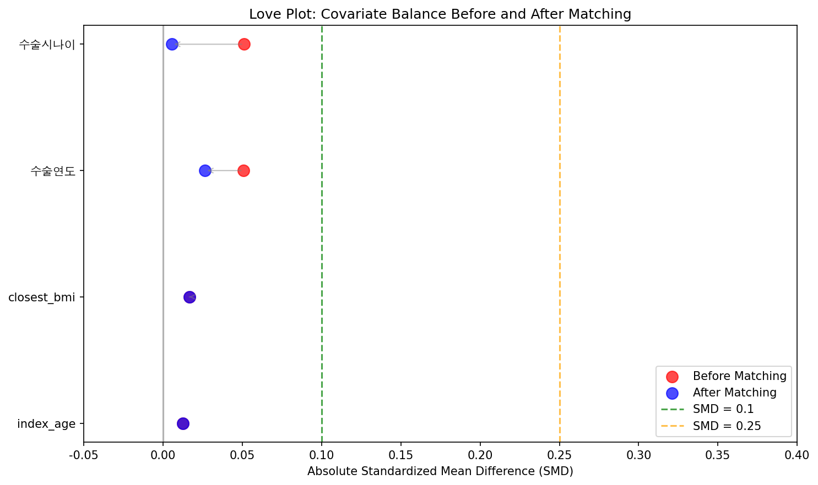

Figure S3. Propensity-score density distributions before and after 1:1 nearest-neighbour matching (Cohort A).
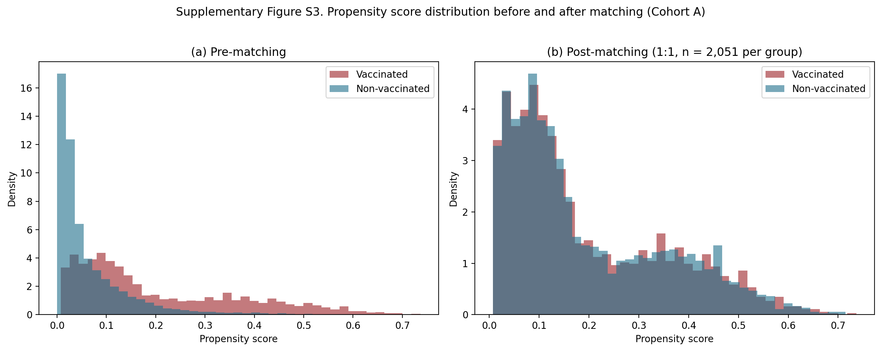

Figure S5. Scaled Schoenfeld residual plots for Cohort A primary models.
A. Any-of-five composite
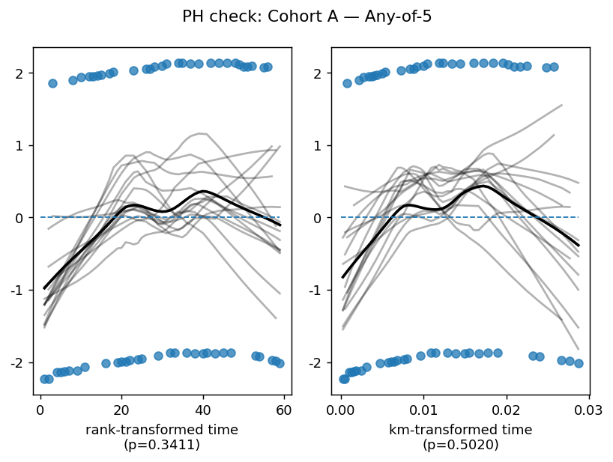
B. Diabetes
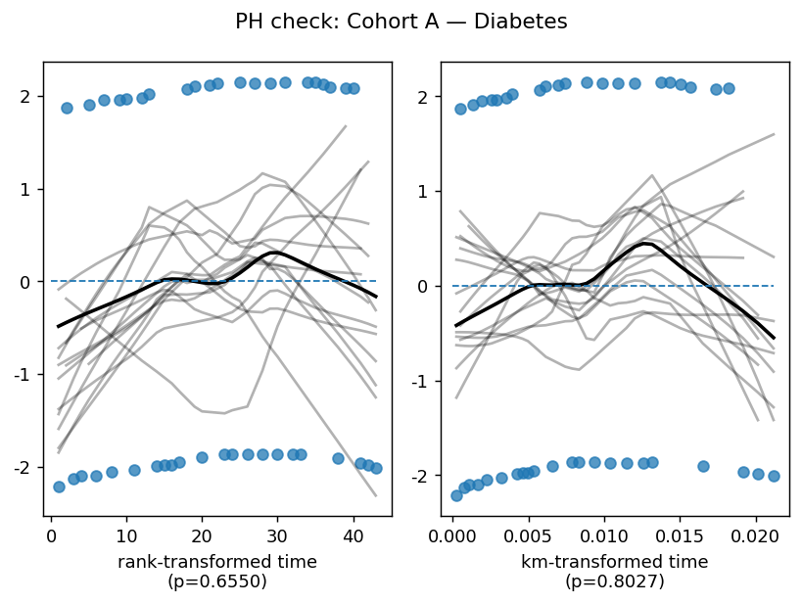

Figure S6. Scaled Schoenfeld residual plots for Cohort B primary models.
A. Lesion recurrence
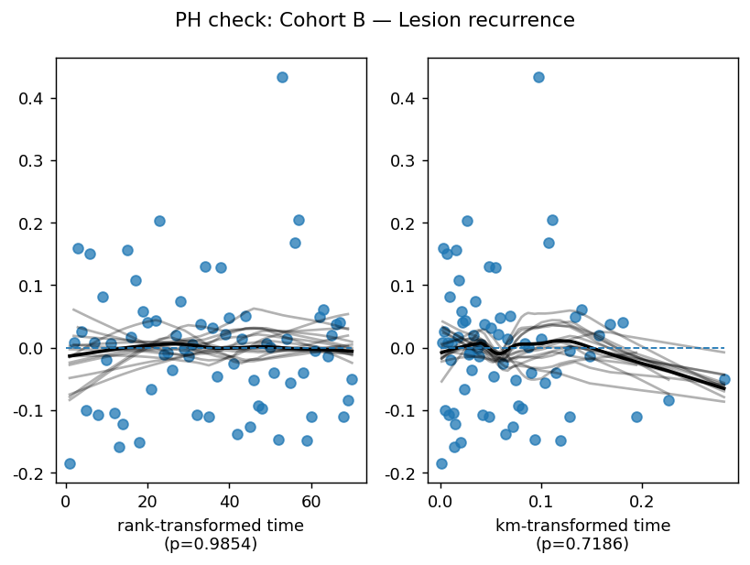
B. HPV reinfection
