Tables and Figures

Long-term safety and post-surgical efficacy of HPV vaccination in women with cervical intraepithelial lesions: a prospective–retrospective cohort study using Korean clinical data warehouse

Table 1. Baseline characteristics of the analytic cohorts after matching
Characteristic | Vaccinated | Unvaccinated | SMD
(a) Entire cohort (Cohort A; propensity-score matched, 1:1) | Vaccinated (n = 2,052) | Unvaccinated (n = 2,052) | SMD
Demographics
Age at index, years | 33.73 ± 9.14 | 33.55 ± 11.46 | 0.018
Birth year | 1982.04 ± 10.06 | 1981.29 ± 11.21 | 0.071
Index year | 2015.73 ± 4.12 | 2014.79 ± 3.81 | 0.238
Residence in Seoul | 714 (34.8%) | 708 (34.5%) | 0.006
Anthropometry and vital signs
Height, cm | 161.36 ± 5.33 | 160.63 ± 5.34 | 0.136
Weight, kg | 57.58 ± 9.81 | 56.87 ± 10.12 | 0.071
BMI, kg/m² | 22.15 ± 3.56 | 22.06 ± 3.69 | 0.024
Systolic BP, mmHg | 113.36 ± 13.26 | 112.64 ± 15.01 | 0.051
Diastolic BP, mmHg | 70.86 ± 10.70 | 70.44 ± 11.03 | 0.039
Smoking status
Never | 629 (30.6%) | 624 (30.4%) | 0.005
Former | 9 (0.4%) | 7 (0.3%) | 0.016
Current | 31 (1.5%) | 35 (1.7%) | 0.015
Unknown | 1384 (67.4%) | 1387 (67.6%) | 0.003
Pre-existing comorbidities
Angina pectoris/MI | 0 (0.0%) | 0 (0.0%) | —
Hypertension | 9 (0.4%) | 5 (0.2%) | 0.033
Diabetes mellitus | 14 (0.7%) | 10 (0.5%) | 0.026
Stroke | 0 (0.0%) | 0 (0.0%) | —
Pulmonary embolism | 0 (0.0%) | 0 (0.0%) | —
Composite (any of 5) | 23 (1.1%) | 15 (0.7%) | 0.041
Follow-up
Follow-up, days | 2195.52 ± 1721.94 | 2725.86 ± 1581.00 | 0.321
Mortality during follow-up | 5 (0.2%) | 23 (1.1%) | 0.107
(b) Surgical cohort (Cohort B; fine-matched, 1:4) | Vaccinated (n = 241) | Unvaccinated (n = 868) | SMD
Demographics
Age at index, years | 37.26 ± 9.45 | 37.17 ± 8.53 | 0.010
Birth year | 1979.56 ± 10.22 | 1979.57 ± 9.43 | 0.000
Index year | 2016.76 ± 3.82 | 2016.69 ± 3.74 | 0.019
Residence in Seoul | 66 (27.4%) | 257 (29.6%) | 0.050
Anthropometry and vital signs
Height, cm | 160.38 ± 4.95 | 160.97 ± 5.43 | 0.113
Weight, kg | 57.14 ± 9.11 | 57.14 ± 9.39 | 0.000
BMI, kg/m² | 22.19 ± 3.52 | 22.15 ± 3.44 | 0.009
Systolic BP, mmHg | 113.43 ± 13.03 | 112.72 ± 13.74 | 0.053
Diastolic BP, mmHg | 72.06 ± 10.53 | 71.31 ± 11.83 | 0.067
Smoking status
Never | 110 (45.6%) | 379 (43.7%) | 0.039
Former | 0 (0.0%) | 6 (0.7%) | 0.118
Current | 10 (4.1%) | 29 (3.3%) | 0.042
Unknown | 121 (50.2%) | 453 (52.2%) | 0.041
Pre-existing comorbidities
Angina pectoris/MI | 0 (0.0%) | 0 (0.0%) | —
Hypertension | 4 (1.7%) | 6 (0.7%) | 0.090
Diabetes mellitus | 3 (1.2%) | 11 (1.3%) | 0.002
Stroke | 0 (0.0%) | 0 (0.0%) | —
Pulmonary embolism | 0 (0.0%) | 0 (0.0%) | —
Composite (any of 5) | 7 (2.9%) | 15 (1.7%) | 0.078
Surgical procedure
Conisation | 240 (99.6%) | 861 (99.3%) | 0.037
Hysterectomy | 1 (0.4%) | 6 (0.7%) | 0.037
Age at surgery, years | 36.68 ± 9.27 | 36.75 ± 8.51 | 0.009
Surgery year | 2016.18 ± 3.79 | 2016.27 ± 3.72 | 0.023
Surgery → index, days | 213.25 ± 380.70 | 153.59 ± 209.66 | 0.194
Follow-up
Follow-up, days | 2233.95 ± 1404.53 | 2236.13 ± 1351.73 | 0.002
Mortality during follow-up | 0 (0.0%) | 4 (0.5%) | 0.096

Data are presented as mean ± SD or n (%). SMD, standardised mean difference; SBP, systolic blood pressure; DBP, diastolic blood pressure; BMI, body mass index; MI, myocardial infarction. Covariate balance was assessed using absolute SMD; values < 0.10 indicate adequate balance. P-values are not reported for matched comparisons.
Table 2. Entire cohort (Cohort A): cause-specific and subdistribution hazard ratios for chronic-disease endpoints (N = 4,102)
Outcome | Ev (V) | Ev (C) | PY (V) | PY (C) | IR (V) | IR (C) | csHR (95% CI) | sHR (95% CI)
Angina pectoris/MI | 3 | 1 | 12,324 | 15,317 | 0.2 | 0.1 | — | —
Hypertension | 8 | 7 | 12,246 | 15,266 | 0.7 | 0.5 | 1.49 (0.53–4.19) | 1.50 (0.54–4.14)
Diabetes mellitus | 21 | 22 | 12,201 | 15,190 | 1.7 | 1.4 | 1.25 (0.68–2.28) | 1.25 (0.69–2.28)
Stroke | 0 | 0 | 12,341 | 15,322 | 0.0 | 0.0 | — | —
Pulmonary embolism | 0 | 1 | 12,341 | 15,320 | 0.0 | 0.1 | — | —
MCE | 3 | 2 | 12,324 | 15,315 | 0.2 | 0.1 | 1.96 (0.31–12.46) | 1.95 (0.33–11.71)
Any of five | 29 | 30 | 12,106 | 15,130 | 2.4 | 2.0 | 1.26 (0.75–2.12) | 1.27 (0.76–2.12)

Ev, events; PY, person-years; IR, incidence rate per 1,000 person-years; csHR, cause-specific hazard ratio; sHR, subdistribution hazard ratio estimated by Fine–Gray regression; MI, myocardial infarction; MCE, major cardiovascular event (myocardial infarction, stroke, or pulmonary embolism); V, vaccinated; C, unvaccinated control. All hazard ratios were estimated with cluster-robust standard errors. The competing event was death from any cause (n = 28). Estimates were not computed when fewer than three events occurred in either group (—).
Table 3. Surgical cohort (Cohort B): age-adjusted hazard ratios for post-surgical outcomes (N = 1,108)
Outcome | N (V) | N (C) | Ev (V) | Ev (C) | PY (V) | PY (C) | IR (V) | IR (C) | HR (95% CI) | p
Lesion recurrence (HSIL/CIN3+) | 241 | 867 | 13 | 57 | 1,474 | 5,308 | 8.8 | 10.7 | 0.76 (0.43–1.33) | 0.337
High-risk HPV reinfection | 241 | 867 | 149 | 546 | 1,474 | 5,308 | 101.1 | 102.9 | 0.97 (0.83–1.14) | 0.712

Ev, events; PY, person-years; IR, incidence rate per 1,000 person-years; HR, hazard ratio; CI, confidence interval; HSIL, high-grade squamous intraepithelial lesion; CIN3, cervical intraepithelial neoplasia grade 3; HPV, human papillomavirus; V, vaccinated; C, unvaccinated control. Hazard ratios were estimated from Cox proportional-hazards models with cluster-robust standard errors, adjusted for age at index date. No multiplicity adjustment was applied.
Figure 1. Cohort selection flow diagram. From the source population (N = 32,969), the entire cohort for chronic-disease safety (Cohort A, n = 4,102) and the surgical cohort for post-surgical efficacy (Cohort B, n = 1,108) were derived.
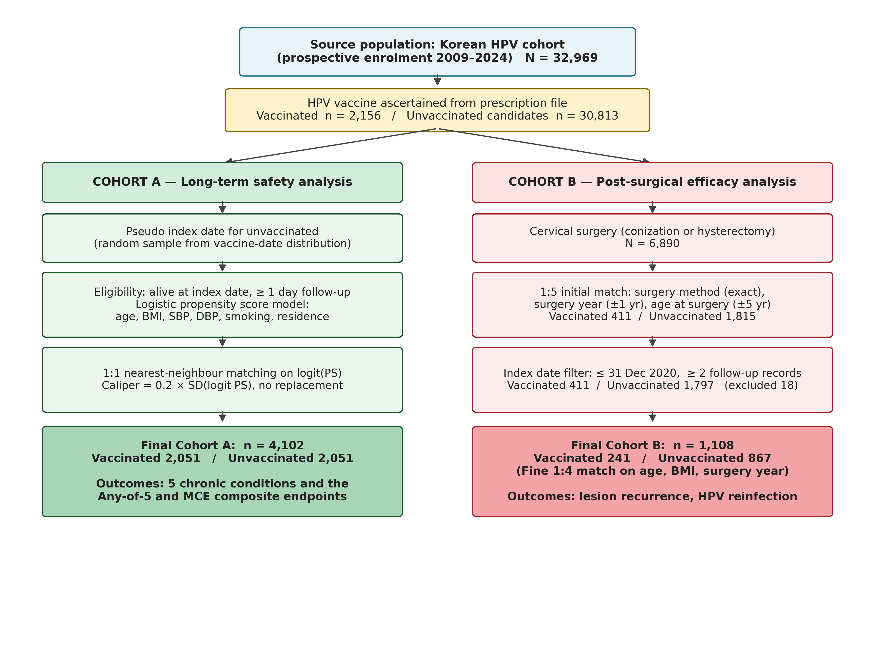
Figure 2. Entire cohort (Cohort A, N = 4,102). Aalen–Johansen cumulative incidence functions and forest plot of cause-specific hazard ratios for five chronic-disease endpoints. Death from any cause was treated as a competing event.
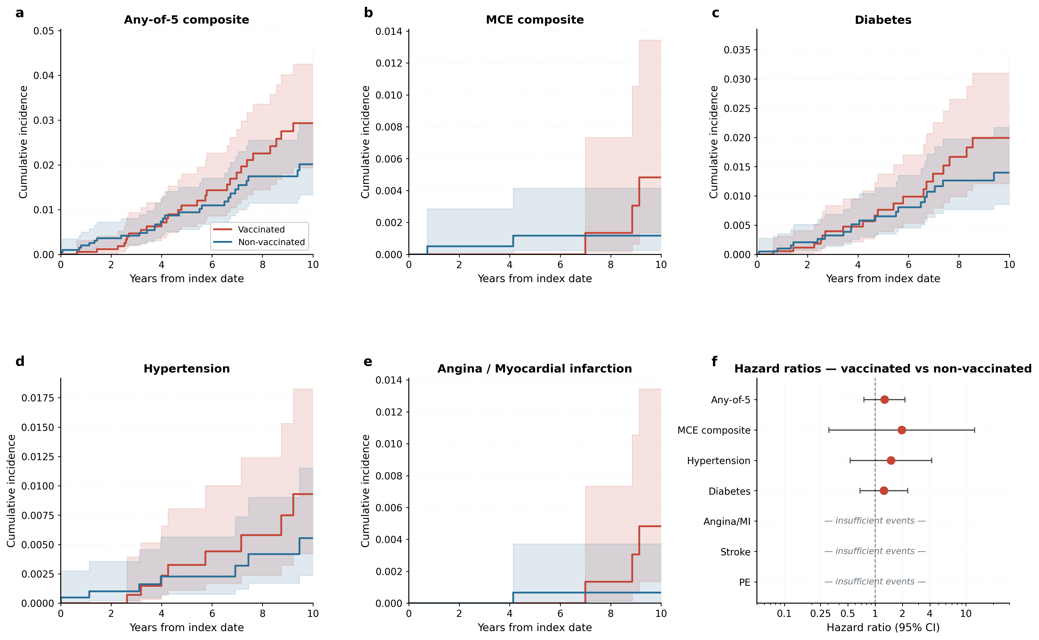
Figure 3. Surgical cohort (Cohort B, N = 1,108). Kaplan–Meier survival curves for biopsy-confirmed lesion recurrence (HSIL/CIN3+) and high-risk HPV reinfection.
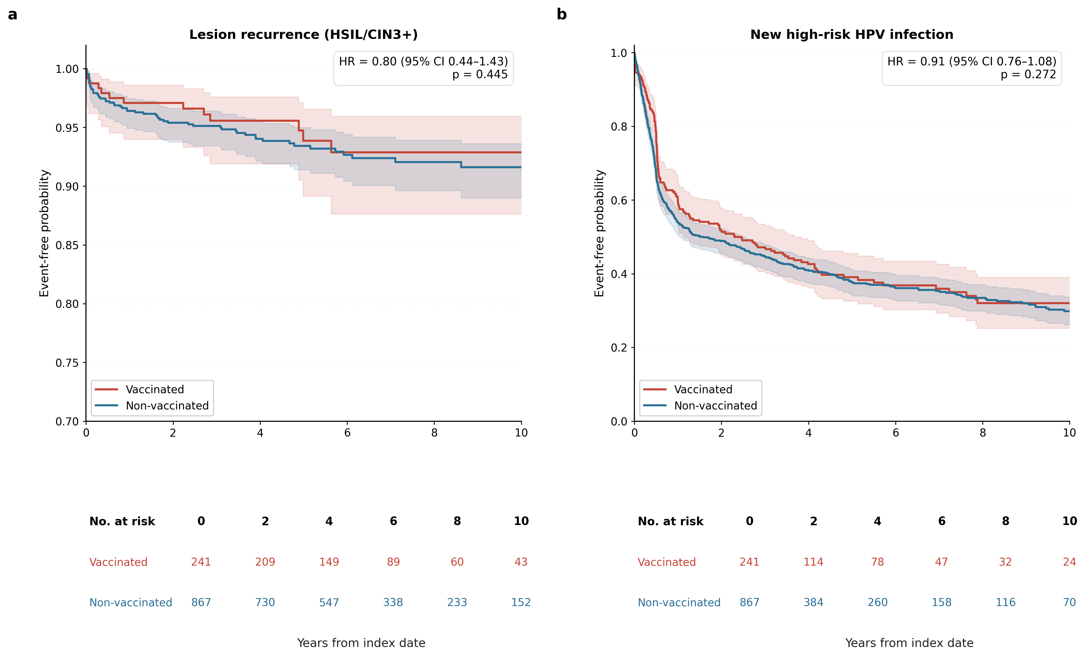
Figure 4. Surgical cohort (Cohort B). Subgroup analyses for lesion recurrence and high-risk HPV reinfection: (a) forest plot of hazard ratios by vaccine type (nonavalent, bivalent, quadrivalent); (b) forest plot of pre-specified age-stratum by follow-up-duration subgroup analysis for lesion recurrence.
