Supplementary materials

Supplementary Figures
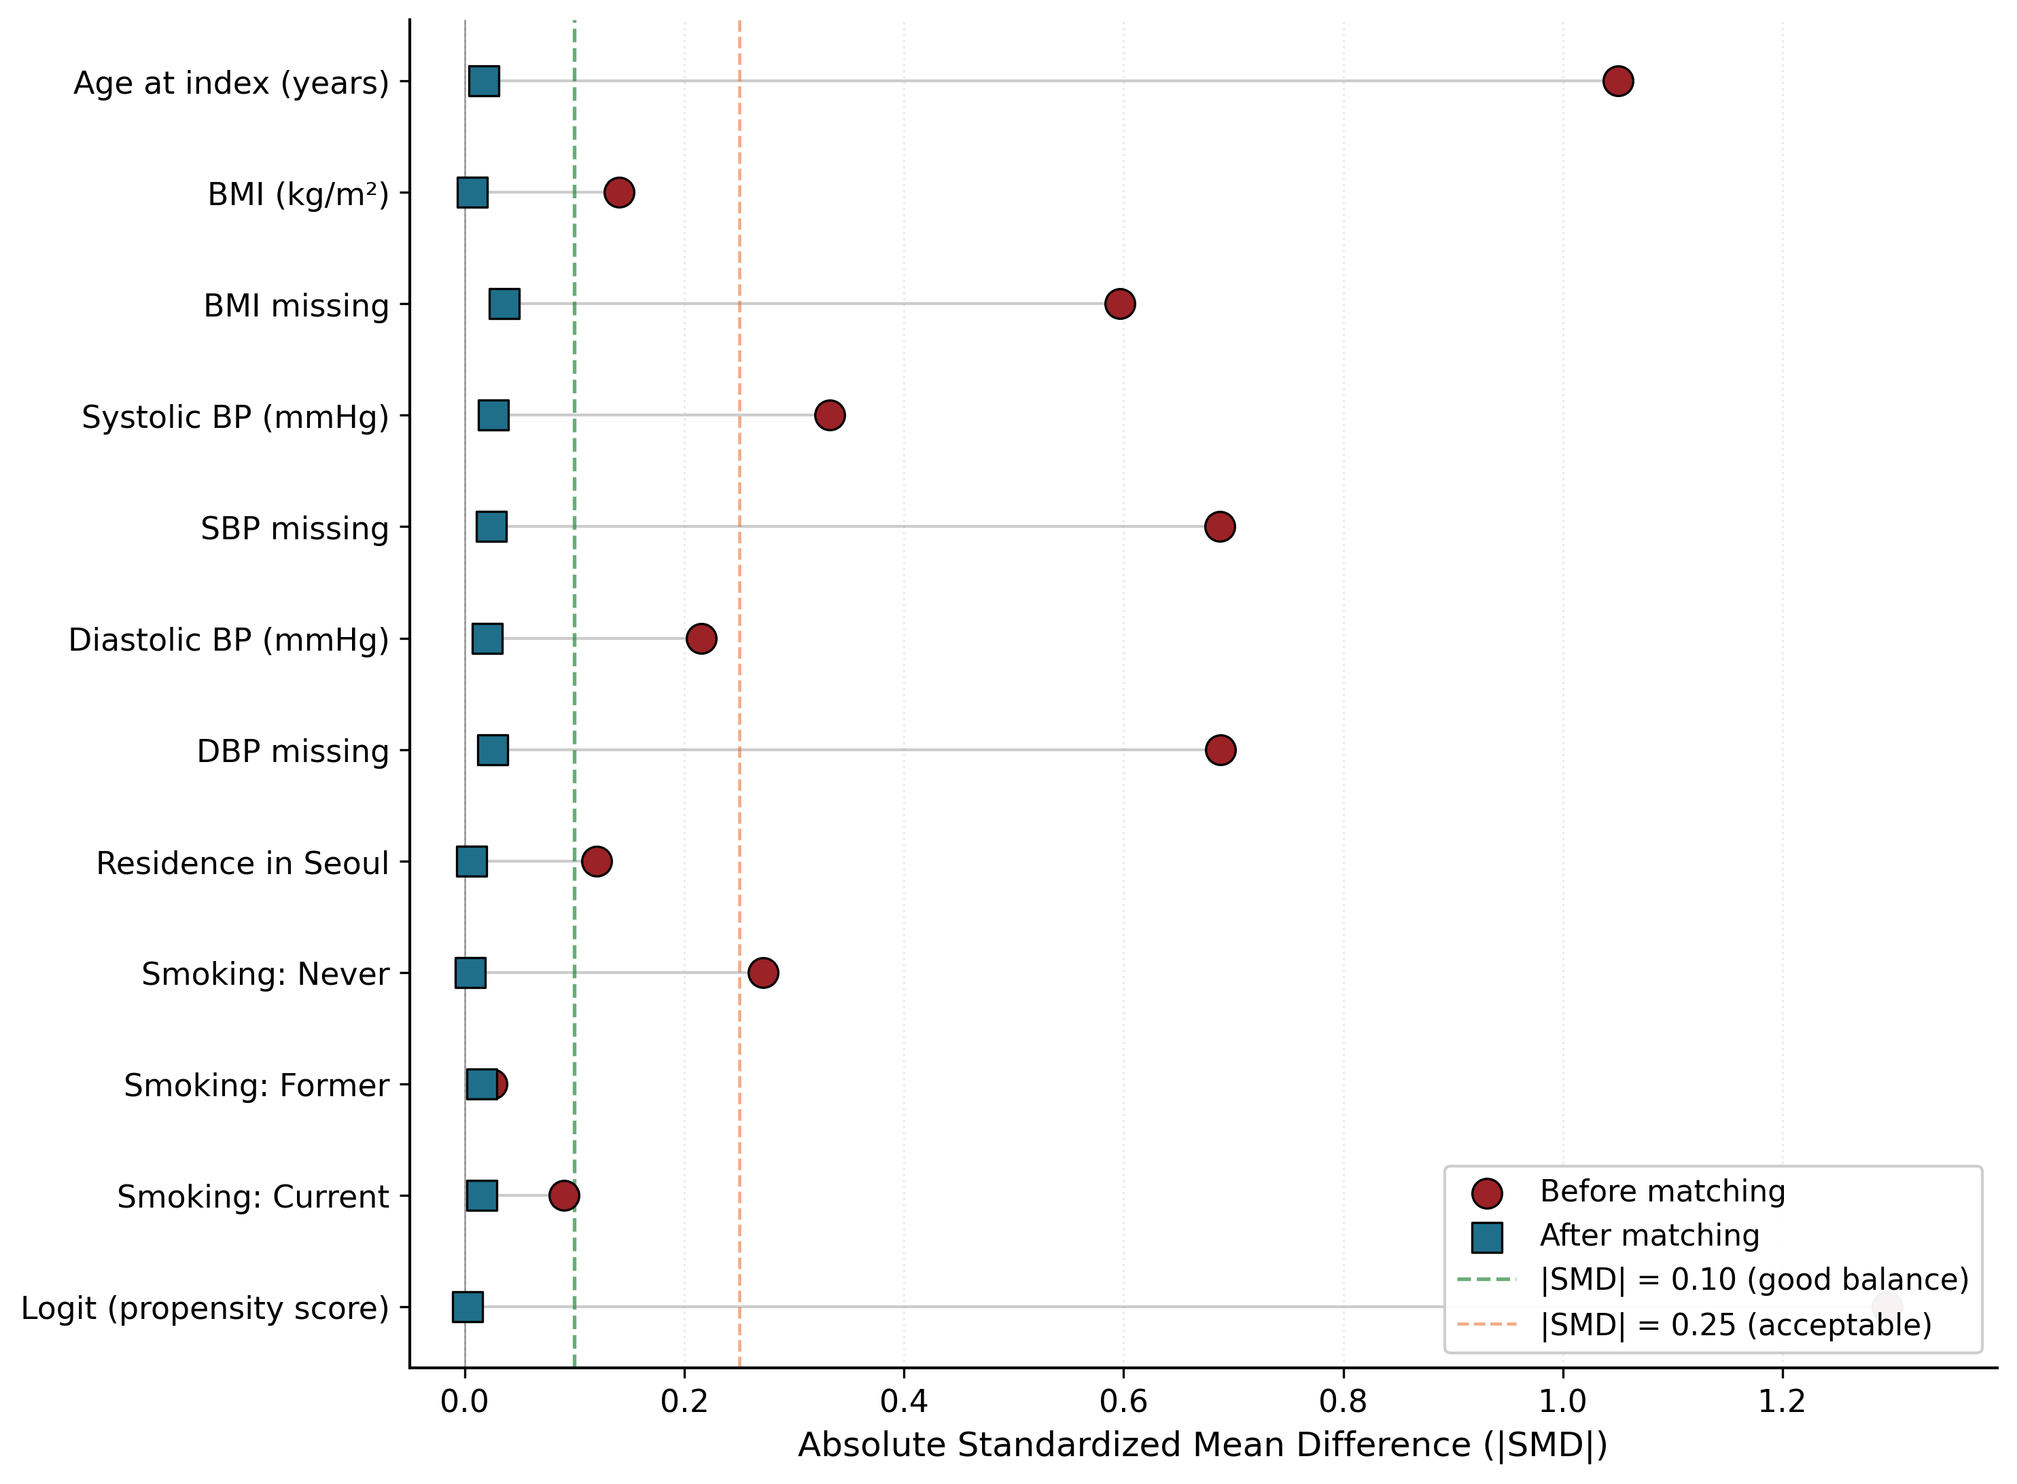
Supplementary Figure S1. Love plot — covariate balance before and after 1:1 propensity-score matching (Cohort A).

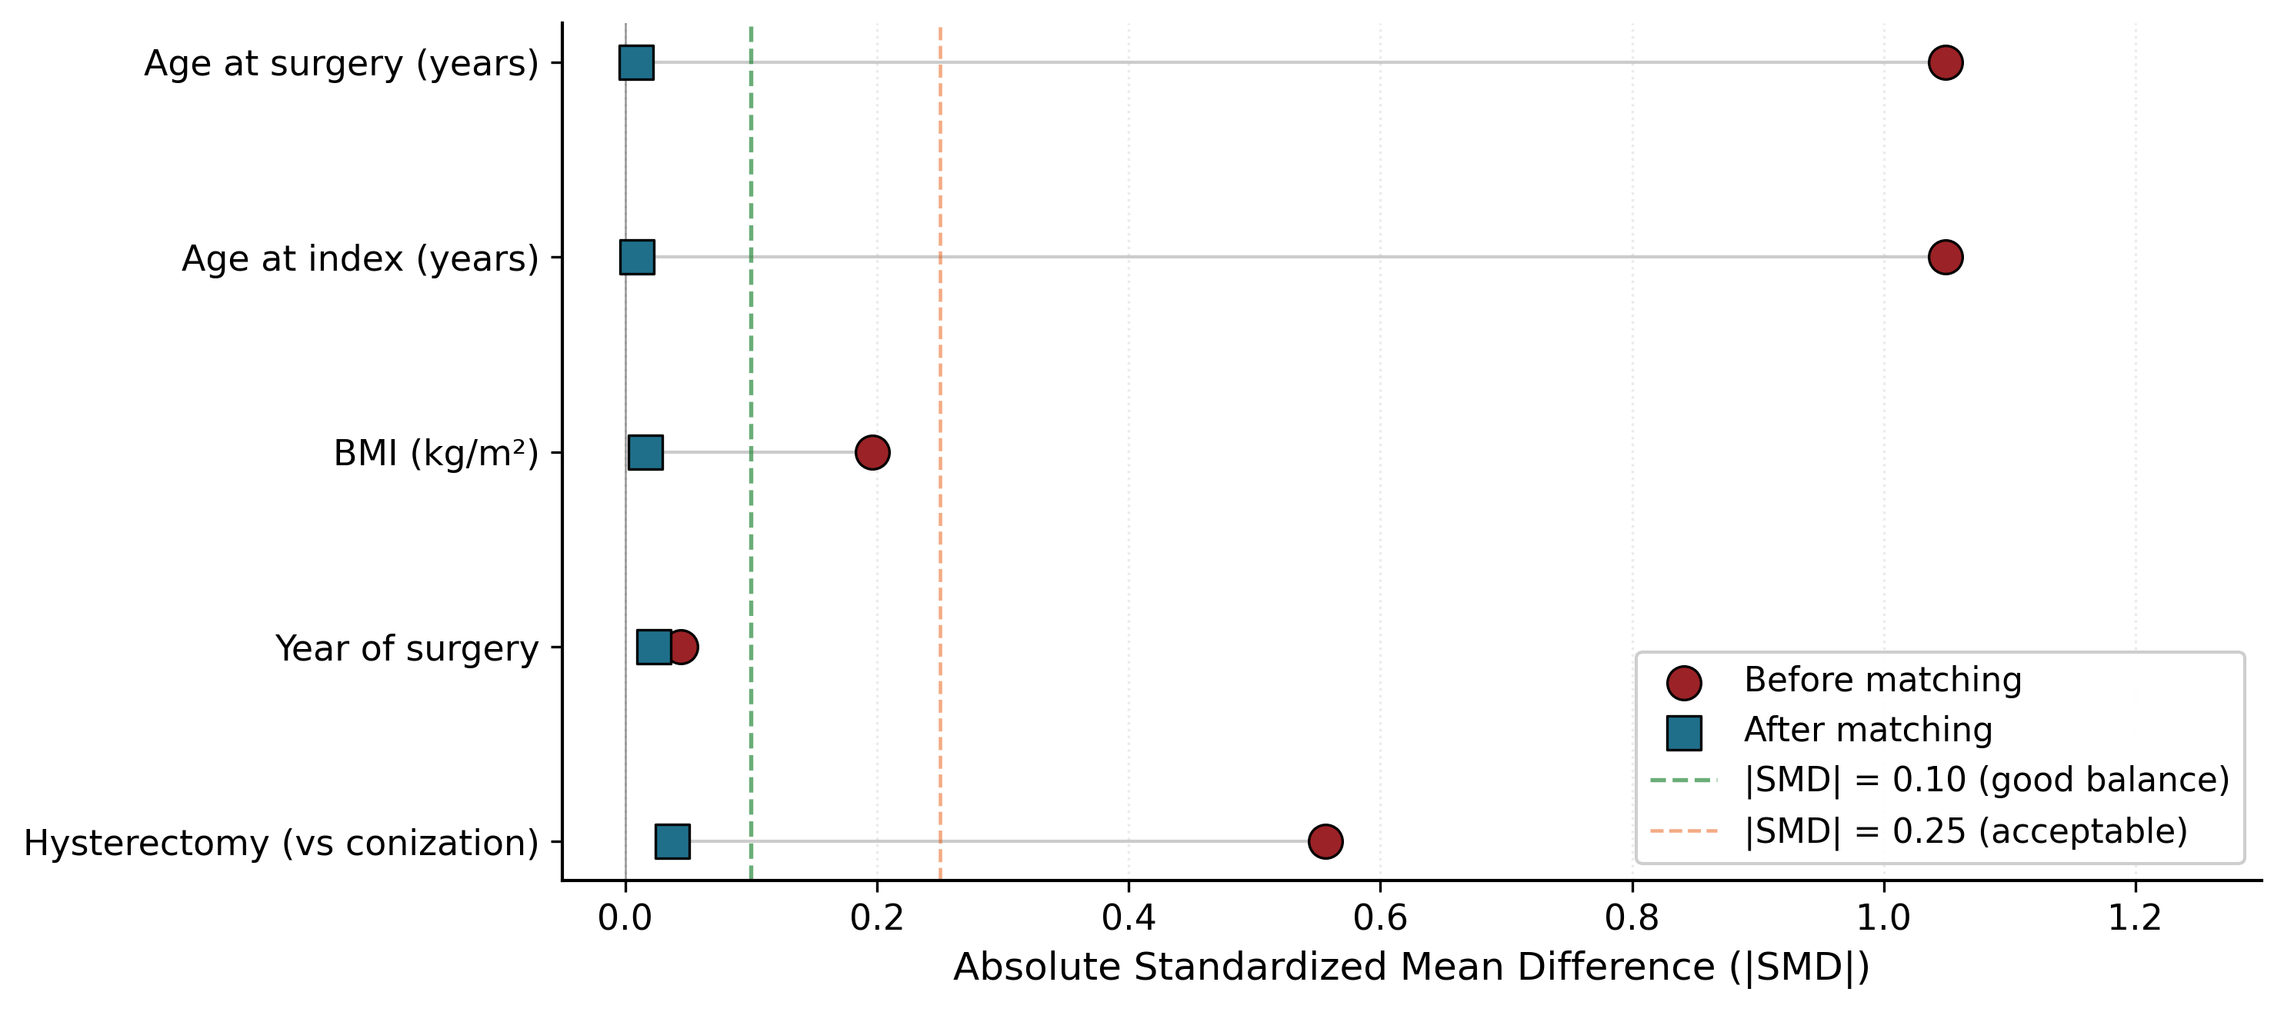
Supplementary Figure S2. Love plot — covariate balance before and after fine variable-ratio (1:up-to-4) matching (Cohort B).

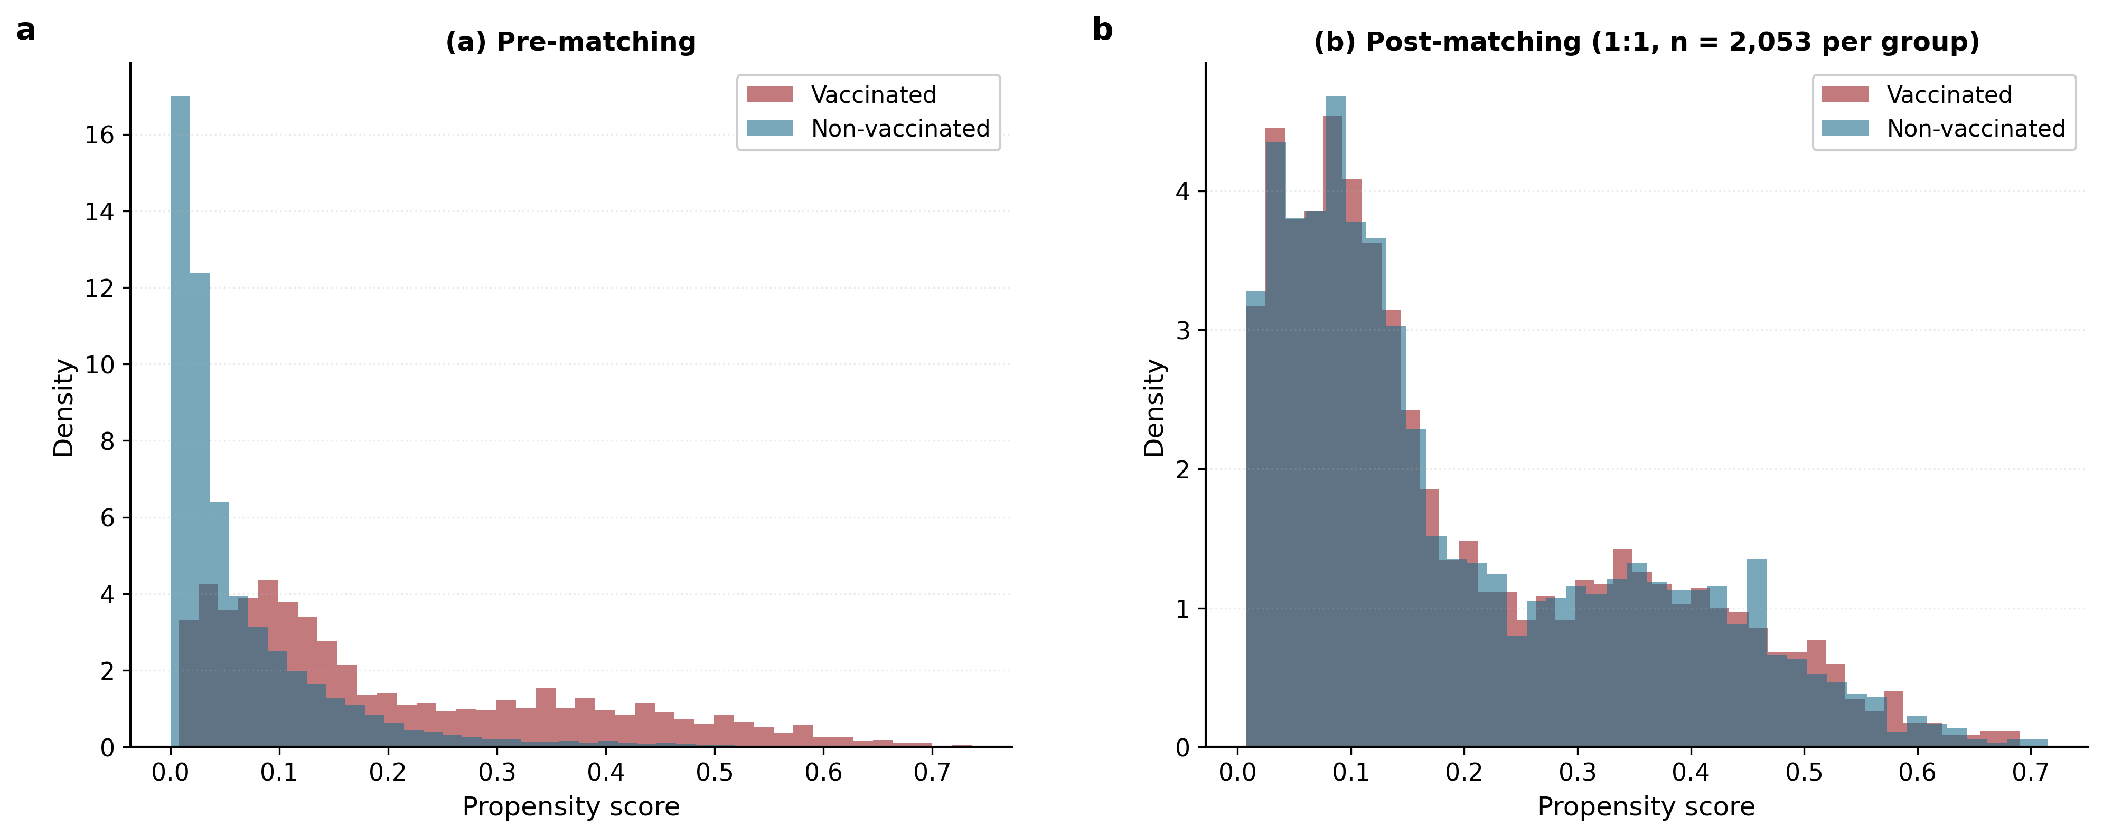
Supplementary Figure S3. Propensity-score density distributions, before and after matching.

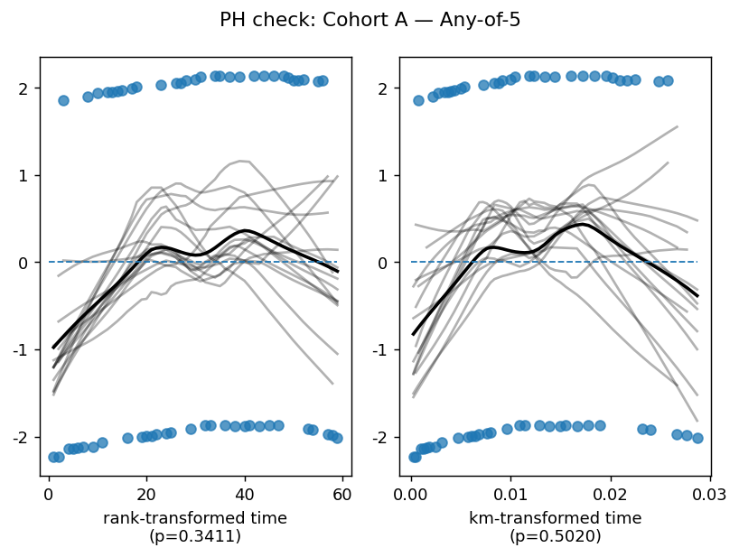
Supplementary Figure S4 panel a. Schoenfeld residual plot — Cohort A, Any-of-5 composite.

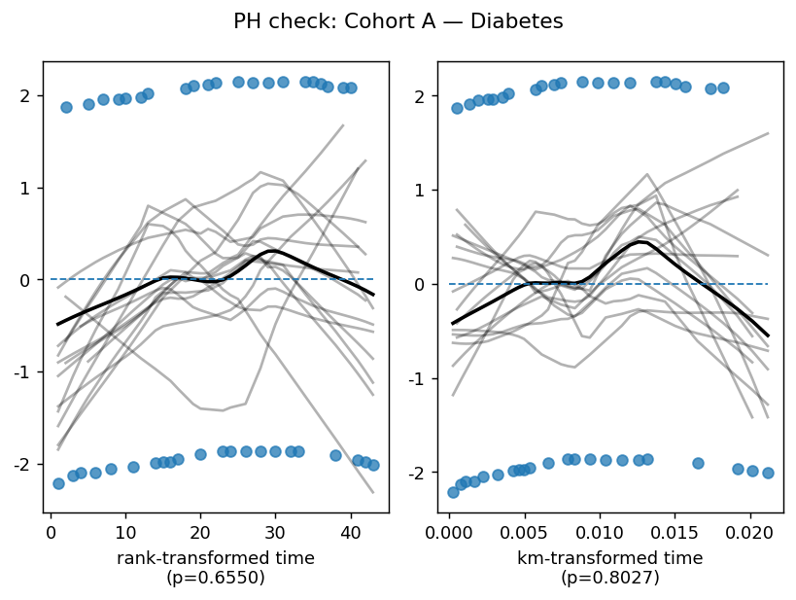
Supplementary Figure S4 panel b. Schoenfeld residual plot — Cohort A, Diabetes.

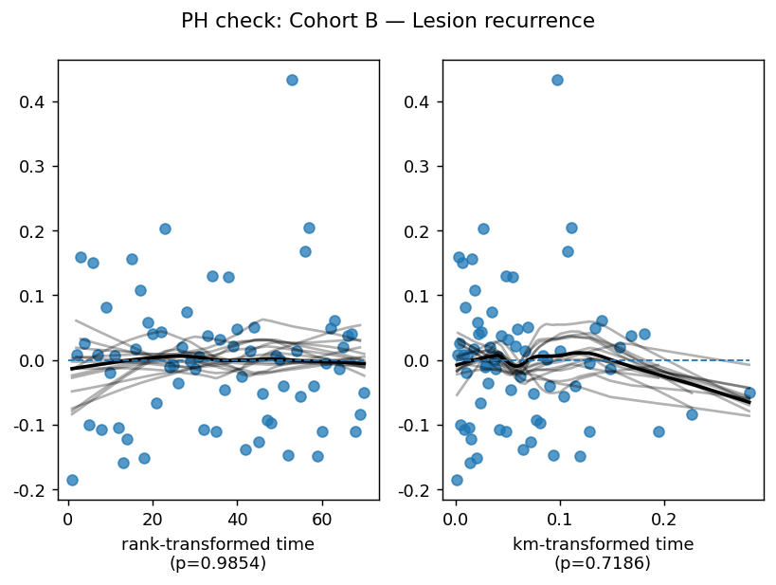
Supplementary Figure S5 panel a. Schoenfeld residual plot — Cohort B lesion recurrence.

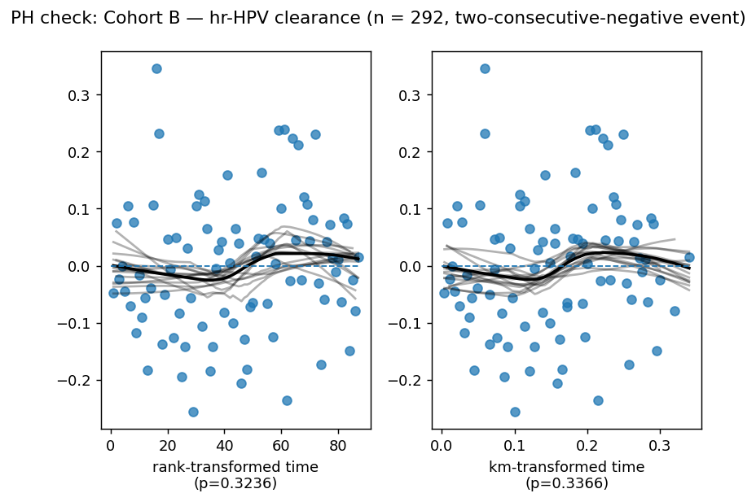
Supplementary Figure S5 panel b. Schoenfeld residual plot — Cohort B hr-HPV clearance (two-consecutive-negative event, pre-vaccine HPV-positive subset).

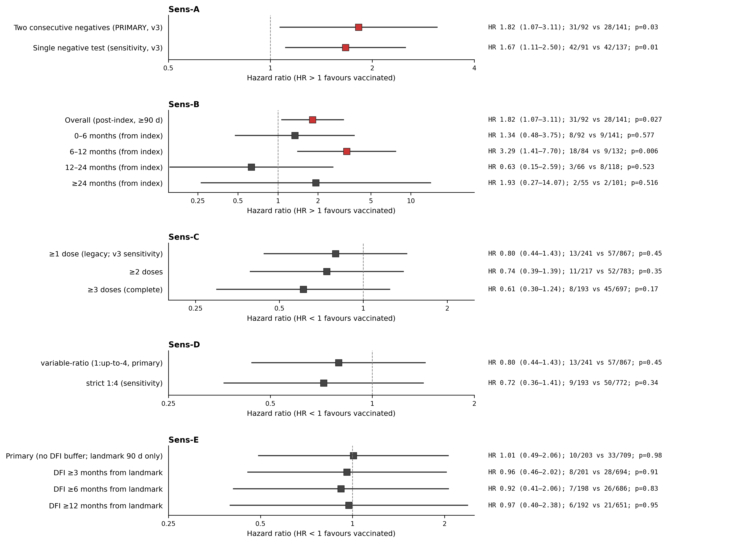
Supplementary Figure S6. Pre-specified Cohort B sensitivity analyses — five-panel summary forest plot (Sens-A event-definition, Sens-B time-stratified, Sens-C dose threshold, Sens-D strict matching, Sens-E disease-free interval).

Supplementary Tables
Supplementary Table S1A. Pre-matching baseline characteristics — Cohort A (full source population, before 1:1 propensity-score matching).

Variable | Vaccinated | Non-vaccinated | p | |SMD|
Demographics
Age at index, years | 33.46 ± 9.18 | 46.90 ± 14.50 | <0.001 | 1.108
Birth year | 1982.32 ± 10.10 | 1968.93 ± 13.91 | <0.001 | 1.102
Index year | 2015.73 ± 4.11 | 2015.77 ± 4.11 | 0.703 | 0.008
Residence in Seoul | 739 (34.3%) | 9031 (29.3%) | <0.001 | 0.107
Anthropometry & Vital signs (closest to index, ±1 yr)
Height, cm | 161.37 ± 5.32 | 158.56 ± 6.63 | <0.001 | 0.468
Weight, kg | 57.50 ± 9.73 | 57.82 ± 9.73 | 0.365 | 0.033
BMI, kg/m² | 22.12 ± 3.53 | 23.34 ± 10.32 | <0.001 | 0.158
Systolic BP, mmHg | 113.01 ± 13.22 | 119.72 ± 17.44 | <0.001 | 0.434
Diastolic BP, mmHg | 70.64 ± 10.65 | 74.21 ± 15.74 | <0.001 | 0.265
Smoking status
Never | 675 (31.3%) | 6582 (21.4%) | <0.001 | 0.227
Former | 10 (0.5%) | 100 (0.3%) | 0.248 | 0.022
Current | 37 (1.7%) | 246 (0.8%) | <0.001 | 0.082
Unknown | 1434 (66.5%) | 23885 (77.5%) | <0.001 | 0.247
Pre-existing comorbidities (before index)
Angina / Myocardial infarction | 0 (0.0%) | 12 (0.0%) | 1.000 | 0.028
Hypertension | 10 (0.5%) | 115 (0.4%) | 0.468 | 0.014
Diabetes | 14 (0.6%) | 128 (0.4%) | 0.122 | 0.032
Stroke | 0 (0.0%) | 8 (0.0%) | 1.000 | 0.023
Pulmonary embolism | 0 (0.0%) | 1 (0.0%) | 1.000 | 0.008
Composite (any of 5) | 24 (1.1%) | 227 (0.7%) | 0.071 | 0.039
Follow-up
Follow-up, days | 2134.52 ± 1733.35 | 2058.48 ± 2146.15 | 0.053 | 0.039
Mortality during follow-up | 6 (0.3%) | 283 (0.9%) | <0.001 | 0.083

Supplementary Table S1B. Pre-matching baseline characteristics — Cohort B (post-surgical population, before 1:up-to-4 fine matching).

Variable | Vaccinated | Non-vaccinated | p | |SMD|
Demographics
Age at index, years | 36.40 ± 9.40 | 49.31 ± 12.94 | <0.001 | 1.141
Birth year | 1979.96 ± 10.11 | 1968.29 ± 13.07 | <0.001 | 0.998
Index year | 2016.32 ± 4.24 | 2017.53 ± 4.01 | <0.001 | 0.295
Residence in Seoul | 164 (29.0%) | 1320 (20.9%) | <0.001 | 0.188
Anthropometry & Vital signs (closest to index, ±1 yr)
Height, cm | 161.21 ± 5.39 | 157.99 ± 6.51 | <0.001 | 0.539
Weight, kg | 57.47 ± 9.65 | 58.12 ± 9.71 | 0.229 | 0.067
BMI, kg/m² | 22.12 ± 3.54 | 23.56 ± 9.25 | <0.001 | 0.205
Systolic BP, mmHg | 113.21 ± 13.44 | 117.45 ± 15.69 | <0.001 | 0.290
Diastolic BP, mmHg | 72.17 ± 11.04 | 73.39 ± 11.73 | 0.035 | 0.107
Smoking status
Never | 207 (36.6%) | 3380 (53.4%) | <0.001 | 0.344
Former | 3 (0.5%) | 31 (0.5%) | 0.756 | 0.006
Current | 17 (3.0%) | 146 (2.3%) | 0.310 | 0.043
Unknown | 339 (59.9%) | 2767 (43.8%) | <0.001 | 0.327
Pre-existing comorbidities (before index)
Angina / Myocardial infarction | 0 (0.0%) | 9 (0.1%) | 1.000 | 0.053
Hypertension | 5 (0.9%) | 132 (2.1%) | 0.057 | 0.100
Diabetes | 4 (0.7%) | 154 (2.4%) | 0.005 | 0.139
Stroke | 0 (0.0%) | 11 (0.2%) | 1.000 | 0.059
Pulmonary embolism | 0 (0.0%) | 4 (0.1%) | 1.000 | 0.036
Composite (any of 5) | 9 (1.6%) | 262 (4.1%) | 0.001 | 0.153
Surgery type
Conization | 545 (96.3%) | 4965 (78.5%) | <0.001 | 0.556
Hysterectomy | 21 (3.7%) | 1359 (21.5%) | <0.001 | 0.556
Age at surgery, years | 36.81 ± 9.41 | 48.67 ± 12.91 | <0.001 | 1.049
Surgery year | 2016.72 ± 4.22 | 2016.89 ± 3.87 | 0.330 | 0.044
Surgery → index, days | -149.37 ± 954.96 | 232.33 ± 381.31 | <0.001 | 0.525
Follow-up
Follow-up, days | 2082.03 ± 1615.73 | 1623.30 ± 1491.23 | <0.001 | 0.295
Mortality during follow-up | 1 (0.2%) | 73 (1.2%) | 0.030 | 0.120

Supplementary Table S2. Propensity-score model coefficients (logistic regression) for Cohort A.

Covariate | Mean (vaccinated) | Mean (non-vaccinated) | Coefficient (β) | Standardized β | Odds ratio
age_at_index | 33.51 | 46.30 | -0.078 | -1.143 | 0.93
bmi | 22.71 | 23.18 | -0.022 | -0.087 | 0.98
bmi_miss | 0.59 | 0.85 | 0.046 | 0.017 | 1.05
sbp | 115.95 | 118.72 | -0.007 | -0.048 | 0.99
sbp_miss | 0.53 | 0.84 | -0.755 | -0.294 | 0.47
dbp | 72.22 | 73.71 | -0.001 | -0.003 | 1.00
dbp_miss | 0.53 | 0.84 | -0.791 | -0.308 | 0.45
is_seoul | 0.34 | 0.29 | 0.029 | 0.013 | 1.03
smoke_Never | 0.32 | 0.20 | 0.640 | 0.260 | 1.90
smoke_Former | 0.00 | 0.00 | 0.443 | 0.025 | 1.56
smoke_Current | 0.02 | 0.01 | 0.513 | 0.045 | 1.67

Supplementary Table S3. Age-stratified hazard ratios for Cohort B lesion recurrence across follow-up windows. Reported descriptively as an exploratory hypothesis-generating analysis; no inference is drawn from these subgroup estimates (see Manuscript Limitations).

Stratum | Follow-up window | n total | Vac events / N | Ctl events / N | HR (95% CI) | p
All ages | 1 yr | 1108 | 7 / 241 | 31 / 867 | 0.78 (0.35–1.76) | 0.549
All ages | 2 yr | 1108 | 7 / 241 | 39 / 867 | 0.62 (0.28–1.38) | 0.242
All ages | 4 yr | 1108 | 10 / 241 | 48 / 867 | 0.72 (0.37–1.39) | 0.329
All ages | Full follow-up | 1108 | 13 / 241 | 57 / 867 | 0.80 (0.44–1.43) | 0.445
<40 years | 1 yr | 686 | 2 / 154 | 12 / 532 | 0.57 (0.13–2.58) | 0.468
<40 years | 2 yr | 686 | 2 / 154 | 16 / 532 | 0.43 (0.10–1.88) | 0.262
<40 years | 4 yr | 686 | 3 / 154 | 22 / 532 | 0.48 (0.15–1.54) | 0.215
<40 years | Full follow-up | 686 | 5 / 154 | 26 / 532 | 0.69 (0.27–1.77) | 0.439
40–49 years | 1 yr | 326 | 1 / 65 | 16 / 261 | 0.25 (0.03–1.92) | 0.182
40–49 years | 2 yr | 326 | 1 / 65 | 18 / 261 | 0.22 (0.03–1.69) | 0.146
40–49 years | 4 yr | 326 | 3 / 65 | 21 / 261 | 0.54 (0.18–1.66) | 0.285
40–49 years | Full follow-up | 326 | 3 / 65 | 26 / 261 | 0.45 (0.15–1.39) | 0.165
≥50 years | 1 yr | 96 | 4 / 22 | 3 / 74 | 4.11 (0.95–17.84) | 0.059
≥50 years | 2 yr | 96 | 4 / 22 | 5 / 74 | 2.60 (0.70–9.72) | 0.154
≥50 years | 4 yr | 96 | 4 / 22 | 5 / 74 | 2.60 (0.70–9.72) | 0.154
≥50 years | Full follow-up | 96 | 5 / 22 | 5 / 74 | 3.23 (0.93–11.22) | 0.065

Supplementary Table S4. Number-at-risk tables for Cohort B cumulative-incidence curves, time origin at the index date; years 0, 2, 4, 6, 8, 10 measured from index. All patients in the primary cohort survived the 3-month landmark event-free by construction, so the number at risk at year 0 equals the primary cohort size and remains unchanged through the first 0.25 years. Lesion-recurrence rows are the primary cohort (n = 912: 203 / 709); hr-HPV clearance rows are the clearance subset (n = 233: 92 / 141).

Outcome | Group | 0 | 2 | 4 | 6 | 8 | 10
Lesion recurrence | Vaccinated | 203 | 176 | 125 | 72 | 51 | 35
Lesion recurrence | Non-vaccinated | 709 | 615 | 457 | 270 | 182 | 113
hr-HPV clearance | Vaccinated | 92 | 55 | 39 | 18 | 12 | 7
hr-HPV clearance | Non-vaccinated | 141 | 101 | 74 | 40 | 22 | 11

Supplementary Table S5. Per-vaccine-type detailed results — single-model interaction-derived hazard ratios with the likelihood-ratio test for vaccine-type heterogeneity. Rows include both co-primary outcomes plus an exploratory post-index hr-HPV detection model that conflates persistence with new acquisition (reported descriptively only).

Outcome | LRT χ² | df | LRT p | Gardasil 9 HR (95% CI) | Cervarix HR (95% CI) | Quadrivalent Gardasil HR (95% CI)
Lesion recurrence (≥CIN2) | 0.64 | 2 | 0.725 | 0.63 (0.23–1.71) | 1.07 (0.43–2.68) | 0.73 (0.16–3.33)
hr-HPV clearance (pre-vaccine HPV+) | 1.73 | 2 | 0.422 | 0.94 (0.44–2.02) | 1.52 (0.79–2.89) | 1.94 (0.78–4.84)
Post-index hr-HPV detection (sensitivity) | 11.27 | 2 | 0.004 | 0.91 (0.71–1.18) | 1.24 (0.91–1.69) | 0.40 (0.21–0.76)

Supplementary Table S6. Cluster-robust hazard ratios with person-years, incidence rates per 1,000 person-years, and Schoenfeld residual p-values for both cohorts. Cohort B rows report both co-primary outcomes (lesion recurrence, hr-HPV clearance) and the Kaplan–Meier sustained-clearance summary.

Cohort | Outcome | Vac events / N | Ctl events / N | IR Vac | IR Ctl | HR (95% CI) | p | Schoenfeld p
Cohort A | Any-of-5 composite | 18/1378 | 21/1371 | 2.32 | 2.01 | 1.27 (0.66–2.48) | 0.475 | —
Cohort A | MCE composite (MI/Stroke/PE) | 1/1396 | 1/1380 | 0.13 | 0.09 | — | — | —
Cohort A | Hypertension | 2/1388 | 3/1378 | 0.25 | 0.28 | 0.86 (0.14–5.22) | 0.868 | —
Cohort A | Diabetes | 16/1386 | 17/1373 | 2.05 | 1.63 | 1.47 (0.70–3.08) | 0.303 | —
Cohort A | Angina/MI | 1/1396 | 0/1380 | 0.13 | 0.00 | — | — | —
Cohort A | Stroke | 0/1396 | 0/1380 | 0.00 | 0.00 | — | — | —
Cohort A | PE | 0/1396 | 1/1380 | 0.00 | 0.09 | — | — | —
Cohort B | Lesion recurrence (≥CIN2 / HSIL+ or invasive carcinoma) — ≥2 dose + 3-mo landmark PRIMARY | 10 / 203 | 33 / 709 | 8.8 | 8.4 | 1.01 (0.49–2.06) | 0.985 | 0.820
Cohort B | hr-HPV clearance (two consecutive negatives; pre-vaccine HPV+ baseline) — ≥2 dose + 3-mo landmark PRIMARY | 31 / 92 | 28 / 141 | 95.7 | 46.6 | 1.82 (1.07–3.11) | 0.027 | 0.028
Cohort B | Sustained clearance — vaccinated† | 31 clearance | 18 censored | — | — | — | — | —
Cohort B | Sustained clearance — non-vaccinated† | — | 28 clearance | — | — | 15 censored | — | —
Cohort B | Sustained clearance — log-rank (vac vs non-vac | — | — | — | — | — | χ² = 1.00 | —
Cohort B | Sensitivity (Sens-C): ≥1 dose | HR<1 | 1405 (9.2) | — | — | 5052 (11.3) | 0.80 (0.44–1.43) | —
Cohort B | Sensitivity (Sens-C): ≥3 dose | HR<1 | 935 (7.5) | — | — | 3206 (12.5) | 0.58 (0.27–1.26) | —
Cohort B | Sensitivity (Sens-C): ≥1 dose | HR>1 | 402 (99.5) | — | — | 764 (62.8) | 1.40 (0.92–2.11) | —
Cohort B | †KM median estimates unstable (small reversion count; 3-year plateau near S(t)=0.5; length-biased selection toward longer-FU patients). 5-year reversion-free probability is reported as a more stable summary; arms differ <4 percentage points at 5 y. |  |  | — | — |  |  | —

Supplementary Table S7. Pseudo-index assignment sensitivity analysis for Cohort A (Any-of-five) — random sampling, calendar-year-matched, and risk-set sampling strategies.

Strategy | Vac events / N | Ctl events / N | HR (95% CI) | p
Random sample (primary) | 29 / 2030 | 30 / 2038 | 1.26 (0.75–2.12) | 0.377
Time-matched (calendar year) | 30 / 2054 | 27 / 2064 | 1.27 (0.75–2.15) | 0.378
Risk-set sampling | 13 / 1096 | 13 / 1102 | 1.21 (0.55–2.66) | 0.627

Supplementary Table S8A. (Sens-C, primary) Dose-threshold sensitivity for both cohorts — re-fitted hazard ratios under ≥1, ≥2, and ≥3 (complete schedule) dose definitions; matched-set integrity preserved by dropping the entire matched set when the vaccinated case fails the threshold.

Cohort | Outcome | Dose threshold | Vac events / N | Ctl events / N | HR (95% CI) | p
A | Any-of-5 composite | ≥1 dose (primary) | 29/2030 | 30/2038 | 1.26 (0.75–2.12) | 0.374
A | Any-of-5 composite | ≥2 doses | 28/1715 | 26/1728 | 1.37 (0.80–2.36) | 0.250
A | Any-of-5 composite | ≥3 doses (complete) | 27/1481 | 24/1494 | 1.38 (0.79–2.41) | 0.253
A | MCE composite | ≥1 dose (primary) | 3/2053 | 2/2053 | 1.96 (0.31–12.46) | 0.474
A | MCE composite | ≥2 doses | 3/1735 | 2/1735 | 1.90 (0.30–11.94) | 0.495
A | MCE composite | ≥3 doses (complete) | 3/1498 | 1/1498 | — | —
A | Diabetes | ≥1 dose (primary) | 21/2039 | 22/2043 | 1.25 (0.68–2.28) | 0.475
A | Diabetes | ≥2 doses | 21/1723 | 20/1730 | 1.33 (0.72–2.47) | 0.368
A | Diabetes | ≥3 doses (complete) | 20/1489 | 19/1496 | 1.28 (0.68–2.42) | 0.439
A | Hypertension | ≥1 dose (primary) | 8/2044 | 7/2048 | 1.49 (0.53–4.19) | 0.448
A | Hypertension | ≥2 doses | 7/1727 | 5/1733 | 1.80 (0.56–5.74) | 0.323
A | Hypertension | ≥3 doses (complete) | 7/1490 | 5/1496 | 1.72 (0.54–5.48) | 0.362
A | Angina/MI | ≥1 dose (primary) | 3/2053 | 1/2053 | — | —
A | Angina/MI | ≥2 doses | 3/1735 | 1/1735 | — | —
A | Angina/MI | ≥3 doses (complete) | 3/1498 | 0/1498 | — | —
B | Lesion recurrence | ≥1 dose (legacy; v3 sensitivity) | 13/241 | 57/867 | 0.80 (0.44–1.43) | 0.445
B | Lesion recurrence | ≥2 doses | 11/217 | 52/783 | 0.74 (0.39–1.39) | 0.349
B | Lesion recurrence | ≥3 doses (complete) | 8/193 | 45/697 | 0.61 (0.30–1.24) | 0.173
B | hr-HPV clearance | ≥1 dose (legacy; v3 sensitivity) | 40/110 | 48/182 | 1.40 (0.92–2.11) | 0.114
B | hr-HPV clearance | ≥2 doses | 37/102 | 44/168 | 1.40 (0.90–2.17) | 0.132
B | hr-HPV clearance | ≥3 doses (complete) | 33/89 | 36/148 | 1.59 (0.97–2.60) | 0.065

Supplementary Table S8B. Immortal-time-bias-corrected dose-threshold sensitivity for Cohort B. Landmarks reflect the standard HPV-vaccine 0–2–6 month schedule plus grace: ≥1 dose at 30 days, ≥2 doses at 90 days, ≥3 doses at 240 days. Patients in both arms must be alive and event-free at the landmark to enter the analysis; for vaccinated cases, the k-th dose must additionally have been received by the landmark. Time is left-truncated at the landmark. The ≥2-dose, 90-day landmark specification coincides with the primary specification used in the main analysis.

Outcome | Definition (landmark) | Vac events / N | Ctl events / N | HR (95% CI) | p
Lesion recurrence | ≥1 dose, 30-d landmark | 10/238 | 48/858 | 0.72 (0.37–1.39) | 0.331
Lesion recurrence | ≥2 doses, 90-d landmark | 10/205 | 30/723 | 1.12 (0.54–2.30) | 0.765
Lesion recurrence | ≥3 doses, 240-d landmark | 6/182 | 18/639 | 1.14 (0.48–2.73) | 0.769
hr-HPV clearance | ≥1 dose, 30-d landmark | 39/109 | 45/179 | 1.45 (0.95–2.21) | 0.081
hr-HPV clearance | ≥2 doses, 90-d landmark | 32/91 | 28/141 | 1.93 (1.14–3.26) | 0.014
hr-HPV clearance | ≥3 doses, 240-d landmark | 11/64 | 12/113 | 1.61 (0.73–3.56) | 0.238

Supplementary Table S9. (Sens-D) Strict 1:4 fine-matching sensitivity for Cohort B — variable-ratio (primary) versus strict (sensitivity) specifications.

Outcome | Design | Vac events / N | Ctl events / N | HR (95% CI) | p
Lesion recurrence | variable-ratio (1:up-to-4, primary) | 13/241 | 57/867 | 0.80 (0.44–1.43) | 0.445
Lesion recurrence | strict 1:4 (sensitivity) | 9/193 | 50/772 | 0.72 (0.36–1.41) | 0.339
hr-HPV clearance | variable-ratio (1:up-to-4, primary) | 40/110 | 48/182 | 1.40 (0.92–2.11) | 0.114
hr-HPV clearance | strict 1:4 (sensitivity) | 31/89 | 40/158 | 1.40 (0.88–2.21) | 0.154

Supplementary Table S10. (Sens-B) Time-stratified hr-HPV clearance hazard ratios decomposed into 0–6, 6–12, 12–24, and ≥24-month windows post-index. Left-truncation at each window's lower bound.

Window | Vac events / N | Ctl events / N | HR (95% CI) | p
Overall (post-index, ≥90 d) | 31/92 | 28/141 | 1.82 (1.07–3.11) | 0.027
0–6 months (from index) | 8/92 | 9/141 | 1.34 (0.48–3.75) | 0.577
6–12 months (from index) | 18/84 | 9/132 | 3.29 (1.41–7.70) | 0.006
12–24 months (from index) | 3/66 | 8/118 | 0.63 (0.15–2.59) | 0.523
≥24 months (from index) | 2/55 | 2/101 | 1.93 (0.27–14.07) | 0.516

Supplementary Table S11. (Sens-A) Single-negative HPV clearance sensitivity — alternative event definition using the FIRST single post-index hr-HPV-negative record, contrasted with the two-consecutive-negative primary.

Clearance definition | Vac events / N | Ctl events / N | HR (95% CI) | p
Two consecutive negatives (PRIMARY, v3) | 31/92 | 28/141 | 1.82 (1.07–3.11) | 0.027
Single negative test (sensitivity, v3) | 42/91 | 42/137 | 1.67 (1.11–2.50) | 0.014

Supplementary Table S12. (Sens-E) Disease-free-interval sensitivity for lesion recurrence — minimum 3-, 6-, and 12-month buffer from the index date before counting a recurrence event.

Disease-free interval | Vac events / N | Ctl events / N | HR (95% CI) | p
Primary (no DFI buffer; landmark 90 d only) | 10/203 | 33/709 | 1.01 (0.49–2.06) | 0.985
DFI ≥3 months from landmark | 8/201 | 28/694 | 0.96 (0.46–2.02) | 0.913
DFI ≥6 months from landmark | 7/198 | 26/686 | 0.92 (0.41–2.06) | 0.833
DFI ≥12 months from landmark | 6/192 | 21/651 | 0.97 (0.40–2.38) | 0.952

