Main tables and figures
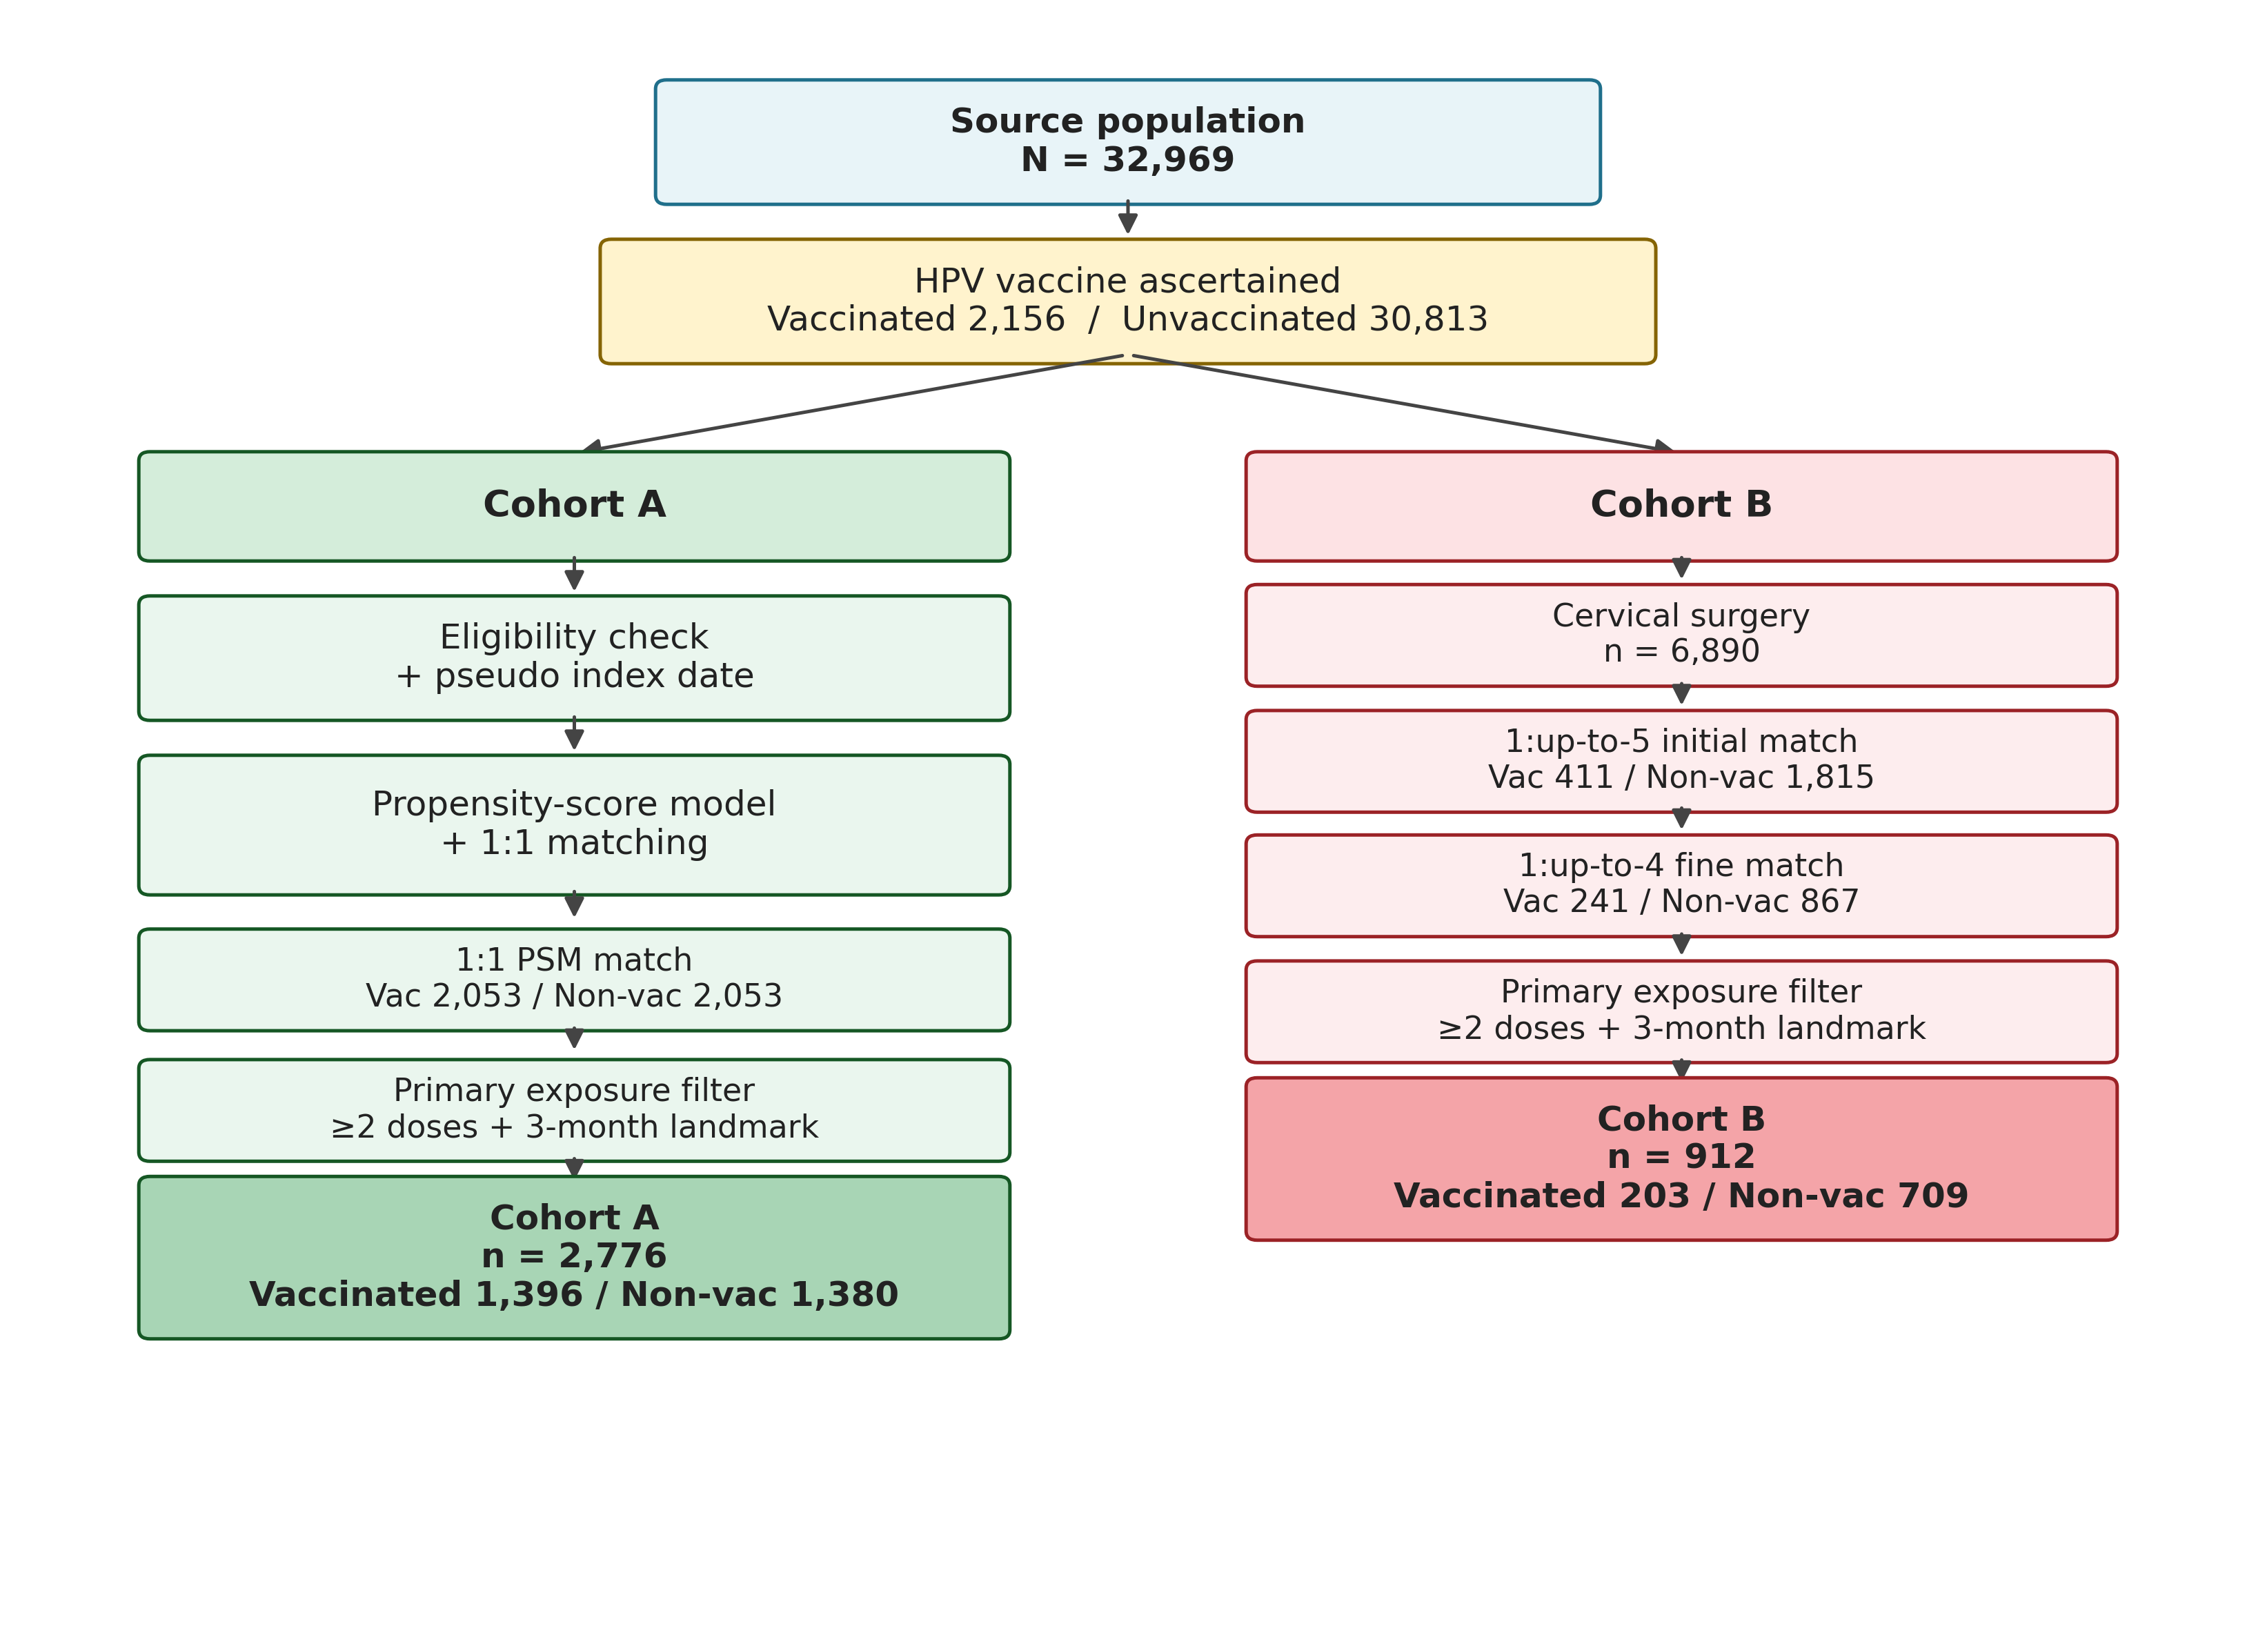
Figure 1. CONSORT-style cohort selection flow diagram. From the single source population (N = 32,969) the diagram traces the derivation of Cohort A (whole-cohort safety analysis) through eligibility filtering, pseudo-index assignment for unvaccinated controls, 1:1 propensity-score matching, and the primary exposure filter (≥2 doses + 3-month landmark with matched-pair integrity preserved) yielding a final analytic cohort n = 2,776 (1,396 vaccinated / 1,380 unvaccinated); and Cohort B (post-surgical efficacy analysis) through the cervical-surgery filter (n = 6,890), 1:up-to-5 initial matching, index-date eligibility, 1:up-to-4 fine matching, and the same primary exposure filter with matched-set integrity preserved, yielding a primary analytic cohort n = 912 (203 vaccinated / 709 fine-matched controls).

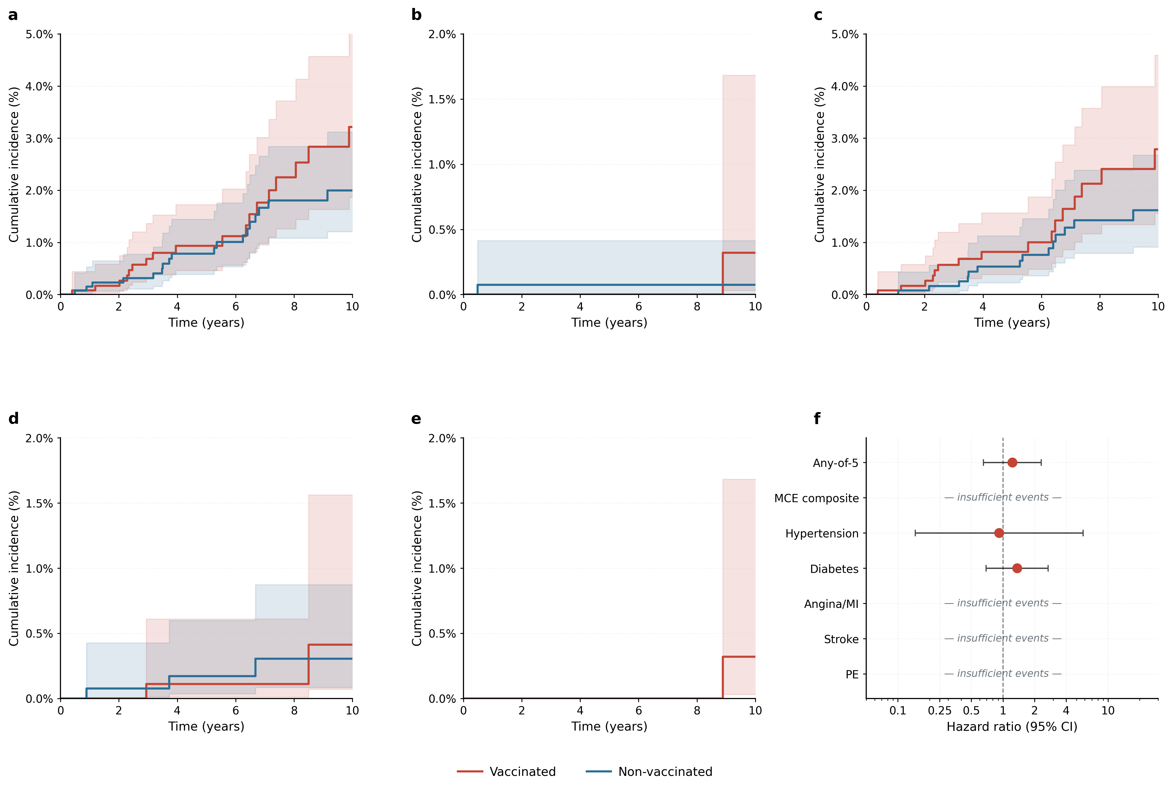
Figure 2. Cohort A — Aalen–Johansen cumulative incidence functions and cluster-robust hazard ratios. Panels a–e: Any-of-5 composite (a), MCE composite (b), Diabetes (c), Hypertension (d), Angina/MI (e); vaccinated red, non-vaccinated blue with 95% pointwise CI bands. Panel f: forest plot of cluster-robust cause-specific hazard ratios; endpoints with fewer than five total events are marked insufficient.

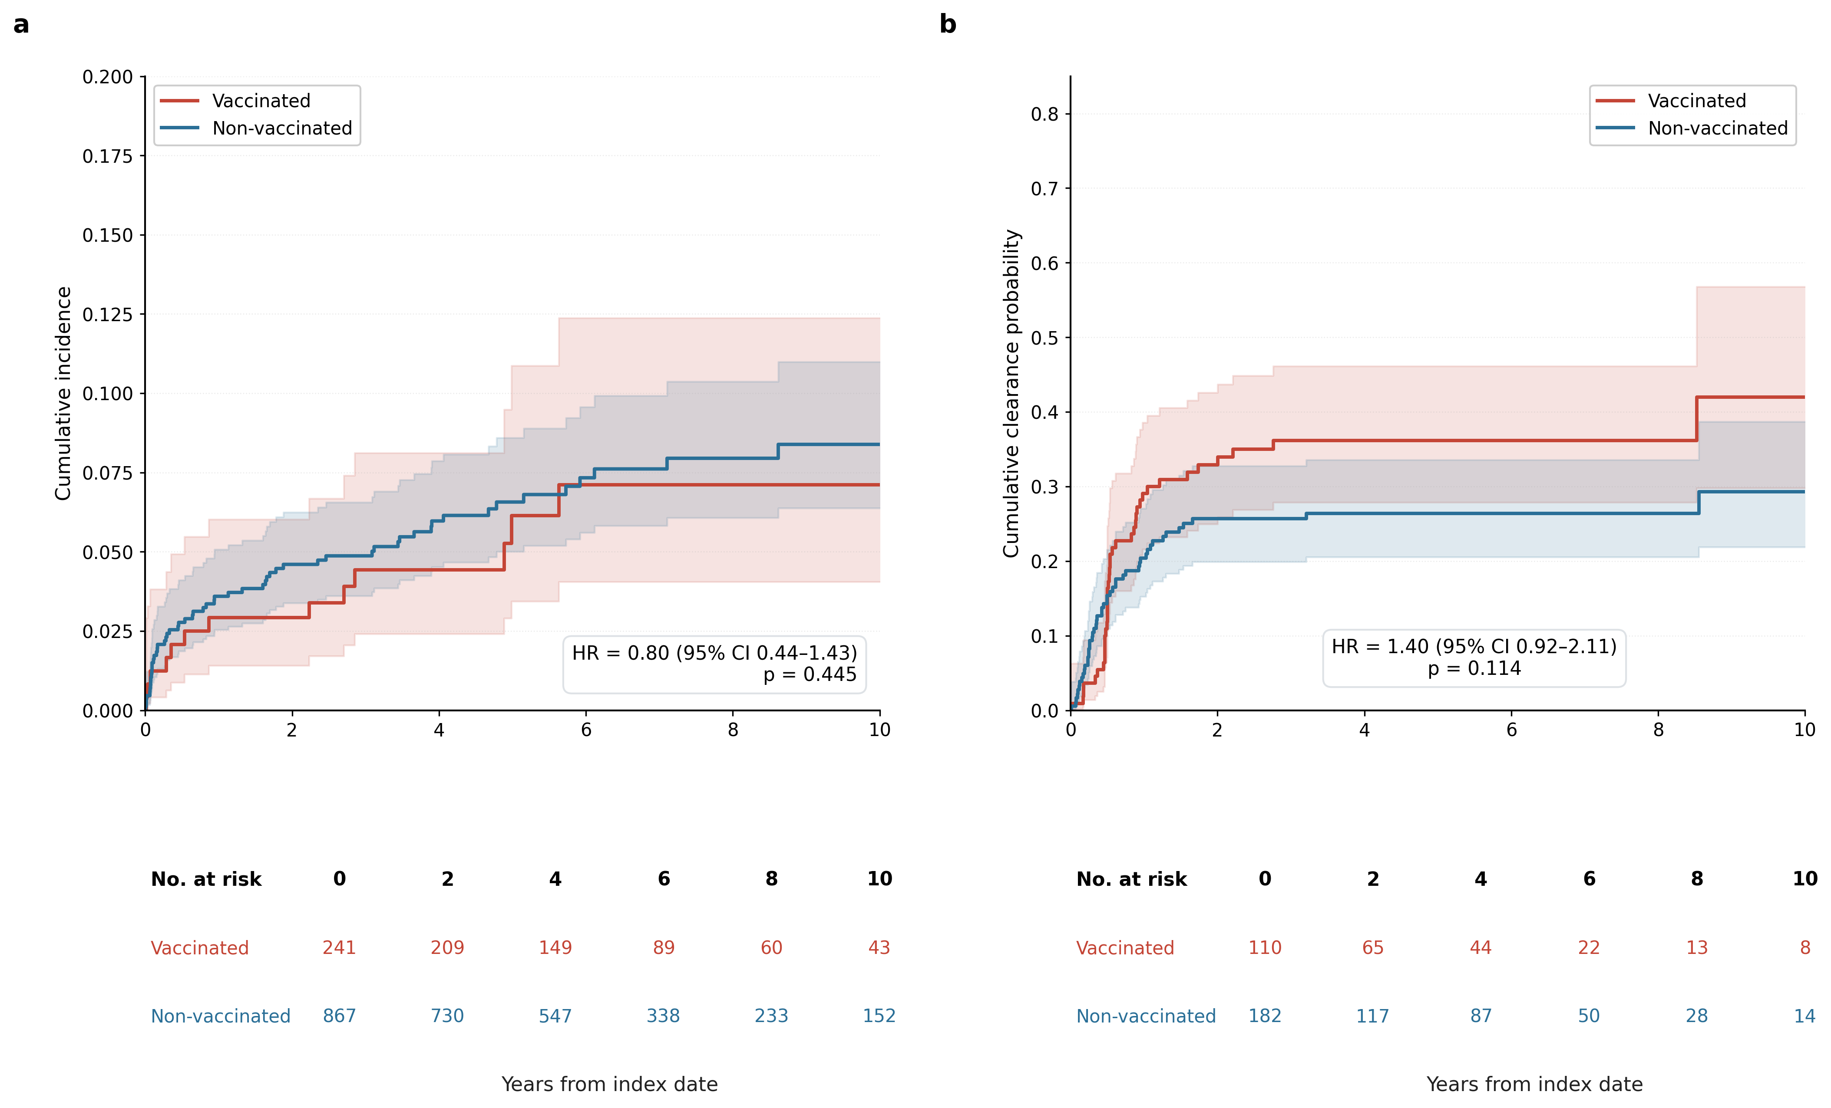
Figure 3. Cohort B co-primary outcomes — cumulative incidence curves with number-at-risk tables. (a) lesion recurrence (≥CIN2) in the primary cohort (n = 912: 203 vaccinated / 709 controls); (b) cumulative clearance of pre-existing hr-HPV (two-consecutive-negative event) in the clearance subset (n = 233: 92 vaccinated / 141 controls). The x-axis is years from index. For clearance, HR > 1 favours the vaccinated arm.

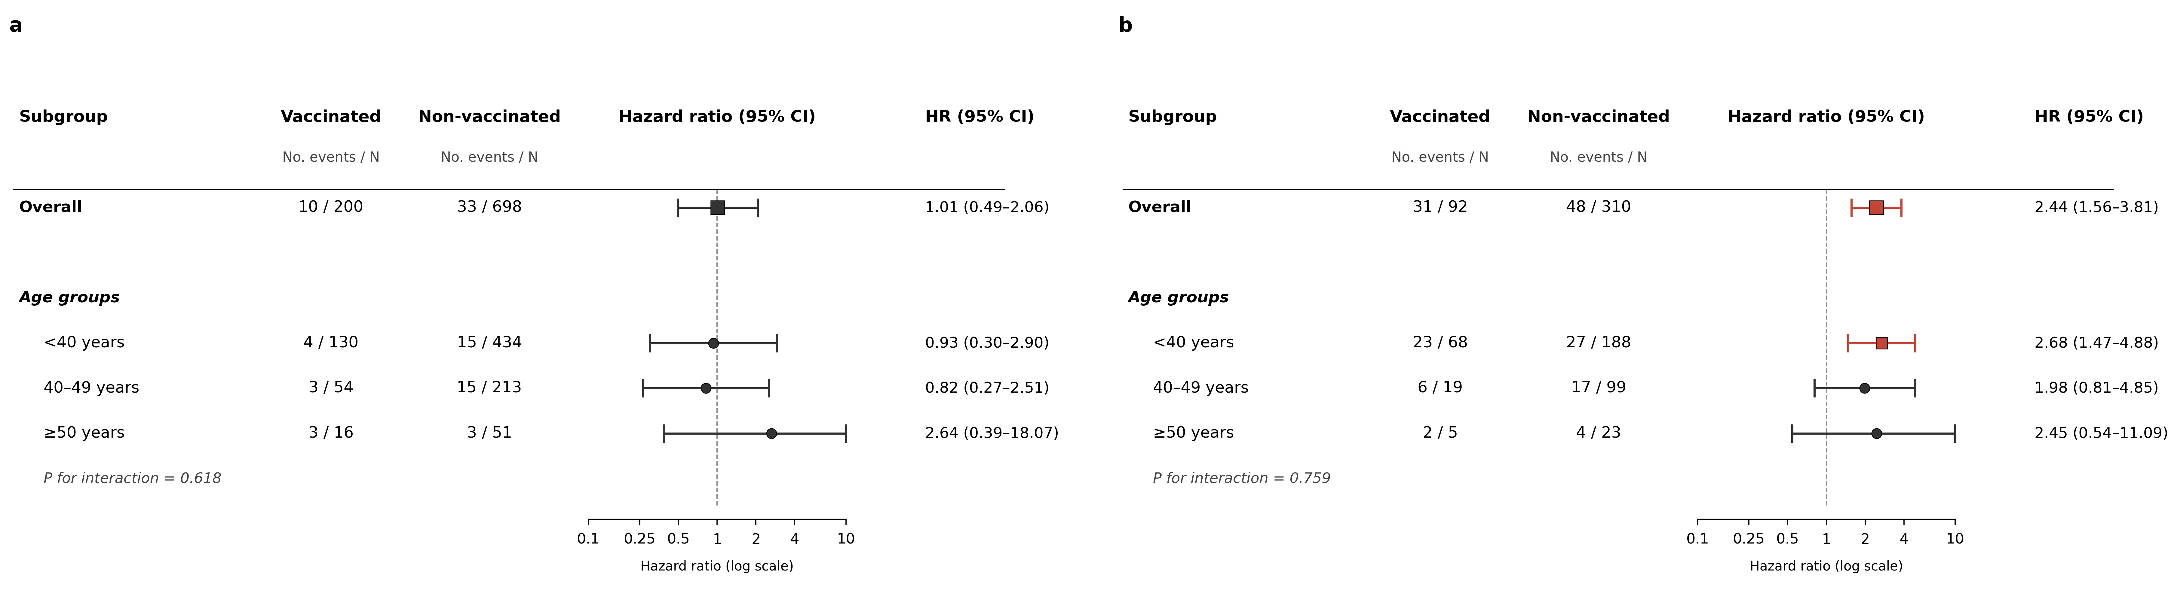
Figure 4. Cohort B subgroup analyses — combined table-with-forest plot for both co-primary outcomes. (a) lesion recurrence (HR < 1 favours vaccination); (b) hr-HPV clearance (HR > 1 favours vaccination). Strata: Overall, age at index (<40 / 40–49 / ≥50), vaccine type (Gardasil 9 / Cervarix / quadrivalent Gardasil). Likelihood-ratio P values for age × vaccination and vaccine-type × vaccination interaction terms are reported beneath each subgroup section.

Table 1A. Baseline characteristics of Cohort A (chronic-disease safety analysis) after 1:1 propensity-score matching and primary exposure filtering. N = 2,776 (1,396 vaccinated / 1,380 matched controls). Absolute standardised mean differences (|SMD|) < 0.10 indicate adequate balance.

Variable | Vaccinated | Non-vaccinated | p value | |SMD|
Demographics
Age at index, years | 33.90 ± 9.34 | 33.27 ± 11.54 | 0.116 | 0.060
Birth year | 1982.36 ± 10.23 | 1981.42 ± 11.23 | 0.021 | 0.088
Index year | 2016.21 ± 3.92 | 2014.63 ± 3.77 | <0.001 | 0.411
Residence in Seoul | 437 (31.3%) | 468 (33.9%) | 0.145 | 0.056
Anthropometry & vital signs (closest to index, ±1 yr)
Height, cm | 161.10 ± 5.38 | 160.66 ± 5.43 | 0.166 | 0.081
Weight, kg | 57.54 ± 10.00 | 56.53 ± 9.91 | 0.087 | 0.101
BMI, kg/m² | 22.75 ± 2.35 | 22.70 ± 2.28 | 0.556 | 0.022
Systolic BP, mmHg | 116.09 ± 9.63 | 115.81 ± 10.23 | 0.458 | 0.028
Diastolic BP, mmHg | 72.42 ± 7.49 | 72.12 ± 7.58 | 0.287 | 0.040
Smoking status
Never | 458 (32.8%) | 421 (30.5%) | 0.206 | 0.049
Former | 6 (0.4%) | 5 (0.4%) | 1.000 | 0.011
Current | 24 (1.7%) | 27 (2.0%) | 0.673 | 0.018
Unknown | 908 (65.0%) | 927 (67.2%) | 0.245 | 0.045
Pre-existing comorbidities (before index)
Angina/MI | 0 (0.0%) | 0 (0.0%) | 1.000 | -
Hypertension | 8 (0.6%) | 2 (0.1%) | 0.109 | 0.072
Diabetes | 10 (0.7%) | 6 (0.4%) | 0.453 | 0.037
Stroke | 0 (0.0%) | 0 (0.0%) | 1.000 | -
PE | 0 (0.0%) | 0 (0.0%) | 1.000 | -
Composite (any of 5) | 18 (1.3%) | 8 (0.6%) | 0.074 | 0.074
Follow-up
Follow-up, days | 2071.01 ± 1566.61 | 2792.10 ± 1562.27 | <0.001 | 0.461
Mortality during follow-up | 2 (0.1%) | 16 (1.2%) | <0.001 | 0.127

Table 1B. Baseline characteristics of Cohort B (post-surgical efficacy analysis) after variable-ratio 1:up-to-4 fine matching and primary exposure filtering. N = 912 (203 vaccinated / 709 fine-matched controls). Absolute standardised mean differences (|SMD|) < 0.10 indicate adequate balance. Pre- and post-surgery HPV status and surgical-pathology severity rows characterise the cervical-disease context at the time of the qualifying surgery.

Variable | Vaccinated | Non-vaccinated | p value | |SMD|
— ≥2 DOSE + 3-MO LANDMARK PRIMARY (n=912: 203 vac / 709 non-vac) —
Age at index, years | 36.99 ± 9.42 | 36.90 ± 8.40 | 0.901 | 0.010
BMI, kg/m² | 22.51 ± 3.63 | 22.38 ± 3.89 | 0.690 | 0.035
Systolic BP, mmHg | 113.59 ± 13.42 | 112.85 ± 13.78 | 0.542 | 0.055
Diastolic BP, mmHg | 72.04 ± 10.41 | 71.48 ± 12.01 | 0.568 | 0.049
Smoking: Never | 36 (17.7%) | 75 (10.6%) | 0.010 | 0.206
Smoking: Former | 0 (0.0%) | 2 (0.3%) | 1.000 | 0.075
Smoking: Current | 5 (2.5%) | 6 (0.8%) | 0.074 | 0.127
Smoking: Unknown | 162 (79.8%) | 626 (88.3%) | 0.003 | 0.233
Seoul residence | 50 (24.6%) | 204 (28.8%) | 0.287 | 0.094
Follow-up, years (from index) | 6.11 ± 3.85 | 6.02 ± 3.58 | 0.763 | 0.025
Surgery year | 2016.35 ± 3.68 | 2016.44 ± 3.61 | 0.746 | 0.026
Surgery type: Conization | 202 (99.5%) | 705 (99.4%) | 1.000 | 0.010
Surgery type: Hysterectomy | 1 (0.5%) | 4 (0.6%) | 1.000 | 0.010
Comorbidity (pre-index): Angina/MI | 0 (0.0%) | 0 (0.0%) | 1.000 | -
Comorbidity (pre-index): Hypertension | 4 (2.0%) | 6 (0.8%) | 0.242 | 0.096
Comorbidity (pre-index): Diabetes | 2 (1.0%) | 9 (1.3%) | 1.000 | 0.027
Comorbidity (pre-index): Stroke | 0 (0.0%) | 0 (0.0%) | 1.000 | -
Comorbidity (pre-index): PE | 0 (0.0%) | 0 (0.0%) | 1.000 | -
Comorbidity (pre-index): Any of 5 | 6 (3.0%) | 13 (1.8%) | 0.400 | 0.073
— HPV testing history —
Pre-surgery HPV status: HR-HPV+ | 72 (35.5%) | 269 (37.9%) | 0.565 | 0.051
Pre-surgery HPV status: non-HR HPV+ | 25 (12.3%) | 67 (9.4%) | 0.236 | 0.092
Pre-surgery HPV status: HPV negative | 39 (19.2%) | 126 (17.8%) | 0.679 | 0.037
Pre-surgery HPV status: No test | 67 (33.0%) | 247 (34.8%) | 0.676 | 0.039
Post-surgery HPV (first test, any time): HR-HPV+ | 77 (37.9%) | 310 (43.7%) | 0.148 | 0.118
Post-surgery HPV (first test, any time): non-HR HPV+ | 10 (4.9%) | 37 (5.2%) | 1.000 | 0.013
Post-surgery HPV (first test, any time): HPV negative | 113 (55.7%) | 349 (49.2%) | 0.112 | 0.129
Post-surgery HPV (first test, any time): No test | 3 (1.5%) | 13 (1.8%) | 1.000 | 0.028
Post-surgery HPV (first test, before vaccine/index): HR-HPV+ | 26 (12.8%) | 85 (12.0%) | 0.808 | 0.025
Post-surgery HPV (first test, before vaccine/index): non-HR HPV+ | 5 (2.5%) | 14 (2.0%) | 0.589 | 0.033
Post-surgery HPV (first test, before vaccine/index): HPV negative | 55 (27.1%) | 141 (19.9%) | 0.033 | 0.171
Post-surgery HPV (first test, before vaccine/index): No test | 117 (57.6%) | 469 (66.1%) | 0.031 | 0.176
— Surgical pathology severity —
Surgical pathology: Invasive cancer | 20 (9.9%) | 74 (10.4%) | 0.896 | 0.019
Surgical pathology: HSIL/CIN3 | 94 (46.3%) | 303 (42.7%) | 0.378 | 0.072
Surgical pathology: CIN2 / moderate dysplasia | 16 (7.9%) | 45 (6.3%) | 0.428 | 0.060
Surgical pathology: CIN1 / LSIL / mild dysplasia | 20 (9.9%) | 81 (11.4%) | 0.612 | 0.051
Surgical pathology: Benign / other | 53 (26.1%) | 206 (29.1%) | 0.428 | 0.066
Pre-vaccine hr-HPV+ (clearance subset eligibility) | 95 (46.8%) | 314 (44.3%) | 0.575 | 0.050

Table 1C. Baseline characteristics of the Cohort B clearance co-primary analytic subset (women with documented pre-vaccine hr-HPV positivity, after matched-set integrity and the 3-month landmark). N = 233 (92 vaccinated / 141 fine-matched controls). Absolute standardised mean differences (|SMD|) describe balance on the matching covariates within the clearance subset.

Variable | Vaccinated | Non-vaccinated | p value | |SMD|
— ≥2 DOSE + 3-MO LANDMARK + PRE-VACCINE hr-HPV+ CLEARANCE SUBSET (n=233: 92 vac / 141 non-vac) —
Age at index, years | 35.62 ± 8.09 | 35.65 ± 7.01 | 0.972 | 0.005
BMI, kg/m² | 22.36 ± 3.34 | 21.84 ± 3.09 | 0.264 | 0.162
Seoul residence | 40 (43.5%) | 70 (49.6%) | 0.421 | 0.124
Follow-up, years (from index) | 6.29 ± 3.89 | 5.72 ± 3.35 | 0.253 | 0.156
Surgery year | 2016.12 ± 3.45 | 2016.84 ± 3.00 | 0.105 | 0.222
Surgery type: Conization | 92 (100.0%) | 140 (99.3%) | 1.000 | 0.120
Surgery type: Hysterectomy | 0 (0.0%) | 1 (0.7%) | 1.000 | 0.120

Table 2. Cohort A — events, person-time, and cluster-robust cause-specific and Fine–Gray subdistribution hazard ratios for each endpoint.

Outcome | Events Vac / N | Events Ctl / N | IR Vac (per 1,000 PY) | IR Ctl | Cause-specific HR (95% CI) | p | Fine–Gray HR (95% CI) | p
Any-of-5 composite | 18 / 1378 | 21 / 1371 | 2.32 | 2.01 | 1.27 (0.66–2.48) | 0.475 | 1.27 (0.66–2.48) | 0.475
MCE composite (MI/Stroke/PE) | 1 / 1396 | 1 / 1380 | 0.13 | 0.09 | — | — | — | —
Hypertension | 2 / 1388 | 3 / 1378 | 0.25 | 0.28 | 0.86 (0.14–5.22) | 0.868 | 0.86 (0.14–5.22) | 0.868
Diabetes | 16 / 1386 | 17 / 1373 | 2.05 | 1.63 | 1.47 (0.70–3.08) | 0.303 | 1.47 (0.70–3.08) | 0.303
Angina/MI | 1 / 1396 | 0 / 1380 | 0.13 | 0.00 | — | — | — | —
Stroke | 0 / 1396 | 0 / 1380 | 0.00 | 0.00 | — | — | — | —
PE | 0 / 1396 | 1 / 1380 | 0.00 | 0.09 | — | — | — | —

Table 3. Cohort B — events, age-adjusted Cox hazard ratios (cluster-robust on the fine-matching identifier) and p-values for the two co-primary outcomes and the legacy post-index hr-HPV detection sensitivity row.

Outcome | Favourable direction | Vaccinated events / N | Vaccinated PY (rate /1000 PY) | Non-vaccinated events / N | Non-vaccinated PY (rate /1000 PY) | HR (95% CI) | p value
Lesion recurrence (≥CIN2 / HSIL+ or invasive carcinoma) — ≥2 dose + 3-mo landmark PRIMARY | HR<1 | 10 / 203 | 1132 (8.8) | 33 / 709 | 3947 (8.4) | 1.01 (0.49–2.06) | 0.985
hr-HPV clearance (two consecutive negatives; pre-vaccine HPV+ baseline) — ≥2 dose + 3-mo landmark PRIMARY | HR>1 | 31 / 92 | 324 (95.7) | 28 / 141 | 601 (46.6) | 1.82 (1.07–3.11) | 0.027
Sustained clearance — vaccinated† | — | 31 clearance | 13 reversion | 18 censored | — | — | —
Sustained clearance — non-vaccinated† | — | — | — | 28 clearance | 13 reversion | 15 censored | —
Sustained clearance — log-rank (vac vs non-vac | reversion-free) | — | — | — | — | — | χ² = 1.00
Sensitivity (Sens-C): ≥1 dose | no landmark — lesion recurrence | HR<1 | 13 / 241 | 1405 (9.2) | 57 / 867 | 5052 (11.3) | 0.80 (0.44–1.43)
Sensitivity (Sens-C): ≥3 dose | no landmark — lesion recurrence | HR<1 | 8 / 193 | 1111 (7.2) | 45 / 697 | 4031 (11.2) | 0.61 (0.30–1.24)
Sensitivity (Sens-C): ≥1 dose | no landmark — hr-HPV clearance | HR>1 | 40 / 110 | 402 (99.5) | 48 / 182 | 764 (62.8) | 1.40 (0.92–2.11)
†KM median estimates unstable (small reversion count; 3-year plateau near S(t)=0.5; length-biased selection toward longer-FU patients). 5-year reversion-free probability is reported as a more stable summary; arms differ <4 percentage points at 5 y.

