Can this module be flashed and loaded with my own firmware? If so, will I need a platform?
Yes. You''ll need the CSR BlueLab software and an SPI interface. The SPI interface can be made like this
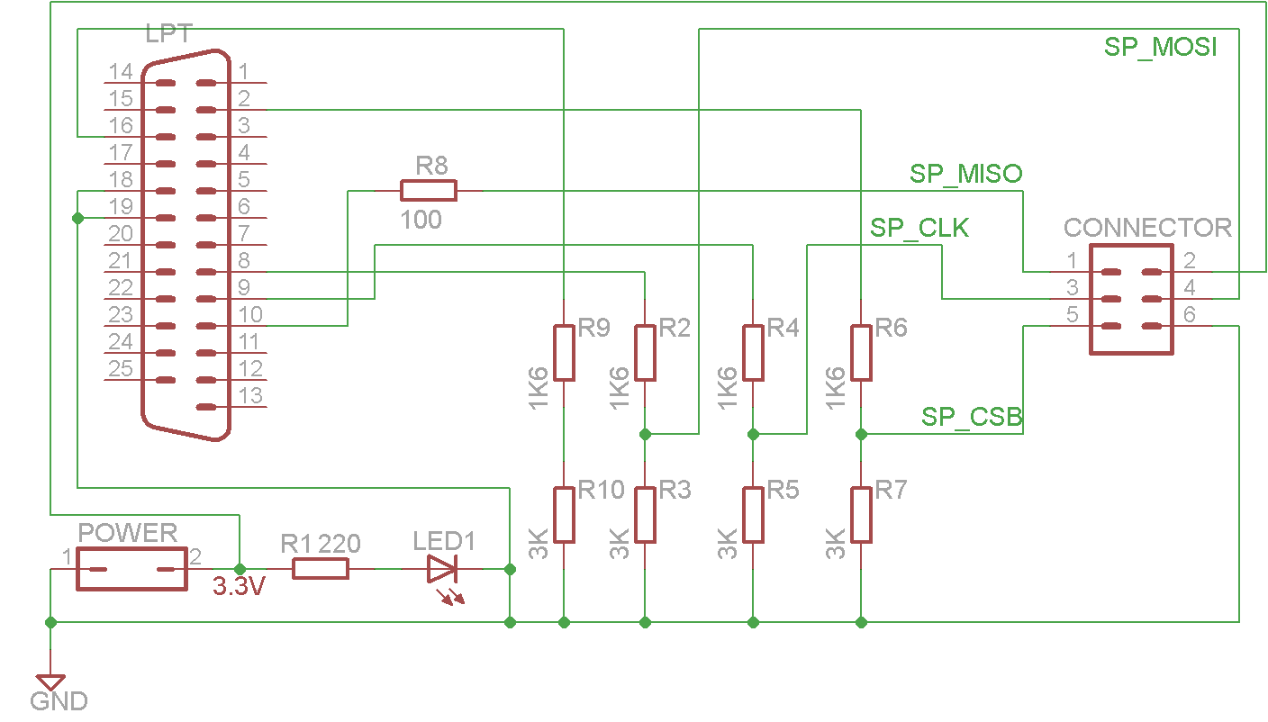
img src: http://i46.tinypic.com/23h9fs4.jpg
. Bluelab costs 3000$, but for hobby use I guess you can use a copy downloaded from the internet. This contains the CSR stack, examples, XAP compiler and everything else you need to make firmware for this device.
I see. Sorry I'm very new -- which pins on the module do the pins 1-6 on the "connector" correspond to? Thanks.
I don't have a datasheet for this module, but have one for another module that looks the same (suppose the same, only with other firmware), power, reset and uart pins match, so I guess the rest will match as well.
Interfaces on this module:
SPI:
16: CSB
17: MOSI
18: MISO
19: CLK
USB:
15: D-
20: D+
PCM:
5: CLK
6: OUT
7: IN
8: SYNC
Analog:
9: AIN0
10: AIN1
GPIO:
23-34: GPIO0-11
Power:
11: Reset
12: 3.3V
13: GND
21: GND
22: GND
UART:
1: TX
2: RX
3: CTS
4: RTS
Everything except UART TX and RX will need your own firmware, even the flow control pins.
Thanks for the info. So, if I can get myself a SPI adapter, connect those 4 pins, and Bluelab, then I can get going with loading my firmware? Is there a particular version of Bluelab that is required for Bluecore4? Something I don't quite understand: since the firmware is to be loaded into the flash, shouldn't I need to interact with the flash rather than the BT chip?
Bluelab 4.1 supports this chip. Googling for this http://www.google.com/search?q=bluelab+4.1 shows a promising first link.
You program the flash chip via the CSR chip.
Thanks again. Finally, do you know where I can get a SPI adapter? They don't seem to be commonly available.. maybe I'm searching with the wrong keywords.
You need to use the schematic I posted and build one.
img src: http://i46.tinypic.com/23h9fs4.jpg
You can also buy one from CSR but it's very expensive for a few resistors.

