班级： 软工11601 姓名： 熊威 序号： 23

上机1 线程不安全
- 上机目的
了解如下：
线程安全就是多线程访问时，采用了加锁机制，当一个线程访问该类的某个数据时，进行保护，其他线程不能进行访问直到该线程读取完，其他线程才可使用。不会出现数据不一致或者数据污染。(Vector,HashTable)
线程不安全就是不提供数据访问保护，有可能出现多个线程先后更改数据造成所得到的数据是脏数据。（ArrayList，LinkedList，HashMap等）
本次实验主要以ArrayList为例，了解线程的安全性
- 上机内容
第一个例子:
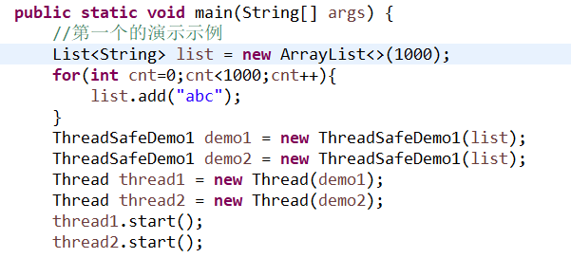
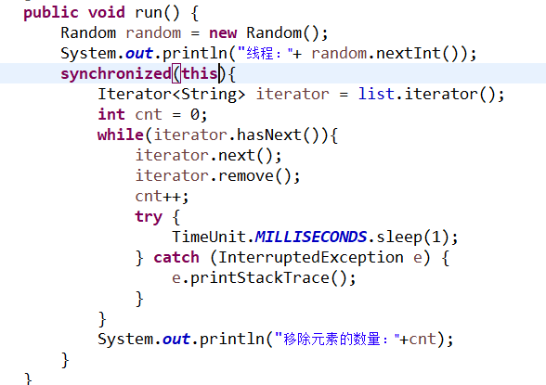
由于ArrayList的不安全性，当第一个线程启动时，在第一个循环沉睡一秒，此时List是被第一个线程占用着的，并没有结束，所以第二个线程启动会报错
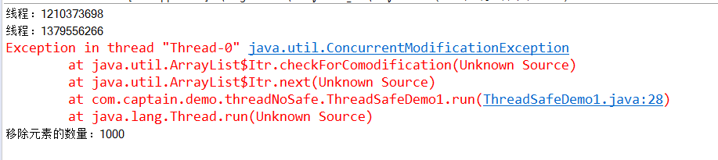
解决方法：因为synchronized(this)不应该锁住this本身，而应该锁住List，synchronized(List)。当锁住列表后，List每次只能被一个线程所用，不会冲突报错。
还有一个解决办法就是用run（）来实现，这是由于start（）和run（）的机制所造成的

第二个例子：
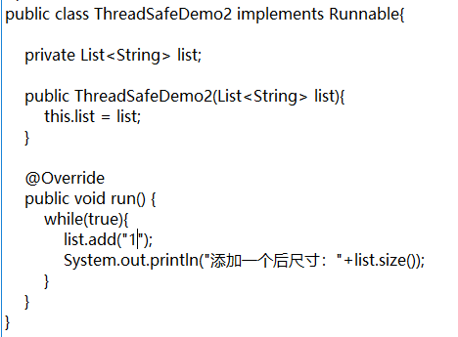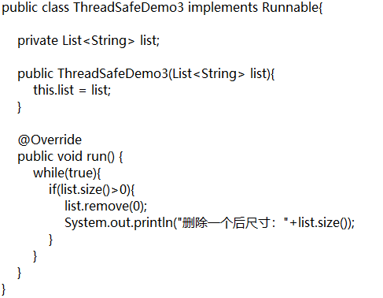
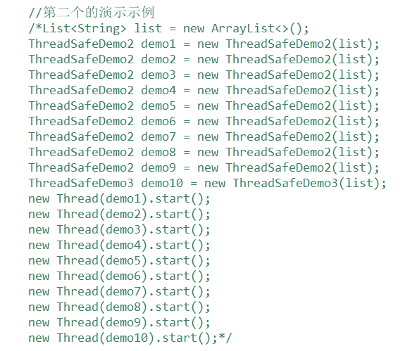
第二个的错误原因也是因为ArrayList的不安全导致，由于岂不安全性，也导致了多个线程同时对List进行操作。结果如下：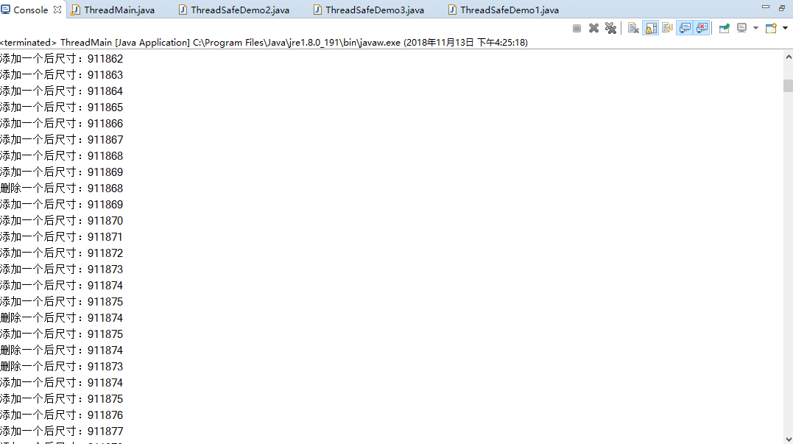
结果中添加元素不定时且大量出现，删除元素出现的极少。多个线程同时对一个List操作导致
解决方法：
由于ArrayList线程不安全，可将其用queue代替，声明BlockingQueue<String> queue = new ArrayBlockingQueue<>(1000)
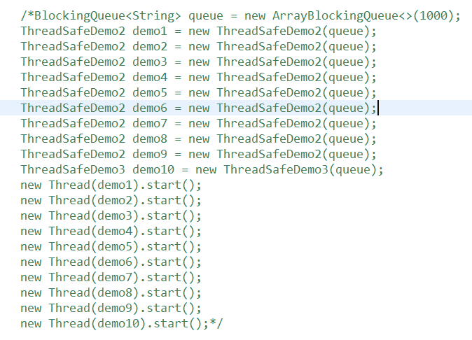
运行结果：
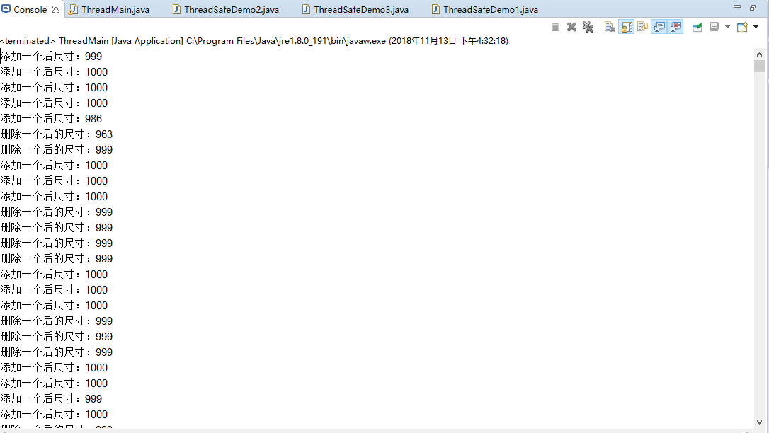
添加或删除是成对出现的，这是因为queue线程安全，一个线程用遍历queue时，另外的线程不能再用。

- 上机代码
- ThreadMain.java
package com.captain.demo.threadNoSafe;

import java.util.ArrayList;
import java.util.List;
import java.util.concurrent.ArrayBlockingQueue;
import java.util.concurrent.BlockingQueue;
/*import java.util.concurrent.CopyOnWriteArrayList;*/

/**
* Created by captain on 2017/7/27.
*/
public class ThreadMain {

public static void main(String[] args) {
//第一个的演示示例
List<String> list = new ArrayList<>(1000);
for(int cnt=0;cnt<1000;cnt++){
list.add("abc");
}
ThreadSafeDemo1 demo1 = new ThreadSafeDemo1(list);
ThreadSafeDemo1 demo2 = new ThreadSafeDemo1(list);
Thread thread1 = new Thread(demo1);
Thread thread2 = new Thread(demo2);
thread1.start();
thread2.start();

//第二个的演示示例
/*List<String> list = new ArrayList<>();
ThreadSafeDemo2 demo1 = new ThreadSafeDemo2(list);
ThreadSafeDemo2 demo2 = new ThreadSafeDemo2(list);
ThreadSafeDemo2 demo3 = new ThreadSafeDemo2(list);
ThreadSafeDemo2 demo4 = new ThreadSafeDemo2(list);
ThreadSafeDemo2 demo5 = new ThreadSafeDemo2(list);
ThreadSafeDemo2 demo6 = new ThreadSafeDemo2(list);
ThreadSafeDemo2 demo7 = new ThreadSafeDemo2(list);
ThreadSafeDemo2 demo8 = new ThreadSafeDemo2(list);
ThreadSafeDemo2 demo9 = new ThreadSafeDemo2(list);
ThreadSafeDemo3 demo10 = new ThreadSafeDemo3(list);
new Thread(demo1).start();
new Thread(demo2).start();
new Thread(demo3).start();
new Thread(demo4).start();
new Thread(demo5).start();
new Thread(demo6).start();
new Thread(demo7).start();
new Thread(demo8).start();
new Thread(demo9).start();
new Thread(demo10).start();*/

/*BlockingQueue<String> queue = new ArrayBlockingQueue<>(1000);
ThreadSafeDemo2 demo1 = new ThreadSafeDemo2(queue);
ThreadSafeDemo2 demo2 = new ThreadSafeDemo2(queue);
ThreadSafeDemo2 demo3 = new ThreadSafeDemo2(queue);
ThreadSafeDemo2 demo4 = new ThreadSafeDemo2(queue);
ThreadSafeDemo2 demo5 = new ThreadSafeDemo2(queue);
ThreadSafeDemo2 demo6 = new ThreadSafeDemo2(queue);
ThreadSafeDemo2 demo7 = new ThreadSafeDemo2(queue);
ThreadSafeDemo2 demo8 = new ThreadSafeDemo2(queue);
ThreadSafeDemo2 demo9 = new ThreadSafeDemo2(queue);
ThreadSafeDemo3 demo10 = new ThreadSafeDemo3(queue);
new Thread(demo1).start();
new Thread(demo2).start();
new Thread(demo3).start();
new Thread(demo4).start();
new Thread(demo5).start();
new Thread(demo6).start();
new Thread(demo7).start();
new Thread(demo8).start();
new Thread(demo9).start();
new Thread(demo10).start();*/
}

}
- ThreadSafeDemo1.java
package com.captain.demo.threadNoSafe;

import java.util.Iterator;
import java.util.List;
import java.util.Random;
import java.util.concurrent.TimeUnit;

/**
* 线程安全演示类
* Created by captain on 2017/7/27.
*/
public class ThreadSafeDemo1 implements Runnable{

private List<String> list;

public ThreadSafeDemo1(List<String> list){
this.list = list;
}

public void run() {
Random random = new Random();
System.out.println("线程："+ random.nextInt());
synchronized(list){
Iterator<String> iterator = list.iterator();
int cnt = 0;
while(iterator.hasNext()){
iterator.next();
iterator.remove();
cnt++;
try {
TimeUnit.MILLISECONDS.sleep(1);
} catch (InterruptedException e) {
e.printStackTrace();
}
}
System.out.println("移除元素的数量："+cnt);
}
}
}

- ThreadSafeDemo2.java
package com.captain.demo.threadNoSafe;

//import java.util.List;
import java.util.concurrent.BlockingQueue;
import java.util.concurrent.TimeUnit;

/**
* 线程安全演示类
* Created by captain on 2017/7/27.
*/
public class ThreadSafeDemo2 implements Runnable{

private BlockingQueue<String> queue;

public ThreadSafeDemo2(BlockingQueue<String> queue2) {
this.queue = queue2;
}

public void run() {
while(true){
try {
queue.offer("1",10,TimeUnit.SECONDS);
} catch (InterruptedException e)
e.printStackTrace();
}
System.out.println("添加一个后尺寸："+queue.size());
}
}
}

- ThreadSafeDemo3.java
package com.captain.demo.threadNoSafe;

//import java.util.List;
import java.util.concurrent.BlockingQueue;
import java.util.concurrent.TimeUnit;

/**
* 线程安全演示类
* Created by captain on 2017/7/27.
*/
public class ThreadSafeDemo3 implements Runnable{

private BlockingQueue<String> queue;
public ThreadSafeDemo3(BlockingQueue<String> queue2) {
this.queue = queue2;
}

public void run() {
while(true){
if(queue.size()>0){
try {
queue.poll(10, TimeUnit.SECONDS);
} catch (InterruptedException e) {
// TODO Auto-generated catch block
e.printStackTrace();
}
System.out.println("删除一个后的尺寸："+queue.size());
}
}
}
}

