Topics:

1. chapter 1 (preliminary math stuff, preliminary c++ stuff)

2. Chapter 2 (complexity theory)

3. Makefiles and g++

4. Chapter 3 (iterators, standard template library(array, vector , list and

unordered_maps), smart pointers), review code covered for these topics

Expect true/false, short answers, multiple choice(maybe),

1 coding question- give a problem and you must code up the solution,

1 question will have you analyze the compliexity of some code.

Proofs: identity a proof, and be familiar with the concept, no explicit Proofs

Skiped from chapter 1: Greatest common divisor algorithm

How the g++ compiler works and its architecture(preprocessor, compiler, linker),

and how to use make. In terms of questions I will only ask about things seen in

the Makefile for assignment 1.

https://makefiletutorial.com/

makefile tutorials:

Understanding mod notation, for example: is this true 9 = 7 mod 3 ? (false)

what is a template, how does it compile , explain why .h and .cpp is weird.

n + nlogn + 7= O(nlogn)

know important runtimes like selection sort = O(n^2)

make sure to know l and r values, references, pointers, big 5 constuctors

How to use arithmetic series, be able to explain what the other series are.

These are some examples but not all!

Useful trees implementations:  
<https://users.cs.fiu.edu/~weiss/dsaa_c++4/code/>

Topics:

1. chapter 1 (preliminary math stuff, preliminary c++ stuff)

2. Chapter 2 (complexity theory)

3. [Makefile](https://makefiletutorial.com/) and [g++](https://www3.ntu.edu.sg/home/ehchua/programming/cpp/gcc_make.html)

-I. look at current dir for header files.

And preprocessor does NOT produce assembly codes.

Preprocessor handles all the #include #define. And produces and intermediate version of source code.

Smart pointers: automatically delete the managed object and free up memory when the smart pointer goes out of scope or is no longer needed. This helps to prevent memory leaks and makes memory management safer and easier.  
Unique pointers: Only one std::unique_ptr can manage a given object at any time. When the std::unique_ptr goes out of scope, it deletes the managed object. std::unique_ptr cannot be copied, but it can be moved.

Shared pointers: can be copied and moved.

4. Chapter 3 (iterators, standard template library(array, vector , list and

unordered_maps), smart pointers), review code covered for these topics

Expect true/false, short answers, multiple choice(maybe),

1 coding question- give a problem and you must code up the solution,

1 question will have you analyze the compliexity of some code.

Proofs: identity a proof, and be familiar with the concept, no explicit Proofs

Skiped from chapter 1: Greatest common divisor algorithm

How the g++ compiler works and its architecture(preprocessor, compiler, linker),

and how to use make. In terms of questions I will only ask about things seen in

the Makefile for assignment 1.

makefile tutorials:

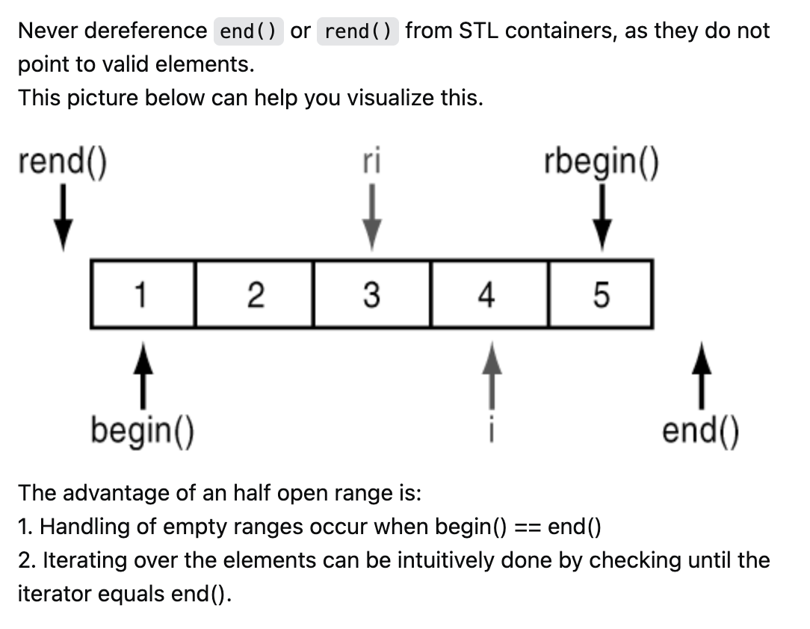

<https://stackoverflow.com/questions/34830192/what-doesone-past-the-last-element-mean-in-vectors>

Summary of C++ [vector](https://cplusplus.com/reference/vector/vector/at/) and C++ [List](https://cplusplus.com/reference/list/list/):

[iterator](https://cplusplus.com/reference/iterator/), assuming it’s a set, then Random_Access is the entire set, and   
bidirectional is a subset

Vector and list both belong to containers of C++

|  |  |  |
| --- | --- | --- |
| Vector | List |  |
| Has its member functions:  e.g.: .at()  shrintk_to_fit()  erase() | Has its member functions  e.g. erase(), begin(), end(), but has less than vector |  |
| Has Random_access_iterators:  ++itr; 🡨pre-increment, preferred, return the incremented iterator  Itr++; 🡨 post-increment, less efficient, make a copy, increment the original, and retun the copy.  *++itr; 🡨increment then dereference  *it++; 🡨 dereference then increment  Itr == itr;  Itr != itr;  Swap(itr, itr2);  Can do arithmetic operations:  Itr – itr2;  Itr – 5;  Itr + 5;  5 + itr;  Itr[5]; 🡨 this does not move the itr, it only does the offset  Itr->display() | Has Bidirectional_iterators:  Has mush less options than random_access_iterators |  |
| Has access to all member functions of iterator class | Has access to all member functions of iterator class |  |
| List.insert() | does not delete list2 |  |
| List.merge() | DELETES list2 |  |
| List.splice() | DELETES list2 |  |
|  |  |  |

You want to insert n random integers into an initially empty List or Vector, while keeping it sorted after each insertion.

Operations in Vector vs List:

|  |  |  |
| --- | --- | --- |
| Operation | Vector | List |
| Sort() – introSort worse and average | O(n*logn) | O(n*logn) |
| Search() on sorted | O(logn) on sorted vector using binary search | Doesn’t have this functionality |
| Search() on unsorted | O(n) have to iterate through | O(n) have to traverse |
| Insert() | O(n), have to move elements down after inserting new | O(1) doubly linked list |
| Overall for each element: | O(logn) + O(n) = O(n) | O(n) + O(1) = O(n) |
| Overall for n elements: | O(n^2) | O(n^2) |

Unordered_map:

Uses forward iterators:

[credit](https://www.alphacodingskills.com/cpp/notes/cpp-unordered-map-end.php)

|  |  |
| --- | --- |
| Operation: | Unorderdmap |
| Find() average | O(1) leverage hash table |
| my_map1.find(1) | Returns iterator is found, else point to .end() |
| auto it = my_map1.find(1); it->first; (*it).first;  Same thing |  |
|  |  |
| auto it = map.find(1); it = map.erase(it); | Now it points to the next element, which is random |

Csci335 midterm topics:

1. Makefile (41 lines) and g++:  
   <https://www3.ntu.edu.sg/home/ehchua/programming/cpp/gcc_make.html>
2. Iterators: for template classes: vectors, array, and list(doubly linkedlist) and unordered map(find.(), key is the input). In the context of the 4, erasing, iterating and insert.

Standard Template Library: has a collection of containers include vectors, array and list

Small coding question, go through a vector and increment every element by 3.  
No codes from project, just the makefile

1. Smart pointers: (no lambda, no mutex): unique pointers and shared pointers,
2. Big-O – upper bound

Big-Omega – lower bound

Big-Theta - average bound, exact bound

Little-o(): strictly smaller than worst.

Little-omega(): strictly larger than best

4n3+7n+7  
https://www.wolframalpha.com/input?i=log%5E2n+vs+log%28log%28n%29%29+from+0+to+1000

The complexity hierarchy of the functions:

Understanding mod notation, for example: is this true 9 = 7 mod 3 ? (false)

what is a template, how does it compile, explain why .h and .cpp is weird.

n + nlogn + 7= O(nlogn)

know important runtimes like selection sort = O(n^2)

make sure to know l and r values, references, pointers, big 5 constuctors

How to use arithmetic series, be able to explain what the other series are.

These are some examples but not all!