PROJECT KASHI
Banking Management System — Academic Project Report
Technology: Python Flask • HTML/CSS • MySQL

1. Abstract
Project Kashi is an educational web application created to demonstrate how a frontend, backend and relational database can work together. The user interacts with HTML pages; Flask handles requests and application logic; and MySQL stores customer, account and transaction data. The application supports customer registration, account opening, deposits, withdrawals, transaction history, customer/account details and a dashboard. It is a learning prototype and is not intended to operate as a real bank.

2. Objectives
- Build a web interface using HTML and CSS.
- Use Python Flask to process form submissions and route requests.
- Connect Flask to MySQL and persist records in database tables.
- Demonstrate basic account and transaction workflows.
- Organize source code and documentation in a GitHub repository.

3. Technology Stack
Frontend: HTML templates and CSS/static assets.
Backend: Python and Flask.
Database: MySQL.
Database connection: MySQL connector configured through db_config.py and local environment variables.
Version control: Git and GitHub.

4. Main Features
- Customer registration: Collects customer details and saves them to MySQL.
- Open account: Creates an account associated with a branch and links it to a customer.
- Deposit: Records a deposit and updates the account balance according to the implemented logic.
- Withdraw: Processes a withdrawal subject to the application's validation rules.
- Transaction history: Shows transactions recorded for an account.
- Customer and account details: Displays stored customer/account information.
- Dashboard: Shows summary figures such as customer/account counts, active balances and successful transaction totals.

5. Architecture and Workflow
1. A user opens a page in the browser.
2. The HTML form sends a request to a Flask route in app.py.
3. Flask validates required form values and calls the database connection helper.
4. SQL statements read or update MySQL tables.
5. Flask returns a rendered HTML template or a success/error response.
6. The user can view the resulting customer, account or transaction information.

6. Database Design
The project design includes the following conceptual entities. Confirm exact columns, data types, primary keys, foreign keys and constraints against the SQL files in the Database folder before final submission.
- CUSTOMER: CustomerID (PK), FirstName, LastName, DateOfBirth, Gender, Mobile, Email, Address, City, RegistrationDate.
- BRANCH: BranchID (PK), BranchName, IFSCCode, Address, City, State, ContactNumber.
- EMPLOYEE: EmployeeID (PK), EmployeeName, Mobile, Email, Designation, Salary, JoiningDate, BranchID (FK).
- ACCOUNT: AccountID (PK), AccountNumber, AccountType, OpeningDate, Balance, Status, BranchID (FK).
- ACCOUNT_HOLDER: CustomerID (PK/FK), AccountID (PK/FK), HolderSince, HolderType. This associative table links customers and accounts.
- TRANSACTION: TransactionID (PK), AccountID (FK), TransactionType, Amount, TransactionDate, Description, ReferenceNumber, TransactionStatus.
- LOAN: LoanID (PK), CustomerID (FK), BranchID (FK), LoanType, LoanAmount, InterestRate, StartDate, TenureMonths, LoanStatus. May be optional in the implemented application.
- LOAN_PAYMENT: PaymentID (PK), LoanID (FK), PaymentDate, Amount, PaymentMode, ReferenceNumber. May be optional in the implemented application.

7. Relationships and Cardinality
- BRANCH to ACCOUNT: one branch can serve many accounts; each account belongs to a branch (1:M).
- BRANCH to EMPLOYEE: one branch can have many employees; each employee is assigned to a branch (1:M).
- CUSTOMER to ACCOUNT through ACCOUNT_HOLDER: a customer can be linked to multiple accounts, and an account can have multiple holders if joint accounts are supported. This is M:N resolved using ACCOUNT_HOLDER.
- ACCOUNT to TRANSACTION: one account can have many transaction records; each transaction belongs to one account (1:M).
- CUSTOMER to LOAN: one customer can have multiple loan records (1:M), if the loan feature is enabled.
- BRANCH to LOAN: one branch can be associated with multiple loans (1:M), if the loan feature is enabled.
- LOAN to LOAN_PAYMENT: one loan can have multiple payment records (1:M), if the loan feature is enabled.
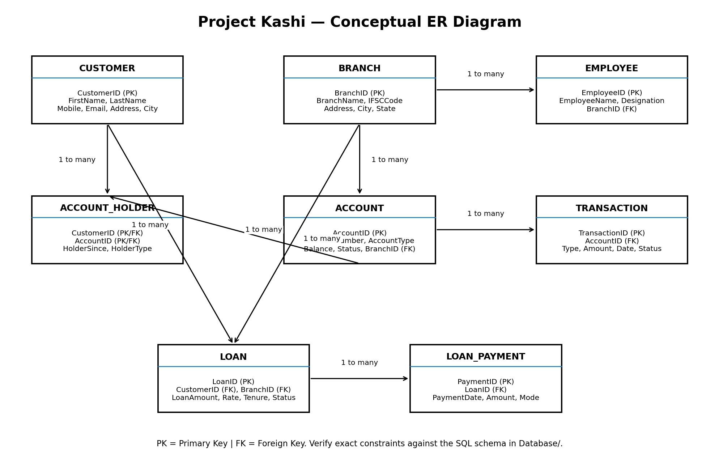
Figure 1. Conceptual ER diagram. Validate against the final SQL schema; the drawing is explanatory and may need adjustment if your implemented foreign keys differ.

8. Security and Limitations
- Database credentials are stored locally in a .env file and excluded from Git using .gitignore.
- Only fictional demonstration data should be used.
- This prototype is not production banking software. It does not claim to provide production-grade authentication, authorization, audit controls, regulatory compliance or secure financial transaction processing.
- For final submission, verify that deposits and withdrawals update balances and transaction records consistently, preferably within database transactions.

9. How to Run
- Install Python and MySQL Server.
- Clone the repository from https://github.com/sufail9/project_kashi.git.
- Create and activate a Python virtual environment.
- Install dependencies with pip install -r requirements.txt.
- Create a local .env file containing DB_HOST, DB_USER, DB_PASSWORD and DB_NAME, matching the configuration expected by db_config.py.
- Run the SQL setup scripts in the Database folder using MySQL Workbench.
- Run python test_db.py to check the database connection.
- Run python app.py and open the local Flask URL shown in the terminal.

10. Conclusion
Project Kashi demonstrates the core workflow of a database-backed web application: collecting input through HTML, processing it in Flask, storing data in MySQL and presenting the result to users. It provides practical learning in routing, form handling, SQL operations, relational design and GitHub-based project organization.

11. Items to Verify Before Submission
- Confirm all database table and column names from the actual SQL scripts.
- Confirm all primary-key and foreign-key constraints.
- Check that .env is not present in the GitHub repository and no password exists in committed files.
- Run each feature once and prepare a short demonstration.
- Update this report with screenshots from the actual running application if required by the instructor.

