1. 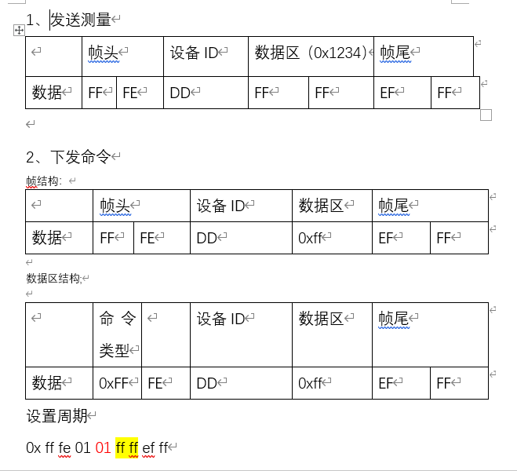发送测量

|  |  |  |  |  |  |  |  |
| --- | --- | --- | --- | --- | --- | --- | --- |
|  | 帧头 | | 设备ID | 数据区（0x1234） | | 帧尾 | |
| 数据 | FF | FE | DD | FF | FF | EF | FF | |

1. 下发命令

帧结构：

|  |  |  |  |  |  |  |
| --- | --- | --- | --- | --- | --- | --- |
|  | 帧头 | | 设备ID | 数据区 | 帧尾 | |
| 数据 | FF | FE | DD | 0xff | EF | FF |

数据区结构;

|  |  |  |  |  |  |  |
| --- | --- | --- | --- | --- | --- | --- |
|  | 命令类型 |  | 设备ID | 数据区 | 帧尾 | |
| 数据 | 0xFF | FE | DD | 0xff | EF | FF |

设置周期

0x ff fe 01 01 ff ff ef ff

设置距离

0x ff fe 01 02 ff ff ef ff

**三、**标定

TOF 传感器再2000mm范围内，准确性较高。

对此区域进行分段线性标定

|  |  |  |  |  |  |  |  |
| --- | --- | --- | --- | --- | --- | --- | --- |
| 标称值 | 0 | 100 | 200 | 300 | … | 1900 | 2000 |
| 标定值 | 0 | 100 | 200 | 300 | … | 1900 | 2000 |

上传云端数据格式

{

"type": "TOFdata",

"timestamp": time.time(),

"messageId": messagID,

"command": "xx/recommend",

"data": {

"devId": id,

"value": value

}

}

