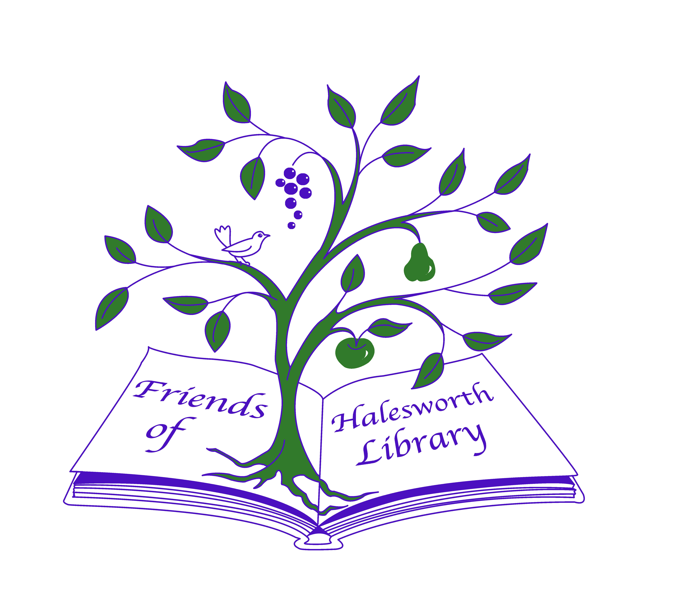

**Junior Friends of Halesworth County Library**

Halesworth County Library, Bridge Street, Halesworth, Suffolk IP19 8AD

Tel: 01986 875095 [halesworth.library@suffolklibraries.co.uk](mailto:halesworth.library@suffolklibraries.co.uk) [www.suffolklibraries.co.uk](http://www.suffolklibraries.co.uk/)

**This is your chance to join a very special group**

The Junior Friends of Halesworth County Library is open to all young Library members. Once you reach 18 you can become a member of the adult Friends Group.

Junior Friends will have their own meetings and will have the opportunity to let the adults know their ideas for what they would like to see and do at the library.

**To become a Junior Member**

You must have your own Suffolk Libraries membership card. If you currently share one with a parent or guardian, now is the time to get your own! Cards are free and can be issued at the Library desk.

-------------------------------------------------------------------------------------------------------------------------------------------

**JUNIOR MEMBERSHIP APPLICATION**

To: Junior Friends of Halesworth County Library, Bridge Street, Halesworth, Suffolk IP19 8AD

I would really like to become a member of the Junior Friends of Halesworth Library

Name:

Address:

Email: Telephone:

Library Card Membership No:

Signed: Date:

Parent/Guardian signature: Date:

Parent/Guardian Email: