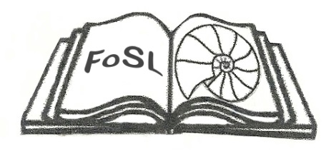

Friends of Southwold Library  
2019 Annual Patron Scheme

Registered Charity Number 1163525

Our Annual Patron Scheme invites supporters of Southwold Library to make a financial contribution towards the running costs of the Library. In return for a minimum donation of £20, you can join the Friends of Southwold Library (FoSL) 2018 Annual Patron Scheme.

FoSL was formed in 2013 to raise money towards the continued running of the services provided by Southwold Library. FoSL is a Registered Charity. The Friends organise fund-raising events throughout the year. Funds raised provide services such as free Wi-Fi, public printing and scanning services and loanable IT equipment.

If you would like to help support the running of our Library, which provides so many valuable services to our local community, why not become a Patron? Patrons’ names will be listed in the FoSL Annual Report (though you may remain anonymous if you prefer). All Patrons will receive a copy of the Annual Report and be invited to our annual Patrons’ Reception where you can discuss the work of FoSL and the Library with the Trustees of FoSL and the Library Manager. Patrons will also have the satisfaction of knowing that they are helping towards the continuing provision of an essential resource available to everyone who lives in, works in or visits Southwold.

----------------------------------------------------------------------------------------------------------------------------------

*I would like to support Southwold Library by becoming a FoSL 2019 Annual Patron*

*I enclose my donation of £…………* Please make cheques payable to: The Friends of Southwold Library.

Please hand in your cheque and completed form at the Library Counter or send it to:

FoSL, Southwold Library, North Green, Southwold, IP18 6AT.

Title………... First Name………………………………………….Surname………………………………………………………………

Address:……………………………………………………………………………………………………..Post Code……………………….

e-mail address…………………………………………………………………………………………….Date……………………………….

If you do not want your name to appear in our Patrons List in the Annual Report tick here

If you are a UK tax payer, you can significantly increase the value of your gift at no cost to you by allowing FoSL to reclaim tax on your donation from HMRC. Please fill in the declaration below:



*I want to Gift Aid my donation of £______ to Friends of Southwold Library. I am a UK taxpayer and understand that if I pay less Income Tax and/or Capital Gains Tax in the current tax year than the amount of Gift Aid claimed on all my donations it is my responsibility to pay any difference.*

Please notify FoSL if you want to cancel this declaration, change your name or home address, or no longer pay sufficient tax on your income and/or capital gains. If you pay Income Tax at the higher or additional rate and want to receive the additional tax relief due to you, you must include all your Gift Aid donations on your Self-Assessment tax return or ask HM Revenue and Customs to adjust your tax code.