**MIRANDA**

**Miranda** is a responsive portfolio HTML template built with Tailwind CSS.

**Template Features:**

* Build with Tailwind CSS v3.3.2
* Fully Responsive and easy to customize
* Compatible with all modern browsers
* W3C Validated Code
* Clean code with comments

**Zip folder contains:**

1. asset – Images (PNG and JPG format)
2. dist – output.css
3. src – Input.css
4. index.html
5. package-lock.json
6. tailwind.config.js

**Folder structure:**

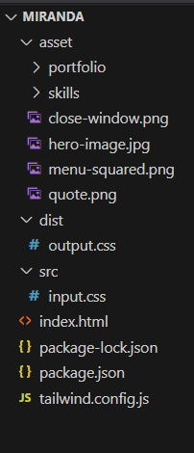

**CSS:**

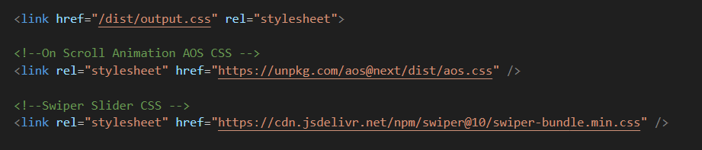

**JS:**

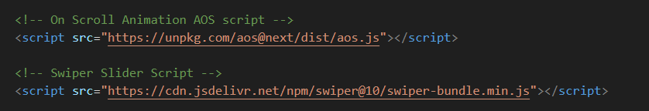

**Custom theme and style:**

1. Install **Node JS** and run “**npm install**” in respective folder and configure in **tailwind.config.js**

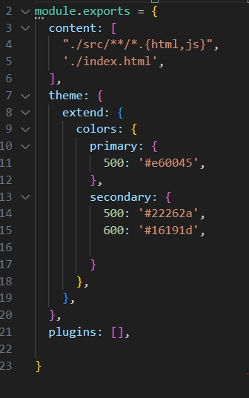

**Other Information:**

1. Template build with [**Tailwind CSS**](https://tailwindcss.com/) **Version 3.3.2**
2. Social icons in hero section are used from [**Bootstrap icons**](https://icons.getbootstrap.com/)
3. Hero section image is copyright free image used from [**Unsplash**](https://unsplash.com/images)
4. “What I do” section SVG icons are used from [**Hero icons**](https://heroicons.com/)
5. “What I do” section on scroll animation is used from [**AOS**](https://michalsnik.github.io/aos/)
6. My Skills section images are used from [**IconSout**](https://iconscout.com/icons/)
7. By using [**Swiper** **JS**](https://swiperjs.com/) Version 10.0.4 created the Testimonial Sliders
8. Profile icons in testimonial slider are used from [**Random User**](https://randomuser.me/)

**Support:**

If you have any questions don't hesitate to reach us at [vigowebs@gmail.com](mailto:vigowebs@gmail.com)