**Step-by-step guidance for running Android-Matlab Image Processing Program**

The connection between Matlab running on PC and Android run Intensity program, is established using TCP/IP channel. Matlab act as the server, and android as a client. Matlab will open the connection first, and then android make the connection to Matlab later.

1. Make sure both computer and android have connected to the same wifi network. Do not make android device as the hotspot source because it cannot be used for our TCP/IP communication.
2. Run Matlab program by typing mainprogram
3. Open the android program (Intensity) and open Setting page by clicking top right icon.

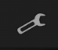

1. Put IP address of the Android into the box “Android IP Address” on Matlab program, and put IP address of the computer (displayed on Matlab Computer IP Address) into the box “Put computer IP and Port here”

Make sure both port are the same number.

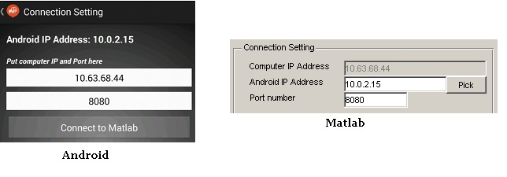

Note: the android IP number which we put on Matlab, will be automatically saved in mat-file IPS.MAT and later we can use the same IP again by clicking *Pick* button.

1. Open the TCP server connection in Matlab by clicking *Open Connection* button.

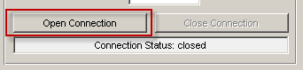

1. Once the server connection successfully opened, then the status will change to “waiting for connection…” and the *Open Connection* button will be disabled. Now we need to connect the Android (the client) to Matlab. Note that this operation blocks all the Matlab processing until we connect android to Matlab, or we issue unblocking command by executing *Ctrl+C* (in Windows) from Matlab Command Window.

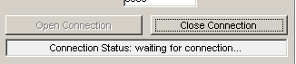

1. On Android, click *Connect to Matlab* button on Intensity program. Connection to the Matlab will be established, and once it has successfully make the connection, it will display message “Connected to Matlab” and the button will change to *Disconnect from Matlab.* The statusbar in Matlab will also change to “connected to <IP Address of Android>”
2. Now Matlab ready to receive the image data. Click *Take Photo* button on Android to take a picture of chemical glasses, and click *Send data to Matlab* to send the image to Matlab.
3. When we send the image to Matlab, android progress bar will display the status, and statusbar in Matlab will show “Status: Receiving data…”

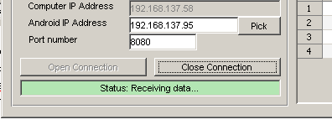

1. After the image has been received by Matlab, then Matlab will do image processing as previous program did, calculate the intensities, and send the intensity values back to Android.
2. To close the connection, click *Close Connection* button on Matlab or click *Disconnect from Matlab* button on Android. Note than android (client) can request close connection to Matlab, and immediately Matlab will also close the connection. But connection closed by Matlab (server) will not close the connection on android. So, it is better to close connection from android.