**GUIDE**

**FACE RECOGNITION**

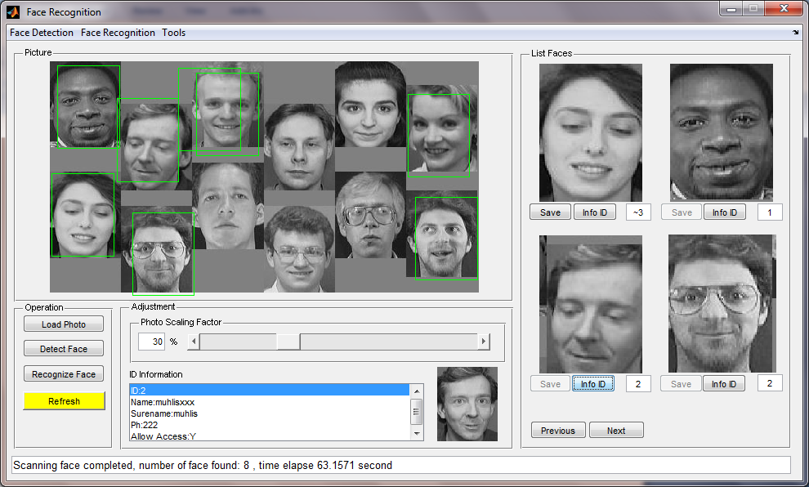

1. MENU FACE DETECTION
   1. Create Database: To create knowledge database for ANN to be trained (executed automatically in the beginning of program execution)
   2. Initialize Network: Initialize parameters on ANN with small random value (executed automatically in the beginning of program execution)
   3. Train Network: To train the network to give a knowledge about face and non-face
   4. Test On Photo: disable
2. MENU FACE RECOGNITION
   1. Select an Image to Add to face Database: Load a single face image in Matlab workspace
   2. Add Face to Database: Save loaded face image (above) to database. You will be asked to fill ID Information form
   3. Total Number of ID: Show total number of ID already stored in database
   4. ID Information
      1. Display Information: Display ID Information based on ID Number or Name of Person
      2. Show Database File: Display all database files that have been created
   5. Delete Database: Delete ID Database. All stored ID Information and reference image will be deleted.
   6. Mean Face and Eigen Face: Display Mean Face and Eigen Face in new windows.
3. MENU TOOLS
   1. Manually Crop Face: To crop manually a face in the photo
   2. Set Width/Height Face Frame: Set the size of face frame (rectangle around the face that found)
4. BUTTON LOAD PHOTO: Load a photo contains faces to be detected and recognized.
5. BUTTON DETECT FACE: Detect faces on photo.
6. BUTTON RECOGNIZE FACE: Recognize faces on photo.
7. BUTTON REFRESH: Clear the result of Face Detection and Face Recognition action.
8. PANEL PHOTO SCALING FACTOR: For scaling the photo
9. BUTTON NEXT: Go to the next face images that already found
10. BUTTON PREVIOUS: Go to the previous face images that already found
11. BUTTON SAVE: Save the current face to database.
12. BUTTON INFO ID: Display ID Information of current face

**HOW TO PLAY**

1. Run the program
2. Train the network
3. Add at least one person to database, by Face Recognition -> **Select an Image to Add to face Database** and continue with -> **Add Face to Database. More persons stored in database, the recognition process will be more valid.**
4. Load a photo contains many faces
5. Detect the face by clicking Detect Face button
6. Recognize the face by clicking Recognize Face button

Note:

1. There are 2 ways to add a person to database.

**1st,** by Manual: menu Face Recognition -> **Select an Image to Add to face Database** and continue with -> **Add Face to Database.**

**2nd,** by click Save button after performing Face Recognize.

**More persons stored in database, the recognition process will be more valid.**

1. Between step 4 and 5 or 5 and 6, we can manually crop the face on the photo. If we manually crop the photo then Detect Face function (by clicking Detect Face button) is void.
2. After faces are detected automatically (by clicking Detect Face button) but before Recognize button is clicked, we can crop other face on the photo manually.
3. After faces are recognized (by clicking Recognize Face button), we can also crop face image manually. Just re-run Recognize Face again to recognize the new cropped face image.
4. If face are recognized, ID of the face will be displayed in the small box right to Info ID button, the Save button is disable, and the Info ID button is Enable. Click the Info ID button to display the ID Information of current face.
5. If face are not recognized but has a similarity to another face, face ID that has similarity to current face will be displayed also in the small box right to Info ID button but with prefix **‘~’**, and both the Save and Info ID button is enable. Hence, we can save this face as new person.
6. If face are not recognized and doesn’t have similarity to other faces, the small box remains empty, the Save button is enable and Info ID is disable.
7. Just click Save button to save face image as a new person. Program will automatically increase ID number and we will be asked to fill ID Information form.
8. Try to add many person to data
9. **Folder face, non-face, file template1.png and template2.png must exist in the same directory of program**